1. Displaying all the files from the local server

1. Opened the Weather Project folder

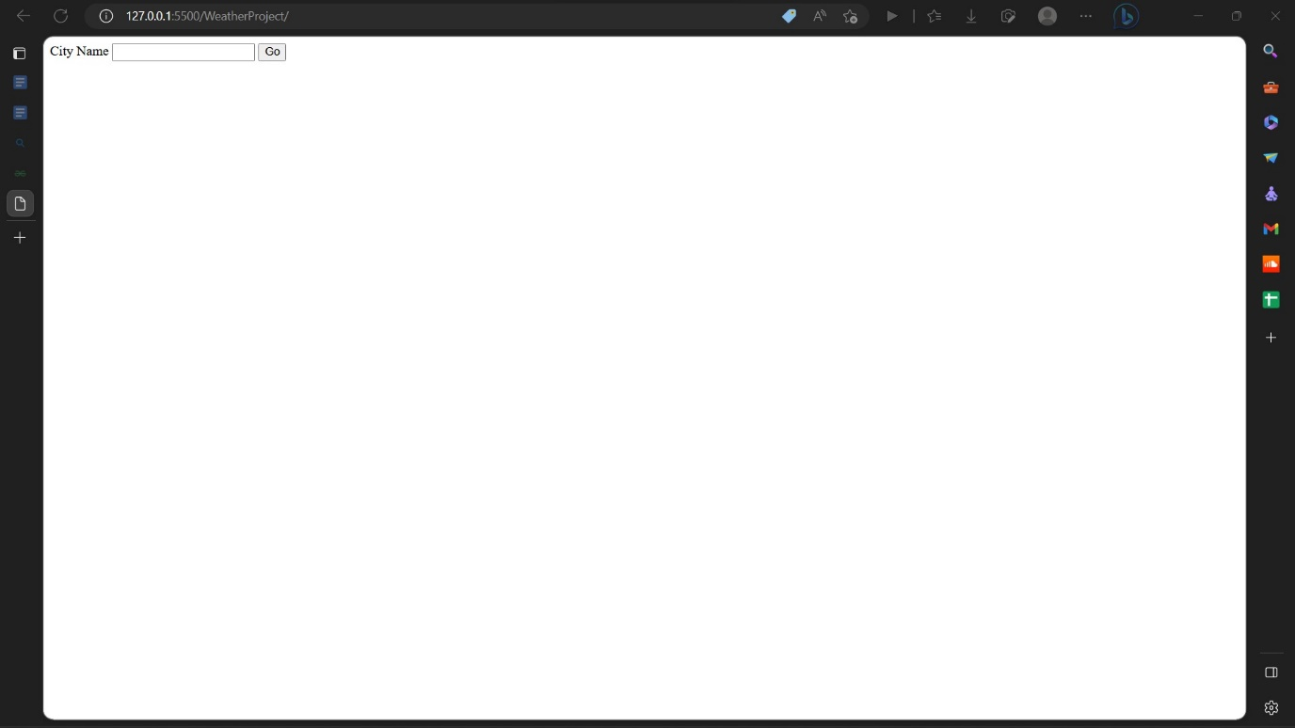

1. Opening the file.txt

