A Database for a Restaurant

Project – 1

**Team Members**

Student Name: Tejaswi Maddineni Student Name: Mrunal Tilekar

Student ID: 801201724 Student ID: 801257239

Student Name: Shalini Marneni Student Name: Nikhitha Modugu

Student ID: 801203229 Student ID: 801201724

**Records of Restaurant**

**Introduction:**

**Project Overview:**

The Database that we have created in this project is : This database represents a small sized restaurant . It stores all the data required to function a restaurant properly. This project involves designing a database to store the details of the student, order, staff, faculty, person, driver, menu, vehicle, location and delivery.

**Database design:**

|  |  |
| --- | --- |
| **Tables** | **Purpose** |
| restaurant | This table has all the details of that particular restaurant |
| driver | This table contains particulars about the driver |
| student | This table has all the information about student such as name, graduation year, etc |
| location | This table contains location information such as latitude, location id, etc |
| staff | This table has all the information about staff |
| person | This table has all the information about person such as person name, email etc. |

|  |  |
| --- | --- |
| vehicle | This table has all the information about vehicle |
| faculty | This table has all the information about faculty which includes degree, titile etc |
| delivery | This table has all the information about delivery. |
| menu | This table contains all the details of menu a restaurant have. |

**ER Diagram:**

**Reverse Engineer:**

Database reverse engineering is the process through which the logical and conceptual schemas of a legacy database, or of a set of files, are reconstructed from various information sources such as DDL code, data dictionary contents, database contents or the source code of application programs that use the database.

Below diagram is obtained after using reverse engineering steps on the database created.

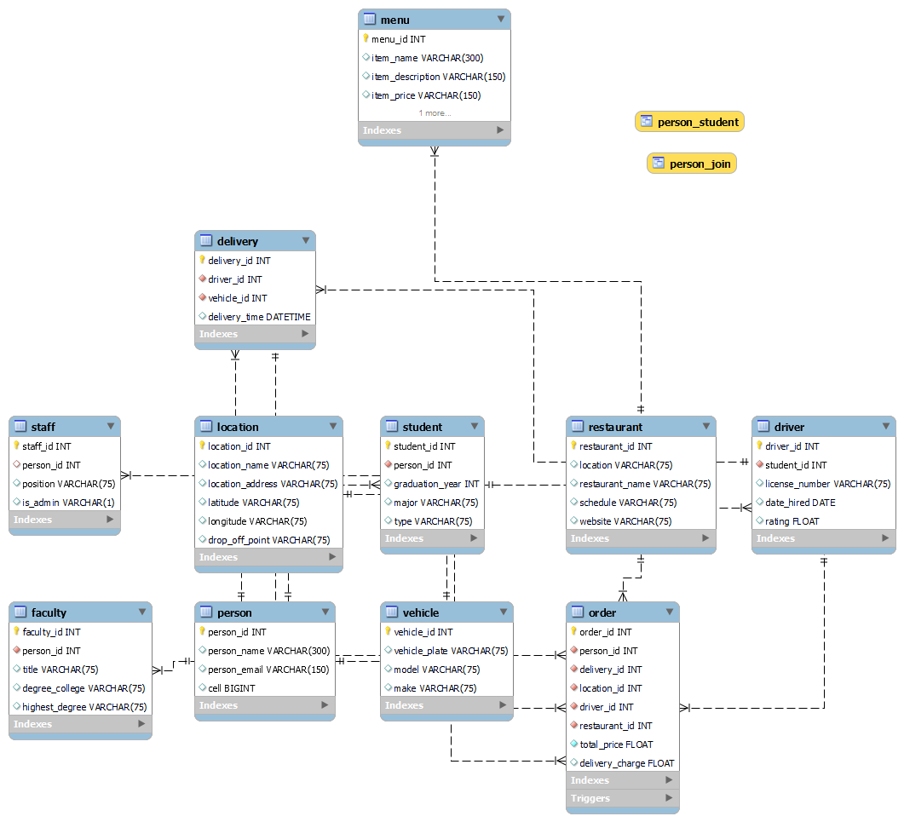

**Database tables:**

**Student Table:**

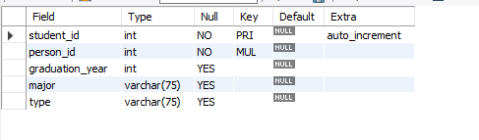

**Restaurant Table:**

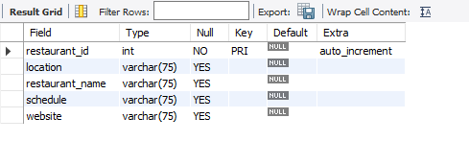

**Driver table:**

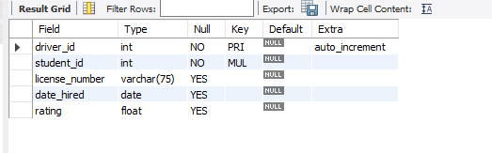

**Location Table:**

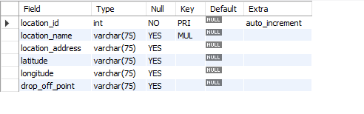

**Delivery Table:**

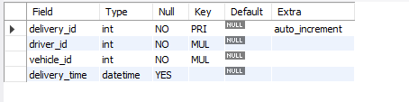

**Staff Table:**

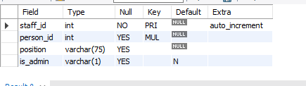

**Menu Table:**

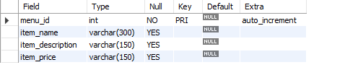

**Faculty Table:**

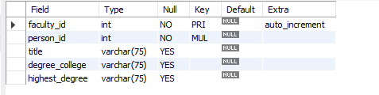

**Person Table:**

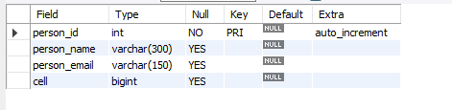

**Vehicle Table**

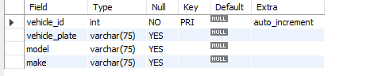

**Order Table:**

