# Mindfulness

Mindfulness means trained attention. Based on thousands of years of practice, mindfulness techniques enable people to manage their attention, improve their awareness, and sharpen their focus and clarity.

**A mind in balance, which sees reality clearly and values ethics.**

Life is about results. Results come from our actions. Our actions come from the choices we make. Our choices come from the thoughts we think.



We are living in an “attention economy” where the ability to man- age our attention and the quality of our attention is key to our success. But in the digital age, where our ability to pay attention at will is under siege, we have a problem.

But from a neurological perspective, we’re not capable of focusing attention on two things at the same time. When we think we are multitasking, what we are doing in reality is shift-tasking : shifting attention rapidly between two or more things.

Mindfulness is about you. It’s about overcoming the multitasking trap, and entering the attention economy being one second ahead of your wandering mind and external distractions. It’s about generating greater mental effectiveness so that you can reach your full potential, both on a professional and a personal level. Effectiveness in this context is the ability to achieve your goals, objectives, and wishes in life.

The central characteristics of mindfulness are sharp focus and open awareness. Sharp focus is the ability to concentrate single-pointedly on any object of choice for a long as you want with minimal effort. Training sharp focus provides the benefit of being fully present with other people or tasks. Open awareness is the ability to see clearly what is happening in your mind and make wise choices about where to focus your attention. Through training open awareness, you gain clarity. The clutter from the outer world and from your own mind is reduced. As you become more insightful, even the most difficult problems appear less complex and become easier to handle. Optimal effectiveness is achieved when people are simultaneously sharply focused and openly aware.

## Rule #1: Focus on What You Choose

Staying focused on the object of your choice is the first rule of mental effectiveness. **A focused mind does not multitask: instead, it’s fully present on the person or task at hand.**

## Rule #2: Choose Your Distractions Mindfully

Rule #2 ensures you work in a focused way while remaining open to your surroundings and recognizing when you should change focus.

Rule #2 invites us to make a subtle evaluation of every distraction. Should I deal with this distraction now or let it go? This doesn’t mean you keep working on the task and shift your atten- tion back and forth between your boss and your task. That would be multitasking, and we already know that doesn’t work. Instead, Rule #2 requires consciously choosing to let go of the task you were working on and focusing your full attention on your boss. Rule #1 becomes re- engaged at this point.

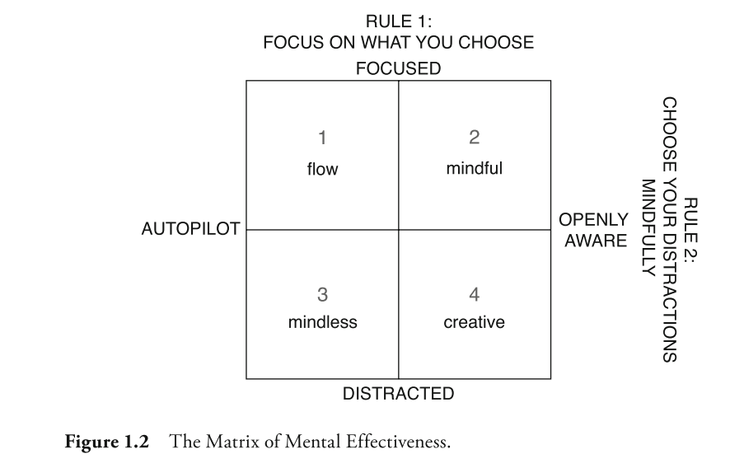

1. As the first quadrant shows, when you are focused but on autopilot, your state of mind can be described as being in “flow.” Some people prefer to be in this state, especially when they’re tackling routine tasks or physical work. Flow is characterized by some degree of absorption and therefore lacking awareness of external distractions. This can pose a problem even during routine work, because you may neglect sensory signals of important events around you or physiological signals indicating you need rest, movement, or food. We need awareness to pick up on relevant distractions—like our boss coming into our office
2. In the second quadrant—defined as “mindful”—we have the greatest mental bandwidth to complete tasks and the highest quality of interactions with our environment and other people. Representing the junction of the two rules of mental effectiveness, the second quad- rant equates to being present with ourselves and what we’re doing. It helps us when we encounter difficult situations and is crucial when we want to optimize our performance at work. It’s a state of mind that is one second ahead of external and mental distractions. It’s the best response to the digital age and a way of improving your performance in an attention economy.
3. In the third quadrant, you’re neither focused nor aware. Some people see this quadrant as the most relaxing. Taking a closer look, though, you may find that is not the case. Next time you find yourself day- dreaming on distracted autopilot, check in with your experience: are you truly relaxed? With a bit of training you will see that a focused mind is much more relaxed than a distracted mind.
4. In the fourth quadrant, you’re aware but easily distracted. There can be benefits to loosening focus and allowing random thoughts to bubble up. Some people find that they come up with more creative ideas in this quadrant. But if your mind is too distracted, you’ll have difficulty retaining any good ideas. Good ideas only become innovative solutions when you have the focus to retain and execute them.

# Techniques

## Emails

Avoid email addition:

* Disable email notifications
* Don’t do emails first thing in the morning ( use energy for something for useful )
* Allocate only certain, fixed times during the day to fully focus on e-mail.

Before sending:

* **Should this e-mail be sent at all? And should all these people be copied?** 
  + E-mail is widely overused. Make sure you’re not just adding to the chatter. Make sure your e-mail really needs to be sent. It’s okay to delete an e-mail if it really isn’t that important.
* **Does the e-mail contain the information needed for it to be understood correctly?** 
  + We’ve all sent or received a message without an attachment or other key detail. Oversights like these can cause multiple messages to go back and forth, all with similar ques- tions. Make sure you aren’t wasting valuable time—yours or any- one else’s.
* **How will the recipient perceive this e-mail?** 
  + Put yourself in the recipient’s shoes. How can you phrase this note to best avoid negative speculation in the recipient’s mind? Taking just one second to think about how your e-mail will be perceived can be the difference between clear communication and an unfortunate misunderstanding. One thing is certain: saying “thanks” and “sorry” are always good ideas.

**Avoid Emotional E-mailing**

* Wait one day before replying. When you come across an e-mail that generates negative reactions, stop. Do not give in to the impulse to answer immediately.
* Think about alternative communications channels.

## Meetings

### Before

Preparing: Before you introduce an agenda, simply invite meeting participants to take a brief mental break, to relax, settle their mind, and become present in the room. Sitting in a room silently for a few moments can create a strong feeling of togetherness and unity.

### During

Be present: In meetings, presence forms the foundation for effectiveness. When we’re present with other people, we get the most out of our time together. Therefore, the fundamental rule for a mindful meeting is: be completely present with those you are together with for as long as you are together.

**Every meeting you’re in, you have the opportunity to make the people you’re with the anchor of your attention. To do so, focus your attention on the person who is speaking.**

### After

Fitting in some time at the end of a meeting to practice mindfulness can also be of benefit in terms of softening a hard stop. Taking just a few minutes can help further clear the mind and increase relaxation, focus, and clarity for upcoming activities.

In fact, some companies have begun letting meetings finish a few minutes early, giving participants the opportunity to settle and clear their minds before their next activity. Also, if the meeting finishes at an appropriate time, there’s less of a rush. This means you have the opportunity to look coworkers in the eye and thank them for their time and attention. When a meeting is concluded with gratitude and appreciation, people are more willing to meet again and a positive pat- tern for meetings develops.

## Goals

When you have clear goals, it’s far easier to stay focused and aware. Similarly, when you’re focused and aware, it’s easier to keep your actions aligned with your goals.

When it comes to maintaining clear goals, it’s important to manage both our conscious mind and our subconscious processes. Our sub- conscious is primarily driven by two simple motivations: grasping for things we like and avoiding things we don’t like. While our subconscious often craves short-term gratification, our conscious goals more often include delayed gratification.

The more mindful you are, the more bandwidth of conscious attention you have. Mindfulness increases the number of conscious bits you can process. At the same time, it gives you a better awareness of what’s happening in your subconscious mind. Mindfulness allows you to better align your conscious goals with your subconscious processes, keeping your goals center stage and enhancing your chances of success.

### Mindful Goal Orientation

* When you find yourself behaving counter to your goals, take a mindful pause (—focus on your breath as you calm down, gaining focus and clarity. This establishes your awareness.
* Ask yourself the question “What stories, beliefs, or grasping or avoidance is keeping me from doing the thing that moves me closer to my goal?”
* Whatever you find, face it and dismantle it by being present with it.
* Adjust your behavior and move on.

### Mindful Goal Setting

* Clearly defined and specific goals are easier for your subconscious to understand.
* Positively framing your goals also makes it easier for your subconscious to process them. By default, the subconscious moves toward the desirable and away from the unpleasant.
* Learning to hold our goals lightly, and let go of them if they won’t bring us long-term happiness, is an important skill.

## Priorities

### Action Addiction

Addiction to action is one of the biggest threats to mental effectiveness and productivity. The root cause of action addition is an untrained mind. A well-trained mind is the only way to overcome it. The tasks are in front of us, and we want to be useful and productive. The problem is, when we don’t step back to ensure we’re spending time on tasks aligned with our main goals, we end up wasting a lot of time on immediate— though often inessential—tasks.

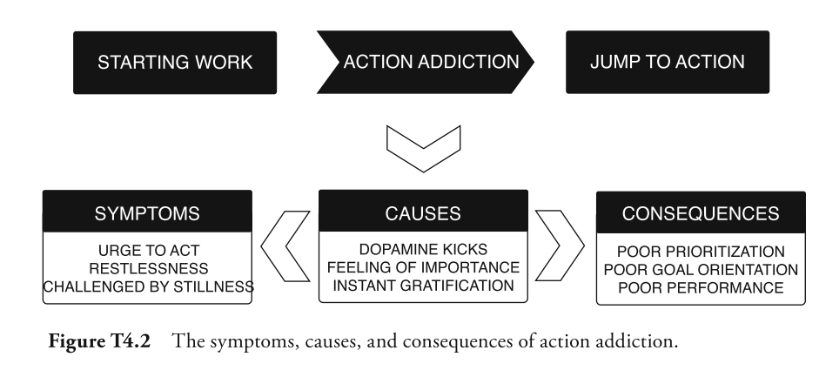

Focus your effort on the 20% that produce 80% of your output.

### Choice points – when priorities conflict

Conflicting priorities are the most common causes of action addiction. When two or more priorities conflict, you reach a choice point: a point at which you need to decide how to best manage multiple priorities or competing urgencies.

We often react to choice points by jumping into action. There it is again, that action addiction. But, as you now know, not all action is aligned with our goals. When priorities conflict, take a breath before you jump into action. Endure the discomfort of conflicting priorities.

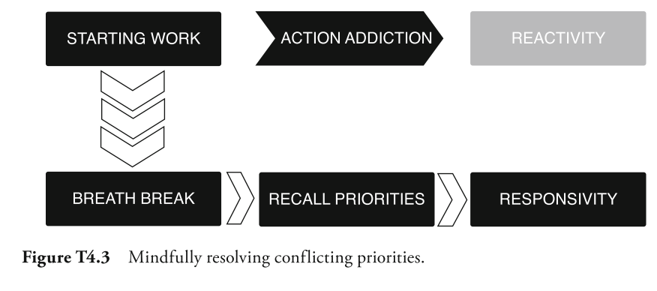

### Speed Up by Slowing Down

By taking a brief pause, you’re able to maintain your focus and awareness. This allows you to respond to situations with the most appropriate action—to concentrate on your priorities and goals—rather than simply acting on autopilot.

## Planning

Real planning requires slowing down, so that you can speed up. It’s an investment in time up front that has significant payback down the road.

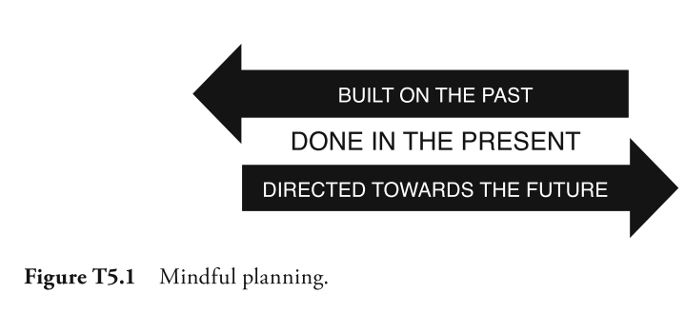

Too often, instead of moving forward through intentional action, we end up stuck in place: working, acting, trying, but not making any real progress. The morning is the most important choice point of the day. As it sets the tone for the rest of the day, it’s critical to begin the morning with a period of clear planning.

### Clear Planning on a Daily Basis

When you get to work, make a habit of reserving the first ten minutes to do the following:

* Do one to two minutes of ABCD mindfulness training to enhance your focus and subdue the impulse of action addiction.
* Make a short list of the highest priority activities of the day—or review a list you made at the end of the previous day.
* Plan your calendar for the day according to the highest priorities.
* Now, get to work.
* Review your plan once or twice during the day to track your progress.

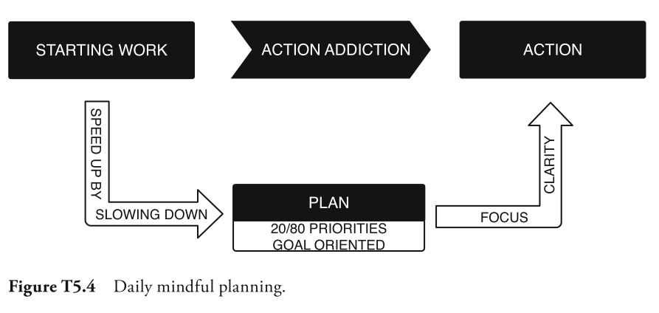

* **Weekly and monthly planning sessions can help you keep the big picture in mind and manage your calendar accordingly.**
* **Allocate most of your time to completing activities that deliver the greatest outcomes for the least amount of effort.**
* **Leave time for the urgent matters that will inevitably crop up. How much time you set aside for urgent matters depends on the nature of your work. Whatever you decide, saving a realistic margin of unscheduled time can help you avoid being put under unnecessary pressure.**
* **Consider how much time you need to recharge your mental batteries every day—whether through small breaks, a short walk, or your ten minutes of mindfulness training.**
* **Finally, make sure to reserve time for unavoidable “transition” activities, such as follow-up communication after meetings and travel.**

## Communication

The foundation of mindful communication is, as in many other aspects of life, being fully present in your interactions with other people. Only when we’re fully present do we get the most out of our time together. And only when we’re fully present can we be sure to under- stand what’s actually being communicated.

Empathy—being in tune with the feelings of others—plays a major role in effective communication. If you have a sense of how the person with whom you’re trying to communicate feels, it’s easier to get on their wavelength.

From a neurological perspective, two fundamental tendencies in the human mind create barriers to effective communication. First, there’s the reality of the mind’s natural tendency to wander. The second tendency is our mind’s orientation to see things as we expect to see them, commonly known as habitual perception. Habitual perception or cognitive rigidity as it’s also known—is the mind’s natural desire to place reality into simple, pre-existing categories. This causes us to believe the mind’s own limited projections about other people, ourselves, and all the things we encounter. Thus we are being cognitively rigid when we limit our perceptions. Both our wandering minds and this rigidity severely hinder our ability to communicate.

### Listen with Mindfulness

Simply put, listening with mindfulness involves giving your full attention to whoever is speaking. There are four guidelines for listening with this type of focus.

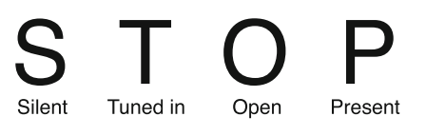

### Speaking with Mindfulness

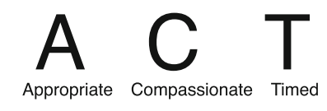

## Creativity

Take more intentional pauses throughout these meetings to give people the opportunity to relax and release any of the attachment they had to one idea or another.

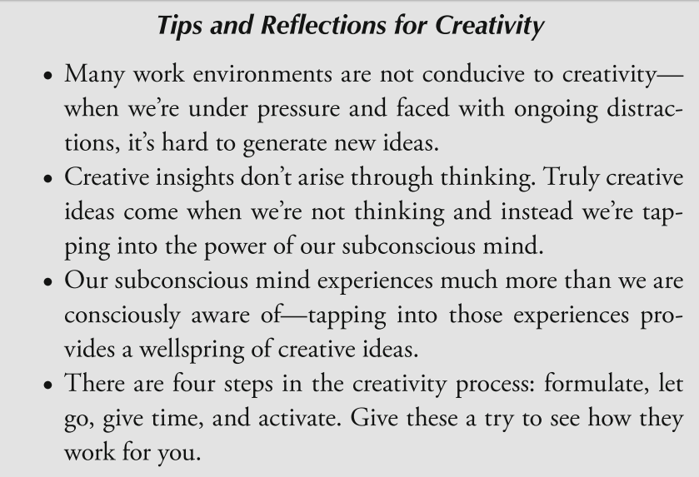

1. Formulate the Problem (and write it down)
2. Let go of the problem
3. Allow time
4. Activate

You’ve now identified a problem, let it go, and given your subconscious time to work. The final task is to help your subconscious communicate with your conscious.

## Change

We are habitual beings. In fact, scientists estimate that 95 percent of our behaviors are based on habit. In other words, only 5 percent of what we do is based on conscious choice. Not only are we habitual, but we’re also neurologically programmed to prefer that things stay the same. Familiarity provides us with a greater sense of psychological safety.

Learning to embrace the reality of constant change is a powerful thing. When we experience a great day at work—or a challenging day—without expecting that the next day will be the same, we become much more resilient in the face of change. Building greater acceptance of the reality of constant change is a foundation for more balance, less stress, better health, and ultimately more peace of mind.

Hardwired to value certainty, our natural response is to resist uncertainty in our environment. In fact, it would be strange if we didn’t experience some resistance to change. Since we’re habitual beings, doing anything differently takes effort. Even if the change is something we want, it requires effort to overcome both our neurological impulse to keep things the same as well as our ingrained habitual patterns.

**When we try to resist resistance, we only generate more of it.** We create an inner struggle that often leads to anger, frustration, stress, and anxiety. Resisting resistance doesn’t help us move forward; instead, it negatively impacts both our health and well-being.

The key to managing resistance and thereby better managing change is to face it and embrace it.

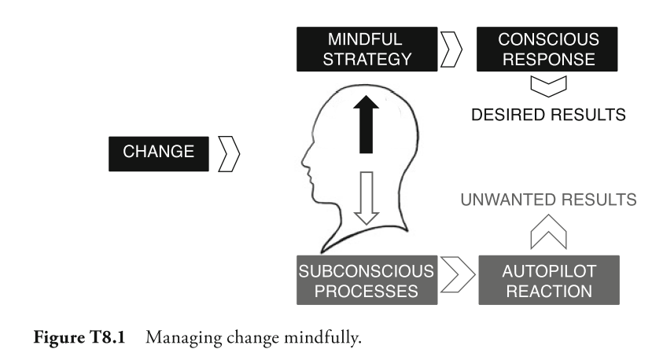

Once you’re able to observe your resistance, see whether there’s anything you can learn from it. Are you resisting simply because of your natural preference for familiarity? Or are you resisting because something legitimately doesn’t make sense? Seeking to understand the underlying driver of your resistance can be insightful.

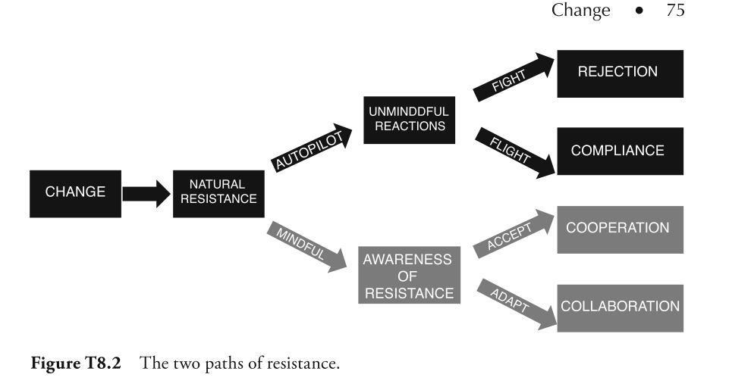

### Steps for Mindful Change Management

1. **Awareness of the change**

The first step is simply to recognize that things are changing. Gain as much information as possible regarding the change and what it might entail. Ideally, this process is done with a mind that accepts the reality of constant change, enabling curiosity, rather than fear, to be the driver behind the investigative process.

1. **Awareness of your own resistance**

The second step is to be aware of any resistance to the change. If you think you don’t have any resistance, think again. It’s natural for us to resist change; there’s nothing wrong with resistance. Resistance can be very instructive and can help us gain insight into how to better manage the change. When you become aware of any resistance, don’t try to run from it or resist it.

1. **Observation of your resistance**

The third step is to observe the resistance. Seek to understand where it comes from and what might be underlying it. See if there’s anything you can learn from it that might inform or enhance the change management process.

1. **Mindfully choose your response**

With a solid understanding of the change and your resistance to it, you can choose a response. This may mean you choose to fully embrace the change and let go of any resistance. It may also mean you choose to try to skillfully influence the change process by mindfully presenting other alternatives. It may mean you choose not to accept the change because you realize it’s not in your best interest. Regardless of your choice, make the decision with a calm, clear mind.

1. **Act**

The final step is to take action in accordance with your choices. This is where you move forward. Although this step will help you better manage the change process, that doesn’t mean it will be easy! It’s helpful to acknowledge that it will be difficult to change habitual patterns. You’ll likely have ongoing spikes of resistance and setbacks in the process. During this step, it’s important to both identify and accept the support you need to manage the change. This could be attending training, being coached, or practicing mindfulness.

## Mental energy

When it comes to conserving mental energy, mindfulness can help in four key ways: being present, maintaining balance, making choices, and leveraging cycles. 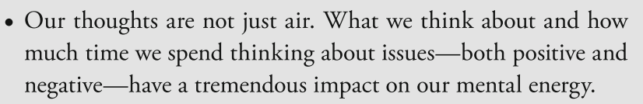

* **Being Present**

Being present in the here and now is a simple and easy way to conserve mental resources. When we allow our mind to wander aimlessly, it’s using up valuable energy that could be better used in other pursuits.

* **Maintaining Balance**

Awareness of negative or positive thought spirals allows us to leverage balance. Being aware of the mind’s tendency to succumb to attraction or aversion—to run toward things we want or away from things we don’t want—is powerful.

* **Making Choices**

Follow the first rule of mental effectiveness and choose a task and stick with it. Notice the impact that not jumping back and forth between tasks can have on your energy.

* **Leveraging Cycles**

Our mental energy naturally ebbs and flows throughout the day, in cycles that have a lot to do with our sleep, nutrition, and level of physical activity. We simply are not always at peak mental performance. For most people, energy levels are higher first thing in the morning, after a good night’s rest. Those energy levels tend to decrease during the day, with a low point after lunch, before increasing again later in the afternoon. Being mindful of our how our energy levels fluctuate enables us to be strategic about what we do and when.

## Enhancing sleep

* TURN off All Screens 60 Minutes before Sleep
* Perceptual Activities 60 Minutes before Sleep

Conceptual activities like intense conversations, replying to e-mails, working, or reading can arouse your attention and suppress your natural sleepiness. Instead of doing the dishes and other practical activities just after dinner, leave that for the last hour before sleep, instead of screen activities.

### Waking Mindfully

As you wake, be determined not to start thinking. Just be. Notice your body. Notice your mind. But do not engage in the thoughts trying to arise. Sit up, at the edge of your bed, and do two minutes of mindfulness training. Focus on your breath and let go of any thoughts.

## Eating and Energy

To get the most out of mindful eating, there are three basic guidelines:

* **Let Your Stomach Do the Eating**

A simple mindful tip for eating is to let your stomach do the eating. There’s no need to finish everything in front of you right this second.

* **Avoid the Blood Sugar Rollercoaster**

Many of us, seeking a quick antidote to feeling sleepy, ride the blood sugar rollercoaster during the afternoon hours. An hour or two after lunch, we hit the afternoon slump—a fatigue our brains mis- takes for a lack of blood glucose. A natural and automatic reaction is to grab a snack, a cup of coffee, or an energy drink to quickly raise our energy levels. But a snack—and a sugary one in particular—can raise blood sugar levels too high, leading to mood swings, brain fog, and stress. After a short while, blood sugar levels plummet. A sense of panic results due to the stress, cortisol, and adrenaline released when fatigue and brain fog set in. Then we’re right back where we started, at the bottom of the roller coaster, with our brains craving another fix of fast energy.

* **The Mindful Minute**

Over time, allowing you a mindful minute before immediately snacking can mitigate the general craving that comes with natural tiredness.

* + Next time you feel desire for food, pause.
  + Allow yourself to mindfully observe the experience of desire.
  + Allow the experience to be present, without engaging and giving in to it. This is not meant to impart strict discipline and impulse control, merely a moment of mindfulness before you eat. Ask yourself, what does it feel like? Where do you experience the feeling, in your stomach or elsewhere? Is the experience changing or does it stay the same?
  + If after the minute, you’re feeling the same desire, you may actually be hungry. In that case, eat. If there’s little or no desire left, you weren’t actually hungry. Your brain tried to trick you. But you were smarter, and dismantled the desire by simply allowing it to rise without engaging in it.

**When you’re mindful of your food, awareness tells you when you have had enough. You tend to eat less. You also tend to enjoy food more, because you actually pay attention to it.**

## Activity and energy

**When you have positive physical experiences, your mind smiles.** In this way, caring for the body is just as impactful as caring for the mind. Getting good and sufficient sleep, eating properly, and being physically active are all foundations for both performance and well- being.

Maintaining a clear focus while undertaking physical activity trans- forms a workout into a semi-mindfulness session and will improve your experience.

**Relaxation—The Absence of Unnecessary Effort**

A relaxed body—one absent of unnecessary tension—has greater endurance and generally feels more pleasant. As you train, occasionally Activity and Energy scan your body for signs of unnecessary effort or tension. Then relax. The more relaxed you are, the more you can do and the more you’ll enjoy it.

While relaxation is also important for the mind to avoid thinking and distraction, the mind needs an object of focus. You need to have an anchor—and that anchor is usually your breath. While breathing is a great anchor while you’re sitting still, it’s equally powerful during physical activity. But breath alone may not be enough. Instead, it can be more effective to synchronize your breath with the natural rhythm of your physical activity. When you run or walk, synchronize your steps with your breath. Take a certain number of steps for each inhalation and each exhalation. This way, you can easily maintain a focused and steady rhythm for long periods. It’s often easier than just focusing on your breathing.

Focus and rhythm can be a big help, especially if you feel poorly or experience pain. Most unpleasantness comes from our thoughts. Thoughts come from physical sensations or other distractions. Your focus creates your reality. Focus on unpleasantness, and your reality will be unpleasant. Instead, focus on your breathing and rhythm—and experience one moment at a time. As distractions appear, don’t try to suppress them. Simply take one moment after the other: one step after the other. Inhale and exhale. Don’t think about how much time you have left. Stay in the moment. With relaxed focus, any unpleasantness or pain will diminish.

## Performance breaks

A mindful performance break is basically a very brief mindfulness training session. And by brief, I mean about 45 seconds. To take mind- ful performance breaks, try this, once every hour during work.

* Let go of your activities. You don’t need to go anywhere special.
* Close your eyes or keep them open, whichever you prefer. Direct your full attention to your breath. For three breath cycles do the following:
  + Breathe in while noticing your breath breathe out while relaxing your shoulders, neck, and arms.
  + Breathe in while focusing fully on your inhale; breathe out while focusing on the exhale.
  + Breathe in while enhancing the clarity of your attention; breathe out while maintaining clarity.
* Let go of the exercise. Return to your work with renewed relaxation, focus, and clarity.

## Emotional balance

Emotions are a natural part of being human. Managed skillfully, they’re a powerful source of joy and energy. Unsuccessfully managed, however, they can get in the way, becoming a source of frustration, conflict, and regret.

In reality, having emotional balance equates to not getting caught up in the natural ups and downs of our emotions. Emotional balance is a state of being aware of our emotions enough to manage them in a way that is gentle, honest, and wise.

Mirroring others’ emotions is normal; it’s your mirror neurons at play. More about mirror neurons is presented in the mental strategy of Joy. But in short, when we face someone joyful, mirror neurons in our brains make us experience a similar joy. The same goes for anger, grief, and almost all other emotions.

Most of us deal with our emotions by either suppressing them or acting them out. The thing about suppressing emotions is that they have to go somewhere. Like pressing down on a balloon, pushing your emotions down only means they will pop up again somewhere else. Additionally, suppressing emotions requires an enormous amount of mental energy—energy that’s diverted from our own focus and clarity. Acting out our emotions, whether aggressively or passive aggressively, might feel good in the moment. But if acting out is effective at all, it’s only in that moment. In the long run, acting out our emotions usually leads to disappointment, regret, or shame.

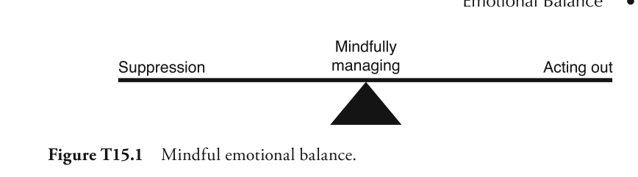

In mindfulness training, we work to develop the mental capacity, the patience, and the courage to endure discomfort. At the same time, we learn to observe our emotions with some neutrality. We put some kind of distance between our emotions and ourselves. Instead of running on autopilot, being absorbed with emotion and caught in its grip, we take a moment to pause. We stay one second ahead of automatic reactions, giving ourselves the time, space, and freedom to make conscious, deliberate choices.

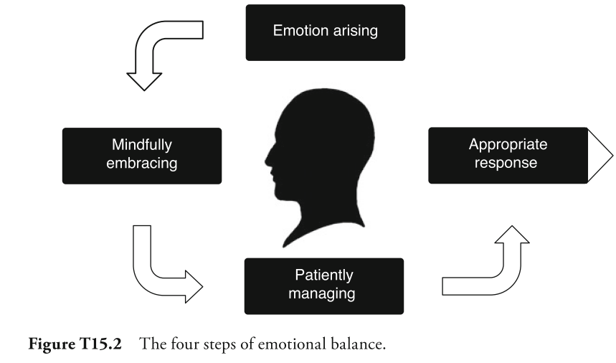

### Emotional Awareness

Being aware of the emotion—may sound obvious, but it’s not always as easy as it sounds. In the midst of our everyday busyness, the mind is already occupied with myriad distractions and mountains of information.

### Mindful Embrace

Simply notice that the emotion is there and hold it without suppressing or acting on it. Open awareness training. Being able to see the emotion as an experience, and not letting it overcome you, diminishes its power. Instead of constantly fighting against the emotion, you’re able to be with it. When it comes to mindful embrace, your breath can be helpful. While observing the emotion, pay attention to your breath; allow its gentle rhythm to calm you.

### Patience and Balance

Patience is about having the courage to face the discomfort of the emotion. Patience will help you endure and contain the emotion, rather than flee from it. Whereas patience can help you ride out the emotion, balance can keep you neutral. Balance can help you avoid any automatic aversion or attraction you may have toward it. With the ability to embrace the emotion with patience and balance, you can now maintain the focus Emotional Balance and clarity necessary to determine the best, most productive response to it.

### Appropriate Response

Making a decision—choosing the most appropriate response to the situation—based on your awareness of the emotion, your embracing of it, and your patience and balance.

## Work-life balance

Imbalance is only a problem if people perceive it that way or if work negatively impacts other areas of life.

**Focus —**Training in mindfulness helps you feel less overwhelmed by daily tasks and challenges. It helps provide the clarity of mind to accept what you can’t change, and make mindful choices about where to place your limited attention—in a way that best serves you and others. Further, it helps you be present with the imbalance, allowing you to sit with the discomfort, observe it, and not let it overwhelm your mind.

**Awareness** —Training in mindfulness helps you maintain awareness of when you’re not in balance. It helps keep you from falling into habitual patterns that are unhealthy, both for yourself and others around you. It also helps you distinguish between what you can and can’t control.

Mindfulness helps you maintain balance within yourself by accepting life’s imbalances. It allows you to let go of things outside of your control, saving all that mental energy to manage things within your control and thereby reducing stress and worry.

# Mental strategies

Think of these strategies as another layer you can add on top of the techniques to quickly and easily improve your performance at work. They don’t replace the techniques—and they certainly don’t replace the foundational training methods—but they do mitigate the most persistent thoughts and habits that can prevent you from being your best self moment to moment.

## Presence

Presence is foundational for mindfulness. By definition, being present means we’re paying attention to the people, objects, and ideas around us. This level of attention is at the very core of managing focus and awareness—the central characteristics of mindfulness—and maintaining mental effectiveness.

**When we’re present for others, we embody all three definitions of present : we’re here and in this moment as a gift for other people. Instead of hopping on the neural carousel, be fully present when you’re with other people. Be fully present with your tasks. Be fully present with challenges when they occur. Being present in the moment doesn’t require a change in what you do . It requires a change in how you pay attention to what you do. It’s a conscious decision to be present in the moment.**

## Patience

**“A moment of patience in a moment of anger saves you a thousand moments of regret.”**

Patience involves choosing to stay calm in the face of challenging situations, even when our fight or flight reflex might already be triggered. It’s the ability to endure unpleasantness, to confront the situation directly and handle it sensibly, rather than on impulse. Patience is more concerned with larger goals than temporary, quick-fix solutions.

Patience is the direct path to living a more effective life that’s focused on the roots of problems instead of the symptoms.

## Kindness

What do we need from other people to be happy? Often the answer is simple: things like presence, attention, respect, understanding, and acceptance. What do other people need from us to be happy? The exact same things. In this way, we’re all experts in making each other happy.

## Beginners mind

In my experience, looking anew is foundational for business success. Without the ability to do so, we default to yesterday’s perception of the market and the competition. We become complacent—and might just wake up to find ourselves behind the bus.

A few natural traits stand between each of us and a beginner’s mind: namely, habitual perception and cognitive rigidity.

The automatic association between what’s actually in front of you and what you’ve seen in the past—the neurological process called habitual perception—can be problematic. It means you often don’t actually see what’s right there in front of you. In fact, what you do see has much less to do with actual reality, and much more to do with the reality your mind creates based on your history and habits. In other words, you have programmed yourself to see reality in a certain way.

Cognitive rigidity—the inflexibility created by automatically recalling our habitual perceptions—is not conducive to creativity. It doesn’t help us innovate. Or help us to see new solutions to old challenges, let alone new solutions to new challenges.

The ability to face reality as it is—or at least not be stuck in old ways of seeing things—is the essence of a beginner’s mind. Without a beginner’s mind, we lock ourselves inside our own experience; we stagnate in our mind’s habitual perception. With a beginner’s mind, we see things with fresh eyes and an open mind.

Challenge yourself to be more curious in your day-to-day activities. Be open to what is happening to you moment to moment. The less you presume to know, the more your mind will open.

## Acceptance

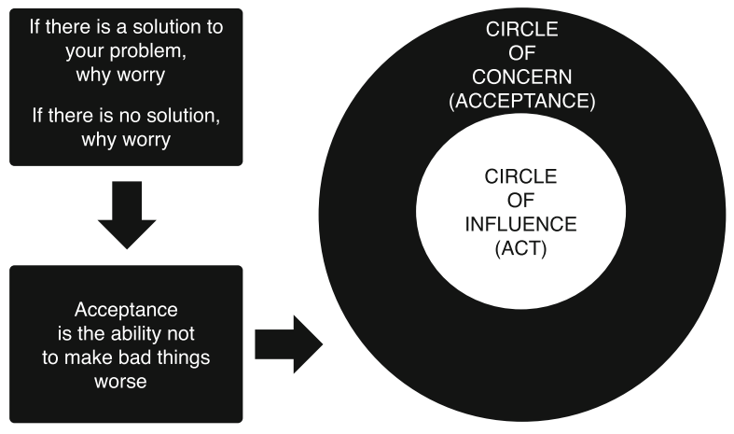

## Balance

When you stop yourself from following an impulse—say, quitting after one serving of your favorite food or drink—serotonin balances out the dopamine release. In your daily mindfulness training, you’re constantly resisting impulses to follow distracting thoughts or hold onto stress.

Consciously identify the tasks at work that bring your instant gratification—say answering an e-mail or text. Now identify the tasks that bring discomfort. This may be fielding com- plaints from customers or confronting a surly coworker. Be aware of your reactions to these tasks and temper those reac- tions by purposefully limiting or delaying the gratification of the experiences you like, while more actively confronting the experiences you dislike.

You train balance by being aware of your reaction to everything you experience, good, bad, and neutral. Notice the experiences you like and those you do not like, things where you experience attraction and things where you experience aversion. Just being aware of these reactions will lead to change. When you become aware of a desire, the desire will lessen as it’s replaced by awareness of the desire. When you become aware of resistance, the resistance will lessen as it’s replaced by awareness of it. If something is pleasant and nice, you observe it neutrally without giving it more value or holding onto it. If something is unpleasant, you observe it neutrally without wanting it to disappear.

## Joy

Joy boosts our energy and performance; it enhances our ability to do good work and excel at business. Like all feelings, joy is something we can enable inside ourselves. Our nervous system reacts to our state of mind. What we feel mentally has a significant effect on our physical body.

Quite simply, joy equates to taking better care of both body and mind. When we’re happy doing something, we expand both our mental and physical resources.

## Letting go

When you identify an issue or problem that seems to stay with you, to follow you from task to task or from work to home, mentally hold on to it. Isolate the initial thought before the related thoughts begin to multiply. Then after you isolate it and observe it, let it pass. And instead, purposefully refocus on what’s happening in the moment.

Use the quality of relaxation to help you let go of your thoughts. When you think, you create tension in your body. When you relax your body, you also relax your thoughts. Relax your body and allow a natural mental relaxation to follow. Then, use your focus on the experience of breathing to help you let go of thoughts and be in the moment—one breath at a time. As you begin to explore the nature of your thoughts, you will notice that some can be very difficult to let go of. Consider seeing these as opportunities to rewire your brain to let go more easily. Every time one of these difficult thoughts comes up, notice the thought is there and see if you can let it go or not.

# Foundational practices

Mindfulness training is an investment. It takes time. And it takes effort. And while many would argue they have no time for mindfulness training because they are busy, I see it very differently. Mindfulness training is increasingly important to me, the busier I get. The more things I need to do, the more time I train. That’s my way of ensuring I can stay focused, calm, and effective and not let the busyness clutter my mind.

## Training sharp focus

Sharp focus is the ability to concentrate on thoughts and tasks of your choice, without feeling the need to indulge each and every distraction that passes through your mind. Having this sort of mental clarity can help the busiest of us thrive, even in high-pressure environments filled with distractions.

## The ABCD Method

Mindfulness training is not passive. It’s an active intervention in your brain’s neural network. For every moment you maintain focus, you create new “focus” neural connections and abilities. Thanks to neuroplasticity, the more you train, the stronger these neural connections and pathways become—and the easier it becomes to stay focused.

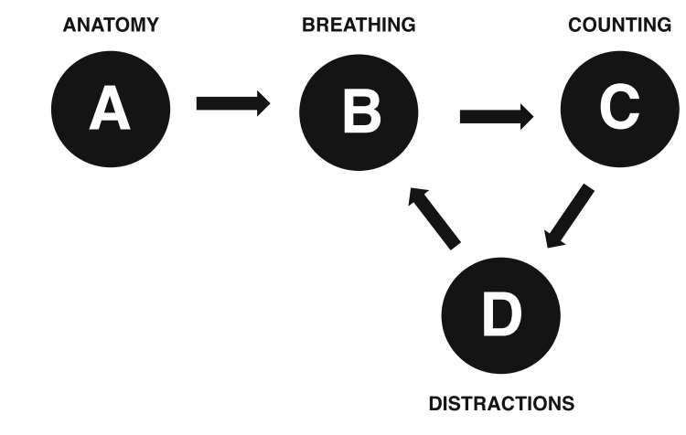

### Anatomy: Finding the Right Posture

* Sit on a chair with both feet planted firmly on the floor.
* Find balance. Don’t lean back, forward, or to either side.
* Sit with your back straight, but relaxed. Sitting up straight will help you to stay awake and alert.
* Relax your body as much as you can. Pay special attention to your neck, shoulders, and arms—the places where many of us carry tension. Take time to release any tension you may feel. If it helps, roll your neck or move your shoulders up and down a few times. Also, take a deep breath and relax as you breathe out.
* Place your hands on your knees or in your lap.
* Close your eyes. If you start to doze off, open your eyes a little. Letting a small amount of light in activates your nervous sys- tem. If you opt to keep your eyes open, look down at the floor in front of you with a soft gaze.
* Breathe in and out through your nose.

You may find it helps to scan your body for tension, releasing it every- where you notice it, for the first few minutes of your training—or as long as it takes to feel alert but relaxed. In this way, you will gradually develop a more relaxed body. And a more relaxed body lays the groundwork for a more relaxed mind, both prerequisites for training sharp focus.

### Breathing: The Anchor for Attention

* Focus your full attention on the experience of breathing. Be aware of how your stomach expands when you breathe in and contracts when you breathe out.
* If focusing on your belly doesn’t feel natural, try observing your breathing at the nostrils. Pay attention to the air flowing in and out of your nose.
* Let the observation of your breath be neutral and effortless. You don’t need to breathe deeply or slowly. You don’t need to manipulate or change it. You don’t have to get involved in it in any way. Observe it in the same way you would waves rolling in to beach. You don’t try to control the waves—you just watch. While it can be challenging, neutral observation is very important as we go further into the training.

### Counting for Focus

* Breathe in. Breathe out. When you finish breathing out, count “one.” A short and succinct mental count. Breathe in again, out again, and count “two.” Carry on in the same way until you get to ten, then count backward to one. Repeat this cycle

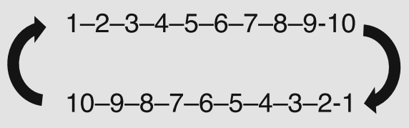

* If you have trouble counting higher than three or seven without losing focus, don’t worry. The point of counting is not to see how many times you get through the cycle; rather, it’s a tool to help you maintain focus.
* If you suddenly find yourself at, you’ve been counting on autopilot and are not managing your attention. Start again at one. In the same way, if you find you’ve stopped counting altogether, simply start again at one.
* If you find thoughts sneaking in between numbers, that’s a sign you’re not fully focused on your breath. Sharpen your focus on your breath and give it your full attention, in a relaxed manner.

If counting, or any other specific tactic gets in the way, don’t get upset. Instead, be grateful that you’ve recognized what doesn’t work for you and see it as an opportunity to make your own training more effective.

### Distractions: Relax, Release, Return

Distractions are your best friends in focus training. Distractions are the ones telling you when you are off track. What is a distraction? Basically anything that is not your breath is a distraction. And they can come from six sources: smell, taste, bodily sensations, sight, sounds, and the mind itself. Regardless of where the distraction comes from, the instructions for dealing with it are the same: Relax, Release, and Return.

* Relax: When you perceive you are distracted by a thought, sound, or sensation, notice whether it creates any tension any- where in your body. Try your best to release that tension. Relax. Recognize the fact that you have been distracted. It’s really not the end of the world. Instead of getting frustrated or annoyed, think of that distraction as a good friend—one who gently reminds you that your attention has drifted. Treat every time you notice yourself being distracted as a moment to celebrate. After all, when you are aware that your mind has drifted, you are being mindful!
* Release: Release whatever distraction you may encounter, simply by redirecting your focus toward your breath. Your full focus One Second Ahead can only be in one place at a time. If you choose your breath, the distraction is gradually released. Let go of the distraction gratefully, it helped you notice the fact that you had lost track of your breathing.
* Return: Once you have released the distraction and regained a sense of relaxation, come back to your breathing with renewed focus and awareness.

You’ll likely find focus training is a continual back and forth between paying attention to your breathing and being distracted. Some days, there will be more distractions than focus. Other days, there will be more focus than distraction.

Remember, the objective is not to sit without distractions. If it were, none of us would succeed. The objective is to be aware of the fact that you’re distracted and to acknowledge that you have the ability to regain your focus on your breath. It’s the conscious placing of our attention that’s critical to training sharp focus.

## The Three Core Qualities of Mindfulness: Relaxation, Focus, and Clarity

### Overcome Tension with Relaxation

When you practice mindfulness, you may find yourself caught up in this neurological “performance mode.” It may seem almost unnatural to sit still, especially with so many tasks that need to be done. In the spirit of performance, you may push yourself to follow training instructions with- out truly understanding their greater purpose. But wanting to be “good at” mindfulness so you can get it over with—and assume the benefits of a high-performing mind as soon as possible—won’t get you very far.

* When you breathe in, scan your body to identify points where you are experiencing tension. When you breathe out, pay attention to that point and allow the tension to release.
* Let the tension be released with the breath. It may be necessary to repeat the exercise several times to be effective. Take as much time as needed with each tension point before moving on to the next point where you find tension.
* Keep in mind the following definition: “Relaxation is the absence of unnecessary effort.” Scan your body for any unnecessary effort and gently let it go.
* Scan and release tension in your body for the first minute of your training or as long as it takes to increase your ability to be alert but relaxed. In this way you will gradually develop a more relaxed body and mind.

### Overcome Overactivity with Focus

A focused mind does not wander. A focused mind can stay focused on an object of choice. But sometimes our minds can be overactive, wandering in every possible direction or following every distraction that arises.

* In many instances, the natural response to an excited mind is frustration, and the result is to try to force greater attention on your breath. Although applying such force may help you Training Sharp Focus maintain focus, it will be exhausting and counterproductive to creating a calm and clear mind. The first response to an overactive and distracted mind is to relax.
* The alternative strategy for increasing focus is to actually let go of performance expectations. Let your breath hold your attention. Your breathing works by itself. Every in-breath is followed by an out-breath. Rest your full attention in this movement, effortlessly, as a neutral observer.

### Overcome Drowsiness with Clarity

* When you experience drowsiness, you need to arouse your attention and increase alertness. You can do this by sitting up a little straighter or taking an intentionally deep breath. You can also open your eyes, keeping them pointed downward toward the floor to minimize distractions. One Second Ahead
* Another strategy to increase clarity is to arouse a deep sense of curiosity in the natural experience of breathing. Experience each breath as a new experience. Be curious about the subtle detail of your breath: Where do you notice it? How does it feel? What’s it doing?
* When you first experience any sense of drowsiness, increase your alertness. Don’t let the dullness take hold. Be purposeful and intentional in your training. With time, it gets easier. You will notice the warning signs earlier and be able to stay clear before drowsiness takes hold.

Ultimately, mindfulness training is not about being able to sit still and maintain focus on your breath. It’s about improving your ability to focus on the most important facets of your life: your work, your coworkers, and your family. Most people notice the greatest impact in these areas after just a few weeks. Try to relax and enjoy the benefits you’re experiencing—even if, in the beginning, this is just ten minutes of space, stillness, and peace in your life.

## From Sharp Focus to Open Awareness

In training open awareness, as explored in the next chapter, you go a step further. During open awareness training, a sharpened focus helps generate insight into both the nature of the mind and how its performance can be optimized. With open awareness training, you develop a panoramic view that helps you see yourself, others, and every situation more objectively—allowing you to decide who and what gets your attention, and who and what does not.

Open awareness is the ability to observe your mind. It is training in becoming familiar with the workings of the mind and how that causes us to experience challenges in life. Open awareness helps you not be a victim of circumstance—only able to react automatically to situations as they develop. Open awareness involves training for a new kind of relationship with your thoughts and the world around you. It engenders certain clarity in the mind, allowing you to stay one second ahead of your reactions, regardless of the situation. With open awareness, autopilot is no longer the default response mechanism. Instead, it catalyzes the ability to relate to the events in your mind, bringing a whole new sense of clarity and direction into your life and work.

**Training open awareness provides you with the opportunity to experience, with a depth of understanding, that your thoughts are the root cause of your problems.**

Open awareness gives sharp focus direction and intentionality. Together, sharp focus and open awareness can help you spend your time, energy, and attention mindfully, ultimately increasing your effectiveness in life and work.

**The essence of open awareness training is observing your thoughts, senses, emotions and tasks in a neutral way—like a mental observatory.**

* As in focus training, start by sitting comfortably, as described under the guidance in the “A” for Anatomy.
* For a minute or two, direct your full attention toward your breathing, like in the focus training. Allow your mind to stabilize and settle. Count your breaths if it helps you let go of distractions. Check off one by one whether your mind has the three core qualities of relaxation, focus, and clarity.
* When you’ve reached some level of these qualities, you can begin to open your awareness.
* Let go of the attention on your breathing and open up to whatever may arise. When the first distraction attracts your attention—a sound, thought, physical sensation, or anything else—direct your full attention to it and use it as an anchor for your awareness.
* Observe the distraction neutrally, just as you did with your breathing. Don’t think about it. Don’t engage in it. Don’t try to make it stay or go away. Simply observe it. If it helps, imagine observing the distractions as if they were waves on the beach.
* Notice when the distraction comes into focus. Notice that it’s there. Notice when at some point it disappears or changes to something else.
* When a distraction disappears, you open up and are ready to receive the next one in the same way. If a distraction changes into something else, you follow the transformation neutrally.
* If at any point you find you’re confused or overwhelmed by your distractions, pause, relax, release the distractions, and return your focus to your breath. After a few moments, when you’ve stabilized your focus, let go of your breathing and open your awareness again.
* At any time, you can always come back to the anchor and simply focus on your breath. Be prepared that you may need to come back to your breath again and again throughout your training to ensure you’re not getting carried away by thoughts and distractions.
* If it’s difficult to have a neutral approach to the distraction, that is, if you notice you start to engage with it, it can be helpful to give it a short mental label. For example, if a thought arises about something you need to buy, you can label it “shopping” and observe the experience of the thought without thinking about what it is and where you will get it. You can also use even simpler labels such as “thought,” “sensation,” and “feeling,” without qualifiers.

While the instructions are simple, the challenge for many is observing thoughts, feelings, sensations, and emotions neutrally without engaging. In fact, many find training open awareness difficult, especially in the beginning.

**Use open awareness as a basis for your training for a couple of weeks as you develop your ability to be a neutral observer of your thoughts and experiences. When you feel able to respond to distractions deliberately rather than react automatically, you can move to the next level of open awareness training that includes the three insights outlined below.**

### Insight #1: Everything Changes

Rationally, we understand that even the most frustrating situation will eventually change. Even so, the mind has a tendency to hold on to difficult situations as if they will always be there.

The first insight of open awareness is about developing an instinctive understanding that everything changes, that everything is transitory. Everything. The more you come to grasp, in a meaningful way, the fact that everything changes, the easier it becomes to deal with negative things, because you know they will change. You will also place a higher value on the positive things you experience, appreciating them more while they last. In your training, and in life, when observing your distractions, regardless of what they are, ask yourself the following questions:

* Is there anything you experience that is unchanging?
* Is there a thought that never goes away?
* Is there anything solid and static, or is it all a process?

### Insight #2: Happiness Is a Choice

Similarly, the situations we experience don’t cause frustration or anger on their own. Rather, it’s the way we relate to our surroundings that creates the problems we perceive in life. Regardless of external circumstances, we are the source of our own happiness or frustration. By changing our worldview, we have the potential to free ourselves from the problems we create.

**“We all have two wolves inside us. One is bad and feels anger, jealousy, envy, falsehoods, and arrogance. The other is good and feels love, empathy, honesty, generosity, and humility. The two wolves constantly fight each other.” One of the grandchildren asks, “But which one wins?” “The one you feed,” the old man answers.**

### Insight #3: Everything Is Potential

The insight that everything is potential and that there is no solid, isolated self means we can redefine ourselves. We can break free of our own limited definitions of ourselves and others. New possibilities open up in every situation we encounter. Nothing is fixed. We have the choice to define all people and all situations based on our perspectives, however narrow or expansive they may be. When everything is potential, it offers each and every one of us an abundance of opportunities and positive outcomes.

# Mastering Your Life—Next Steps

The minutes that you sit training your focus or awareness may be the only few minutes of the day that are really yours. Allow yourself to rest in these precious moments. It’s your time. It’s your mind. It’s your life.

## How Long and How Often to Train

In my experience of guiding many people from a wide range of cultures, a minimum of ten minutes a day of mindfulness training ensures good results. As you gradually develop, you can increase the duration as much as you like. The more you do it, the more you’ll get out of it. Just like with physical exercise, more time spent training equates to greater outcomes.

In terms of frequency, I recommend you set aside time every day to practice. Daily training is the best way to get results. When you do it every day, it will become a habit.

In my experience, the morning is a good time for most people. The mind is fresh, and therefore you get more out of the training. In addition, when you spend ten minutes at the start of the day to consciously be focused and aware, it has a strong influence on the rest of the day.

## Self-Directed Mindfulness Program

The following are the most basic guidelines for a ten week self-directed training program.

Each week you:

* Undertake ten minutes of sharp focus or open awareness training on a daily basis;
* Select a mental strategy from Part II;
* Select one or two workplace techniques from Part I.

This program begins with focus training because it’s the foundation for all the other elements. Only after you’ve developed a substantial level of focus—typically after four to five weeks of daily training— should you move on to awareness training. After the ten weeks, you’ll have experienced both types of training and can choose the one you prefer.