# Philosophy

* Pursuit of wisdom

The actual word philosophy is Greek in origin, and it is the composite of two Greek roots: “philein”, a Greek word for love, and “Sophia”, the Greek word for wisdom. Taken together, they mean the love or pursuit of wisdom. Wisdom = ability to use and apply knowledge with great intelligence.

Philosophy is committed to the truth rather than popular opinion, prevailing norms, or conventional wisdom.

Aim of philosophy:

* Thinking critically, questioning your beliefs
  + **Open-minded:** In discussions they listen carefully to every viewpoint, evaluating each perspective carefully and fairly.
  + **Knowledgeable:** When they offer an opinion, it’s always based on facts or evidence. On the other hand, if they lack knowledge of the subject, they acknowledge this.
  + **Mentally active:** They take initiative and actively use their intelligence to confront problems and meet challenges, instead of simply responding passively to events.
  + **Curious:** They explore situations with probing questions that penetrate beneath the surface of issues, instead of being satisfied with superficial explanations.
  + **Independent thinkers:** They are not afraid to disagree with the group opinion. They develop well-supported beliefs through thoughtful analysis, instead of uncritically borrowing the beliefs of others or simply going along with the crowd.
  + **Skilled discussants:** They are able to discuss ideas in an organized and intelligent way. Even when the issues are controversial, they listen carefully to opposing viewpoints and respond thoughtfully.
  + **Insightful:** They are able to get to the heart of the issue or problem. While others may be distracted by details, they are able to zero in on the essence, seeing the forest as well the trees.
  + **Self-aware:** They are aware of their own biases and are quick to point them out and take them into consideration when analyzing a situation.
  + **Creative:** They can break out of established patterns of thinking and approach situations from innovative directions.
  + **Passionate:** They have a passion for understanding and are always striving to see issues and problems with more clarity.
* The complete liberty of the mind
* Freedom from all social, political, or religious prejudice
* To care for the well-being of the soul
* Answer the question, “What is it all about?”

## Branches of philosophy

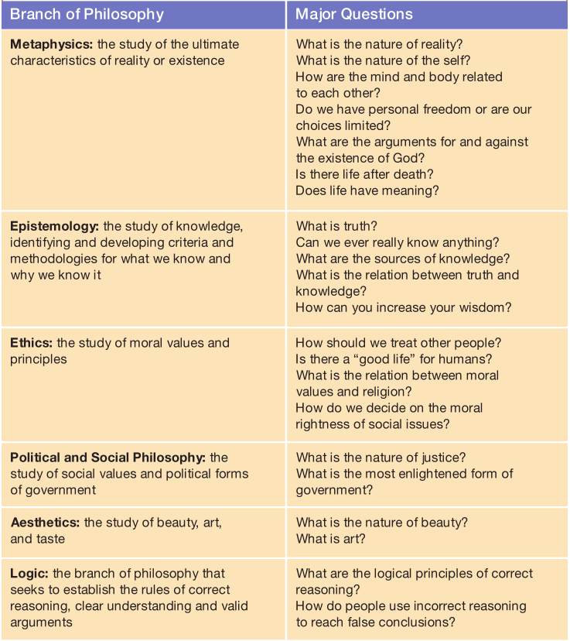

## Critical thinking process

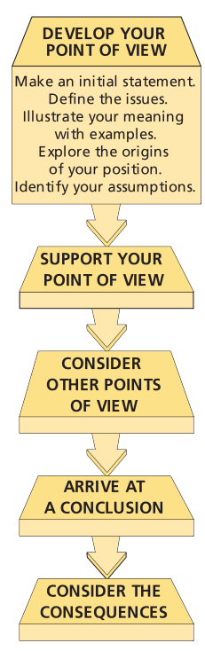

## Arguments:

### Deductive:

In a deductive argument, if the argument form is valid, and if you accept the supporting reasons (also called premises) as true, then you must necessarily accept the conclusion as true.

Reason/Premise: All men are mortal.

Reason/Premise: Socrates is a man.

Conclusion: Therefore, Socrates is mortal.

### Inductive:

An argument form in which one reasons from premises to a conclusion that is supported by the premises but does not follow necessarily from them. When you reason inductively, your premises provide evidence that makes it more or less probable (but not certain) that the conclusion is true.

# Socrates

**“The unexamined life is not worth living.”**

The goal of life is to know thyself and improve our souls through virtuous living.

The Socratic Method Seeking clarity and truth through penetrating questioning and astute analysis

Socrates left no writing of his own, so all of what we know about him comes through other sources. The richest source of his ideas comes from the Dialogues, short dramas written by Socrates student and disciple, Plato. Although Plato wrote these masterful and enduring Dialogues years after Socrates death, most experts agree that at least the initial Dialogues (Euthyphro, The Apology, Crito) are faithful portrayals of Socrates ideas.

**“The truth lies within each of us.”** By living an examined life, we can discover the principles of right thinking and action within us. In our effort to improve our souls and make them more godlike, we need only to apply the divine gift of reason to look deep within ourselves and discover immutable, universal truths. Of course, this process is aided tremendously by engaging in shared explorations with others through dialectical conversations. But the ultimate answers lie within us. Socrates also extends this concept of implicit knowledge to other insights regarding the nature of reality, such as mathematics.

**“We should strive for excellence in all areas of life.”** As previously mentioned, the Greeks in general and Socrates in particular believed that happiness was a con- sequence of actively exercising all of our soul s powers, and Socrates was a living example of this commitment.

**“It is better to suffer wickedness than to commit it.”** Why be moral? As just noted, Socrates response is that becoming a moral person is the only way to become a truly happy, psychologically healthy person. Often adages are clichéd and empty of meaning, but for Socrates, the idea that Virtue is its own reward contains a substantial measure of truth, a point he expresses in his observation that doing wrong will harm and corrupt that part of ourselves that is improved by just actions and destroyed by unjust actions. As a thinking individual, you create yourself through the choices that you make much as a sculptor gradually forms a figure through countless cuts of the chisel.

Socrates was committed to making our actions reflect our convictions. **For Socrates, striving to think well-meant striving to live well, developing consistent and rigorous standards of conduct and then following through with the choices that we make. For Socrates, there was no distinction between theory and practice, thought and action in the virtuous person, they are the same.** There is an intimate connection between knowledge and virtue, and as we gain intellectual understanding, we should naturally live more enlightened lives.

# CONSCIOUSNESS, IDENTITY, AND THE SELF

## Rationalism

The view that reason is the primary source of all knowledge and that only our reasoning abilities can enable us to understand sense experience and reach accurate conclusions.

## Empiricism

The view that sense experience is the primary source of all knowledge and that only a careful attention to sense experience can enable us to understand the world and achieve accurate conclusions.

## Materialism

The philosophical view that all aspects of the universe are composed of matter and energy and can be explained by physical laws. Many philosophers and psychologists view the self from a materialistic point of view, contending that in the final analysis mental states are identical with, reducible to, or explainable in terms of physical brain states.

Mark Twain: **“How come the mind gets drunk when the body does the drinking?”**

## Socrates

The soul is immortal

For Socrates, reality is dualistic, comprised of two dichotomous realms. One realm is changeable, transient, and imperfect, whereas the other realm is unchanging, eternal, and immortal. The physical world in which we live comprising all that we can see, hear, taste, smell, and feel belongs to the former realm. All aspects of our physical world are continually changing, transforming, disappearing.

In contrast, the unchanging, eternal, perfect realm includes the intellectual essences of the universe, concepts such as truth, goodness, and beauty. We find examples of these ideal forms in the physical world for example, we might describe someone as truthful, good, or beautiful. But these examples are always imperfect and limited: It is only the ideal forms themselves that are perfect, unchanging, and eternal.

What is truly remarkable about these ideas is how closely they parallel modern Western consciousness. A finite body; an immortal soul; a perfect, eternal realm with which the soul seeks communion and eternal bliss: All of the basic elements of Western (and some Eastern) religions are present.

## Plato

Three-part soul/

1. **Reason:** Our divine essence that enables us to think deeply, make wise choices, and achieve a true understanding of eternal truths.
2. **Physical Appetite**: Our basic biological needs such as hunger, thirst, and sexual desire.
3. **Spirit or Passion:** Our basic emotions such as love, anger, ambition, aggressive- ness, empathy.

Plato believed that genuine happiness can only be achieved by people who consistently make sure that their Reason is in control of their Spirits and Appetites (critique: overemphasizing the power and authority of reason, and underemphasizing the importance of the body and emotions). Plato illustrates his view of the soul/self in Phaedrus with a vivid metaphor: The soul is likened to a chariot drawn by two powerful winged horses a noble horse, representing Spirit, and a wild horse, embodying Appetite. The charioteer is Reason, whose task is to guide the chariot to the eternal realm by controlling the two independent- minded horses. Those charioteers who are successful in setting a true course and ensuring that the two steeds work together in harmonious unity achieve true wisdom and banquet with the gods. However, those charioteers who are unable to control their horses and keep their chariot on track are destined to experience personal, intellectual, and spiritual failure.

## Buddhism

**Milindapanha, The Simile of the Chariot (http://www.usna.edu/Users/history/abels/hh205/milinda.html)**

For Buddhists, every aspect of life is impermanent, and all elements of the universe are in a continual process of change and transition, a process that includes each self as well. The self can best be thought of as a flame that is continually passed from candle to candle, retaining a certain continuity but no real personal identity a concept very different from the self of Western consciousness.

According to Buddhist philosophy, the self is composed of five aggregates:

1. physical form
2. sensation
3. conceptualization
4. dispositions to act
5. consciousness

Each self is comprised of the continual interplay of these five elements, but there is no substance or identity beyond the dynamic interaction of these five elements.

## Descartes

**Cogito, ergo sum = I think, therefore I am.**

Descartes confesses that he has come to the conclusion that virtually everything he has been taught from authorities and other adults is questionable and likely false. His radical solution? To establish a fresh start on gaining true, well-supported beliefs by simply erasing his endorsement of anything he has previously been taught.

**Cogito, ergo sum** is the first principle of Descartes theory of knowledge because he is confident that no rational person will doubt his or her own existence as a conscious, thinking entity while we are aware of thinking about our self. Even if we are dreaming or hallucinating, even if our consciousness is being manipulated by some external entity, it is still my self-aware self that is dreaming, hallucinating, or being manipulated.

**If your self-identity is dependent on the fact that you are capable of being aware you are engaging in these mental operations while you are engaged in them. If you were consistently not conscious of your mental operations, consistently unaware of your thinking, reasoning, and perceiving processes, then it would not be possible for you to have a self-identity, a unique essence, a you.**

## Locke

1. To discover the nature of personal identity, we’re going to have to find out what it means to be a person.
2. A person is a thinking, intelligent being who has the abilities to reason and to reflect.
3. A person is also someone who considers itself to be the same thing in different times and different places.
4. Consciousness being aware that we are thinking always accompanies thinking and is an essential part of the thinking process.
5. Consciousness is what makes possible our belief that we are the same identity in different times and different places.

## Kant

Our minds actively sort, organize, relate, and synthesize the fragmented, fluctuating collection of sense data that our sense organs take in. For example, imagine that someone dumped a pile of puzzle pieces on the table in front of you. They would initially appear to be a random collection of items, unrelated to one another and containing no meaning for you, much like the basic sensations of immediate unreflective experience. However, as you began to assemble the pieces, these fragmentary items would gradually begin to form a coherent image that would have significance for you. According to Kant this meaning-constructing activity is precisely what our minds are doing all of the time: taking the raw data of experience and actively synthesizing it into the familiar, orderly, meaningful world in which we live. As you might imagine, this mental process is astonishing in its power and complexity, and it is going on all of the time.

**Unity of consciousness**. Thoughts and perceptions of any given mind are bound together in a unity by being all contained in your consciousness. This picture is uniquely your picture.

**Your self is able to perform this synthesizing, unifying function because it transcends sense experience.**

How do our minds know the best way to construct an intelligible world out of a never-ending avalanche of sensations? We each have fundamental organizing rules or principles built into the architecture of our minds. These dynamic principles naturally order, categorize, organize, and synthesize sense data into the familiar fabric of our lives, bounded by space and time. These organizing rules are **a priori in the sense that they precede the sensations of experience and they exist independently of these sensations.** We didn’t have to learn these a priori ways of organizing and relating the world they came as software already installed in our intellectual operating systems.

# FREEDOM AND DETERMINISM

**External vs. internal forces**

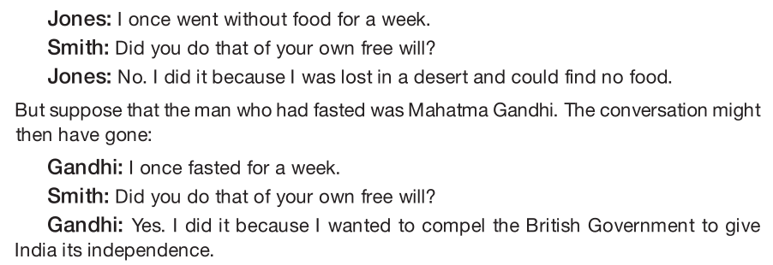

**If you are limited by external forces**, the way to free yourself is to neutralize or remove them, so that you can make choices that reflect your genuine desires. For example, if your choices are constrained by an unreasonable boss, you have to either change that person s coercive behavior or remove yourself from the situation to achieve genuine freedom. If you believe that your choices are excessively limited by the geographical location in which you live, you might have to move in order to increase your possibilities.

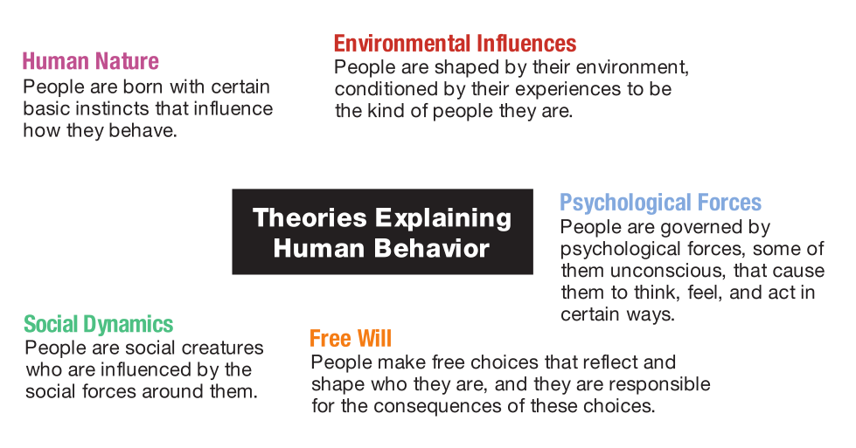

## Existentialism,

A philosophical movement that emphasizes the challenge and responsibility of all people to create a meaningful existence through the free choices they make. In seeking meaning, existentialists believe that we cannot look outward to a supernatural creator or an intelligible universe: We must look inward, to our own resources and possibilities, as we struggle to create meaning in a world that often seems chaotic and absurd.

## Determinism

The view that every event, including human actions, is brought about by previous events in accordance with universal causal laws that govern the world. Human freedom is an illusion.

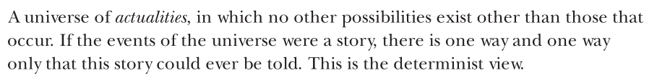

## Indeterminism

The view that some events, including human actions, are not necessarily determined by previous events in accordance with universal causal laws.

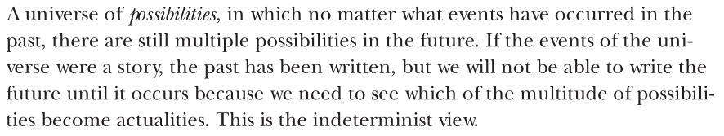

## Libertarianism

The view that humans are able to make authentically free choices that are not determined by previous events in accordance with universal causal laws, that there is a meaningful sense that though we made one choice, we could have done otherwise.

## Compatibilism

The view that all events, including human actions, are caused. However, we can consider human actions free if they are the result of internal motivations, not the product of external influences or constraints.

# How can we know the nature of reality?

## Metaphysics – What is real?

Most generally, the philosophical investigation of the nature, constitution, and structure of reality.

## Epistemology – What is true?

The study of the nature of knowledge and justification.

Plato:

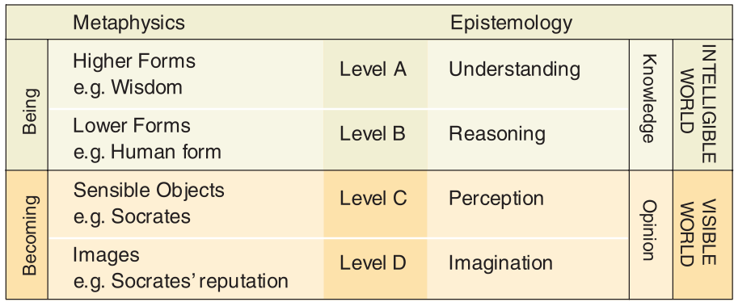

As we saw, Plato s metaphysical belief in the world of Being and the eternal Forms is tied to:

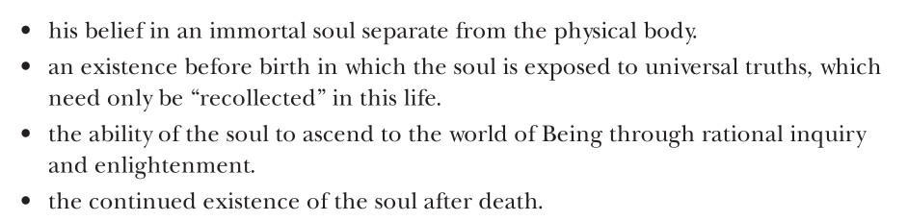

## Kant:

Sensations would be nothing to us, and would not concern us in the least, if they were not received into our (orderly) consciousness. Knowledge is impossible in any other way. . . . For perceptions could not be perceptions of anything for me unless they . . . could at least be connected together into (my) one conscious- ness. This principle stands firm a priori, and may be called “the transcendental principle of unity” for all the multiplicity of our perceptions and sensations.

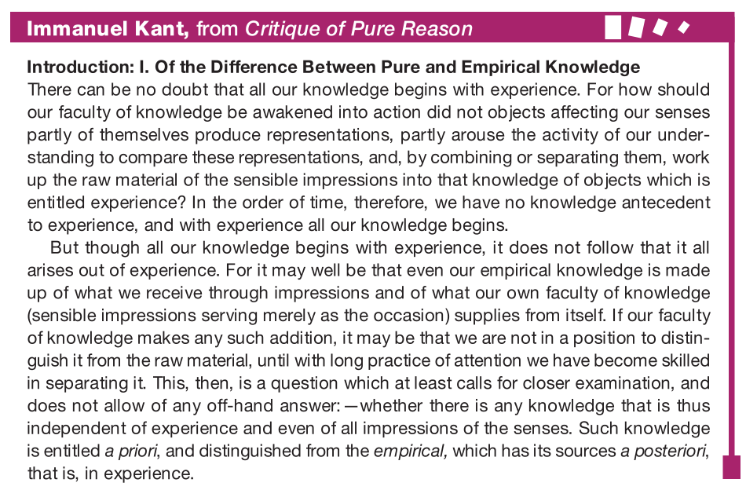

**The entire reality, which we assume to be completely independent of ourselves, is in fact, as Kant maintained, constituted by the active structuring of our minds. Categories or schemata (such as time, space, cause and effect) are universally present in normally functioning humans, we all share a common universe, constituted and defined by the same basic qualities and relations.**

**Universal concepts:**

* Unity, plurality, and totality for concept of quantity;
* reality, negation, and limitation, for the concept of quality;
* inherence and subsistence, cause and effect, and community for the concept of relation;
* possibility-impossibility, existence-nonexistence, and necessity and contingency for the concept of modality.

## Emotions

Emotions vs. feelings:

The point is that what we perceive in the world and our judgments about these perceptions influence our emotional reactions. And conversely, our emotions have a dramatic influence on what we perceive and how we interpret it. And because our knowledge of the world begins with perceptions, values and emotions are a natural and inseparable part of this knowing process.

**Physiological feelings may accompany emotions, they are clearly not the same phenomenon. As Jaggar notes, feelings are episodic in the sense that they occur at a given moment in time, whereas emotions extend over time: For instance, we may assert truthfully that we are outraged by, proud of or saddened by certain events, even if at the moment we are neither agitated nor tearful. In addition, although people may be unaware of their emotional state angry, ambivalent, depressed they are (nearly) always aware of what they are feeling at any given moment in time. If emotions include but also transcend episodic feelings, what else are they? One perspective the cognitivist point of view sees emotions as involving intentional judgments as well as physiological sensations. So, for example, you may be feeling anxious or agitated but is the emotion involved related to concern about an upcoming exam or concern about an upcoming romantic date? In other words, an important component in emotions is the intentional judgment that is associated with the physiological feeling. We may conclude, for instance, that it is our (intentional) evaluation of an upcoming date that is responsible for the anxiety ( butterflies ) we are feeling. Yet as important as intentional judgments are for understanding the nature of emotions, we still have not fully accounted for the complex nature of emotional experience.**

**In addition to immediate feelings and intentional judgments, emotions are also constituted by the social context in which they occur. For example, individuals in each culture are taught the appropriate emotional responses to people (strangers, authorities, religious figures, romantic interests) as well as situations (competitive sports, academic achievement, perceived insults). Each culture has its own unique emotional vocabulary that members of the culture learn at an early age, and this emotional vocabulary is an essential component in what emotions are all about. This vocabulary is expressed in the concepts and language of the culture, as well as in the actions and attitudes of the members. Jaggar s example of the emotion romantic love is pertinent here. Although there is general agreement regarding what this emotional concept means, each culture also tends to define the emotion and its affiliated attitudes and behavior in ways that are distinctive to that culture. The net result is that these social influences are integral elements in the construction of human emotions: hence the notion of emotions as social constructs.**

# Is there a spiritual reality - Religion

* A means to achieve ultimate spiritual transformation. And such a spiritual quest necessarily involves what we think, feel, and do. The way we live our lives becomes a vehicle for achieving ultimate spiritual transformation, and our religion provides us with the ethical roadmap.
* Second, religion provides a metaphysical grounding for morality. If a person or people develop an ethical system and instruct us to abide by its principles, we can legitimately ask, why should I follow your principles? What gives you special legitimacy over any other person to determine ethical guidelines? However, if an ethical system is grounded in a supernatural creator or what is thought to be a fundamental principle of the universe, then the ethical system speaks with a special authority. Why should I follow these principles? Because God (or some other metaphysical authority) endorses these principles. That removes moral values from the level of human-to-human debate and raises it to a spiritual level.

## A Brief Survey of World Religions

### Hinduism

Hinduism is the term used to designate the complex mosaic of religious beliefs and practices of the vast majority of the people of India.

* One of the oldest living religions in the world
* No single founder but evolved over a period of four thousand years, its history interwoven with **religious and cultural** movements.
* Hindu -> Sanskrit word sindu for river (Hindu referring to the Indus River)
* Alternative term for Hinduism preferred today is Sanatana Dharma.
  + Sanatana -> eternal religion
  + Dharma embodies a holistic approach to both personal spiritual fulfillment and social harmony.
* Many manifestations of single God assuming different forms.
* Vedas -> Ancient scriptures revered by Hindus. 4 parts
* **Upanishads**  -> The philosophical part of the Vedas, intended only for serious seekers.
* The Upanishads are thought to have developed between 600 and 400 B.C.E., about the same time that Gautama Buddha (c. 563 483 B.C.E.), the founder of Buddhism, lived on the Indian subcontinent.
* Five main themes:
  + **Contemplation of the luminous self.** Spiritual enlightenment can be achieved only by turning one’s attention inward to discover a transcendent reality from within. The bodily senses are made for looking outward and are easily enticed by sensory pleasures and worldly spectacles. But these sensations are fleeting and impermanent, passing away when one dies, and obscure the search for the infinite, everlasting reality. This unseen but all-pervading reality they called Brahman, the Unknowable. From Brahman originate the multiplicity of all forms, including humans, and thus Brahman can be discovered in the soul (atman) within ourselves.
  + **Reincarnation.** The belief that the soul leaves the dead body and enters a new one, being born over and over in countless bodies. Whether the body is that of an animal or other life form, the self remains constant. But rebirth as a human being is a precious and rare opportunity for the soul to advance toward its ultimate goal of liberation from rebirth and merging with the Brahman.
  + **Karma**. Progress toward a merging with Brahman is the result of karma, which refers to one’s actions as well as the consequences of one’s actions. The ultimate goal of creating ourselves through good choices is to escape from the karmic wheel of birth, death, and rebirth, which is called samsara. To escape from samsara is to achieve liberation from the limitations of space, time, and matter through realization of the immortal absolute.
  + **Yogic practices**. Disciplines that clear the mind and support a state of serene, detached awareness. This desired state of balance, purity, and peacefulness of mind is described as sattvic, in contrast with active, restless states or lethargic dull states. The practices for increasing sattvic qualities are known collectively as yoga, from the Sanskrit word for union (in this case the union of body, mind, and spirit).
  + **Fire sacrifices**

### Buddhism

http://www.usna.edu/Users/history/abels/hh205/milinda.html

Nontheist religion that does **not believe in a super- natural God or Creator**. Instead, the **ultimate transformation** to which Buddhists aspire is to escape the world of suffering through our own efforts until we finally **achieve Nirvana** (the ultimate egoless state of bliss).

* originator of Buddhism -> Siddhartha Gautama
* 4 noble truths of suffering:
  + **Life inevitably involves suffering, is imperfect and unsatisfactory**. Suffering and frustration is an unavoidable part of living- Happiness is fleeting, with unhappiness its constant shadow. Even the self is an impermanent illusion. The I is really a perpetually transient bundle of fleeting sensations, impressions, ideas, and feelings. The metaphor often used for the Buddhist concept of the self is that of a flame being passed from candle to candle in continual movement.
  + **Suffering originates in our desires**. Desires are wishes for things to be different than they are. We wish for good health, riches and fame, eternal life, perpetual happiness, permanence and security, and many other things as well. But none of these wishes can be achieved in a permanent fashion because life and the universe are essentially impermanent. And because our wishes are continually thwarted and events in the world are beyond our control, frustration and suffering are unavoidable.
  + **Suffering will cease if all desires cease**. This can be achieved only by realizing and accepting the fact that there is no unique, separate, permanent, immortal self. Once we understand that our self is simply an impermanent flow of energy tied to the larger energies of the cosmos, we are freed to realize that desires and suffering are irrelevant. In practical terms, accepting the non- existence of a permanent self encourages us to live happily and fully in the moment, liberated from self-centeredness and full of compassion for others.
  + **There is a way to realize this state: the Noble Eightfold Path.** Extinguishing desire and suffering is a process that can be achieved by following the guidelines embodied in the Noble Eightfold Path, devoted to pursuing morality, focus, and wisdom. The Noble Eightfold Path is a systematic philosophy of life that enables people gradually to free themselves from desire and suffering and achieve the ultimate peace of Nirvana. This process typically extends over multiple lifetimes, as we are caught in the perpetual cycle of death and rebirth. Once again, the self is not a permanent, immortal entity but is akin to a flame being passed from moment to moment, lifetime to lifetime. The Noble Eightfold Path includes right understanding, right thought and motives, right mindfulness, and right mediation.

### Daoism/Taoism

At the time that India was giving birth to Hinduism and Buddhism, East Asia saw the creation of Daoism and Confucianism (in China) and Shinto (in Japan). Daoism, on the other hand, is a way of life inspired from the rhythms of natural phenomena. Daoism promotes a constant interaction with our environment and the importance of being aware of it.

Dao is believed to be the first cause of the universe. It is the unnamable and eternally real force that flows through life, and each believer s goal is to become one with the Dao. Although Dao can be translated as path or the way, it is basically indefinable. Reality cannot be named or known through language, logic, or concepts it must be experienced. Dao refers to a power that envelops and flows through all things, living and nonliving. The Dao regulates natural processes and balances the universe.

Daoists do not pray to a Supreme Being; instead, they seek answers to life s problems through inner meditation and observation. For the Daoist, time is cyclical, not linear as in Western thinking. The entire cosmos is a manifestation of an impersonal self-generating energy called qi (ch i). This force has two aspects whose interplay causes the ever-changing phenomena of the universe. Yin is the dark, receptive, female aspect; Yang is the bright, assertive, male aspect. The Yin is considered to be the breath that formed Earth, whereas the Yang is the breath that formed the heavens. These two forces symbolize the pairs of opposites that are seen throughout the universe, such as good and evil, light and dark, male and female. Wisdom lies in recognizing the ever-shifting, but regular and balanced, patterns of movement of Yin and Yang and moving along with them. The Dao is this creative rhythm of the universe. Daoists follow the art of wu-wei, which is to let nature take its course, rather than trying to impede it. To take a metaphor from the natural world, one should allow a river to flow toward the sea unimpeded, instead of erecting a dam that would interfere with its natural flow. Analogously, we should be like flowing water ourselves, bypassing and gently wearing away obstacles rather than aggressively attacking them, effortlessly moving through life without struggling, leaving all accomplishment behind without trying to hold on to them.

Even when difficulties arise, the Daoist does not panic and take unnecessary action. This is a philosophy that Daoists believe should be practiced on a social and political level as well.

### Judaism

Judaism traces its roots to about 3,800 years ago, when, according to the holy scriptures known col- lectively as the TaNaKh, God entered into a covenant with Abraham. According to the covenant, Abraham and his descendants would give God (Yah- weh) their exclusive devotion and obedience, and God would choose them to enjoy special consideration and protection (thus the idea that Jews are God’ s chosen people ). Jewish scripture also states that God promised Canaan (now Israel) to the Jews as their homeland.

First and foremost is monotheism, a belief in one Creator God, all-pow- erful, all-loving, and ever-present. In stories from scripture, this God demands obe- dience, metes out rewards and punishments, and issues a moral code (the Ten Commandments). Religious holidays and rituals are based on key events in Jewish history as recorded in Jewish scriptures. These events serve as moral paradigms, symbolically rich stories that have continued relevance to contemporary lives. Divinely inspired laws that cover every aspect of Jewish social, communal, and religious life are another core element of Jewish religious faith. These laws have been codified in the Torah, a word which has a variety of meanings. One meaning refers to the first five books of the TaNaKh, believed to be the word of God as told to Moses. These teachings have evolved over time through the ongoing study and writings of Jew- ish scholars.

### Christianity

Christianity emerged and split off from Judaism some 1,800 years after Abraham. At its core is the belief that Jesus is the son of God and savior whose sacrificial death and resurrection make it possible for souls to have eternal life in heaven. Chris- tian scriptures consist of the Hebrew TaNaKh, which Chris- tians refer to as the Old Testament, and the writings of Jesus s followers, known as the New Testament. Christianity is the largest of the world s religions, with approximately 2.1 billion adherents. The New Testament contains the teachings of Jesus, a Jew who lived in Palestine under Roman rule at the beginning of the first millennium C.E. Jesus describes God as a loving Father who will take care of those who love Him and want to follow the path of righteousness. Jesus message was to reveal this path, through words and actions, so that all could achieve spiritual perfection and salvation in preparation for life after death. He makes clear that each person s relationship with God is intensely personal, nurtured through worship, reflection, and personal prayer.

Jesus preached a radical ethic, focusing his attention on the most disinherited people of the day, including the poor, the outcasts, the prostitutes, and even the most despised people of the day, the Roman tax collectors. What s more, Jesus preached that, in the next life, the favored individuals would include the poor in spirit, the meek, the mourners, the seekers of righteousness, the pure in heart, the merciful, the peacemakers, and those who are persecuted for the sake of righteousness and for spreading the gospel. In addition to complete devotion to God, the core of Jesus message was a love and devotion to others. In fact, Jesus preached that in extending ourselves to the less fortunate in society, we are symbolically worshiping God.

### Islam

The world s second largest religion, Islam, views itself as the ultimate expression of the monotheistic tradition that began when God spoke to Abraham. Muslims believe that Muhammad, who lived in the Arabian pennisula from 570 to 632 C.E., is the last and final prophet to receive the word of Allah (Allah is the Arabic word for God). Jesus is also viewed as a prophet, but Muslims believe that his message was corrupted by followers who insisted on his divinity. According to Islam, God revealed his messages to Muhammad through the angel Gabriel over the course of twenty- three years. These revelations constitute the text of the Qur an, the unchanged, untranslated word of God.

The Five Pillars spell out the way of Muslim life and its purposes:

* The First Pillar is shahadah, **the profession of faith**. There is no God but Allah, and Muhammad is his Prophet. This is the foundation stone of Islam, incorporating both a monotheistic belief in God and the recognition that while Muhammad is not divine, he is the last and greatest prophet of God. Although Islam believes that there might be many names for God, it is a religion built on the firm conviction that there is only one God, and it is our responsibility to submit totally to God s will in every dimension of our lives.
* The Second Pillar of Islam is salat, **the performance of a continual round of prayers**, a response to the natural yearning of the human heart to pour forth its love and gratitude toward its Creator. Regular prayer also keeps a Muslim s life in proper perspective, a reminder to submit to God s will as rightfully sovereign over his or her life. A Muslim should pray five times daily on rising, at noon, in midafternoon, after sunset, and before retiring.
* The Third Pillar is zakat, **the yearly setting aside of a portion of one’s wealth for the benefit of others.** There are always those who possess more material things than others, and Islam tries to bring a balance to this situation by asking those who have much to help lift the burden of those who have less. In addition to the zakat, Muslims are encouraged to give alms to charities. The
* Fourth Pillar is sawm, **the observance of Ramadan**, the holy month in the Arabian calendar. This was the period in which Muhammad received his initial commission as a prophet and ten years later made his historic flight from Mecca to Medina. To commemorate these two occasions, those who are physically able to fast during the entire month. From dawn to sunset, Muslims do not eat, drink, have sexual intercourse, or smoke. Fasting underscores humankind s depen- dence on God and, by experiencing what it is like to feel hunger and suffering, helps make us more compassionate.
* The Fifth Pillar is hajj, **the pilgrimage to Mecca** where one performs a set of rites. Once in a lifetime a Muslim is expected, if physical and economic conditions per- mit, to make this journey to Mecca where God s ultimate revelation was first dis- closed. Here again, similar to fasting during Ramadan, the purpose is to heighten the pilgrim s devotion to God and to His revealed will.

## “Leap of faith” Soren Kierkegaard

Then how do we achieve a confidence in God s existence? Kierkegaard says we must let go of our efforts to prove God s existence with logical, rational means and instead simply let the reality of his existence become manifest. But this act of letting go is difficult: We naturally strive for objective certainty, demonstrable proof that will satisfy the demands of reason. To let go of this compulsion requires an act of will, a leap of faith in God s reality. And when we truly let go of our rational efforts, our faith is rewarded by our experiencing the reality of God s existence in nonrational or supra- rational ways. We can again see the analogy with nurturing a loving relationship: We need to let go of our need to analyze every dimension of the relationship for the authentic emotions to be released and suffuse our shared experiences.

# ETHICS

The study of ethics is derived from the ancient Greek word ethos, which refers to moral purpose or character as in a person of upstanding character. Ethos is also associated with the idea of cultural customs or habits. In addition, the etymology of the word moral can be traced back to the Latin word moralis, which also means custom. Thus the origins of these key concepts reflect both the private and the public nature of the moral life: We strive to become morally enlightened people, but we do so within the social context of cultural customs.

In philosophy, one of the most important value domains includes your moral values, those personal qualities and rules of conduct that distinguish a person (and group of people) of upstanding character.

But most people in our culture today have not been exposed to these teachings in depth. They have not challenged themselves to think deeply about ethical concepts, nor have they been guided to develop coherent, well- grounded ethical systems of their own. In many cases people attempt to navigate their passage through the turbulent and treacherous waters of contemporary life without an accurate moral compass, relying instead on a tangled mélange of childhood teachings, popular wisdom, and unreliable intuitions. These homegrown and unreflective ethical systems are simply not up to the task of sorting out the moral complexities in our bewildering and fast-paced world, contributing to the moral crisis.

Which of your moral values are clearly articulated and well-grounded?

Which are ill-defined and tenuously rooted?

Do your values form a coherent whole, consistent with one another, or do you detect fragmentation and inconsistency?

The fatal flaw of **ethical subjectivism** is that it does not entail tolerance for the views or interests of others. It simply invests each individual with the moral authority to determine what is morally right and wrong, even if this means violating the rights or interests of others.

Gandhi:

The golden rule of conduct, therefore, is mutual tolerance, seeing that we will never all think alike and we shall see Truth in fragments and from different angles of vision. Conscience is not the same thing for all. Whilst there, it is a good guide for individual conduct, imposition of that conduct upon all will be an insufferable interference with everybody s freedom of conscience.

The popular statement “Everyone is entitled to his or her own belief “ suggests that no individual person has the right to say to another, “Your belief is wrong you should believe this instead.” In fact, it’s often considered bad manners to question the beliefs of others and to suggest that their beliefs are confused, unfounded, illogical, or outright wrong. This approach seems to be tolerant and democratic, and it often works well for matters of taste. It doesn’t make sense for you to say to someone else, You are wrong to wear your hair in a mullet, sport a tattoo, and eat chunky peanut butter directly from the jar. You might reasonably say, That’s not my style, or I prefer a different look, but not that a person with different tastes is wrong.

But moral beliefs are very, very different. If someone says, I agree with Hitler there is only one super-race, and all others are inferior, it does make sense to disagree and say, I think your belief is unethical and wrong. On what rationale do you base it? Similarly, if someone says, I think that the sexual abuse of children is all right, that person is not simply stating a personal belief: The individual is enunciating a general moral value that he or she believes applies to everyone. That s the unique logic of moral beliefs: When I say that something is right or wrong, I am by definition suggesting that it is right or wrong not just for me but for everyone.

Moral beliefs implicate and influence our relationships with others in a way that matters of taste never will. Because moral beliefs affect the treatment and well-being of others, they are held to a much higher standard of evaluation and justification than other types **The point is that our moral beliefs, whether openly acknowledged or implicit, have real-world consequences.**

## Ethical egoism

Ayn Rand

The virtue of altruism that traditional ethical theories and religions recommend is actually a vice because it encourages people not to pursue their own self-interest as their top priority.



Again ethical egoism

* Confusion 1: It is false to believe that selfishness means the same thing as self-interest.
* Confusion 2: It is false to say that every action is done either from self-interest or from other-regarding motives.
* Confusion 3: It is false to assume that a concern for one’s own welfare is incompatible with any genuine concern for the welfare of others.

Do the gods love piety because it is pious, or is it pious because they love it? In other words, is a moral value good or right because God commands it to be so, or is the moral value good or right independently of God s commands (though it is presumably consistent with divine moral values)?

## Character: Virtue Ethics

For Aristotle and other believers in virtue ethics, it is the cultivation of a virtuous character that is the goal of ethics, to become a virtuous person. The assumption is that genuinely virtuous people will act in morally principled ways as a natural expression of their moral goodness. And these moral actions will in turn strengthen their virtuous nature.

Aristotle points out that, though we desire pleasure, wealth, fame, and success, we desire them mainly because we hope that they will bring us happiness. Similarly, people often strive to achieve virtues such as honor and intellectual insight, though again the ultimate aim is to be happy.

Doctrine of the Golden Mean, a moral philosophy that is based on the concepts of temperance (moderation), self-discipline, and balance (an approach analogous to the Middle Way practiced in Buddhism).

Virtue then is a state of deliberate moral purpose consisting in a mean that is relative to ourselves, the mean being determined by reason, or as a prudent man would determine it.

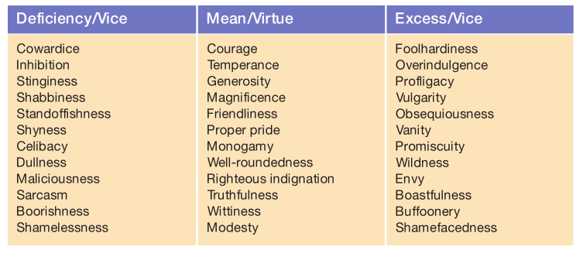

## Existentialism

For existentialism the questions are more along the lines of: How do I live my life authentically? How can I create myself to be a uniquely significant individual? How can I invest my life with meaning while existing in a universe that lacks ultimate meaning? How can I develop an approach to moral responsibility that is grounded in my absolute freedom of choice?

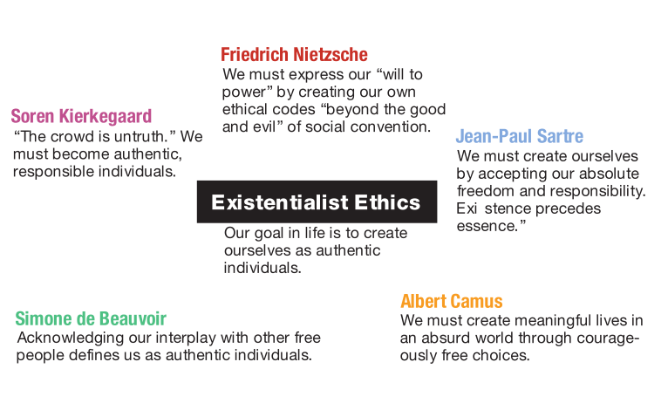

Once you have developed a clear understanding of your moral code, the struggle has just begun. Becoming a morally enlightened person a person of character and integrity requires not just an insightful moral compass but also the commitment to use the compass to navigate the way through the storms and shoals of your moral life. As a reflective critical thinker, you will be conscious of the choices you are making and the reasons you are making them, and you will learn from experience, refining your code of ethics and improving your moral choices through self-exploration. Achieving moral enlightenment is an ongoing process, but it is a struggle that cannot be avoided if you are to live a life of purpose and meaning, created by a self that is authentic and, as Aristotle would say, great-souled.