Understanding Influence in GitHub’s Open-Source Developer Community
1. Research Question, Stakeholders, and Decisions
Research Question
In the vast world of open-source software development, some developers stand out—not just because of how much code they write, but because of how effectively they connect and collaborate with others. Imagine you're a tech recruiter looking to hire someone who not only writes great code but also strengthens your team by bridging gaps, sharing knowledge, and fostering innovation. How could you reliably identify these influential figures?
By analyzing collaboration networks within GitHub, we can uncover precisely those developers whose interactions show exceptional influence. Doing this enables recruiters to strategically approach candidates who can significantly amplify team performance and innovation.
Stakeholders: Tech Recruiters - Professionals from tech firms and startups looking to hire influential, collaborative developers.
2. Data Description
To identify influential developers effectively, we'd ideally need a dataset capturing detailed interactions between developers on GitHub. This would include fields such as:
- Developer Username: To uniquely identify contributors.
- Repository Name: Indicating the project being worked on.
- Interaction Type: Describing the nature of the interaction (commit, pull request, issue comment, review).
- Timestamp: Allowing analysis of how interactions evolve over time.
Such a dataset is valuable because it directly maps the collaborative connections among developers. It reveals not just individual productivity, but the critical social ties that signify genuine influence within the community.
3. Data Collection and Preprocessing - Explain how you collected some subset of this data.
I collected data from the GH Archive, focusing specifically on a manageable subset from January 1, 2024, to perform initial analysis. Using Python scripts leveraging the requests library, I downloaded hourly JSON archives (.json.gz files) provided by GH Archive. These compressed archives were then parsed using Python's built-in gzip and json modules.
The extracted data included:
- actor.login: GitHub usernames of developers involved.
- repo.name: Names of repositories where interactions occurred.
- type: Types of interaction events (e.g., commits, pull requests).
These fields allowed me to map clear connections between developers based on their collaborative contributions, forming the basis for the network analysis.

4. Defining Nodes and Edges – add more details
In this collaborative network analysis, nodes represent individual GitHub developers, each identified uniquely by their username. Each developer is depicted as a single entity within the network, regardless of how many repositories they have contributed to.
Edges, or connections between these nodes, indicate a collaborative relationship: two developers are connected by an edge if they have both contributed to at least one common repository. The strength of this relationship (the edge weight) reflects how many repositories they've shared. This approach captures not just individual contributions, but also how developers collaborate, highlighting key interactions and influential relationships within GitHub's open-source community.
5. Measuring Node Importance and Influential Developers
Defining Importance
In this analysis, a developer’s "importance" was measured using degree centrality, which quantifies the number of unique collaborators a developer interacts with directly. Developers with high degree centrality aren't just prolific coders—they serve as hubs of collaboration, connecting diverse developers and projects within GitHub’s open-source ecosystem.
Degree centrality was chosen because it emphasizes social connectivity rather than just individual productivity, making it especially valuable for tech recruiters seeking candidates who foster teamwork and community engagement.
Based on this metric, here are three influential developers identified from our analysis:
- github-actions[bot] (Degree Centrality: 0.1219)
- dependabot[bot] (Degree Centrality: 0.0731)
- vercel[bot] (Degree Centrality: 0.0453)
- jaygohil1309 (Degree Centrality: 0.0403)
- Bella3215 (Degree Centrality: 0.0366)
However, the prominence of bot accounts highlights an important limitation: automated accounts significantly influence interactions. Thus, future refinements of the data might involve filtering out bot accounts to better identify influential human developers.
6. Analysis Results
By visualizing the collaborative relationships among GitHub developers, we found clear hubs of influence—developers whose interactions significantly connect various communities within GitHub. In the network visualization below, each node represents a developer, and the node size reflects their degree centrality, indicating how broadly they collaborate with others.
In particular, we observed several prominent nodes (larger nodes), clearly standing out in the network due to their extensive collaborative reach. Notably, the most influential entities included several automated accounts such as github-actions[bot] and dependabot[bot], alongside human contributors like jaygohil1309 and Bella3215.
This visualization directly answers our initial research question by highlighting developers who play central roles in GitHub collaborations, offering actionable insights to recruiters: developers positioned as influential hubs can strengthen teams by bridging communities and facilitating knowledge sharing.
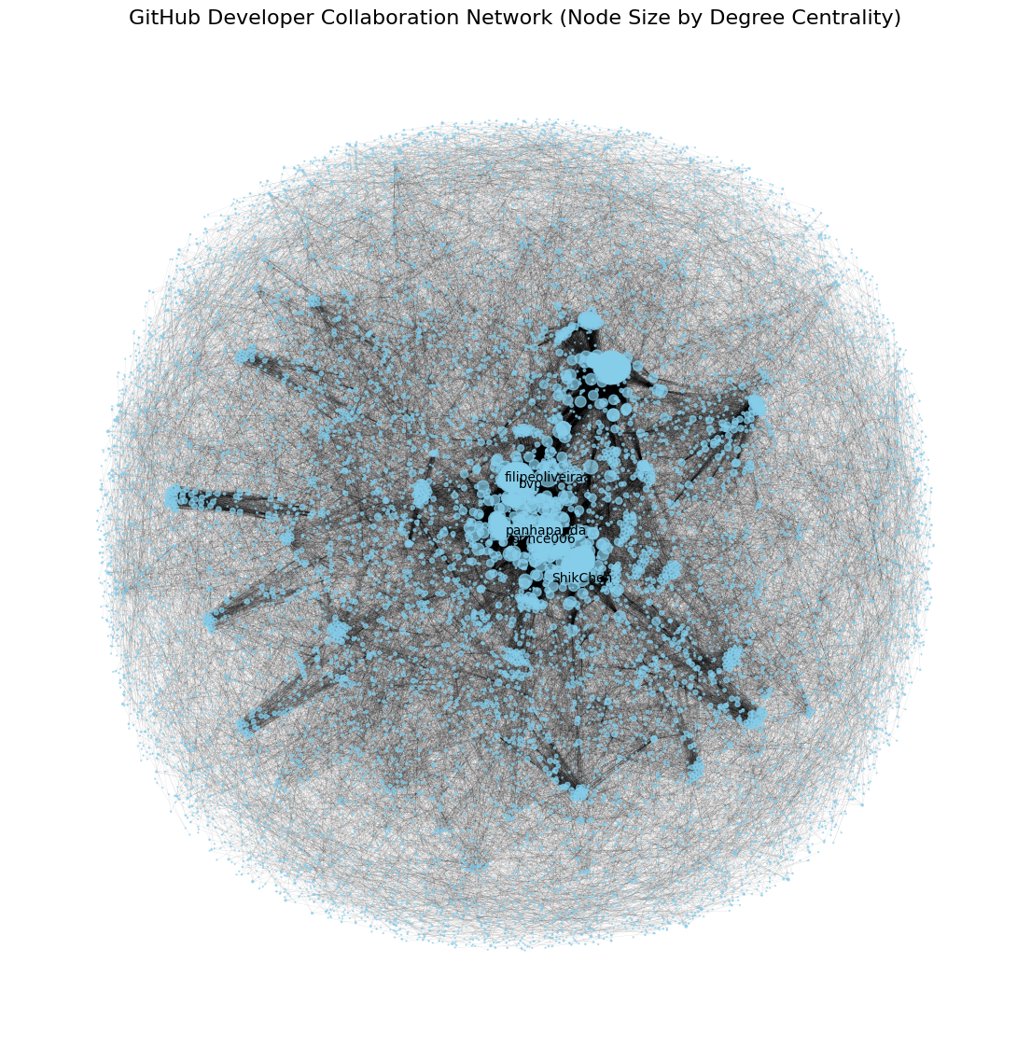
7. Data Cleaning Insights
During data collection from GH Archive, the following considerations and challenges arose:
- Handling Missing or Malformed Data:
Each hourly dataset contained JSON-formatted records, some of which occasionally included malformed lines or incomplete data. These problematic records were handled gracefully using Python's try-except blocks within loops, ensuring that the script continued running without interruption.
- Duplicate Developer Contributions:
To accurately represent collaboration, contributions were aggregated into a set for each repository. This approach inherently removes duplicates by storing unique developer usernames, thus avoiding overstating collaboration intensity.
- Large Data Volumes and Performance:
Downloading and processing multiple hourly files posed performance issues. To handle this, the data was initially limited to a small, manageable timeframe (e.g., a single day), allowing for quicker exploratory analysis before scaling up.
Future users of this data may encounter similar issues. Implementing robust error handling, using sets to avoid duplicates, and starting with smaller datasets are recommended best practices. ​
8. Limitations of the Analysis
While this network analysis provides valuable insights into developer influence on GitHub, several limitations must be considered:
- Bot Influence:
A significant portion of interactions involved automated bot accounts (e.g., github-actions[bot], dependabot[bot]). These bots inflate centrality measures and obscure the true human interactions, potentially misrepresenting genuine collaboration among developers.
- Short Timeframe:
The dataset analyzed covers only a limited period (a single day), providing a narrow snapshot of collaboration. A longer-term analysis might yield different influential developers and patterns.
- Indirect Influences Not Captured:
Degree centrality captures only direct interactions, neglecting indirect yet potentially influential connections (e.g., developers bridging separate clusters). Metrics like betweenness or eigenvector centrality might reveal additional insights.
- Activity ≠ Influence:
Frequent interactions do not always indicate significant influence. Developers with fewer, but more strategically valuable interactions might be underestimated by purely quantitative measures.
To mitigate these biases, future analyses should exclude known bots explicitly, extend the data collection period, and integrate additional centrality metrics.
9. GitHub Repository
INSERT HERE

