Write a Medium post describing how you applied supervised learning to extract insights from a dataset. Using methods from module 6, you should construct a dataset of interest, identify the type of supervision problem (i.e., classification or regression), describe (and justify) your selection of the supervised learning model, and explain the supervised labels/scores you will use (i.e., where they come from and what they mean). After training and applying your model to your dataset, explain how you determined whether the model was performing well or not. Then, select 5 samples that your learning model got wrong, and discuss why you think these samples were incorrectly labeled/scored.
Your post should include the following:
- Describe a question you think can be answered using network data, what specific stakeholder is asking this question, and what decision(s) the answer to this question will inform.

Can we accurately estimate a country’s democracy level using institutional indicators from large-scale datasets like V-Dem? This question is especially relevant to policy advisors at World Bank Organization. For a policy advisor working on democratic governance or foreign assistance programs, having a reliable, data-driven estimate of a country's democratic status is critical for:
• Prioritizing technical assistance
• Guiding diplomatic engagement
• Assessing vulnerability to authoritarian backsliding
Expert indices like the EIU Democracy Index are valuable but limited in scope and frequency. By applying supervised machine learning to high-resolution governance data, we can build scalable models that generate annual, country-specific democracy scores aligned with expert benchmarks. This approach supports smarter, faster, and more transparent decision-making—especially in regions where democracy is fragile or rapidly evolving.

- Describe the data that could answer this question, what fields it contains, how ground-truth labels were generated, and why it is relevant to your question.

To answer whether a country’s democratic status can be predicted using machine learning, we need a dataset that captures the institutional and political conditions shaping democratic governance. The ideal dataset includes annual, country-level indicators that measure the functioning of key democratic components such as elections, civil liberties, judicial independence, executive constraints, and political participation.
The V-Dem (Varieties of Democracy) dataset is well-suited for this task. It contains hundreds of expert-coded variables spanning multiple dimensions of democracy for over 200 countries and territories, updated annually. Fields such as v2x_polyarchy, v2x_libdem, v2x_civlib, and v2x_jucon provide comprehensive measures of electoral integrity, liberal democracy, civil liberties, and judicial constraints. These variables serve as features for supervised learning.
The ground-truth labels used for training the model come from the Economist Intelligence Unit (EIU) Democracy Index, which scores countries on a scale from 0 to 10. This score is based on five key dimensions: electoral process and pluralism, civil liberties, functioning of government, political participation, and political culture. These expert assessments offer a consolidated and interpretable label that reflects overall democratic quality, making them ideal for supervised regression.

- Explain how you collected some subset of this data (e.g., libraries like requests, BeautifulSoup, tweepy, praw, etc. or from data archive).

To construct the dataset used in this project, I downloaded two main sources: the V-Dem dataset and the EIU Democracy Index. The V-Dem data was obtained as a CSV file from the official V-Dem Institute website. This file includes annual country-level observations and was loaded into a pandas DataFrame for filtering and analysis.
I selected a subset of V-Dem variables focused on institutional indicators relevant to democracy and governance. These included measures of electoral fairness, civil liberties, executive oversight, and political participation. After filtering to retain only relevant features, I merged this data with the EIU Democracy Index, which was sourced from a publicly shared dataset compiled by researchers and available online. The datasets were joined on country_name and year, and I dropped any rows with missing democracy scores or invalid feature values to ensure the dataset was suitable for supervised regression modeling.

- Discuss and justify whether you are using a classification or regression model for this analysis; include a description of the feature you are predicting (e.g., is it continuous, binary, categorical, numeric, etc).

For this analysis, I am using a regression model, not classification. This decision is based on the nature of the target variable: the EIU Democracy Index, which is a continuous, numeric score ranging from 0 to 10. Each country receives a score with decimal precision that reflects the degree of democracy present in a given year. This makes regression the appropriate modeling choice, as the goal is to predict the exact value of a democracy score rather than placing countries into broad categories like "democracy" or "authoritarian regime."
Using classification would require simplifying the data into discrete classes (e.g., "democracy" vs. "non-democracy"), which would discard valuable information about differences between countries that fall within the same category but have very different democratic profiles. Regression preserves this granularity and allows for more nuanced analysis, such as identifying small improvements or declines in democratic performance over time.
By framing the problem as a regression task, I can directly model how institutional features—like civil liberties, electoral fairness, and judicial independence—quantitatively relate to the overall democratic quality of a country.

- Define what features you are using for your supervised model.

For this analysis, I used a broad set of institutional indicators from the V-Dem dataset as input features for the regression model. These indicators capture various dimensions of democratic governance, including electoral integrity, civil liberties, judicial independence, executive oversight, political participation, and corruption control. While the full dataset includes over 50 variables, the model’s core relies on approximately 10 key composite indices such as v2x_polyarchy, v2x_libdem, v2x_civlib, and v2x_jucon.
These selected features represent aggregated measures of core democratic principles. For example, v2x_polyarchy captures the degree to which political power is allocated through inclusive and competitive elections, while v2x_libdem reflects liberal democratic norms by combining electoral democracy with rule of law and institutional checks. v2x_civlib measures civil liberties like freedom of expression and association, and v2x_jucon evaluates the strength of judicial constraints on executive authority. Other features, such as v2x_partip, measure political participation, and v2x_corr tracks perceived corruption. These indicators provide a detailed, institutional-level view of a country’s democratic functioning and serve as strong predictors of overall democracy quality.
The full list of features used, along with the filtering and preprocessing steps, is available in the GitHub repository linked at the end of this post.

- After applying your trained model, identify 5 samples that your learning model got wrong, and discuss why you think these samples were incorrectly labeled/scored.

After applying the trained Random Forest model, I examined the predictions with the highest absolute error. Below are five specific examples where the model’s predicted democracy score differed most from the actual EIU Democracy Index value, along with possible explanations for each error:
- Nepal (2023)
Actual: 4.60 | Predicted: 6.15 | Error: 1.55
The model likely overestimated Nepal’s democratic performance based on strong scores in formal institutions, such as electoral procedures or civil society indicators. However, the EIU may penalize instability, political deadlock, or poor governance, which aren’t fully captured in V-Dem’s structural metrics.
- Armenia (2019)
Actual: 5.54 | Predicted: 7.06 | Error: 1.52
Armenia’s post-2018 political reforms improved its V-Dem scores rapidly, especially in participation and judicial independence. However, the EIU may have taken a more conservative view due to concerns about implementation or remaining institutional weaknesses.
- Guinea-Bissau (2012)
Actual: 1.43 | Predicted: 2.73 | Error: 1.30
This overestimation may reflect the model’s sensitivity to formal institutions that exist on paper but function poorly in practice. V-Dem might assign modest values to electoral or legislative systems that the EIU considers ineffective or unstable.
- Bhutan (2019)
Actual: 5.30 | Predicted: 6.50 | Error: 1.20
Bhutan consistently scores high on institutional indicators, including civic participation and executive constraints. However, its democratic structure remains limited by constitutional monarchy and party control, which may be penalized more by EIU than reflected in V-Dem’s features.
- Mauritius (2023)
Actual: 8.14 | Predicted: 7.18 | Error: 0.96
The model slightly underpredicted Mauritius’s score. This may stem from recent fluctuations in specific indicators like media freedom or judicial performance, which affected the V-Dem input but weren’t enough to significantly reduce EIU’s overall democracy rating.

- Provide an answer to your question, explaining your analysis of the data you collected, and how it answers that question.

Based on the analysis, the answer to the question—Can we accurately estimate a country’s level of democracy using institutional indicators from open political datasets?—is yes.
Using a Random Forest regression model trained on over 50 V-Dem indicators, I was able to predict EIU Democracy Index scores with high accuracy. The model achieved a mean absolute error (MAE) of just 0.20 on a 0–10 scale and an R² score of 0.98, indicating that it explained 98% of the variance in the actual democracy scores. This demonstrates that V-Dem’s institutional indicators, when combined with machine learning, are highly effective at estimating how democratic a country is, without relying directly on expert-coded democracy labels.
The results also show that the model performs consistently well across the full spectrum of democratic regimes—from authoritarian states to liberal democracies. Most prediction errors were relatively small, and large errors tended to appear in countries with unique or transitional political structures (e.g., Bhutan or Nepal), where institutional measures may diverge from expert assessments due to cultural or contextual factors.
Overall, the findings support the idea that democracy can be measured programmatically with high precision using publicly available governance data. This provides a scalable and transparent method for monitoring global democratic trends—one that can be particularly useful for analysts, researchers, and policy advisors seeking faster or more frequent assessments than expert-coded indices alone can provide.

- Include figures or tables summarizing your findings.

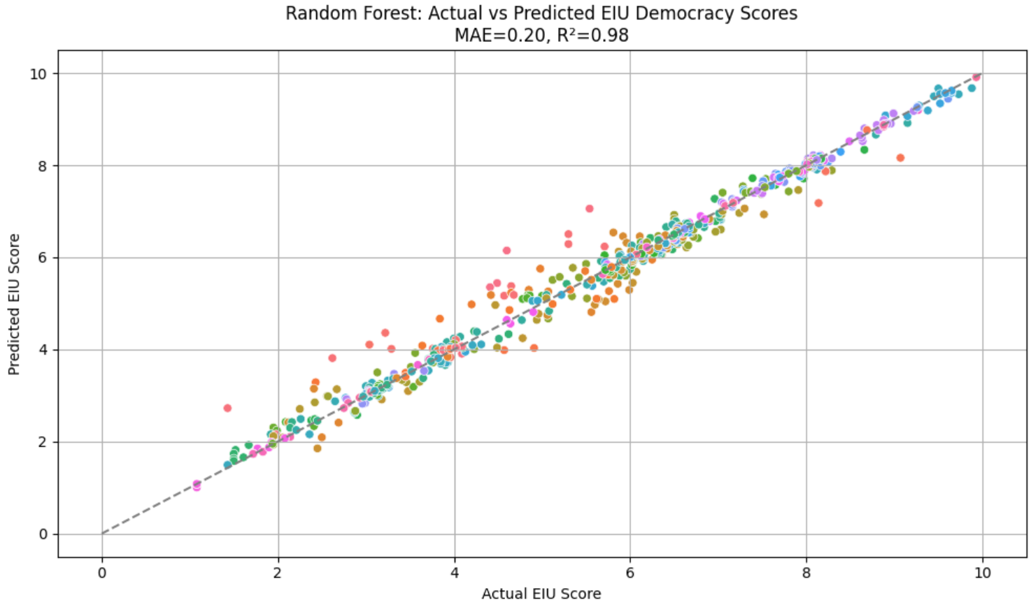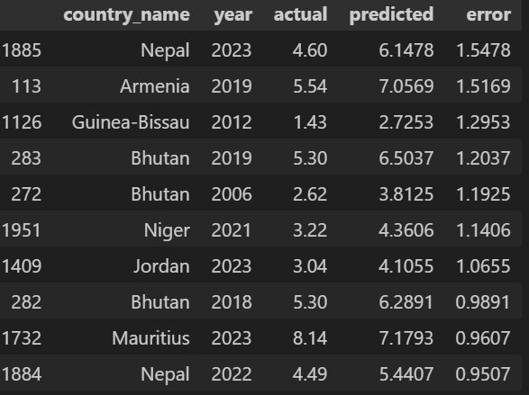

- Describe how you cleaned up this data, common bugs you think others might encounter, and if you used ChatGPT/AI assistance, what did you have to do to the output to make sure it was right or reasonably correct?

Since I used the same V-Dem Core dataset as in my previous analysis, the data cleaning process followed a similar pattern. I began by selecting a subset of relevant governance and democracy indicators based on the V-Dem documentation, focusing on mid-level and high-level indices that meaningfully capture institutional performance.
Examples of filters applied:
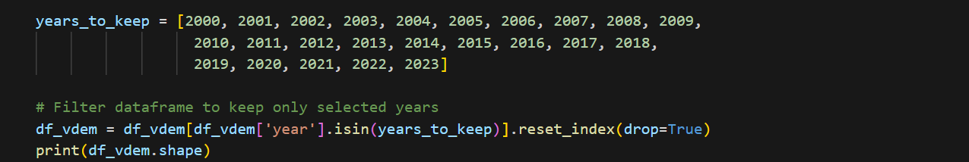
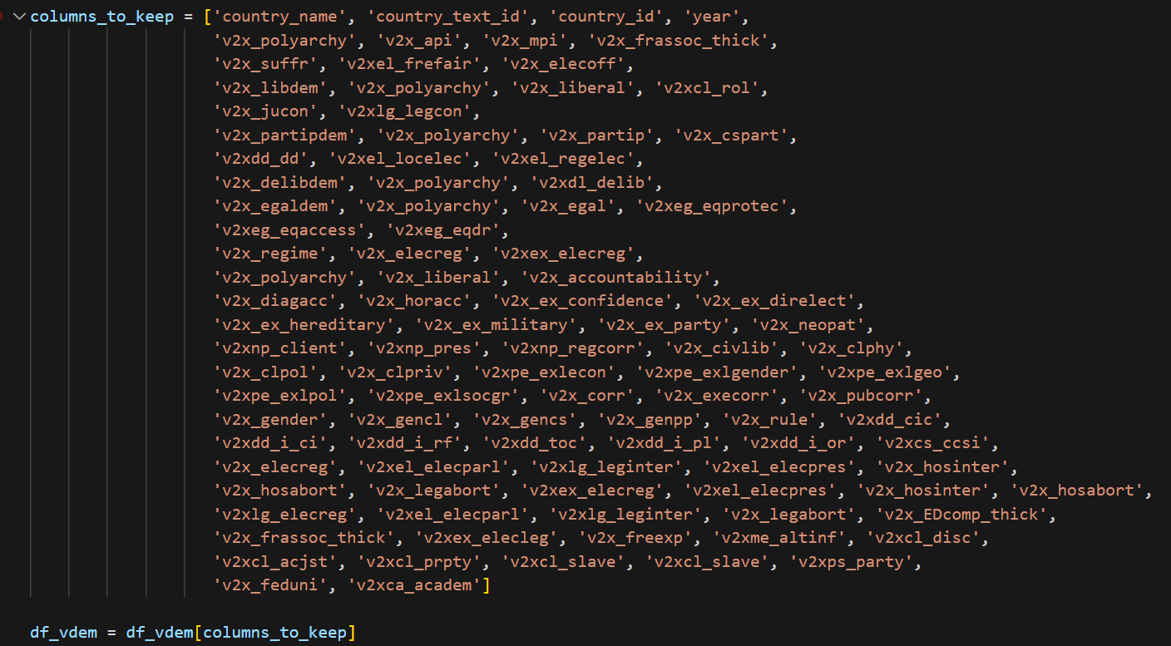
To prepare the dataset for clustering, I removed non-numeric columns and dropped any rows with missing values — which accounted for about 7% of the data. I then applied Min-Max normalization to ensure all features were scaled to a common 0–1 range. This step was particularly important for ensuring that no single feature disproportionately influenced the clustering process.
Common bugs I encountered — and others might too — include inconsistent column naming (some features are duplicated or appear under slightly different names), missing data for certain countries in specific years, and issues with identifier columns like country_name vs. country_text_id. Filtering by year and ensuring feature consistency is crucial to avoid skewed results or mismatched data.
I also Dropped NaN rows since regression models don’t support NaN values:
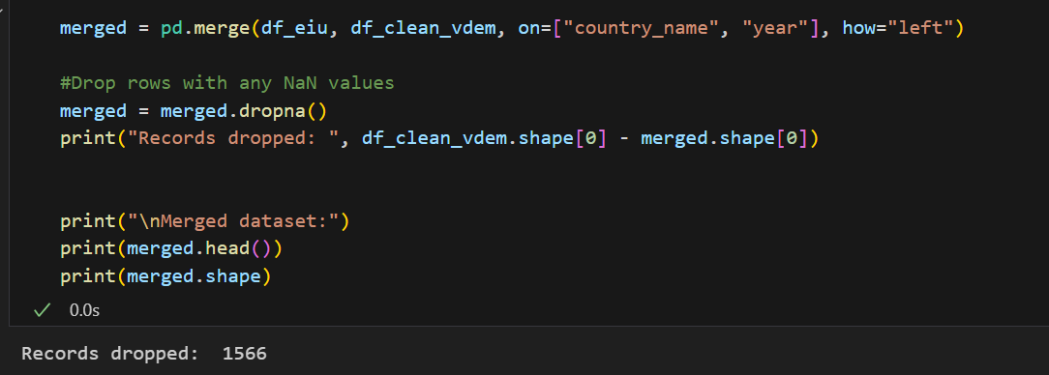
As for AI assistance, I used ChatGPT to help polish my writing and improve the structure of my explanations. While the models provided strong starting points for phrasing and organization, I reviewed and revised all technical descriptions and interpretations to ensure accuracy and alignment with the data and context.

- Discuss the limitations of your analysis. What’s missing? How might it be biased?

While the model performed well, there are several important limitations to consider that affect the generalizability and reliability of the results.
First, the analysis is limited by the nature of the input data. V-Dem indicators are expert-coded and derived from structured institutional characteristics. While they are rich and comprehensive, they may miss important informal dynamics, sudden political shifts, or contextual nuances that influence how democracy functions in practice. For example, a country might score well on formal institutional indicators but still experience democratic erosion through media suppression, elite capture, or extra-legal executive power—all factors that may not be fully reflected in V-Dem data.
Second, the target variable—the EIU Democracy Index—is itself an expert-curated product and may reflect the subjective judgments or biases of the researchers who compiled it. Training a model on this label may inadvertently reproduce these assumptions rather than offering a fully independent or objective prediction. The EIU index is also not available for all countries and years, which reduces the amount of supervised data and may skew the training sample toward countries with more complete reporting.
Third, there is a potential for data leakage or redundancy among V-Dem indicators. Many features are composites of others, or are highly correlated, which can inflate the model's performance during training. Although Random Forests are robust to multicollinearity, this still limits the interpretability of feature importance and may reduce the model’s generalizability to newer, unseen data structures.
Lastly, this analysis assumes that the past structure of governance remains predictive for the present and future, which may not hold true in rapidly changing political environments. Countries undergoing coups, revolutions, or major institutional breakdowns may exhibit behaviors that fall outside the model’s learned patterns.
In summary, while the model offers strong predictive value, it should be viewed as a complement to expert judgment rather than a replacement. It is most useful when combined with context-specific political analysis and real-time observation.

- Include a link to one of your GitHub repositories that contains the code you have developed for this assignment.
LINK TO INCLUDE
When you have written your post, publish it via Medium, add your post it to the class publication via Medium, and submit the URL to it via ELMS.
Tag your story as "inst414spr25a06" - Articles with this tag will automatically be added to the appropriate assignment tab after I accept on the class

