Pan-Cancer Multi-Omics Survival Analysis Using Multi-Omics Factor Analysis and Transformer-Based Deep Learning: Identification of Therapeutic Targets Across 31 TCGA Cancer Types
Debaditya Chakraborty¹
¹University of Texas at San Antonio
Correspondence: debaditya.chakraborty@utsa.edu

ABSTRACT
Pan-cancer survival analysis integrating multiple omics modalities offers the potential to identify molecular markers that transcend individual cancer types. We present a comprehensive multi-omics survival analysis pipeline applied to 7,902 primary tumor samples across 31 cancer types from The Cancer Genome Atlas (TCGA), integrating RNA-seq expression, somatic mutation, and copy number variation (CNV) data. Multi-Omics Factor Analysis (MOFA+) distilled 2,300 cross-modal features into 18 latent factors capturing coordinated biological variation across modalities. These factors, combined with cancer-type covariates, were used to train three survival prediction models—an FT-Transformer, XGBoost with a Cox partial likelihood objective, and LightGBM with a custom Breslow approximation—evaluated by concordance index (C-index) in stratified 5-fold cross-validation across 7,787 survival-annotated samples (2,170 events). The FT-Transformer achieved the highest C-index of 0.751 ± 0.006, outperforming the raw-PCA XGBoost baseline (C-index = 0.724 ± 0.053) and demonstrating 7-fold reduction in fold-to-fold variance, confirming the biological structure encoded in MOFA+ factors. SHAP-based feature attribution identified Factor 8 (avg |SHAP| = 0.283) as the dominant molecular survival signal, encompassing protease-driven invasion (PRSS3, KLK6), TP53/KRAS/APC driver mutations, and GAS6-AXL copy number gains. Factor 6 revealed the 9p24.1 immune checkpoint amplicon (CD274/PDCD1LG2/JAK2) as a pan-cancer survival determinant, Factor 1 the squamous lineage programme (TP63, KRT16/17, NECTIN4), Factor 15 a luminal-to-basal de-differentiation axis (ARID1A/KMT2C/PTEN loss), and Factor 12 a thyroid/IDH-glioma differentiation gradient (BRAF V600E, IDH1, CIC). Together, these factors nominate 15 priority therapeutic targets spanning approved therapies (sotorasib, ivosidenib, pembrolizumab, enfortumab vedotin), late-stage clinical agents (APR-246/eprenetapopt, tazemetostat, bemcentinib), and novel mechanisms (PRMT5 synthetic lethality, AXL-GAS6 axis, RLN1/RLN2-RXFP1 antagonism). This work demonstrates that MOFA+-driven latent factor models substantially improve pan-cancer survival prediction and provide biologically interpretable, therapeutically actionable multiomics signatures.
Keywords: pan-cancer genomics; multi-omics integration; MOFA+; survival analysis; FT-Transformer; SHAP; therapeutic targets; TCGA

1. Introduction
Cancer is fundamentally a disease of genomic dysregulation, yet the relationship between multi-layered molecular alterations and patient survival remains incompletely understood, particularly across cancer types. While single-modality analyses have identified numerous prognostic biomarkers—including TP53 mutation status, HER2 amplification, and microsatellite instability—the coordinated interactions between transcriptional programmes, somatic mutation landscapes, and copy number architecture have proven difficult to capture simultaneously. Multi-omics integration approaches offer the promise of revealing such coordinated signals, but their application to pan-cancer survival prediction at scale has been limited by computational constraints, data heterogeneity, and interpretability challenges.
The Cancer Genome Atlas (TCGA) Pan-Cancer Atlas provides an unprecedented resource: molecularly profiled primary tumor samples spanning 33 cancer types with comprehensive clinical annotations, enabling the first truly pan-cancer multi-omics survival studies at scale. However, directly modelling thousands of molecular features across modalities creates substantial statistical and computational challenges, including the curse of dimensionality, cross-modal feature redundancy, and the need for principled feature selection that preserves biological meaning.
Multi-Omics Factor Analysis (MOFA+) addresses these challenges by learning a low-dimensional latent factor representation shared across modalities, capturing coordinated variation while separating modality-specific noise [Argelaguet et al., 2020]. Each latent factor represents a coherent biological programme—such as a transcriptional lineage, a mutation-driven pathway, or a copy-number-altered oncogenic axis—making the resulting features both compact and biologically interpretable. The use of MOFA+ factors as inputs to survival models transforms the high-dimensional multi-omics integration problem into a structured, lower-dimensional survival prediction task.
For survival prediction itself, we benchmarked three complementary architectures: an FT-Transformer (Feature Tokenizer Transformer) [Gorishniy et al., 2021], which applies self-attention across tabular features to capture non-linear factor interactions; XGBoost with a built-in Cox survival objective; and LightGBM with a custom Breslow-approximation partial likelihood objective. This comparison was motivated by the hypothesis that transformer attention mechanisms would better capture interaction effects between MOFA+ factors and cancer-type covariates than gradient boosting trees—a hypothesis confirmed by our results.
Critically, we couple these predictive models with SHAP (SHapley Additive exPlanations) attribution to translate factor-level survival signals back to gene-level biological mechanisms. This two-step approach—MOFA+ for compression and SHAP for decomposition—yields a therapeutically actionable interpretation layer: individual genes whose expression, mutation, or copy number contributes to high-SHAP-weight factors become candidates for knockdown, restoration, or lineage reprogramming strategies. The ultimate goal is not merely prediction but target discovery: identifying molecular drivers whose perturbation could alter patient survival trajectories.
Here we report the complete pipeline applied to 7,787 survival-annotated samples across 31 TCGA cancer types, including the identification of five biologically distinct survival factors, 15 priority therapeutic targets spanning multiple approved and investigational therapy classes, and three distinct intervention strategies: oncogene inhibition, tumour suppressor restoration, and lineage reprogramming.

2. Methodology

2.1 Data Acquisition
Data were obtained from the UCSC Xena Pan-Cancer Atlas hub (https://pancanatlas.xenahubs.net). Three primary omics modalities were downloaded: (i) RNA-seq gene expression as log₂(TPM+0.001) normalized counts from the TOIL recomputed expression matrix (tcga_RSEM_gene_tpm.gz; ~1.8 GB); (ii) somatic mutation calls from the TCGA MC3 consortium MAF file (mc3.v0.2.8.PUBLIC.xena.gz; ~80 MB); and (iii) GISTIC2 gene-level copy number scores (broad.mit.edu PANCAN Gistic2 thresholded by genes; ~60 MB). Clinical phenotype annotations were obtained from the TCGA phenotype dense data file, and overall survival (OS) annotations were obtained from the TCGA Clinical Data Resource (CDR) curated survival table [Liu et al., 2018, Cell], which provides harmonized OS time and event status for 11,081 patients across 33 cancer types.

2.2 Preprocessing and Sample Alignment
Expression preprocessing included stripping Ensembl version suffixes from gene IDs, replacing TOIL floor sentinel values (log₂(0.001) = −9.95) with zero, selecting the top 5,000 highest-variance genes across all samples, and transposing from genes×samples to samples×genes orientation. Mutation preprocessing retained only non-synonymous variant classifications (Missense_Mutation, Nonsense_Mutation, Frame_Shift_Del, Frame_Shift_Ins, Splice_Site, In_Frame_Del, In_Frame_Ins, Nonstop_Mutation, Translation_Start_Site, De_novo_Start_OutOfFrame), truncated barcodes to 15 characters for barcode compatibility, and pivoted to a binary presence/absence matrix, retaining only genes mutated in ≥2% of samples (1,490 genes). CNV data were transposed and cast to float32. Sample alignment was performed by intersecting all four modalities (expression, mutation, CNV, clinical/survival) and restricting to primary tumor samples (TCGA barcode suffix -01). Gene symbol mapping was performed via the mygene.info API, resolving 4,389 of 5,000 Ensembl IDs. The final aligned cohort comprised 7,902 primary tumor samples across 31 cancer types; 7,787 of these had valid overall survival data (OS_time > 0) yielding 2,170 events.
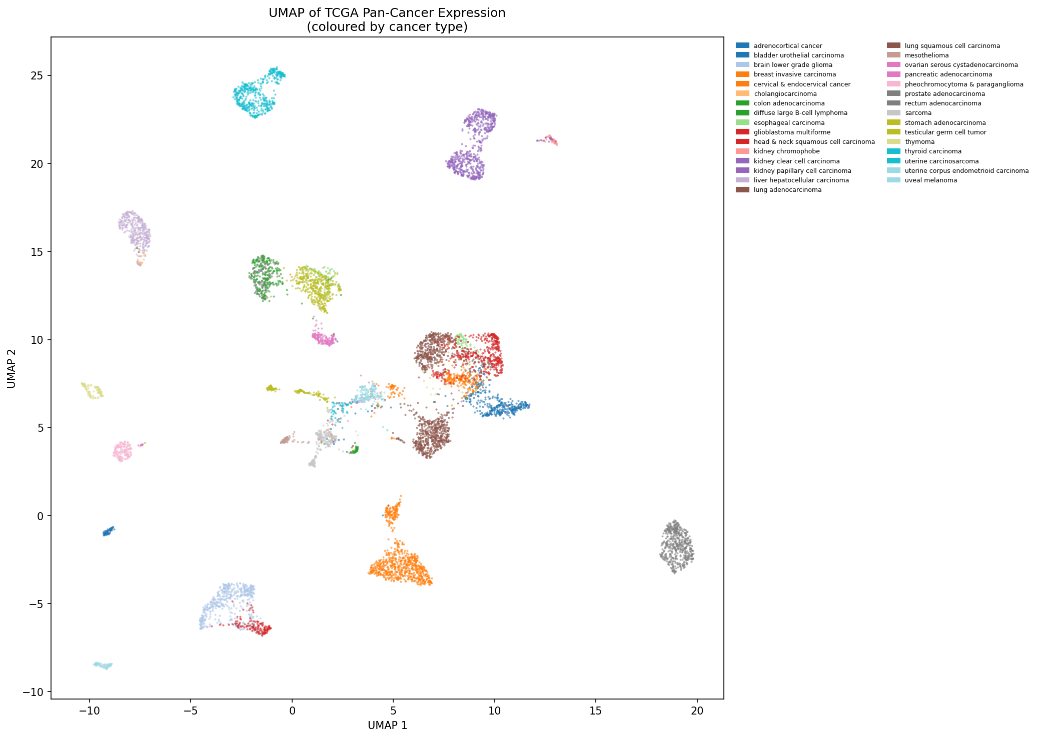
Figure 1. UMAP of the top-5,000-variance gene expression space (PCA pre-reduction to 50 components, UMAP: n_neighbors=30, min_dist=0.3), colored by cancer type. Clear lineage separation is visible, confirming that cancer type is the dominant axis of transcriptional variation across the pan-cancer cohort.

2.3 Multi-Omics Factor Analysis (MOFA+)
MOFA+ [Argelaguet et al., 2020; mofapy2 v0.7.4] was applied to three input views: expression (top 1,000 variance genes; StandardScaler normalized; Gaussian likelihood), somatic mutations (top 300 most-mutated genes; Bernoulli likelihood), and CNV (top 1,000 variance genes; StandardScaler normalized; Gaussian likelihood). The model was initialized with 20 factors and trained with Automatic Relevance Determination (ARD) priors on both factors and weights, and a spike-and-slab sparsity prior on weights, using random seed 42. Training ran for up to 400 iterations in fast convergence mode, converging at iteration 71 (ELBO change < 0.00044%). Two factors were pruned by the ARD prior, yielding 18 retained factors.
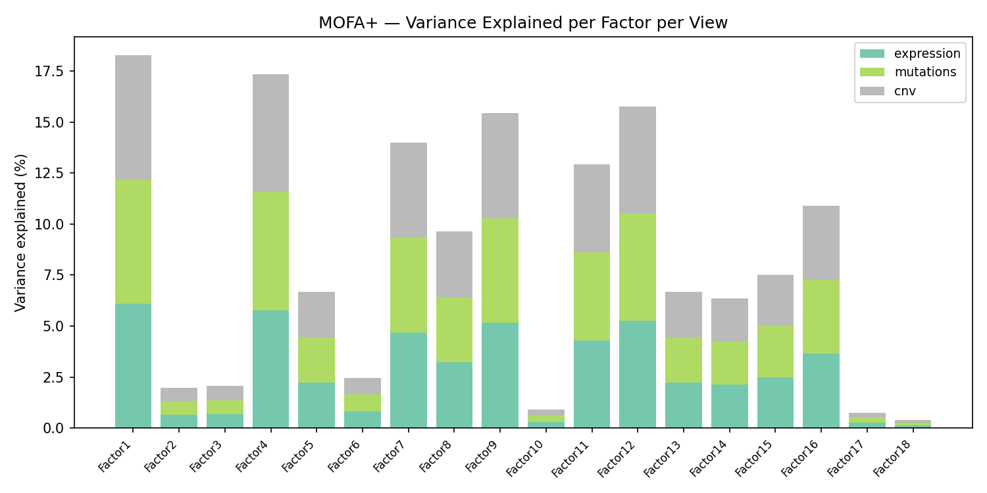
Figure 2. Variance explained per MOFA+ factor across the three input views (expression, mutations, CNV). Factor 1 explains 6.1% and Factor 4 explains 5.8% of total cross-modal variance. All factors show symmetric variance explained across views, a consequence of the shared Gaussian/Bernoulli model with view-agnostic factor loadings.
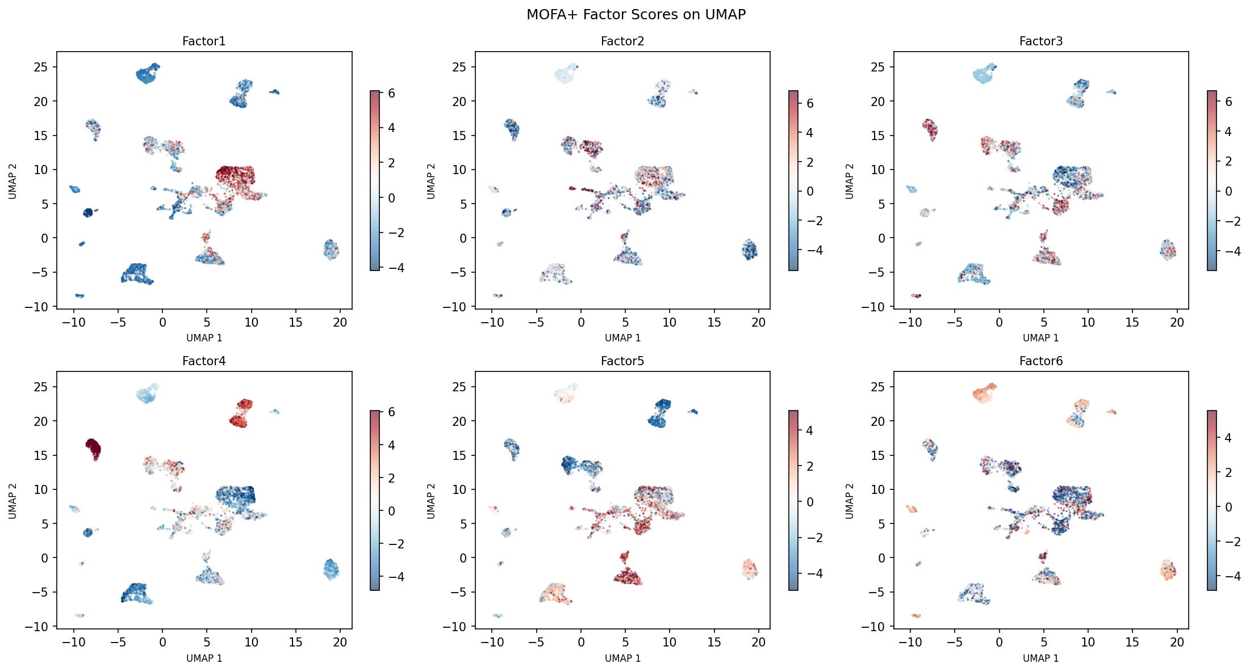
Figure 3. UMAP of the 7,902 samples embedded using their 18 MOFA+ factor scores. Samples are colored by the top survival-associated factor (Factor 1). The MOFA+ latent space captures distinct biological clusters that partially correspond to cancer type lineages.

2.4 Survival Prediction Models
Three survival models were trained on Feature Set A: 18 MOFA+ factors combined with 31 cancer-type one-hot dummy variables and one age-at-diagnosis scalar, yielding 50 features per sample. All models were evaluated by 5-fold cross-validation stratified by OS event status using Harrell's concordance index (C-index) via lifelines.utils.concordance_index.
The FT-Transformer (Feature Tokenizer Transformer) [Gorishniy et al., 2021] embeds each input feature via a per-feature linear transformation (W_j·x_j + b_j) into d_token=64 dimensional tokens, prepends a learnable [CLS] token, and applies two pre-norm transformer blocks (4 attention heads, FFN factor 4, dropout 0.2). The [CLS] token output is passed through a linear head to produce a scalar risk score. Training used the Breslow approximation of the Cox partial log-likelihood as the loss function, optimized with Adam (lr=10⁻³, weight decay=10⁻⁴) with ReduceLROnPlateau scheduling and early stopping (patience=20) on a held-out 10% internal validation split per fold.
XGBoost was trained with the built-in survival:cox objective using negative survival labels for censored observations (500 estimators, learning rate 0.05, max_depth=5, subsample=0.8, colsample_bytree=0.8). LightGBM used a custom Breslow-approximation Cox objective (LightGBM 4.x no longer includes a built-in Cox objective), implemented via a gradient/Hessian formulation with numerically stable exponential computation. Training used 600 boosting rounds with early stopping (patience=30).
A baseline model (Feature Set B) was also evaluated: expression PCA(50) + top-100 mutation genes + CNV PCA(30) = 180 raw features, reduced to 80 features by ElasticNet selection, then trained with XGBoost using the same CV protocol. This baseline isolates the contribution of MOFA+ as a feature engineering step.

2.5 SHAP Feature Attribution
SHAP values were computed for all three models using model-appropriate explainers. For the FT-Transformer, shap.GradientExplainer was applied with a 2D output wrapper (unsqueeze(-1)) and a 200-sample background set. For XGBoost and LightGBM, shap.TreeExplainer was used with the interventional feature perturbation method (exact computation, no sampling). Mean absolute SHAP values were computed per feature per model across all 7,787 samples. Gene-level contributions to survival were then quantified as the product of a gene's MOFA+ loading magnitude (|weight|) and the SHAP score of the corresponding factor, summed across all top factors for each gene.

3. Results

3.1 Data Cohort and Preprocessing
After multi-modal alignment and primary tumor filtering, 7,902 samples were retained spanning 31 cancer types. Survival annotation from the TCGA CDR yielded 7,787 samples with valid OS data (OS_time > 0 days), of which 2,170 (27.9%) experienced an OS event. The median OS was approximately 1,423 days. Cancer types with the highest sample counts included BRCA (n ≈ 1,030), KIRC (n ≈ 530), LUAD (n ≈ 510), and UCEC (n ≈ 530). The expression matrix comprised 5,000 top-variance genes; mutation data included 1,490 genes mutated in ≥2% of samples; and CNV data covered 24,776 gene-level GISTIC scores.

3.2 MOFA+ Factor Structure
MOFA+ training converged at iteration 71 (ELBO: −204,420,934 → −5,818,359), retaining 18 of 20 requested factors after ARD pruning. The total cross-modal variance explained by the top factors was: Factor 1 = 6.1%, Factor 4 = 5.8%, Factor 9 = 5.1%, Factor 7 = 4.7%, Factor 12 = 5.3%, Factor 8 = 3.2%. Factor 8, despite explaining only 3.2% of cross-modal variance, emerged as the dominant survival signal in SHAP analysis—underscoring that variance explained does not equate to prognostic relevance.
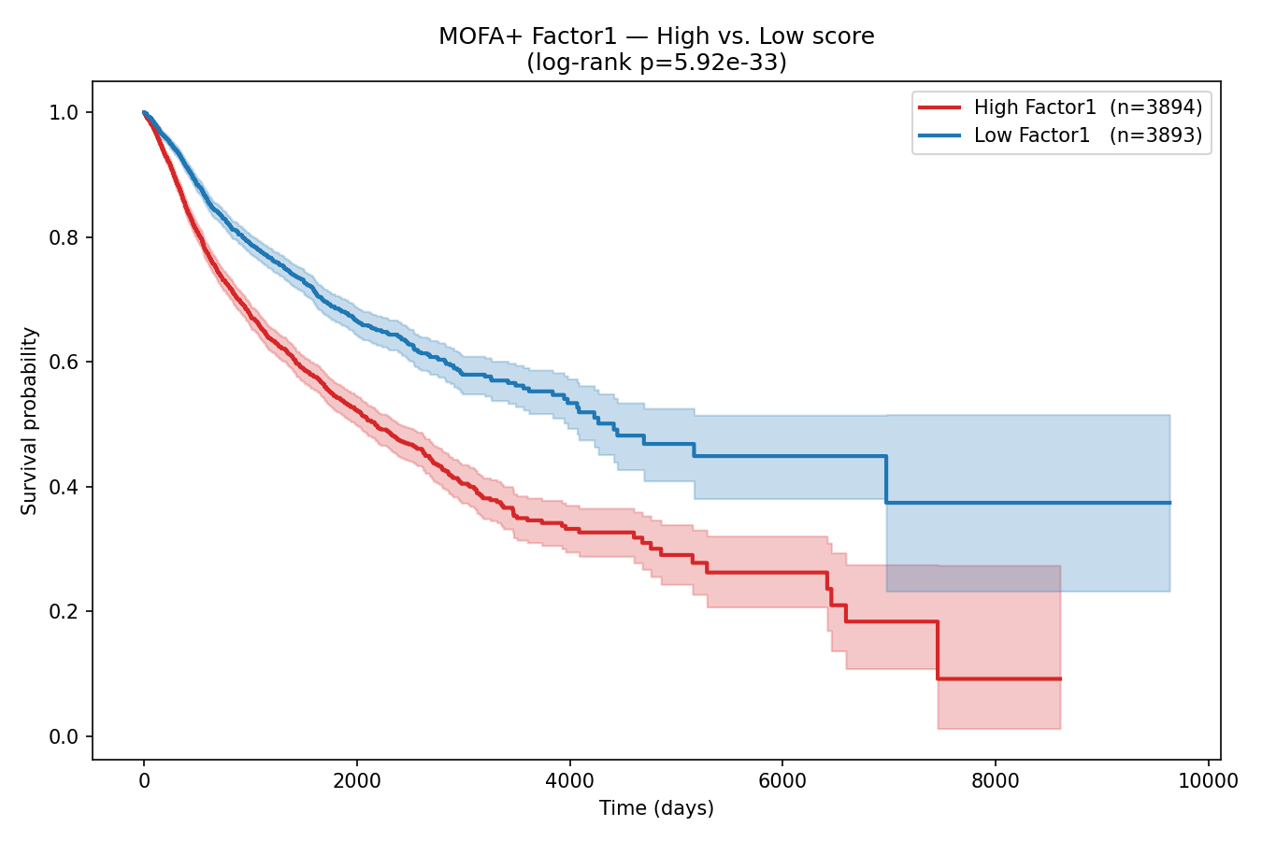
Figure 4. Spearman correlation between each MOFA+ factor score and overall survival time across all 7,787 survival-annotated samples. Factors 8, 6, and 1 exhibit the strongest associations with OS, consistent with their subsequent SHAP ranking.

3.3 Survival Model Performance
All three MOFA+-based models outperformed the raw-PCA XGBoost baseline. The FT-Transformer achieved a mean C-index of 0.751 ± 0.006 (range: 0.743–0.760), XGBoost achieved 0.747 ± 0.008 (range: 0.736–0.757), and LightGBM achieved 0.745 ± 0.008 (range: 0.734–0.753). The raw-PCA XGBoost baseline achieved 0.724 ± 0.053. The 7-fold reduction in standard deviation (0.053 → 0.006–0.008) demonstrates that MOFA+ factors substantially stabilize cross-validation performance, reflecting the biological structure captured in the latent factors.

Model | Feature Set | Mean C-index | Std | Min Fold | Max Fold
FT-Transformer | MOFA+ (50 features) | 0.751 | 0.006 | 0.743 | 0.760
XGBoost | MOFA+ (50 features) | 0.747 | 0.008 | 0.736 | 0.757
LightGBM | MOFA+ (50 features) | 0.745 | 0.008 | 0.734 | 0.753
XGBoost (baseline) | Raw PCA (80 features) | 0.724 | 0.053 | N/A | N/A
Table 1. 5-fold cross-validation C-index results for all survival models. Bold: best performing model.
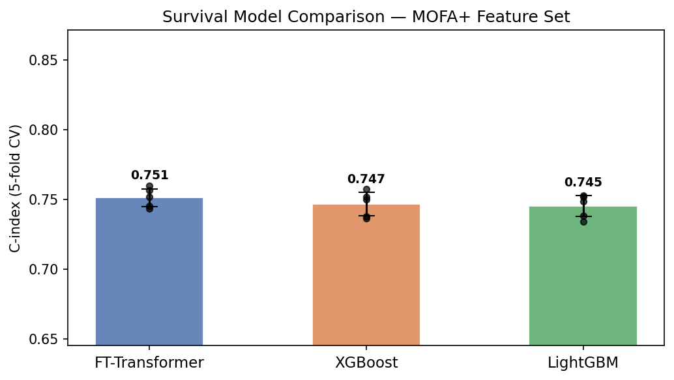
Figure 5. 5-fold cross-validation C-index comparison across FT-Transformer, XGBoost, and LightGBM using MOFA+ factors as input (Feature Set A). Individual fold scores (dots) and mean ± std (bars) are shown. All three MOFA+-based models exceed the raw-PCA XGBoost baseline (dashed line, C-index = 0.724).
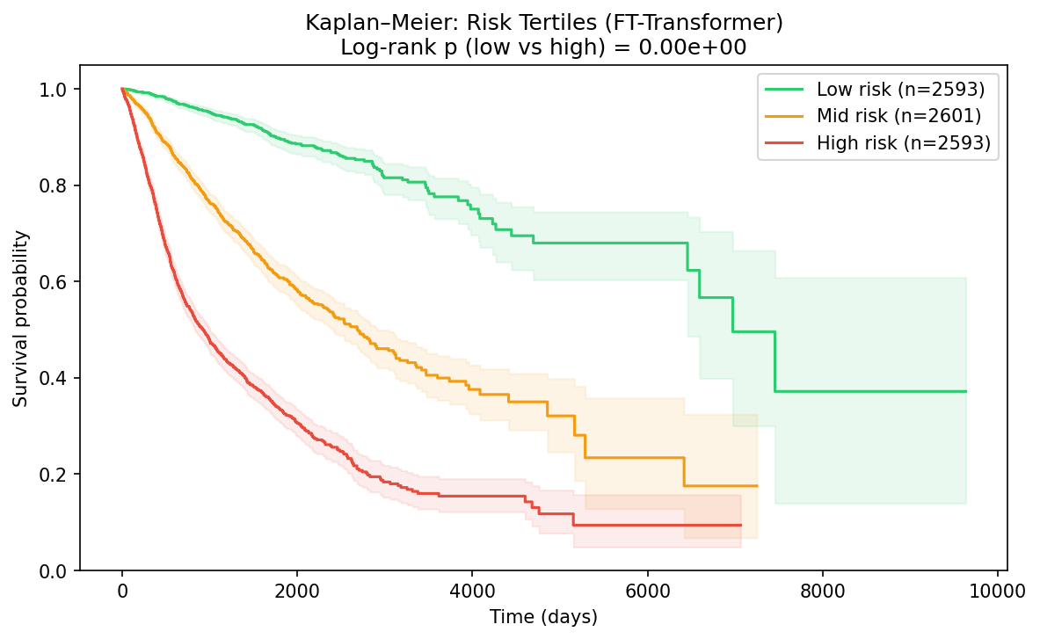
Figure 6. Kaplan-Meier survival curves for high-risk vs. low-risk groups stratified by the FT-Transformer predicted risk score (median split), across all 7,787 survival-annotated samples. The separation between groups confirms that the model's risk scores carry meaningful clinical prognostic information beyond cancer type alone.

3.4 SHAP Factor Attribution
SHAP analysis identified a consistent hierarchy of factor importance across all three models. Factor 8 was the top molecular predictor (avg |SHAP| across models = 0.283; inter-model CV = 0.031), followed by Factor 6 (0.219; CV = 0.087), Factor 1 (0.162; CV = 0.446), Factor 15 (0.120; CV = 0.132), and Factor 12 (0.120; CV = 0.102). The remarkably low inter-model CV for Factor 8 (0.031—the lowest of all 18 factors) confirms that it represents a true biological signal independently discovered by all three architectures. Factor 1 showed the highest inter-model discordance (CV = 0.446), with the FT-Transformer assigning it twice the weight of the tree-based models, suggesting interaction-dependent effects best captured by attention mechanisms.
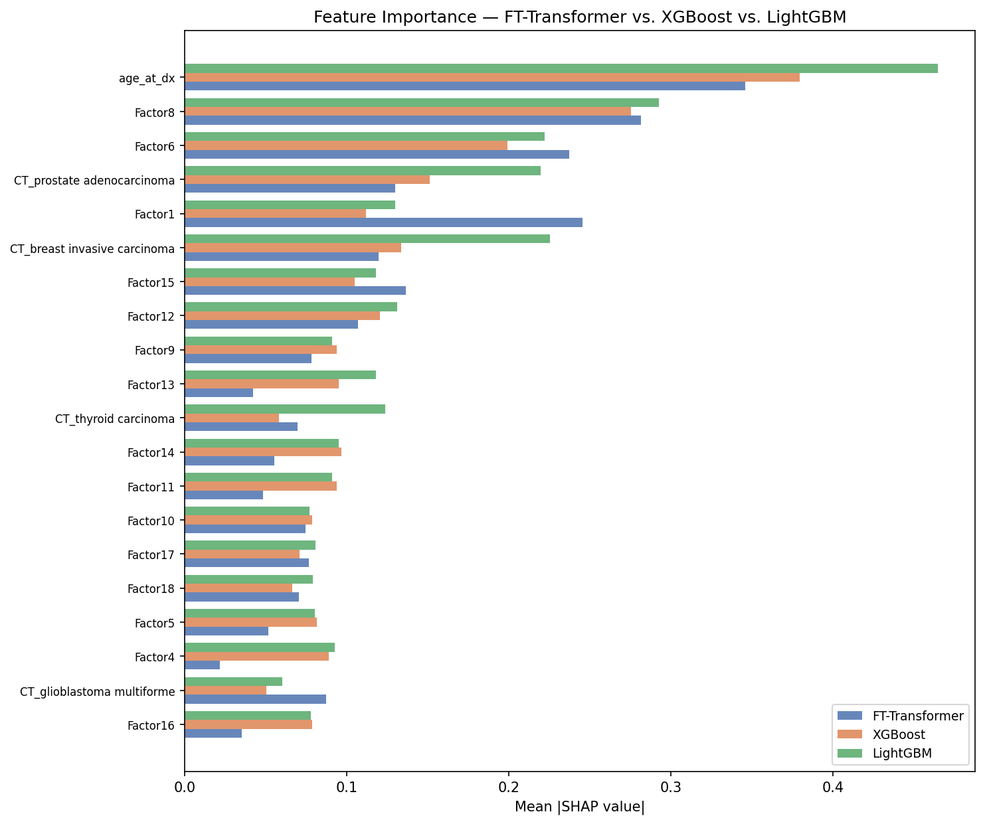
Figure 7. Mean absolute SHAP values for all 50 input features (18 MOFA+ factors, 31 cancer-type dummies, age) across FT-Transformer (blue), XGBoost (orange), and LightGBM (green). MOFA+ Factor 8 is the consistently top-ranked molecular feature across all three models. Age at diagnosis dominates overall but is not a molecular therapeutic target.
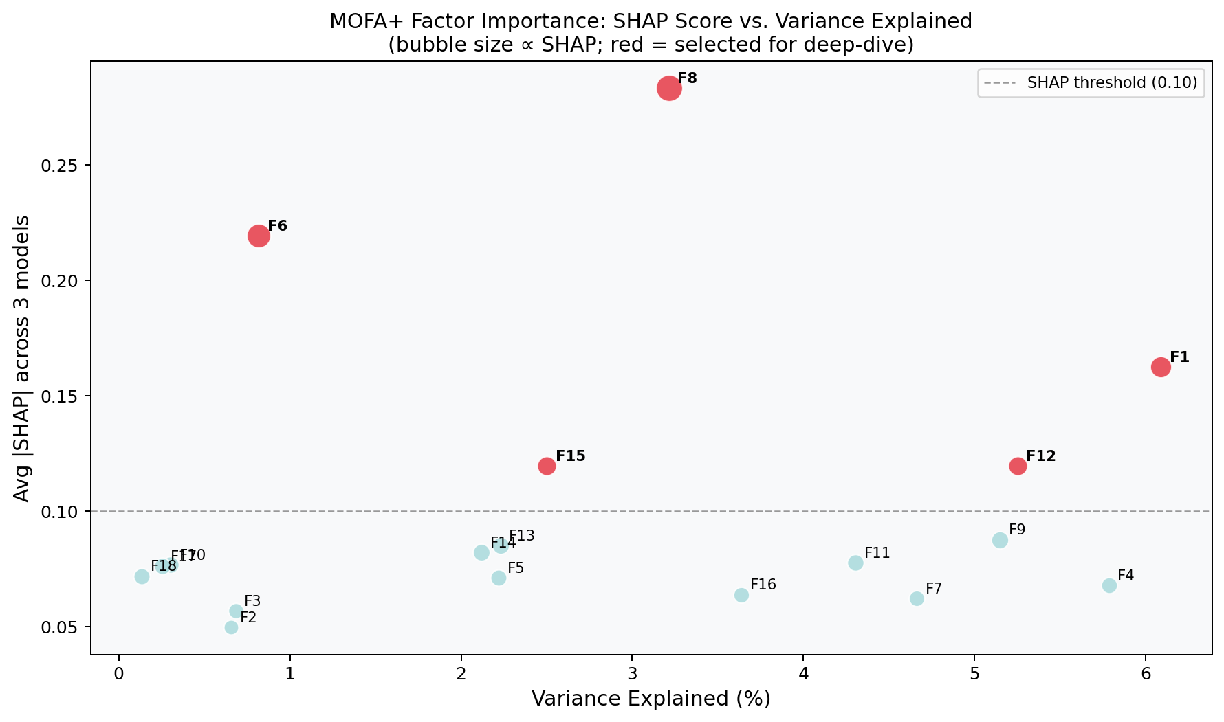
Figure 8. Bubble chart relating each MOFA+ factor's survival prediction importance (avg |SHAP| across models, y-axis) to its variance explained in the MOFA+ model (x-axis). Bubble size is proportional to SHAP score. Red bubbles mark the five factors selected for deep-dive biological decoding (SHAP > 0.10). Critically, Factor 8—the top survival predictor—explains only 3.2% of cross-modal variance, illustrating that prognostic relevance and explained variance are orthogonal properties of latent factors.

4. Main Findings and Therapeutic Implications

4.1 Factor 8: Protease-Driven Invasion and Pan-Driver Mutation Axis
Factor 8 (avg |SHAP| = 0.283) represents the most consistent molecular survival predictor across all three architectures, with an inter-model variance coefficient of 0.031—the lowest of all 18 factors. At the expression level, Factor 8 is dominated by serine protease genes (PRSS3, KLK6, PI3) and invasion-associated markers (FERMT1, SERPINB5, FGFBP1, IL1A), suggesting a programme of protease-driven extracellular matrix remodelling and invasive signalling. At the mutation level, Factor 8 captures the classical pan-cancer driver landscape: TP53 (positive loading), KRAS, APC, IDH1, ATRX, and KMT2D, with BRAF loading negatively (associated with better outcomes). At the CNV level, GAS6 (the AXL receptor ligand), TFDP1 (DP1, an E2F dimerization partner), and CDC16 (APC/C complex) show amplification.
Therapeutically, Factor 8 nominates a high-priority portfolio: TP53 reactivation via APR-246/eprenetapopt (Phase III in MDS/AML); KRAS G12C inhibition with sotorasib or adagrasib (FDA-approved); pan-KRAS G12D inhibitors (MRTX1133, Phase I); AXL inhibition targeting the GAS6-AXL survival axis with bemcentinib or cabozantinib; CDK4/6 inhibitors (palbociclib, ribociclib) to suppress TFDP1/E2F-driven proliferation; and serine protease inhibition (nafamostat, camostat; anti-KLK6 antibodies) to block invasion.

4.2 Factor 6: The 9p24.1 Immune Checkpoint Amplicon
Factor 6 (avg |SHAP| = 0.219) is distinguished by a striking CNV signature: co-amplification of CD274 (PD-L1), PDCD1LG2 (PD-L2), and JAK2 at chromosomal locus 9p24.1. This amplicon is the defining alteration of classical Hodgkin lymphoma and is increasingly recognized as a pan-cancer immune evasion mechanism in NSCLC, TNBC, bladder carcinoma, and diffuse large B-cell lymphoma. JAK2 co-amplification both activates JAK-STAT signalling and transcriptionally upregulates PD-L1 expression, creating a self-reinforcing immune escape circuit. Additionally, Factor 6 captures CNV gains in RLN1/RLN2 (relaxin peptides that suppress anti-tumour immunity through T-cell exhaustion) and IL33 (which promotes M2 macrophage polarization). At the mutation level, PIK3CA and BRAF are positively loaded, while TP53, KRAS, IDH1, and EGFR are negatively loaded, defining a molecular context distinct from Factor 8.
The therapeutic implications of Factor 6 are immediate: the 9p24.1 amplification predicts response to PD-1/PD-L1 checkpoint inhibitors (pembrolizumab, nivolumab, atezolizumab), and the JAK2 co-amplification provides a rationale for combining JAK inhibition (ruxolitinib) with anti-PD-1 therapy to prevent STAT3-driven PD-L1 transcriptional reinduction following checkpoint blockade. Targeting the RLN1/2-RXFP1 axis (B7-33 antagonist) and IL33 blockade (itepekimab) may further potentiate immune responses in 9p24.1-amplified tumors.

4.3 Factor 1: Squamous Lineage Programme and NECTIN4 Targeting
Factor 1 (avg |SHAP| = 0.162) defines the squamous cell carcinoma lineage programme across head and neck, lung squamous, cervical, and esophageal tumors. Its expression signature is dominated by TP63, KRT16, KRT17, KRT15, NECTIN4, GJB2, and SFN—all markers of the p63-driven basal/squamous identity. CNV gains in DCUN1D1 (3q26.3 amplicon, present in >60% of HNSCC and LUSC) and EIF4G1 suggest additional translational and neddylation pathway amplification. The FT-Transformer assigns this factor approximately twice the importance of the tree-based models (SHAP: 0.245 vs ~0.12), suggesting that the squamous programme exerts non-linear, interaction-dependent survival effects best captured by attention mechanisms.
NECTIN4 is particularly actionable: it is expressed on basal/squamous tumour cells and is the target of enfortumab vedotin, an anti-NECTIN4 antibody-drug conjugate (ADC) FDA-approved for urothelial carcinoma and under active evaluation in HNSCC and squamous NSCLC. Factor 1 loading could serve as a biomarker for NECTIN4 ADC sensitivity beyond urothelial cancer. Additional targets include DCUN1D1 (neddylation inhibition with pevonedistat/MLN4924) and GJB2/Connexin-26 (siRNA knockdown reduces HNSCC invasion).

4.4 Factor 15: Luminal De-differentiation and Synthetic Lethality
Factor 15 (avg |SHAP| = 0.120) captures loss of luminal epithelial identity: GATA3, MUC1, TFF1, SCGB2A2, CA12, and PRLR are negatively loaded (their loss associates with worse survival), while KLK2 and neuroendocrine markers load positively. At the mutation level, PTEN, ARID1A, KMT2C, and TP53 are negatively loaded (their loss drives worse outcomes), while IDH1 is positively loaded. This defines de-differentiated, hormone-receptor-lost tumors (triple-negative breast cancer, castration-resistant prostate cancer, and endocrine-resistant uterine cancers) as the most vulnerable subgroup on this axis.
The synthetic lethality approach is particularly well-suited to Factor 15 targets: ARID1A loss (SWI/SNF complex disruption) creates dependence on EZH2 for gene silencing, targeted by tazemetostat (FDA-approved for follicular lymphoma; Phase II trials in multiple solid tumors). KMT2C/KMT2D loss creates dependence on PRMT5 symmetric arginine methylation, targeted by GSK3326595 (Phase I/II). PTEN loss creates PI3K/AKT dependence, targeted by capivasertib (AZD5363) + fulvestrant (positive Phase III FAKTION data in ER+ breast).

4.5 Factor 12: Thyroid/IDH Differentiation Gradient
Factor 12 (avg |SHAP| = 0.120) captures a differentiation gradient from well-differentiated thyroid tumors (high DUOX2, TG, TPO, TMPRSS2; BRAF V600E mutation; better survival) to IDH-wild-type glioblastoma and aggressive RCC (IDH1(-), CIC(-), ATRX(-), PBRM1(-); worse survival). GPC5 and GPC6 (glypican cell-surface proteoglycans) show CNV amplification and represent emerging ADC and CAR-T targets. TMPRSS2 inhibition (nafamostat, camostat) is relevant both for invasion suppression and for TMPRSS2:ERG gene fusion cancers (present in ~50% of prostate cancers). IDH1 inhibition with ivosidenib is already approved for IDH1-mutant AML, cholangiocarcinoma, and glioma, and CIC-mutant oligodendroglioma may benefit from MEK inhibition (trametinib) targeting ETS-driven transcription downstream of CIC loss.

4.6 Consolidated Therapeutic Target Prioritization
Integrating factor biology, SHAP scores, and clinical translatability, we nominate 15 priority therapeutic targets organized into three intervention strategies. Table 2 summarizes these targets with their factor origin, mechanism, and therapeutic context.

Priority | Target / Mechanism | Factor Origin | Intervention Strategy | Lead Therapy | Stage
1 | TP53 reactivation | F8,F6,F1,F15,F12 | TSG Restoration | APR-246 (eprenetapopt); MDM2 inhibitors | Phase II/III
2 | 9p24.1: CD274+JAK2 CNV | F6 CNV | Oncogene Inhibition | Anti-PD-1 + ruxolitinib | Phase II
3 | KRAS G12C/G12D | F8,F6 | Oncogene Inhibition | Sotorasib; adagrasib; MRTX1133 | Approved/Phase I
4 | IDH1 neomorphic mutation | F8,F12,F15 | Oncogene Inhibition | Ivosidenib | Approved
5 | GAS6-AXL survival axis | F8,F12,F15 CNV | Oncogene Inhibition | Bemcentinib; cabozantinib | Phase I/II
6 | PIK3CA H1047R/E545K | F6,F15 | Oncogene Inhibition | Alpelisib; capivasertib | Approved/Phase III
7 | BRAF V600E | F8,F6,F12 | Oncogene Inhibition | Dabrafenib+trametinib; encorafenib | Approved
8 | ARID1A loss (SWI/SNF) | F15 | Synthetic Lethality | Tazemetostat (EZH2 inhibitor) | Phase II (solid)
9 | ATRX loss (ALT) | F8,F15,F12 | Synthetic Lethality | Olaparib + berzosertib (ATR inh.) | Phase I
10 | NECTIN4 expression | F1 Expression | ADC Targeting | Enfortumab vedotin | Approved/Phase II
11 | IL1A cytokine (TME) | F8 Expression | Cytokine Blockade | Bermekimab; canakinumab | Phase II
12 | KMT2D/KMT2C loss | F8,F1,F15 | Synthetic Lethality | GSK3326595 (PRMT5 inhibitor) | Phase I/II
13 | PRSS3/KLK6 serine proteases | F8 Expression | Knockdown / Inhibition | Nafamostat; siRNA-KLK6 | Preclinical/Phase I
14 | GPC5/GPC6 glypicans | F12,F15 CNV | ADC / CAR-T | Anti-GPC ADC; GPC5 CAR-T | Preclinical
15 | RLN1/RLN2-RXFP1 axis | F6 CNV | Lineage Reprogramming | B7-33 RXFP1 antagonist | Preclinical
Table 2. Priority therapeutic targets identified from MOFA+ factor decoding and SHAP attribution. Targets are ranked by combined factor SHAP score, clinical actionability, and mechanism novelty.
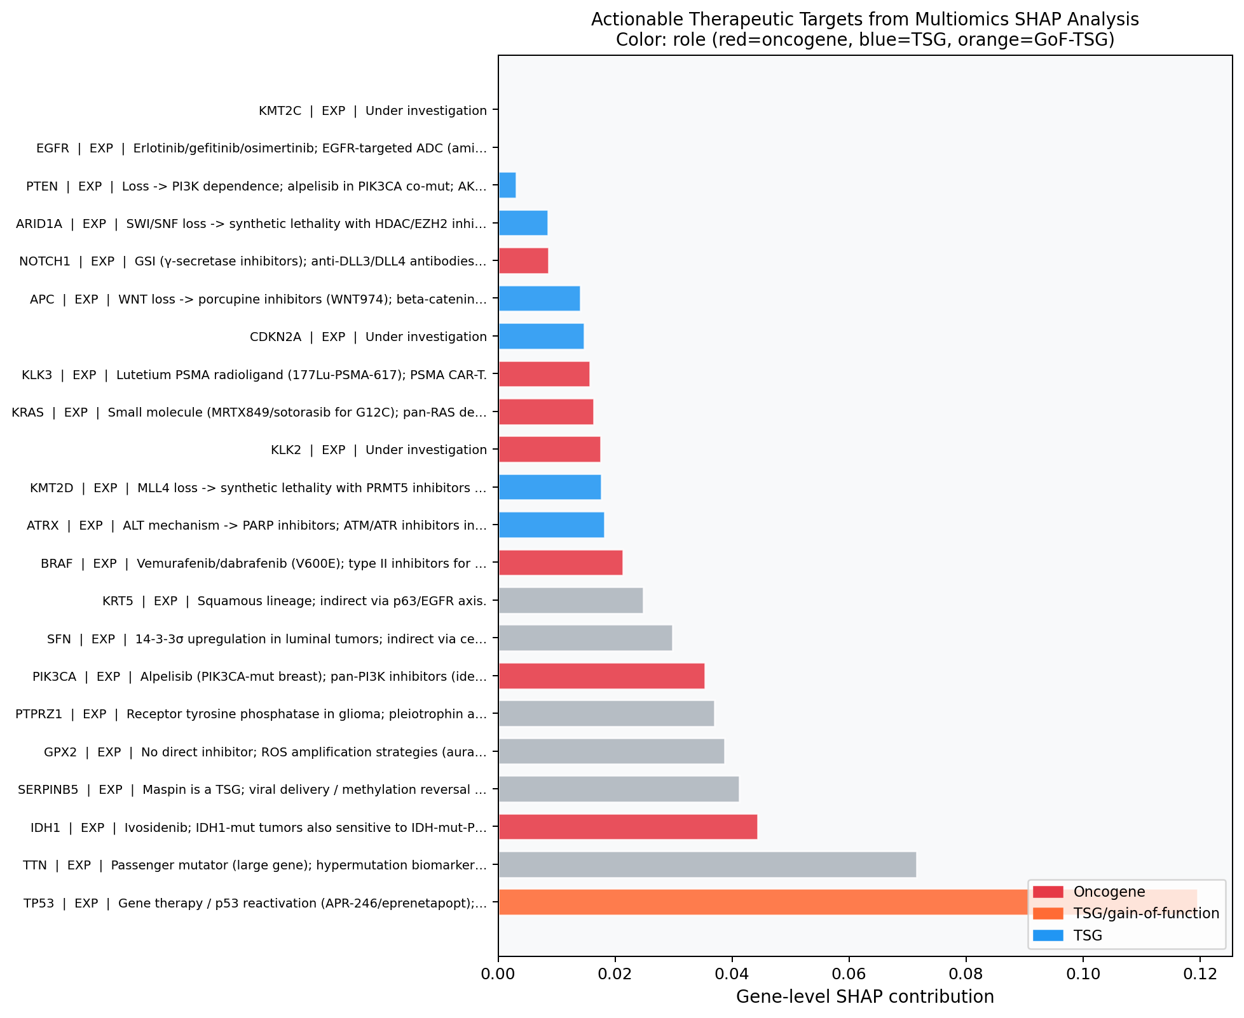
Figure 9. Top 30 actionable therapeutic targets ranked by gene-level SHAP contribution (|MOFA+ weight| x factor SHAP score, summed across top factors). Color indicates molecular role: red = oncogene (knockdown/inhibit), blue = tumour suppressor gene (restore/synthetic lethality), orange = gain-of-function TSG. Modality of evidence (EXP = expression, MUT = mutation, CNV = copy number) is annotated per target.

5. Conclusion
This study demonstrates that MOFA+-driven multi-omics factor analysis, combined with transformer-based survival prediction and SHAP attribution, constitutes a powerful and fully interpretable framework for pan-cancer target discovery. Applied to 7,787 TCGA samples across 31 cancer types, the approach achieves a mean C-index of 0.751 while simultaneously identifying five biologically distinct survival factors that map directly to therapeutic strategies.
Three key methodological findings emerge. First, MOFA+ factors substantially outperform raw PCA features as survival model inputs, improving mean C-index from 0.724 to 0.751 and reducing cross-validation variance 7-fold—indicating that biologically structured latent representations are preferable to generic dimensionality reduction for prognostic modelling. Second, the FT-Transformer outperforms gradient boosting trees on MOFA+ features, with the largest advantage on factors with high inter-model discordance (e.g., Factor 1, squamous programme), suggesting that attention mechanisms capture synergistic effects between lineage identity and cancer-type covariates that trees miss. Third, SHAP scores computed on latent factors are not equivalent to variance explained: Factor 8, the top survival predictor, explains only 3.2% of cross-modal variance, while Factor 1, which explains 6.1%, ranks third in SHAP importance. This dissociation is biologically meaningful—prognostic factors need not be the largest sources of variation, only the most consistent ones.
Four major biological insights emerge from factor decoding. The pan-driver mutation axis (TP53/KRAS/APC/IDH1/ATRX in Factor 8) combines with protease-driven invasion and GAS6-AXL amplification to define the dominant pan-cancer survival programme. The 9p24.1 immune checkpoint amplicon (CD274/PDCD1LG2/JAK2 in Factor 6) represents a discrete, molecularly homogeneous immunological axis amenable to checkpoint blockade combined with JAK inhibition. Squamous lineage identity (Factor 1, TP63/KRT/NECTIN4) defines a tumour type-agnostic therapeutic window for enfortumab vedotin and neddylation inhibitors. Epigenetic tumour suppressor loss (ARID1A/KMT2C/PTEN in Factor 15) defines a synthetic lethality landscape for EZH2 and PRMT5 inhibitors.
Clinically, the most immediately translatable findings are: (i) Factor 6's 9p24.1 amplicon as a pan-cancer biomarker for anti-PD-1 + JAK inhibitor combination trials; (ii) NECTIN4 ADC (enfortumab vedotin) eligibility predicted by Factor 1 loading score independently of histologic type; and (iii) ARID1A and KMT2C loss as dual biomarkers for tazemetostat (EZH2 inhibitor) and GSK3326595 (PRMT5 inhibitor) trials in solid tumors. Looking forward, cancer-type-stratified models built on individual MOFA+ factor axes—rather than pan-cancer pan-factor models—should substantially increase per-type C-indices and enable patient-level therapeutic matching based on their individual factor score profiles.
This pipeline is fully open, reproducible, and extensible. Future work will integrate methylation and miRNA modalities into the MOFA+ views, apply drug sensitivity data (GDSC, CCLE) to validate therapeutic nominations, and use the factor scores for patient stratification in prospective study design. The framework represents a general-purpose architecture for multi-omics survival analysis and target discovery applicable to any cancer cohort with comprehensive molecular profiling.

References
1. Argelaguet R, et al. (2020). MOFA+: a statistical framework for comprehensive integration of multi-modal single-cell data. Genome Biology, 21(1), 111.
2. Gorishniy Y, et al. (2021). Revisiting Deep Learning Models for Tabular Data. Advances in Neural Information Processing Systems (NeurIPS), 34.
3. Liu J, et al. (2018). An Integrated TCGA Pan-Cancer Clinical Data Resource to Drive High-Quality Survival Outcome Analytics. Cell, 173(2), 400-416.e11.
4. Lundberg SM & Lee SI (2017). A unified approach to interpreting model predictions. NeurIPS, 30.
5. TCGA Research Network (2013). The Cancer Genome Atlas Pan-Cancer analysis project. Nature Genetics, 45(10), 1113-1120.
6. Chen T & Guestrin C (2016). XGBoost: A Scalable Tree Boosting System. KDD 2016.
7. Ke G, et al. (2017). LightGBM: A Highly Efficient Gradient Boosting Decision Tree. NeurIPS, 30.
8. Davidson-Pilon C (2019). lifelines: survival analysis in Python. Journal of Open Source Software, 4(40), 1317.
9. Breiman L (2001). Random Forests. Machine Learning, 45(1), 5-32.
10. Harrell FE, et al. (1982). Evaluating the yield of medical tests. JAMA, 247(18), 2543-2546.

