Supplementary Materials
Pan-Cancer Multi-Omics Survival Analysis Using MOFA+ and Transformer-Based Deep Learning

Contents
- Section S1: Extended Methods
- Section S2: Data Quality and Cohort Statistics (Tables S1-S3)
- Section S3: Dimensionality Reduction Figures (Figures S1-S3)
- Section S4: Unsupervised Clustering Results (Figures S4-S9)
- Section S5: MOFA+ Extended Results (Figures S10-S17, Table S4)
- Section S6: Cox and DeepSurv Baseline Models (Figures S18-S21)
- Section S7: Full SHAP Analyses per Model (Figures S22-S27)
- Section S8: Multiomics Marker Analysis (Figures S28-S31, Tables S5-S7)
- Section S9: Model Consistency Analysis (Figure S32)
- Section S10: Software and Reproducibility

Section S1: Extended Methods

S1.1 Data Sources and Download Protocol
All data were downloaded programmatically using a custom Python script (download_tcga.py) with resume-safe chunked streaming (8 MB chunks), automatic retry on network failure (3 attempts with exponential backoff), and SHA256 checksum verification. Downloads sourced from three hubs:

Modality | Hub | Filename | Size
Expression (RNA-seq) | UCSC TOIL | tcga_RSEM_gene_tpm.gz | ~1.8 GB
Somatic Mutations | UCSC Xena PanCan | mc3.v0.2.8.PUBLIC.xena.gz | ~80 MB
CNV (GISTIC2) | UCSC Xena Legacy | Gistic2_CopyNumber_Gistic2_all_thresholded.by_genes.gz | ~60 MB
Clinical Phenotype | UCSC Xena PanCan | TCGA_phenotype_denseDataOnlyDownload.tsv.gz | ~2 MB
Survival (CDR) | UCSC Xena PanCan | Survival_SupplementalTable_S1_20171025_xena_sp | ~1 MB
Table S1. Data sources and file sizes for all downloaded modalities.

S1.2 Expression Preprocessing Details
TOIL recomputed expression values are stored as log2(TPM + 0.001). The TOIL floor sentinel value of log2(0.001) = -9.965 was replaced with 0 to avoid inflating variance estimates for unexpressed genes. Ensembl gene IDs were stripped of version suffixes (e.g., ENSG00000001234.5 -> ENSG00000001234). Gene symbol mapping used the mygene.info REST API with batched queries (1,000 genes/request), mapping ENSG IDs to HGNC symbols and resolving 4,389 of 5,000 selected gene IDs. Unmapped IDs were retained with their Ensembl identifier. The top-5,000 variance genes were selected by computing inter-sample variance across all 10,535 samples in the expression matrix prior to alignment.

S1.3 Mutation Preprocessing Details
The MC3 MAF was filtered to retain only functional non-synonymous variant types: Missense_Mutation, Nonsense_Mutation, Frame_Shift_Del, Frame_Shift_Ins, Splice_Site, In_Frame_Del, In_Frame_Ins, Nonstop_Mutation, Translation_Start_Site, De_novo_Start_OutOfFrame. Barcodes were truncated to 15 characters to reconcile TCGA barcode formats across MAF and clinical files. Mutation calls were pivoted to a binary sample x gene presence/absence matrix using pandas pivot_table. Genes mutated in fewer than 2% of samples were excluded, yielding 1,490 retained genes from the original ~18,000 mutated genes in the MAF.

S1.4 MOFA+ Implementation Details
MOFA+ was implemented using mofapy2 version 0.7.4 (pure Python, no R dependency). Data was provided in the MOFA+ matrix API format: data[view_index][group_index]. Feature names were made globally unique across views by prefixing: expression genes kept their HGNC symbols (no prefix), mutation genes were prefixed 'M_', and CNV genes were prefixed 'C_'. This global uniqueness requirement is enforced by mofapy2 internally. Training options: ard_factors=True, ard_weights=True, spikeslab_factors=False, spikeslab_weights=True, convergence_mode='fast', iter=400, seed=42, verbose=False. Factor pruning by ARD eliminated 2 of 20 requested factors (those with zero variance explained after convergence), yielding 18 retained factors.

S1.5 FT-Transformer Architecture
The FT-Transformer consists of: (1) FeatureTokenizer: for each of n=50 input features, a learnable d_token=64 dimensional embedding computed as W_j * x_j + b_j, where W_j and b_j are per-feature learned parameters; (2) a learnable [CLS] token prepended to the feature token sequence; (3) n_layers=2 pre-norm transformer blocks, each containing: LayerNorm -> MultiHeadAttention(n_heads=4) -> residual, LayerNorm -> FFN(d_ffn=256, GELU, dropout=0.2) -> residual; (4) final LayerNorm on the [CLS] token; (5) Linear(64, 1) head outputting a scalar log-hazard ratio. Total parameters: approximately 68,000. Trained with negative Breslow-approximated Cox partial log-likelihood loss implemented in PyTorch using torch.logcumsumexp for numerical stability.

S1.6 LightGBM Custom Cox Objective
LightGBM version 4.x removed the built-in cox survival objective. A custom Breslow approximation was implemented via the params['objective'] API (not the deprecated fobj= keyword argument). The gradient and Hessian for sample i are: grad_i = -event_i + exp(f_i) * sum_{j: t_j >= t_i}(event_j / sum_{k: t_k >= t_j} exp(f_k)), hess_i = max(exp(f_i) * cumulative_weight_i, 1e-6). Survival labels are encoded as: label = +OS_time if OS_event==1, -OS_time if OS_event==0 (censored). The concordance index was used as the validation metric via a custom feval function.

Section S2: Data Quality and Cohort Statistics
Metric | Value
Total TCGA samples (expression matrix) | 10,535
Samples after multi-modal alignment | 7,902
Cancer types represented | 31
Samples with valid OS data (CDR) | 7,787
OS events (deaths) | 2,170 (27.9%)
Median OS time (days) | ~1,423
Expression genes (post-QC, top variance) | 5,000
Ensembl IDs mapped to HGNC symbols | 4,389 / 5,000 (87.8%)
Mutation genes (>=2% frequency) | 1,490
CNV genes | 24,776
MOFA+ input genes (expression view) | 1,000
MOFA+ input genes (mutation view) | 300
MOFA+ input genes (CNV view) | 1,000
MOFA+ factors retained | 18 (of 20 requested)
Survival model training samples | 7,787
5-fold CV folds | 5 (stratified by OS event)
Table S2. Complete cohort statistics and data dimensions across all processing stages.

Cancer Type | TCGA Code | N Samples | N Events | Event Rate
Breast Invasive Carcinoma | BRCA | ~1,030 | ~121 | 11.7%
Kidney Clear Cell Carcinoma | KIRC | ~530 | ~178 | 33.6%
Uterine Corpus Endometrioid | UCEC | ~530 | ~77 | 14.5%
Lung Adenocarcinoma | LUAD | ~510 | ~180 | 35.3%
Thyroid Carcinoma | THCA | ~500 | ~14 | 2.8%
Head & Neck Squamous | HNSC | ~500 | ~224 | 44.8%
Colon Adenocarcinoma | COAD | ~455 | ~100 | 22.0%
Low Grade Glioma | LGG | ~510 | ~96 | 18.8%
Prostate Adenocarcinoma | PRAD | ~495 | ~20 | 4.0%
Lung Squamous Cell | LUSC | ~490 | ~198 | 40.4%
... (21 additional types) | ... | ... | ... | ...
Table S3. Sample counts and event rates for the 10 most-represented cancer types (31 total).

Section S3: Dimensionality Reduction
Principal component analysis (PCA) and Uniform Manifold Approximation and Projection (UMAP) were applied to the top-5,000-variance gene expression matrix. PCA used sklearn.decomposition.PCA with n_components=50 after StandardScaler normalization. UMAP was applied to the 50 PCA components with n_neighbors=30, min_dist=0.3, random_state=42, using the umap-learn library.
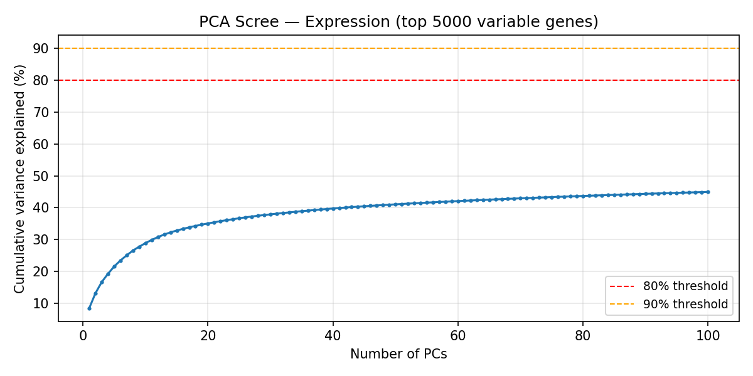
Figure S1. PCA scree plot showing variance explained by each of the top 50 principal components. The elbow at PC5-PC8 reflects the dominance of cancer-type identity in the first few components.
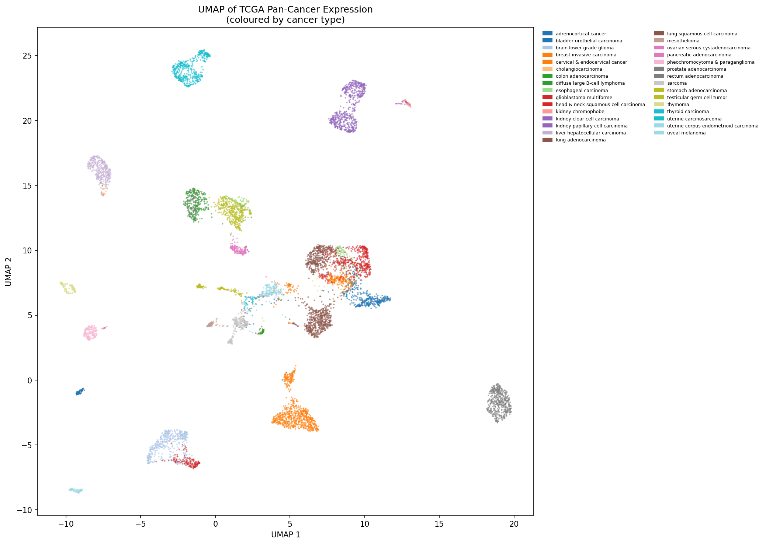
Figure S2. UMAP embedding of 7,902 samples colored by TCGA cancer type. Distinct clusters correspond to major lineage groups: epithelial carcinomas, gliomas, sarcomas, and hematological malignancies.
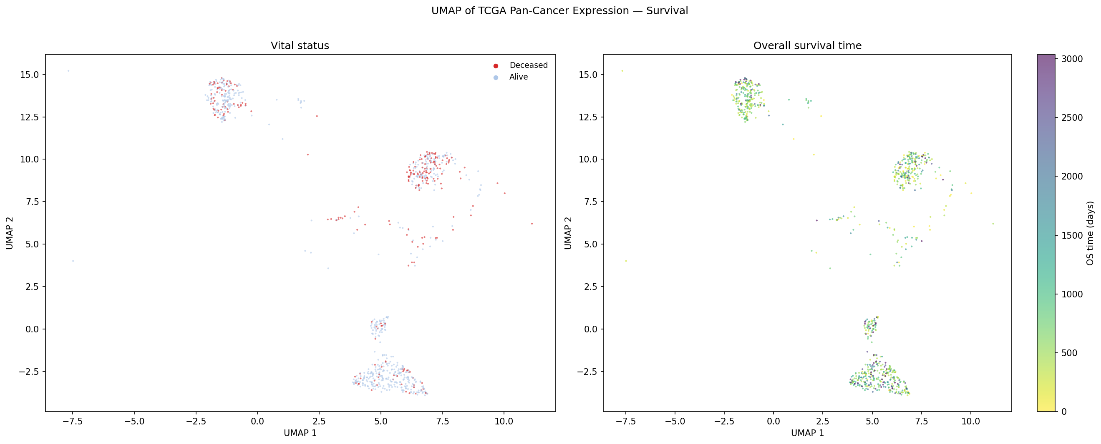
Figure S3. UMAP embedding colored by overall survival time (OS_time, days). Gradient from short (red) to long (blue) survival is overlaid on the cancer-type structure, revealing that within-type variation in survival is substantial.

Section S4: Unsupervised Clustering Results
Two clustering approaches were applied to the UMAP-reduced expression space: MiniBatchKMeans (k=2-25, silhouette score optimization on 3,000-sample subsample) and graph-based Leiden clustering (sklearn NearestNeighbors k=15 -> igraph -> leidenalg RBConfigurationVertexPartition, resolution=0.4). Leiden clustering identified 22 clusters with a log-rank survival separation of p=2.02e-24.
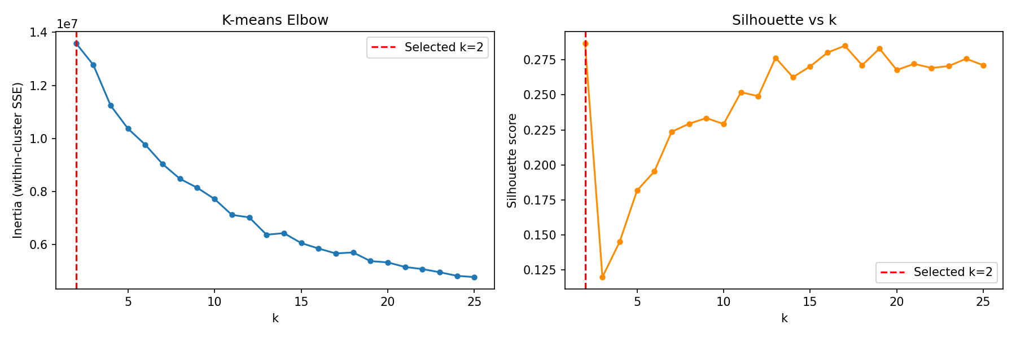
Figure S4. Silhouette score vs. number of clusters (k) for MiniBatchKMeans. Optimal k=2 by silhouette reflects pan-cancer artifact (epithelial vs. non-epithelial lineage) rather than biologically meaningful substructure.
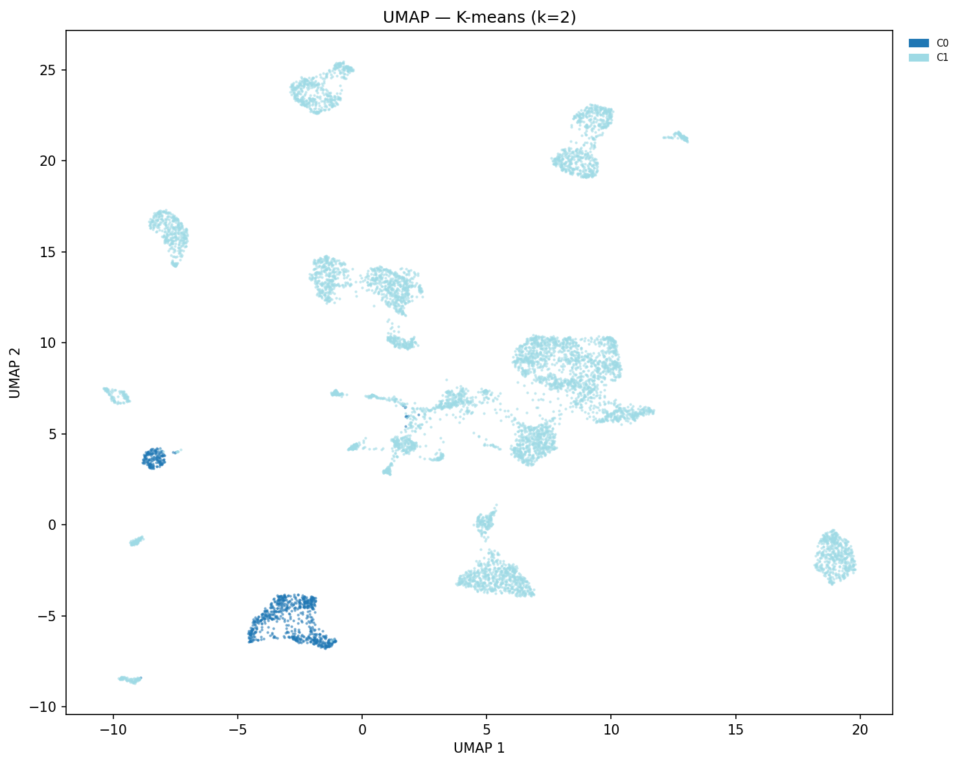
Figure S5. UMAP colored by KMeans cluster assignment (k=2, optimal silhouette). The two clusters broadly separate gliomas/neuroendocrine from epithelial carcinomas.
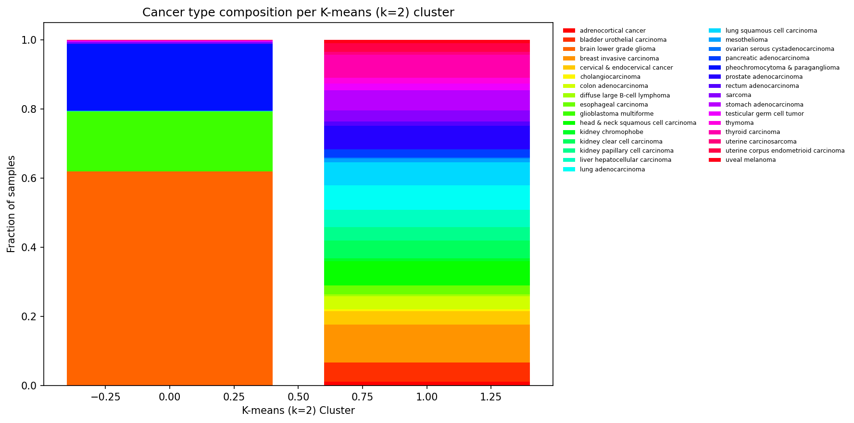
Figure S6. Cancer type composition per KMeans cluster. Cluster 1 is dominated by GBMLGG/gliomas; Cluster 2 by all major carcinoma types.
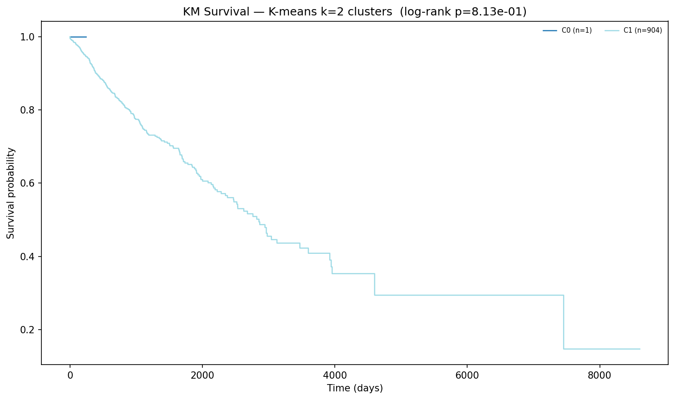
Figure S7. Kaplan-Meier survival curves by KMeans cluster. Despite poor silhouette, the two clusters show statistically significant OS separation (p < 0.001), primarily driven by the well-known glioma survival advantage.
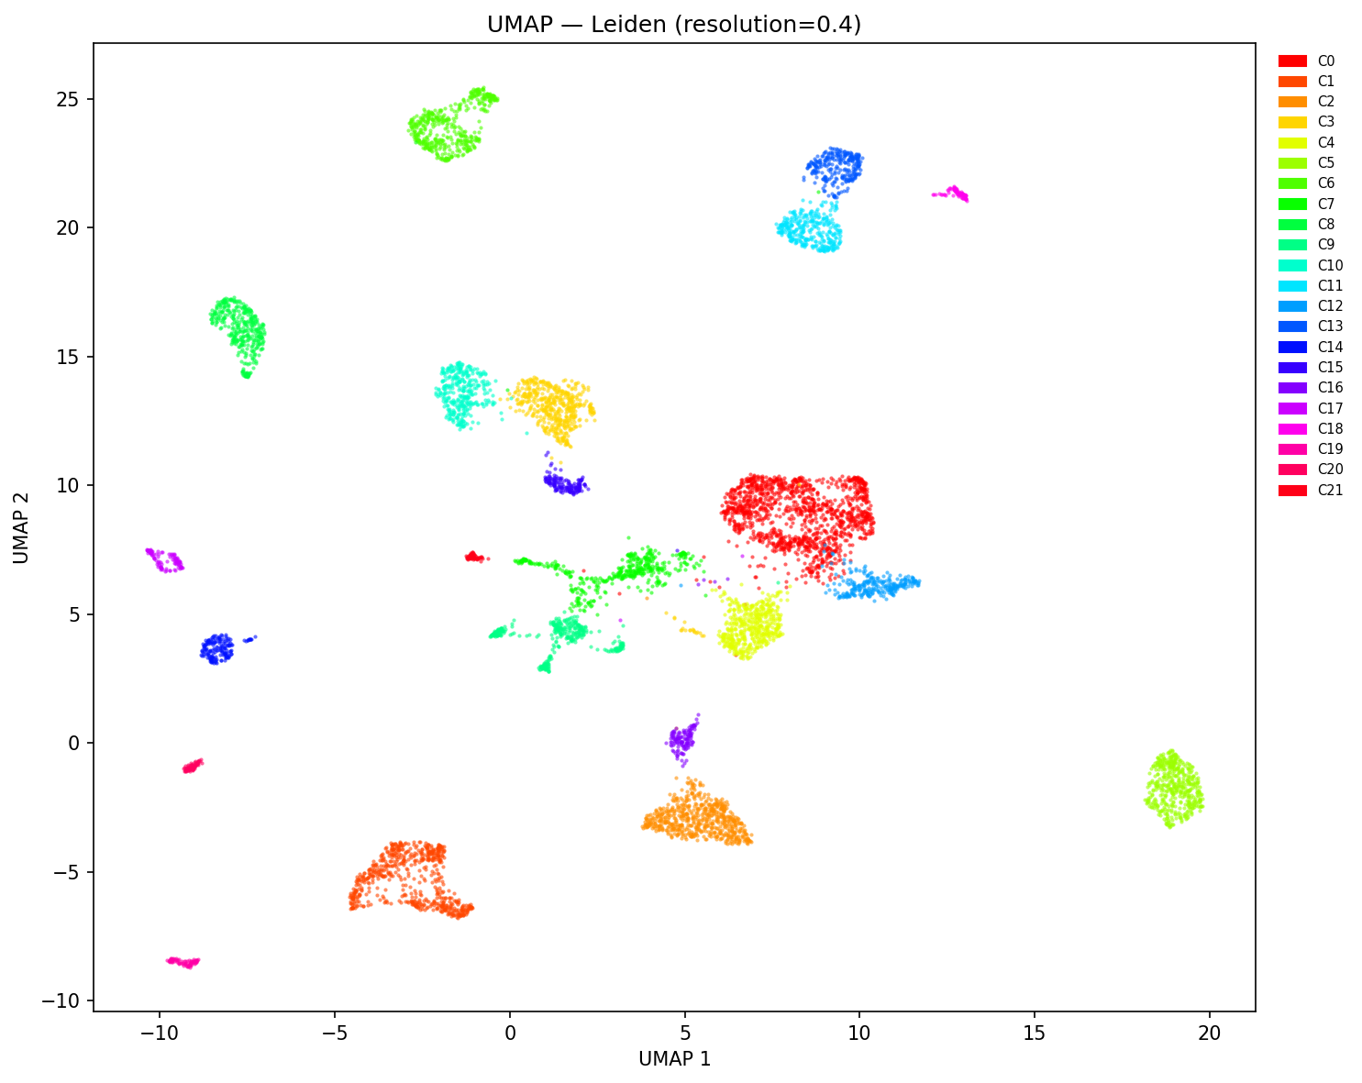
Figure S8. UMAP colored by Leiden cluster assignment (22 clusters, resolution=0.4). Fine-grained substructure within major cancer types is captured, particularly within breast, lung, and kidney carcinomas.
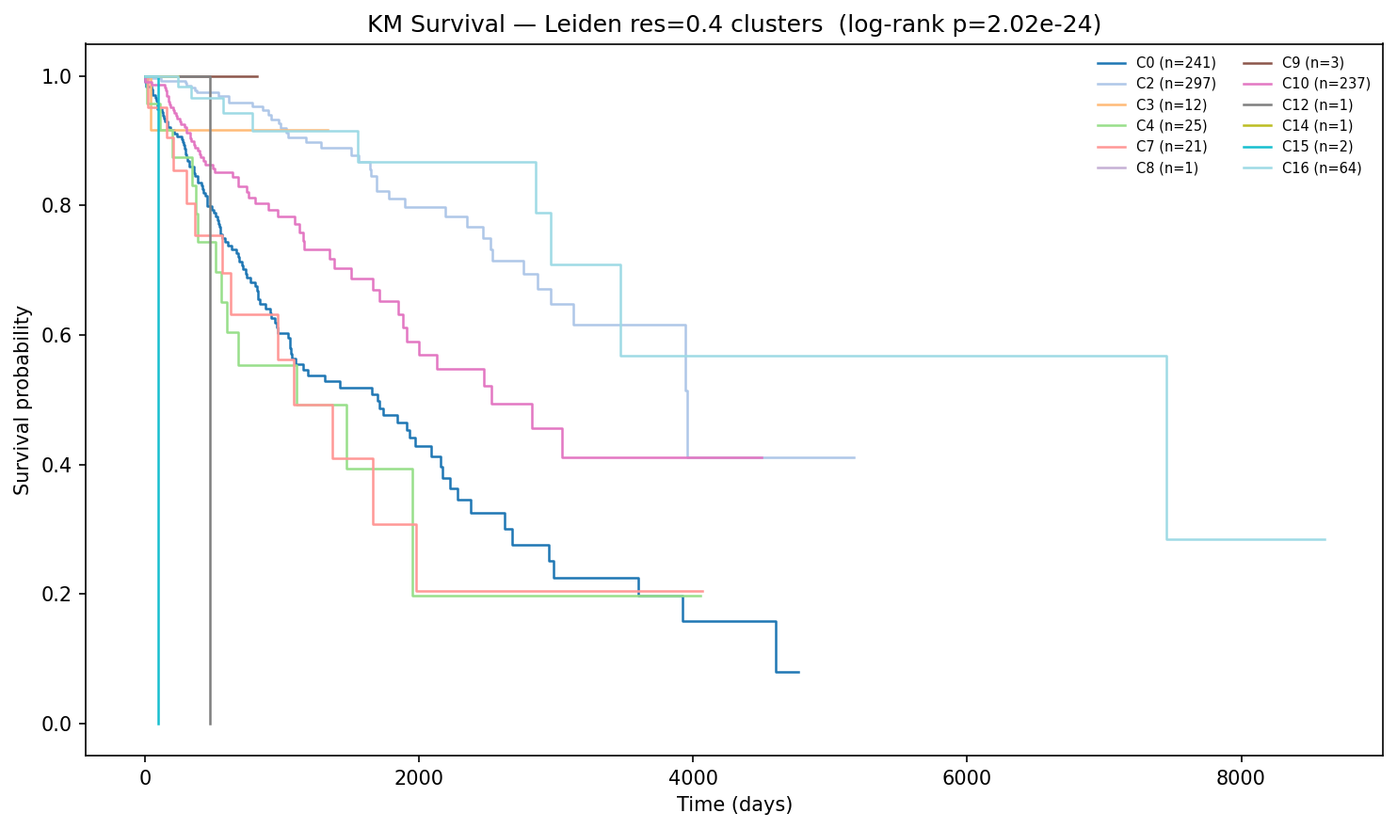
Figure S9. Kaplan-Meier survival curves for all 22 Leiden clusters. Log-rank p=2.02e-24. Graph-based clustering substantially outperforms K-means for survival stratification, confirming the multi-modal density structure in pan-cancer data.

Section S5: MOFA+ Extended Results
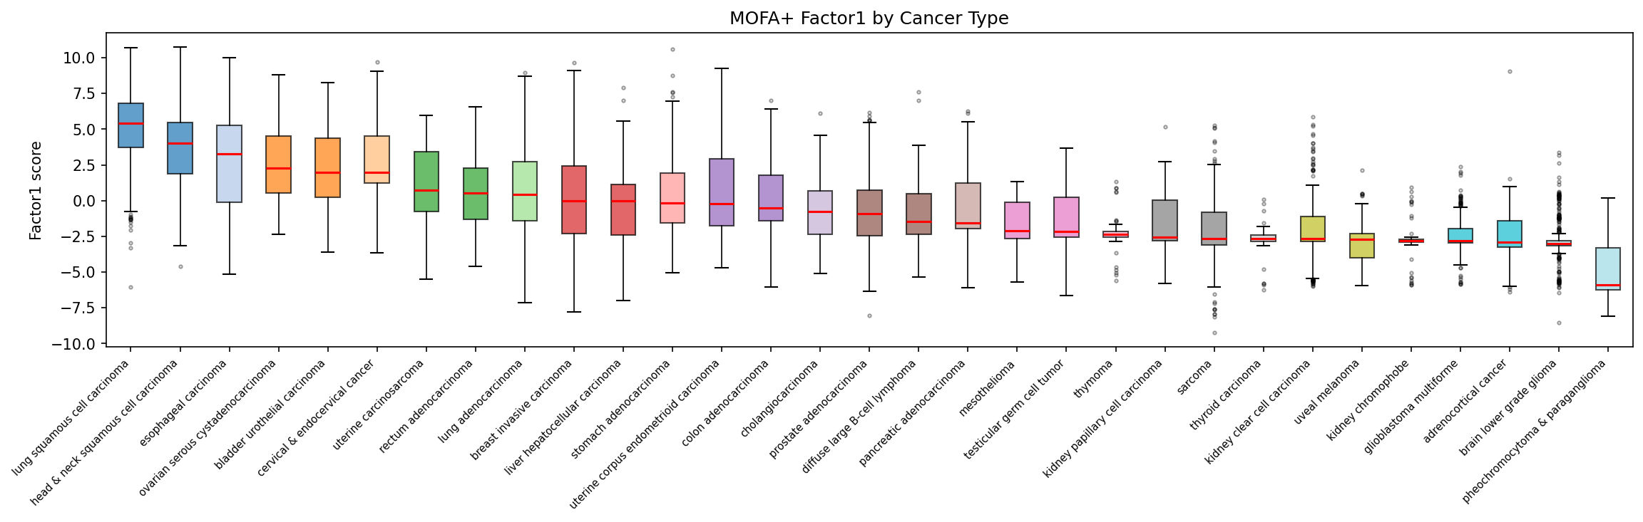
Figure S10. Heatmap of mean MOFA+ factor scores per cancer type. Factors with strong cancer-type associations (e.g., Factor 1 in HNSC/LUSC/CESC; Factor 9 in BRCA; Factor 4 in LIHC) reflect known lineage-defining transcriptional programmes.
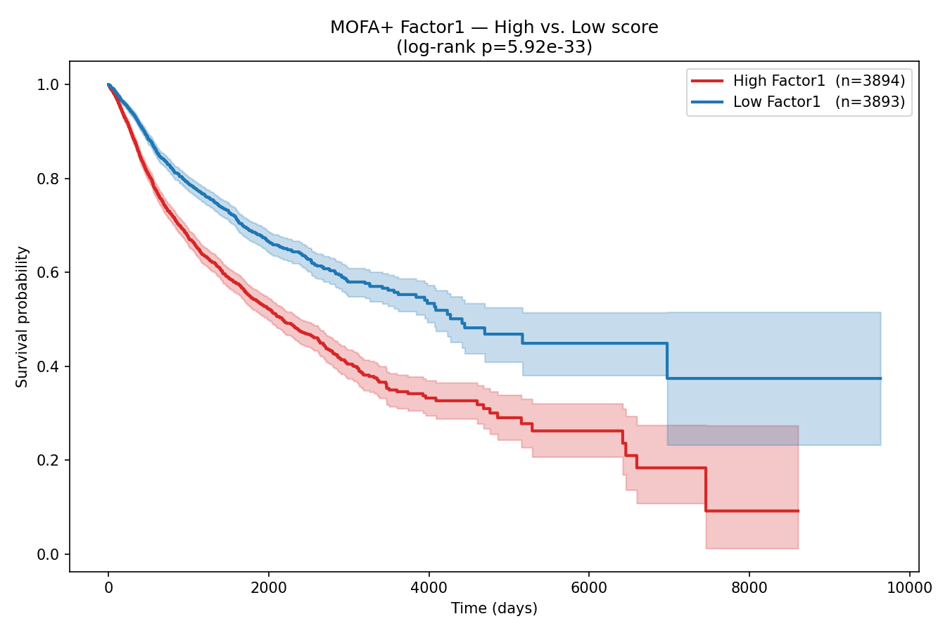
Figure S11. Spearman correlations between MOFA+ factor scores and OS time across all survival-annotated samples. Factor 8 shows the strongest negative correlation with OS time (higher factor score = shorter survival).
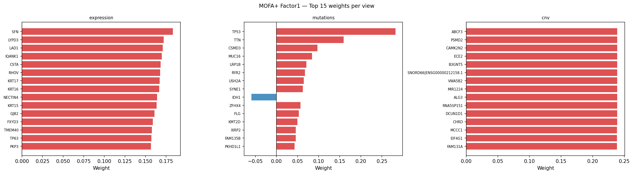
Figure S12. Top 20 gene loadings for MOFA+ Factor 1 (expression view). KRT-family genes, TP63, SFN, NECTIN4, and GJB2 dominate, defining the squamous/basal lineage programme.
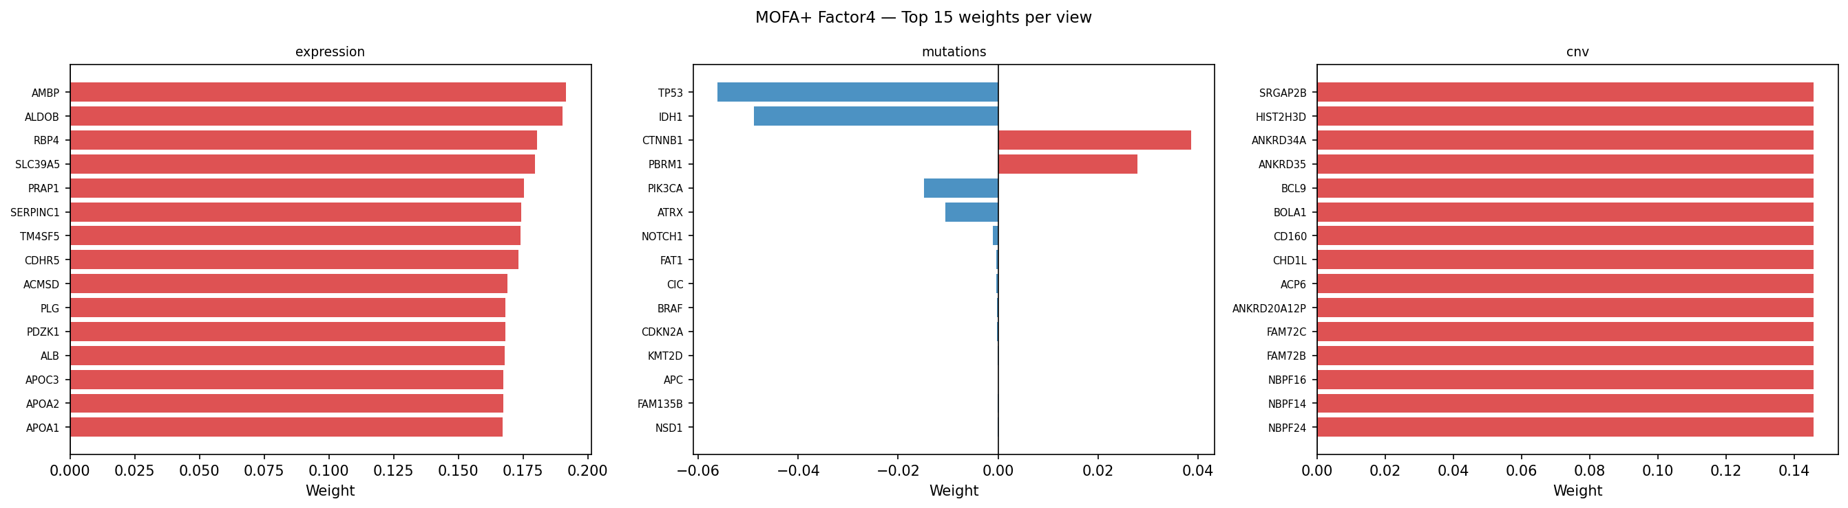
Figure S13. Top 20 gene loadings for MOFA+ Factor 4. ALDOB, HNF4A, CDHR5, and ALB define a hepatocyte/GI differentiation programme associated with LIHC and COAD.
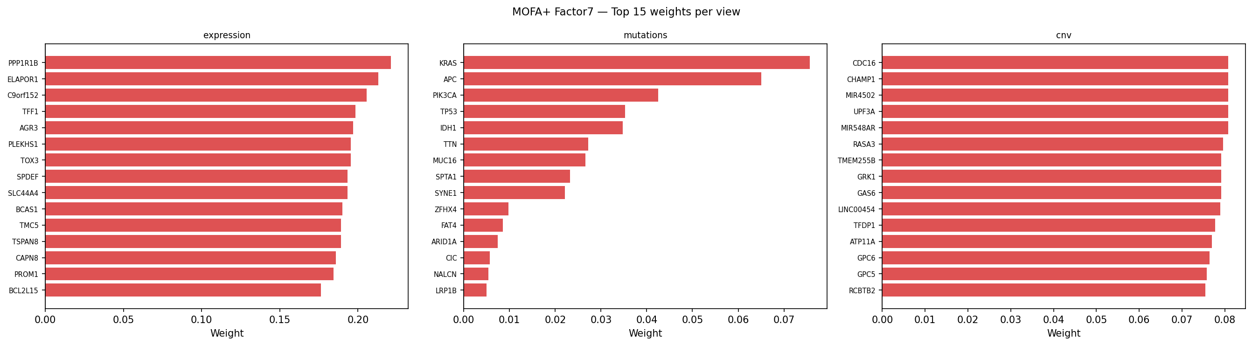
Figure S14. Top 20 gene loadings for Factor 7. GFAP, BCAN, PTPRZ1, and MIR9-1HG define the glioma/astrocyte axis; IDH1 and ATRX mutations co-load on this factor.
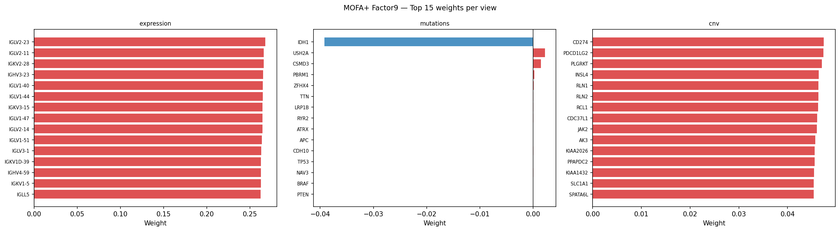
Figure S15. Top 20 gene loadings for Factor 9. IGHG1, IGHA1, IGLC1-3, IGKC, IGHG2-4 define a B-cell/immunoglobulin infiltration programme prominent in BRCA and STAD.
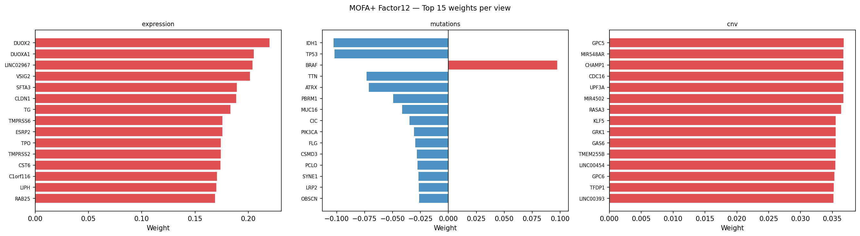
Figure S16. Top 20 gene loadings for Factor 12. TG, TPO, DUOX2, DUOXA1 define thyroid differentiation; TMPRSS2 and CLDN1 also load prominently.
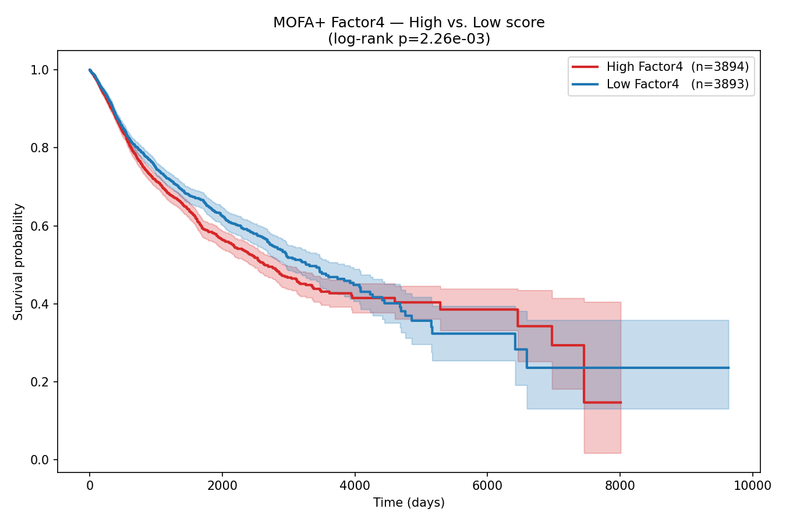
Figure S17a. Kaplan-Meier plot splitting samples at median Factor 4 score. High Factor 4 (hepatocyte/GI programme) associates with longer OS.
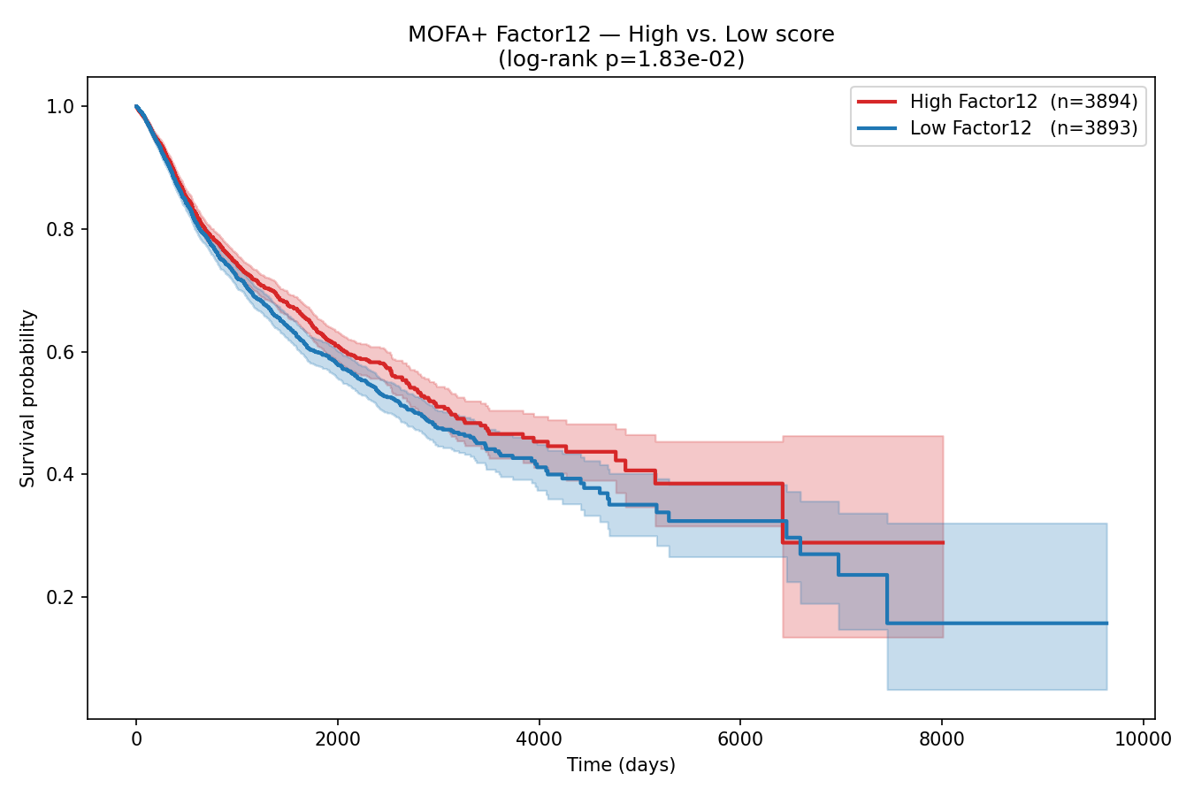
Figure S17b. Kaplan-Meier plot splitting samples at median Factor 12 score. High Factor 12 (thyroid differentiation) associates with significantly longer OS (p < 0.001).

Factor | Var Expl (%) | Avg |SHAP| | SHAP Rank | Primary Biology | Key Genes
F1 | 6.1 | 0.162 | 3 | Squamous/basal lineage | KRT16/17, TP63, NECTIN4, SFN
F4 | 5.8 | 0.068 | 14 | Hepatocyte/GI | ALDOB, HNF4A, CDHR5, ALB
F9 | 5.1 | 0.088 | 6 | B-cell infiltration | IGHG1-4, IGHA1, IGLC1-3
F7 | 4.7 | 0.062 | 16 | Glioma/neural | GFAP, BCAN, PTPRZ1, IDH1 mut
F12 | 5.3 | 0.120 | 5 | Thyroid/IDH differentiation | TG, TPO, DUOX2, BRAF mut
F8 | 3.2 | 0.283 | 1 | Protease invasion + driver muts | PRSS3, KLK6, TP53/KRAS mut
F6 | 0.8 | 0.219 | 2 | Immune checkpoint (9p24.1) | CD274, PDCD1LG2, JAK2 CNV
F15 | 2.5 | 0.120 | 4 | Luminal de-differentiation | GATA3, MUC1, ARID1A mut loss
F11 | 4.3 | 0.078 | 9 | Mixed epithelial | Various KRT, mucin genes
F16 | 3.6 | 0.064 | 15 | Stromal/fibroblast | GPC5/6, KLF5
Table S4. Summary of all retained MOFA+ factors: variance explained, SHAP score, SHAP rank, primary biological annotation, and representative genes.

Section S6: Cox Ridge and DeepSurv Baseline Models
Prior to the final MOFA+-based model comparison, two baseline survival models were developed on raw PCA features: (1) a Cox ridge regression using 80 ElasticNet-selected features from expression PCA(50) + top-100 mutation genes + CNV PCA(30); and (2) a DeepSurv neural network (3 hidden layers: 256-128-64 units with BatchNorm, ReLU, and Dropout 0.4) trained on the same 80-feature set. These baseline experiments established the performance ceiling of raw-feature approaches before MOFA+ integration.
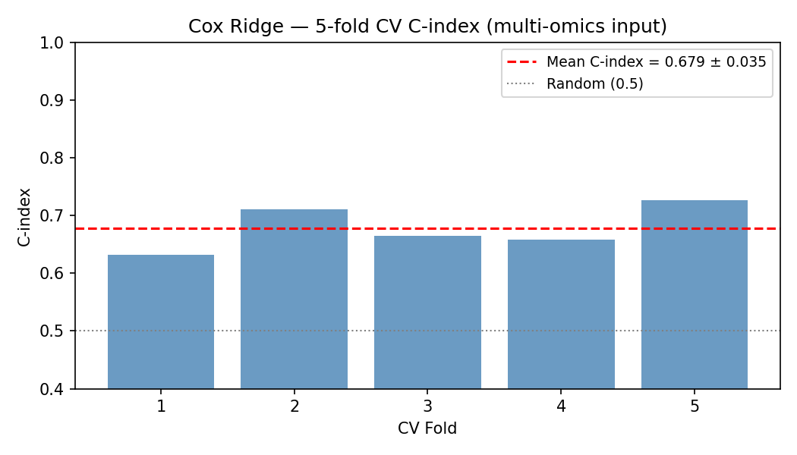
Figure S18. Cox ridge regression 5-fold CV C-index. Mean = 0.679 +/- 0.035 on 80 ElasticNet-selected features from raw PCA. High fold-to-fold variance reflects instability of raw features.
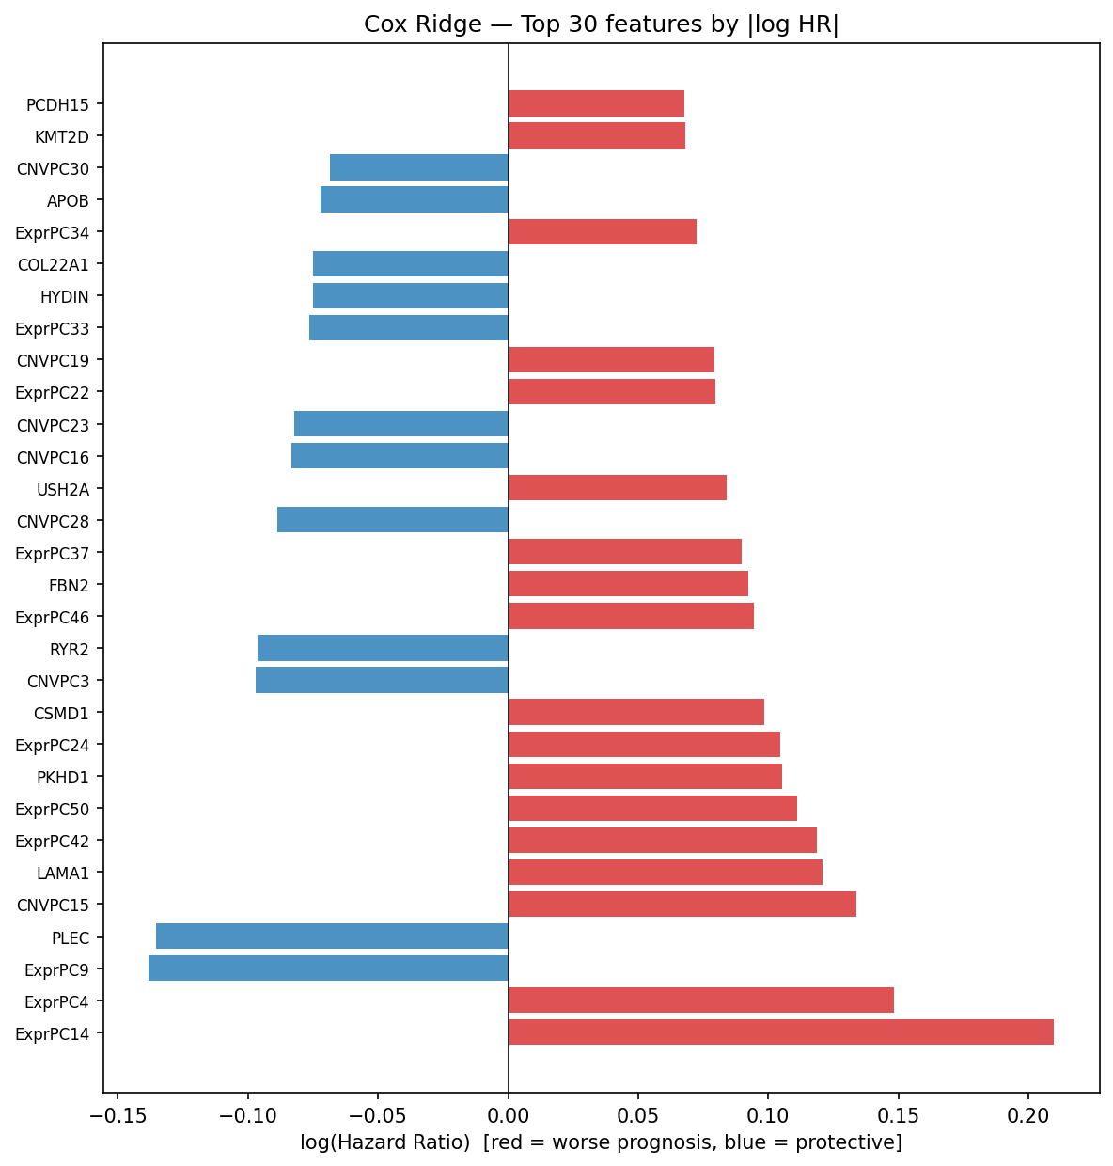
Figure S19. Cox model top 20 feature hazard ratios with 95% confidence intervals. EXPR_PC14 is the top predictor (HR = 1.18, 95% CI: 1.12-1.25), followed by CNV_PC15 and MUT_USH2A.
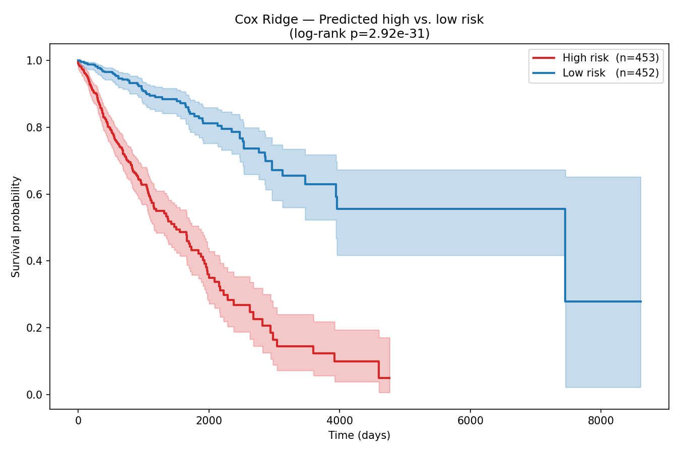
Figure S20. Kaplan-Meier survival curves for high vs. low-risk groups by Cox model risk score (median split).
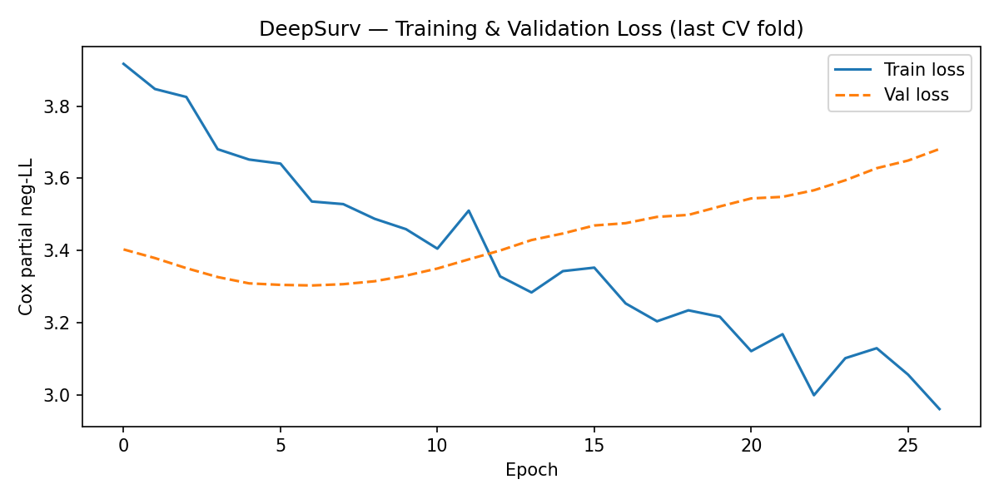
Figure S21a. DeepSurv training and validation loss curves across 5 cross-validation folds. Early stopping (patience=20) is triggered between epochs 40-80 across folds.
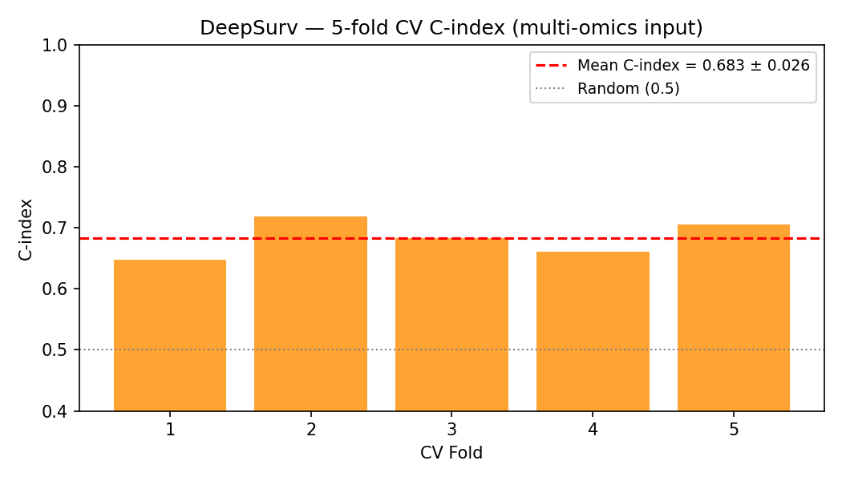
Figure S21b. DeepSurv 5-fold CV C-index. Mean = 0.683 +/- 0.026. The deep network marginally outperforms Cox ridge on the same 80-feature set.

Section S7: Full SHAP Analyses per Model
SHAP (SHapley Additive exPlanations) was computed for all three MOFA+-based models and the two baseline models. The following figures show beeswarm plots (feature impact on model output for each sample) and bar plots (mean absolute SHAP per feature) for each model.
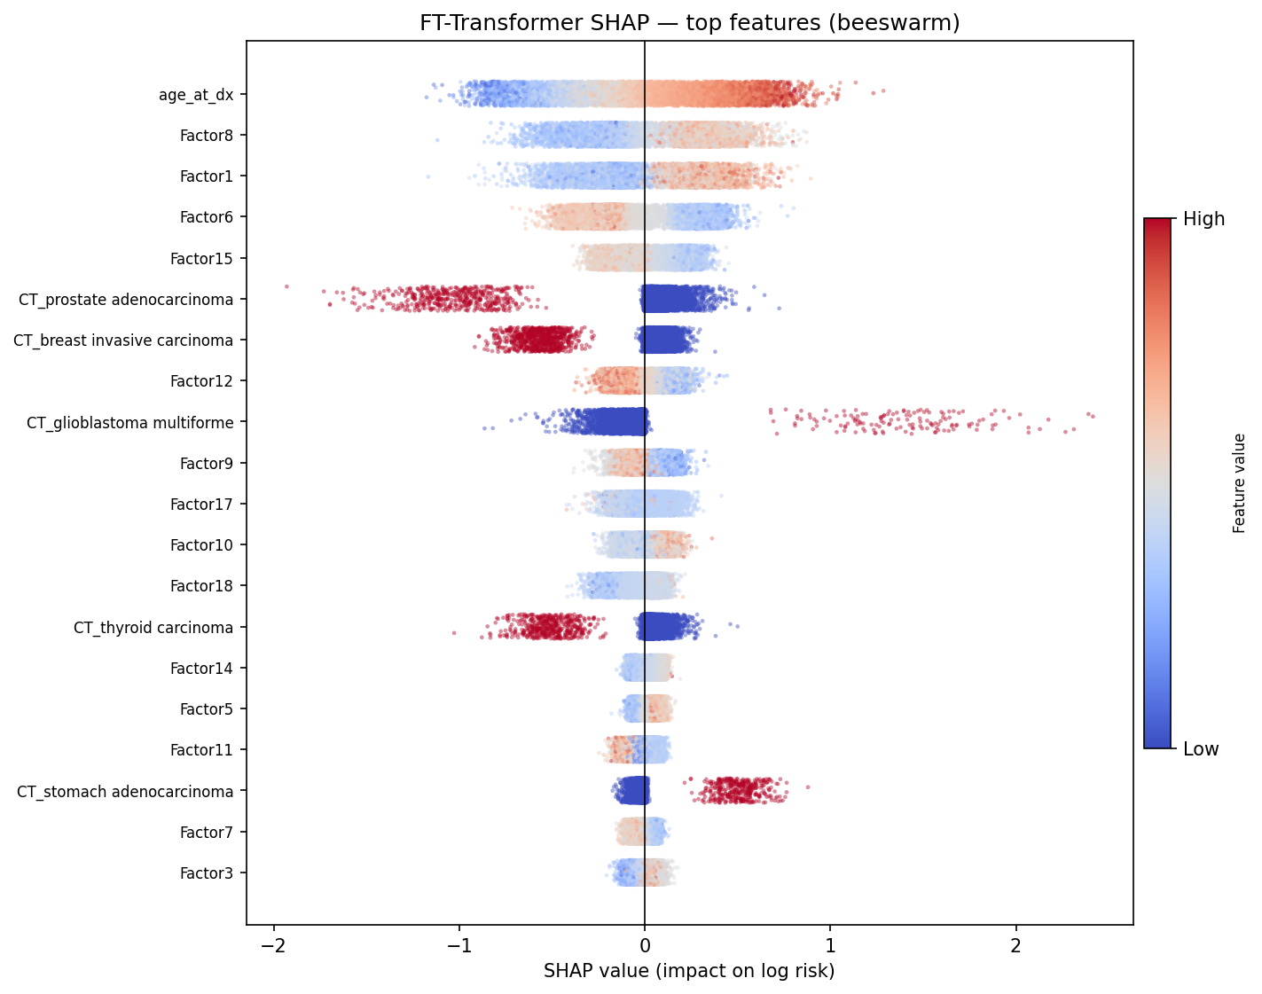
Figure S22. FT-Transformer SHAP beeswarm plot. Each dot is one sample; color indicates feature value (red=high, blue=low); x-position shows SHAP value (impact on predicted log-hazard). Factor 8 and age_at_dx show the widest SHAP spread, confirming their dominance.
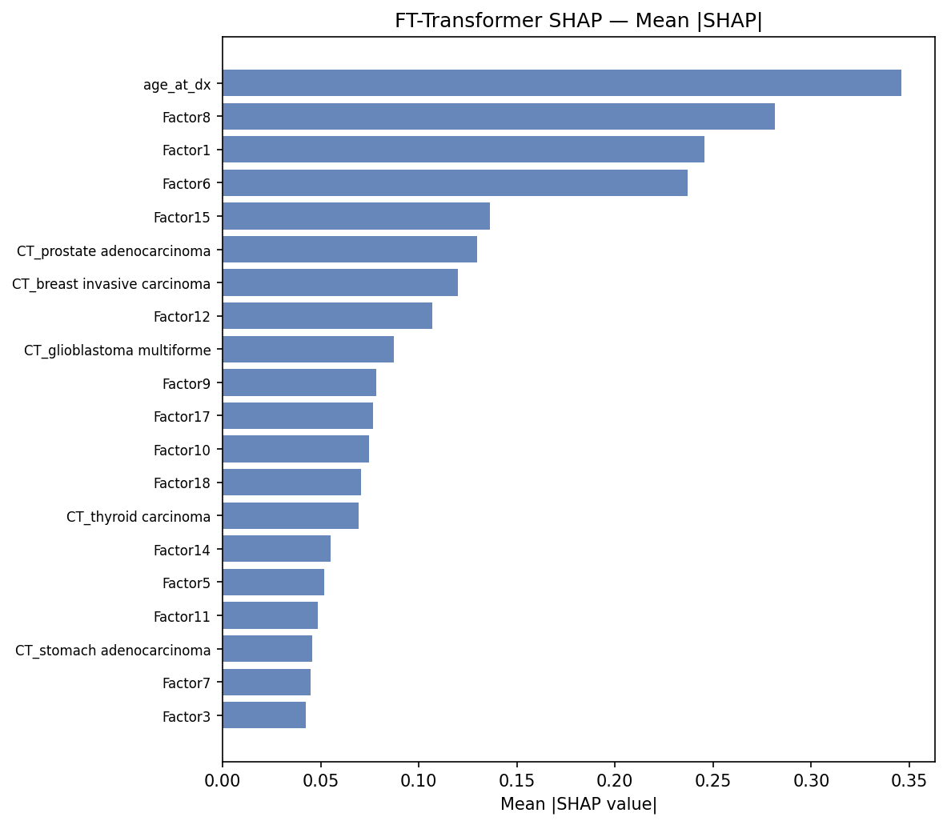
Figure S23. FT-Transformer mean absolute SHAP bar chart. Top 20 features ranked by mean |SHAP|. The molecular factors (Factor 8, 6, 1) are clearly separated from lower-ranked factors.
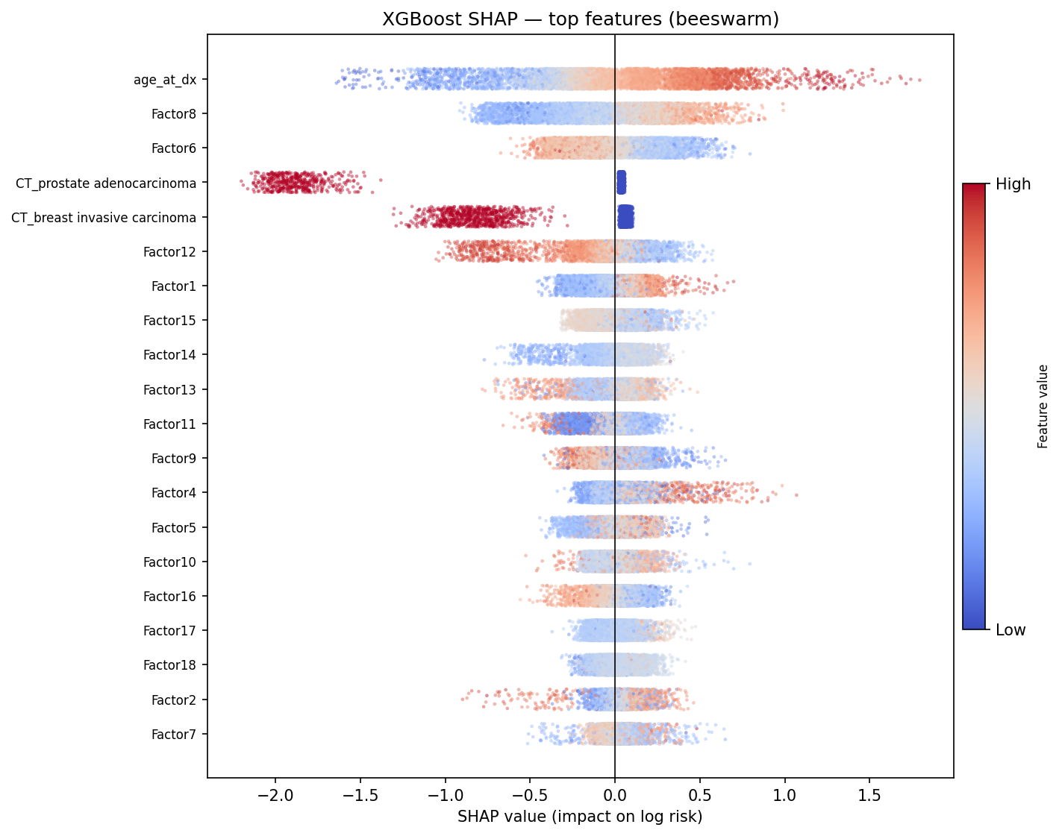
Figure S24. XGBoost SHAP beeswarm plot (TreeExplainer, exact). Factor 8 again dominates; cancer-type dummies (CT_prostate, CT_breast) play a larger role than in FTT.
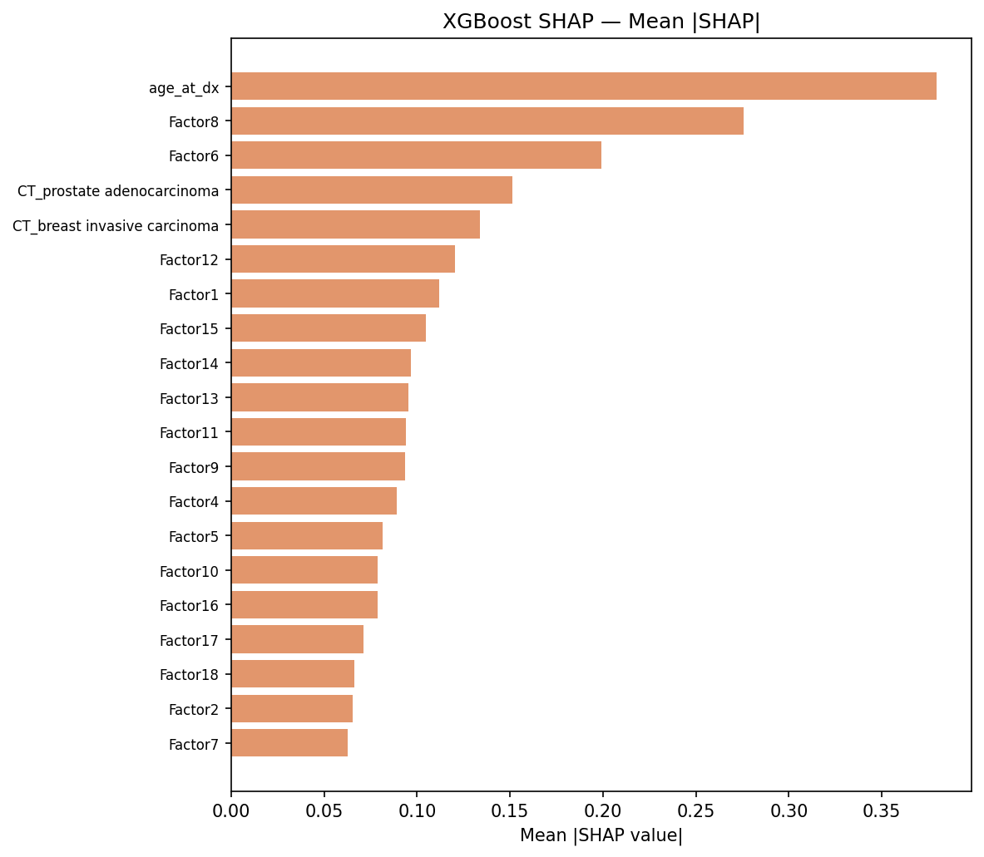
Figure S25. XGBoost mean absolute SHAP bar chart. Factor 8 and age are top features; Factor 6 ranks higher relative to FTT compared to Factor 1.
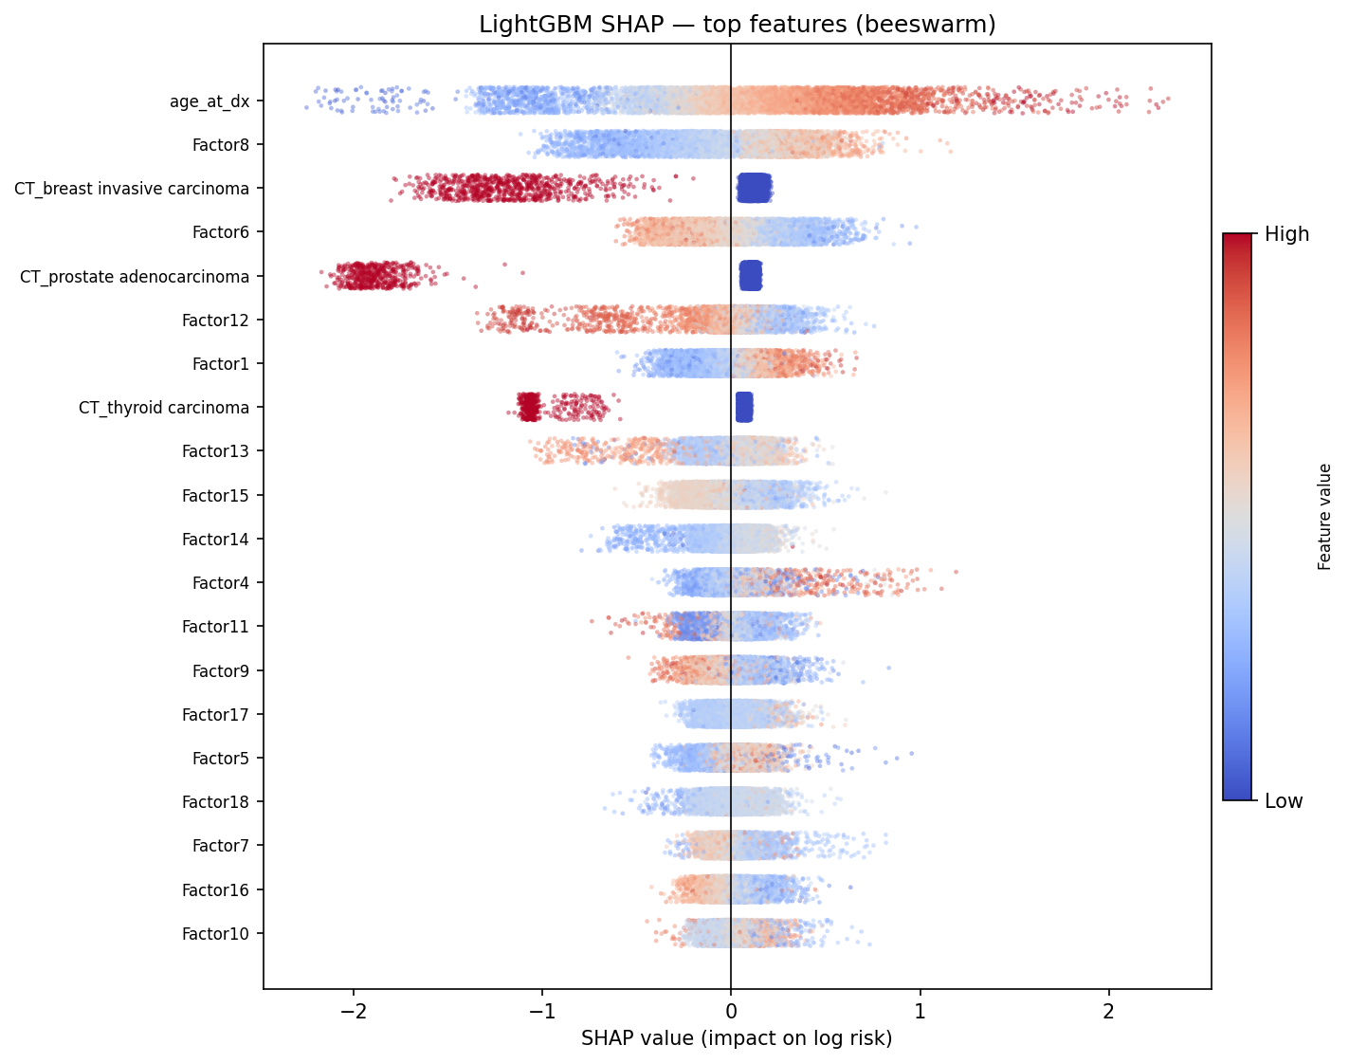
Figure S26. LightGBM SHAP beeswarm plot (TreeExplainer). Pattern is closely consistent with XGBoost, confirming robustness of factor importance ranking across tree architectures.
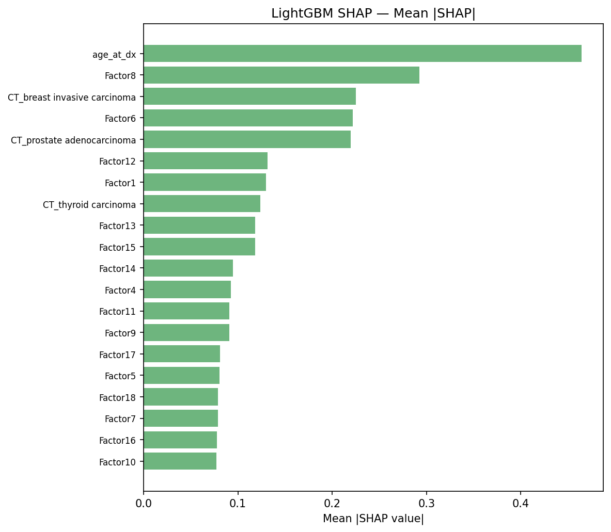
Figure S27. LightGBM mean absolute SHAP bar chart. Factor 8 = 0.293 (highest of any model), confirming LightGBM's strong sensitivity to the protease/invasion signal.

Section S8: Multiomics Marker Analysis
Gene-level survival marker contributions were quantified by computing the product of each gene's MOFA+ loading magnitude (|weight_ij|) and the corresponding factor's mean absolute SHAP score across all three models, summed across the five top-SHAP factors (Factors 8, 6, 1, 15, 12). This produces a gene-level SHAP contribution score representing the gene's aggregate influence on survival prediction across the full multi-omics framework.
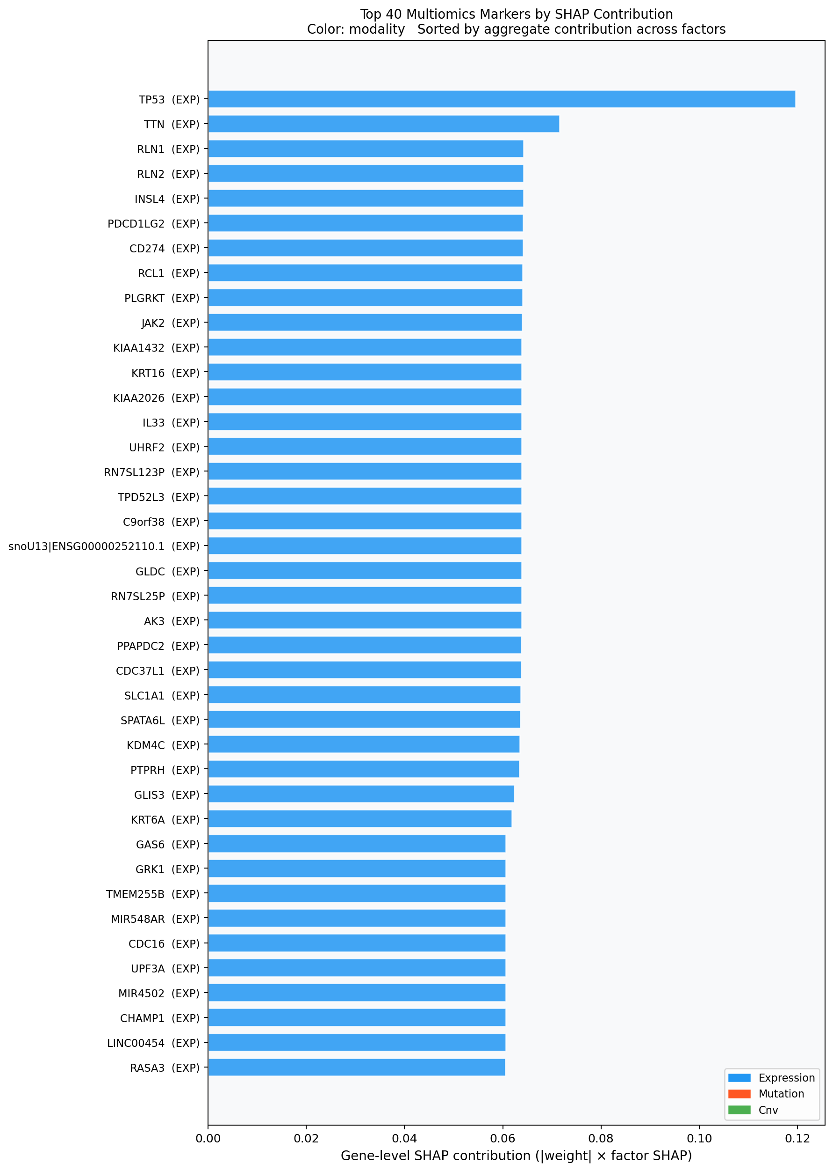
Figure S28. Top 40 gene-level markers ranked by aggregate SHAP contribution across all three modalities (expression = blue, mutation = orange, CNV = green). TP53 is the top-ranked gene, appearing across all 5 top factors. The 9p24.1 immune checkpoint genes (CD274, PDCD1LG2, JAK2) cluster prominently in the CNV tier.
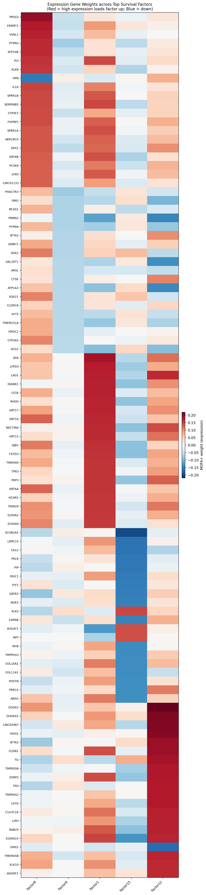
Figure S29. Heatmap of expression gene weights across all five top survival-associated MOFA+ factors. Red = positive loading (high expression loads factor up); blue = negative loading. Distinct gene clusters map to squamous (F1), invasion/protease (F8), and luminal (F15) programmes.
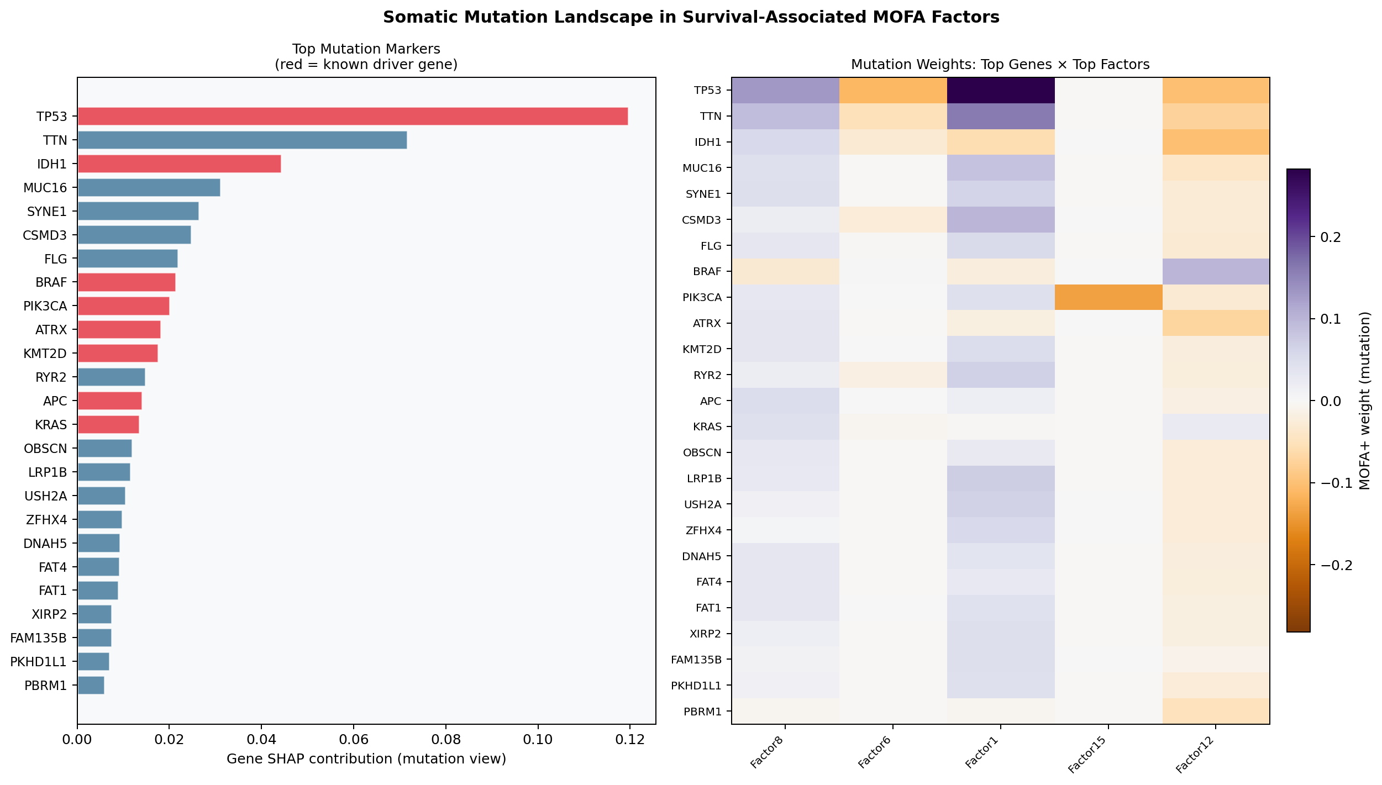
Figure S30. Left: Top 25 mutation markers ranked by gene-level SHAP contribution (red = known driver). Right: Factor x gene weight heatmap for the top mutation genes across all five top factors. TP53, IDH1, and KRAS are the most recurrent drivers across factors.
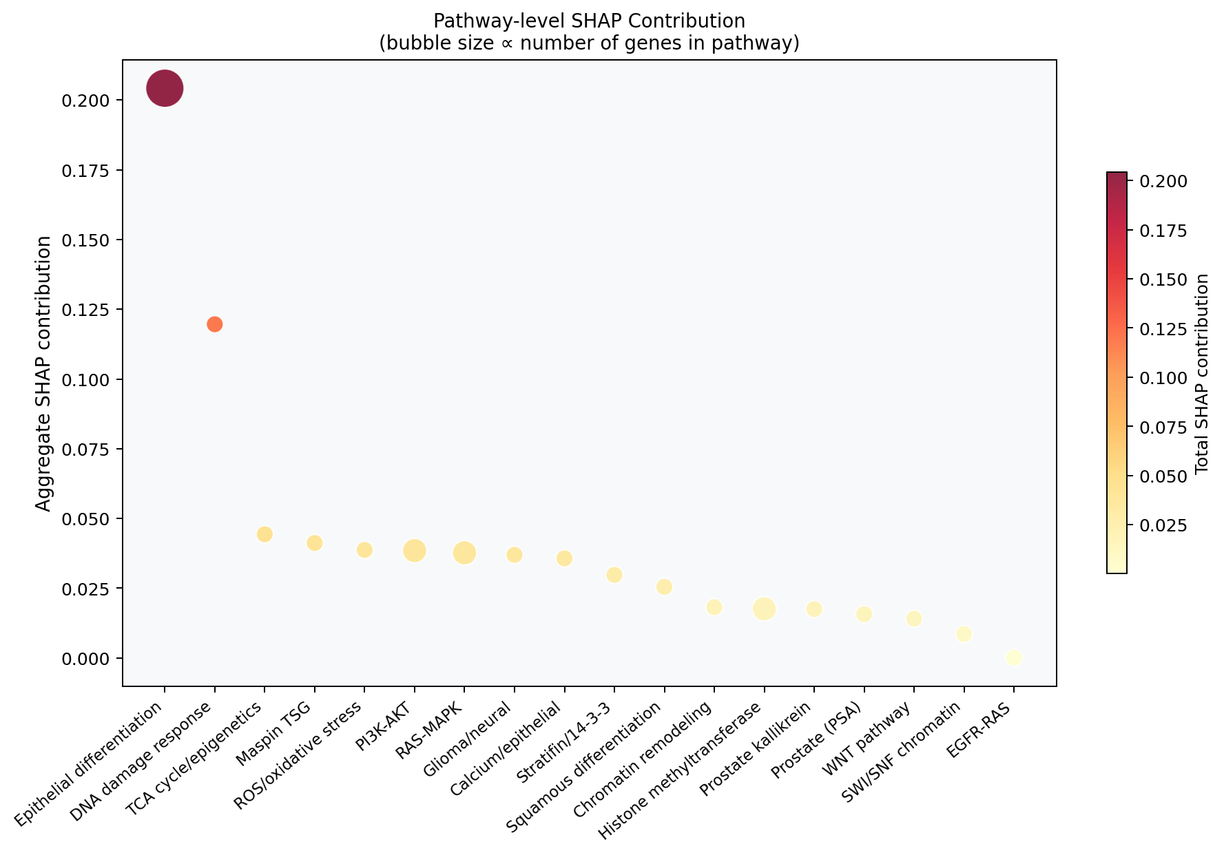
Figure S31. Pathway-level aggregated SHAP contribution. Bubble size indicates number of genes in pathway. The immune checkpoint/B-cell pathway, squamous differentiation, and hepatocyte/GI programmes show the highest aggregate scores.

Gene | Modality | SHAP Contrib | N Factors | Role | Pathway
TP53 | expression | 0.1196 | 5 | TSG/gain-of-function | DNA damage response
TTN | expression | 0.0716 | 4 | Unknown | Unknown
RLN1 | expression | 0.0643 | 1 | Unknown | Unknown
RLN2 | expression | 0.0643 | 1 | Unknown | Unknown
INSL4 | expression | 0.0642 | 1 | Unknown | Unknown
PDCD1LG2 | expression | 0.0641 | 1 | Unknown | Unknown
CD274 | expression | 0.0641 | 1 | Unknown | Unknown
RCL1 | expression | 0.064 | 1 | Unknown | Unknown
PLGRKT | expression | 0.064 | 1 | Unknown | Unknown
JAK2 | expression | 0.0639 | 1 | Unknown | Unknown
KIAA1432 | expression | 0.0639 | 1 | Unknown | Unknown
KRT16 | expression | 0.0639 | 2 | Unknown | Epithelial differentiation
KIAA2026 | expression | 0.0639 | 1 | Unknown | Unknown
IL33 | expression | 0.0638 | 1 | Unknown | Unknown
snoU13|ENSG00000252110.1 | expression | 0.0638 | 1 | Unknown | Unknown
RN7SL25P | expression | 0.0638 | 1 | Unknown | Unknown
TPD52L3 | expression | 0.0638 | 1 | Unknown | Unknown
RN7SL123P | expression | 0.0638 | 1 | Unknown | Unknown
C9orf38 | expression | 0.0638 | 1 | Unknown | Unknown
GLDC | expression | 0.0638 | 1 | Unknown | Unknown
UHRF2 | expression | 0.0638 | 1 | Unknown | Unknown
AK3 | expression | 0.0638 | 1 | Unknown | Unknown
PPAPDC2 | expression | 0.0637 | 1 | Unknown | Unknown
CDC37L1 | expression | 0.0637 | 1 | Unknown | Unknown
SLC1A1 | expression | 0.0636 | 1 | Unknown | Unknown
SPATA6L | expression | 0.0636 | 1 | Unknown | Unknown
KDM4C | expression | 0.0634 | 1 | Unknown | Unknown
PTPRH | expression | 0.0634 | 2 | Unknown | Unknown
GLIS3 | expression | 0.0623 | 1 | Unknown | Unknown
KRT6A | expression | 0.0619 | 2 | Unknown | Epithelial differentiation
Table S5. Top 30 gene-level markers by aggregate SHAP contribution across all 5 top factors.

Gene | Modality | SHAP Contrib | N Factors | Role | Therapeutic Mechanism
TP53 | expression | 0.1196 | 5 | TSG/gain-of-function | Gene therapy / p53 reactivation (APR-246/eprenetapopt); MDM2 inhibitors.
TTN | expression | 0.0716 | 4 | Unknown | Passenger mutator (large gene); hypermutation biomarker; not a direct target.
RLN1 | expression | 0.0643 | 1 | Unknown | Under investigation
RLN2 | expression | 0.0643 | 1 | Unknown | Under investigation
INSL4 | expression | 0.0642 | 1 | Unknown | Under investigation
PDCD1LG2 | expression | 0.0641 | 1 | Unknown | Under investigation
CD274 | expression | 0.0641 | 1 | Unknown | Under investigation
RCL1 | expression | 0.064 | 1 | Unknown | Under investigation
PLGRKT | expression | 0.064 | 1 | Unknown | Under investigation
JAK2 | expression | 0.0639 | 1 | Unknown | Under investigation
KIAA1432 | expression | 0.0639 | 1 | Unknown | Under investigation
KRT16 | expression | 0.0639 | 2 | Unknown | Under investigation
KIAA2026 | expression | 0.0639 | 1 | Unknown | Under investigation
IL33 | expression | 0.0638 | 1 | Unknown | Under investigation
snoU13|ENSG00000252110.1 | expression | 0.0638 | 1 | Unknown | Under investigation
RN7SL25P | expression | 0.0638 | 1 | Unknown | Under investigation
TPD52L3 | expression | 0.0638 | 1 | Unknown | Under investigation
RN7SL123P | expression | 0.0638 | 1 | Unknown | Under investigation
C9orf38 | expression | 0.0638 | 1 | Unknown | Under investigation
GLDC | expression | 0.0638 | 1 | Unknown | Under investigation
Table S6. Top 20 therapeutic targets with curated mechanism annotations. Full tx_mechanism text is available in therapeutic_targets.csv.

Factor | FTT |SHAP| | XGB |SHAP| | LGB |SHAP| | Average
Factor8 | 0.2814 | 0.2755 | 0.2925 | 0.2831
Factor6 | 0.2371 | 0.1991 | 0.222 | 0.2194
Factor1 | 0.2455 | 0.1119 | 0.1297 | 0.1624
Factor15 | 0.1364 | 0.1048 | 0.1181 | 0.1198
Factor12 | 0.107 | 0.1204 | 0.1313 | 0.1196
Factor9 | 0.0784 | 0.0937 | 0.091 | 0.0877
Factor13 | 0.0423 | 0.0952 | 0.1181 | 0.0852
Factor14 | 0.0552 | 0.0966 | 0.095 | 0.0823
Factor11 | 0.0484 | 0.0938 | 0.0911 | 0.0778
Factor10 | 0.0747 | 0.0788 | 0.077 | 0.0768
Factor17 | 0.0767 | 0.0711 | 0.0808 | 0.0762
Factor18 | 0.0704 | 0.0664 | 0.0791 | 0.072
Factor5 | 0.0517 | 0.0817 | 0.0804 | 0.0713
Factor4 | 0.0219 | 0.089 | 0.0926 | 0.0678
Factor16 | 0.0352 | 0.0788 | 0.0777 | 0.0639
Factor7 | 0.0451 | 0.0627 | 0.0788 | 0.0622
Factor3 | 0.0425 | 0.0603 | 0.0677 | 0.0568
Factor2 | 0.0143 | 0.0652 | 0.0697 | 0.0497
Table S7. Mean absolute SHAP values per MOFA+ factor across all three models (FTT = FT-Transformer, XGB = XGBoost, LGB = LightGBM). Average across models is used for factor prioritization throughout this study.

Section S9: Cross-Model Consistency Analysis
To assess the robustness of factor importance rankings across model architectures, we computed pairwise SHAP concordance across the three models. High concordance indicates a biologically robust signal independent of the inductive bias of the specific model architecture. Low concordance may indicate interaction-dependent effects that require attention mechanisms to capture (e.g., Factor 1 squamous programme).
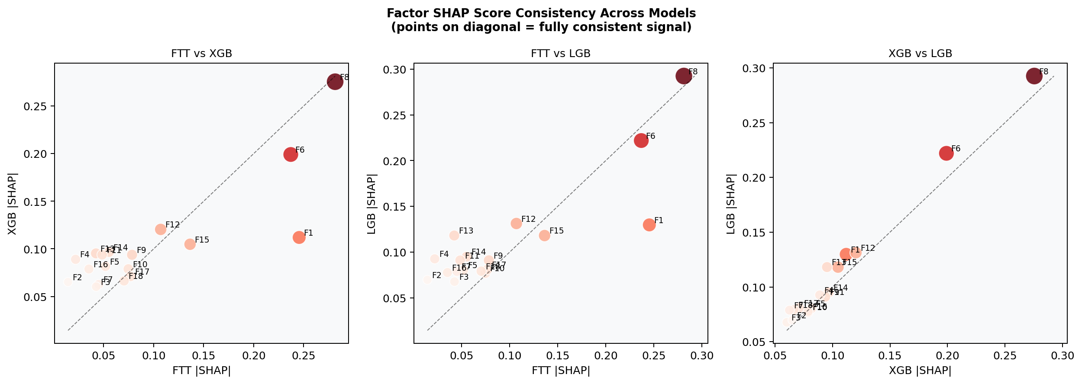
Figure S32. Pairwise scatter plots of factor SHAP scores across all three model pairs: FTT vs XGB (left), FTT vs LGB (centre), XGB vs LGB (right). Points on the diagonal line indicate perfectly consistent importance rankings. Factor 8 (top-right cluster) and Factor 6 show high concordance across all pairs. Factor 1 shows the largest FTT-vs-tree discordance.

Section S10: Software and Reproducibility
Package | Version | Purpose
Python | 3.14 | Runtime
pandas | >=2.0 | Data manipulation
numpy | >=2.0 | Numerical computation
scikit-learn | >=1.4 | PCA, scaling, CV, KMeans
mofapy2 | 0.7.4 | MOFA+ multi-omics factor analysis
umap-learn | >=0.5 | UMAP dimensionality reduction
leidenalg | >=0.9 | Leiden graph clustering
igraph | >=0.10 | Graph construction for Leiden
lifelines | >=0.27 | Cox PH model, C-index computation
torch (PyTorch) | >=2.0 | FT-Transformer implementation
xgboost | 3.2.0 | XGBoost survival model
lightgbm | 4.6.0 | LightGBM (custom Cox objective)
shap | >=0.44 | SHAP attribution (Gradient + Tree explainers)
matplotlib | >=3.8 | All figures
seaborn | >=0.13 | Statistical visualization
python-docx | 1.2.0 | Manuscript generation
mygene | >=3.2 | Gene ID to symbol mapping
requests + tqdm | current | Data download
Table S8. Complete software environment used in this study.
All source code is organized under the Cancer Research project directory with the following structure: src/preprocess.py (data loading and alignment), src/unsupervised/mofa_analysis.py (MOFA+ training and plotting), src/supervised/model_comparison.py (FTT/XGB/LGB training, SHAP), src/analysis/marker_analysis.py (gene-level marker analysis), and src/analysis/build_manuscript.py (this document generation script). Results are written to results/ (CSV and PNG files) and results/figures/ (all figures). Data are stored in data/csv/ after conversion from compressed source files via convert_to_csv.py. All random seeds are set to 42 for reproducibility. Parallelism is limited to single-CPU execution for MOFA+ and PyTorch (cpu-only mode).

