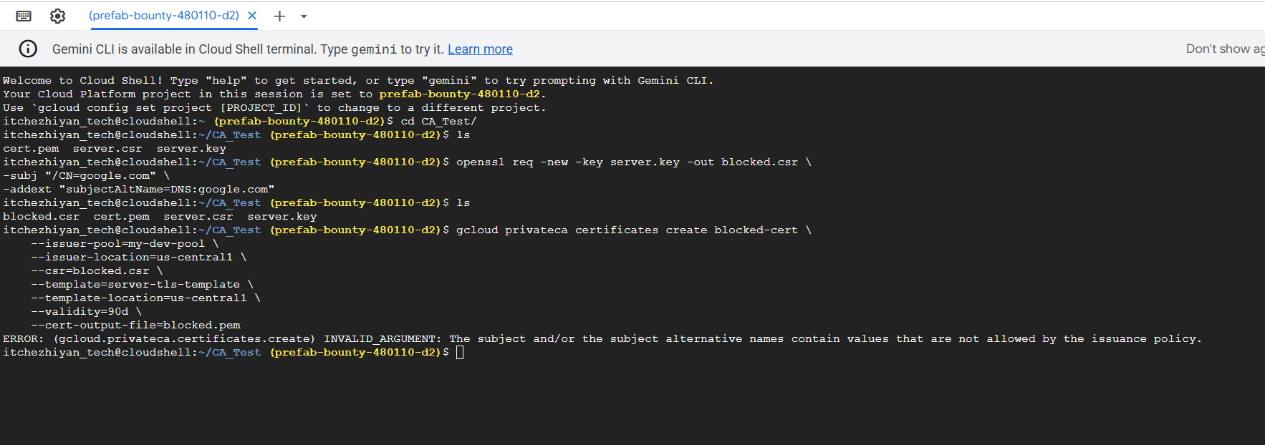

subject_alt_names.all(san,
san.type == DNS &&
san.value.endsWith(".prod.internal.company.com")
)

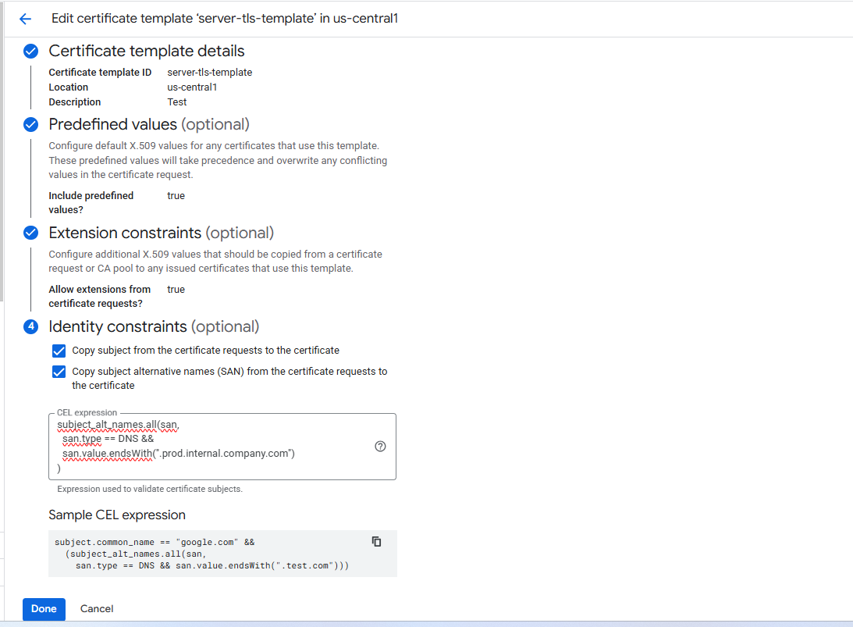

After Adding Certificate Template
Now flow becomes:
- User generates CSR
- CAS checks template policy automatically:
  - Allowed DNS only
  - SAN validation
  - Key usage validation
  - Validity limits
- If CSR violates → auto reject
- If valid → issue certificate
- Upload to Secret Manager
👉 Same operational flow
👉 But security enforcement is now automated

Dear [Manager’s Name],
I would like to brief you on an important enhancement implemented in our certificate issuance process within GCP Certificate Authority Service (CAS).
1. Previous Model (Before Certificate Templates)
In the earlier approach:
- End users generated a private key and CSR.
- The CSR was shared with our team for signing via CAS.
- The issued certificate was uploaded to Secret Manager for user retrieval.
- Validation of CSR attributes (CN, SAN, key usage, domain scope, validity period) relied on manual or script-level checks.
Security Observations:
- No centralized policy enforcement at the CA level.
- Risk of accidental issuance for unauthorized domains.
- Manual validation dependency increased operational and compliance risk.
- Governance controls were procedural rather than technical enforcement.

2. Current Model (After Implementing Certificate Templates)
We have now implemented Certificate Templates in CAS with policy enforcement enabled.
The updated process includes:
- Domain-level restrictions using CEL-based validation rules.
- Controlled SAN and subject validation.
- Enforced key usage and validity limits.
- Automated rejection of non-compliant CSRs at the CA level.
Security Improvements:
- Centralized, policy-driven certificate governance.
- Automated enforcement reduces human error.
- Prevents unauthorized domain issuance.
- Strengthens compliance posture (Zero Trust-aligned control).
- Improves auditability and traceability of certificate issuance.

3. Risk Reduction Achieved
Area | Before | After
Domain misuse risk | Possible | Enforced restriction
Manual validation dependency | High | Eliminated
Policy standardization | Partial | Centralized at CA
Governance maturity | Operational control | Technical enforcement

4. Next Steps
- Communicate the updated process to application teams.
- Enforce CSR-only submission (private keys must remain with end users).
- Gradually transition all issuance to template-based enforcement.
- Document this as part of PKI governance control for audit reference.
This enhancement significantly strengthens our internal PKI control framework and aligns with security best practices for enterprise certificate lifecycle management.
Please let me know if you would like a short walkthrough of the technical implementation and governance controls.
Regards,
Dhananchezhiyan

Dear [Manager’s Name],
I would like to provide a brief update on an important security enhancement implemented in our certificate issuance workflow within GCP Certificate Authority Service (CAS).
Previous State
Certificate issuance relied on CSR submission from application teams, followed by manual or script-level validation before signing. While operationally functional, domain validation, SAN controls, and certificate policy enforcement were not technically restricted at the CA layer. This introduced potential governance and compliance risk.
Current Enhancement
We have now implemented Certificate Templates with enforced policy controls at the CA level. This enables:
- Domain-restricted issuance (DNS constraint enforcement)
- Controlled SAN and subject validation
- Standardized key usage and validity limits
- Automatic rejection of non-compliant CSRs
Risk & Governance Impact
- Eliminates manual validation dependency
- Prevents unauthorized domain certificate issuance
- Strengthens centralized PKI governance
- Improves auditability and compliance posture
- Aligns with Zero Trust and enterprise security best practices
This transition moves our certificate lifecycle management from operational control to enforced technical governance.
I will coordinate communication to application teams to ensure controlled adoption of the updated model.
Please let me know if you would like a brief walkthrough of the implementation and control framework.
Regards,
Dhananchezhiyan

-----------------------------------------------

