Burglary is often a crime people don’t think about until it happens to them. Televisions, electronics, and jewelry are often the high value items that stand to be targeted. However, these items are often not the biggest loss. It is a shattered sense of security, the thought that you may not be as safe in your own home as you once thought. Many victims run through the [range of emotions that are often associated with assault, rape, and similar violent crimes](http://netwatchsystem.com/psychological-effects-of-burglaries/). Within Washington, D.C., 2122 burglaries occurred in 2016. This is a ten year low and 16.7% decrease from 2015. Examining burglary rate as a function of an expanding population, Burglary per 10,000 people is also at its lowest point in the past decade (31.2) and a 17.8% decrease from 2015. Overall, burglary is has been trending downward for seven consecutive years since 2010.

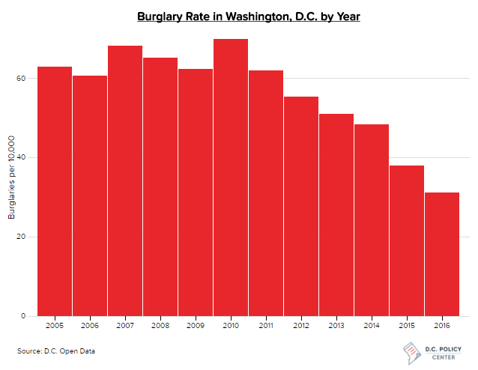

**<iframe src="INSERT URL " name="frame1" scrolling="no" frameborder="no" align="center" height = "550px" width = "200%"></iframe></iframe>**

**Burglary\Graphs\barchart\barchart.html**

Despite the decrease in burglary, it is still a crime felt so personally by its victims. With this in mind, I wanted to analyze the spatial patterns of burglary in 2016, identify where it occurred, what areas may be seeing significant increases or decreases, and explore if any identifiable variables may have influenced burglary.

In an effort to understand how burglary may have shifted during the year period, I calculated percent change in burglary by census tract to illuminate those trends. The first observation that I notice is the increase in neighborhoods such as Spring Valley, Pallisades, and Woodley Park. Some census tracts saw an increase in the 100s of percent. In stark contrast, neighborhoods such as Barry Farms, Woodland, and Garfield Heights saw decreases. This would suggest a large shift in burglary from the East of the city to the West.

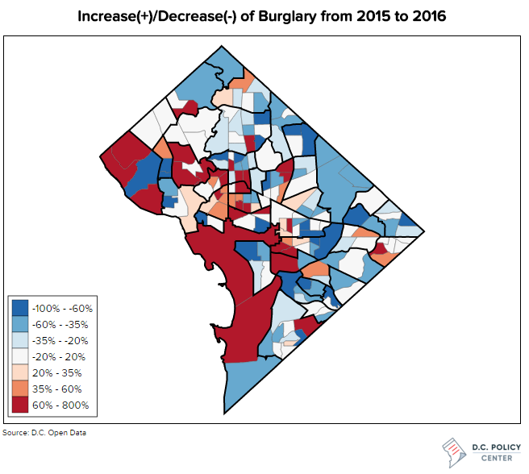

**<iframe src="INSERT URL" name="frame1" scrolling="no" frameborder="no" align="center" height = "675px" width = "150%"></iframe>**

Burglary\Maps\difference\index.html

## Analysis

Plotting individual burglaries on a map gives us an overall picture of exactly where burglaries occurred in the District. However, individual point data can be difficult to interpret. Identifying trends and clusters is broad and doesn’t give us an accurate enough representation. To begin the analysis I spatially joined individual burglaries to census tracts within the District. By joining the data to census tracts, this has the benefit of allowing for regression analysis with multiple demographic variables

### Where did burglaries occur?

With burglary counts aggregated to each census tract, we begin to see patterns appear on the map. The first thing that jumped out to myself was how widespread burglary is in the District. Every ward of the city and almost every census tract had a record of this crime. A crime that doesn’t discriminate obvious social and economic divides in the city. There are a few clusters that pop out though. These areas include South of Dupont Circle and Golden Triangle, tracts around Ivy City, and several tracts around Greenway and Fort Dupont.

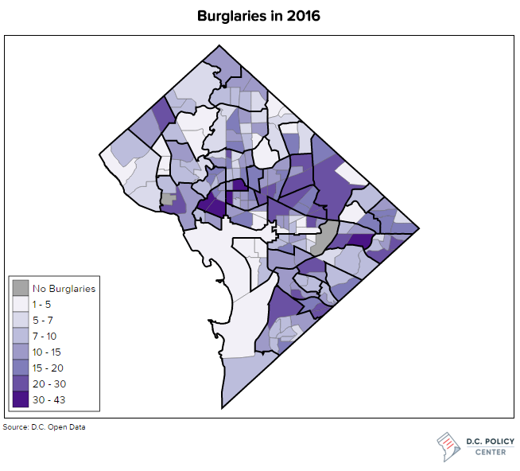

**<iframe src="INSERT URL" name="frame1" scrolling="no" frameborder="no" align="center" height = "675px" width = "150%"></iframe>**

**Burglary\Maps\2016\index.html**

Looking back to the 2015 data on burglary, we can get a sense if there have been any changes in the trends and clustering from one year to the next. Similar to 2016, burglary was a District wide occurrence. No singular ward was immune to act. Unlike in 2016, there were noticeable clusters in varied geographic areas. There is a distinct concentration in both Wards 5 and 7. A visible high incident cluster that we didn’t see in 2016, were burglary seems to be more evenly spread.

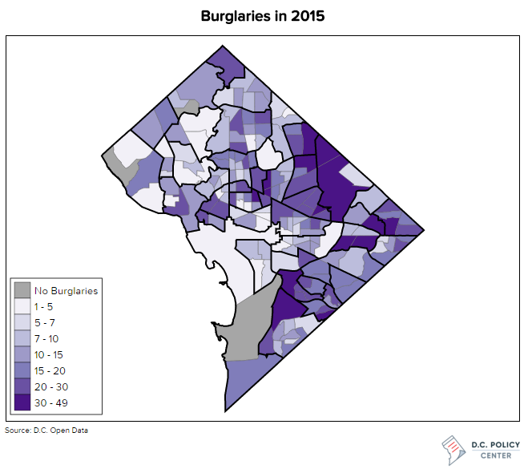

**<iframe src="INSERT URL" name="frame1" scrolling="no" frameborder="no" align="center" height = "675px" width = "150%"></iframe>**

**Burglary\Maps\2015\index.html**

### When did burglaries occur?

Breaking down burglaries temporally aids in answering when burglaries occurred throughout the District in 2016. The time heat map below breaks down burglaries by day of the week and hour of the day. Burglaries occurred in all hours of the day and week. However, there was a clear uptick in burglary between 9am and 10pm. We can see some noticeable patterns of burglary occurring at 1pm and around 6pm to 10pm. You can postulate that burglary around 1pm likely happened at homes where the owners were are work.

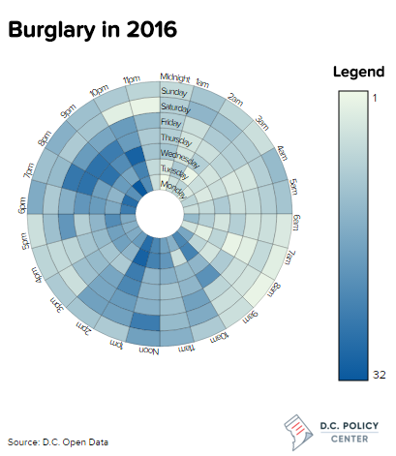

**<iframe src="http://www.rhsmithjr.com/projects/dcpolicycenter/burglary/Graphs/2016/index.html" name="frame1" scrolling="no" frameborder="no" align="center" height = "500px" width = "200%"></iframe>**

**Burglary\Graphs\2016\index.html**

Exploring the 2015 data temporally didn’t yield as many differences as we observed spatially. We can see a general uptick starting around 9am and dropping after 10pm. Again, one can postulate that these hours are generally associated when the population is at work. A prime opportunity for a burglar.

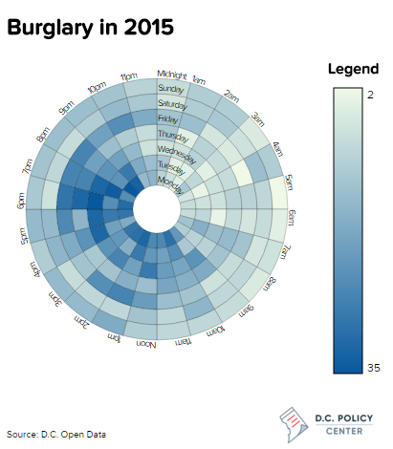

### **<iframe src="http://www.rhsmithjr.com/projects/dcpolicycenter/burglary/Graphs/2015/index.html" name="frame1" scrolling="no" frameborder="no" align="center" height = "500px" width = "200%"></iframe>**

Burglary\Graphs\2015\index.html

### Why did burglaries occur?

To gain a better understanding on why burglaries are occurring more frequently in certain geographic areas and not others, I ran a regression analysis. I set the dependent variable as Burglaries per 10,000 Households for each census tract. Loading over 110 social and economic factors, I was able to devise a best-fit model, identifying six explanatory factors.

The regression model identified these demographics to be the most important:

* Percentage of population that are in the age group 30-34 years old,
* Percentage of population that are in the age group 65-69 years old,
* Percentage of the population that have some college,
* Percentage of the population that retain a bachelor’s degree,
* Percentage of the population that receive SNAP benefits, and
* the total number of married family households.

Despite being the best model, it yielded an R2 of only 0.28. Indicating very little correlation between the explanatory variables and dependent variable.

## Conclusion: Demographics did not influence burglary in 2016

The low R2 tells us that demographics are not a driving factor for burglary. It is able to explain a small portion of the incidents but other forces are driving the frequency of the crime. Researching my finding, I came across a [graduate study from Embry-Riddle Aeronautical University](http://commons.erau.edu/cgi/viewcontent.cgi?article=1014&context=edt) that investigated factors associated with burglary. The study furthered previous research that stated burglary hotspots are highly influenced by three things, presence of law enforcement, distances associated with a target property, and opportunity to commit the offense. All of these relate to giving a criminal the highest possibility of succeeding in a burglary. Considering these findings, we can better understand why demographics did not correlate very well with this specific type of crime.

**The Data**

Data for the demographic model used was obtained from the US Census Bureau’s [American Community Survey, 2015](https://factfinder.census.gov/faces/nav/jsf/pages/index.xhtml). Criminal datasets obtained from [D.C. Open Data](http://opendata.dc.gov/), 2016. Visit my [GitHub page](https://github.com/smitty1788/DCPolicyCenter/tree/master/January%202017/Burglary) for code used in each visual.