2021

Raje Singh

Durham College

9/24/2021

MODE4201 – Lab 1



Table of Contents

Mobile Development – Mobile Banking 1

What is Mobile Banking? 1

Uses of Mobile Banking 1

History of Mobile Banking 2

Advantages of Mobile Banking 3

Disadvantages of Mobile Banking 3

Mobile Manufacturer – Apple vs Samsung (Google) 4

Mobile Plans – Bell vs Rogers 6

References 7

# Mobile Development – Mobile Banking

## What is Mobile Banking?

Mobile Banking is a service offered by banks or other financial/banking institutions which allows its customers to carry out their financial transactions using a mobile device (e.g., their smartphone). This is usually done through an application on the mobile device. It is different from mobile payments, which is using your mobile device to pay for a good or service (e.g., Apple Pay).

**Note : An internet connection is required in order to use mobile banking services.**

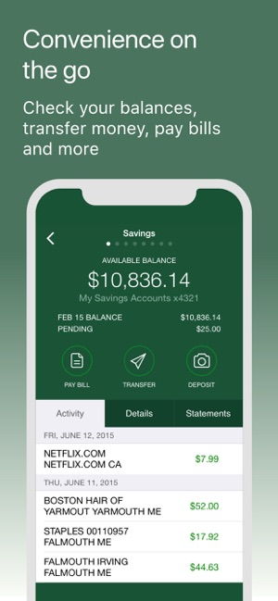

**Example Mobile Banking App from TD Bank (US) App Page on the Apple App Store**

## Uses of Mobile Banking

Mobile Banking allows users to transfer funds, pay bills, check their account balance, see a history of their transactions and even disable their card with some institutions. (goodreturns.in, 2020).

The service has evolved to a point where you can do almost anything you could do at a bank, even requesting for credit, mortgage approval and insurance coverage.

## History of Mobile Banking

Mobile Banking started out with SMS (Short Message Service) Banking. This was possible due to the introduction of smartphones that supported WAP (Wireless Application Protocol), with European banks being the first to offer mobile banking in 1999.

Before mobile applications were widespread, mobile banking was done using SMS or the mobile web (accessing the World Wide Web with a handheld device). The first fully functional banking app was not launched until May 2011, when RBS (The Royal Bank of Scotland) launched it for Apple devices (Pandey, 2019).

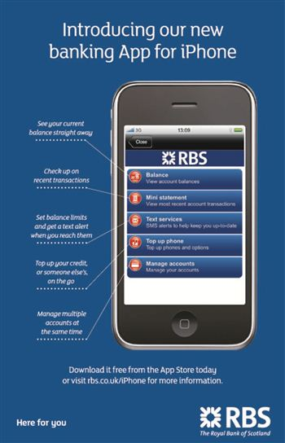

**Promotional Image from RBS’ Banking App Launch courtesy of deadlinenews.co.uk**

The exploding growth of the iPhone and resulting rapid growth of android devices led to the increase in use of special mobile apps. Advancements in web technologies like HTML5, CSS3 and JavaScript saw more banking apps launch mobile services, with many applications consisting of a web app module in JSP (Das et al., 2014, p.377).

## Advantages of Mobile Banking

* Transfer from your account to another account at any time (24/7) and place to anywhere in the world, as long as the bank’s mobile service is up.
* Secure transactions protected by a private key stored in your SIM card (Choudhary, 2021).
* Can be doubly secure by requiring your fingerprint on devices that support it.
* Time saving, no longer have to go to a brick-and-mortar institution for your banking needs.
* Easily monitor your transactions and enables you to recognize fraud early. (Palisades Credit Union, 2020)
* Completely free to use mobile banking once you are with your bank.

## Disadvantages of Mobile Banking

* Technical Problems may arise, such as slow wifi on the user’s end or the bank’s service going down completely.
* Requires a smartphone with an app store that has your bank’s mobile banking app.
* Some banks may have extra charges with heavy mobile banking use.
* Mobile Banking while on unsecure, public wifi may allow thieves to steal your information.

# Mobile Manufacturer – Apple vs Samsung (Google)

|  |  |  |
| --- | --- | --- |
| Manafacturer & Model | IPhone 13 Pro Max (Apple) | Galaxy Z Fold3 5G (Samsung) |
| Photo | Apple iPhone 13 Pro Max MORE PICTURES  **Image from gsmarena.com** | Samsung Galaxy Z Fold3 5G MORE PICTURES  **Image from gsmarena.com** |
| Price | Starting at US$1049.00 (128GB Model, MSRP) (**price from cnet)** | Starting at US$1799 (256GB Model, MSRP) (**price from cnn)** |
| Release Date | September 14, 2021 | August 11, 2021 |
| Operating System | iOS 15 | Android 11, One UI 3.1.1 |
| Chipset | Apple A15 Bionic (5 nm) | Qualcomm SM8350 Snapdragon 888 5G (5nm) |
| Processor (CPU) | Hexa-Core (2x3.22 GHz Avalanche + 4x X.X GHz Blizzard) | Octa-Core (1x2.84 GHz Kyro 680, 3x2.42 Ghz Kyro 680 & 4x1.80 GHz Kyro 680) |
| Memory (RAM) | 6GB | 12GB |
| Internal Memory | 128GB, 256GB, 512GB, 1TB | 256GB, 512GB |
| External Memory | N/A (no card Slot) | N/A (no card slot) |
| Display | 6.7” Super Retina XDR OLED (120Hz, HDR10) 1284x2778, 19.5:9 ratio | 7.6” Foldable Dynamic AMOLED 2X (120Hz, HDR10+)  1768x2208  Cover Display: 6.2” 832x2268 (25:9 ratio) |
| Rear Camera | Quad Camera 3x12MP with TOF 3D LiDar Scanner for Depth 4K@24/30/60fps, 1080p@30/60/120/240fps | Triple Camera 3x12MP  4k@60fps, 1080p@60/240fps |
| Front Camera | Dual Camera 1x12MP and SL 3D for Depth 4K@24/25/30/60fps,1080p@30/60/120fps | Single 4MP Under Display, 10MP Main Selfie Camera 4k@30fps, 1080p@30fps |
| GPS | Yes (A-GPS, GLONASS, GALILEO, BDS, QZSS) | Yes (A-GPS, GLONASS, GALILEO, BDS, QZSS |
| Battery | Li-Ion 4373 mAh (16.75 Wh) | Li-Po 4400 mAh, non-removable |
| Battery (Talk Time) | **Could not find information.** | **Could not find information.** |
| Battery (Standby) | Up to 28 hours | **Could not find information.** |
| Network | Wifi 802.11 a/b/g/n/ac/6, dual-band, hotspot | Wi-Fi 802.11 a/b/g/n/ac/6e, dual-band, WiFi Direct, hotspot |
| Sync with Desktop/Laptop | Lightning to USB-C Cable | USB-C Cable |
| Voice Enabled | Yes | Yes |
| Browser | Safari | Samsung Browser (Internet) |
| Weight | 240g (8.47 oz) | 271g (9.56 oz) |
| Dimensions | 160.8 x 78.1 x 7.7 mm (6.33 x 3.07 x 0.30 in) | Unfolded: 158.2 x 128.1 x 6.4 mm Folded: 158.2 x 67.1 x 14.4-16 mm |

***Information Taken from GSM Arena for each Respective Phone***

# Mobile Plans – Bell vs Rogers

|  |  |  |
| --- | --- | --- |
|  | Bell | Rogers |
| Plan | *Unlimited Share 30* | *Infinite 30GB Plan with Unlimited Canada Minutes* |
| Calls | Unlimited Canada Wide Calling | Unlimited Canada Wide Calling |
| Data | 30GB Full Speed Data | 30GB Full Speed Data |
| Messaging | Unlimited Canada-wide text, picture and video messages | Unlimited Text, Picture and Video Messaging |
| Global Texting | Texts sent with a messaging application and roaming (international GSM texts) | Sent international texts and sent/received picture/video messages (as applicable) while roaming are not included and charged at applicable rates. |
| Voice Mail | **Could not find information.** | 35 messages each up to 5 minutes in length, each one can be saved for 10 days |
| Call Features | Call Waiting and Conference Calling | 2500 Call Forwarding minutes included automatically. Additional Call Forwarding minutes 10¢/minute. |
| Service Credits (as free upgrades) | Yes | Yes |
| Fees | CA$80/month | CA$80/month |
| Usage Policy | <https://www.bell.ca/Bell_Mobility_Terms_of_service> | <https://www.rogers.com/cms/pdf/en/Rogers-Infinite-Plans-Data-Policy-en.pdf> |
| Coverage | Coverage within Canada. 5G Coverage varies, may not include indoor coverage. | Extended Coverage Areas within Canada |
| Contract? | No | No |
| Speed after Allocated Data | 512 Kbps | 512 Kbps |

# References

***Apple iPhone 13 Pro Max***. Apple iPhone 13 Pro Max - Full phone specifications. (n.d.). Retrieved September 24, 2021, [from https://www.gsmarena.com/apple_iphone_13_pro_max-11089.php](from%20https:/www.gsmarena.com/apple_iphone_13_pro_max-11089.php).

***Cell phone Plans: Bell Mobility: Bell Canada***. www.bell.ca. (n.d.). Retrieved September 24, 2021, from <https://www.bell.ca/Mobility/Cell_phone_plans>.

**Krol, J**. (2021, August 30). The Galaxy Z Fold 3 is a great combination of phone and tablet — but is it worth $1,799? CNN Underscored. Retrieved September 24, 2021, from <https://www.cnn.com/2021/08/30/cnn-underscored/samsung-galaxy-z-fold-3-review/index.html>.

***Starr, D****.* (2021, September 24). *iPhone 13 sale prices at Target, Best Buy, VERIZON, more: Today's best deals on Apple's new phone*. CNET. Retrieved September 24, 2021, from [https://www.cnet.com/tech/mobile/iphone-13-sale-prices-at-target-best-buy-verizon-more-todays-best-deals-on-apples-new-phone/.](https://www.cnet.com/tech/mobile/iphone-13-sale-prices-at-target-best-buy-verizon-more-todays-best-deals-on-apples-new-phone/.%20)

***Samsung Galaxy z Fold3 5G***. Samsung Galaxy Z Fold3 5G - Full phone specifications. (n.d.). Retrieved September 24, 2021, from <https://www.gsmarena.com/samsung_galaxy_z_fold3_5g-10906.php>.

***Rogers infinite plans***. Rogers. (n.d.). Retrieved September 24, 2021, from <https://www.rogers.com/plans>.

***Stonecoldtea*** (2009, November 11). *RBS launches mobile banking app*. Deadline News. Retrieved September 24, 2021, from <https://www.deadlinenews.co.uk/2009/11/11/11363-2036/>.

***Staff.*** (2020, February 27). *Mobile banking: What are the advantages and disadvantages?* https://www.goodreturns.in/. Retrieved September 24, 2021, from <https://www.goodreturns.in/2014/12/05/mobile-banking-what-are-the-advantages-disadvantages-325811.html>.

***Choudhary, R.*** (2021, July 2). *Mobile banking: Advantages & disadvantages of mobile banking*. Banking. Retrieved September 24, 2021, from [https://bank.caknowledge.com/mobile-banking/.](https://bank.caknowledge.com/mobile-banking/.%20)

***Palisades Credit Union.*** (2020, August 17). *What are the benefits of mobile banking?* Palisades Credit Union. Retrieved September 24, 2021, from <https://www.palisadesfcu.org/blog/mobile-banking-benefits>.

***Pandey, P.*** (2019, June 23). *Mobile banking: History and what it does*. Create your own Mobile App within 5 mins. Retrieved September 24, 2021, from <https://www.shapemyapp.com/blogs/mobile-banking-history-and-what-it-does>.