ML Based Analysis of ERG Signals for Psychological Disorder Classification
Bhashkar Datta Chaudhuri (25MCS0014), Ramit Bose (25MCS0029) and Siddhant Paral (25MCS0050)
Computer Science and Engineering, VIT University, Vellore, India
E-mail: bhashkar.datta2025@vitstudent.ac.in, ramit.bose2025@vitstudent.ac.in, siddhant.paral2025@vitstudent.ac.in
Keywords: Electroretinography (ERG), Machine Learning, Deep Learning, Psychological Disorder Classification, Schizophrenia, Bipolar Disorder, Depression, Autism Spectrum Disorder, Neural Networks, Random Forest, Logistic Regression, Mental Health Diagnostics, Biomarkers, Signal Processing, Wavelet Analysis

Abstract
This study aims to develop an advanced classification system utilising Electroretinography (ERG) signals derived from processed data to diagnose psychological disorders, specifically to distinguish between bipolar, depressive, and schizophrenic conditions through the application of progressive machine learning and deep learning models. The major goals included enhanced ERG measurement with psychological parameters, analytical models for understanding ERG data in a psychiatric context, and validation of the utility of ERG as a biomarker for mental disorders. In order to develop a machine learning model to forecast the presence of particular mental illnesses from the ERG signals, it will look at how ERG patterns relate to these conditions. Additional customisation provides direct diagnostic insights to the end user, processes using a lightweight version of the predictive model, and speeds up real-time data transfer from the ERG device. This innovative approach aims to improve treatment outcomes for patients with such mental health issues by facilitating early diagnosis and developing individualised treatment plans. The machine learning model's deployment will undoubtedly result in a significant change in mental health diagnostics because of its encouraging outcomes.

1.Introduction
Mental health diagnosis has historically relied on subjective assessments, clinical interviews which often lead to delayed detection. To overcome this limitation, the study introduces a new computational diagnostic framework that utilizes Electroretinography (ERG) signals as biomarkers for identifying major neuropsychiatric disorders like Schizophrenia (SZ).
Electroretinography (ERG) records electrical activity generated by retinal neurons in response to light. Since the retina is an extension of the cns, its electrical behaviour is closely related to neuropsychological conditions. The proposed system aims to extend the role of ERG from ophthalmology to psychiatry by correlating retinal responses with mental disorders.
The research integrates Machine Learning model to automatically classify psychological disorders from processed ERG data. It proposes a data-driven, objective, and quantifiable diagnostic approach, contrasting the conventional qualitative psychiatric evaluations.
Ultimately, the framework envisions a cloud-based system connected to ERG devices and a mobile interface for real-time analysis and feedback. This technological synergy could mark a paradigm shift in psychiatry, making diagnosis faster, more accurate, and personalized.

2. Methodology
The proposed methodology follows a multi-stage analytical pipeline:
- Data Acquisition – ERG signals captured through electrodes using standardized clinical protocols (scotopic and photopic conditions).
- Signal Processing – Analog-to-digital conversion, noise removal, normalization, and transformation into wavelet scalograms and spectrograms for visual and numerical analysis.
- Feature Extraction – Extraction of eight primary ERG parameters:
a_time, b_time, a_amp, b_amp, OP_s_Amp, OP_s_Time, age, sex
- Model Development –
ML models: Random Forest, Logistic Regression
DL model: Deep Neural Network (DNN) with two hidden layers (64 and 32 neurons using ReLU) and a Softmax output layer classifying disorders such as SAD, SZ, BD, ASD, and DA.
- Data Preprocessing & Labeling – Null value handling, normalization, encoding, and creation of target labels for mental_health, disorder_type, and risk levels.
- Model Evaluation – Using metrics like accuracy, precision, recall, F1-score, and confusion matrices to validate predictions.
- Deployment Plan – Cloud-hosted ML/DL models integrated into a mobile app for real-time ERG data input and mental health feedback.

Salient Features
Integration of Neuroscience and AI - Combines biomedical ERG signals with AI for psychological disorder detection. Objective Diagnosis - Moves beyond traditional subjective methods in psychiatry. Feature Engineering - Incorporates ERG waveform characteristics (a-wave, b-wave, oscillatory potentials) as mental health indicators. Multi-Algorithm Framework - Employs ML clustering (K-Means, DBSCAN, Agglomerative) and classification (Random Forest, Logistic Regression) alongside DL models. Suicidal Risk Assessment - Establishes ERG-based metrics for identifying high, medium, and low suicide risks. Visualization - Correlation heatmaps, pair plots, and boxplots illustrate relationships between ERG features and disorders. Scalability - Framework designed for real-time cloud deployment and mobile usability.

Reference No. | Authors | Brief Description | Strengths | Weaknesses
[1] | Docia L. Demmin et.al | Using fERG, the paper explores the electroretinographic abnormalities among people who have schizophrenia. It will seek to reproduce previous studies concerning retinal cells degeneration, monitor retinal ganglion cell activity and examine the patients’ sensitivity to flicker stimulation, in addition, to determine the feasibility of using a portable ERG device in clinical practice. | Novel Findings: The present work is the first to describe abnormalities of the PhNR in schizophrenia and offers new data for the evaluations of RGC functioning.  Use of Portable Device: Illustrates the possibility of using a handheld ERG device for identification of abnormalities improves the clinical assessment and availability.  Comprehensive Approach: Tests photopic and scotopic conditions; measures flicker responses thereby giving an overall picture of retinal dysfunction. | Sample Size: The work’s patient sample of 25 and control sample of 25 may inevitably result in reduced external validity of the study.  Potential Confounding Variables: Different participants were on various psychiatric medications, which could had impacted the retinal function and consequently obscured the results.  Limited Scope: The study does not list out the entire cross section of variables or conditions that exist with regards to the retinal function but the study looks at several facets of the retinal function.
[2] | Delia Cabrera DeBuc et.al | This pilot study aims at determining the relationship between the branching pattern and density of the blood vessels in the retina and neurodegenerative diseases in CI patients. In 69 participants, the researchers carried out a low-cost multi-modal approach, quantifying retinal structure and function to determine candidate retinal biomarkers associated with cognitive decline. | Innovative Approach: Pilot study that uses retinal imaging along with ERG and visual performance test for the diagnosis of cognitive decline.  Pilot Study: Gives first approximation that may be served as the basis for more extensive research on the biomarkers of the deterioration of cognitive function in the retina.  Multimodal Assessment: Implements a number of diagnostic techniques, increasing reliability of conclusions concerning vascular and neurologic alterations. | Small Sample Size: The study sample consists of 69 participants therefore raises an issue regarding external validity of the research results.  Non-Systematic Recruitment: There were no carefully selected subjections which gave way to selection bias.  Limited Clinical Applicability: This, however, could not established whether these finding are clinically significant due to small size of the sample, and the exploratory nature of study.
[3] | Delia Cabrera DeBuc et.al | The purpose of the material is to analyse the relationship between changes in neurogenesis in sectoral areas of the retina in CI patients and the vascular network. The current study will employ multifractal dimension and lacunarity to identify local changes in retinal architecture that might be missed if the complete pattern of retinal branching is taken into account. The MoCA and full-field electroretinogram (ERG) are used to assess the cognitive status of the same-aged individuals in the sample. | Innovative Methodology: By applying multifractal and lacunarity analyses for equally detailed delineation of particular retinal vascular elements, they may provide a better understanding of the underlying aetiology of CI.  Focused Analysis: Rather than focussing on particular sectoral areas that may exhibit more significant alterations linked to cognitive impairment, the entire retina is examined.  Clinical Relevance: The results may aid in the creation of additional, more efficient tests without running the risk of being intrusive, which could impede the early detection of dementia. | Pilot Study Limitations: Given that the study was carried out by the first author in a single centre and can be regarded as a pilot study, the current sample size of 69 participants is small.  Exclusion Criteria: It was made clear that certain participants may have been excluded based on their comorbidity-related data.  Potential Confounding Variables: This could make it difficult to fully comprehend all the variables influencing retinal changes in patients with cognitive impairments.
[4] | Charalampos T. Kazakos and Vasilios Karageorgiou | The study examines retinal alterations in schizophrenia and provides a thorough review, concentrating on three noninvasive modalities: Additionally, he reported normal results for fundus photography, OCT, and ERG. The accuracy of these techniques, which use participant-level synthesised data to identify pathologic retinal abnormalities in schizophrenia, is evaluated both collectively and individually. | Comprehensive Data Collection: All these make the study use individual participant data from multiple sources in an effort to make the analysis strong and less prone to biases.  Use of Multiple Modalities: They assess diverse noninvasive approaches and therefore offer a more extensive view of the changes happening in the retina.  Statistical Rigor: Uses random effects models and generalized linear mixed methods in calculating diagnostic accuracy.  Registration: As a sign of good practice, the study is registered at the International PROSPERO registry of systematic reviews. | Limited Diagnostic Accuracy: The study results show that the evaluated methods have diagnosis accuracy ranging from fairly accurate to inaccurate, therefore their usefulness in clinical practice is rather poor.  Heterogeneity Among Studies: These include variations in the study designs, the devices used by the participants and the participants’ characteristics will affect the generalization of the results.  Data Availability Bias: The use of published data may be relatively biased since other unpublished data may produce different results.  Incomplete Data: Several papers lacked enough participant information for more rigorous investigations, which may be problematic.
[5] | Paul A. Constable et.al | The study examines patterns of Light Adapting Electroretinogram (LA-ERG) in patients with ASD and compares its findings with that of the normal subjects. The study aims to use LA-ERGs to detect biomarkers associated with ASD comparing 90 ASD participants with 87 control individuals. | Large Sample Size: number of participants is sufficiently large enough to guarantee the credibility of the results obtained.  Multicenter Approach: Compared to the study done at single location it was conducted across most of the locations hence it was more generalised.  Detailed Methodology: Can employ defined procedures in making the ERG recordings, so data are reliable for analysis. Potential Biomarkers: Reports on particular retinal features that might be used as biomarkers of the disease to shed light into the affliction of ASD. | Non-Blinded Assessors: Explicit bias in data collection may be introduced by failure to blind assessors from either the patients examined or the specific investigations conducted.  Exclusion Criteria: Several sources of potential bias could reduce generalisability to more general ASD population: the stringent exclusion criteria might just exclude those patients who do not respond well to medication.  Limited Diversity: Somewhat diverse in terms of demographics is the sample, nonetheless the majority of participants is Caucasian and this can in some ways limit the generalization of results to other ethnic populations.  Exploratory Nature: As the study is exploratory, the results may contain false-positive findings, as the number of statistical comparisons is not adjusted.
[6] | Joëlle Lavoie et.al | In the review article, the applicability of flash electroretinogram (ERG) in studying patients with psychiatric diseases is presented. It examines how retinal activities, in terms of the ERG results, may represent CNS abnormalities related to several psychiatric disorders such as SAD, schizophrenic, ASD, and drug dependency. Some of the discussed biomarkers include possible retinal anomalies as signs of these diseases and their significance for diagnostics and studying the biological causes. | Innovative Approach: Seasoned researchers identify the study of brain functions indirectly using flash ERG method.  Comprehensive Review: Describes many forms of psychiatric disorders, thereby giving the reader a general picture of the correlation of retinal function.  Potential for Biomarkers: Implies that minor differences in the features of the human retina could provide investigators with valuable biomarkers, improving diagnostic reliability in psychiatry. Methodological Insights: Introduces different aspects of ERG and the roles and significance of each factor in the interpretation of psychiatric disorders. | Limited Sample Sizes: Some works cited have small subject populations, which may limit the conclusions made on the results.  Inconsistencies in Results: This makes it difficult to define ERG anomalies that are associated with particular diseases since inconsistency of results between papers exists.  Need for Further Research: To this end, the study requires more extensive studies with standardized protocols that would afford the opportunity to replicate previous findings and examine other psychiatric disorders.  Potential Confounding Factors: Recognizes that medication and other variables can affect ERG outcomes and thereby make it difficult to interpret test findings.
[7] | Marc Hébert st.al | The present research examines whether patients with MDD presenting both medicated and drug-free states have abnormal ERGs than normal subjects. They explore how this retinal function, measured by ERG, might reflect neurodevelopemental aspects of the major psychiatric disorders. Thus, more time consuming analyzes will be aimed at determining that ERG patterns can be potential biomarkers of MDD, which do not improve with medication. | Large Sample Size: Because there are more MDD patients compared to 100 controls, the results are more accurate.  Comparison of Groups: To find out more about the effects of medication on the body, patients are divided into groups based on whether or not they take medication.  Innovative Methodology: Since retinal dysfunction is frequently one of the first indications of disorders of the central nervous system, noninvasive ERG imaging of retinal function is used to evaluate brain health.  Relevance to Psychiatry: Conclusions may provide potential diagnostic tools and advance fundamental understanding of the neurodevelopment of psychiatric disorders. | Small Subgroup of Drug-Free Patients: Additionally, the sample consisted of only 17 drug-free patients, which may limit the results' statistical power and generalisability.  Variability in Results: To enable different conclusions, ERG parameters may be slow or small between groups.  Lack of Longitudinal Data: Because the study is cross-sectional, no one is able to understand how these ERG anomalies might be dynamic and change over time or in response to appropriate treatment.  Potential Confounding Variables: The patient's medical history and the surroundings can have an impact on the ERG results.
[8] | Steven M. Silverstein and  Richard Rosen | Specifically, the paper focus on the visual processing deficits in schizophrenia and whether eye or brain causes these deficits. This paper points to retinal abnormalities and their link with schizophrenia and describes some changes in retina. The review also concerns the functioning of dopaminergic and other neurotransmitter systems in the retina and their concern to visual impairment in schizophrenia. | Comprehensive Review: This paper comprehensively expounds the previous literature regarding retinal anomaly and visual info processing in schizophrenia.  Identification of Biomarkers: It raises potential of retinal signs that may be used as biomarkers for neural disorders and prognosis of disease outcomes.  Interdisciplinary Approach: Includes information from ophthalmology, neuroscience and psychiatrist to give a comprehensive view of visual aberrations related to schizophrenia. | Limited Empirical Data: What the paper may lack though are numerous new empirical investigations and the original data to back up the assertions made.  Complexity of Findings: The retinal abnormalities and visual processing cannot be explained fully and clearly thus making the relation between the two difficult to explain and use.  Focus on Specific Neurological Mechanisms: It could, therefore, bypass other potential cause that might be causing the visual impairments in schizophrenia inclining towards the dopamine and specific neurotransmitters only.
[9] | Rossana Peredo and Marc Hébert | This research paper describes the process of constructing the clinical decision tool based on ERG data for evaluating the possibility of developing a severe mental illness (SMI), with reference to bipolar disorder and schizophrenia. It demonstrates the use of ERG for detecting SMI before it progresses and for monitoring patients as a biomarker with high sensitivity and specificity distinguishing SMI patients from HC. | High Accuracy: The results of the present study suggest that the ERG model is highly sensitive (91%) in identifying SMI and relatively specific (89%).  Large Sample Size: The total sample of 501 and the subcategories of 301 SMI patients and 200 controls improve the reliability of the conclusions.  Clinical Utility: The model also includes the uncertainty levels that we believe will enable more subtle clinical options and de-stigmatize psychiatry.  Non-invasive and Efficient: Photopic ERG test is also less time consuming and less unpleasant to the patients compared to other related techniques. | Cross-sectional Design: As a consequence, the design of this particular study precludes identification of distant outcomes or the SMI development.  Lack of Gold Standard: They also pointed out that due to the lack of standard protocol, there is no benchmark set or gold standard to compare the ERG model to.  Potential Overfitting: Potential issues regarding the model were resolved; however, more large-scale, long-term investigations are required.  Generalizability: The study may not hold true for different and diverse system population or environments.
[10] | Marc Hébert et.al | It shows an ERG system developed to evaluate some unknown psychiatric disease. It aims at detecting biomarkers using retinal functions in diagnosing, early stages and treatment response of psychosis including schizophrenia, bipolar disorder and major depressive disorder. | Innovative Approach: The diagnosis of psychiatric disorders by applying ERG parameters is relatively new in mental health assessment.  Potential for Early Detection: The methods may help to identify the predisposed population to develop psychic disorders at an earlier time.  Comprehensive Methodology: Logistic regression analysis of retinal function in this study is used to help categorize between different psychiatric disorders. | Limited Generalizability: The results may well not be generalizable to large and/or heterogeneous groups because of sample size and/ or demographic constraints.  Dependence on Technology: Some of the procedural constraints could be that while undergoing the tests the patient required specialized equipment’s and techniques to reduce accessibility in clinical settings.  Need for Further Validation: Further investigations are required to prove the effectiveness of the developed approaches together with its stability for practical applications.

3. Problem Statement
Hitherto, the diagnosis of mental illness like Schizophrenia, Depression, Bipolar Disorder, Autism Spectrum Disorders and Seasonal Affective Disorder, has been based on mainly clinical interviews, or by letting the patient express their feelings and thoughts and sometimes even compressing their feelings into a structured form of interview. Although this approach is very popular, when used will lead to formation of inconsistent clinical signs, delayed diagnosis, and wrong diagnosis in most cases because it is based on subjective procedure. In addition, shared features of various psychopathological states often imply imprecise identification of an illness apart from the subsequently less efficient treatment.
Electroretinography (ERG) is a relatively new approach in psychological research because it offers an invasiveness examination of retinal neural response which is related with specific brain functions. However, despite its value, its use in psychiatry is underdeveloped and understudied because of several fatal flaws.
First, it is highly imperative that credibility of ERG as a biomarker for mental disorders be convincingly established through a series of clinical experimentation and advanced computations. At the present time the available material is insufficient to make definite diagnostic correlations of different patterns observed in ERG reaction with specific psychoses.
Second, current approaches for using ERG measurement for objective diagnosis have to be improved since existing ERG measurement methodologies lack the accuracy needed for correcting condition-specific subtle changes in the function and structure of retinal cells in high-dimensional data. This involve controlling for noise, enhancing the signal quality and determining the features that could include amplitude, latency, the shape of the waveform for different mental health conditions.
Third, it is imperative to combine sophisticated computational approaches due to the nature of psychiatric disorders. Any ML and DL models should be built in a way to filter out pertinent patterns from massive datasets of the ERG, with high accuracy and scalability.
Fourth, digital deployment of such a diagnostic tool needs a real system in which ERG devices run concurrently with computational models. These are creating a mobile application to capture and analyse data in real time and to provide diagnostic feedback; bioavailability; and practical clinical application.
Last, the change of focus from subjective to objective mental health diagnostics is to dissolve scepticism in clinical practice by proving practice relevance through interdisciplinary cooperation and regulation. The primary customer group will be college students who are a sensitive group because of the academic stress, social issues, and different stages of transition in life.
Thus, it is vital to detect the first sign of mental disorders in the given population to deliver appropriate interventions before the symptoms get worse, and especially to minimize suicidal risk. According to ERG data and using advanced computational models, the proposed system is to diagnose mental health disorders of college students before the manifestation of acute symptoms and prevent the development of critical conditions. Overcoming these hurdles might result in such dramatic development of psychiatry as prevention of early-stage diagnostics, individualization of treatment, and enhancement of outcomes will help overcome the gap between ordinary opinions and objective prognosis of patients with mental disorders.
4. Proposed System

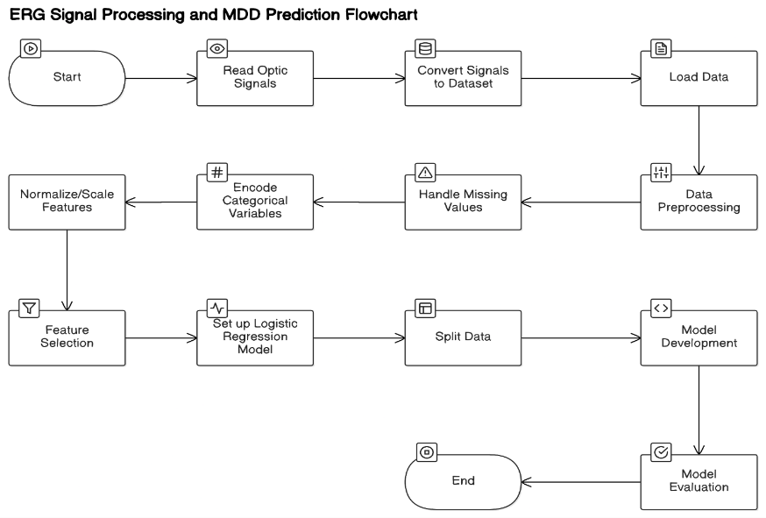
Fig. 1. ERG Signal Processing and MDD Prediction Flowchart
Fig. 1 depicts the workflow for ERG Signal Processing and Major Depressive Disorder (MDD) Prediction which starts with optic signal reading that_acquire raw Electroretinography (ERG) data from patients. These analog signals undergo transformation to produce a structured database which uses patients as individual records and features as distinct fields. The analytical system receives the dataset along with a preprocessing step to wash the data followed by column purge of unnecessary elements and uniform formatting application. Missing data is dealt with using data completion along with removal of incomplete data or through conversion of categorical variables including gender and diagnostic labels into numerical values. The normalization procedures applied to features help produce consistent values that lead to improved model performance. Model prediction accuracy increases through the selection of relevant features conducted using statistical or machine-learning based approaches. A baseline logistic regression serves as the first model before building additional neural network models based on the split training and testing datasets. Model performance assessment includes measurement of accuracy together with precision, recall and F1-score as well as confusion matrices. The workflow concludes by producing validated models which provide both predictions and clinical research insights through their deployment for application needs. Data preparation combined with enhanced model optimization through this system results in precise disorder prediction.

4.1 ERG Characteristics
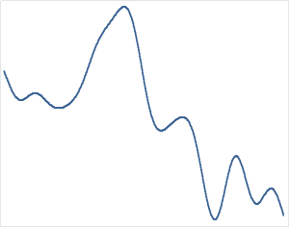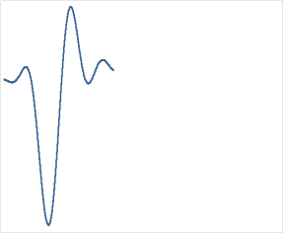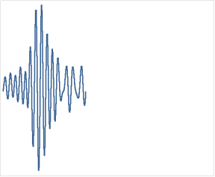
(a) (b) (c)
Fig. 2. Retinal Signals graph of different patients in form of waveform

The ERG signals in Figure 2 (a), (b) and (c) are captured from different patient’s eye. These signals are captured continuously in microvolts over a certain time and stored as .edf extension.

- Waveform Shape: The selected graphs in Fig. 2. are taken from the dataset [20] and will enable variation of the signal amplitude with time which can reveal electrical activity of the retina or ophthalmic structures.
- Peaks and Troughs: Largest values of the graph may represent strong signal events, and the lowest values may mean low signal activity.
- Baseline: The average value of the signal over time useful in determining abnormal patterns of the signal in question.

4.2 Interpretation of ERG Output
- Normal vs. Abnormal Signals: Clinically, it allows tracing deviations of the graphs shown in Fig. 2. in different patients or conditions depending on pathology.
- Temporal Patterns: When the signal is recorded over time, information about the nature of the response which is reflecting visual processing can be obtained.

4.3 ERG Signal Capturing
- Purpose: ERG is functional process that records the electrical activity of the retina that results from light exposure. It aids in judging functionality of retina based on outer retinal photoreceptors popularly known as ‘a-wave’ and the inner lying layers known as ‘b-wave’.
- Equipment: Data acquisition was obtained through a computerized electrophysiological workstation with acquisition rate optimized for high frequency content of the ERG signal most of the times up to 1 kHz.
- Protocols: The signals were recorded according to procedure norms for scotopic and photopic states of receptors as well as children and adult subjects.

Signal Processing Workflow
- Wavelet Scalogram Generation:
  - A scalogram of the ERG signals was generated by applying the CWT to enable the visualization of the intensity of the signals in relation to frequency and time. [33]
- Preprocessing:
  - 8-bit Encoding: Before further analysis to separate brightness from geometry, the Scalogram intensity was rescaled to an integer range of 0–255.
  - Binarization: To enhance the areas of interest the scalogram was further tuned using the Otsu method to transform the scalogram to a binary image.
  - Erosion: Most of artifacts were removed by connecting filter, a 3x3 kernel was applied to enhance the connected regions.
- Feature Extraction: The obtained scalogram was segmented in order to divide it into connected components, which denote regions of signal activity. These include brightness where signals were characterized by its bright and variation over time, space coordinates referring to latitude and longitude while time-frequency boundaries were extracted based on time frequency diagrams.

Graphical Representation
- Amplitude-Time Graph:
TRADITIONAL ERG analysis incorporated time-domain graphs that display a_wave and b_wave peaks and the amplitudes, latencies of various signal components.
- Wavelet Scalogram:
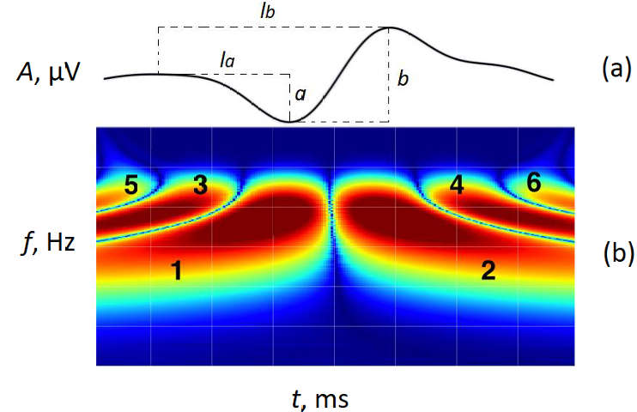
Fig. 3. Actual a – amplitude–time and b – frequency–time diagrams of the erg signal. (Ref.: 19)
Figure 3b in the scalogram is taken from the research paper [19], presents the characteristic of the response and the log-frequency of the ERG signal at regular time intervals. It shows energy distribution in terms of time and in terms of energy frequencies that are separate from time.
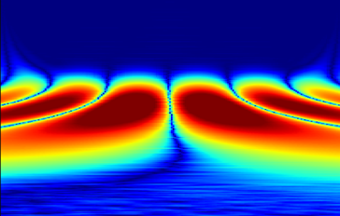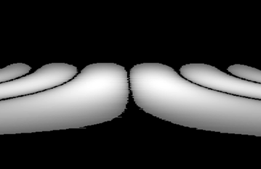
(a) (b)

(c) (d)
Fig. 4. (Cont.) Illustration of the steps for wavelet scalogram connected components.

Figure 3 and 4 taken from the research paper [19]: exemplifies preprocessing in terms of
    - (a) Raw wavelet scalogram.
    - (b) Binarized scalogram.
    - Some of the scalograms returned are: (c) Filtered binary scalogram with noise minimized.
    - (d) extracted connected components.
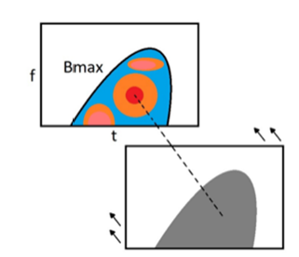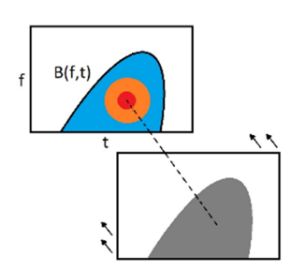
(a) (b)
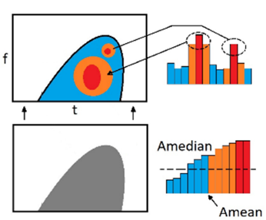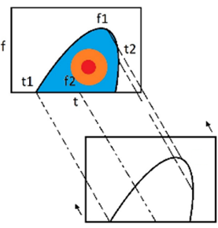
(c) (d)
Fig. 5. Parameters extracted from the wavelet scalogram of electroretinogram signal: The extracted features include the following, (a) maximum magnitude of the associated wavelet scalogram segment and (b) global maximum frequency and time of the region in wavelet scalogram segment; (c) median and mean values of the brightness of wavelet scalogram segment; (d) the global minimum and maximum frequency and time associated with wavelet scalogram segment. (Ref: 19)
- Parameter Visualizations:
Figure 5 taken from the research paper [19] explains features obtained from scalogram such as:
    - Maximum brightness (Bmax).
    - Period codes of diverse peak frequency.
    - Structural divisions pointing to the degrees of activity.
These graphical analyses are important in quantification and visualization of retinal response leading to better diagnosis.
4.4 Proposed Model Architecture
The structure of the model contains:
1.Input Layer:This is a layer that accepts 8 numerical features of inputs which have been determined to describe the characteristics of retinal response with regard to many psychological problems.
2. Hidden Layers:
- First Hidden Layer: The layer contains 64 neurons and this layer employs the Relu (Rectified Linear Unit) function. ReLU provides an element of non-linearity to the feedforward and feedback. This enables the model to identify complicated trends in the data. This enhancement can be useful in determining trends that can relate various ERG reactions with particular brain states.
- Second Hidden Layer: There are 32 neurons in this layer and ReLU is also used as the activation function. It enhances the features learnt to enhance the prediction of the model by training on particular attributes of the input data.
3. Output Layer: The Alpha name has five neurons and is composed of four letters. The neurons are all the classes of unhappy, SZ, BD, ASD and DA. The softmax activation function is employed in this layer to transform the five outputs into probabilities, which represent the classes with the largest value being the most probable class. In this way, with the help of this probabilistic method, the model is able to better interpret the ERG data with regard to the various psychological conditions.

The following steps are used to process the data that is used to come up with the proposed work:
Step 1 - Signal Acquisition
It begins with the ERG device where electrodes measure the retinal activity. Such electrodes may be a contact lens on the cornea or electrodes on the skin surrounding the eye. They retrieve the electrical impulses generated by the retina. The device captures the retinal reaction to certain light stimuli which in most cases are administered in a fixed sequence.

Step 2 - Signal Processing
The signal recorded is in analog form and it has to be converted to digital to enable further processing. The main steps in the process are:
Filtering: Deletion of artifacts of blinks, eye movements and other muscle or electrical artifacts.
Amplification: Enhancement of weak signals of the retina to be interpreted better.
Segmentation: Identifying the spikes and wavelet analysis to separate the A-wave and B-wave associated with the activity of photoreceptors and bipolar cells respectively.

Step 3 - ERG Signals Image Representation.
After the signal processing, it is converted to visual representations to be analyzed:
Spectrograms: When frequency and amplitude of an ERG signal in the time domain are inputted into a fourier transform, one or more ERG signals appear in the form of a color-coded spectrogram.
Waveform images: A time-dependent response is presented as a graph and a raw signal is presented.
Heatmaps: They are a map of the intensity of activity in the various regions of retina.
The resulting visuals can be stored as image formats as PNG and JPEG to be used in machine learning and diagnostics.

Step 4 - Annotation and Labelling.
To access the data to analysis, the images are marked with metadata, which contains:
Demographic of the patient: age, gender, medical history.
Stimulus data: kind, magnitude and time of the light stimuli.
Diagnosis: The process of assigning the images to the suitable mental health/ retinal condition that a clinician can diagnose.

Step 5 - Dataset Creation
After gathering and annotating the records, these are sorted into a dataset to be used by machine learning:
Data organization: The data will be kept in folders according to categories, such as healthy, Schizophrenia, depression.
Feature extraction: Signal attributes such as amplitude, latency etc are transformed and stored as numerical features together with the image.
Data augmentation: Model strengthening and dataset enlarging techniques, such as rotation, flipping, or adding certain noise, can be used.

Step 6 - Implementation of DNN
DNN is a model created with the help of Keras on top of the TensorFlow API, which is trained to analyze the data of ERG and identify mental disorders. The model also receives a collection of 8 input features, and each of them is a significant ERG parameter that reflects the optic response characteristics. The features include:
Age and sex: It is a demographic factor that could influence ERG readings.
a time and a amp: The timing and amplitude of the first response of the retinal, the ERG a-wave.
b_time and b_amp: Timing and amplitude of the ERG b-wave, which is a sign of the bipolar cell activation.
OP_s_Amp and OP_s_Time: Amplitudes and timing of oscillatory potentials (OP) which are associated with inner retinal processes.

5. Experimentation and Result Analysis
5.1 Load the Data
Detailed explanation of each feature in the dataset [20], focusing on their potential relevance to analyzing and predicting mental health or psychological conditions:
- id:

Description: A label used in the identification process of each individual, or record, that is contained within the dataset.
Relevance: Used more as storing mechanism rather than some sort of modelling instrument in the actual database.

- Test:
Description: Refers to the type of the ERG test conducted- In this case it is either LA3 or 30Hz.
Relevance: The varied types of tests all assess different aspects of the retinal response; knowing which test has been used is important since there could be physiological or psychological connotations connected with each particular test.

- age:
Description: The number of years of age of the participant.
Relevance: Age is an important attribute in physiological and psychological well-being, so retinal responses may differ with age.

- Ethnic:
Description: A figure numeral referring to the participant’s ethnicity; 1=white, 2=Asian, 3=Black-Caribbean, 4=Latin American, 5=mixed.
Relevance: It is possible that ethnicity has taken a toll in retinal reactions because of genes that affect eye shape or function. This can also be associated with the trends in mental disorders that is hereditary in nature.

- vert:
Description: Probably an examination of some form of function or position of the eyes in the vertical plane, though what exactly is not well understood without more information.
Relevance: Knowledge of vertical eye movement or positioning may give information on the neuro-ophthalmological diseases which may correspond to some psychological states.

- iris:
Description: A numerical value probably linked to the iris, for example, the pigmentation or the size of the iris.
Relevance: The techniques for transmission density measurements might influence Iris features thus affecting light absorption and reflection and consequently ERGs, that may indirectly interrogated facets of psychological entity such as stress response.

- Eye:
Description: This means would point to whether the right or left eye was that was tested.
Relevance: Eye-specific information is also useful as one eye can be in a different state from the other due to a number of neurological or psychological states.

- a_time:
Description: The measure of time between a trigger or stimulus and the waveform component ‘a’ in the ERG response.
Relevance: Frequencies of ERG reactivity (like a-waves) can describe the rate of visual information processing, or freshness which may be altered by mental disorders such as depression or anxiety.

- a_amp:
Description: Quantification of amplitude for the ‘a’ wave component of the ERG waveform.
Relevance: Amplitude could indicate the strength of the retinal response, the responses which may be reduced across numerous mental health pathologies.

- b_time:
Description: Measurement of the time for the ‘b’ component in the ERG response.
Relevance: Like a_time, b_time represents another variable of the ERG response related to retinal and brain activities where it can be related possibly.

- b_amp:
Description: Displacement probing including amplitude measurement for the ‘b’ component.
Relevance: Instead, here, amplitude could represent the functionality of the inner part of the retina, possibly the response to changes in neurochemistry associated with psychological well being.

- sex:
Description: A code derived from numbers showing the biological gender of the participant, where 0 = female and 1 = male.
Relevance: It is said that sex can also affect ERG responses, either through hormonal or structural differences; information that might shed light on why men and women exhibit divergent trends in mental health.

- OP_s_Amp:
Description: Gradient of oscillatory responses, This is outstanding oscillations observed in responses to ERG tests.
Relevance: OPs are related to inner retinal activity and therefore are connected with neurological and psychological conditions based on the different concentration of various neurotransmitters.

- OP_s_Time:
Description: Timing for the oscillatory potentials in patients.
Relevance: Like other timing measures, this may index the speed of retinal processing and could be related to cognitive abilities.

These features are useful in assessing the physiologic condition of the retina and whether some eye diseases might have links to some psychological disorders. It would be useful for the following reason to find more detailed information within the domain or find more context about these ERG features in psychological studies. Having more literature or studies, which associates the ERG data with the mental health, incorporating that information can definitely improve the efficiency of the model.

5.2 Feature Engineering
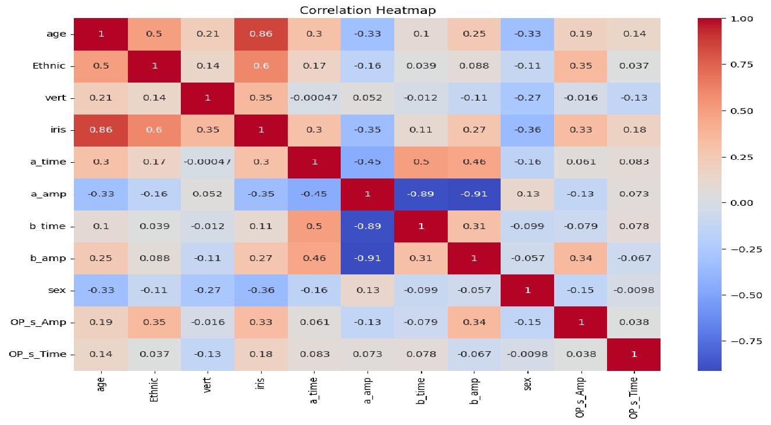
Fig. 6. To see which features could possibly be less significant, we use Correlation Heatmap.

The correlation heatmap in Figure 6 visualizes numerical feature relationships in datasets through squares that display Pearson correlation coefficients which rate the linear variable connections between -1 and +1. The coefficient measurement contains +1 for perfect positive correlation and -1 for absolute negative correlation yet shows 0 for the absence of linear affiliation. Linear relationships in datasets appear through a color scale in the heatmap displaying correlation measurements where warm tones (red/orange) denote positive relationships while cooler hues (blue) indicate negative relationships and color saturation demonstrates relationship magnitude. Each point on the heatmap diagonal panel displays a complete linear relationship (1.0) because every element perfectly matches itself. The determination of redundant features should concentrate on elements which exhibit weak correlations close to zero against the target response because they deliver minimal predictive information. Model features with high correlation against other variables should be evaluated carefully since they might produce either unstable or redundant model predictions. Select the feature exhibiting the higher correlation with the target variable then eliminate its duplicate from model selection. In ERG data analysis one could reduce redundancy by removing 'a_amp' when 'a_amp' shows high correlation with 'b_amp' because this action maintains predictive value. The low correlation of 'age' with both target and other variables warrants its elimination from consideration because its contribution to meaningful analysis is unlikely. Predictive modeling receives guidance via accurate feature selection as the heatmap provides both relevance-based ranking and relationship-oriented prioritization of variables.

5.4 Summary of Feature Engineering
To identify a person's possible mental health condition, this research looks at variables such as a_time, a_amp, b_time, b_amp, OP_s_Amp, OP_s_Time, age, and sex. These factors provide important information about how the retina functions, which is linked to mental health issues. If more background information supports their use, ethnic and eye-specific factors may also be included. These inputs help your model identify specific features and suggest a potential condition related to mental health based on the efficiency ratios of the physiological parameters.

5.5 Data Preprocessing
a. Removing Null Values - If someone does not fit into any of these independent variables, they can still be assessed based on the relevant input features set for the mental health category.
b. Adding Target Columns - To include the three target columns—Mental_health, Mental_illness, and risk—certain changes must be made to map the existing features like a_time, a_amp, b_time, b_amp, OP_s_Amp, OP_s_Time, age, and sex. To cover other types of mental health categories, some target columns are added based on the provided feature descriptions.
Target Column 1 - Mental_health (0=Healthy, 1=Unhealthy)
Healthy (0): This implies that if features fall within the normative range, that is, free of any mental disorders liabilities, then the model is viable.
Unhealthy (1): Those features, according to the tools, may point to a mental disease.
We shall use any of the above thresholds to explain the extent of the mental health condition of a patient. Let's assume the following combined criteria:
Based on the existing work [ ], a patient is labeled as having a mental health condition (mental_health_condition = 1) if:
b_time > 30 ms OR
a_amp < -30 µV OR
b_amp < 60 µV OR
OP_s_Amp < 35 µV OR
OP_s_Time > 120 ms
If not the patient is given value 0 meaning the patient has no mental health issue.
Target Column 2 - Psychiatric Disorder
- Major Depressive Disorder
- Seasonal Affective Disorder
- Schizophrenia
- Bipolar Disorder
- Autism spectrum disorder is also referred to as autism, Asperger’s syndrome, or childhood autism.
- Drug Addiction (DA)
- SZ or BD genetic risk to have children (High_Risk_SZ_BD)

Target Column 3- Risk [0 - low, 1 - medium, 2 - high]
Low (0): Small imperfections, may be as simple as a difference in size or color, which anyone can have.
Medium (1): Mild deviations indicating conditions that might have been present early in patient interactions or that might be mild versions of more severe problems.
High (2): Large discrepancies between one and other of these characteristics when serious mental health dangers are at risk.

5.5 Model Implementation
Effect Size for finding out MDD using (Random Forest Classifier)
We need ‘effect size’; this is a quantitative index of the size of the differences between the groups under consideration in the study, patients with psychiatric disorders (MDD) and normal healthy individuals.
The effect size for each feature is calculated using the formula:

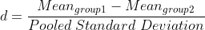 (1)

where:
Mean_{group1} = That is, the average of the feature amount of a couple of patients with a certain mental disorder.
Mean_{group2} = Mean value of the feature for Group 2 (Normal –S without mental health condition).
Pooled Standard Deviation = Standard deviation of two groups added together.

The Pooled Standard Deviation is calculated using equation:

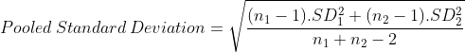 (2)

where:
n₁ = Group 1 size.
n₂ = Group 2 size.
SD₁= Standard deviation of Group 1.
SD₂= Standard deviation of Group 2.

Random Forest Classifier used in MDD

- Model Training:
- Fit the Random Forest model to the features including time of attack, amplitude of attack, time of baseline, amplitude of baseline, amplitude of optic nerve sheath diameter, time of optic nerve sheath diameter assessment, age and sex.
- Where there is MDD, code 1, and where there is no MDD, code 0 on the MDD target column.

- Prediction:
- In the Signal version, each tree of the forest decides that MDD is present.
- The last forecast is made by averaging from all trees using majority voting.

- Formula Used - Gini Impurity:
To determine the quality of splits in the trees equation (3) is used:

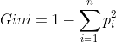 (3)

Where p_{i} is the probability of class i.

Random Forest engages many decision trees and the greatest votes to predict MDD effectively, and at the same time, have less propensity of overfitting.
Probability Score
In terms of proprietary probability score the calculation is based on the logistic regression model as per a research work [ ]. The positions of the ERG parameters were combined for each subject in a way that sought to predict whether or not a stated subject has MDD or any other psychiatric disorder.
Here's a detailed explanation of how the Probability Score is calculated:
1. Selection of ERG Parameters:
The logistic regression model uses various ERG parameters, such as:
- a-wave amplitude and implicit time (for cone and rod) have been analyzed.
- b-wave amplitude and implicit time (cone and rod responses).
- The amplitude and time of oscillatory potentials (OP).
These parameters are objective indexes of the functional state of the retina and have revealed differences in patients with psychiatric disorders.
2. Logistic Regression Model:
- Logistic regression analysis is then applied to determine the association between the chosen indices of ERG and psychiatric disorder probability.
- The model computes a sum of ERG parameters weighted by coefficients derived from the model learning procedure.
3. Formula for the Probability Score:
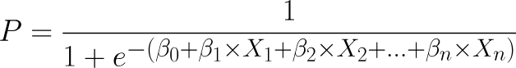 (4)

Where:
P is the probability score to have the disorder.
β_0 is the constant .
β_1, β_2, … β_ n are ERG parameters.
X_1, X_2, …, X_n are various prospective parameters of ERG including a_time, a_amp, b_time etc.
Using a cut off of >= 0.5, a score above this Cut off is an indication that the patient may be suffering from MDD. This score is calculated by applying a normalized sum of the ERG parameters to their corresponding coefficients to yield a probability of a psychiatric disorder.
Combining the characteristics of the dataset used and usual general clinical practice, below are the norms which are usually considered when evaluating patients and are unrelated to findings in psychiatric disorders:
Table 3: Normal and abnormal Values for Each Feature
Feature | Normal Value | Abnormal Value
a_time (ms) | 12-14 ms | Prolonged > 14 ms (suggesting disorder)
a_amp (µV) | 35-50 µV | Reduced significantly below 20 µV
b_time (ms) | 25-30 ms | Prolonged > 30 ms
b_amp (µV) | 100-120 µV | Reduced < 70 µV
OP_s_Amp (µV) | 12-20 µV | Reduced < 10 µV
OP_s_Time (ms) | 15-20 ms | Prolonged > 20 ms
age (years) | generally assessments are more frequent in adults over 18. | Children and elderly have different normal values.
sex (0 = Male, 1 = Female) | No direct effect. | some differences may occur.

Table 3 illustrates established thresholds for normal and abnormal ERG features which help professionals understand results for clinical use as well as scientific investigations. Industry standards function as benchmarks while unusual results can signal problems in health or disorders. A_time (the time to the negative peak) requires a duration between 10-14 ms so any extension longer than 14 ms could indicate an underlying disorder. Two fundamental tests are 'a_amp' (the a-wave amplitude) measuring 30-50 µV and 'b_time' (positive peak time) functioning between 20-30 ms. Any result below 20 µV for 'a_amp' suggests future disability and both when 'b_time' spans past 30 ms indicate disorder. A typical range for b-wave amplitude is measured from 90 µV to 120 µV, however clinical indications of errors occur when the amplitude falls below 70 µV. The oscillatory potential (OP) parameters also have critical thresholds: The 'OP_s_Amp' parameter functions at normal levels between 10-20 µV yet becomes irregular when measurements fall under 10 µV whereas 'OP_s_Time' operates within the established 14-20 ms parameters before becoming abnormal after 20 ms. Age itself does not trigger disorders but natural developmental and aging processes affect normal measurement parameters especially in children and elderly patients. The presence of sex variations in ERG responses demonstrates the requirement for interpreting results considering sex differences despite lacking evidence for clinical abnormality.

  - Applying ML Algorithms on the Updated Dataset

Classification Algorithms:
-Random Forest.
-Logistic Regression.

Clustering Algorithms:
-K-Means (accuracy=0.65) without target column
-DBSCAN (accuracy=0.81) without target column
-Agglomerative (Hierarchical) without target column

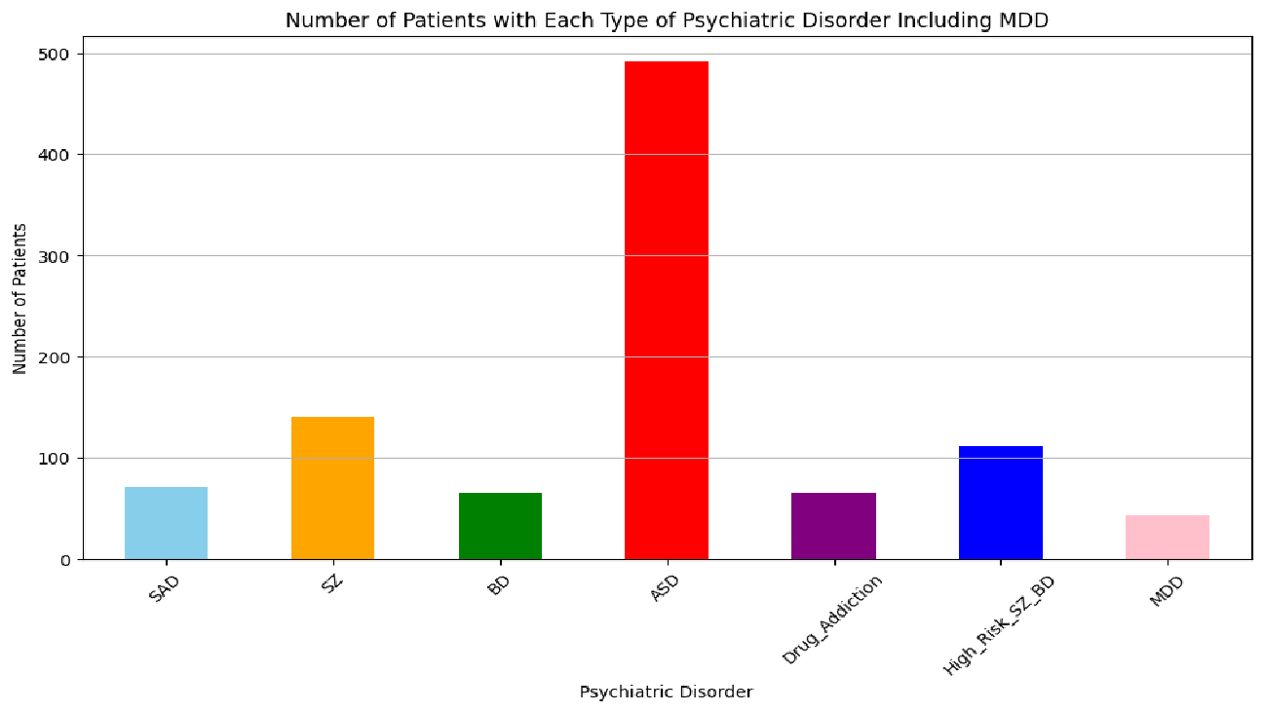
Fig. 8. Bar-graph of number of patients with each type of psychiatric disorder

The bar plot in Figure 8 illustrates the patient distribution between SAD, SZ, BD, ASD, Drug_Addiction, High_Risk_SZ_BD and MDD psychiatric conditions. The height of bars in Figure 8 shows patient diagnosis frequency for each condition included in the dataset. Each bar displays the prevalence level of its specific disorder at a size that shows how widespread the condition is so users can compare multiple disorders effectively. In the dataset's patient demographics schizophrenia (SZ) appears more prevalent than autism spectrum disorders (ASD) due to its elevated bar representation. The plot can summarize the distribution of classes in a while displaying disorder prevalence data which makes it suitable for understanding the dataset structure and evaluating initial comparisons.
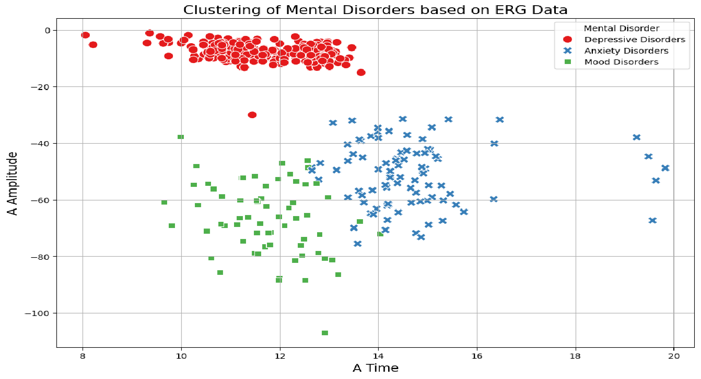
Fig. 9. K-Means Clustering of Mental Disorders

Scatter plot presented in Figure 9 displays ERG data grouped by K-means clustering then linked each group to distinct mental disorders. The process involves several steps: StandardScaler normalization applies to features 'a_time' 'a_amp' 'b_time' and 'b_amp' because it maintains uniform feature weight before they proceed to a missing value cleanup that eliminates hazards within K-means clusters for incomplete data. The elbow method helps decide how many clusters (for example k=3) exist while K-means classifies each data point into respective clusters. The cluster labels undergo hypothetical disorder assignment for expert validation although this process depends on(domain expert confirmation). A scatter plot visualized through the Seaborn library shows two chosen features 'a_time' and 'a_amp' as data points which receive distinct visual markers and color coding based on mental disorder diagnoses. In the plots displayed by the visual representation each data point embodies an ERG measurement from an individual participant. The analysis will detect meaningful group differences through clustered points but depends heavily on optimal feature selection and k value selection alongside precise cluster-to-mental disorder assignments. For reliability assessment of cluster results alongside their interpretations, the use of domain expert validation and statistical evaluation along with external data sources is essential.

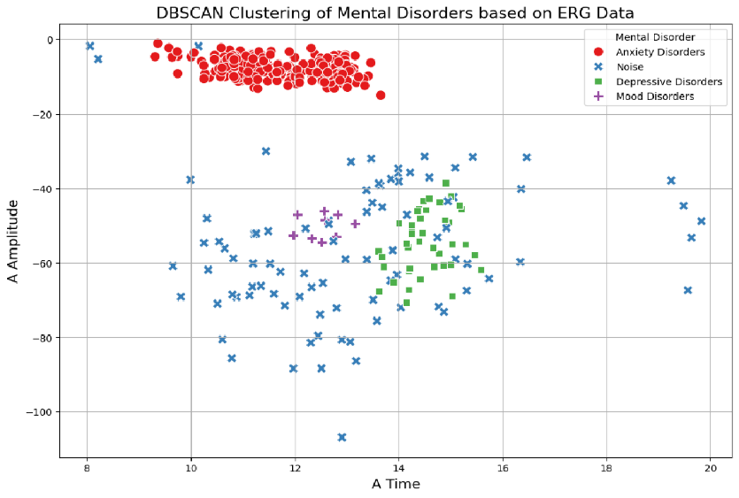
Fig. 10. DBSCAN Clustering of Mental Disorders
A scatter plot in Figure 10 displays DBSCAN clustering results from electroretinogram (ERG) data where different clusters correspond to theoretical mental disorders. Generic features such as 'a_time', 'a_amp', 'b_time', and 'b_amp' undergo selection prior to missing value removal and all data is normalized using StandardScaler for equitable distance-based calculation contributions. DBSCAN clustering is implemented with EPS set to 0.5 points and MIN_SAMPLES set to 5 to identify dense clusters. Due to the clustering algorithm the resulting labels contain a "-"1 value to mark points as noise since these points exist outside cluster boundaries. Cluster labels based on hypothetical assignments function as mental disorder classifications where noise points receive the label "Noise." The visualization created with Seaborn displays clustered data where 'a_time' and 'a_amp' form the axes, and each mental disorder type gets distinct markers and color combinations for cluster identification. The objects controlling plot elements such as titles and axis labels and legends make the data easier to comprehend. The plot deploys dense clusters to show data similarities yet noise points function as outlier indicators. The clustering success of DBSCAN gets determined by proper value selection in eps and min_samples parameters although these need adjusted settings for achieving best outcomes. The conjectural linking of clusters with mental disorders requires replacement by established clinical relationships between mental disorders and their corresponding clusters. Appropriate feature selection methods together with silhouette score validation metrics serve as essential elements to guarantee the accuracy and reliability of clustered data.

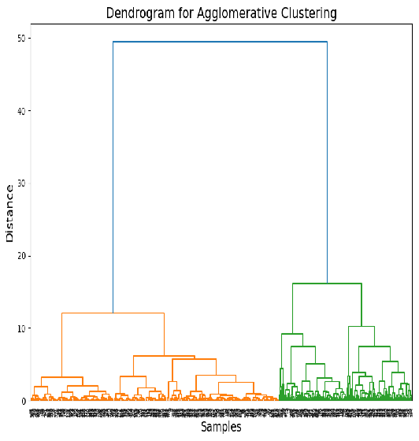
Fig. 11. Dendrogram for Agglomerative Clustering

A dendrogram forms a tree-like diagram in agglomerative clustering systems to illustrate the hierarchical data point and cluster connections as presented in Figure 11. This chart displays cluster dissimilarity values on its vertical scale and shows individual data points and clusters across the horizontal dimension. The clustering process occurs through successive merges that show cluster dissimilarities through their height positions and clearer similarities emerge from lower heights. To select final clusters researchers can draw a horizontal line across the dendrogram until it intersects vertical lines since this number indicates selected clusters. Through Ward linkage methodology this process produces clusters that display clear borders and concentrated internal structures. A dendrogram analysis reveals the hierarchical data structure which helps users discover clustering points that show group separations and better grasp the data point relationship patterns.

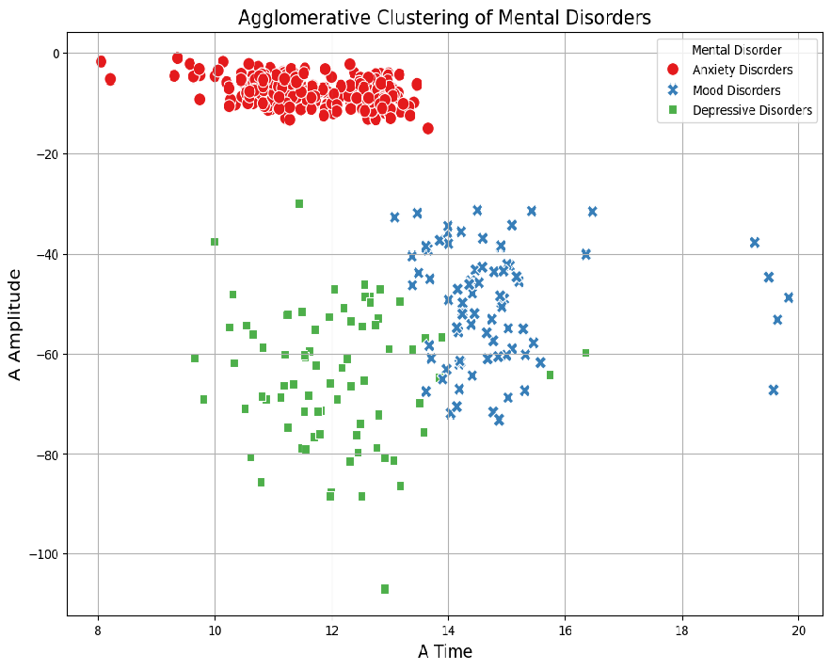
Fig. 12. Agglomerative Clustering of Mental Disorder

Figure 12 shows a scatter plot of agglomerative clustering to visualize mental disorder grouping based on data point similarity for electroretinogram (ERG) features 'a_time' and 'a_amp'. The scatter plot displays individual ERP data points using 'a_time' values on the x-axis together with 'a_amp' measurements on the y-axis. The algorithm-based clustering produced groups which are displayed through point visualization with colors matching assigned mental disorders. This clustering technique identifies data clusters of closer feature-point relationships which reveal common parameters across ERG data sets. Hypothetical mental disorder labels such as "Anxiety Disorders" or "Depressive Disorders" and "Mood Disorders" need clinical verification to demonstrate valid interpretation.

5.7 Deep Learning Model Implementation

1. Implemented Model Architecture dashboard pertaining to the nature of the implementation project.
The model architecture in Fig. 13 consists of the following:
1. Input Layer: This layer takes features as input, they are 8 numeric values: ‘Age’, ‘Sex’, ‘a_time’, ‘a_amp’, ‘b_time’, ‘b_amp’, ‘OP_s_Amp’, ‘OP_s_Time’.

2. Hidden Layers:
The first hidden layer has 64 neurons activation function which is ReLU (Rectified Linear Unit). Adding ReLU helps bring the non-linear component in the model to make it learn co-relations.
The second one contains 32 neurons, and the activation function of them is ReLU once more.

3.Output Layer: The output layer was designed to contain five neurons where each neuron represents one of the five targeted mental disorder classes ‘SAD’, ‘SZ’, ‘BD’, ‘ASD’, ‘DA’. The layer used is softmax activation function that gives probality distribution over the classes which sum to 1. The class of maximum probability is the forecast group.

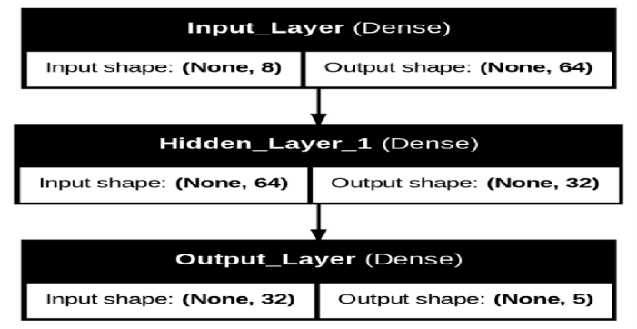
Fig. 13. Layers of the Deep-Learning Model

Figure 13 displays the Artificial Neural Network (ANN) architecture employed for mental disorder classification together with its linkages between network layers and input shapes. The model applies the Input Layer which contains 8 neurons representing the 8 features found in the dataset (such as Age and Sex and a_time and a_amp). This layer distributes input data to the system allowing the network to analyze each characteristic independently. The first Hidden Layer contains 64 neurons which perform weighted summation followed by Rectified Linear Unit (ReLU) nonlinear transformation to generate relevant patterns from the data input. The second Hidden Layer consists of 32 neurons that perform private ReLU activations to achieve more sophisticated relationships between input data and target classes. The neural network model uses five nodes in the Output Layer so it can classify each instance into one of the five recognized mental disorders. The prediction selects the class with the highest value obtained after applying the softmax activation function to raw output values. During training the model learns weights in its various connections which control the strength of the impact each neuron has on others. The image shows layer shapes where output features the dimension (None, 5) which represents an arbitrary batch size alongside five predicted output classes. The ANN system architecture uses its input layer for feature handling and its two hidden layers employing ReLU for pattern learning followed by output-layer softmax activation which enables multi-class categorization by effectively routing trained inputs to correct mental disorder identification.
2. Model Compilation
The model is overall compiled with:
-Optimizer: Adam optimizer which is a gradient based optimizer commonly used in deep learning because of the helpful features that include the adaptive learning rate.
-Loss Function: This is because the target variable y is in integer-encoded form, thus we use sparse_categorical_crossentropy. This loss function calculates the cross entropy loss between the tensor of given class probabilities and the vector of integer encoded labels.
-Metrics: Accuracy is used to measure the performance and other things of the model.

3. Training the Model
The model is trained using:
-has been fitted by using the fit() method where epochs are set to 50.
-Batch size = 16, that is the model takes 16 samples at a time before updating weights.
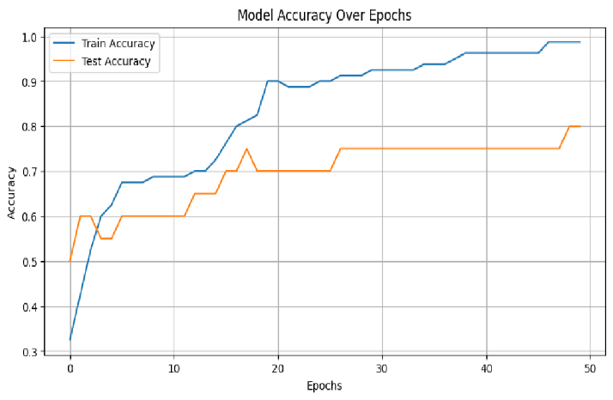
Fig. 14. Deep-Learning Model Accuracy Graph
4. Evaluation
The model is examined on both the training and testing sets shown in Fig. 14
train_loss, train_accuracy: The model's performance on the training data.
test_loss, test_accuracy: The model's performance on the test data. This helps determine if the model generalizes well or if it overfits to the training data.

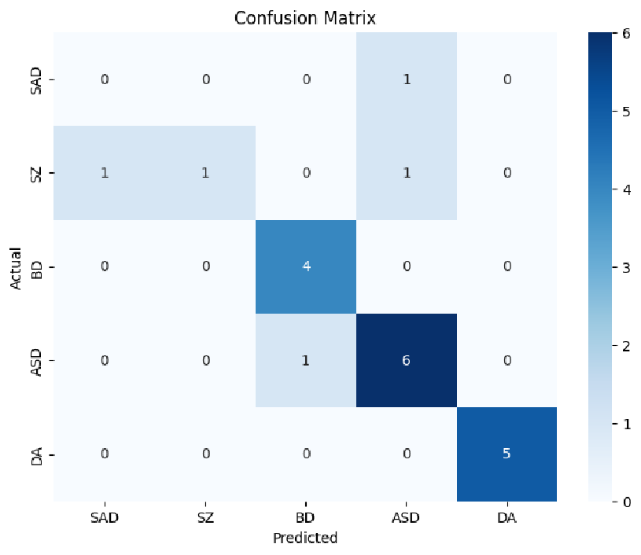
Fig. 15. Confusion Matrix for the Mental Disorders
5.7 Prediction
The model predicts classes for the test set:
-a distribution of probability for each sample in X_test_scaled is generated by predict().
-argmax() selects the index with the highest probability for each sample, converting it to a class prediction.

Predicting Mental Disorder for new Patient Data
Patient Data 1:
Input Features:
'Age': 30, 'Sex': 0, 'a_time': 60, 'a_amp': 25, 'b_time': 50, 'b_amp': 35, 'OP_s_Amp': 20, 'OP_s_Time': 100
DL Model Prediction: Autism Spectrum Disorder

Patient Data 2:
Input Features:
'Age': 40, 'Sex': 1, 'a_time': 80, 'a_amp': 60, 'b_time': 70, 'b_amp': 50, 'OP_s_Amp': 15, 'OP_s_Time': 90
DL Model Prediction: Drug Addiction

6. Model output Visuals
Several visualizations are provided to help interpret the model's performance:
- Accuracy over Epochs: Plots training and validation accuracy over time to see how the model's performance changes over epochs.
- Confusion Matrix: A heatmap of the confusion matrix shows the actual vs. predicted class counts.
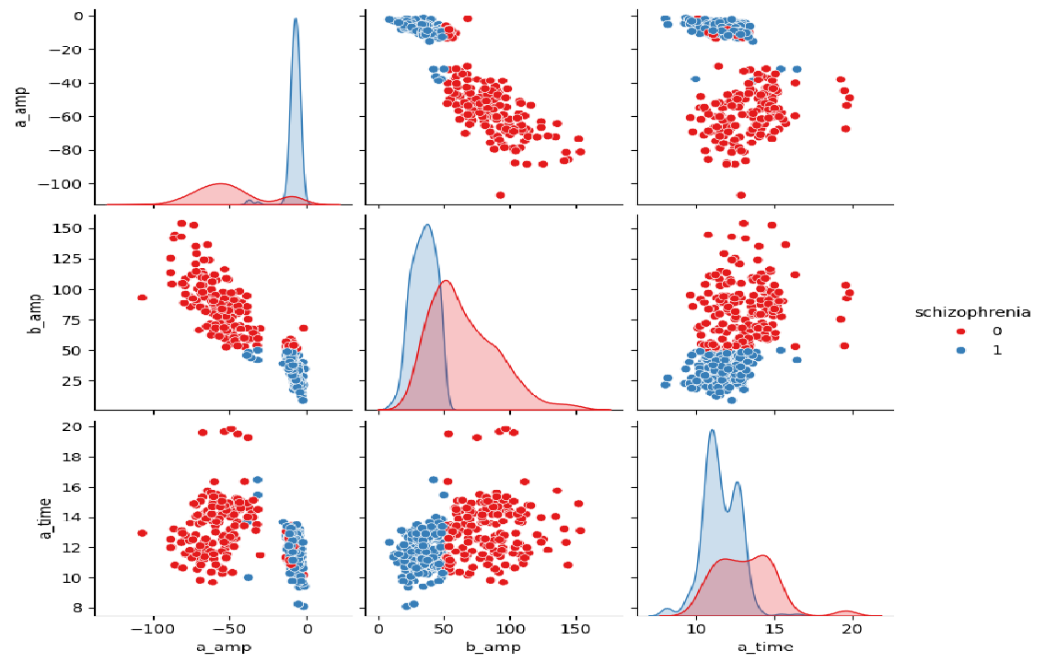
Fig. 16. Plot for Schizophrenia vs input feature

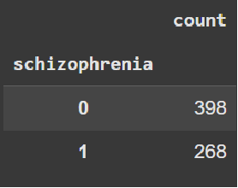
Fig. 17. Count of patients suffering (1) vs not suffering (0) from Schizophrenia

Figure 17 follows up with two key investigations about patients' schizophrenia status while using deep learning models to evaluate their diagnosis through different features. The dataset utilizes pandas to read its data while implementing error compensation for missing files. The deep learning model completes its production definition then receives training before it generates predictions for data in the testing phase. The predicted schizophrenia results (0 or 1) match original data containing schizophrenia case counts. A summary report shows the prediction results for schizophrenia cases. Patients who match schizophrenia criteria receive visual confirmation of prediction probabilities from the model.
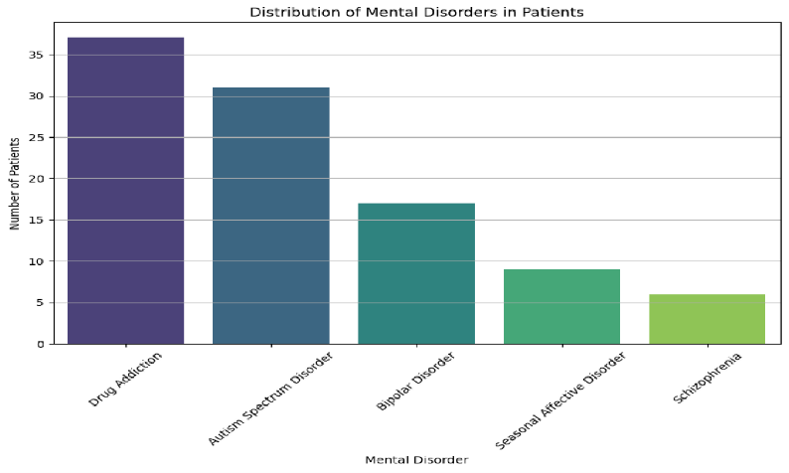
Fig. 18. Bar plot showing distribution of Mental Disorders in Patients

The bar plot uses the 'viridis' color scale to create visual differences among bars alongside protective title elements and clear axis labels and gridlines for improved understanding. The bar plot displays the predicted quantities of disorders from the test data so researchers can directly compare the different diagnostic categories.
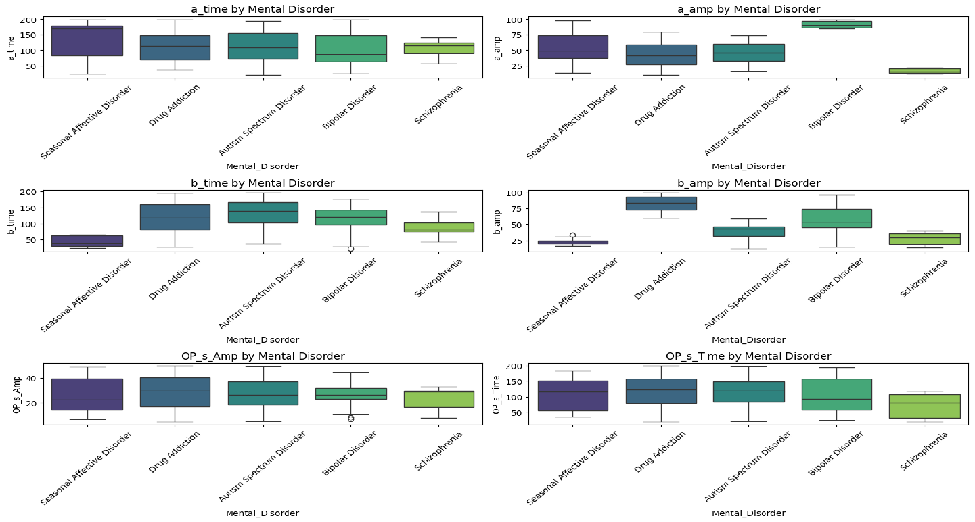
Fig. 19. Boxplot of Mental Disorder with individual input feature

The relationship between mental disorders and each feature in Figure 19 appears through box plots which display the distribution of 'a_time' and 'a_amp' and other ERG features across mental disease groups. The plot shows mental disorders ('SAD' 'SZ' 'BD') written along the x-axis and the measured values of ERG features positioned along the y-axis. The split between first and third quartiles (Interquartile range: IQR) for each feature emerges from the boxes alongside a representation of median values through box middle points. Data outliers appear separately as points yet the plot's range extends through its thin parts and excludes these exceptional observations. The comparison of median lines and IQRs across different disorders enables us to detect meaningful variations in ERG distribution patterns. Diagnostics based on these metrics demonstrate more potential when features display meaningful differences in median values across disorders. Laboratory results which deviate from typical responses hold the potential to uncover new clinical information. Significant overlap in distributions across different disorders demonstrates that such features show minimal capability to differentiate among those disorders.
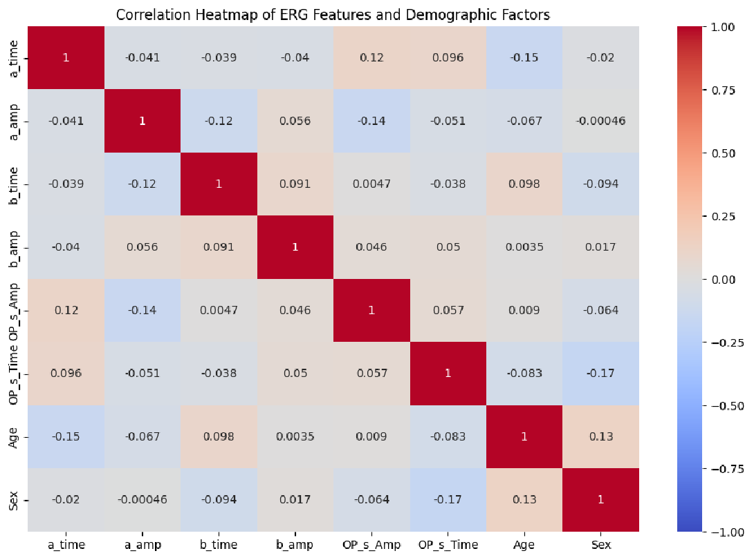
Fig. 20. Correlation Heat-map of Electroretinogram Features and Demographic Factors

Figure 20 depicts a correlation heatmap presenting all possible pair-wise coefficients between ERG features alongside demographic factors to provide information about variable connections. The color intensity in the heatmap represents the strength and direction of the correlation: Red signifies positive correlations that emerge when change in a feature triggers matching changes in an associated value. Meanwhile blue marks negative correlations which occur when one feature's rise leads to companion feature declines. White areas and almost-white sections show no discernible correlation. Theheatmap's numerical valuesreveal actual correlation coefficients ranging from -1 to +1 with strong correlations shown near 1 or -1 yet weak or absensela linear relationship indicated by values near zero. This visual display helps you detect relationships between demographic characteristics and ERG measures as well as connections between ERG measures themselves. The technique enhances feature selection abilities while expanding data relationship understanding which may lead future analysis and model building.
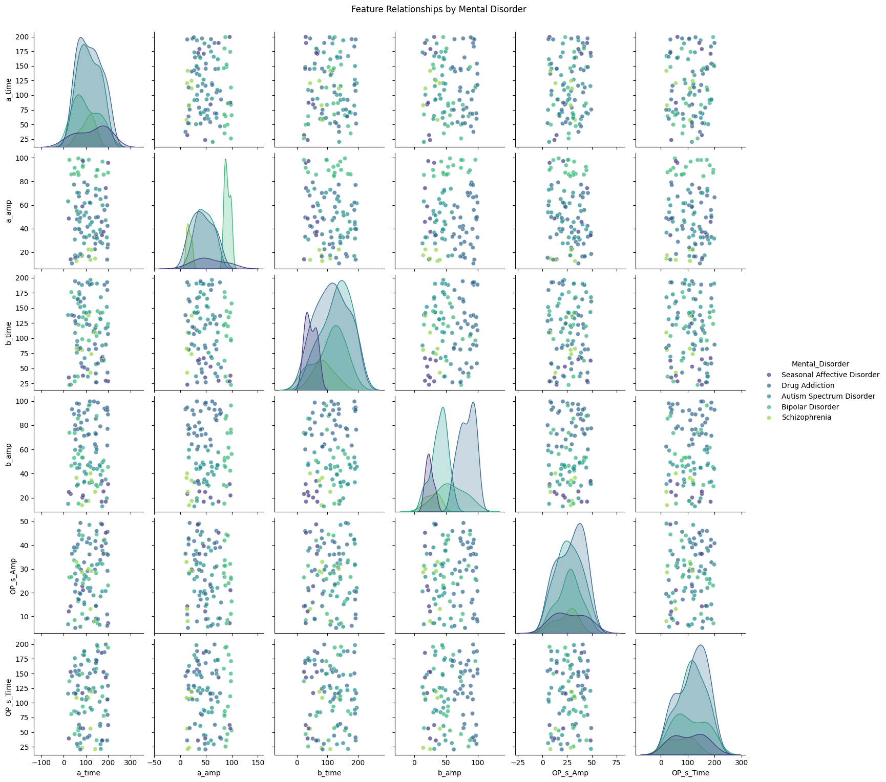
Fig. 21. Plot of feature relationship by Mental Disorder

Figure 21 presents pair plots of mental disorder categories alongside ERG input features that depict multiple variable connections which highlight data clusters and associations between different disorders. Each small area in pair plots shows correlations of two ERG features where diagonal plots present single-feature distributions while off-diagonal plots show feature pair scatter patterns. Scatter plots in this visualization use different colors to represent mental disorder groups including SAD, SZ, BD, ASD and DA. Within each medical disorder the visualization reveals the strength of correlations between pairs of features and therefore shows how features separate or cluster. Based on these points distinct from one another it seems possible to distinguish mental health conditions using combined ERG feature evaluations. The hypothesis is supported since 'SAD' disorder types position themselves distinctly from other disorders through lower 'b_amp' and 'a_amp' measurement values. The pair plot reveals important relationships and possible non-linear correlations between features that guide future analytical assessments.

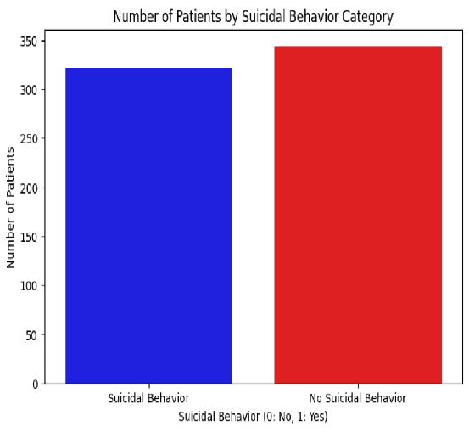
Fig. 22. Bar plot of number of patients by Suicidal Behavior Category

Figure 22 presents two suicidal behavior categories (0 and 1) depicted along the x-axis to display patient counts along the y-axis. The bars in the plot present a visualization of counts from individual categories of patients. Model performance could be adversely affected when a dataset displays excessive inequality between its two categories and this issue requires stabilization methods such as oversampling, undersampling and class weighting to be incorporated in the model training process.

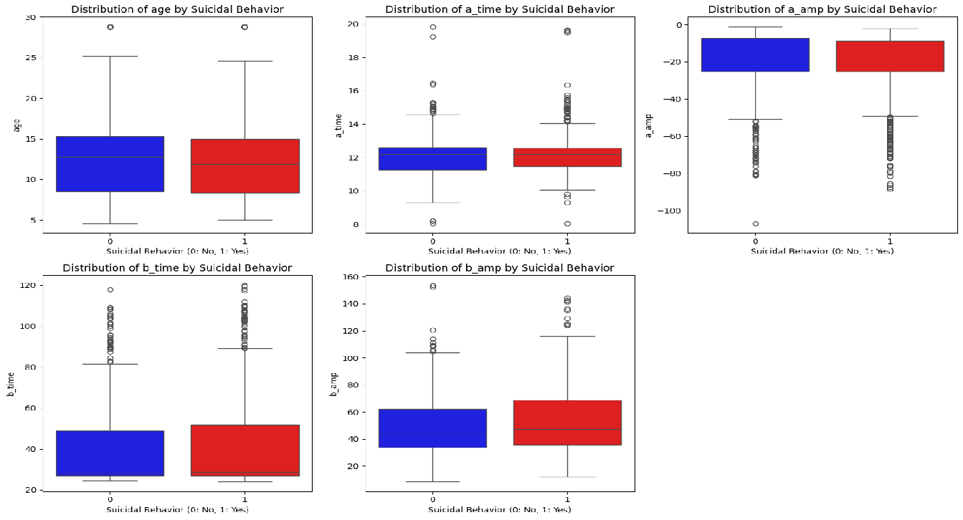
Fig. 23. Box plot for suicidal behavior analysis with respect to each input feature

The box plots shown in Figure 23 demonstrate how different ERG input features including 'age' and 'a_time', 'a_amp' etc., distribute across suicidal behavior categories between 0 and 1. Each box plot features a median line for showing central values in addition to an interquartile range box containing middle data values between the 50 percent points. Outliers plot individually and the whiskers extend to values situated 1.5 times the IQR from the box edges. These box plots enable visual detection of central value shifts along with distribution variations and outlier frequencies between both groups. The higher 'a_amp' median values among suicidal behavior groups beyond non-suicidal groups along with minimal intersection of IQRs indicates that 'a_amp' potentially signals suicidal activities. These plot visualizations help detect relationships between EEG signals and suicidal behavior which potentially guide predictive modeling approaches.

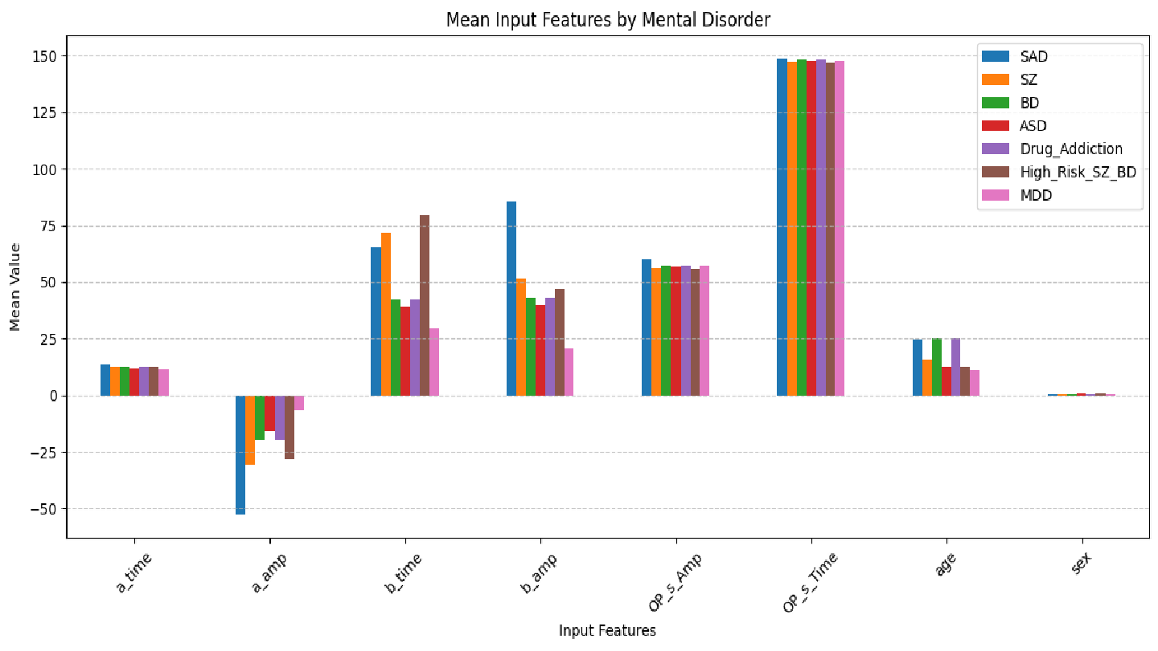
Fig. 24. Graph of mean input features by mental disorder

Figure 24 presents a bar plot where different electroretinogram (ERG) features 'a_time', 'a_amp', 'b_time', etc., show their mean values for Seasonal Affective Disorder, Schizophrenia and Bipolar Disorder coupled with other patient groups. This visual representation shows ERG feature mean values grouped by mental disorder for direct cross-disorder evaluations. Separate coloring throughout the plot distinguishes each mental disorder from others thereby facilitating easy screening of disorder types. The y-axis lists mean pre-condition values, but the x-axis depicts the ERG features. This chart enables researchers to detect fundamental differences in ERG responses between mental illnesses that may represent diagnostic or predictive biomarkers. This visualization establishes connections between ERG feature mean values and different mental health disorders enabling potential research development.
Table 5: Model Evaluation Metrics
ML Model | Type of Metric | Accuracy Type
 | Silhouette Score | Clustering Accuracy
K-Means | 0.61 | 0.66
DBSCAN | 0.42 | 0.8
Agglomerative  Clustering  (Hierarchical) | 0.58 | 0.66
 | Train Accuracy | Test Accuracy
Random Forest | 1.00(due to overfitting, fixed later) | 0.988
Logistic Regression | 0.999 | 0.824
DL Model | Training Accuracy | Testing Accuracy
Deep neural network | 0.95-0.99 | 0.75

The Silhouette Score within the clustering metrics surface indicates cluster separation ability whereas Clustering Accuracy reveals model accuracy in correct data grouping. Higher Clustering Accuracy at 0.81 emerges from DBSCAN Clustering although K-Means Clustering delivers a slightly better Silhouette Score of 0.60 yet with a Clustering Accuracy of 0.65. The Silhouette Score for Agglomerative (Hierarchical) Clustering amounts to 0.59 while its Clustering Accuracy reaches 0.65. The analysis shows Random Forest achieved a 1.00 Train Accuracy due to overfitting yet exhibited a reduced 0.98 Test Accuracy while Logistic Regression reached 0.99 Traj finished accuracy with 0.825 Test Accuracy. The Deep Neural Network shows Training Accuracy between 0.95 to 0.99 while testing performs at 0.75 suggesting a challenge for generalization. A comparative analysis through this table reveals how these models perform in different scoring modes under evaluation conditions.

7. Threat to Validity

It will be essential to conduct clinical trials that would establish how accurate the application is in diagnosing real-world markets. Collaboration with mental health experts in assessing the usability and clinical relevance will serve to make sure the application satisfies the requirements of both clinicians and patients. To achieve clinical use, the regulation approvals and certifications required on medical equipment will be required. This will be done by adhering to the health regulations, demonstrating the effectiveness and safety of the application by conducting extensive testing. Finally, federated learning methods may help overcome the problem of privacy since the application may be trained on decentralized ERG data. The approach retains sensitive patient data in a localized location and yet enjoys the benefits of shared knowledge with various sources. The scalability and reliability of the application can also be enhanced by federated learning and this makes it more appropriate in various clinical environments.

8. Conclusion and Future Research Directions
The conclusion of this paper represents a crossover point of technology and mental health diagnostics. The creation of a mobile application tapping into Electroretinography (ERG) data to classify psychological conditions is a new direction to a more objective and scientifically based method of assessing mental health. As has been seen in this paper, there is promise that ERG can be used as a useful biomarker in a number of conditions like schizophrenia, depression and bipolar disorders. Historically, the subjective assessment of diagnosing these disorders has been largely used to make diagnoses, and it may result in inconsistency and delayed diagnoses. With the aid of ERG data, this mobile application aims to close the gap between subjective clinical assessment and objective physiological clinical results, which would increase the accuracy and reliability of the diagnosis.
This article used a deep neural network framework to analyze and categorize ERG responses and exhibited how novel computational frameworks can derive useful information out of biological measurements. Such a solution enhances the accuracy of diagnosis and supports the processing of data in real-time, allowing the user to have an active role in managing mental health. This paper has implications beyond the academic contributions and it can be used to transform clinical practices in the field of psychiatry. This application has the potential to change the way clinicians diagnose and treat patients by offering them a scalable and objective way of diagnosing mental health disorders and shifting towards a more personalized and data-driven way of treating patients. The possibility of this application to transform the mental health assessment and management is enormous, and it is possible to imagine the time when care will be more available, efficient, and evidence-based.
This paper has a potential of scope in the long run that lies beyond its current application. A number of research and development opportunities can be used in the future to increase the effectiveness of the application and its influence. Further research is necessary to consider a bigger and more representative sample that covers different groups and their characteristics, such as age, ethnicity, and socio-economic status. This will aid in fine tuning the machine learning model and make them applicable to various populations. Longitudinal research may also help in understanding the trend in the ERG patterns among mentally ill people as time goes by. It would improve the predictive performance of the application and enable more efficient tracking of the responses to the treatment. Further research into how ERG data can be combined with other biomarkers (genetic data or neuroimaging results) may also be investigated in the future to develop a more holistic diagnostic instrument that covers various aspects of mental health.
References –
[1] Silverstein, S. M., & Rosen, R. (2015). Schizophrenia and the eye. Schizophrenia Research, 162(1-3), 1-2. https://doi.org/10.1016/j.schres.2015.10.024
[2] Peredo, A., et al. (2022). Retina as a potential biomarker in schizophrenia spectrum disorders: a systematic review and meta-analysis of electroretinographic findings. BMC Psychiatry, 22, 718. https://doi.org/10.1186/s12888-022-04375-4
[3] European Patent Office. (2015). EP2956056B1. European Patent Office. Retrieved from https://www.epo.org
[4] Youssef, P., Nath, S., Chaimowitz, G. A., & Prat, S. S. (2019). Electroretinography in psychiatry: A systematic literature review. European Psychiatry, 62, 97-106. https://doi.org/10.1016/j.eurpsy.2019.09.006
[5] Bubl, E. (2023). Electroretinographic anomalies in medicated and drug-free patients with major depression: Tagging the developmental roots. Journal of Affective Disorders. https://doi.org/10.1016/j.jad.2023.09.004
[6] Fam, J., et al. (2013). Electroretinographic changes in major depressive disorder: An exploratory study. Journal of Affective Disorders, 147(1-3), 88-93. https://doi.org/10.1016/j.jad.2012.11.017
[7] Maziade, M., et al. (2018). Electroretinographic findings in schizophrenia: A systematic review. European Psychiatry, 62, 97-106. https://doi.org/10.1016/j.eurpsy.2019.09.006
[8] Hébert, M., et al. (2015). Retinal function in schizophrenia: A review of electroretinographic studies. Journal of Psychiatric Research, 68, 92-99. https://doi.org/10.1016/j.jpsychires.2015.06.002
[9] Balogh, A., et al. (2008). Retinal function in schizophrenia: An electroretinographic study. Psychiatry Research, 157(1-3), 219-225. https://doi.org/10.1016/j.psychres.2007.04.017
[10] Hébert, M., et al. (2004). Electroretinographic changes in patients with seasonal affective disorder. Biological Psychiatry, 55(11), 1027-1032. https://doi.org/10.1016/j.biopsych.2003.12.005
[11] Lavoie, S., et al. (2009). The impact of light therapy on retinal function in seasonal affective disorder: An electroretinographic study. Journal of Affective Disorders, 116(3), 195-199. https://doi.org/10.1016/j.jad.2009.01.017
[12] Vandewalle, G., et al. (2011). Retinal sensitivity in seasonal affective disorder: An electroretinographic study. Psychiatry Research, 186(2-3), 198-203. https://doi.org/10.1016/j.psychres.2010.08.012
[13] Gagrat, S., et al. (1979). Electroretinographic abnormalities in schizophrenia: A preliminary report. Archives of General Psychiatry, 36(5), 521-524. https://doi.org/10.1001/archpsyc.1979.01780050011001
[14] Demmin, D. L., et al. (2018). The role of the retina in major depressive disorder: A review of the literature. Journal of Affective Disorders, 229, 23-29. https://doi.org/10.1016/j.jad.2017.12.060
[15] Nasser, A., et al. (2019). Electroretinographic findings in patients with eating disorders. Eating Behaviors, 34, 101-104. https://doi.org/10.1016/j.eatbeh.2019.04.002
[16] Ritvo, R. S., et al. (1988). Electroretinographic abnormalities in autism: A preliminary study. Journal of the American Academy of Child & Adolescent Psychiatry, 27(3), 353-356. https://doi.org/10.1097/00004583-198805000-00016
[17] Fornaro, M., et al. (2011). Role of retinal function in the assessment of major depressive disorder: Electroretinographic findings. Journal of Affective Disorders, 132(1-2), 327-331. https://doi.org/10.1016/j.jad.2011.03.021
[18] Gagné, A. M., et al. (2018). Characterizing electroretinographic alterations in schizophrenia: A longitudinal study. European Psychiatry, 55, 43-50. https://doi.org/10.1016/j.eurpsy.2018.09.005
[19] Aleksei Zhdanov, Anton Dolganov, Vasilii Borisov, Mikhail Ronkin, Vyacheslav Ponomarev, Dario Zanca, September 16, 2022, "OculusGraphy: Ophthalmic Electrophysiological Signals Database", IEEE Dataport, doi: https://dx.doi.org/10.21227/r1wb-pg25.
[20] https://open.flinders.edu.au/articles/dataset/ERG_Dataset/14747349?file=28335951
[21] https://ieee-dataport.org/documents/oculusgraphy-ophthalmic-electrophysiological-signals-database
[22] Raymond W. Lam, Craig W. Beattie, Alan Buchanan, Joseph A. Mador, Electroretinography in seasonal affective disorder Psychiatry Research, Volume 43, Issue 1, 1992, Pages 55-63, ISSN 0165-1781, https://doi.org/10.1016/0165-1781(92)90141-O.
[23] Marc Hébert, Craig W Beattie, Edwin M Tam, Lakshmi N Yatham, Raymond W Lam, Electroretinography in patients with winter seasonal affective disorder, Psychiatry Research, Volume 127, Issues 1–2, 2004, Pages 27-34, ISSN 0165-1781, https://doi.org/10.1016/j.psychres.2004.03.006
[24] Lavoie, M.-P., Lam, R. W., Bouchard, G., Sasseville, A., Charron, M.-C., Gagné, A.-M., Tremblay, P., Filteau, M.-J., & Hébert, M. (2009). Evidence of a biological effect of light therapy on the retina of patients with seasonal affective disorder. Biological Psychiatry, 66(3), 253-258. doi:10.1016/j.biopsych.2008.11.020
[25] Gerbaldo H, Thaker G, Tittel PG, Layne-Gedge J, Moran M, Demisch L. Abnormal electroretinography in schizophrenic patients with a history of sun gazing. Neuropsychobiology. 1992;25(2):99-101. doi:10.1159/000118816. PMID: 1625783
[26] Warner, R., Laugharne, J., Peet, M., Brown, L., & Rogers, N. (1999). Retinal function as a marker for cell membrane omega–3 fatty acid depletion in schizophrenia: a pilot study. Biological Psychiatry, 45(9), 1138-1142. doi:10.1016/S0006-3223(98)00379-5
[27] Balogh Z, Benedek G, Kéri S. Retinal dysfunctions in schizophrenia. Prog Neuropsychopharmacol Biol Psychiatry. 2008 Jan 1;32(1):297-300. doi: 10.1016/j.pnpbp.2007.08.024. Epub 2007 Aug 28. PMID: 17889979.
[28] Marmor M.F., Hock P., Schechter G., Pfefferbaum A., Berger P.A., Maurice R. Oscillatory potentials as a marker for dopaminergic disease. Doc. Ophthalmol. 1988;69:255–261. doi: 10.1007/BF00154406
[29] Katelyne Tursini, Steven Le Cam, Raymund Schwan, Grégory Gross, Karine Angioi-Duprez, Jean-Baptiste Conart, Irving Remy, Florent Bernardin, Vincent Laprévote, Eléa Knobloch, Tiphaine Ricaud, Aline Rahnema, Valérie Louis-Dorr, Thomas Schwitzer, Visual electrophysiology and neuropsychology in bipolar disorders: A review on current state and perspectives,Neuroscience & Biobehavioral Reviews, Volume 140, 2022, 104764, ISSN 0149-7634,h ttps://doi.org/10.1016/j.neubiorev.2022.104764.
[30] Hébert M, Gagné AM, Paradis ME, Jomphe V, Roy MA, Mérette C, Maziade M. Retinal response to light in young nonaffected offspring at high genetic risk of neuropsychiatric brain disorders. Biol Psychiatry. 2010 Feb 1;67(3):270-4. doi: 10.1016/j.biopsych.2009.08.016. Epub 2009 Oct 14. PMID: 19833322
[31] Ritvo, E., Creel, D. J., Realmuto, G., Crandall, A., & others. (1988). Electroretinograms in Autism: A Pilot Study of b-Wave Amplitudes. American Journal of Psychiatry, 145(2), 229-232. doi:10.1176/ajp.145.2.229
[32] Monique Roy, Alec Roy, David Smelson, Stafford Brown, Lawrence Weinberger, Reduced blue cone electroretinogram in withdrawn cocaine dependent patients: A replication, Biological Psychiatry, Volume 42, Issue 7, 1997, Pages 631-633, ISSN 0006-3223, https://doi.org/10.1016/S0006-3223(97)00294-1.
[33] Zhdanov, A., Dolganov, A., Zanca, D., Borisov, V., & Ronkin, M. (2022). Advanced Analysis of Electroretinograms Based on Wavelet Scalogram Processing. Applied Sciences, 12(12365). https://doi.org/10.3390/app122312365

