LASER PROCEDURE

OPO and picoTRAIN lasers (SEQ-86 & 87)

**LASER INFORMATION**

APE Levante OPO, 800-1400 nm, pulsed, glasses: OD > 4

HighQ Laser Picotrain IC-1064-1000/532-4000, 1064 nm + 532 nm, pulsed, glasses: OD > 4

**TURN ON**

1. Turn on the keys of the two boxes on the upper shelf of the optical table (Figure 1).
2. Open the two shutters at the back of the picoTRAIN laser. The green laser beam that pumps the OPO will appear, and the second beam is the 1064 nm output (only visible with a detection card).
3. Change the OPO wavelength using the monitor near the computer (Figure 2).
4. Change the OPO power using the half waveplate near the polarizing beam splitter at the output of the laser.
5. If there is no signal coming out of OPO or if it is written “NO SIGNAL” on the OPO monitor, play a little bit with the knob on the front side of the OPO to change the mirror position inside the laser cavity.

**TURN OFF**

1. Close the two shutters at the back of the picoTRAIN laser.

**EMERGENCY TURN OFF**

1. Turn off the two keys of the two boxes on the upper shelf (Figure 1).

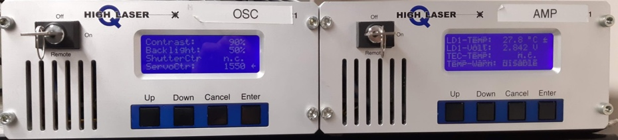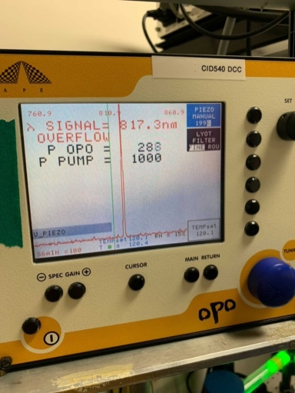

*Figure 2*

*Figure 1*