 | FROG  Field Redaction & Obfuscation Gadget  Team User Guide  Applies to FROG v1.1.x | July 2026

Purpose
Use FROG to replace likely personal data in support logs before pasting the scrubbed result into an approved LLM chat tool. FROG runs locally and preserves repeated-value relationships so technical diagnosis remains meaningful.

Important
FROG is a risk-reduction aid, not a certified Data Loss Prevention control. Always review the scrubbed output before sharing it. Never paste or share the local mapping because it contains the original values.

Quick answer: using a ServiceNow incident number as the seed
Yes — in Synthetic mode, using INC123456789 as the seed means the same real value will receive the same synthetic replacement when you scrub it again with that same seed, provided you use the same FROG version/generation logic.
Seed: INC123456789
Marcus Vance-Delgado → the same synthetic name each time
GB29BARC20451288102938 → the same synthetic IBAN each time
Seed caveat
This deterministic behaviour applies to Synthetic mode. In Redact mode, placeholders such as [NAME_1] are numbered by first appearance in the current log, so using the same seed does not guarantee the same placeholder number across separate logs.

1. What FROG does
FROG scans pasted or loaded log text for likely personal data and replaces each unique value in one of two ways:
- Synthetic mode (recommended for technical diagnosis): replaces each value with a realistic, format-preserving synthetic value.
- Redact mode: replaces each value with a numbered placeholder such as [NAME_1] or [ACCOUNT_NUMBER_2].
Within a scrub, the same original value is always replaced consistently. For example, ten appearances of one customer name all become the same synthetic name.

What FROG detects by default
Data type | Examples / behaviour
Email addresses | name@example.com
IBANs | Labelled IBANs are scrubbed even if malformed; unlabelled candidates must pass checksum validation.
UK National Insurance numbers | Common spaced and unspaced formats.
UK postcodes | Syntax-based matching.
UK sort codes | For example 12-34-56.
UK phone numbers | Including 07… and +44 formats.
Account numbers | Only when label-anchored, reducing false positives.
Card numbers | Only candidates that pass a Luhn check.
Dates of birth | Only when label-anchored, such as DOB: 04/11/1985.
Names | Labelled names, titled names and names supplied through the optional known-names file.
Not a guarantee
Pattern matching can miss unfamiliar or organisation-specific formats. Review the right-hand output before pasting it anywhere. Internal customer IDs, IP addresses, street addresses, BIC/SWIFT codes and other identifiers may require custom rules.

2. Before you start
- Use FROG only on an approved company device, follow local security and data-handling policies, and use invented data when demonstrating or testing the tool.
- Do not upload the original log to any external location in order to use FROG.
- Treat any saved mapping as original PII. Store it only in an approved restricted location.
- Use only approved LLM tools, and paste only the reviewed scrubbed output—not the input or mapping.

3. Quick start: scrub a log
- Launch FROG.exe. No installation or administrator rights should be required for the standalone version.
- Leave Mode set to Synthetic unless you specifically need blank placeholders.
- Enter the incident reference in Seed, for example INC123456789, when you may need repeatable synthetic values later.
- Leave Include LLM preamble selected. The note helps the receiving LLM understand that identifiers are synthetic and should not be treated as the fault.
- Paste the log into Input log, or choose Load .log / .txt…
- Select Scrub. If Auto-scrub after paste/edit is enabled, wait briefly and the output will update automatically.
- Review the entire Scrubbed output panel. Confirm that sensitive values are replaced and technical content remains intact.
- Select Copy Output and paste it into the approved LLM. FROG copies the scrubbed output only; it does not copy the mapping.
- Use View Mapping (Local Only) only when you need to translate synthetic values back to the originals. Never paste or share that mapping.

Recommended incident workflow
Stage | Recommended action
Start of incident | Use the ServiceNow incident reference as the Synthetic-mode seed, e.g. INC123456789.
First log | Scrub, review, and copy only the output. Save the mapping only when operationally necessary.
Additional logs | Reuse the exact same incident seed. The same original value should receive the same synthetic replacement across those logs.
Mapping management | Each mapping contains only values found in that particular scrub. Save each required mapping, or scrub related logs together when appropriate.
End of incident | Dispose of mappings and source copies according to the incident record-retention and data-handling policy.

4. Interface guide
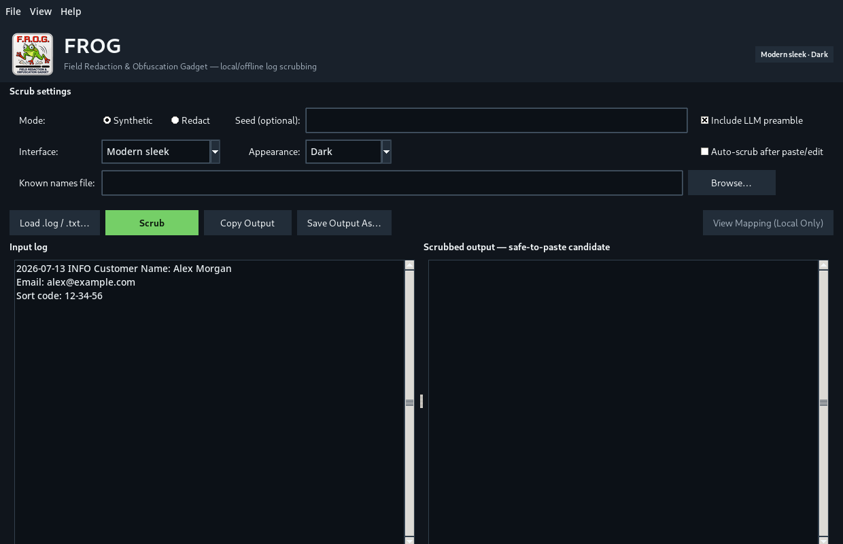
Example: Modern sleek interface in dark mode
Control | What it does | Recommended use
Mode: Synthetic | Creates realistic, format-preserving pseudonyms. | Default for troubleshooting because relationships and data shapes remain useful.
Mode: Redact | Creates placeholders such as [EMAIL_1]. | Use when realistic values are unnecessary. Cross-log placeholder numbering is not seed-stable.
Seed (optional) | Makes Synthetic-mode output deterministic for the same original value and data type. | Use the incident reference when repeatability is needed.
Include LLM preamble | Adds a short note explaining that PII was replaced consistently. | Normally leave enabled.
Interface | Switches between Retro 90s and Modern sleek. | Visual preference only; it does not change scrubbing logic.
Appearance | Switches between Light and Dark. | Visual preference only.
Auto-scrub after paste/edit | Scrubs after input settles for about half a second. | Useful for rapid incident work. Still review the output.
Known names file | Loads one known person name per line. | Use when names appear without a label or title and are otherwise missed.
Load .log / .txt… | Loads a text log from disk. | Use instead of copy/paste for long files.
Scrub | Runs the local detection and replacement engine. | Use when auto-scrub is disabled or to force a fresh pass.
Copy Output | Copies only the scrubbed output. | Safe workflow for moving reviewed output to the approved LLM.
Save Output As… | Saves the scrubbed output to a text file. | Store only in an approved location.
View Mapping (Local Only) | Shows synthetic-to-real translations. | Sensitive: never share or paste it.

5. Seed guide: repeatable values across an incident
Recommended pattern
For Synthetic mode, use the ServiceNow incident reference exactly as written, such as INC123456789. Reuse the same seed for every related log that needs the same pseudonyms.

What stays the same
With the same seed, same original value, same detected data type and same FROG version/generation logic:
- The same name receives the same synthetic name.
- The same email receives the same synthetic email.
- The same sort code, account number, card number and IBAN receive the same synthetic equivalents.
- Equivalent supported formats may be linked—for example, a UK phone shown as 07700… and +44 7700…

Example
Incident seed: INC123456789
Log A: Customer Name: Marcus Vance-Delgado
Log B: Retry failed for Marcus Vance-Delgado
Result: both logs use the same synthetic name when scrubbed with that seed.

Important seed rules
- Use the exact same spelling and case for the seed. INC123456789 and inc123456789 are different seeds.
- Do not use customer PII as the seed. An approved incident reference is better.
- The seed is not encryption and cannot reverse a synthetic value. The local mapping is required for translation.
- The seed itself is shown in the status and local mapping, not normally inserted into the scrubbed output.
- Keep the same FROG executable/version for the duration of a case where exact repeatability matters. Future generator changes may alter outputs.
- A blank seed creates a fresh random effective seed. Values remain consistent inside that one scrub, but a later scrub may produce different pseudonyms.
Redact-mode exception
The seed does not control [TYPE_N] numbering in Redact mode. Placeholder numbers are assigned according to first appearance in the current input. Use Synthetic mode when consistent cross-log identities are required.

Cross-log mapping note
Reusing the seed makes generation repeatable, but each mapping window contains only the values detected in that particular input. If Log A and Log B contain different identifiers, save the required mapping for each scrub or combine the relevant logs before scrubbing when policy and practicality allow.

6. Synthetic mode versus Redact mode
Feature | Synthetic mode | Redact mode
Example | John Smith → Daniel Fletcher | John Smith → [NAME_1]
Best for | Technical investigation where shapes and relationships matter. | Simple removal where realistic structure is unnecessary.
Repeated values in one log | Consistent | Consistent
Same seed across separate logs | Deterministic for the same value/type | Does not guarantee the same placeholder number
Format preservation | Yes, where supported | No—uses a placeholder
Mapping available | Yes | Yes

Why Synthetic mode is usually preferred
Synthetic mode reduces the chance that the LLM misdiagnoses a problem caused only by redaction. For example, a card remains card-shaped, an IBAN remains IBAN-shaped, and repeated identifiers remain linked. FROG can also preserve the relationship between a GB IBAN and separately detected sort-code/account-number fields.

7. Reviewing the output
Mandatory review
Do not assume that a completed scrub means the log is guaranteed free of PII. Read the output before pasting it into an LLM.

- Search visually for names, emails, addresses, IP addresses, customer IDs and other organisation-specific values.
- Confirm that timestamps, trace IDs, error messages, stack traces and event order are still readable.
- Confirm repeated synthetic values are consistent where the original values were consistent.
- Check that the output contains the optional LLM preamble when it will help prevent misinterpretation.
- Do not copy the mapping into the LLM, ticket comments, email or chat.

Example before and after
BEFORE (invented)
Customer Name: Alex Morgan
Email: alex.morgan@example.test
Account Number: 88102938
Alex Morgan called back; she confirmed the payment was hers.
AFTER (illustrative)
Customer Name: Emily Murphy
Email: rebecca.watson731@example.com
Account Number: 55302096
Emily Murphy called back; she confirmed the payment was hers.
The later pronoun cue can be used when FROG chooses a gender-appropriate synthetic name. The replacement is generated only after FROG has examined all detected occurrences of that name.

8. Local-only mapping
The mapping translates each fake value back to the original value. It exists so an engineer can interpret an LLM response that refers to synthetic identifiers.
Classification warning
The mapping contains the original PII. Treat it at least as sensitively as the source log. Never paste it into an LLM or share it outside approved restricted channels.

Safe handling
- Open it only when translation is needed.
- Save it only to an approved restricted location, if saving is necessary.
- Do not attach it to general tickets, emails or chat messages.
- Delete or retain it according to the relevant incident and data-retention policy.

9. Known names file
Names are difficult to detect reliably with pattern matching. Use a known-names file when a person appears in free text without a label or title.
- Create a plain-text file in an approved location.
- Add one complete name per line.
Alex Morgan
Marcus Vance-Delgado
Jane Doe
- Choose Browse… beside Known names file and select it.
- Scrub and review the output.
Sensitive file
A real known-names file contains PII. Do not upload it to source control, email it externally or include it with the FROG application.

10. Auto-scrub
When enabled, FROG waits roughly half a second after paste/edit activity settles and then performs a local scrub on a background thread. If the input changes while a scrub is running, FROG discards the outdated result and refreshes using the latest input.
- Useful when repeatedly pasting short log extracts.
- No data is sent over the network.
- Nothing is automatically saved to disk.
- Manual review remains required.

11. Limitations and data types requiring care
Area | Current position / user action
Street addresses | Not fully detected by default. Review manually or add an approved custom rule.
IP addresses | Not scrubbed by the built-in rules. Assess whether they are personal data in context.
Internal customer/user IDs | May require a custom organisation-specific rule.
BIC/SWIFT | Not scrubbed by default.
Unlabelled account numbers | Intentionally not matched to avoid replacing arbitrary numbers.
Unlabelled dates | Not treated as DOB without context.
Names in free text | May be missed unless labelled, titled or listed in the known-names file.
UK postcodes | Syntax checked; not validated against a live address database.
Synthetic values | Format-shaped and diagnostic-friendly, but not claims that a real issued account/person exists.

12. Troubleshooting
Issue | What to check
The output did not update | Press Scrub, or confirm Auto-scrub is selected and wait briefly.
A value was not replaced | Check whether it is a supported type and correctly labelled. Add a known name or approved custom rule where appropriate.
Too much text was replaced | Record the example using invented data and raise it for rule tuning. Do not weaken controls on real logs without review.
The same value changed between runs | Confirm Synthetic mode, the exact same seed, same original value/type and same FROG executable/version.
Redact placeholders differ between logs | Expected: Redact numbering is based on first appearance. Use Synthetic mode for deterministic cross-log identities.
View Mapping is disabled | Run a successful scrub first.
The application is blocked | Do not bypass endpoint controls. Request internal approval, signing or allow-listing.
The app appears unresponsive on a very large log | Allow the background scrub to finish; avoid repeatedly editing the input during processing.

13. Frequently asked questions
Does FROG use AI?
No. FROG uses local Python pattern matching, validators and deterministic synthetic-data generation.
Does FROG send logs anywhere?
No network functionality is implemented in the application. Scrubbing runs locally.
Where do fake names come from?
From the locally bundled British-English Faker dataset. Email replacements use the reserved example.com domain.
Is the seed a password or encryption key?
No. It controls deterministic pseudonym generation. It does not encrypt or reverse values.
Can I use one incident reference for all related logs?
Yes in Synthetic mode. Reuse the exact incident reference to keep the same real identifiers mapped to the same synthetic values.
Can I share the mapping?
No. It contains the originals and is marked local-only.
Does a successful scrub certify that no PII remains?
No. Review remains mandatory and organisation-specific formats may require extra rules.

14. Team ownership and escalation
Complete these fields before publishing the guide in Confluence:
Item | Team value
Application owner | [Insert team / owner]
Support route | [Insert channel or queue]
Approved download location | [Insert internal location]
Approved mapping storage | [Insert restricted location or policy reference]
Custom-rule change process | [Insert review/approval route]
Current approved version | [Insert approved FROG version/hash]
Suggested Confluence summary
FROG is a local pseudonymisation utility for support logs. Use Synthetic mode with the ServiceNow incident reference as the seed, review the scrubbed output, paste only that output into the approved LLM, and never share the local mapping.

