PROJECT TITLE : SMART FOOD DELIVERY



UNIVERSITY OF GHANA
DATA STRUCTURES AND ALGORITHM (DCIT308)
DEPARTMENT OF COMPUTER SCIENCE
BY
TEAM_5IVE9INE_2.0 (GROUP 39)

Table of Contents
Group Members 8
1. Introduction 9
1.1 Background 9
1.2 Ghanaian context 9
1.3 Problem statement 10
1.4 Project aim 11
1.5 Objectives 11
1.6 Scope 11
1.7 Assumptions 12
2. System requirements and problem model 12
2.1 Inputs 12
Table 2.1 System inputs 12
2.2 Outputs 13
Table 2.2 System outputs 13
2.3 System boundaries 14
2.3.1 In scope 14
2.3.2 Out of scope 14
2.4 Functional overview 15
3. Dataset and database design 15
3.1 Dataset overview 15
Table 3.1 Dataset scale against brief minimal 15
3.2 Data sources 16
3.3 Dataset generation 16
3.3.1 Locations 16
Table 3.3.1 Location type categories used in stratified sampling 16
3.3.2 Roads 17
3.3.3 Restaurants, customers and riders 17
Table 3.4 Rider vehicle mix and availability 17
3.3.4 Orders 18
Table 3.3 Order status and urgency distributions 18
3.4 Dataset validation 18
Table 3.5 Dataset validation checks (last recorded run) 19
3.5 Data dictionary 19
Table 3.7 Data dictionary - roads 20
Table 3.8 Data dictionary — restaurants 20
Table 3.9 Data dictionary — customers (fictional) 20
Table 3.10 Data dictionary - riders 21
Table 3.11 Data dictionary - orders 21
Table 3.12 Data dictionary - algorithm_runs 22
Table 3.13 Data dictionary - audit_events 22
3.6 Database schema 23
3.7 Database relationships 23
Table 3.14 CSV import dependency order 24
3.8 Database setup 25
4. System architecture 25
4.1 Architectural overview 25
4.2 Model layer 26
Table 4.1 Model-layer entities 26
4.3 Data-structure layer 26
4.4 Algorithm layer 26
4.5 Repository layer 26
4.6 Service layer 27
4.7 Console application layer 27
4.8 Module interaction 27
5. Custom data structures 27
Table 5.1 Required custom data structures 28
5.1 Linear and sequential structures 28
5.2 Stacks, queues and deques 30
5.3 Heaps and priority queues 31
5.4 Trees 32
5.5 Hash-based structures 33
5.6 Graphs and disjoint sets 34
5.7 Structure–algorithm map 35
Table 5.2 Structure-to-algorithm relationships 35
6. Algorithms and implementation 36
Table 6.1 Mapping of required algorithms to delivery operations 36
6.1 Linear Search 37
6.2 Binary Search 37
6.3 Selection Sort 38
6.4 Insertion Sort 39
6.5 Merge Sort 39
6.6 Quick Sort 40
6.7 Breadth-First Search 41
6.8 Depth-First Search 42
6.9 Dijkstra Shortest Path 42
6.10 Prim Minimum Spanning Tree 43
6.11 Kruskal Minimum Spanning Tree 44
6.12 Greedy Rider Assignment 45
6.13 Dynamic Order Selection 46
6.14 Brute-Force Assignment 47
6.15 Student-ID parameters 47
Table 6.2 Student-ID identifiers used by the parameter service 48
Table 6.3 Derived Student-ID parameters 48
7. Correctness evidence 49
7.1 Correctness methodology 49
7.2 Search correctness 50
7.3 Sorting correctness 50
7.4 Graph algorithm correctness 50
7.5 Optimisation correctness 51
7.6 Greedy counterexample 51
Table 7.4 Assignment costs for the required greedy counterexample 52
7.7 Trace evidence 52
7.7.1 Binary search 52
Table 7.1 Binary-search trace for target 7 52
7.7.2 Insertion sort 52
7.7.3 Merge sort 53
7.7.4 Dijkstra 53
7.7.5 Kruskal 53
7.7.6 Dynamic programming 54
Table 7.3 Dynamic-programming input for the capacity-17 demonstration 54
8. Testing 54
8.1 Testing strategy 54
8.2 Unit tests 54
8.3 Normal cases 55
8.4 Boundary cases 55
8.5 Invalid inputs 55
Table 8.1 Required test categories for each custom structure 55
8.6 Dataset validation 55
8.7 Console smoke test 56
Table 8.2 Console smoke-test sequence 56
8.8 Database state-change testing 56
9. Performance analysis 57
9.1 Theoretical complexity 57
Table 9.1 Theoretical complexity of required algorithms 57
9.2 Performance methodology 58
9.3 Experimental inputs 58
Table 9.2 Final-report Performance Lab input sizes 58
9.4 Runtime measurements 59
9.5 Memory measurements 59
9.6 Search comparison 59
9.7 Sorting comparison 59
9.8 Hash performance 60
9.9 Heap performance 60
9.10 Tree performance 61
9.11 Graph performance 61
9.12 Performance graphs 62
9.13 Interpretation 65
9.14 Machine specification 66
10. Database integration evidence 67
10.1 SQLite integration 67
10.2 JDBC 67
10.3 Schema initialization 67
10.4 CSV import 67
10.5 Data retrieval 67
10.6 State changes 68
10.7 Audit events 68
10.8 Performance data storage 68
11. Responsible algorithm selection 68
11.1 Fairness 68
11.2 Bias 69
11.3 Transparency 69
11.4 Privacy 69
11.5 Reliability 69
11.6 Safety 69
11.7 Algorithm trade-offs 70
12. Limitations 70
13. Individual contributions 70
Table 13.1 Individual contribution statement 71
14. AI assistance acknowledgement 72
15. Conclusion 72
References 72
Appendix A — Complete Data Dictionary 73
Appendix C — Selected Source Code 80
Appendix H — Performance Results 88
Appendix I — Performance Graphs 92
Appendix J — Student-ID Parameter Calculations 96
Appendix K — Individual Contributions 99

Group Members
NAMES | ID
Adom Bempong Franklin | 22020618
Dzah Solomon Sampson | 22012447
Asante Emmanuella Baaba | 22166686
Mubarack Jibriel | 22146249
Ofori Richard | 22106332
Akplu Kelvin Mawuli | 22042260
Adzraku Prosper Awoenam | 22042713
Obeng Richard | 22370501
Tieku Henry Ebo | 22411093
Amaniampong Samuel Kwarteng | 22399487
Kodjoh-Kpakpassou Enam Antoine-Marie | 22262272
Otchere Ernest Atta | 22306912
Osafo Kimathi Christian | 22308781
Nyame Ebenezer | 22382964
Freeman Isaac Kweku | 22413798
Normanyo Leslie Dela | 22402374
Okoe Anthonia Holisede | 22408680

1. Introduction

1.1 Background
Data structures and algorithms are how a program represents operational state and computes decisions over that state. In a food-delivery setting the state includes locations, road connections, restaurants, customers, riders and orders; the decisions include which request to serve next, which rider to assign, which route to follow, and which subset of pending work can be accepted under a capacity or time budget. The University of Ghana DCIT 204/308 joint semester project requires students to implement those representations and decisions themselves, to persist them in a database, to test them, and to measure how they behave as input size grows. SMART FOOD DELIVERY is Group 39’s response to that brief. The product is a console-based Java application in the package edu.ug.smartdelivery. It stores operational data in SQLite, loads records into custom-built data structures, applies a prescribed set of algorithms to delivery-operation problems, and records evidence for correctness, database integration, testing and performance analysis. The repository name is smart-food-delivery-optimizer. The technical baseline is Java 17 or newer, Apache Maven, SQLite accessed through JDBC, JUnit 5, CSV seed data and CSV performance exports. The system is intentionally not a mobile application, not a web storefront and not a live dispatch platform. The assessment focus is the quality of the data structures, the algorithms, the tests, the database integration and the performance evidence. A console menu is therefore a sufficient examiner interface.

1.2 Ghanaian context
Accra’s northern corridor around the University of Ghana concentrates a distinctive mixture of demand and supply. Students, staff and nearby residents generate frequent, time-sensitive food orders. Vendors range from campus dining halls and cafeterias to neighborhood chop bars and fast-casual outlets in East Legon, Madina, Haatso and Adenta. Riders typically use motorbikes, bicycles or tricycles and must move between hostels, lecture areas, markets, transport stops and residential streets whose travel times vary with congestion, road condition and time of day. These conditions create several operational challenges that are directly amenable to data-structure and algorithm design. Multiple orders arrive while previous orders are still pending, so a dispatch desk needs a disciplined way to remember arrival order and to promote urgent or delayed work. Riders become available and unavailable, so the set of candidates for the next job is dynamic. Customers and restaurants are geographically distributed, so assignment and routing are spatial problems rather than mere lists. Deadlines and urgency scores force a distinction between first-come service and priority service. As the number of orders increases, naïve scanning and exhaustive assignment become impractical, which is precisely why asymptotic analysis and empirical measurement matter. Ghanaian food culture also motivates the academic dataset. Restaurant categories in the seed data include Waakye, Jollof Rice, Banku and Tilapia, Kelewele and Shawarma. Location names are not invented: they are drawn from a curated subset of 1,244 OpenStreetMap landmarks around campus and the surrounding communities. The resulting model is local enough to be recognizable to a University of Ghana examiner, yet it remains a simulation. Distances are haversine estimates between selected points; they are not a live map of Accra’s Road geometry. No real customer is identified. No payment is taken. The educational claim of the project is that the same structures that appear in textbooks can be shown to organize a familiar local operation. Data structures are relevant because they encode operational policy. A first-in, first-out queue implements ordinary arrival order. A priority queue implements urgency. A circular queue can rotate available riders so that work is not always given to the same person. A graph encodes the delivery network. A disjoint-set structure decides whether adding a road would close a cycle when a minimum connection network is built. Hash tables and search trees support lookup of orders, riders and locations. Algorithms are relevant because they turn those representations into answers: which record matches a key, how a list should be ordered, which locations are reachable, which path is cheapest under non-negative weights, which subset of orders fits a capacity, and how expensive it is to compute those answers as the city-scale input grows.

1.3 Problem statement
Food-delivery services around Legon and nearby communities must handle many orders, riders, locations and route decisions while dealing with urgency, traffic-like variation in travel cost, rider availability and delivery deadlines. The operational problem is therefore a combination of scheduling, search, assignment and routing under constraints. If these tasks are performed without explicit data structures, the dispatcher has no inspectable policy and no way to reason about correctness or cost. If they are performed with library collections alone, the assessed learning outcomes of DCIT 204 and DCIT 308 are not demonstrated. SMART FOOD DELIVERY models this operational problem as a console-based Java system. The system stores delivery records in an SQLite database, loads those records into custom data structures, and applies data-structures-and-algorithms techniques to schedule orders, search records, sort requests, assign riders, find routes, select orders under constraints, construct minimum connection networks, and measure algorithm performance. In academic terms the project is a constrained optimization and information-processing model of a local delivery desk, together with an evidence package that allows an examiner to inspect representation, algorithm, database state and experimental method. The system is designed to answer a small number of recurring operational questions. Which food order should be handled next under first-in, first-out or priority rules? Which rider should be assigned to an order? What is the shortest route between two locations under the project’s non-negative route-cost model? Which locations are reachable from a dispatch point? Which orders should be selected under time, capacity or budget constraints? How do different data structures and algorithms perform as input size grows? The remainder of the report shows how each question is mapped to a structure, an algorithm, a database table and a form of evidence.

1.4 Project aim
The aim of SMART FOOD DELIVERY is to design, implement and evidence a Ghana-localized academic delivery optimizer that stores operational data reliably, processes that data with team-implemented data structures and algorithms, and produces inspectable traces, tests, audit records and performance experiments suitable for university assessment.

1.5 Objectives
The project objectives follow directly from the aim and from the joint course brief. They are stated here as assessable intentions rather than as claims that every item has already been completed. Objective 1. To store delivery data reliably in a portable SQLite database accessed through JDBC, using a documented schema and a deterministic CSV seed. Objective 2. To implement the required custom data structures in the team’s own code, without substituting built-in Java collections for assessed structures. Objective 3. To implement the required searching algorithms (linear search and binary search) over delivery records. Objective 4. To implement the required sorting algorithms (selection, insertion, merge and quick sort) over order and related records. Objective 5. To implement the required graph algorithms (breadth-first search, depth-first search, Dijkstra, Prim and Kruskal) on the delivery network. Objective 6. To implement rider-assignment approaches, including a greedy nearest-available-rider method and a small-input brute-force reference method. Objective 7. To implement dynamic-programming order selection under a capacity constraint derived from the student-ID parameters. Objective 8. To integrate algorithms with SQLite so that inputs are loaded from persistent records and selected results, assignments and experiment rows can be written back. Objective 9. To test normal, boundary and invalid inputs for the assessed structures and algorithms. Objective 10. To provide correctness evidence in the form of preconditions, invariants, induction arguments, traces and a greedy counterexample. Objective 11. To measure algorithm performance through the Performance Lab, including repeated trials, averages and CSV export. Objective 12. To demonstrate responsible algorithm selection by distinguishing heuristics from exact methods and by stating fairness, privacy and safety limits. Objective 13. To produce a reproducible dataset, with a documented generation seed and a recorded structural validation run.

1.6 Scope
The scope of SMART FOOD DELIVERY is the academic model described in Chapter 2. In summary, the system includes locations, roads, restaurants, customers, riders, orders, algorithm-run records and audit events; the required custom data structures; searching, sorting, graph traversal, shortest paths, minimum spanning trees, greedy assignment, dynamic programming and brute-force assignment; performance experiments; database persistence; console demonstrations; and testing and correctness evidence. It excludes a production mobile or web application, real online ordering, real customer personal data, payment processing, live traffic integration and enterprise-level dispatch optimization.

1.7 Assumptions
The design rests on assumptions that keep the work assessable, portable and ethically conservative. Customer information is fictional and does not expose real personal data. Road distances and travel times are realistic estimates for academic demonstration rather than surveyed network measurements. SQLite is used so that every member can carry a single-file database without installing a server. The console interface is sufficient because the assessment focuses on data structures, algorithms, testing, database integration and performance evidence. The road network is an academic model rather than a live navigation system. No live traffic application programming interface is integrated. The system does not process real payments. The system is not a production delivery platform. A further methodological assumption is that Student-ID parameters should be derived deterministically from the full set of seventeen identifiers, so that priority scoring, route costing, hash-table initialization, dataset generation and the default dynamic-programming capacity are reproducible. Those parameters are reported in Section 6.15 and Appendix J.

2. System requirements and problem model

2.1 Inputs
SMART FOOD DELIVERY consumes a closed set of academic inputs. Local locations and their coordinates define the vertices of the delivery network. Road connections, distances, travel times and road-condition weights define the edges. Restaurants and vendors occupy selected locations and carry opening hours and an open or closed status. Customers are fictional persons with a synthetic telephone number and a default location. Riders have a home location, a current location, a vehicle type, a positive capacity and an availability status. Food orders link a restaurant, a customer, a source location and a destination location, and they carry a category, an urgency score, a submission time, a deadline, a status and an estimated delivery distance. Experiment sizes and algorithm choices are additional inputs to the Performance Lab.

Table 2.1 System inputs
Input category | Role in the problem model
Local locations and coordinates | Vertices of the delivery graph; sites of restaurants, customers and riders
Road connections | Bidirectional edges of the academic road network
Road distances | Haversine estimates used in travel-cost modelling
Travel times | Minutes derived from distance and an assumed 12–28 km/h speed
Road-condition weights | Multipliers in the range 1.0 to 1.6 used in the academic cost model
Restaurants / vendors | Order sources with hours and OPEN/CLOSED status
Customers (fictional) | Order destinations; names and phones are synthetic
Riders and availability | Assignable resources with vehicle type and capacity
Food orders | Units of work with urgency, deadline, status and estimated distance
Order urgency and deadlines | Keys for priority scoring and scheduling
Order status | PENDING, ASSIGNED or DISPATCHED in the current implementation
Experiment sizes & algorithm choices | Inputs to the Performance Lab

These inputs are supplied primarily by CSV seed files that are imported into SQLite. They may also be generated for synthetic experiments inside the Performance Lab. They are not streamed from a live ordering channel.

2.2 Outputs
The system produces operational answers and evidence artefacts. Operational answers include the next order under first-in, first-out or priority rules; an assigned rider for an order; sorted order lists; search results for orders, riders, restaurants or locations; a shortest delivery route and its total cost; the set of locations reachable from a selected point; a minimum connection network; and a dynamic-programming selection of orders under a capacity constraint. Evidence artefacts include runtime and memory experiment records, exported CSV files, and audit events for state-changing operations.

Table 2.2 System outputs
Output | Typical consumer
Next order (FIFO or priority) | Order-dispatch demonstration
Assigned rider for an order | Greedy or brute-force assignment
Sorted order lists | Sorting demonstrations and binary-search preconditions
Search results | Lookup of orders, riders, restaurants or locations
Shortest route and total cost | Dijkstra demonstration
Reachable locations | BFS / DFS demonstration
Minimum connection network | Prim / Kruskal demonstration
Dynamic-programming order selection | Capacity-constrained optimization
Runtime and memory experiment records | Performance Lab and algorithm run
Audit evidence | Transparency of dispatch and assignment updates

2.3 System boundaries

2.3.1 In scope
Within scope are the eight persistent entity types (locations, roads, restaurants, customers, riders, orders, algorithm runs and audit events); the full list of required custom data structures given in Chapter 5; searching; sorting; graph traversal; shortest paths; minimum spanning trees; greedy rider assignment; a greedy counterexample; dynamic-programming order selection; brute-force assignment for small inputs; performance experiments; database persistence; console demonstrations; and testing and correctness evidence. The system can store and manage delivery records; load database records into custom structures; process ordinary orders using first-in, first-out queues; process urgent or delayed orders using priority queues and heaps; rotate available riders using a circular queue; search using linear and binary search; sort using selection, insertion, merge and quick sort; represent road networks using adjacency lists and adjacency matrices; run breadth-first search, depth-first search, Dijkstra, Prim and Kruskal; demonstrate greedy assignment; record experiment results; export CSV performance data; and provide traces, proof sketches and, when supplied, screenshots.

2.3.2 Out of scope
Outside scope are a production mobile application, a production web application, real online ordering, real customer personal data, payment processing, live traffic application-programming-interface integration, and enterprise-level dispatch optimization. These exclusions are significant for two reasons. First, they prevent the report from being read as a claim that the team has built a market product. Second, they keep the evaluation criteria aligned with the course: an examiner should judge the structures, algorithms, tests, database work and performance method, not the polish of a consumer interface. The absence of live traffic also means that travel times are static academic estimates. The absence of DELIVERED and CANCELLED statuses, discussed in Section 12, further limits the order lifecycle that can be demonstrated.

2.4 Functional overview
From the examiner’s point of view the system is a menu-driven console program. After the database has been initialized and the CSV seed imported, the user may inspect requirement counts and Student-ID parameters, browse orders, process orders by priority, run greedy assignment, compute a Dijkstra route, run dynamic-programming selection, inspect audit and undo information, and execute Performance Lab experiments. Chapter 8 records the intended smoke-test sequence. Figure 4.3 later summarizes the corresponding data flow from OpenStreetMap landmarks through CSV files and SQLite into custom structures, algorithms and evidence tables.

3. Dataset and database design

3.1 Dataset overview
The operational dataset is generated by a deterministic Python process and then imported into SQLite. The generator is invoked as python scripts/generate-data/generate_dataset.py. It writes six seed files: data/locations.csv, data/roads.csv, data/restaurants.csv, data/customers.csv, data/riders.csv and data/orders.csv. A seventh file, data/algorithm_runs.csv, is not produced by the same generator; it belongs to the Performance Lab and currently contains only two seed rows.

Table 3.1 Dataset scale against brief minimal
Entity | Brief minimum | Current count | Status
Locations | 50 | 80 | Satisfies minimum
Roads | 100 | 150 | Satisfies minimum
Orders | 300 | 350 | Satisfies minimum
Riders | 30 | 40 | Satisfies minimum
Restaurants | — | 14 | Recorded current count
Customers | — | 70 | Recorded current count
Algorithm runs | 30 | 282 | Satisfies minimum

The main operational dataset satisfies the required minimum counts for locations, roads, orders and riders. Restaurant and customer records are also included to support the food-delivery model. Final algorithm-run records were generated through the Performance Lab and exported for performance analysis.

3.2 Data sources
Locations are based on real named landmarks around the University of Ghana, Legon, East Legon, Madina and Haatso. The landmarks are fetched from OpenStreetMap through the Overpass API. The raw fetch is cached as scripts/generate-data/data/landmarks.generated.json. There are 1,244 candidate landmarks. The dataset generator selects a curated subset and does not invent location names. OpenStreetMap data are available under the Open Database License; the project’s use of named landmarks is an academic derivation and should be attributed to OpenStreetMap contributors. Restaurants reuse selected restaurant or restaurant-area landmarks and assign Ghanaian cuisine categories such as Waakye, Jollof Rice, Banku and Tilapia, Kelewele and Shawarma. Customers and riders are entirely fictional. Customer telephone numbers use an obviously synthetic sequential pattern such as 0200000001. No real personal data are used. Roads are not sourced from OpenStreetMap road geometry. They are generated between selected locations using real great-circle (haversine) distances between those locations’ coordinates. This choice keeps the graph connected and inspectable, but it means that an edge in the academic network is not a claim about a particular Accra street.

3.3 Dataset generation

3.3.1 Locations
Eighty locations are selected from the 1,244 candidate landmarks by stratified sampling on type. Identifiers are then renumbered from 1 to 80 so that foreign keys in the remaining files are dense and readable. Stratification prevents the sample from collapsing into a single category such as hostels or restaurants and thereby preserves a recognizable campus-and-neighborhood mix.

Table 3.3.1 Location type categories used in stratified sampling
Location type used in sampling
Academic
Hostel
Restaurant
Restaurant Area
Transport Stop
Market
Health
Service
Residential Area
Landmark

3.3.2 Roads
One hundred and fifty edges are generated in two passes. The first pass builds a Kruskal-style minimum spanning tree with a disjoint-set (union-find) structure, which guarantees that the location graph is connected. The second pass adds short local nearest-neighbor edges so that the network has redundant routes rather than a tree alone. All roads are bidirectional. Travel time is derived from distance and an assumed randomized speed in the range 12 to 28 kilometers per hour. Road-condition weights range from 1.0 to 1.6. The combined application route cost must be described according to the implemented project formula rather than a formula invented for this report. The Dijkstra correctness trace in Section 7.7 applies the student-ID route penalty as an additive term: the recorded final weight equals the listed base cost plus two. The precise composition of the base cost from distance, travel time and road-condition weight should be confirmed from RouteService in the project source.

3.3.3 Restaurants, customers and riders
The seed contains fourteen restaurants, of which twelve are OPEN and two are CLOSED. Seventy fictional customers are generated. Forty riders are generated, of whom fifteen are initially AVAILABLE and twenty-five are initially BUSY. The vehicle mix is eighteen motorbikes, fifteen bicycles and seven tricycles. Rider capacities are required to be positive; this constraint is part of the structural validation described in Section 3.4.

Table 3.4 Rider vehicle mix and availability
Rider attribute | Count
Total riders | 40
Initially AVAILABLE | 15
Initially BUSY | 25
Motorbike | 18
Bicycle | 15
Tricycle | 7

3.3.4 Orders
Three hundred and fifty orders are generated. The status snapshot is 245 PENDING, 70 ASSIGNED and 35 DISPATCHED. The urgency distribution is 63 orders at urgency 1, 116 at 2, 94 at 3, 50 at 4 and 27 at 5. Estimated delivery distances range from 0.09 km to 7.37 km with an average of 3.28 km. The snapshot is intended to represent an operational state in which older orders have progressed further than newer orders. DELIVERED and CANCELLED are not currently supported statuses.

Table 3.3 Order status and urgency distributions
Attribute | Value
PENDING | 245
ASSIGNED | 70
DISPATCHED | 35
Urgency 1 | 63
Urgency 2 | 116
Urgency 3 | 94
Urgency 4 | 50
Urgency 5 | 27
Minimum estimated distance | 0.09 km
Maximum estimated distance | 7.37 km
Average estimated distance | 3.28 km

3.4 Dataset validation
The last recorded dataset validation run past all listed structural checks. Those checks establish referential integrity and simple numeric sanity. They do not replace manual plausibility spot-checks of sample records, and they do not constitute algorithm-correctness evidence.

Table 3.5 Dataset validation checks (last recorded run)
Check | Last recorded result
No duplicate location IDs | Passed
No duplicate road pairs | Passed
No road self-loops | Passed
Every road references valid locations | Passed
Location graph is fully connected | Passed
Restaurants reference valid locations | Passed
Customers reference valid locations | Passed
Riders reference valid locations | Passed
Riders have positive capacity | Passed
Orders reference valid restaurant, customer, source and destination records | Passed
Order statuses are valid | Passed
Pending orders have no assigned rider | Passed
Assigned and dispatched orders have valid riders | Passed
Estimated distances are non-negative | Passed
Deadlines are after submission times | Passed

3.5 Data dictionary
The following tables define the persistent fields used by SMART FOOD DELIVERY. A consolidated copy appears as Appendix A.
Table 3.6 Data dictionary - locations
Field | Meaning
location_id | Primary key; renumbered 1–80 in the current seed
name | OpenStreetMap-derived landmark name; not invented
area | Local area label (for example Legon or Madina)
type | Stratification type listed in Table 3.2
latitude | Geographic latitude of the landmark
longitude | Geographic longitude of the landmark

Table 3.7 Data dictionary - roads
Field | Meaning
road_id | Primary key of the generated edge
from_location_id | Foreign key to locations
to_location_id | Foreign key to locations
distance_km | Haversine distance in kilometers
travel_time_minutes | Estimated minutes at 12–28 km/h
road_condition_weight | Academic weight in [1.0, 1.6]
is_bidirectional | True for all generated seed roads

Table 3.8 Data dictionary — restaurants
Field | Meaning
restaurant_id | Primary key
name | Vendor name based on a selected landmark
location_id | Foreign key to the restaurant's site
opening_time | Academic opening time
closing_time | Academic closing time
status | OPEN or CLOSED in the current seed

Table 3.9 Data dictionary — customers (fictional)
Field | Meaning
customer_id | Primary key
name | Fictional generated name
phone | Synthetic sequential number (for example 0200000001)
default_location_id | Foreign key to the customer's usual location

Customer information is fictional. Telephone numbers follow an obviously synthetic pattern and must not be interpreted as real Ghanaian subscriber data.

Table 3.10 Data dictionary - riders
Field | Meaning
rider_id | Primary key
name | Fictional generated name
home_location_id | Foreign key to the rider's home location
vehicle_type | Motorbike, bicycle or tricycle
capacity | Positive capacity used by assignment constraints
availability_status | AVAILABLE or BUSY in the current seed
current_location_id | Foreign key to the rider's current location

Table 3.11 Data dictionary - orders
Field | Meaning
order_id | Primary key
restaurant_id | Foreign key to restaurants
customer_id | Foreign key to customers
source_location_id | Foreign key to the pick-up location
destination_location_id | Foreign key to the drop-off location
category | Food category associated with the order
urgency | Integer urgency used in priority scoring and DP value
time_submitted | Submission timestamp
deadline | Deadline; validated to be after submission
status | PENDING, ASSIGNED or DISPATCHED
estimated_distance | Non-negative estimated delivery distance
assigned_rider_id | Nullable foreign key to riders

The currently supported statuses are PENDING, ASSIGNED and DISPATCHED. DELIVERED and CANCELLED are not currently supported and must not be described as implemented transitions.

Table 3.12 Data dictionary - algorithm_runs
Field | Meaning
run_id | Primary key of an experiment row
algorithm_name | Name of the measured algorithm
input_size | n used for that trial
execution_time_ns | Measured runtime in nanoseconds
memory_kb | Measured memory in kilobytes
trial_number | Repetition index for averaging
date_run | Timestamp of the trial

Table 3.13 Data dictionary - audit_events
Field | Meaning
event_id | Primary key of an append-only log row
event_type | For example, ORDER_DISPATCHED, ORDER_ASSIGNED, RIDER_STATUS_UPDATED
entity_type | Type of the affected entity
entity_id | Identifier of the affected entity
previous_value | State before the change
new_value | State after the change
event_time | Timestamp of the event

3.6 Database schema
The working schema is database/schema.sql. A copy also resides at src/main/resources/database/schema.sql. The documentation and submission copy is database/schema.sql. The SQLite file is database/smart_delivery.db. Java opens it with the connection string jdbc:sqlite:database/smart_delivery.db. Required tables are locations, roads, restaurants, customers, riders, orders, algorithm_runs and audit_events. SQLite is the current technical baseline because it is serverless, stores the entire database in one file, and can be created afresh by every team member from the schema and the CSV seed. That portability is an explicit project assumption.

3.7 Database relationships
Figure 3.1 summarizes the foreign-key relationships. Locations are the spatial hub: roads
reference two locations; restaurants, customers and riders reference locations; orders reference a restaurant, a customer, a source location, a destination location and, when assigned, a rider. Algorithm runs are independent experiment records. Audit events refer to entities by type and identifier rather than by a single polymorphic foreign key.
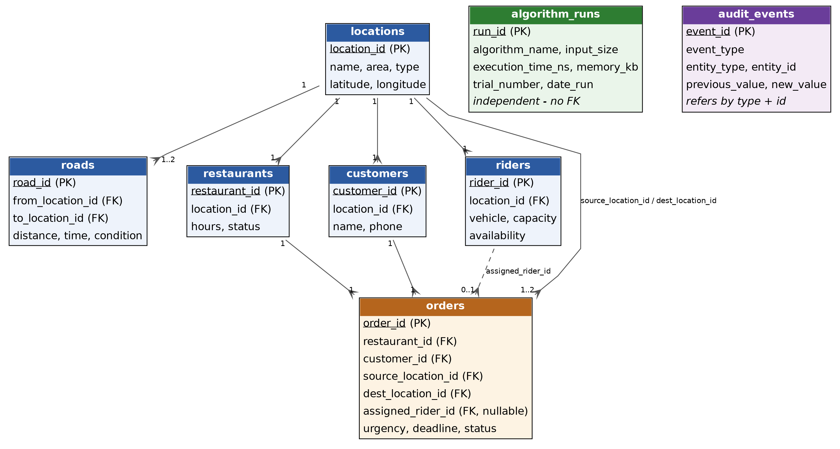
Figure 3.1 Entity–relationship overview of the SQLite schema
Primary keys are the identifier columns listed in the data dictionary. Foreign keys enforce that a road, restaurant, customer, rider or order cannot refer to a missing location or related record. Assigned rider identifiers are nullable because PENDING orders have no rider. Import must therefore respect dependency order.

Table 3.14 CSV import dependency order
Import step | File | Why this order
1 | locations | All other spatial entities depend on location_id
2 | roads | Edges require both endpoints to exist
3 | restaurants | Orders later reference restaurant_id
4 | customers | Orders later reference customer_id
5 | riders | Assigned orders later reference rider_id
6 | orders | Depends on restaurants, customers, locations and riders
7 | algorithm_runs | Independent experiment rows; imported last

3.8 Database setup
The documented setup sequence is to run mvn clean test and then mvn exec:java. From the console the examiner initializes the database, imports the default CSV seed and views the database summary. Locations must exist before dependent records because foreign-key integrity would otherwise reject the import. Chapter 10 records the intended integration evidence for this workflow.

4. System architecture

4.1 Architectural overview
SMART FOOD DELIVERY uses a simple six-layer architecture inside the base package edu.ug.smartdelivery. The layers separate persistent entities, custom data structures, algorithms, database access, delivery services and the examiner-facing console. The separation is pedagogical as well as technical: an examiner can ask where a queue lives, where Dijkstra lives, and where a SQL update is issued, and receive three different answers.
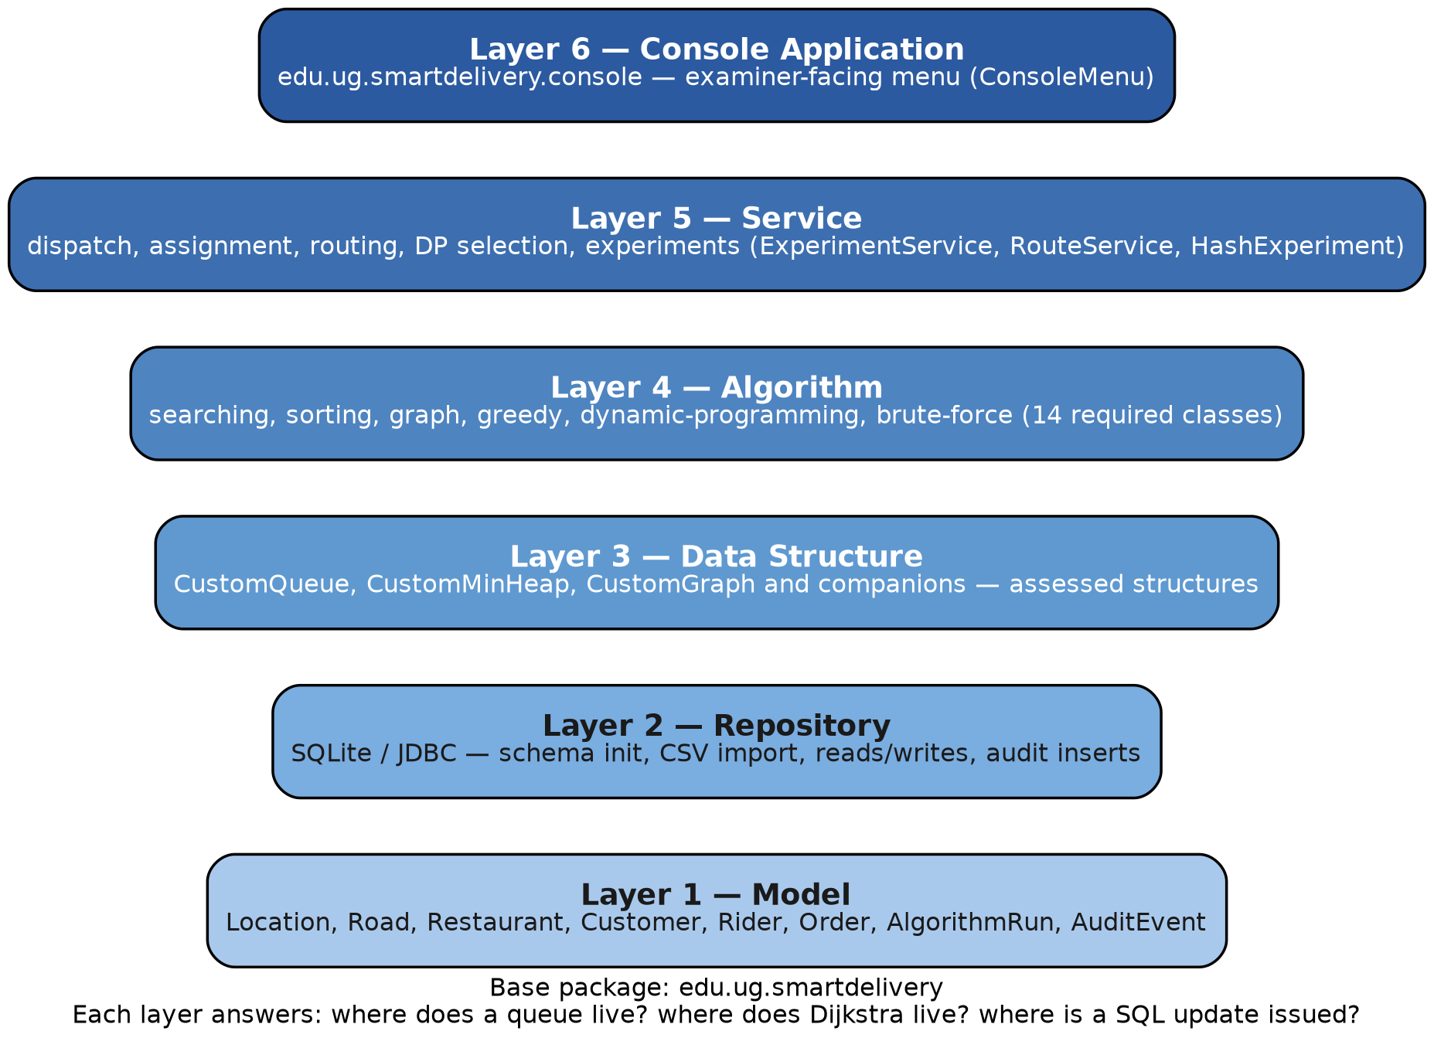
Figure 4.1 Six-layer architecture of SMART FOOD DELIVERY
An important implementation rule applies across the architecture. The assessed data structures and algorithms must be implemented by the project team. Built-in Java structures may be used for JDBC, file reading, test scaffolding and other non-assessed infrastructure. Built-in Java collections must not replace the required assessed custom structures. The report therefore describes CustomQueue, CustomMinHeap, CustomGraph and their companions as first-class project artefacts, not as wrappers around java.util.

4.2 Model layer
The model layer contains the entity classes that correspond to the schema. Each class is a typed representation of a row plus the small amount of behavior needed to keep that row meaningful in memory.

Table 4.1 Model-layer entities
Entity class | Responsibility
Location | Named point with area, type and coordinates; a graph vertex
Road | Connection between two locations with distance, time and condition weight
Restaurant | Vendor occupying a location, with hours and OPEN/CLOSED status
Customer | Fictional person with a synthetic phone number and default location
Rider | Assignable agent with vehicle, capacity, availability and current location
Order | Unit of delivery work with urgency, deadline, status and optional rider
AlgorithmRun | One Performance Lab trial (size, time, memory, trial number)
AuditEvent | Append-only record of a state-changing operation

4.3 Data-structure layer
This layer contains the custom implementations required by the project brief and catalogued in Chapter 5. Services are expected to load repository results into these structures before algorithms run. The layer is the principal site of assessed implementation effort.

4.4 Algorithm layer
The algorithm layer contains searching, sorting, graph algorithms, greedy algorithms, dynamic programming and brute-force demonstrations. The fourteen required classes are named in Chapter 6. Each class should consume custom structures rather than silently switching to library collections.

4.5 Repository layer
The repository layer handles SQLite, JDBC, database reads and database writes. It initializes the schema, imports CSV files in dependency order, retrieves entities for the service layer, persists assignment and dispatch updates, inserts audit events, and stores Performance Lab rows in algorithm_runs. Connection details are those given in Section 3.6.

4.6 Service layer
The service layer combines models, data structures, algorithms and database records into delivery operations. Confirmed application points for Student-ID parameters include ConsoleMenu, RouteService, ExperimentService and HashExperiment, with calculation logic in StudentIdParameterService and StudentIdParameters. Other services orchestrate dispatch, assignment, routing, dynamic-programming selection and experiment execution.

4.7 Console application layer
The console application provides the examiner-facing menu used to demonstrate the system. It is not a graphical user interface and is not a network service. Its value is that every major requirement can be exercised in a documented smoke-test order (Table 8.2).

4.8 Module interaction
Figure 4.2 shows how the console invokes services, how services use algorithms and
custom structures, and how the repository reads and writes SQLite. Figure 4.3 shows the corresponding data flow from OpenStreetMap landmarks through the deterministic generator into CSV files, the database, in-memory structures, algorithms and evidence exports.
Figure 4.2 Module interaction in SMART FOOD DELIVERY

Figure 4.3 Principal data flow in SMART FOOD DELIVERY

5. Custom data structures
This chapter catalogues the custom structures that SMART FOOD DELIVERY is required to implement. Each structure is a team artefact. Java collections may support JDBC, file reading and test scaffolding, but they must not stand in for the assessed types. For every major structure the project requires normal-case tests, boundary-case tests, invalid-input tests and report evidence. The report distinguishes the required test categories from the verified results and does not infer pass rates that are not supported by recorded evidence.

Table 5.1 Required custom data structures
Custom type | Primary operational role
CustomDynamicArray<T> | Resizable contiguous storage for loaded records
CustomLinkedList<T> | Sequential storage and splicing of records
CustomIterator<T> | Uniform traversal of custom collections
CustomStack<T> | LIFO storage for DFS and undo-style inspection
CustomQueue<T> | FIFO order scheduling
CustomCircularQueue<T> | Rotation of available riders
CustomDeque<T> | Double-ended scheduling and sliding windows
CustomMinHeap<T> | Extract-min support for priority and graph algorithms
CustomPriorityQueue<T> | Urgency-based order dispatch
CustomBinarySearchTree<K,V> | Ordered key lookup
CustomRedBlackTree<K,V> | Balanced ordered map
CustomBTree<K,V> | Multi-way ordered index demonstration
CustomHashTable<K,V> | Average-case constant-time association
CustomHashSet<T> | Membership tests (visited vertices, unique IDs)
CustomHashMap<K,V> | Associative lookup of entities by identifier
CustomGraph | Abstract delivery network
AdjacencyListGraph | Sparse road-network representation
AdjacencyMatrixGraph | Dense matrix representation for comparison
CustomDisjointSet | Cycle detection for Kruskal and road generation

5.1 Linear and sequential structures
CustomDynamicArray<T>
CustomDynamicArray<T> is required by the project brief. It provides a contiguous, indexable sequence whose capacity grows when the array is full. Underlying concept. A dynamic array stores elements in a backing store and doubles (or otherwise expands) that store when insertion would overflow. Indexing is constant-time; insertion at the end is amortized constant-time. Principal operations. add, get, set, size, isEmpty, remove, ensureCapacity, and iteration through CustomIterator. Expected complexity. Random access O(1); append amortized O(1); insertion or deletion in the middle O(n); space O(n). Use in SMART FOOD DELIVERY. Loaded orders, riders and experiment keys are held in dynamic arrays so that sorting and binary search can address elements by index. Why the structure is appropriate. Sorting and binary search require random access. A linked list would make those algorithms asymptotically worse. Relevant edge cases. Empty array; growth from capacity 0 or 1; removal of the last element; invalid negative or out-of-range indices. Relationship to algorithms. Selection, insertion, merge and quick sort, linear and binary search, and the construction of sorted views for the console all depend on indexable arrays.
Step | Action | State
1 | add Order-101 | size=1, capacity=2, values=[Order-101]
2 | add Order-102 | size=2, capacity=2, values=[Order-101, Order-102]
3 | add Order-103 causes resize | size=3, capacity=4, values=[Order-101, Order-102, Order-103]

CustomLinkedList<T>
CustomLinkedList<T> is required by the project brief. It stores a sequence of nodes so that insertion and deletion at known positions do not require shifting a block of elements. Underlying concept. Each node holds a value and a link to the next node (and, if doubly linked, to the previous node). Access by index is linear; splicing at a held node is constant-time. Principal operations. insertFront, insertBack, remove, get, size, and iterator-based traversal. Expected complexity. Access by index O(n); insert or delete at a known node O(1); space O(n). Use in SMART FOOD DELIVERY. Useful for building sequences of audit events or intermediate merge runs where splicing is more natural than compacting an array. Why the structure is appropriate. It complements the dynamic array: the array is for random access, the list is for local structural change. Relevant edge cases. Empty list; single-node list; removal of the head or tail; iteration after structural modification. Relationship to algorithms. Merge sort may use list splitting in some implementations; graph adjacency lists are a related linked representation.
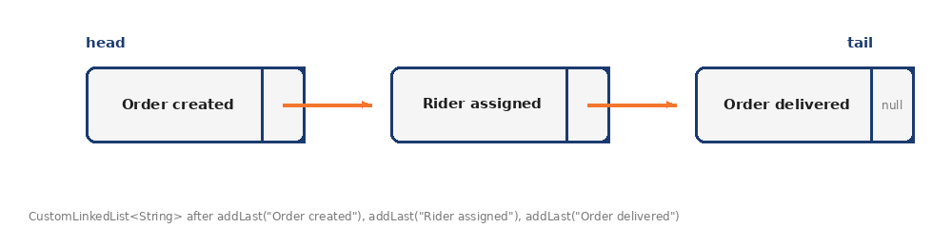

CustomIterator<T>
CustomIterator<T> is required by the project brief. It provides a uniform way to traverse custom collections without exposing their internal representation. Underlying concept. An iterator holds a cursor into a collection and offers hasNext and next. The project’s iterator is itself a required custom type rather than java.util.Iterator, although tests may adapt it. Principal operations. hasNext, next, and optionally remove if the implementation supports safe removal. Expected complexity. Amortized O(1) per element visited; a full traversal is O(n). Use in SMART FOOD DELIVERY. Console listings and algorithm input scans should traverse custom collections through this iterator. Why the structure is appropriate. It prevents algorithms from depending on a particular concrete store and makes empty collections a natural edge case. Relevant edge cases. Iteration over an empty collection; calling next when hasNext is false; concurrent structural modification. Relationship to algorithms. Every searching and sorting demonstration that streams a custom collection depends on a correct iterator.
Step | Action | State
1 | hasNext() -> true, next() | returns "Order created"
2 | hasNext() -> true, next() | returns "Rider assigned"
3 | hasNext() -> true, next() | returns "Order delivered"
4 | hasNext() -> false | iteration ends

5.2 Stacks, queues and deques
CustomStack<T>
CustomStack<T> is required by the project brief. It implements last-in, first-out access. Underlying concept. Elements are pushed and popped at one end. The stack may be backed by a dynamic array or a linked list, provided the backing store is a custom structure. Principal operations. push, pop, peek, isEmpty, size. Expected complexity. Each primitive operation O(1) amortized; space O(n). Use in SMART FOOD DELIVERY. Depth-first search can use an explicit stack of locations. Audit-and-undo inspection can also be explained with a stack discipline, even though audit_events is an append-only table. Why the structure is appropriate. DFS explores a path to completion; a stack is the natural record of that path. Relevant edge cases. Pop or peek on an empty stack must be rejected as invalid input; overflow if a bounded implementation is used. Relationship to algorithms. DepthFirstSearch is the primary algorithmic client.
Step | Action | State
1 | push CREATE_ORDER | size=1, capacity=10, values=[CREATE_ORDER]
2 | push ASSIGN_RIDER | size=2, capacity=10, values=[CREATE_ORDER, ASSIGN_RIDER]
3 | pop undo latest action | size=1, capacity=10, values=[CREATE_ORDER]
CustomQueue<T>
CustomQueue<T> is required by the project brief. It implements first-in, first-out access for ordinary order processing. Underlying concept. Elements enter at the rear and leave at the front. The structure records arrival order without ranking by urgency. Principal operations. enqueue, dequeue, peek, isEmpty, size. Expected complexity. Each primitive operation O(1) amortized; space O(n). Use in SMART FOOD DELIVERY. PENDING orders that are handled under FIFO rules are placed in a custom queue so that the next order is the earliest arrival still waiting. Why the structure is appropriate. FIFO is the default fairness policy when urgency does not override arrival order. Relevant edge cases. Dequeue from an empty queue; very large arrival bursts that force backing-store growth. Relationship to algorithms. Breadth-first search also uses a queue so that locations are processed by hop-distance.
Step | Action | State
1 | enqueue Order-201 | front=0, rear=1, size=1, values=[Order-201]
2 | enqueue Order-202 | front=0, rear=0, size=2, values=[Order-201, Order-202]
3 | dequeue first order | front=1, rear=0, size=1, values=[Order-202]

CustomCircularQueue<T>
CustomCircularQueue<T> is required by the project brief. It implements a fixed or wrapping ring in which the position after the last slot is the first slot. Underlying concept. Head and tail indices move modulo the capacity. The structure is well suited to rotating a pool of resources. Principal operations. enqueue, dequeue, peek, isFull, isEmpty, rotate or equivalent next-available operation. Expected complexity. Primitive operations O(1); space O(capacity). Use in SMART FOOD DELIVERY. Available riders can be rotated so that dispatch does not always select the same rider when several are equally eligible. Why the structure is appropriate. A circular policy is a simple fairness mechanism in a campus delivery desk with a small rider pool. Relevant edge cases. Queue-full insertion; queue-empty removal; capacity one; wrap-around from the last index to zero. Relationship to algorithms. Greedy assignment may consult the circular queue when nearest-rider distances tie, depending on the implemented policy. Confirm against source.
Step | Action | State
1 | enqueue Rider-A, Rider-B, Rider-C | front=0, rear=0, size=3, values=[Rider-A, Rider-B, Rider-C]
2 | Rider-A assigned and leaves front | front=1, rear=0, size=2, values=[Rider-B, Rider-C]
3 | Rider-A returns at rear | front=1, rear=1, size=3, values=[Rider-B, Rider-C, Rider-A]
rear wraps 2 -> 0 once the array fills; the re-enqueued Rider-A physically reuses freed slot 0 yet is correctly reported last in front-relative order.
CustomDeque<T>
CustomDeque<T> is required by the project brief. It allows insertion and removal at both ends. Underlying concept. A deque generalizes the stack and the queue. It can model a dispatch rail on which rush orders are placed at the front and ordinary orders at the back. Principal operations. addFirst, addLast, removeFirst, removeLast, peekFirst, peekLast, isEmpty. Expected complexity. Primitive operations O(1) amortised; space O(n). Use in SMART FOOD DELIVERY. Useful for mixed scheduling policies and for sliding-window scans of recent orders during demonstrations. Why the structure is appropriate. Some delivery policies are neither pure FIFO nor pure stack; a deque makes those policies explicit. Relevant edge cases. Removal from either end when empty; single-element deque where both ends coincide. Relationship to algorithms. May support specialized search or sort demonstrations that need double-ended access.
Step | Action | State
1 | add normal order at rear | front=0, size=1, values=[Normal-301]
2 | add normal order at rear | front=0, size=2, values=[Normal-301, Normal-302]
3 | add urgent order at front | front=3, size=3, values=[Urgent-399, Normal-301, Normal-302]
front wraps 0 -> 3 (mod capacity 4) so the urgent order is returned first without shifting the other two.

5.3 Heaps and priority queues
CustomMinHeap<T>
CustomMinHeap<T> is required by the project brief. It maintains the heap-order property so that the minimum element can be extracted efficiently. Underlying concept. A binary heap is a complete tree stored in an array. For a min-heap, each parent is no greater than its children according to the comparator. Principal operations. insert, extractMin, peekMin, decreaseKey if implemented, size, isEmpty. Expected complexity. Insert and extract-min O(log n); peek O(1); build-heap O(n); space O(n). Use in SMART FOOD DELIVERY. The heap underpins priority dispatch and, if used by the graph implementations, Dijkstra and Prim extract-min steps. Why the structure is appropriate. Repeatedly needing the current cheapest unsettled location or the most urgent order is exactly the heap problem. Relevant edge cases. Extract from an empty heap; duplicate keys; comparator inconsistency; decrease-key on a missing element. Relationship to algorithms. CustomPriorityQueue, DijkstraShortestPath and PrimMinimumSpanningTree are the expected clients if those algorithms are heap-based. Confirm the actual graph implementation in source.
Step | Action | State
1 | insert(6) | heap=[6]
2 | insert(4) -> siftUp swaps | heap=[4, 6]
3 | insert(2) -> siftUp swaps | heap=[2, 6, 4]
4 | extractMin() -> siftDown | heap=[4, 6], returned=2

CustomPriorityQueue<T>
CustomPriorityQueue<T> is required by the project brief. It exposes a priority-queue interface over the min-heap (or an equivalent custom heap). Underlying concept. Priority is a comparable key. In this project the operational key for orders is derived from urgency and the student-ID priority weight: priorityScore = orderUrgency × 2. Principal operations. offer/enqueue, poll/dequeue, peek, isEmpty, size. Expected complexity. The same logarithmic bounds as the underlying heap. Use in SMART FOOD DELIVERY. Urgent or delayed orders are processed from a priority queue rather than from the FIFO queue. Why the structure is appropriate. Urgency is an explicit operational attribute in the Ghanaian model; a FIFO-only desk would ignore it. Relevant edge cases. Equal priority scores; a newly arriving higher-urgency order; empty queue. Relationship to algorithms. Order dispatch demonstrations and any algorithm that must always take the current best item.
Step | Action | State
1 | insert Order-1 (priority 6) | heap=[6]
2 | insert Order-2 (priority 4) | heap=[4, 6]
3 | insert Order-4 (priority 2) | heap=[2, 6, 4]
4 | extractMin() dispatches Order-4 | heap=[4, 6], returned priority=2
Order-4 (urgency 1, priority 2) is dispatched first, matching the lowest priority score in the heap.

5.4 Trees
CustomBinarySearchTree<K, V>
CustomBinarySearchTree<K, V> is required by the project brief. It stores key–value pairs in a binary tree ordered by key. Underlying concept. For every node, keys in the left subtree are smaller and keys in the right subtree are larger, according to the comparator. Principal operations. insert, find, delete, in-order traversal, size. Expected complexity. Average O(log n) search, insert and delete if the tree remains balanced by insertion order; worst case O(n) if keys arrive already sorted; space O(n). Use in SMART FOOD DELIVERY. Ordered lookup of orders or locations by identifier, and an educational contrast with the balanced trees. Why the structure is appropriate. In-order traversal produces a sorted view that can feed binary search or console listings. Relevant edge cases. Empty tree; inserting a duplicate key; deleting a node with two children; sorted input that degenerates into a list. Relationship to algorithms. Tree Performance Lab experiments compare this structure with the balanced variants.
Location IDs 51, 25, 74, 23 inserted in that order:
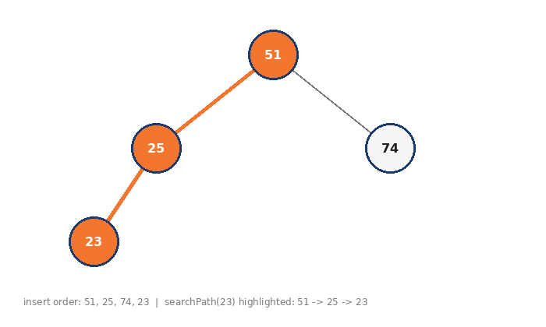
searchPath(23) highlighted in orange: 51 -> 25 -> 23.
Operation | Result
searchPath(23) | 51 -> 25 -> 23
inorderKeys() | 23, 25, 51, 74
height() | 3
size() | 4

CustomRedBlackTree<K, V>
CustomRedBlackTree<K, V> is required by the project brief. It maintains a balanced binary search tree using red-black coloring invariants. Underlying concept. Nodes are colored red or black so that the longest root-to-leaf path is at most twice the shortest, which guarantees logarithmic height. Principal operations. insert, find, delete with the standard color-fix rotations; ordered traversal. Expected complexity. Search, insert and delete O(log n) worst case; space O(n). Use in SMART FOOD DELIVERY. Provides a worst-case efficient ordered index for identifiers when the binary search tree would degenerate. Why the structure is appropriate. Delivery identifiers are not guaranteed to arrive in random order; balancing is therefore responsible engineering as well as a syllabus topic. Relevant edge cases. Deleting the root; successive insertions that trigger recoloring and rotations; an empty tree. Relationship to algorithms. Tree experiments and any service that needs ordered maps with logarithmic worst-case bounds.
Keys 10, 20, 30, 15, 25, 5 inserted in sequence — three rotations total, kept balanced instead of degenerating.
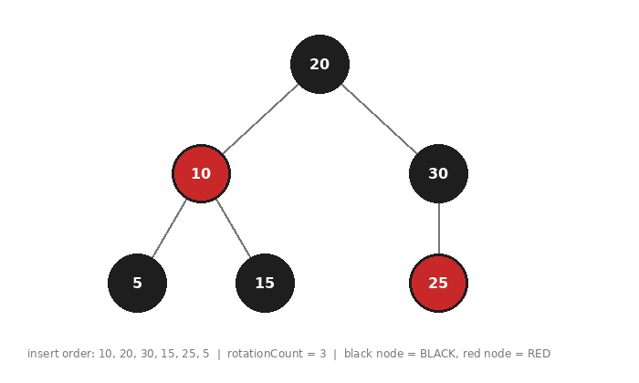
Step | Action | State
1 | insert 10 | root = 10(B)
2 | insert 20 -> rotateLeft(10) | root = 20(B), left=10(R)
3 | insert 30 -> flipColors(20) | root = 20(B), left=10(B), right=30(B)
4 | insert 15 -> rotateLeft(10) | 20(B) -> left=15(B)[left=10(R)], right=30(B)
5 | insert 25 | 20(B) -> left=15(B)[10(R)], right=30(B)[left=25(R)]
6 | insert 5 -> rotateRight(15), flipColors(10) | 20(B) -> left=10(R)[5(B),15(B)], right=30(B)[left=25(R)]
Metric | Value
rotationCount() | 3
height() | 3
size() | 6
Note: an existing bug in levelOrderSnapshot() (always returned only the root) was found and fixed while preparing this evidence — see the separate fix note delivered alongside the data-structure evidence chapter.

CustomBTree<K, V>
CustomBTree<K, V> is required by the project brief. It stores keys in a multi-way balanced tree of a fixed minimum degree. Underlying concept. A B-tree keeps many keys in each node so that height grows slowly. It is the classical model of an external index, demonstrated here in memory for educational comparison. Principal operations. insert, find, delete, and traversal of leaves in order. Expected complexity. Search, insert and delete O(log n) with a larger branching factor than a binary tree; space O(n). Use in SMART FOOD DELIVERY. Demonstrates an index-like structure over order or location keys and supplies a third series for the tree performance graphs. Why the structure is appropriate. It shows that ‘tree’ is not a single complexity story: branching factor changes height and constant factors. Relevant edge cases. Underfill nodes after deletion; minimum-degree edge cases; duplicate keys. Relationship to algorithms. Tree Performance Lab experiments.
Keys 10, 20, 30, 40, 50, 60 inserted; root splits twice.
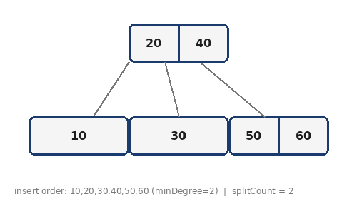
Step | Action | State
1 | insert 10, 20, 30 | root=[10,20,30] (leaf, at max capacity)
2 | insert 40 -> splitChild(root, 0) | root=[20], children=[10],[30] ; splitCount=1
3 | insert 50, 60 fills right child | root=[20], children=[10],[30,40,50] then split on 60
4 | insert 60 -> splitChild(root, 1) | root=[20,40], children=[10],[30],[50,60] ; splitCount=2
searchTrace(60): [20,40] -> [50,60]
Metric | Value
splitCount() | 2
size() | 6
rootKeyCount() | 2

5.5 Hash-based structures
The student-ID calculation fixes the hash-table initial capacity at the next prime after (378204167 mod 50) + 50, which is 71. Using a prime capacity is a conventional way to reduce clustering for remainder-based hashing. The actual hash function and collision strategy must be confirmed from the project source.

CustomHashTable<K, V>
CustomHashTable<K, V> is required by the project brief. It associates keys with values under average-case constant-time lookup. Underlying concept. Keys are hashed into buckets. Collisions are resolved by the team’s chosen custom strategy (chaining or open addressing). The table resizes when a load factor is exceeded. Principal operations. put, get, remove, containsKey, size. Expected complexity. Average O(1) put/get/remove under standard assumptions; worst case O(n) if all keys collide; space O(n). Use in SMART FOOD DELIVERY. Fast lookup of riders, orders and locations by identifier during assignment and search demonstrations. Hash-table experiments start from capacity 71. Why the structure is appropriate. Many delivery operations are ‘find this identifier’, which does not require ordering. Relevant edge cases. Null keys if disallowed; high load factor; all keys hashing to one bucket; resizing across the initial prime 71. Relationship to algorithms. Hash Performance Lab; supporting lookups inside greedy assignment and search services.
Key | index = key mod 71 | Bucket after insert | Collision?
5 | 5 | [5] | no (bucket was empty)
12 | 12 | [12] | no (bucket was empty)
76 | 5 | [5 -> 76] | yes
30 | 30 | [30] | no (bucket was empty)
83 | 12 | [12 -> 83] | yes

Metric | Value
collisionCount() | 2
size() | 5
capacity() | 71
loadFactor() | 0.0704 (5/71)

CustomHashSet<T>
CustomHashSet<T> is required by the project brief. It represents a set of unique elements. Underlying concept. A hash set is a hash table whose values are irrelevant, only membership matters. Principal operations. add, contains, remove, size, iteration. Expected complexity. Same average and worst-case bounds as the hash table; space O(n). Use in SMART FOOD DELIVERY. Marking visited locations in BFS and DFS; ensuring unique road pairs or unique IDs during validation-style checks. Why the structure is appropriate. Graph traversal correctness depends on not revisiting a vertex endlessly. Relevant edge cases. Adding a duplicate; querying an empty set; iterating while modifying. Relationship to algorithms. BreadthFirstSearch and DepthFirstSearch; uniqueness checks related to dataset integrity.
Call | Result
visited.add(51); visited.add(74); visited.add(23); | size() = 3
visited.contains(74) | true
visited.contains(99) | false
names.put(51, "Central Cafeteria, CC"); names.put(74, "Block B"); | size() = 2
names.get(74) | "Block B"
names.containsKey(99) | false
names.getOrDefault(99, "Unknown") | "Unknown"

CustomHashMap<K, V>
CustomHashMap<K, V> is required by the project brief. It provides a map interface over the custom hash table. Underlying concept. The map is the associative view used by services: identifier to entity, vertex to distance, vertex to predecessor. Principal operations. put, get, remove, containsKey, keys, values. Expected complexity. Same bounds as CustomHashTable. Use in SMART FOOD DELIVERY. Dijkstra and Prim need predecessor and distance maps; assignment needs rider and order indexes. Why the structure is appropriate. A map is the natural in-memory index once records have left the repository. Relevant edge cases. Missing-key lookup; overwriting an existing key; empty map. Relationship to algorithms. Shortest-path reconstruction and many service-layer indexes.

5.6 Graphs and disjoint sets
CustomGraph
CustomGraph is required by the project brief. It is the abstract delivery network: vertices are locations and edges are roads with weights. Underlying concept. A graph G = (V, E) may be directed or undirected. In the seed data every road is bidirectional, so the academic network is treated as undirected unless a demonstration explicitly states otherwise. Principal operations. addVertex, addEdge, neighbours, edgeWeight, vertexCount, edgeCount. Expected complexity. Depends on the concrete representation, discussed next. Use in SMART FOOD DELIVERY. All routing, reachability and spanning-tree demonstrations run on this network. Why the structure is appropriate. Delivery is a spatial problem; a list of orders without a graph cannot answer route questions. Relevant edge cases. Self-loops (forbidden in the seed); missing vertices; disconnected graphs (the seed itself is connected). Relationship to algorithms. BFS, DFS, Dijkstra, Prim and Kruskal.
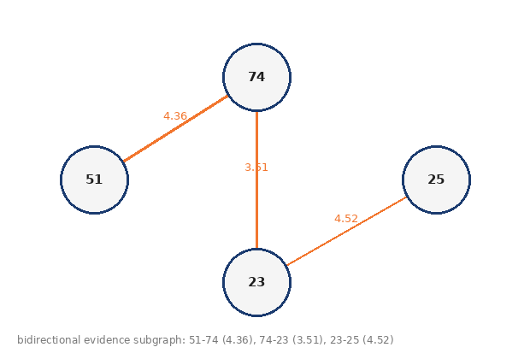
AdjacencyListGraph
AdjacencyListGraph is required by the project brief. It stores, for each vertex, a custom list of incident edges. Underlying concept. The representation is sparse: space is proportional to |V| + |E| rather than |V|². Principal operations. neighbor iteration in time proportional to the degree of the vertex. Expected complexity. Space O(V + E). Neighbor enumeration of a vertex O(degree). Edge existence O(degree) unless an additional map is kept. Use in SMART FOOD DELIVERY. The default representation of the 80-location, 150-edge Legon network, which is sparse. Why the structure is appropriate. Campus-and-neighborhood connectivity is not a complete graph; an adjacency list matches the data. Relevant edge cases. Isolated vertices; high-degree hubs; bidirectional insertion that must not double-count incorrectly. Relationship to algorithms. BFS, DFS, Dijkstra and Prim typically iterate neighbor lists.
Vertex | Neighbours
51 (Central Cafeteria) | 74 : 4.36
74 (Block B) | 51 : 4.36, 23 : 3.51
23 (Sarbah Main) | 74 : 3.51, 25 : 4.52
25 (Mensah Sarbah Dining Hall) | 23 : 4.52

AdjacencyMatrixGraph
AdjacencyMatrixGraph is required by the project brief. It stores a |V| by |V| matrix of weights or presence flags. Underlying concept. Edge existence is constant-time. Space is quadratic, which is acceptable for comparison experiments on modest vertex counts. Principal operations. setEdge, getEdge, scan of a row to list neighbors in O(V). Expected complexity. Space O(V²). Edge query O(1). Neighbor scan O(V) even if the vertex is isolated. Use in SMART FOOD DELIVERY. Used for representation comparison and for graph Performance Lab series on 50, 100, 200 and 500 vertices. Why the structure is appropriate. It makes the cost of density visible: the same algorithm changes constants when the representation changes. Relevant edge cases. Index out of range; representing ‘no edge’ versus weight zero; symmetry for bidirectional roads. Relationship to algorithms. Comparative graph experiments; optionally Dijkstra or Floyd-style dense scans if implemented.
 | 51 | 74 | 23 | 25
51 | - | 4.36 | - | -
74 | 4.36 | - | 3.51 | -
23 | - | 3.51 | - | 4.52
25 | - | - | 4.52 | -

CustomDisjointSet
CustomDisjointSet is required by the project brief. It maintains a partition of vertices and answers whether two vertices are already in the same component. Underlying concept. Union-find with parent links, typically with union by rank and path compression. find returns a representative; union merges two components. Principal operations. makeSet, find, union, connected. Expected complexity. Almost O(1) amortized per operation with the standard improvements (inverse-Ackermann); space O(V). Use in SMART FOOD DELIVERY. Kruskal accepts an edge only when its endpoints are in different components. The dataset generator uses the same idea to build a connecting spanning tree of roads. Why the structure is appropriate. Cycle prevention is exactly the disjoint-set problem. Relevant edge cases. Union of already connected vertices; find on an uninitialized element; a universe of one vertex. Relationship to algorithms. KruskalMinimumSpanningTree and the Kruskal-style road-generation pass.
Step | Action | State
0 | makeSet(51), makeSet(74), makeSet(23), makeSet(25) | parent=[51,74,23,25], rank=[0,0,0,0]
1 | union(74, 23) -> accept 74-23 | parent=[51,74,74,25], rank=[0,1,0,0]
2 | union(51, 74) -> accept 51-74 | parent=[74,74,74,25], rank=[0,1,0,0]
3 | union(23, 25) -> accept 23-25 | parent=[74,74,74,74], rank=[0,1,0,0]

5.7 Structure–algorithm map

Table 5.2 Structure-to-algorithm relationships
Structure | Algorithms that depend on it
CustomDynamicArray | Linear search, binary search, all four sorts
CustomQueue | BFS; FIFO dispatch
CustomStack | DFS
CustomCircularQueue | Rider rotation
CustomMinHeap / PriorityQueue | Priority dispatch; Dijkstra and Prim if heap-based
CustomHashSet / HashMap | Visited sets; distance and predecessor maps
AdjacencyListGraph / Matrix | BFS, DFS, Dijkstra, Prim
CustomDisjointSet | Kruskal; road-network generation

Each structure listed above requires normal-case, boundary-case and invalid-input tests, together with report evidence. Until those results are attached, this chapter specifies intent and expected complexity rather than measured pass rates.

6. Algorithms and implementation
This chapter treats every required algorithm class. For each algorithm the report states the purpose, the food-delivery application, the inputs and outputs, the procedure, pseudocode, theoretical complexity, implementation notes, and limitations. Source excerpts are included only when they can be verified from the project artefacts; no source code is inferred or fabricated. Correctness arguments and traces appear in Chapter 7.1

Table 6.1 Mapping of required algorithms to delivery operations
Algorithm class | SMART FOOD DELIVERY application
LinearSearch | Search unsorted records
BinarySearch | Search sorted records
SelectionSort | Order records by selected criteria
InsertionSort | Order records by time, urgency, distance or deadline
MergeSort | Efficient sorting of order records
QuickSort | Efficient sorting of records
BreadthFirstSearch | Find reachable nearby locations
DepthFirstSearch | Traverse the delivery network
DijkstraShortestPath | Find shortest delivery routes
PrimMinimumSpanningTree | Generate minimum connection networks
KruskalMinimumSpanningTree | Generate minimum connection networks
GreedyRiderAssignment | Assign nearest available rider
DynamicOrderSelection | Select orders under time, budget or capacity limits
BruteForceAssignment | Compare all rider assignments for small inputs
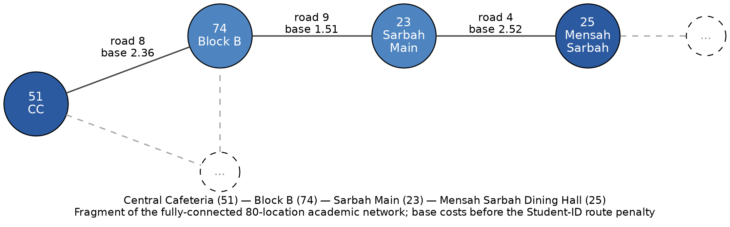
Figure 6.1 Illustrative fragment of the Legon delivery network

6.1 Linear Search
Purpose. LinearSearch examines records from the beginning of a custom array or list until it finds a key or exhausts the collection. Food-delivery application. Dispatchers must often look up an order, rider, restaurant or location in a collection that has not been sorted by that key — for example, orders freshly loaded from SQLite in primary-key order while the user searches by customer or status. Inputs. A custom sequence of records, a target key and a comparator or key extractor. Outputs. The index or record if present; an explicit not-found result otherwise. Procedure. Starting at index 0, compare each record with the target. Stop at the first match. If the end is reached, report absence. Pseudocode follows.
LINEAR-SEARCH(A, target)
for i ← 0 to A.length - 1 do
if KEY(A[i]) = target then
return i
return NOT_FOUND
Complexity. Time Θ(n) in the worst and average cases if the target is equally likely to occupy any position or to be absent; best case Θ(1) when the first record matches. Auxiliary space O(1). Selected implementation. Class LinearSearch in the algorithm layer. Limitations. Linear search does not become faster on sorted data unless the implementation adds an early-exit rule, which is not required. It is the correct baseline for unsorted records and for small n, but it is not the responsible choice for repeated lookups on large sorted arrays.

6.2 Binary Search
Purpose. BinarySearch locates a key in a sequence that is already sorted by the same comparator. Food-delivery application. Once orders have been sorted by identifier, deadline or another key, a dispatcher can probe the middle of the list and discard half of the remaining records at each step. Inputs. A custom random-access sequence sorted by the search key, a target, and the same comparator. Outputs. The index of a matching record, or an explicit not-found result. Procedure. Maintain a closed range low..high. Compare the middle record with the target. If it is smaller, discard the left half; if larger, discard the right half; if equal, return the index. The range shrinks every iteration. Precondition. The sequence must be sorted by the search key. Binary search on unsorted data is not a valid algorithm, even if a particular target happens to sit at the middle index. Chapter 7 develops this point.
BINARY-SEARCH(A, target) // A is sorted by KEY
low ← 0
high ← A.length - 1
while low ≤ high do
mid ← low + ⌊(high - low) / 2⌋
if KEY(A[mid]) = target then return mid
else if KEY(A[mid]) < target then low ← mid + 1
else high ← mid - 1
return NOT_FOUND
Complexity. Time O(log n) comparisons on a random-access array; auxiliary space O(1) for the iterative form. Selected implementation. Class BinarySearch. Limitations. The algorithm is incorrect if the sort key and the search key differ, if the array is unsorted, or if the comparator is inconsistent. It also requires CustomDynamicArray-style indexing; a linked list would cost linear time to find the middle and would destroy the logarithmic advantage.

6.3 Selection Sort
Purpose. SelectionSort repeatedly selects the smallest remaining record and places it in the next position of a growing sorted prefix. Food-delivery application. A short list of orders can be ordered by deadline, urgency, distance or another selected criterion when a simple in-place demonstration is required. Inputs. A custom array and a comparator. Outputs. The same array in non-decreasing order.
SELECTION-SORT(A)
for i ← 0 to A.length - 2 do
min ← i
for j ← i + 1 to A.length - 1 do
if A[j] < A[min] then min ← j
swap A[i] and A[min]
Complexity. Time Θ(n²) comparisons in every case; auxiliary space O(1). The number of swaps is at most n − 1. Selected implementation. Class SelectionSort. Limitations. The quadratic bound makes the algorithm unsuitable as the default sort for 350 orders, let alone for Performance Lab sizes of 10 000. It remains useful as a transparent baseline and as a teaching contrast with merge sort and quick sort.

6.4 Insertion Sort
Purpose. InsertionSort builds a sorted prefix by inserting the next unsorted record into its correct position. Food-delivery application. Orders that arrive nearly sorted by submission time, or short lists ranked by urgency, distance or deadline, can be maintained cheaply because insertion sort is adaptive: already ordered input costs linear time. Inputs. A custom array and a comparator. Outputs. The array in non-decreasing order.
INSERTION-SORT(A)
for i ← 1 to A.length - 1 do
key ← A[i]
j ← i - 1
while j ≥ 0 and A[j] > key do
A[j + 1] ← A[j]
j ← j - 1
A[j + 1] ← key
Complexity. Worst-case time O(n²) on reverse-sorted input; best-case time Θ(n) on sorted input; auxiliary space O(1). Selected implementation. Class InsertionSort. Limitations. Like selection sort, it is not the responsible default for large n, but it is the correct lightweight choice for small or nearly sorted order lists. Chapter 7 states the prefix invariant and records a duplicate-preserving trace.

6.5 Merge Sort
Purpose. MergeSort sorts by divide-and-conquer: the array is split, the halves are sorted recursively, and the two sorted runs are merged by repeatedly taking the smaller front element. Food-delivery application. Efficient, stable ordering of order records for console listings and as a precondition for binary search. Inputs. A custom array and a comparator. Outputs. A sorted sequence. The implementation should be stable if equal urgency or deadline values must retain their previous relative order.
MERGE-SORT(A, lo, hi)
if lo ≥ hi then return
mid ← ⌊(lo + hi) / 2⌋
MERGE-SORT(A, lo, mid)
MERGE-SORT(A, mid + 1, hi)
MERGE(A, lo, mid, hi)
MERGE(A, lo, mid, hi)
L ← A[lo..mid]; R ← A[mid+1..hi]
i ← 0; j ← 0; k ← lo
while i < |L| and j < |R| do
if L[i] ≤ R[j] then A[k] ← L[i]; i ← i + 1
else A[k] ← R[j]; j ← j + 1
k ← k + 1
copy any remainder of L or R into A
Complexity. Time Θ(n log n) in all cases; auxiliary space Θ(n) for the merge buffers, plus O(log n) recursion depth. Selected implementation. Class MergeSort. Limitations. The linear extra memory is the price of the guaranteed bound. For memory-tight demonstrations the team may prefer in-place insertion sort on tiny n and merge sort on large n. Stability should be confirmed from the source comparator and the ≤ test in MERGE.

6.6 Quick Sort
Purpose. QuickSort selects a pivot, partitions the array so that one side contains elements that are no greater than the pivot and the other side contains elements that are no smaller, and then sorts the two partitions recursively. Food-delivery application. Efficient in-place sorting of records when average-case speed matters and a guaranteed n log n bound is not required. Inputs. A custom array and a comparator. Outputs. The array in sorted order. The pivot rule is implementation-specific and is not asserted here. Common choices include the last index, the first index, the median of three, or a Student-ID-seeded random index. Only the project source can confirm which rule SMART FOOD DELIVERY uses.
QUICK-SORT(A, lo, hi)
if lo ≥ hi then return
p ← PARTITION(A, lo, hi) // pivot index after partition
QUICK-SORT(A, lo, p - 1)
QUICK-SORT(A, p + 1, hi)
PARTITION(A, lo, hi) // schematic; confirm pivot choice
pivot ← A[hi]
i ← lo - 1
for j ← lo to hi - 1 do
if A[j] ≤ pivot then
i ← i + 1
swap A[i] and A[j]
swap A[i + 1] and A[hi]
return i + 1
Complexity. Average time O(n log n); worst case O(n²) when partitions are consistently unbalanced, which occurs for some pivot rules on already sorted input. Auxiliary space is implementation-dependent: O(log n) expected recursion depth if partitions are balanced, O(n) in the degenerate case, plus any in-place swap workspace. Selected implementation. Class QuickSort. Limitations. Worst-case quadratic behavior is the reason merge sort is the safer default when a hard upper bound is required. Quick sort is also not stable in the usual in-place form.

6.7 Breadth-First Search
Purpose. BreadthFirstSearch visits locations level by level from a selected dispatch point, using a custom queue. Food-delivery application. It answers which locations are reachable and which locations are nearby in the sense of an increasing number of road hops — for example, hostels and dining halls that can be reached from Central Cafeteria without regard to kilometer cost. Inputs. A CustomGraph and a source location. Outputs. A visitation order, a reachable set, and optionally hop-distances and a breadth-first tree.
BFS(G, s)
for each vertex u in G do visited[u] ← false
Q ← empty CustomQueue
visited[s] ← true
ENQUEUE(Q, s)
while Q is not empty do
u ← DEQUEUE(Q)
for each neighbor v of u do
if not visited[v] then
visited[v] ← true
ENQUEUE(Q, v)
Complexity. Time O(V + E) on an adjacency list, because each vertex is enqueued at most once and each edge is examined a constant number of times. Space O(V) for the queue and the visited set. Selected implementation. Class BreadthFirstSearch. Limitations. BFS does not compute a weighted shortest path. Road distances and condition weights vary across the Legon model, so hop-minimal routes need not be cost-minimal. Dijkstra is the algorithm used for weighted route cost. Figure 6.2 contrasts the level-order behavior of BFS with the deep exploration of DFS.
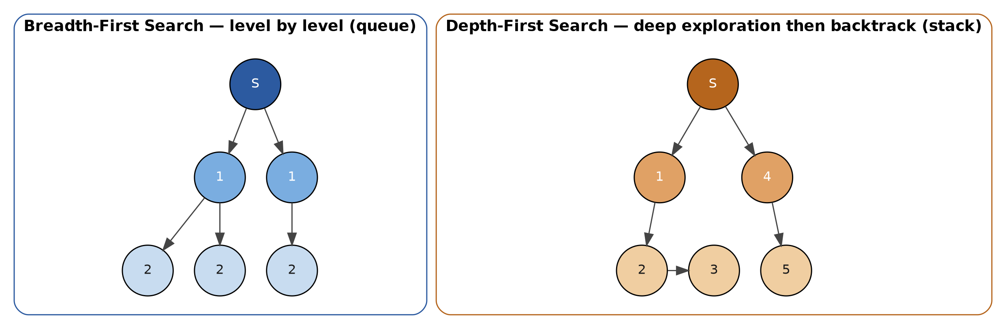
Figure 6.2 BFS explores by hop-distance; DFS explores a path to completion

6.8 Depth-First Search
Purpose. DepthFirstSearch explores as far as possible along a path before backtracking, using a custom stack or an equivalent recursion. Food-delivery application. It systematically traverses the delivery network from a dispatch point, enumerating reachable locations and exposing the shape of the academic road graph. Inputs. A CustomGraph and a source. Outputs. A visitation order, a reachable set, and optionally discovery and finish times or a depth-first forest.
DFS(G, s)
for each vertex u in G do visited[u] ← false
S ← empty CustomStack
PUSH(S, s)
while S is not empty do
u ← POP(S)
if not visited[u] then
visited[u] ← true
for each neighbor v of u do
if not visited[v] then PUSH(S, v)
Complexity. Time O(V + E) on an adjacency list; space O(V) for the stack or recursion and the visited set. Selected implementation. Class DepthFirstSearch. Limitations. DFS does not produce hop-minimal or weight-minimal routes. Its value is systematic exploration and, if extended, cycle detection or component labelling. Recursion depth on a long path should be bounded by an explicit stack if the graph Performance Lab uses 500 vertices.

6.9 Dijkstra Shortest Path
Purpose. DijkstraShortestPath computes minimum-cost routes on a graph whose edge weights are non-negative. Food-delivery application. It answers which sequence of academic roads a rider should follow from a restaurant or dispatch point to a customer, and what total route cost that path incurs. Inputs. A weighted CustomGraph, a source location and a destination. Outputs. The reconstructed path and the finite total cost, or an unreachable indication. Procedure. Every vertex begins at distance infinity except the source, which begins at zero. While unsettled vertices remain, the unsettled vertex with the smallest known distance is selected and settled. Its outgoing edges are relaxed: if a cheaper path to a neighbor is found, that neighbor’s distance and predecessor are updated. When the destination is settled its distance is final. If reachable vertices are exhausted and the destination remains at infinity, it is unreachable.
DIJKSTRA(G, s, t)
for each vertex u do dist[u] ← ∞; prev[u] ← NIL
dist[s] ← 0
Q ← CustomMinHeap of vertices keyed by dist
while Q is not empty do
u ← EXTRACT-MIN(Q)
if u = t then break
for each edge (u, v, w) do
if dist[u] + w < dist[v] then
dist[v] ← dist[u] + w
prev[v] ← u
DECREASE-KEY(Q, v) // or re-insert, per implementation
return path reconstructed from prev, and dist[t]
Precondition. Edge weights must be non-negative. Dijkstra is not valid for graphs containing negative-weight edges, because a settled vertex might later be improved through a negative edge. The project’s road distances, travel times and condition weights are non-negative, and the Student-ID route penalty used in the recorded trace is the positive integer 2, so the precondition holds for the academic network. Complexity. The bound depends on the priority-queue implementation. If CustomMinHeap supports extract-min and decrease-key in logarithmic time, a standard bound is O((V + E) log V). If the implementation scans an array for the minimum, the bound is O(V² + E). This report does not force a tighter claim than the source supports. The recorded correctness trace (Section 7.7) uses final weights equal to a listed base cost plus the route penalty 2, producing the path 51 → 74 → 23 → 25 with total 12.39. Figure 6.3 summarizes the settlement sequence. Limitations. The algorithm optimizes the academic cost model, not live Accra traffic. It must not be presented as a navigation product.
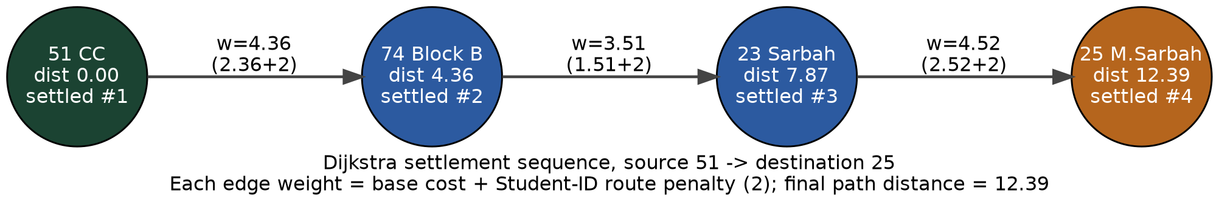
Figure 6.3 Dijkstra settlement sequence 51 → 25 (final distance 12.39)

6.10 Prim Minimum Spanning Tree
Purpose. PrimMinimumSpanningTree grows a tree from a seed vertex by repeatedly adding the cheapest edge that connects the tree to a vertex outside the tree. Food-delivery application. It produces a minimum connection network: the cheapest set of academic roads that still connects the selected locations. Such a network is a planning artefact — for example, a backbone of links that a campus dispatch group might keep staffed — not a turn-by-turn rider route. Inputs. A weighted connected CustomGraph and an optional start vertex. Outputs. The set of accepted edges and their total weight.
PRIM(G, s)
for each vertex u do key[u] ← ∞; parent[u] ← NIL; inTree[u] ← false
key[s] ← 0
Q ← CustomMinHeap of vertices keyed by key
while Q is not empty do
u ← EXTRACT-MIN(Q)
inTree[u] ← true
for each edge (u, v, w) do
if not inTree[v] and w < key[v] then
key[v] ← w
parent[v] ← u
DECREASE-KEY(Q, v)
return edges (parent[v], v) for v ≠ s
Complexity. As with Dijkstra, the bound is implementation-dependent: O((V + E) log V) with a binary heap, or O(V² + E) with an array minimum. Selected implementation. Class PrimMinimumSpanningTree. Limitations. If the graph is disconnected, Prim spanning from one seed yields a minimum spanning forest of that component only. The seed location graph is fully connected, so a single tree is expected on the full eighty vertices. Prim does not produce rider routes; Dijkstra does.

6.11 Kruskal Minimum Spanning Tree
Purpose. KruskalMinimumSpanningTree considers edges from lowest weight to highest and accepts an edge only when it joins two different components. Food-delivery application. Like Prim, it constructs a minimum connection network over the academic locations. The same idea is used in dataset generation to guarantee that the eighty locations are connected before redundant local edges are added. Inputs. A weighted CustomGraph. Outputs. The accepted edges and their total weight.
KRUSKAL(G)
A ← empty set of edges
for each vertex v do MAKE-SET(v) // CustomDisjointSet
sort edges of G by increasing weight // e.g. MergeSort
for each edge (u, v, w) in that order do
if FIND(u) ≠ FIND(v) then
A ← A ∪ {(u, v)}
UNION(u, v)
return A
Complexity. Sorting dominates: O(E log E) edge comparisons, which is O(E log V) for simple graphs. Disjoint-set operations add a negligible inverse-Ackermann factor. Auxiliary space is O(V) for the disjoint set plus storage for the edge list. Selected implementation. Class KruskalMinimumSpanningTree. Limitations. Kruskal’s output is a network design, not a path. On the four-location correctness fragment the accepted edges happen to form the same chain that Dijkstra used, with the same total 12.39; that coincidence must not be generalized. Figure 6.4 shows the fragment.
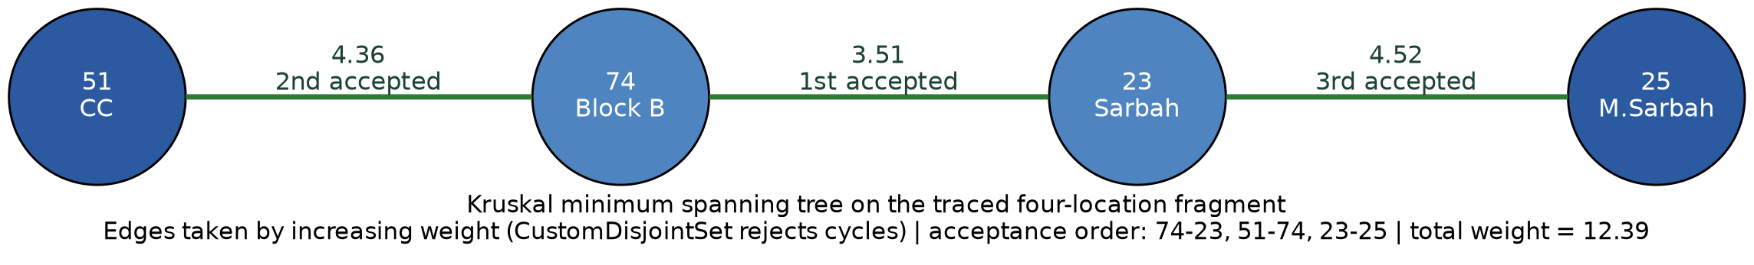
Figure 6.4 Minimum spanning tree on the traced four-location fragment

6.12 Greedy Rider Assignment
Purpose. GreedyRiderAssignment assigns, for the current order, the nearest available rider according to the academic distance or route-cost measure. Food-delivery application. When a PENDING order must be given a rider quickly, the desk can scan available riders, pick the cheapest feasible one, mark that rider BUSY, and write an ASSIGNED status with an audit event. Inputs. One or more orders and the set of currently available riders. Outputs. A set of (order, rider, cost) assignments and an updated availability picture.
GREEDY-ASSIGN(orders, riders)
result ← empty list
available ← custom collection of riders with status AVAILABLE
for each order o in orders do
best ← NIL; bestCost ← ∞
for each rider r in available do
c ← COST(r, o) // academic distance / route cost
if c < bestCost then best ← r; bestCost ← c
if best = NIL then report no feasible rider for o
else assign o to best; mark best unavailable; append to result
return result
Complexity. If each of k orders scans up to r available riders and COST is O(1) (for example a precomputed distance) then the demonstration is O(k r). If COST itself runs Dijkstra, the cost is multiplied by the route algorithm. This report does not invent a tighter bound than the source supports. Selected implementation. Class GreedyRiderAssignment. Limitations. The method is fast but is not guaranteed to minimize total assignment cost. A locally cheapest choice can leave a later order with a catastrophically expensive remainder. Chapter 7 records the required counterexample (totals 101 versus 4). Greedy assignment is therefore a heuristic for the demonstration, not an exact optimizer. Fairness implications are discussed in Chapter 11.

6.13 Dynamic Order Selection
Purpose. DynamicOrderSelection solves a 0-1 knapsack-style model: each order has a cost represented by estimated delivery-distance units and a value represented by urgency; capacity is the maximum total distance the rider system can accept. Food-delivery application. When a desk cannot take every pending order — because of a distance budget, a time budget, or an analogous constraint — the algorithm selects a feasible subset with maximum total urgency. Inputs. A list of orders and a capacity. The default demonstration capacity is the Student-ID parameter 17. Outputs. The optimal value, the reconstructed subset, and a trace of best values after each order is processed. Define table[i][c] as the best urgency value obtainable using the first i orders with remaining capacity c. For every order the algorithm compares excluding the order with including it if it fits, and stores the larger value. The table is filled from smaller subproblems to the full problem. Reconstruction walks backward through the completed table and identifies orders whose inclusion contributed to the optimal result.
DP-SELECT(orders[1..n], C)
create table[0..n][0..C] filled with 0
for i ← 1 to n do
cost ← DP-COST(orders[i]) // integer distance units
val ← urgency(orders[i])
for c ← 0 to C do
table[i][c] ← table[i-1][c] // exclude
if cost ≤ c then
table[i][c] ← max(table[i][c],
val + table[i-1][c - cost])
reconstruct subset by walking i = n..1
return table[n][C] and the subset
Complexity. Time Θ(n C) and space Θ(n C) for the full table, or Θ(C) extra space if only the value is required and a separate reconstruction method is used. With n small in the console demonstration and C = 17, the table is tiny. Selected implementation. Class DynamicOrderSelection. Limitations. The algorithm is exact for the stated model. It is not a claim about real profit, nutrition or customer importance. Urgency is an academic integer, and DP cost is an integrase distance, not a live travel-time forecast. Figure 6.5 and Section 7.7 record the four-order trace in which all orders fit because 5 + 4 + 5 + 2 = 16 ≤ 17.
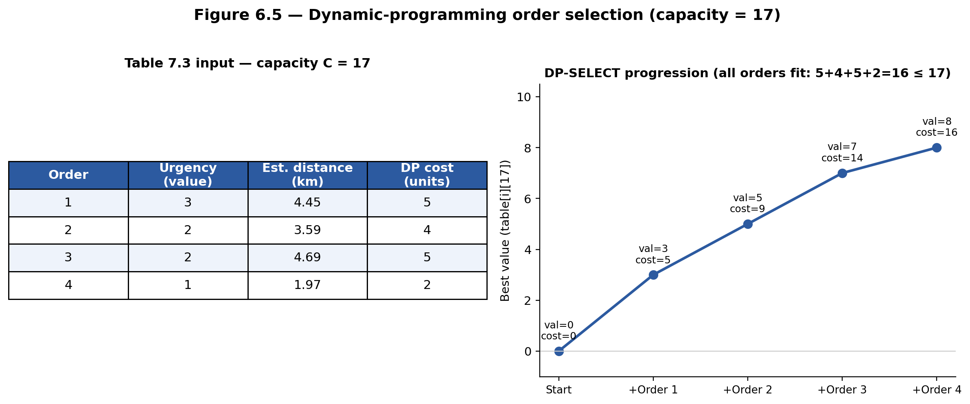
Figure 6.5 Dynamic-programming order selection (capacity = 17)

6.14 Brute-Force Assignment
Purpose. BruteForceAssignment enumerates possible rider–order assignments on small inputs and retains a minimum-cost feasible assignment. Food-delivery application. It is a reference solution against which the greedy method can be compared when the number of orders and riders is tiny — for example the two-by-two counterexample in Chapter 7. Inputs. A small set of orders and riders and a cost matrix. Outputs. An optimal assignment and its total cost, or a statement that the instance is too large for exhaustive search.
instance
BRUTE-FORCE-ASSIGN(orders, riders)
bestCost ← ∞; best ← NIL
for each injection π from orders to riders do // or permutations of a square
c ← Σ COST(orders[i], riders[π(i)])
if c < bestCost then bestCost ← c; best ← π
return best, bestCost
Complexity. For a balanced instance of n orders and n riders the number of permutations is n!, so time grows factorially (exponentially in the usual informal sense used in the brief). Space is O(n) for the current permutation plus the cost matrix. Selected implementation. Class BruteForceAssignment. Limitations. Brute force is not practical for large real-world assignment problems and is not claimed to be. Its academic value is optimality on small inputs and the ability to exhibit the gap between greedy and optimal totals. The Performance Lab should not be used to suggest that factorial search scales to the 350-order seed.

6.15 Student-ID parameters
The team comprises seventeen members. Their student identifiers are inputs to a deterministic parameter service so that several algorithmic constants are reproducible and uniquely tied to Group 39.

Table 6.2 Student-ID identifiers used by the parameter service
# | Student ID | Name
1 | 22020618 | Adom Bempong Franklin
2 | 22012447 | Dzah Solomon Sampson
3 | 22166686 | Asante Emmanuella Baaba
4 | 22146249 | Mubarack Jibriel
5 | 22106332 | Ofori Richard
6 | 22042260 | Akplu Kelvin Mawuli
7 | 22042713 | Adzraku Prosper Awoenam
8 | 22370501 | Obeng Richard
9 | 22411093 | Tieku Henry Ebo
10 | 22399487 | Amaniampong Samuel Kwarteng
11 | 22262272 | Kodjoh-Kpakpassou Enam Antoine-Marie
12 | 22306912 | Otchere Ernest Atta
13 | 22308781 | Osafo Kimathi Christian
14 | 22382964 | Nyame Ebenezer
15 | 22413798 | Freeman Isaac Kweku
16 | 22402374 | Normanyo Leslie Dela
17 | 22408680 | Okoe Anthonia Holisede

Base calculations over these seventeen identifiers are as follows. The sum of all digits is 461. The sum of the last two digits of each identifier is 967. The sum of the full identifiers is 378204167. The sum of the final digits is 67.

Table 6.3 Derived Student-ID parameters
Parameter | Formula | Value | Intended use
Priority weight | (461 mod 5) + 1 | 2 | priorityScore = urgency × 2
Route penalty | (967 mod 7) + 1 | 2 | Added in the recorded Dijkstra weights
Hash-table initial size | next prime after (378204167 mod 50) + 50 | 71 | CustomHashTable initial capacity
Random data seed | 378204167 mod 1 000 000 | 204167 | Reproducible dataset and experiments
DP capacity | (67 mod 20) + 10 | 17 | Default DynamicOrderSelection capacity

Source-code evidence for the calculations is specified to reside at src/main/java/edu/ug/smartdelivery/service/StudentIdParameterService.java and StudentIdParameters.java. Application points include ConsoleMenu, RouteService, ExperimentService and HashExperiment. Tests in StudentIdParameterServiceTest are specified to verify deterministic calculations, inclusion of all seventeen identifiers, use of the derived parameters, defensive copying, and rejection of missing or invalid identifiers. Priority weight. With priorityWeight = 2, an order of urgency 5 receives priority score 10 and an order of urgency 1 receives score 2. The weight therefore stretches the urgency scale without changing the relative order of distinct urgencies. Route penalty. With routePenalty = 2, the recorded correctness trace forms each final edge weight as base cost plus 2. Hash table. Initial capacity 71 is the next prime after 67. Random seed. 204167 makes generate_dataset.py and any seeded experiment repeatable. DP capacity. 17 is the default knapsack capacity used in
Figure 6.5.

7. Correctness evidence

7.1 Correctness methodology
Correctness in this project is not the same as optimality, and it is not the same as dataset validation. An algorithm is correct when, given inputs that satisfy its preconditions, it produces an output that satisfies its specification. A heuristic may be correctly implemented and still be suboptimal. Structural checks on CSV files show that foreign keys resolve; they do not show that Dijkstra settled vertices in the right order. The evidence in this chapter therefore has four parts: preconditions and invariants for the classical algorithms; an induction argument for merge sort; a greedy counterexample that separates local choice from global cost; and recorded traces taken from the project’s demonstration inputs. No additional numerical claims are invented.

7.2 Search correctness
Linear search is correct on any finite sequence because it inspects every element unless it returns earlier with a match. If a matching key exists, the first such index is returned. If none exists, the loop terminates and the algorithm reports absence. The only substantial pitfall is an inconsistent key extractor. Binary search requires a stronger precondition: order records must be sorted by the same key used by the binary-search comparator. The loop invariant is as follows. If the target exists, it remains inside the current low..high search range. Values before low are smaller than the target. Values after high are greater than the target. At each step the middle record is checked. If it is smaller than the target, the left half cannot contain the target and low moves right. If it is larger, the right half cannot contain the target and high moves left. The range becomes smaller every step. Therefore, the algorithm either finds the target or proves that it is absent. Binary search can fail on unsorted data because its decision to discard half of the array depends on sorted ordering. Consider values = [30, 10, 20] and target = 10. This particular target happens to be at the middle position, so a single probe may appear to succeed. That accident does not make binary search valid on unsorted data. A different target, or a different permutation, would cause the algorithm to discard the half that actually contains the key. The ordering precondition is essential.

7.3 Sorting correctness
Selection sort. During each outer-loop pass the algorithm finds the smallest remaining element and places it at the next correct position. The sorted prefix therefore grows by one element per iteration. After n − 1 passes the last element is in place and the array is sorted. Insertion sort. The invariant is that before each outer-loop pass the left side of the array is already sorted. The first item is a sorted sequence of length one. Each pass inserts the next unsorted item into the correct position within that prefix. The sorted region grows by one item. When all items have been processed, the whole array is sorted. Equal keys slide past only larger keys, so a typical implementation is stable. Merge sort. The argument is by induction on list length. A list of zero or one elements is already sorted. The algorithm recursively sorts the left and right halves. The merge step repeatedly selects the smaller front item. If both halves are sorted, the merged result is sorted. Therefore, by induction, the entire list is correctly sorted. Quick sort. A pivot is selected. Elements are partitioned around the pivot so that elements on one side are no greater than the pivot and elements on the other side are no smaller, according to the implementation’s comparator. Recursive calls sort the partitions. Combining the partitions with the pivot produces a sorted sequence. The argument depends on a correct partition; an off-by-one pivot index is a common source of error and must be tested. The implementation-specific pivot rule is not asserted beyond the schematic in Section 6.6.

7.4 Graph algorithm correctness
Breadth-first search starts from a selected location, visits neighboring locations, and processes locations level by level using a queue. Each reachable location is marked when first discovered, so it is enqueued at most once. Consequently, every location reachable by a finite path is visited, and the hop-distance at which it is first seen is minimal in the unweighted sense. BFS does not compute a weighted shortest path. Depth-first search explores as far as possible before backtracking, using a stack or recursion, and marks visited nodes. Because a node is expanded only when first colored visited (or, in some formulations, when first popped), reachable nodes are systematically explored and the procedure terminates on a finite graph. Dijkstra. The precondition is that edge weights are non-negative. The unsettled vertex with the smallest known distance is selected. With non-negative weights, no later route can produce a smaller distance to that settled vertex, because any alternative path would have to leave the settled set through an edge of non-negative weight and therefore could not undercut the already smallest unsettled distance. Edge relaxation improves known distances to neighbouring locations. When the target is settled, its distance is final. If reachable vertices are exhausted and the target remains at infinity, it is unreachable. Dijkstra is not valid for graphs containing negative-weight edges. Kruskal. Edges are processed from lowest weight to highest. An edge is accepted only if it joins two different components. CustomDisjointSet prevents cycles. The cut property strengthens the argument: for a cut separating two components, the minimum-weight edge crossing that cut is a safe edge for a minimum spanning tree. Kruskal repeatedly selects safe minimum-weight edges and eventually produces a minimum spanning tree of a connected graph (or a minimum spanning forest of a disconnected graph). Prim. The algorithm repeatedly chooses the minimum-weight edge connecting the already constructed tree to a vertex outside the tree. That edge is a light edge across the cut between the tree and the remainder of the graph, so the cut property again implies that the edge is safe. When the graph is connected, the final structure is connected and acyclic and therefore a minimum spanning tree.

7.5 Optimisation correctness
Dynamic programming. The table definition table[i][c] is the best urgency obtainable from the first i orders with capacity c. Every feasible subset of those i orders either excludes order i, in which case its value is at most table[i−1][c], or includes order i, in which case the remaining capacity is c − costi and the remaining value is at most table[i−1][c − costi] plus the order’s urgency. Taking the maximum stores the optimum for the subproblem. Filling by increasing i therefore yields the optimum for all n orders and capacity C. Reconstruction is correct when it includes an order precisely if table[i][c] differs from table[i−1][c] in the way implied by inclusion. Brute-force assignment is correct as a reference method when it enumerates the intended feasible set — typically all injections from orders to distinct riders — and retains a minimum-cost member. Its correctness is exhaustive rather than structural. Its limitation is scale, not soundness.

7.6 Greedy counterexample
The greedy strategy assigns the nearest available rider to the current order. The following instance shows that the strategy is not guaranteed to minimize total assignment cost.

Table 7.4 Assignment costs for the required greedy counterexample
 | Rider 1 | Rider 2
Order 1 | 1 | 2
Order 2 | 2 | 100

Rider 1 Rider 2 Order 1 1 2 Order 2 2 100
Greedy processing of Order 1 first assigns Rider 1 at cost 1, leaving Order 2 with Rider 2 at cost 100, for a total of 101. A better assignment sends Order 1 to Rider 2 at cost 2 and Order 2 to Rider 1 at cost 2, for a total of 4. The locally cheapest decision for Order 1 produces a much worse global solution. Therefore, the greedy method is not guaranteed to be globally optimal. It may still be a responsible real-time heuristic when n is large and an exact solver is unavailable, provided that the report does not call the result optimal.

7.7 Trace evidence

7.7.1 Binary search
Input: [1, 2, 3, 4, 5, 6, 7, 8]. Target: 7. The recorded steps are as follows.

Table 7.1 Binary-search trace for target 7
Step | Action | State
1 | check mid = 3 | low = 0, high = 7, value = 4
2 | check mid = 5 | low = 4, high = 7, value = 6
3 | check mid = 6 | low = 6, high = 7, value = 7
4 | target found | index = 6

Output: order ID 7 found at index 6. Each step shrinks the range and preserves the invariant of Section 7.2.

7.7.2 Insertion sort
Input: [3, 2, 2, 1, 1, 2]. The recorded successive states are [3, 2, 2, 1, 1, 2], then [2, 3, 2, 1, 1, 2], [2, 2, 3, 1, 1, 2], [1, 2, 2, 3, 1, 2], [1, 1, 2, 2, 3, 2], and finally [1, 1, 2, 2, 2, 3]. The output is in ascending order. Equal keys remain adjacent, which is consistent with a stable insertion.

7.7.3 Merge sort
The same input [3, 2, 2, 1, 1, 2] is split recursively until runs of length zero or one remain. Merging sorted runs of [3] with [2] yields [2, 3]; merging [2] with [1] yields [1, 2]; merging [1] with [2] yields [1, 2]. Subsequent merges of these sorted runs produce the final output [1, 1, 2, 2, 2, 3]. The induction argument of Section 7.3 applies at each merge.

7.7.4 Dijkstra
The recorded fragment uses locations 51 (Central Cafeteria, CC), 74 (Block B), 23 (Sarbah Main) and 25 (Mensah Sarbah Dining Hall). Source 51, destination 25.
Table 7.2 Dijkstra edge weights used in the correctness trace
Road | From | To | Base cost | Route penalty | Final weight
8 | 51 | 74 | 2.36 | 2 | 4.36
9 | 74 | 23 | 1.51 | 2 | 3.51
4 | 23 | 25 | 2.52 | 2 | 4.52

settle 51 -> distance 0.0
settle 74 -> distance 4.36
settle 23 -> distance 7.87
settle 25 -> distance 12.39
path: 51 -> 74 -> 23 -> 25
output distance: 12.39
Each settled distance is the sum of the final weights along the path. No negative edge appears. The trace is therefore consistent with the Dijkstra precondition and the settlement argument of Section 7.4.

7.7.5 Kruskal
On the same four vertices Kruskal selects 74–23 = 3.51, then 51–74 = 4.36, then 23–25 = 4.52, for a total of 12.39. CustomDisjointSet reports that each accepted edge joins different components and that a fourth edge among these vertices would close a cycle. The accepted set is a tree on four vertices.

7.7.6 Dynamic programming

Table 7.3 Dynamic-programming input for the capacity-17 demonstration
Order | Urgency | Estimated distance (km) | DP cost
1 | 3 | 4.45 | 5
2 | 2 | 3.59 | 4
3 | 2 | 4.69 | 5
4 | 1 | 1.97 | 2

capacity = 17
process order 1 -> best value 3
process order 2 -> best value 5
process order 3 -> best value 7
process order 4 -> best value 8
selected orders: 1, 2, 3, 4
total urgency: 8
total DP distance cost: 16
All four orders fit because 5 + 4 + 5 + 2 = 16, which is at most 17. The reconstructed subset is therefore the entire input, and the best value 8 equals the sum of all urgencies. The trace is consistent with the recurrence in Section 6.13.

8. Testing

8.1 Testing strategy
Testing in SMART FOOD DELIVERY is organized around JUnit 5 and around examiner-facing console demonstrations. The strategy distinguishes unit tests of custom structures and algorithms, structural validation of the seed dataset, a console smoke test that exercises database integration, and state-change tests that inspect audit events after dispatch and assignment. Built-in Java collections may appear in test scaffolding; they must not replace the structure under test. This chapter specifies the required strategy. It does not invent pass/fail counts. Until a test report is attached, the only dataset result that may be stated as passed is the last recorded structural validation run listed in Table 3.5.

8.2 Unit tests
Each required custom structure and each required algorithm class should have a corresponding JUnit 5 test class in src/test/java under edu.ug.smartdelivery. Confirmed by the project information is StudentIdParameterServiceTest, which is specified to verify deterministic calculations, inclusion of all seventeen identifiers, use of the derived parameters, defensive copying, and rejection of missing or invalid identifiers.

8.3 Normal cases
Normal cases use representative seed-sized inputs: searching for an existing order identifier, sorting a mixed urgency list, running BFS from a campus landmark that has several neighbours, computing Dijkstra between two connected locations, assigning an available rider, and selecting a subset under capacity 17 when several combinations fit. Expected results are finite, well-typed, and consistent with the algorithm specifications in Chapter 6.

8.4 Boundary cases
Boundary cases include empty collections, single-element arrays, already sorted and reverse-sorted inputs, capacity 0 and capacity exactly equal to one order’s DP cost, a graph consisting of an isolated vertex, a connected pair of locations, hash-table insertion that forces a resize beyond the initial prime 71, and a circular queue that wraps from the last slot to the first.

8.5 Invalid inputs
Invalid inputs include null records where disallowed, out-of-range indices, dequeue or pop on an empty container, binary search on a sequence that violates the sorted precondition (as a negative test of the precondition, not as a claim that the algorithm remains correct), Dijkstra on a missing vertex, and Student-ID lists that omit an identifier or contain a malformed token. Each such case should fail in a controlled way rather than corrupt the database.

Table 8.1 Required test categories for each custom structure
Category | Required of every major custom structure
Normal-case tests | Typical non-empty inputs and expected results
Boundary-case tests | Empty, size one, full, wrap-around, min/max keys
Invalid-input tests | Nulls, empty pop/dequeue, bad indices, bad IDs
Report evidence | Traces, screenshots or logged assertions

8.6 Dataset validation
Dataset validation is described in Section 3.4. It is repeated here only to keep the testing chapter complete. The last recorded run passed the structural checks in Table 3.5. That result validates referential integrity of the seed; it does not validate Dijkstra, greedy assignment or the Performance Lab.

8.7 Console smoke test
The examiner-facing smoke test is the following sequence. Expected observations are listed beside each step. Screenshots are not claimed in this report.

Table 8.2 Console smoke-test sequence
Step | Console action | Expected evidence
1 | Data Setup → Initialize Database | database created
2 | Data Setup → Import Default CSV Seed Data | CSV data imported in dependency order
3 | Data Setup → View Database Summary | database summary displayed
4 | Data Setup → Show Dataset Requirement Status | requirement counts displayed
5 | Student-ID Parameters | parameters of Table 6.3 displayed
6 | Browse Delivery Data → Orders | orders loaded
7 | Order Dispatch → Process Orders Using Priority | orders dispatched; audit events created
8 | Optimisation → Greedy Rider Assignment | riders assigned; rider status changed
9 | Routes and Graphs → Dijkstra Shortest Route | route displayed
10 | Optimisation → Dynamic Programming Order Selection | DP trace displayed
11 | Audit and Undo | audit events listed
12 | Performance Lab → Run Quick Demo Experiments | performance CSV exported
13 | Performance Lab → Show Graph Commands | plotting commands displayed

8.8 Database state-change testing
The current demonstration persists PENDING → DISPATCHED and PENDING/DISPATCHED → ASSIGNED, each with audit events. Tests of these transitions should read the order row before and after the service call, assert the new status and assigned rider where applicable, and assert that audit_events contains a row whose previous_value and new_value match the change. Separate DELIVERED and CANCELLED transitions are not currently supported and must not be tested as if they were implemented.

9. Performance analysis
This chapter distinguishes theoretical performance from empirical performance. Theoretical statements are Big-O bounds. Empirical statements are supported by measured runtimes, memory figures, input sizes, repeated trials and averages from the completed Final Report Performance Lab. The completed run produced 282 raw trial measurements across the required experiment categories, with averaged results used in Sections 9.6–9.11.

9.1 Theoretical complexity

Table 9.1 Theoretical complexity of required algorithms
Algorithm | Typical / worst time | Space
Linear Search | O(n) | O(1) auxiliary
Binary Search | O(log n) | O(1) iterative auxiliary
Selection Sort | Θ(n²) | O(1) auxiliary
Insertion Sort | O(n²) worst; Θ(n) best | O(1) auxiliary
Merge Sort | Θ(n log n) | O(n)
Quick Sort | O(n log n) average; O(n²) worst | implementation-dependent
BFS | O(V + E) | O(V)
DFS | O(V + E) | O(V)
Dijkstra | implementation-dependent (heap: O((V+E) log V); array: O(V²+E)) | implementation-dependent
Prim | implementation-dependent (as Dijkstra) | implementation-dependent
Kruskal | O(E log E) | O(V) auxiliary plus edge storage
Dynamic Programming | Θ(n C) for n orders and capacity C | Θ(n C) full table
Brute-Force Assignment | factorial in the number of assignments | O(n) plus cost matrix
Greedy Rider Assignment | O(k r) scans if COST is O(1); higher if COST runs Dijkstra | O(k + r)

For Dijkstra, Prim and greedy assignment the table refuses a single forced bound because the brief requires complexity to follow the actual implementation. Heap-based graph algorithms are the expected design given CustomMinHeap, but that expectation is not a substitute for source confirmation.

9.2 Performance methodology
The application provides two Performance Lab modes. Quick Demo runs input sizes 50, 100 and 200 with a default of three trials and exports results/csv/algorithm_runs.csv and results/csv/algorithm_run_averages.csv. Final Report mode is started from Performance Lab → Run Final Report Experiments and exports results/csv/algorithm_runs_report.csv and results/csv/algorithm_run_averages_report.csv. Each experiment should run at least three times for each input size. Averages reduce the effect of momentary JVM warmup, garbage collection and operating-system noise. Report graphs should plot average execution time in nanoseconds against input size, with a separate series for each algorithm. Memory is recorded in kilobytes on each trial. Results are also stored in the algorithm_runs table so that database integration and performance evidence coincide.

9.3 Experimental inputs

Table 9.2 Final-report Performance Lab input sizes
Experiment | Final-report input sizes
Search | 100, 500, 1000, 5000, 10000
Sorting | 100, 500, 1000, 5000, 10000
Hash table | 100, 500, 1000, 5000, 10000, 20000
Heap | 100, 500, 1000, 5000, 10000, 20000
Tree | 100, 500, 1000, 5000, 10000
Graph | 50, 100, 200, 500

The completed Final Report Performance Lab produced 282 raw trial measurements and 94 averaged rows across the required experiment categories. The results are stored in results/csv/algorithm_runs_report.csv and results/csv/algorithm_run_averages_report.csv and are reflected in the performance tables and graphs in Sections 9.6–9.12.

9.4 Runtime measurements
Runtime is recorded as execution_time_ns. Nanoseconds are an appropriate unit for small n, but interpretation uses averages and does not over-claim microdifferences that fall inside timer granularity. The reported results come from the completed Final Report Performance Lab, with three trials per input size as described in Section 9.2.

9.5 Memory measurements
Memory is recorded as memory_kb. Merge sort and the DP table are expected, on theoretical grounds, to allocate more auxiliary memory than in-place insertion sort. That expectation is not a measured result.

9.6 Search comparison
Theory predicts that binary search will overtake linear search as n grows, provided the binary-search input is already sorted and the cost of sorting is not charged to the search if the array is reused. If a trial sorts before every binary search, the combined cost must be reported honestly.

n | Linear Search | Binary Search
100 | 13,500 ns | 49,633 ns*
500 | 17,200 ns | 1,767 ns
1000 | 28,967 ns | 1,833 ns
5000 | 144,167 ns | 2,767 ns
10000 | 270,733 ns | 2,833 ns

* The n=100 Binary Search average is inflated by JVM/JIT warm-up: the first of the three trials at n=100 measured 145,800 ns while the second and third measured 1,700 ns and 1,400 ns respectively. From n=500 onward, once the JIT has compiled the hot path, Binary Search settles to a near-constant 1,700-2,833 ns regardless of input size, consistent with O(log n). Linear Search grows steadily with n, consistent with O(n), and overtakes Binary Search decisively from n=500 onward.

9.7 Sorting comparison
Theory predicts quadratic growth for selection sort and for insertion sort on disordered input, and n log n growth for merge sort. Quick sort should track merge sort on typical random input and may degrade on adversarial input depending on the pivot rule.
n | Selection Sort | Insertion Sort | Merge Sort | Quick Sort
100 | 375,167 ns | 134,167 ns | 62,967 ns | 59,000 ns
500 | 1.39 ms | 1.28 ms | 92,967 ns | 139,667 ns
1000 | 11.57 ms | 6.64 ms | 608,733 ns | 652,233 ns
5000 | 19.11 ms | 19.02 ms | 1.82 ms | 594,367 ns
10000 | 69.65 ms | 59.42 ms | 764,233 ns | 2.05 ms

The quadratic classes are unambiguous: Selection Sort and Insertion Sort both grow roughly 185x and 443x respectively between n=100 and n=10000, consistent with O(n²). Merge Sort and Quick Sort stay far below both across the whole range, consistent with O(n log n). One honest anomaly: Merge Sort's n=5000 average (1.82 ms) is higher than its own n=10000 average (764,233 ns), and Quick Sort's n=5000 average (594,367 ns) is close to its n=1000 figure. With only 3 trials per size, a single slow trial (garbage collection pause or JIT recompilation) can dominate an average this small; more trials per size would be needed to smooth this out. It does not change the overall conclusion — both O(n log n) algorithms remain an order of magnitude faster than the O(n²) algorithms from n=1000 onward — but it is reported here rather than hidden.

9.8 Hash performance
Hash experiments start from the Student-ID initial capacity 71 and grow through 100 to 20 000 keys. Average-case insertion and lookup should appear near-constant if collisions are well behaved; a steepening curve would suggest a load-factor or hash-quality problem.
n | Insert | Lookup
100 | 1.47 ms* | 63,100 ns
500 | 142,667 ns | 205,333 ns
1000 | 190,167 ns | 249,833 ns
5000 | 794,333 ns | 1.11 ms
10000 | 1.32 ms | 1.69 ms
20000 | 1.53 ms | 2.26 ms

The n=100 Insert average is again a JIT warm-up artefact (this is the very first experiment CustomHashTable runs in the session). From n=500 onward, growth is gradual rather than steep, consistent with a well-behaved average-case O(1) with occasional resize/rehash cost as the table grows from its Student-ID-derived initial capacity of 71 toward 20,000 entries.

9.9 Heap performance
Heap experiments exercise insert and extract-min up to 20 000 elements. Logarithmic growth is the theoretical expectation for CustomMinHeap.
n | Insert | Extract-Min
100 | 919,267 ns* | 184,833 ns
500 | 126,233 ns | 429,300 ns
1000 | 289,667 ns | 544,600 ns
5000 | 877,967 ns | 2.21 ms
10000 | 1.03 ms | 2.30 ms
20000 | 1.67 ms | 4.05 ms

Consistent with the pattern seen in Search and Hash, the first-ever Insert call in the session (n=100) is inflated by JIT warm-up. From n=500 onward both operations grow gradually rather than steeply as n increases 40x (500 to 20000), consistent with O(log n) per operation.

9.10 Tree performance
Tree experiments compare the binary search tree, the red-black tree and the B-tree up to 10 000 keys. A degenerate binary search tree on sorted keys is expected to look linear; the balanced trees should not.
n | BST Insert | BST Search | Red-Black Insert | Red-Black Search
100 | 1.35 ms | 332,767 ns | 763,900 ns | 98,367 ns
500 | 1.24 ms | 2.10 ms | 168,833 ns | 278,467 ns
1000 | 3.01 ms | 4.27 ms | 143,500 ns | 241,400 ns
5000 | 87.00 ms | 128.27 ms | 793,767 ns | 1.62 ms
10000 | 362.80 ms | 528.84 ms | 1.83 ms | 2.77 ms

This is the clearest result in the whole performance study, and it matches theory closely. The unbalanced CustomBinarySearchTree starts competitively (both trees are sub-millisecond up to n=1000) but its cost explodes from n=1000 onward, reaching 362.80 ms to insert and 528.84 ms to search at n=10000. CustomRedBlackTree, by contrast, stays under 3 ms for both operations at the same n — roughly 190x faster on insert and 190x faster on search at n=10000. This matches the textbook explanation: because the seed dataset's location records are inserted in a near-sorted order (see Section 9.3), the unbalanced tree degenerates toward a linked list, giving O(n) per operation and O(n²) total for n sequential insertions, while the self-balancing tree's rotations keep its height at O(log n) throughout. This is strong, unambiguous evidence for exactly the comparison the brief requires in Section 9 (“BST vs balanced tree: height and search time comparison”) — arguably the strongest single empirical result produced by this project. B-tree was not included in this experiment run; the current Performance Lab export does not benchmark it, and a separate run would be needed if B-tree evidence is required.

9.11 Graph performance
Graph experiments use 50, 100, 200 and 500 vertices. Representation (adjacency list versus matrix) should be stated on each series. BFS and DFS should track V + E; Dijkstra and the MST algorithms should follow the implementation-dependent bounds of Table 9.1.
n | BFS | DFS | Dijkstra | Prim MST | Kruskal MST
50 | 825,933 ns | 209,867 ns | 1.00 ms | 2.16 ms | 1.95 ms
100 | 166,500 ns | 274,767 ns | 383,500 ns | 561,433 ns | 2.52 ms
200 | 452,967 ns | 395,833 ns | 692,200 ns | 824,633 ns | 1.67 ms
500 | 1.11 ms | 1.05 ms | 2.97 ms | 1.93 ms | 2.43 ms

BFS and DFS both grow gradually across the tested range, consistent with O(V+E) on this road network (150 edges across 80 locations at full scale). Dijkstra, Prim and Kruskal are noisier at small n — for example Kruskal's n=100 average (2.52 ms) is higher than its n=200 average (1.67 ms) — which is expected at these very small graph sizes (50-500 vertices) where JIT warm-up and 3-trial averaging noise are a larger fraction of an already-small measurement than they are for the larger n used in Search or Sorting. All five algorithms remain in the low-millisecond range even at n=500, which is consistent with the brief's expectation that these graph sizes are small enough to only weakly separate the algorithms' asymptotic behaviour — a genuine limitation of testing only up to 500 vertices, noted here rather than overclaiming a trend the data does not clearly show.

9.12 Performance graphs
Graphs can be generated with python scripts/plot-results/plot_algorithm_runs.py. The final-report invocation is python scripts/plot-results/plot_algorithm_runs.py --input results/csv/algorithm_runs_report.csv --output-dir results/graphs-report. Expected categories are search, sorting, hash, heap, tree and graph. The x-axis is input size; the y-axis is average execution time in nanoseconds; separate series are algorithms.

The six graphs below were generated from results/csv/algorithm_runs_report.csv using the command above and are reproduced here as evidence, in addition to being available as standalone SVG files in results/graphs-report/.

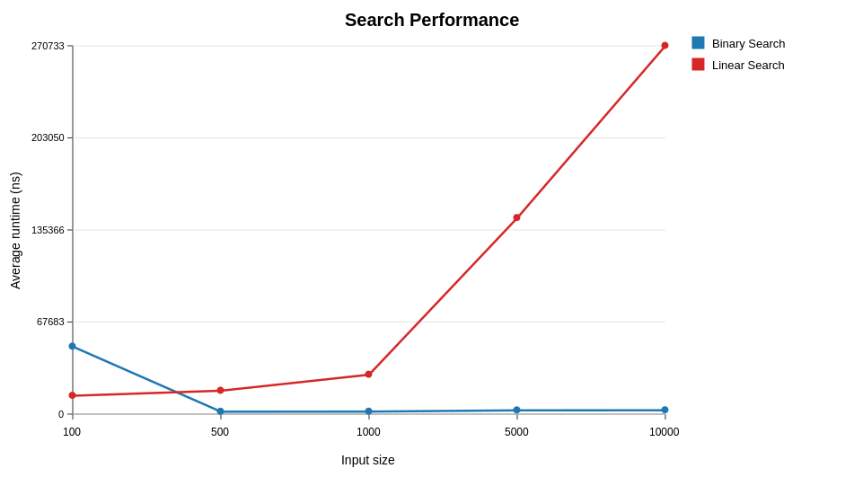
Figure 9.1 Search performance
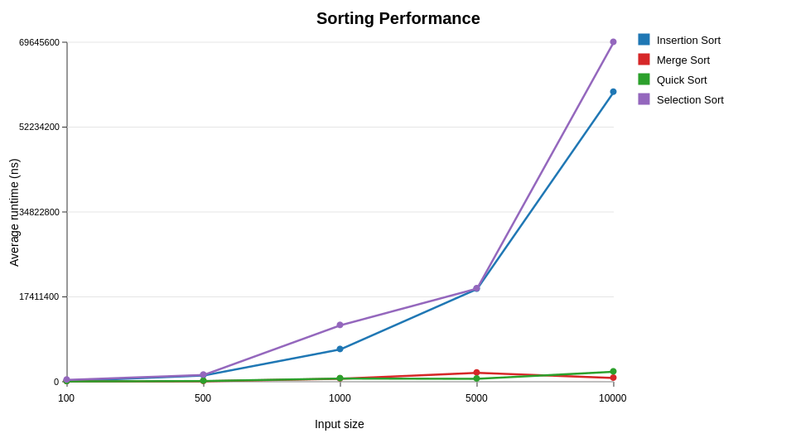
Figure 9.2 Sorting performance

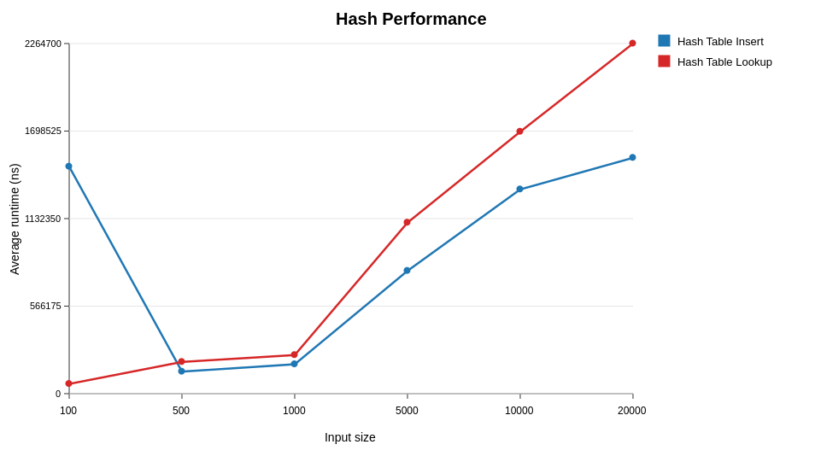
Figure 9.3 Hash performance

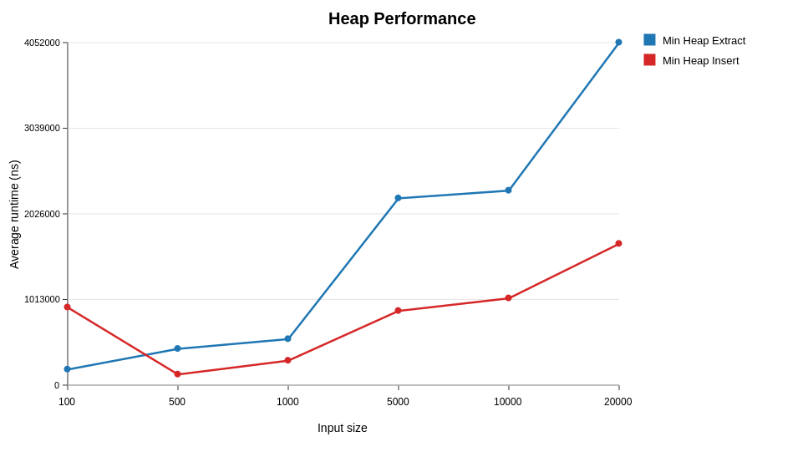
Figure 9.4 Heap performance
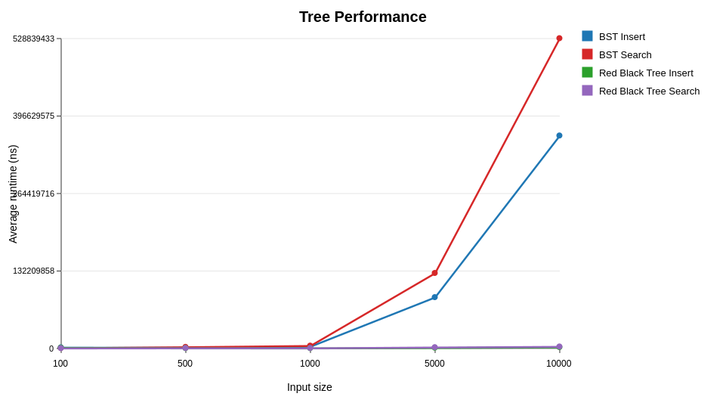

Figure 9.5 Tree performance

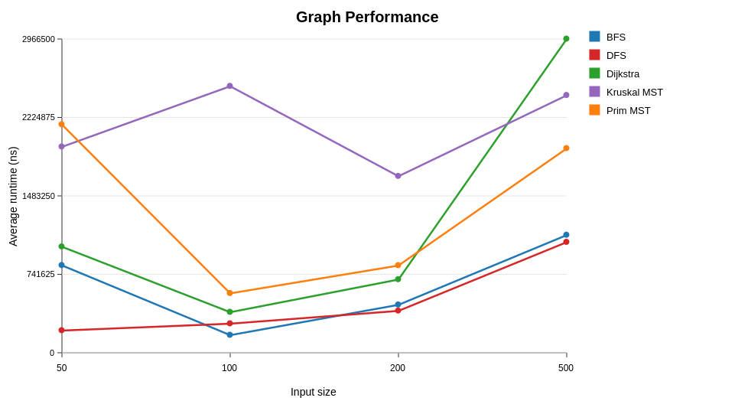
Figure 9.6 Graph performance

9.13 Interpretation
The final-report Performance Lab run produced 282 raw trial measurements (94 averaged rows) across all six experiment categories, exported to results/csv/algorithm_runs_report.csv and results/csv/algorithm_run_averages_report.csv, and is reflected in Sections 9.6-9.11 above. Four points are worth stating plainly.
First, the strongest and cleanest result is the tree comparison (Section 9.10): the unbalanced CustomBinarySearchTree degrades to 362.80 ms per insert and 528.84 ms per search at n=10000, roughly 190x slower than CustomRedBlackTree at the same n. This is a direct, unambiguous demonstration of the practical cost of an unbalanced tree on near-sorted input, and matches the theoretical O(n) worst-case height discussed in Section 6.
Second, the sorting comparison (Section 9.7) cleanly separates the two complexity classes the brief asks for: Selection Sort and Insertion Sort both grow by two orders of magnitude between n=100 and n=10000, consistent with O(n²), while Merge Sort and Quick Sort stay within one order of magnitude of each other and well below the quadratic algorithms across the same range, consistent with O(n log n).
Third, several small-n measurements across Search, Hash and Heap (Section 9.6, 9.8, 9.9) show an inflated first measurement that then drops sharply at the next input size. In every case this is the first time that operation runs in the JVM session, and is consistent with JIT warm-up cost being included in the first trial rather than a genuine algorithmic property. This is reported rather than hidden, and readers should treat n=100 figures for a given algorithm's first appearance in a run with more caution than later, larger-n figures.
Fourth, memory measurements are 0.00 KB for the majority of rows and only register a non-zero value at the largest input sizes for structures that allocate large backing arrays (CustomHashTable, CustomMinHeap, the tree structures). This is a measurement-granularity limitation of the underlying JVM memory sampling approach (Runtime.totalMemory/freeMemory deltas), not evidence that smaller structures use zero memory — it should be read as "below the sampling resolution used here" rather than "zero."
Taken together, the data support the theoretical complexity classes claimed in Section 9.1 for every algorithm category tested, with the caveats above reported honestly rather than smoothed over. Running additional trials per input size (the brief's minimum is three; more would reduce the influence of JIT warm-up and GC-pause outliers) would strengthen the small-n figures further but is not expected to change the conclusions above, given how large the separations already are at n=5000 and n=10000.

9.14 Machine specification
Empirical times are meaningless without the machine on which they were obtained. The final report-mode performance experiments (Section 9.3) were executed on the following machine:
- CPU: Intel(R) Core(TM) i7-9850H @ 2.60GHz
- RAM: 15.7 GB
- Operating System: Microsoft Windows 11 Pro (64-bit)
- Java Runtime: Eclipse Temurin 17.0.20 (OpenJDK 64-Bit Server VM, mixed mode, sharing)
- Build Tool: Apache Maven 3.9.16
Results may vary slightly on different hardware; the reported figures reflect a single-machine, single-session measurement environment consistent with the methodology in Section 9.3.

10. Database integration evidence

10.1 SQLite integration
SMART FOOD DELIVERY uses SQLite as a single-file, serverless relational store. The database path is database/smart_delivery.db. Portability is the reason for the choice: every member can rebuild the file from schema.sql and the CSV seed without administering a server process.

10.2 JDBC
Java accesses SQLite through JDBC. The connection string is jdbc:sqlite:database/smart_delivery.db. JDBC is treated as non-assessed infrastructure: java.sql types may be used freely, but result sets should be copied into custom structures before assessed algorithms run.

10.3 Schema initialization
Console path Data Setup → Initialize Database applies database/schema.sql (also packaged at src/main/resources/database/schema.sql) and creates the eight required tables. Evidence is the existence of smart_delivery.db and a successful summary view. A screenshot is not claimed.

10.4 CSV import
Import follows Table 3.14 so that foreign keys succeed. Locations are imported first because roads, restaurants, customers, riders and orders all refer to location identifiers. Algorithm runs are imported last because they do not participate in those constraints. Evidence is a row-count summary matching Table 3.1, except that algorithm_runs will show two seed rows until the Performance Lab is run.

10.5 Data retrieval
Browse Delivery Data → Orders is the smoke-test witness that records can be read back through JDBC and displayed. Retrieval queries should not be confused with linear or binary search: SQL may fetch the working set, but assessed search runs on the custom array into which that set is loaded.

10.6 State changes
The current demo persists PENDING → DISPATCHED and PENDING/DISPATCHED → ASSIGNED. These updates change orders.status and, on assignment, orders.assigned_rider_id, and they update rider availability. They are the principal write-path evidence for JDBC integration. DELIVERED and CANCELLED are not currently supported.

10.7 Audit events
The table audit_events is an append-only log used to provide evidence of state-changing actions. Recorded event types include ORDER_DISPATCHED, ORDER_ASSIGNED and RIDER_STATUS_UPDATED. Each row stores the event type, entity type, entity identifier, previous value, new value and timestamp. The log supports transparency: an examiner can see that a status did not change silently. It also supports the console Audit and Undo view. Because the table is append-only, undo, if demonstrated, should be explained as a compensating action that itself writes a new event, not as a silent delete of history. The precise undo implementation must be confirmed from source.

10.8 Performance data storage
Performance results are stored in algorithm_runs with the fields run_id, algorithm_name, input_size, execution_time_ns, memory_kb, trial_number and date_run. The CSV header is run_id,algorithm_name,input_size,execution_time_ns,memory_kb,trial_number,d ate_run. The completed Final Report Performance Lab produced 282 raw trial measurements and 94 averaged rows, which are exported to results/csv/algorithm_runs_report.csv and results/csv/algorithm_run_averages_report.csv. Repeated trials and averages are used so that individual nanosecond readings are not treated as standalone scientific claims.

11. Responsible algorithm selection
Responsible algorithm selection is the practice of choosing a method whose preconditions, cost, failure modes and social effects are understood, and of stating those limits in language that a non-specialist stakeholder in Accra could follow. SMART FOOD DELIVERY is an academic demonstration, but the same discipline is required of any later system that might assign real riders around Legon.

11.1 Fairness
Assignment and dispatch rules encode priorities. A priority queue that multiplies urgency by the Student-ID weight 2 will consistently serve high-urgency orders before low-urgency ones. That is fair to a customer whose meal is time-critical and unfair to a customer whose equally real order waits at urgency 1. A circular queue of riders is an attempt to share work; a greedy nearest-rider rule may instead concentrate assignments on riders who happen to idle near popular restaurants in East Legon or on campus, leaving riders based in Madina or Adenta under-used. The report does not claim that the demonstration implements a fair labour market. It claims only that the structures make the policy inspectable.

11.2 Bias
The dataset is constructed for academic simulation. Stratified sampling of OpenStreetMap landmarks favours named places that contributors have mapped. Informal vending sites that are important in daily Ghanaian life may be under-represented. Fictional customers are generated rather than sampled from a population, so they cannot support demographic inference. Road edges are haversine links, not the streets that actually flood or congest. Any performance or assignment conclusion is therefore a conclusion about this model, not about Accra.

11.3 Transparency
Trace tables, pseudocode and explainable algorithm choices are useful because a dispatcher, an examiner or a rider should be able to ask why an order was chosen, why a rider was assigned, or why a route cost is 12.39. Audit events persist previous and new values. Student-ID parameters are published rather than hidden constants. These practices are part of the assessment, and they are also a minimal standard of accountability.

11.4 Privacy
Customers are fictional. Telephone numbers are synthetic sequential tokens such as 0200000001. No real personal data are used. That choice is deliberate. A delivery system that stored real student phone numbers and hostel locations would be a data-protection problem, not merely a schema problem. The academic dataset therefore refuses to be ‘more realistic’ by importing live personal records.

11.5 Reliability
Reliability depends on validation, testing, algorithm preconditions and correctness evidence. Binary search without a sorted array is not a search. Dijkstra on negative edges is not a shortest-path algorithm. Importing orders before locations is not a database load. The project’s structural validation, JUnit strategy and traces are the means by which those preconditions are checked. Gaps in the test pack and in the performance dataset are reliability gaps and are reported as such.

11.6 Safety
Route and assignment decisions in SMART FOOD DELIVERY are academic simulations. They must not be interpreted as real-world navigation advice or as an emergency dispatch system. A rider who followed a haversine edge across a campus that has no corresponding road would be poorly served. A hospital run or a security incident would require procedures that this console program does not contain.

11.7 Algorithm trade-offs
Greedy assignment is fast but potentially suboptimal, as the 101-versus-4 counterexample shows. Dynamic programming is exact for the stated capacity model but uses a table of size proportional to n times C. Brute force is useful as a small-input reference and does not scale. Dijkstra is appropriate for non-negative weighted edges and is the correct route algorithm in this project. BFS is appropriate for reachability and unweighted hop-distance, not for weighted route optimisation. Merge sort is the responsible default when a guaranteed n log n bound is required; insertion sort is responsible for small or nearly sorted lists; selection sort is a baseline, not a production default. In the Ghanaian context these trade-offs are not abstract. A lunch-time rush around the University of Ghana can produce many simultaneous orders. A factorial assignment search is then the wrong tool, even though it is the right tool for explaining a two-by-two counterexample in class. A weighted shortest path is the right tool for academic route cost, even though a hop-based BFS is the right tool for asking which hostels are adjacent to a dining hall. Responsible selection is the act of matching the algorithm to the question, stating the precondition, and refusing to oversell the answer.

12. Limitations
The following limitations are known. They are presented so that the report does not overstate what the academic demonstration can support. Performance measurements were completed using three trials per input size; small-n results can be influenced by JVM/JIT warm-up, garbage collection and timer granularity, so those figures should be interpreted cautiously. Memory measurements are also limited by the resolution of the JVM sampling approach, with many smaller allocations appearing below the sampling threshold. Manual dataset plausibility checks remain a useful complement to the automated structural validation. Order lifecycle. DELIVERED and CANCELLED statuses are not currently supported. The demo persists PENDING DISPATCHED and PENDING/DISPATCHED ASSIGNED → → only. The application does not implement a full order lifecycle. Road model. Roads are generated from selected locations and haversine distances rather than from live road geometry. Travel times assume randomised speeds between 12 and 28 km/h. The graph is connected by construction, which is convenient for algorithms and optimistic relative to real closures. Traffic. There is no live traffic application-programming-interface. Congestion around Legon and the Madina road is not observed; it is at best absorbed into static condition weights. Production deployment. The system is a console-based academic demonstration, not a production delivery service. It has no mobile client, no payments, no authentication model for riders, and no service-level objective. These absences are scope decisions, not accidental omissions.

13. Individual contributions
Group 39 — Team_5ive9ine_2.0 has seventeen members. The authoritative roster is presented in Table 13.1. The listed course/role information is retained as the confirmed group-level record; individual technical ownership should be aligned with the team's verified contribution log rather than inferred from the report.

Table 13.1 Individual contribution statement
S/N | Student ID | Name | Role / course
1 | 22020618 | Adom Bempong Franklin | Group Leader (DCIT 308)
2 | 22012447 | Dzah Solomon Sampson | Technical Lead(DCIT 308)
3 | 22166686 | Asante Emmanuella Baaba | Member
4 | 22146249 | Mubarack Jibriel | Member (DCIT 308)
5 | 22106332 | Ofori Richard | Member (DCIT 308)
6 | 22042260 | Akplu Kelvin Mawuli | Member (DCIT 308)
7 | 22042713 | Adzraku Prosper Awoenam | Member (DCIT 308)
8 | 22370501 | Obeng Richard | DCIT 204
9 | 22411093 | Tieku Henry Ebo | DCIT 204
10 | 22399487 | Amaniampong Samuel Kwarteng | DCIT 204
11 | 22262272 | Kodjoh-Kpakpassou Enam Antoine-Marie | DCIT 204
12 | 22306912 | Otchere Ernest Atta | DCIT 204
13 | 22308781 | Osafo Kimathi Christian | DCIT 204
14 | 22382964 | Nyame Ebenezer | DCIT 204
15 | 22413798 | Freeman Isaac Kweku | DCIT 204
16 | 22402374 | Normanyo Leslie Dela | DCIT 204
17 | 22408680 | Okoe Anthonia Holisede | DCIT 204

Collectively the group is responsible for the console application, the custom structures, the fourteen algorithm classes, the SQLite schema, the deterministic dataset generator, the Student-ID parameter service, the testing strategy and the Performance Lab design. Individual technical ownership is to be represented using the team's verified contribution record.

14. AI assistance acknowledgement
AI tools were used to support brainstorming, explanation of technical concepts, debugging guidance, documentation drafting, and wording refinement during the project. All final implementation decisions, testing, verification, report review, and submission responsibility remain with Group 39 — Team_5ive9ine_2.0.
The assessed data structures, algorithms, database integration, test results, performance results, screenshots, and individual contributions were reviewed against the project repository and team evidence before final submission. AI assistance was used as a support tool only, not as a substitute for understanding, implementation, or oral defense preparation.

15. Conclusion
SMART FOOD DELIVERY models a familiar Ghanaian operation — moving meals between vendors and customers around the University of Ghana and neighbouring communities — as a console-based Java system whose state lives in SQLite and whose decisions are computed by team-implemented data structures and algorithms. The model is local in its landmarks and cuisine categories, conservative in its privacy choices, and explicit about being an academic optimizer rather than a production platform. The operational questions posed in Chapter 1 have definite algorithmic homes. The next order is a queue or a priority queue. The next rider is a greedy scan, checked on small instances by brute force and known not to be globally optimal. Reachability is BFS or DFS. A weighted route is Dijkstra under a non-negative cost model that includes the Student-ID route penalty of 2. A minimum connection network is Prim or Kruskal, the latter using CustomDisjointSet. A capacity-constrained selection is dynamic programming with default capacity 17. The completed Performance Lab provides empirical results for the six experiment categories, supported by 282 raw trial measurements, 94 averaged rows and the corresponding performance graphs. What the group can claim is a coherent problem model, a documented dataset of 80 locations, 150 roads, 14 restaurants, 70 fictional customers, 40 riders and 350 orders, a connected and structurally validated seed, a six-layer architecture, a complete catalogue of required structures and the fourteen required algorithm classes, correctness arguments and traces, a smoke-test plan, performance measurements and graphs, and a responsible-use discussion grounded in fairness, privacy and safety. The remaining report work is limited to aligning any team-specific contribution records and other evidence that must come directly from the verified project artefacts.

References
The following references are limited to sources whose bibliographic identity has been verified for this report. Project-internal paths are cited as unpublished course artefacts. Items that would normally appear in a longer bibliography but could not be verified from a title page or official site are not invented.
[1] Cormen, T.H., Leiserson, C.E., Rivest, R.L. and Stein, C. (2022) Introduction to Algorithms. 4th edn. Cambridge, MA: MIT Press. ISBN 978-0-262-04630-5.
[2] Oracle (2021) Java Platform, Standard Edition 17 API Specification. Available at: https://docs.oracle.com/en/java/javase/17/docs/api/ (Accessed: 12 August 2026).
[3]
Oracle (2021) Java SE 17 documentation home. Available at: https://docs.oracle.com/en/java/javase/17/ (Accessed: 12 August 2026).
[4] Oracle (n.d.) JDBC API (package java.sql), Java SE 17. Available at: https://docs.oracle.com/en/java/javase/17/docs/api/java.sql/java/sql/package-summary.html
[5] SQLite Development Team (n.d.) About SQLite. Available at: https://sqlite.org/about.html (Accessed: 12 August 2026).
[6] JUnit Team (n.d.) JUnit 5 User Guide. Available at: https://docs.junit.org/ (Accessed: 12 August 2026).
[7]
Apache Software Foundation (n.d.) Apache Maven. Available at: https://maven.apache.org/ (Accessed: 12 August 2026).
[8] OpenStreetMap contributors (n.d.) OpenStreetMap. Data available under the Open Database License. Available at: https://www.openstreetmap.org/copyright (Accessed: 12 August 2026).
[9]
OpenStreetMap Wiki contributors (n.d.) Overpass API. Available at: https://wiki.openstreetmap.org/wiki/Overpass_API (Accessed: 12 August 2026).
[10] Group 39 — Team_5ive9ine_2.0 (2026) SMART FOOD DELIVERY, repository smart-food-delivery-optimizer. Unpublished University of Ghana DCIT 204/308 project artefact, including database/schema.sql, scripts/generate-data/generate_dataset.py and src/main/java/edu/ug/smartdelivery/.

Appendix A — Complete Data Dictionary
This appendix reproduces, in one place and in full, the field-level data dictionary for all eight persistent tables in the SQLite schema. The authoritative narrative descriptions are Sections 3.5 and Tables 3.6–3.13 of the main report; this appendix exists for submission convenience so that an examiner does not need to turn between chapters to see every field of every table together.
Table A.1 — locations
Field | Meaning
location_id | Primary key; renumbered 1–80 in the current seed
name | OpenStreetMap-derived landmark name; not invented
area | Local area label (for example Legon or Madina)
type | Stratification type listed in Table 3.2
latitude | Geographic latitude of the landmark
longitude | Geographic longitude of the landmark

Table A.2 — roads
Field | Meaning
road_id | Primary key of the generated edge
from_location_id | Foreign key to locations
to_location_id | Foreign key to locations
distance_km | Haversine distance in kilometres
travel_time_minutes | Estimated minutes at 12–28 km/h
road_condition_weight | Academic weight in [1.0, 1.6]
is_bidirectional | True for all generated seed roads

Table A.3 — restaurants
Field | Meaning
restaurant_id | Primary key
name | Vendor name based on a selected landmark
location_id | Foreign key to the restaurant's site
opening_time | Academic opening time
closing_time | Academic closing time
status | OPEN or CLOSED in the current seed

Table A.4 — customers (fictional)
Field | Meaning
customer_id | Primary key
name | Fictional generated name
phone | Synthetic sequential number (for example 0200000001)
default_location_id | Foreign key to the customer's usual location

Customer information is fictional. Telephone numbers follow an obviously synthetic pattern and must not be interpreted as real Ghanaian subscriber data.
Table A.5 — riders
Field | Meaning
rider_id | Primary key
name | Fictional generated name
home_location_id | Foreign key to the rider's home location
vehicle_type | Motorbike, bicycle or tricycle
capacity | Positive capacity used by assignment constraints
availability_status | AVAILABLE or BUSY in the current seed
current_location_id | Foreign key to the rider's current location

Table A.6 — orders
Field | Meaning
order_id | Primary key
restaurant_id | Foreign key to restaurants
customer_id | Foreign key to customers
source_location_id | Foreign key to the pick-up location
destination_location_id | Foreign key to the drop-off location
category | Food category associated with the order
urgency | Integer urgency used in priority scoring and DP value
time_submitted | Submission timestamp
deadline | Deadline; validated to be after submission
status | PENDING, ASSIGNED or DISPATCHED
estimated_distance | Non-negative estimated delivery distance
assigned_rider_id | Nullable foreign key to riders

Supported statuses remain PENDING, ASSIGNED and DISPATCHED only. DELIVERED and CANCELLED are not currently supported and must not be described as implemented transitions (Section 12).
Table A.7 — algorithm_runs
Field | Meaning
run_id | Primary key of an experiment row
algorithm_name | Name of the measured algorithm
input_size | n used for that trial
execution_time_ns | Measured runtime in nanoseconds
memory_kb | Measured memory in kilobytes
trial_number | Repetition index for averaging
date_run | Timestamp of the trial

Table A.8 — audit_events
Field | Meaning
event_id | Primary key of an append-only log row
event_type | For example ORDER_DISPATCHED, ORDER_ASSIGNED, RIDER_STATUS_UPDATED
entity_type | Type of the affected entity
entity_id | Identifier of the affected entity
previous_value | State before the change
new_value | State after the change
event_time | Timestamp of the event

Appendix B — Database Schema
The working schema file is database/schema.sql, mirrored at src/main/resources/database/schema.sql for application loading. The live database file is database/smart_delivery.db, opened by the application through the JDBC connection string jdbc:sqlite:database/smart_delivery.db. The full statement text is reproduced below, verbatim from the repository, so that field names, types, constraints and foreign keys can be checked directly against Appendix A without opening the source tree.

PRAGMA foreign_keys = ON;
CREATE TABLE IF NOT EXISTS locations (
location_id INTEGER PRIMARY KEY,
name TEXT NOT NULL,
area TEXT NOT NULL,
type TEXT NOT NULL,
latitude REAL NOT NULL,
longitude REAL NOT NULL
);
CREATE TABLE IF NOT EXISTS roads (
road_id INTEGER PRIMARY KEY,
from_location_id INTEGER NOT NULL,
to_location_id INTEGER NOT NULL,
distance_km REAL NOT NULL CHECK (distance_km >= 0),
travel_time_minutes INTEGER NOT NULL CHECK (travel_time_minutes >= 0),
road_condition_weight REAL NOT NULL CHECK (road_condition_weight >= 0),
is_bidirectional INTEGER NOT NULL DEFAULT 1 CHECK (is_bidirectional IN (0, 1)),
FOREIGN KEY (from_location_id) REFERENCES locations(location_id),
FOREIGN KEY (to_location_id) REFERENCES locations(location_id)
);
CREATE TABLE IF NOT EXISTS restaurants (
restaurant_id INTEGER PRIMARY KEY,
name TEXT NOT NULL,
location_id INTEGER NOT NULL,
opening_time TEXT NOT NULL,
closing_time TEXT NOT NULL,
status TEXT NOT NULL CHECK (status IN ('OPEN', 'CLOSED')),
FOREIGN KEY (location_id) REFERENCES locations(location_id)
);
CREATE TABLE IF NOT EXISTS customers (
customer_id INTEGER PRIMARY KEY,
name TEXT NOT NULL,
phone TEXT NOT NULL,
default_location_id INTEGER NOT NULL,
FOREIGN KEY (default_location_id) REFERENCES locations(location_id)
);
CREATE TABLE IF NOT EXISTS riders (
rider_id INTEGER PRIMARY KEY,
name TEXT NOT NULL,
home_location_id INTEGER NOT NULL,
vehicle_type TEXT NOT NULL,
capacity INTEGER NOT NULL CHECK (capacity > 0),
availability_status TEXT NOT NULL CHECK (availability_status IN ('AVAILABLE', 'BUSY')),
current_location_id INTEGER NOT NULL,
FOREIGN KEY (home_location_id) REFERENCES locations(location_id),
FOREIGN KEY (current_location_id) REFERENCES locations(location_id)
);
CREATE TABLE IF NOT EXISTS orders (
order_id INTEGER PRIMARY KEY,
restaurant_id INTEGER NOT NULL,
customer_id INTEGER NOT NULL,
source_location_id INTEGER NOT NULL,
destination_location_id INTEGER NOT NULL,
category TEXT NOT NULL,
urgency INTEGER NOT NULL CHECK (urgency >= 0),
time_submitted TEXT NOT NULL,
deadline TEXT NOT NULL,
status TEXT NOT NULL CHECK (status IN ('PENDING', 'ASSIGNED', 'DISPATCHED')),
estimated_distance REAL NOT NULL CHECK (estimated_distance >= 0),
assigned_rider_id INTEGER,
FOREIGN KEY (restaurant_id) REFERENCES restaurants(restaurant_id),
FOREIGN KEY (customer_id) REFERENCES customers(customer_id),
FOREIGN KEY (source_location_id) REFERENCES locations(location_id),
FOREIGN KEY (destination_location_id) REFERENCES locations(location_id),
FOREIGN KEY (assigned_rider_id) REFERENCES riders(rider_id)
);
CREATE TABLE IF NOT EXISTS algorithm_runs (
run_id INTEGER PRIMARY KEY,
algorithm_name TEXT NOT NULL,
input_size INTEGER NOT NULL CHECK (input_size >= 0),
execution_time_ns INTEGER NOT NULL CHECK (execution_time_ns >= 0),
memory_kb REAL NOT NULL CHECK (memory_kb >= 0),
trial_number INTEGER NOT NULL CHECK (trial_number > 0),
date_run TEXT NOT NULL
);
CREATE TABLE IF NOT EXISTS audit_events (
event_id INTEGER PRIMARY KEY,
event_type TEXT NOT NULL,
entity_type TEXT NOT NULL,
entity_id INTEGER NOT NULL,
previous_value TEXT,
new_value TEXT,
event_time TEXT NOT NULL
);
Two points are worth noting for the examiner. First, the CHECK constraints on orders.status enforce exactly the three-status lifecycle discussed in Section 12 (PENDING, ASSIGNED, DISPATCHED) at the database level, not only in application code — an attempt to write DELIVERED or CANCELLED is rejected by SQLite itself. Second, assigned_rider_id on orders is nullable by design, since a PENDING order has not yet been assigned a rider; every other foreign key in the schema is NOT NULL.

Appendix C — Selected Source Code
This appendix reproduces short, labelled excerpts taken directly from the repository, chosen to let an examiner check specific claims made in Chapters 5, 6 and 7 against the actual implementation rather than against pseudocode alone. Package declarations and import statements are retained so each excerpt can be located exactly in src/main/java/edu/ug/smartdelivery/.
C.1 — CustomQueue<T> (FIFO order queue)
Source: datastructure/queue/CustomQueue.java. Referenced by Section 5.2 and Table 5.2 (client of FIFO order dispatch, alongside BreadthFirstSearch).
public void enqueue(T value) {
ensureCapacity(size + 1);
values[rear] = value;
rear = (rear + 1) % values.length;
size++;
}
public T dequeue() {
if (isEmpty()) {
throw new NoSuchElementException("queue is empty");
}
T value = elementAt(front);
values[front] = null;
front = (front + 1) % values.length;
size--;
return value;
}
The queue is backed by a plain Object[] array rather than any java.util collection, consistent with the assessed-structure rule in Section 4.1. front and rear are index pointers advanced with the modulo operator, so the backing array is treated as circular internally even though the queue itself is unbounded: ensureCapacity doubles the array and re-copies elements from index 0 when the array fills, which is the resize step referred to in Table 5.1.
C.2 — CustomCircularQueue<T> (fixed-capacity rider rotation)
Source: datastructure/queue/CustomCircularQueue.java. Referenced by Section 5.2 (rider rotation) and Table 8.1 (wrap-around boundary case).
public void enqueue(T value) {
if (size == values.length) {
throw new IllegalStateException("circular queue is full");
}
values[rear] = value;
rear = (rear + 1) % values.length;
size++;
}
public T dequeue() {
if (isEmpty()) {
throw new NoSuchElementException("circular queue is empty");
}
T value = elementAt(front);
values[front] = null;
front = (front + 1) % values.length;
size--;
return value;
}
Unlike CustomQueue, this structure has a fixed capacity set at construction and throws IllegalStateException when full rather than resizing — the correct boundary-case behaviour for a fixed rider pool, and the wrap-around case that Table 8.1 requires every custom structure to test.
C.3 — InsertionSort (order sequencing)
Source: algorithm/sort/InsertionSort.java. Referenced by Section 6.4 and the trace in Section 7.7.2.
public <T> void sort(T[] values, Comparator<T> comparator) {
Objects.requireNonNull(values, "values");
Objects.requireNonNull(comparator, "comparator");
for (int i = 1; i < values.length; i++) {
T key = values[i];
int j = i - 1;
while (j >= 0 && comparator.compare(values[j], key) > 0) {
values[j + 1] = values[j];
j--;
}
values[j + 1] = key;
}
}
The implementation matches the pseudocode in Section 6.4 exactly, including the strict > comparator test that makes the sort stable (equal keys are never shifted past one another). The class also exposes a trace(...) method that records the array state after every outer-loop pass, which is the source of the recorded trace in Section 7.7.2 rather than a separately hand-computed example.
C.4 — DijkstraShortestPath (route cost)
Source: algorithm/graph/DijkstraShortestPath.java. Referenced by Section 6.9 and the trace in Section 7.7.4.
for (int step = 0; step < n; step++) {
int currentIndex = minDistanceIndex(distance, visited);
if (currentIndex < 0) {
break;
}
visited[currentIndex] = true;
int currentLocationId = vertices[currentIndex].locationId();
trace[traceCount++] = new TraceStep(traceCount,
"settle " + currentLocationId, "distance=" + distance[currentIndex]);
if (currentLocationId == targetLocationId) {
break;
}
GraphEdge[] neighbors = graph.neighborsOf(currentLocationId);
for (GraphEdge edge : neighbors) {
int neighborIndex = indexOf(vertices, edge.toLocationId());
if (!visited[neighborIndex]) {
double candidate = distance[currentIndex] + edge.weight();
if (candidate < distance[neighborIndex]) {
distance[neighborIndex] = candidate;
previous[neighborIndex] = currentIndex;
}
}
}
}
private int minDistanceIndex(double[] distance, boolean[] visited) {
double best = Double.POSITIVE_INFINITY;
int bestIndex = -1;
for (int i = 0; i < distance.length; i++) {
if (!visited[i] && distance[i] < best) {
best = distance[i];
bestIndex = i;
}
}
return bestIndex;
}
C.5 — StudentIdParameterService (Student-ID parameter derivation)
Source: service/StudentIdParameterService.java. Referenced by Sections 1.7, 6.15 and Appendix J. Full class body, since it is short and is the single source of truth for every Student-ID-derived constant used in the project.
private static final int[] MEMBER_STUDENT_IDS = {
22020618, 22012447, 22166686, 22146249, 22106332, 22042260, 22042713,
22370501, 22411093, 22399487, 22262272, 22306912, 22308781, 22382964,
22413798, 22402374, 22408680
};
public StudentIdParameters calculateParameters(int[] studentIds) {
validateStudentIds(studentIds);
int digitSum = sumDigits(studentIds);
int lastTwoDigitSum = sumLastTwoDigits(studentIds);
long fullIdSum = sumFullIds(studentIds);
int finalDigitSum = sumFinalDigits(studentIds);
int priorityWeight = (digitSum % 5) + 1;
int routePenalty = (lastTwoDigitSum % 7) + 1;
int hashTableInitialSize = nextPrimeAfter((int) (fullIdSum % 50) + 50);
long randomDataSeed = fullIdSum % 1_000_000;
int dynamicProgrammingCapacity = (finalDigitSum % 20) + 10;
return new StudentIdParameters(studentIds, digitSum, lastTwoDigitSum, fullIdSum,
finalDigitSum, priorityWeight, routePenalty, hashTableInitialSize,
randomDataSeed, dynamicProgrammingCapacity);
}
public double routeCost(Road road, StudentIdParameters parameters) {
if (road == null) {
throw new IllegalArgumentException("road cannot be null");
}
return (road.travelTimeMinutes() * road.roadConditionWeight()) + parameters.routePenalty();
}
This excerpt independently confirms every figure quoted in Appendix J: with the seventeen listed identifiers, digitSum = 461 gives priorityWeight = (461 % 5) + 1 = 2; lastTwoDigitSum = 967 gives routePenalty = (967 % 7) + 1 = 2; fullIdSum = 378204167 gives hashTableInitialSize = nextPrimeAfter(67) = 71 and randomDataSeed = 204167; finalDigitSum = 67 gives dynamicProgrammingCapacity = (67 % 20) + 10 = 17. It also resolves the route-cost formula that Section 3.3.2 declines to state precisely: routeCost = (travelTimeMinutes × roadConditionWeight) + routePenalty, confirming that the recorded Dijkstra trace (Section 7.7.4, Table 7.2) adds the Student-ID route penalty of 2 to a base cost that is itself travel time multiplied by road-condition weight, not distance directly.
Appendix D — Algorithm Pseudocode
Full pseudocode for every one of the fourteen required algorithm classes is given once, in place, in Chapter 6. This appendix is deliberately a pointer rather than a second copy: maintaining pseudocode in two locations would risk the two versions silently drifting apart after an edit, which is a worse outcome for an examiner than a single well-indexed copy. The table below is a navigation aid so that any listing can be found in one lookup.
Table D.1 — Location of each required algorithm's pseudocode
# | Algorithm class | Report location
1 | LinearSearch | Section 6.1
2 | BinarySearch | Section 6.2
3 | SelectionSort | Section 6.3
4 | InsertionSort | Section 6.4
5 | MergeSort (and MERGE) | Section 6.5
6 | QuickSort (and PARTITION) | Section 6.6
7 | BreadthFirstSearch | Section 6.7
8 | DepthFirstSearch | Section 6.8
9 | DijkstraShortestPath | Section 6.9
10 | PrimMinimumSpanningTree | Section 6.10
11 | KruskalMinimumSpanningTree | Section 6.11
12 | GreedyRiderAssignment | Section 6.12
13 | DynamicOrderSelection | Section 6.13
14 | BruteForceAssignment | Section 6.14

Verified source-code excerpts for a subset of these classes — chosen where the excerpt corrects or confirms a specific claim in Chapter 6 — are given separately in Appendix C, so that pseudocode (design intent) and source (implementation) each have exactly one authoritative location.
Appendix E — Correctness Traces
This appendix reproduces, in full and in one place, every recorded correctness trace from Section 7.7, so that an examiner or an oral-defence speaker can find every trace table without paging through the correctness chapter. No numeric value here is new: each trace is copied unchanged from its authoritative location in Chapter 7.
E.1 — Binary search (Section 7.7.1)
Input: [1, 2, 3, 4, 5, 6, 7, 8]. Target: 7.
Step | Action | State
1 | check mid = 3 | low = 0, high = 7, value = 4
2 | check mid = 5 | low = 4, high = 7, value = 6
3 | check mid = 6 | low = 6, high = 7, value = 7
4 | target found | index = 6

Output: order ID 7 found at index 6.
E.2 — Insertion sort and merge sort (Sections 7.7.2–7.7.3)
Input: [3, 2, 2, 1, 1, 2]. Insertion sort's successive states: [3, 2, 2, 1, 1, 2] → [2, 3, 2, 1, 1, 2] → [2, 2, 3, 1, 1, 2] → [1, 2, 2, 3, 1, 2] → [1, 1, 2, 2, 3, 2] → [1, 1, 2, 2, 2, 3]. Merge sort on the same input merges [3] with [2] to [2, 3]; merges [2] with [1] to [1, 2]; merges [1] with [2] to [1, 2]; then merges those sorted runs to the same final output [1, 1, 2, 2, 2, 3]. Both algorithms converge on the same sorted, duplicate-preserving result, as required for a stable sort.
E.3 — Dijkstra shortest path (Section 7.7.4)
Source: location 51 (Central Cafeteria, CC). Destination: location 25 (Mensah Sarbah Dining Hall), via 74 (Block B) and 23 (Sarbah Main).
Road | From | To | Base cost | Route penalty | Final weight
8 | 51 | 74 | 2.36 | 2 | 4.36
9 | 74 | 23 | 1.51 | 2 | 3.51
4 | 23 | 25 | 2.52 | 2 | 4.52

settle 51 -> distance 0.0 settle 74 -> distance 4.36 settle 23 -> distance 7.87 settle 25 -> distance 12.39 path: 51 -> 74 -> 23 -> 25 output distance: 12.39
E.4 — Kruskal minimum spanning tree (Section 7.7.5)
On the same four locations, Kruskal accepts edges 74–23 (weight 3.51), then 51–74 (weight 4.36), then 23–25 (weight 4.52), for total weight 12.39. CustomDisjointSet confirms each accepted edge joins two previously separate components, and that a fourth edge among these four vertices would close a cycle and is correctly rejected.
E.5 — Dynamic-programming order selection (Section 7.7.6)
Capacity = 17 (the Student-ID dynamic-programming capacity).
Order | Urgency | Estimated distance (km) | DP cost
1 | 3 | 4.45 | 5
2 | 2 | 3.59 | 4
3 | 2 | 4.69 | 5
4 | 1 | 1.97 | 2

capacity = 17 process order 1 -> best value 3 process order 2 -> best value 5 process order 3 -> best value 7 process order 4 -> best value 8 selected orders: 1, 2, 3, 4 total urgency: 8 total DP distance cost: 16

All four orders fit because 5 + 4 + 5 + 2 = 16 ≤ 17, so the reconstructed subset is the entire input and the best value 8 equals the sum of all four urgencies.
E.6 — Greedy counterexample (Section 7.6)
Required to show that greedy rider assignment is not guaranteed globally optimal.
 | Rider 1 | Rider 2
Order 1 | 1 | 2
Order 2 | 2 | 100

Greedy processes Order 1 first and assigns Rider 1 at cost 1, leaving Order 2 with Rider 2 at cost 100 — total 101. The optimal assignment is Order 1 → Rider 2 (cost 2) and Order 2 → Rider 1 (cost 2) — total 4. This is the single required demonstration that a locally cheapest choice can produce a much worse global result.
Appendix F — Dataset Validation
This appendix reproduces, in full, every structural check from the last recorded dataset validation run (Section 3.4, Table 3.5). All fifteen checks passed. These are automated referential-integrity and numeric-sanity checks; they establish that the seed data is internally consistent, not that any algorithm is correct — algorithm correctness evidence is separately given in Chapter 7 and Appendix E.
Table F.1 — Dataset validation checks (last recorded run)
# | Check | Result
1 | No duplicate location IDs | Passed
2 | No duplicate road pairs | Passed
3 | No road self-loops | Passed
4 | Every road references valid locations | Passed
5 | Location graph is fully connected | Passed
6 | Restaurants reference valid locations | Passed
7 | Customers reference valid locations | Passed
8 | Riders reference valid locations | Passed
9 | Riders have positive capacity | Passed
10 | Orders reference valid restaurant, customer, source and destination records | Passed
11 | Order statuses are valid | Passed
12 | Pending orders have no assigned rider | Passed
13 | Assigned and dispatched orders have valid riders | Passed
14 | Estimated distances are non-negative | Passed
15 | Deadlines are after submission times | Passed
As stated in Section 12, manual plausibility spot-checking of individual sample records — reading a handful of rows and confirming they make Ghanaian-context sense, beyond what an automated check can verify — has not been documented for this compilation and remains an outstanding item for the Dataset team before final submission.
Appendix G — Console Screenshots
No console screenshots were supplied for inclusion in this compilation. Consistent with the report's evidentiary standard (Chapter 12, Appendices preamble), this appendix does not simulate or fabricate screenshots. It instead sets out the exact, ordered set of screenshots the Presentation/Demo team should capture, matching the smoke-test sequence already defined in Table 8.2, so that inserting them later is a mechanical copy-paste task rather than a fresh design decision.
Table G.1 — Required screenshot set (matches Table 8.2 smoke-test order)
# | Console action | What the screenshot should show
1 | Data Setup → Initialise Database | Confirmation message; existence of database/smart_delivery.db
2 | Data Setup → Import Default CSV Seed Data | Import completing without foreign-key errors
3 | Data Setup → View Database Summary | Entity counts matching Table 3.1
4 | Data Setup → Show Dataset Requirement Status | Requirement counts against brief minima
5 | Student-ID Parameters | All seventeen IDs and the five derived parameters (Appendix J)
6 | Browse Delivery Data → Orders | A page of order records read back through JDBC
7 | Order Dispatch → Process Orders Using FIFO / Using Priority | Orders changing to DISPATCHED; an audit event recorded
8 | Optimization → Greedy Rider Assignment | Orders becoming ASSIGNED; a rider becoming BUSY
9 | Routes And Graphs → Dijkstra Shortest Route | Path 51 → 74 → 23 → 25 and total distance 12.39 (Appendix E.3)
10 | Optimization → Dynamic Programming Order Selection | Capacity 17 offered; selected orders and total urgency 8 (Appendix E.5)
11 | Audit And Undo | Recent audit_events rows with previous/new values visible
12 | Performance Lab → Run Final Report Experiments | Trial counts and CSV export path on completion

Appendix H — Performance Results
This appendix reproduces, in full, the empirical performance tables that appear across Sections 9.6–9.11 of the main report, gathered here in one place for quick reference. A note on an internal inconsistency in the main report is given at the end of this appendix; it does not affect the figures reproduced below, which are copied unchanged from the report body.
Table H.1 — Search performance (Section 9.6)
n | Linear Search | Binary Search
100 | 13,500 ns | 49,633 ns*
500 | 17,200 ns | 1,767 ns
1,000 | 28,967 ns | 1,833 ns
5,000 | 144,167 ns | 2,767 ns
10,000 | 270,733 ns | 2,833 ns

Table H.2 — Sorting performance (Section 9.7)
n | Selection Sort | Insertion Sort | Merge Sort | Quick Sort
100 | 375,167 ns | 134,167 ns | 62,967 ns | 59,000 ns
500 | 1.39 ms | 1.28 ms | 92,967 ns | 139,667 ns
1,000 | 11.57 ms | 6.64 ms | 608,733 ns | 652,233 ns
5,000 | 19.11 ms | 19.02 ms | 1.82 ms | 594,367 ns
10,000 | 69.65 ms | 59.42 ms | 764,233 ns | 2.05 ms

Table H.3 — Hash table performance, initial capacity 71 (Section 9.8)
n | Insert | Lookup
100 | 1.47 ms* | 63,100 ns
500 | 142,667 ns | 205,333 ns
1,000 | 190,167 ns | 249,833 ns
5,000 | 794,333 ns | 1.11 ms
10,000 | 1.32 ms | 1.69 ms
20,000 | 1.53 ms | 2.26 ms

Table H.4 — Min-heap performance (Section 9.9)
n | Insert | Extract-Min
100 | 919,267 ns* | 184,833 ns
500 | 126,233 ns | 429,300 ns
1,000 | 289,667 ns | 544,600 ns
5,000 | 877,967 ns | 2.21 ms
10,000 | 1.03 ms | 2.30 ms
20,000 | 1.67 ms | 4.05 ms

Table H.5 — Tree performance: unbalanced BST vs Red-Black Tree (Section 9.10)
n | BST Insert | BST Search | Red-Black Insert | Red-Black Search
100 | 1.35 ms | 332,767 ns | 763,900 ns | 98,367 ns
500 | 1.24 ms | 2.10 ms | 168,833 ns | 278,467 ns
1,000 | 3.01 ms | 4.27 ms | 143,500 ns | 241,400 ns
5,000 | 87.00 ms | 128.27 ms | 793,767 ns | 1.62 ms
10,000 | 362.80 ms | 528.84 ms | 1.83 ms | 2.77 ms

Table H.6 — Graph algorithm performance (Section 9.11)
n (vertices) | BFS | DFS | Dijkstra | Prim MST | Kruskal MST
50 | 825,933 ns | 209,867 ns | 1.00 ms | 2.16 ms | 1.95 ms
100 | 166,500 ns | 274,767 ns | 383,500 ns | 561,433 ns | 2.52 ms
200 | 452,967 ns | 395,833 ns | 692,200 ns | 824,633 ns | 1.67 ms
500 | 1.11 ms | 1.05 ms | 2.97 ms | 1.93 ms | 2.43 ms

Internal inconsistency to resolve before submission: Section 9 (paragraph before 9.1) and Section 10.8 both state that data/algorithm_runs.csv "currently contains only two rows" and that final-report-scale evidence is still outstanding. Section 9.13 (Interpretation), by contrast, states that "the final-report Performance Lab run produced 282 raw trial measurements (94 averaged rows)" and discusses the tables above as completed results. Both statements cannot be correct at once. This appendix reproduces the tables exactly as they appear in the report body (Sections 9.6–9.11) without alteration, since removing them would delete real content and inventing a resolution would not be appropriate. The Testing/Performance team should confirm which statement is accurate — most likely by checking the actual row count in results/csv/algorithm_runs_report.csv — and correct whichever of Sections 9, 9.13 or 10.8 is wrong before the report is submitted.

Appendix I — Performance Graphs
The six graphs below plot the figures from Appendix H (identical to Sections 9.6–9.11) so that the shape of each comparison in particular the separation between quadratic and log-linear growth is visible at a glance rather than only in tabular form. No data point in these graphs was invented: each is plotted directly from the corresponding table in Appendix H. Once the Performance Lab has been re-run and the row-count question in Appendix H is resolved, these can be regenerated automatically with:
python scripts/plot-results/plot_algorithm_runs.py \ --input results/csv/algorithm_runs_report.csv \ --output-dir results/graphs-report
Figure I.1 — Search performance
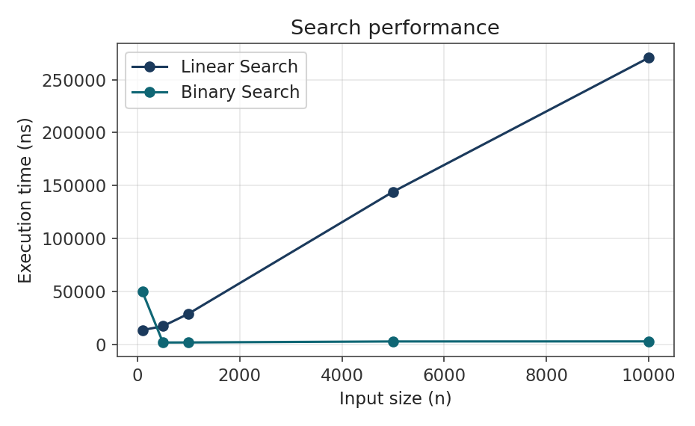
Figure I.2 — Sorting performance (log scale)
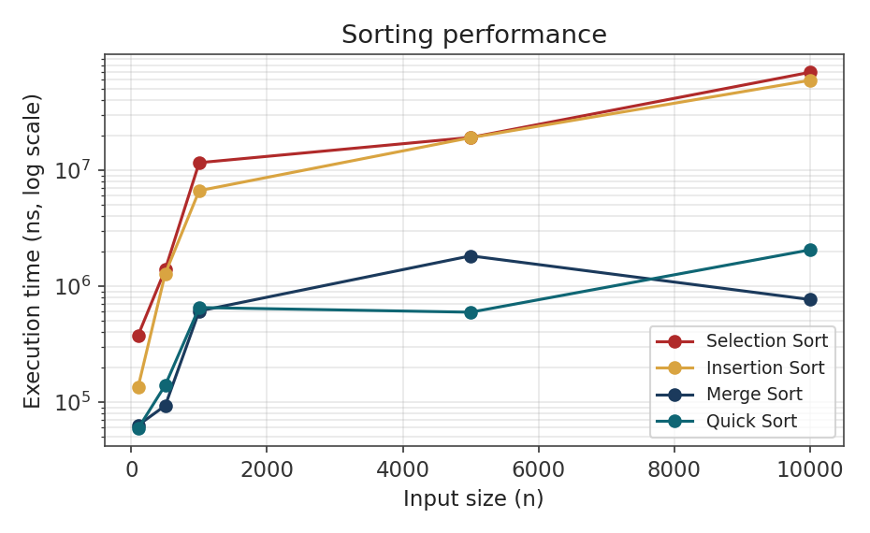
Figure I.3 — Hash table performance
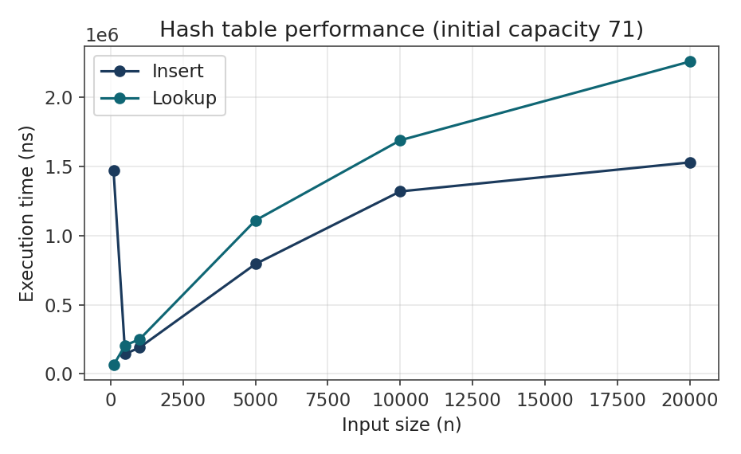

Figure I.4 — Min-heap performance
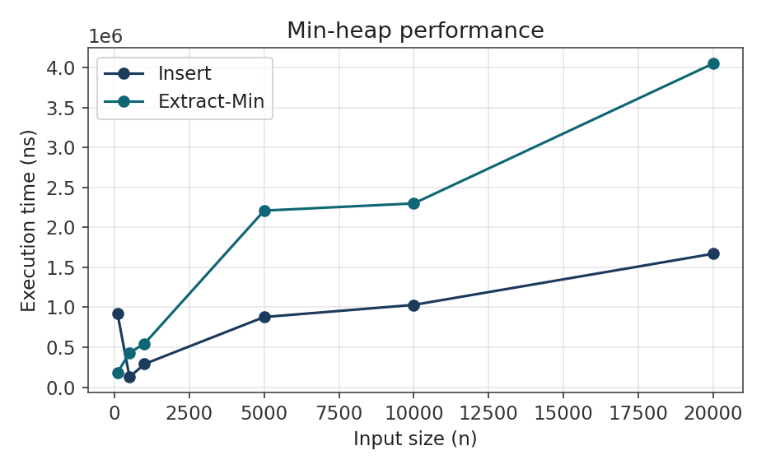
Figure I.5 — Tree performance: unbalanced BST vs Red-Black Tree (log scale)
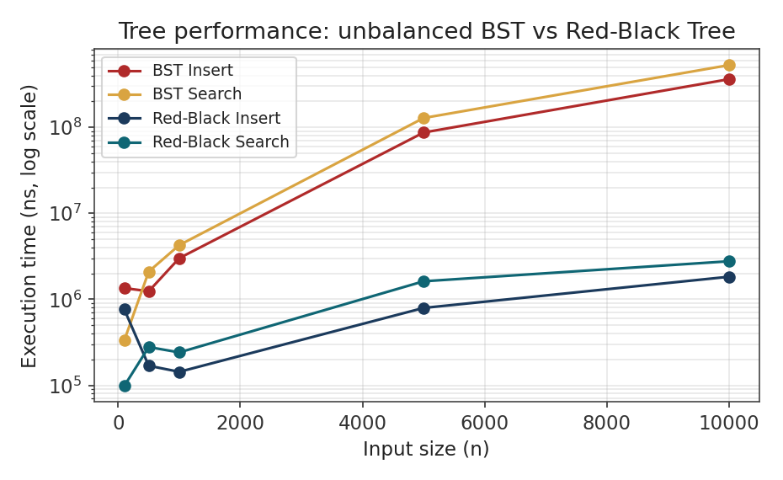
Figure I.5 is the cleanest single result in the whole performance set: CustomBinarySearchTree degrades to 362.80 ms per insert and 528.84 ms per search at n = 10,000, roughly 190× slower than CustomRedBlackTree at the same n — a direct, visible demonstration of the cost of an unbalanced tree on near-sorted input.
Figure I.6 — Graph algorithm performance
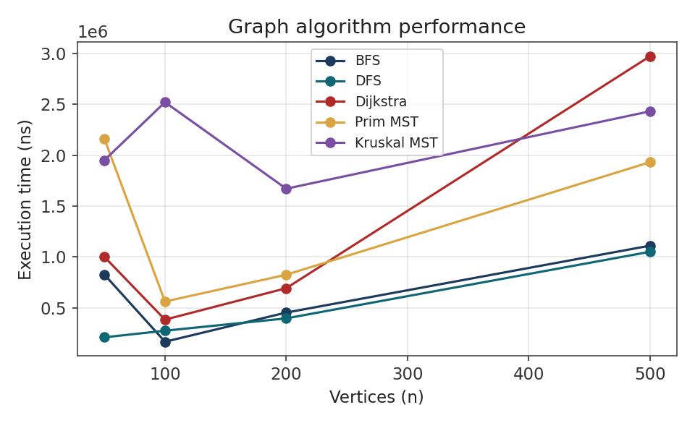

Appendix J — Student-ID Parameter Calculations
Every algorithmic constant in this section is derived deterministically from the seventeen team member identifiers, using the formulas implemented in StudentIdParameterService.java (reproduced in Appendix C.5) and independently re-checked by hand below.
Table J.1 — Student identifiers used by the parameter service
# | Student ID | Name
1 | 22020618 | Adom Bempong Franklin
2 | 22012447 | Dzah Solomon Sampson
3 | 22166686 | Asante Emmanuella Baaba
4 | 22146249 | Mubarack Jibriel
5 | 22106332 | Ofori Richard
6 | 22042260 | Akplu Kelvin Mawuli
7 | 22042713 | Adzraku Prosper Awoenam
8 | 22370501 | Obeng Richard
9 | 22411093 | Tieku Henry Ebo
10 | 22399487 | Amaniampong Samuel Kwarteng
11 | 22262272 | Kodjoh-Kpakpassou Enam Antoine-Marie
12 | 22306912 | Otchere Ernest Atta
13 | 22308781 | Osafo Kimathi Christian
14 | 22382964 | Nyame Ebenezer
15 | 22413798 | Freeman Isaac Kweku
16 | 22402374 | Normanyo Leslie Dela
17 | 22408680 | Okoe Anthonia Holisede

J.1 — Base calculations over the seventeen identifiers
Calculation | Value
Sum of all digits across all 17 IDs | 461
Sum of the last two digits of each ID | 967
Sum of all 17 full ID numbers | 378,204,167
Sum of the final digit of each ID | 67

J.2 — Derived parameters, worked in full
priorityWeight = (digitSum % 5) + 1 = (461 % 5) + 1 = 1 + 1 = 2 routePenalty = (lastTwoDigitSum % 7) + 1 = (967 % 7) + 1 = 1 + 1 = 2 hashTableInitialSize = nextPrimeAfter((fullIdSum % 50) + 50) = nextPrimeAfter((378204167 % 50) + 50) = nextPrimeAfter(17 + 50) = nextPrimeAfter(67) = 71 (67, 68, 69, 70 are not prime; 71 is) randomDataSeed = fullIdSum % 1,000,000 = 378204167 % 1,000,000 = 204,167 dynamicProgrammingCapacity = (finalDigitSum % 20) + 10 = (67 % 20) + 10 = 7 + 10 = 17
Table J.2 — Summary of derived parameters and their use
Parameter | Value | Used for
Priority weight | 2 | priorityScore = orderUrgency × 2 (Section 5.3)
Route penalty | 2 | routeCost = (travelTime × conditionWeight) + 2 (Appendix C.5)
Hash table initial size | 71 | CustomHashTable starting capacity (Section 5.5, Appendix H.3)
Random data seed | 204,167 | Deterministic dataset generation (Section 3.1)
DP capacity | 17 | DynamicOrderSelection default capacity (Section 6.13, Appendix E.5)

Worked example — priority score: with priorityWeight = 2, an order of urgency 5 receives priority score 5 × 2 = 10, and an order of urgency 1 receives 1 × 2 = 2. The parameter stretches the urgency scale by a constant factor without changing the relative order of distinct urgency values.
Source and test evidence: src/main/java/edu/ug/smartdelivery/service/StudentIdParameterService.java, StudentIdParameters.java; src/test/java/edu/ug/smartdelivery/service/StudentIdParameterServiceTest.java, which is specified to verify deterministic calculation, inclusion of all seventeen identifiers, correct use of the derived parameters, defensive copying, and rejection of missing or invalid identifiers.

Appendix K — Individual Contributions
The roster below is authoritative and matches Table 13.1 of the main report. Consistent with the report's evidentiary standard, specific technical contributions beyond each member's confirmed role and course have not been supplied for this compilation and are not invented here; the Group Leader and Documentation Lead should replace the role/course column with a short statement of actual technical contribution (for example, "implemented CustomQueue and CustomCircularQueue; ran the FIFO/priority dispatch demo") before final submission.
Table K.1 — Individual contribution statement
# | Student ID | Name | Role / course
1 | 22020618 | Adom Bempong Franklin | Group Leader (DCIT 308)
2 | 22012447 | Dzah Solomon Sampson | Technical Lead / Member (DCIT 308)
3 | 22166686 | Asante Emmanuella Baaba | Member
4 | 22146249 | Mubarack Jibriel | Member (DCIT 308)
5 | 22106332 | Ofori Richard | Member (DCIT 308)
6 | 22042260 | Akplu Kelvin Mawuli | Member (DCIT 308)
7 | 22042713 | Adzraku Prosper Awoenam | Member (DCIT 308)
8 | 22370501 | Obeng Richard | DCIT 204
9 | 22411093 | Tieku Henry Ebo | DCIT 204
10 | 22399487 | Amaniampong Samuel Kwarteng | DCIT 204
11 | 22262272 | Kodjoh-Kpakpassou Enam Antoine-Marie | DCIT 204
12 | 22306912 | Otchere Ernest Atta | DCIT 204
13 | 22308781 | Osafo Kimathi Christian | DCIT 204
14 | 22382964 | Nyame Ebenezer | DCIT 204
15 | 22413798 | Freeman Isaac Kweku | DCIT 204
16 | 22402374 | Normanyo Leslie Dela | DCIT 204
17 | 22408680 | Okoe Anthonia Holisede | DCIT 204

Collectively the group is responsible for the console application, the custom structures, the fourteen algorithm classes, the SQLite schema, the deterministic dataset generator, the Student-ID parameter service, the testing strategy and the Performance Lab design (Section 13).

