Computer Organization and Architecture
Course Design

The Experiment Report

Of

CPU

I . Purpose
The purpose of this project is to design a simple CPU (Central Processing Unit). This CPU has basic instruction set, and we will utilize its instruction set to generate a very simple program to verify its performance. For simplicity, we will only consider the relationship among the CPU, registers, memory and instruction set. That is to say we only need consider the following items: Read/Write Registers, Read/Write Memory and Execute the instructions.
At least four parts constitute a simple CPU: the control unit, the internal registers, the ALU and instruction set, which are the main aspects of our project design and will be studied.
II . Instruction Set
Single-address instruction format is used in our simple CPU design. The instruction word contains two sections: the operation code (opcode), which defines the function of instructions (addition, subtraction, logic operations, etc.); the address part, in most instructions, the address part contains the memory location of the datum to be operated, we called it direct addressing. In some instructions, the address part is the operand, which is called immediate addressing.
For simplicity, the size of memory is 256× 16 in the computer. The instruction word has 16 bits. The opcode part has 8 bits and address part has 8 bits. The instruction word format can be expressed in Figure 1:
OPCODE  [15..0] | ADDRESS  [7..0]
Figure 1 the instruction format
The opcode of the relevant instructions are listed in Table 1.
In Table 1, the notation [x] represents the contents of the location x in the memory. For example, the instruction word 00000011101110012 (03B916) means that the CPU adds word at location B916 in memory into the accumulator (ACC); the instruction word 00000101000001112 (050716) means if the sign bit of the ACC (ACC [15]) is 0, the CPU will use the address part of the instruction as the address of next instruction, if the sign bit is 1, the CPU will increase the program counter (PC) and use its content as the address of the next instruction.
Table 1 List of opcode of the relevant instructions
INSTRUCTION | OPCODE | COMMENTS
STORE X | 01H | ACC→[X]
LOAD X | 02H | [X]→ACC
ADD X | 03H | ACC+[X]→ACC
SUB X | 04H | ACC-[X]→ACC
JMPGZ X | 05H | IF ACC>0 THEN X→PC ELSE PC+1→PC
AND X | 06H | ACC and [X]→ACC
OR X | 07H | ACC or [X]→ACC
NOT X | 08H | Not [X]→ACC
SHIFTR X | 09H | SHIFL ACC to RIGHT 1 bit, Logic Shift
SHIFTL X | 0AH | SHIFT ACC to LEFT 1 bit, Logic Shift
MPY X | 0BH | ACC×[X]→ACC
HALT | 0CH | HALT A PROGRAM
A program is designed to test these instructions:
Calculate the sum of all integers from 1 to 100.
(1), programming with C language:
sum=0;
temp=100;
loop :sum=sum+temp;
temp=temp-1;
if temp>=0 goto loop;
end
(2), Assume in the RAM_DQ:
sum is stored at location A4,
temp is stored at location A3,
the contents of location A0 is 0,
the contents of location A1 is 1,
the contents of location A2 is 10010=6416.
We can translate the above C language program with the instructions listed in Table 1 into the instruction program as shown in Table 2.

Table 2 Example of a program to sum from 1 to 100
Program with C | Program with  instructions | Contents of RAM_DQ in HEX
Program with C | Program with  instructions | Address | Contents
sum=0; | LOAD A0 | 00 | 02A0
sum=0; | STORE A4 | 01 | 01A4
temp=100 | LOAD A2 | 02 | 02A2
temp=100 | STORE A3 | 03 | 01A3
loop:sum=sum+temp; | LOOP:LOAD A4 | 04 | 02A4
loop:sum=sum+temp; | ADD A3 | 05 | 03A3
loop:sum=sum+temp; | STORE A4 | 06 | 01A4
temp=temp-1; | LOAD A3 | 07 | 02A3
temp=temp-1; | SUB A1 | 08 | 04A1
temp=temp-1; | STORE A3 | 09 | 01A3
if temp>0 goto loop; | JMPGZ LOOP | 0A | 0504
end; | HALT | 0B | 0C00
 |  | 0C
 |  | … | …
 |  | A0 | 0000
 |  | A1 | 0001
 |  | A2 | 0064
 |  | A3
 |  | A4
 |  | … | …

III. Internal Registers and Memory
MAR (Memory Address Register)
MAR contains the memory location of the word to be read from the memory or written into the memory. Here, READ operation is denoted as the CPU reads from memory, and WRITE operation is denoted as the CPU writes to memory. In our design, MAR has 8 bits to access one of 256 addresses of the memory.

MBR (Memory Buffer Register)
MBR contains the value to be stored in memory or the last value read from memory. MBR is connected to the address lines of the system bus. In our design, MBR has 16 Bits.

PC (Program Counter)
PC keeps track of the instructions to be used in the program. In our design, PC has 8 bits.

IR (Instruction Register)
IR contains the opcode part of an instruction. In our design, IR has 8 bits.

BR (Buffer Register)
BR is used as an input of ALU, it holds other operand for ALU. In our design, BR has
16 bits.

LPM_RAM_DQ
LPM_RAM_DQ is a RAM with separate input and output ports. It works as a memory, and its size is 256×16. Although it’s not an internal register of CPU, we need it to simulate and test the performance of CPU.

LPM_ROM
LPM_ROM is a ROM with one address input port and one data output port, and its size of data is 32bits which contains control signals to execute micro-operations.

IV.ALU
ALU (Arithmetic Logic Unit) is a calculation unit which accomplishes basic arithmetic and logic operations. In our design, some operations must be supported which are listed as follows:
Table 3 ALU Operations
ALU control signal | Operations | Explanations
3H | ADD | ACC←ACC+BR
4H | SUB | ACC←ACC- BR
6H | AND | ACC←ACC and BR
7H | OR | ACC←ACC or BR
8H | NOT | ACC←not ACC
9H | SHIFTR | ACC←Shift ACC to Right 1 bit
0AH | SHIFTL | ACC←Shift ACC to Left 1 bit
V. Micro-programmed Control Unit
In the Microprogrammed control, the microprogram consists of some microinstruction and the microprogram is stored in control memory that generates all the control signals required to execute the instruction set correctly. The microinstruction contains some micro-operations which are executed at the same time.
Figure 2 shows the key elements of such an implementation.
The set of microinstructions is stored in the control memory. The control address register contains the address of the next microinstructions to be read. When a microinstruction is read from the control memory, it is transferred to a control buffer register. The register connects to the control lines emanating from the control unit. Thus, reading a microinstruction from the control memory is the same as executing that microinstruction. The third element shown in the figure is a sequencing unit that loads the control address register and issues a read command.
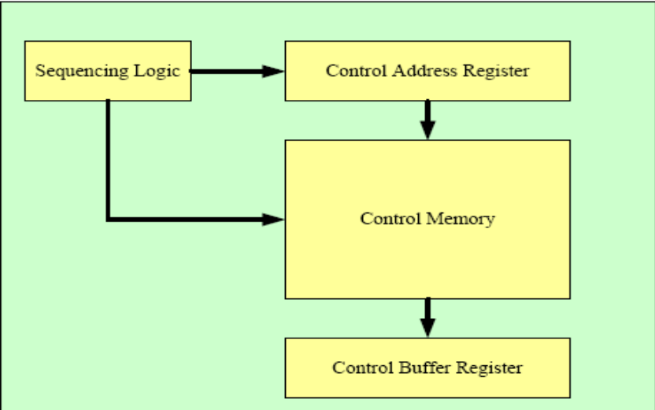
Figure 2 Control Unit Micro-architecture
(I)Total control signals for instructions are listed as follows:
Table 4 Control signals for the micro-operations
Bits in Control Memory | Micro-operation | Meaning
C0~C7 | / | Branch Addresses
C8 | PC←0 | Clear PC
C9 | PC←PC+1 | Increment PC
C10 | PC←MBR[7..0] | MBR[7..0] to PC
C11 | ACC←0 | Clear ACC
C12--C15 | ALU CONTROL | Control operations of ALU
C16 | R | Read data from Memory to MBR
C17 | W | Write data to Memory
C18 | MAR←MBR[7..0] | MBR[7..0] to MAR as address
C19 | MAR←PC | PC value to MAR
C20 | MBR←ACC | ACC value to MBR
C21 | IR←MBR[15..8] | MBR[15..8] to IR as opcode
C22 | BR←MBR | Copy MBR to BR
C23 | CAR←CAR+1 | Increment CAR
C24 | CAR←C0~C7 | C7~C0 to CAR
C25 | CAR←OPCODE+CAR | Add OP to CAR
C26 | CAR←0 | Reset CAR
C27--C31 | Not use | -----------
(II)The contents in rom.mif and the corresponding microprograms are listed as follows:
0 : 00810000; R←1, CAR←CAR+1
1 : 00A00000; OP←MBR[15..8],CAR←CAR+1
2 : 02000000; CAR←CAR+OP
3 : 01000014; CAR←14H
4 : 01000019; CAR←19H
5 : 0100001E; CAR←1EH
6 : 01000023; CAR←23H
7 : 01000041; CAR←41H
8 : 01000028; CAR←28H
9 : 0100002D; CAR←2DH
a : 01000032; CAR←32H
b : 01000037; CAR←37H
c : 0100003C; CAR←3CH
d : 01000046; CAR←46H
e : 0100004B; CAR←4BH
f : 01000050; CAR←50H (DIV)
10 : 00000000;
… ……
14 : 00840000; MAR←MBR[7..0], CAR←CAR+1 ------STORE
15 : 00920200; MBR←ACC, PC←PC+1,W←1,CAR←CAR+1
16 : 04080000; CAR←0, MAR←PC
17 : 00000000;
18 : 00000000;
19 : 00840000; MAR←MBR[7..0], CAR←CAR+1 ------LOAD
1a : 00810A00; PC←PC+1,R←1,ACC←0,CAR←CAR+1
1b : 00C03000; BR←MBR,ACC←ACC+BR, CAR←CAR+1
1c : 04080000; CAR←0
1d : 00000000;
1e : 00840000; MAR←MBR[7..0], CAR←CAR+1 ----------ADD
1f : 00810200; PC←PC+1,R←1,CAR←CAR+1
20 : 00C03000; BR←MBR,ACC←ACC+BR, CAR←CAR+1
21 : 04080000; CAR←0
22 : 00000000;
23 : 00840000; MAR←MBR[7..0], CAR←CAR+1 ----------SUB
24 : 00810200; PC←PC+1,R←1,CAR←CAR+1
25 : 00C04000; BR←MBR,ACC←ACC-BR, CAR←CAR+1
26 : 04080000; CAR←0
27 : 00000000;
28 : 00840000; MAR←MBR[7..0], CAR←CAR+1 ---------AND
29 : 00810200; PC←PC+1,R←1,CAR←CAR+1
2a : 00C06000; BR←MBR,ACC←ACC AND BR,CAR←CAR+1
2b : 04080000; CAR←0
2c : 00000000;
2d : 00840000; MAR←MBR[7..0], CAR←CAR+1 ---------OR
2e : 00810200; PC←PC+1,R←1,CAR←CAR+1
2f : 00C07000; BR←MBR,ACC←ACC OR BR, CAR←CAR+1
30 : 04080000; CAR←0
31 : 00000000;
32 : 00840000; MAR←MBR[7..0], CAR←CAR+1 ----------NOT
33 : 00808200; PC←PC+1, ACC←NOT ACC,CAR←CAR+1
34 : 04080000; CAR←0
35 : 00000000;
36 : 00000000;
37 : 00840000; MAR←MBR[7..0], CAR←CAR+1 ----------SHIFTR
38 : 08092000; PC←PC+1, ACC←SHIFT ACC to Right 1 bit,CAR←CAR+1
39 : 04080000; CAR←0
3a : 00000000;
3b : 00000000;
3c : 00840000; MAR←MBR[7..0], CAR←CAR+1 -----------SHIFTL
3d : 0080A200; PC←PC+1, ACC←SHIFT ACC to Left 1 bit,CAR←CAR+1
3e : 04080000; CAR←0
3f : 00000000;
40 : 00000000;
41 : 00840000; MAR←MBR[7..0], CAR←CAR+1 -----------JMPGEZ
42 : 00805000; CAR←CAR+1,(if ACC>0 then PCjmp<='1', PCout<=MBR_PC)
43 : 04080000; CAR←0
44 : 00000000;
45 : 00000000;
46 : 00840000; MAR←MBR[7..0], CAR←CAR+1 ------------MPY
47 : 00810200; PC←PC+1,R←1,CAR←CAR+1
48 : 00C0B000; BR←MBR,ACC←ACC*BR, CAR←CAR+1
49 : 04080000; CAR←0
4a : 00000000;
4b : 0100004B; CAR←4BH ------------------------------HALT
4c : 00000000;
4d : 00000000;
4e : 00000000;
4f : 00000000;
50 : 00840000; MAR←MBR[7:0], CAR←CAR+1 --------------DIV
51 : 00810200; PC←PC+1, R←1, CAR←CAR+1
52 : 00C0C000; BR←MBR, ACC←ACC/BR, CAR←CAR+1
ACC <- Q = NR_DIV(ACC, BR) //加减交替法(f4b3v2)
53 : 04080000; CAR←0
54 : 00000000;
(IIa) CPU电路图

(III)The simulation waveforms of some operates
1, load, add, store, halt (22+10)
The contents in RAM:
0 : 022A; Load 2A
1 : 032B; ADD 2B
2 : 012C; Store 2C
3 : 0C00; Halt
2a : 0016;
2b : 000A;
The content in RAM addressed of 2b is 0020(H).
The waveform of the operate:
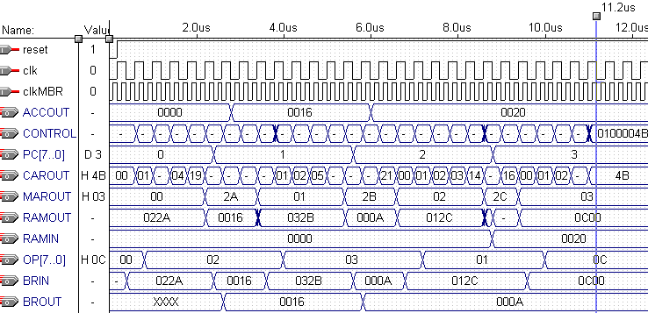
程序1波形图及逐条指令、逐个阶段、逐个操作、逐个部件逐个数据变化的对应关系分析，数据运算过程分析。
详细分析可任选一条指令为例，必须结合测试波形、电路图、代码、指令系统设计具体说明，标注控制信号，地址，数据等信息的每一次流动、变化。
（必做）
以pc=0为例:
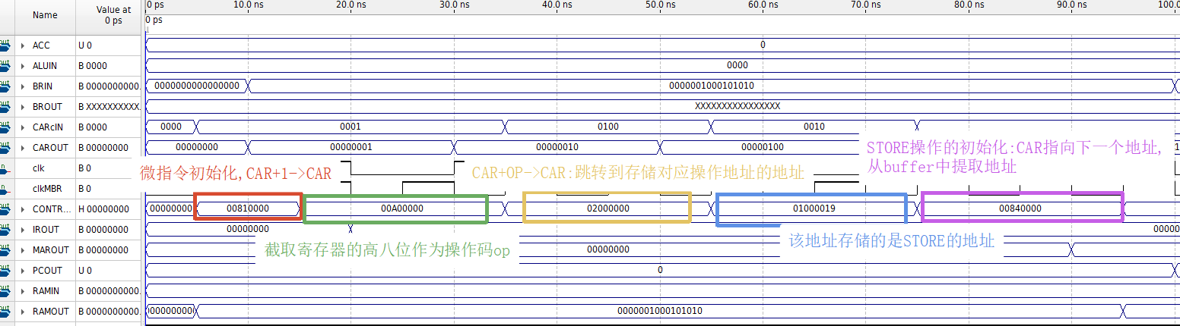
一、机器指令
PC=00时，从RAM[00]取出的机器指令为022A。
02：LOAD操作码。
2A：操作数地址。
RAM[2A]=0016H=22。
因此，022A表示：LOAD 2A，即把RAM[2A]中的数值22装入ACC。

二、微指令及控制信号

1. CONTROLIN=00810000，CAR=00
控制操作：R=1，CAR<-CAR+1。
地址总线：MAROUT=00，指向机器指令地址RAM[00]。
数据总线：RAMOUT输出022A。
微地址变化：CAR由00变为01。

2. CONTROLIN=00A00000，CAR=01
控制操作：MBR_OPc=1，OP<-MBR[15..8]，CAR<-CAR+1。
寄存器变化：从022A的高8位取出操作码02，送入OP/IROUT。
微地址变化：CAR由01变为02。

3. CONTROLIN=02000000，CAR=02
控制操作：CAR<-CAR+OP。
微地址计算：02H+02H=04H。
微地址变化：CAR由02跳到04，进入LOAD指令分派入口。

4. CONTROLIN=01000019，CAR=04
控制操作：CAR<-19H。
微地址变化：CAR由04跳到19H，进入LOAD执行微程序。

5. CONTROLIN=00840000，CAR=19
控制操作：MBR_MARc=1，MAR<-MBR[7..0]，CAR<-CAR+1。
地址变化：从022A的低8位取出2A，送入MAR。
地址总线：MAROUT由00变为2A，准备访问RAM[2A]。
微地址变化：CAR由19H变为1AH。

6. CONTROLIN=00810A00，CAR=1A
控制操作：PCinc=1，R=1，ACCclear=1，CAR<-CAR+1。
PC变化：PC由00变为01，指向下一条机器指令。
存储器操作：读取RAM[2A]，RAMOUT输出0016H。
寄存器变化：ACC先清零。
微地址变化：CAR由1AH变为1BH。

7. CONTROLIN=00C03000，CAR=1B
控制操作：MBR_BRc=1，ALU控制码为0011，CAR<-CAR+1。
数据流动：RAM[2A]中的0016H经MBR送入BR。
ALU操作：ACC<-ACC+BR=0000H+0016H=0016H。
执行结果：ACC中得到22，完成LOAD 2A。
微地址变化：CAR由1BH变为1CH。

8. CONTROLIN=04080000，CAR=1C
控制操作：PC_MARc=1，CARc=1000。
微地址变化：CAR<-00，返回公共取指微程序。
地址变化：MAR<-PC=01，地址总线指向下一条机器指令。

三、完整变化过程
CAR微地址：00->01->02->04->19->1A->1B->1C->00。
PC程序地址：00->01。
地址总线MAROUT：00->2A->01。
读数据总线RAMOUT：022A->0016H。
ACC：0000H->0016H，即十进制22。

四、执行结果
PC=0时执行LOAD 2A，将RAM[2A]中的0016H装入ACC。
执行结束后，ACC=0016H，PC=01，MAR=01。
下一条机器指令为RAM[01]=032B，即ADD 2B。

2, load, SUB, store, halt (22-10)
The contents in RAM:
0 : 022A; Load 2A
1 : 042B; SUB 2B
2 : 012C; Store 2C
3 : 0C00; Halt
2a : 0016;
2b : 000A;
The content in RAM addressed of 2c is 000C(H).
The waveform of the operate:
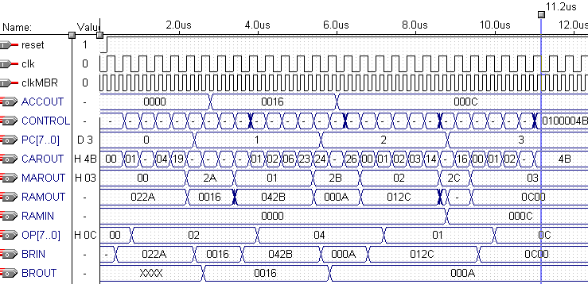
程序2波形图及逐条指令、逐个阶段、逐个操作、逐个部件逐个数据变化的对应关系分析，数据运算过程分析。（可选做）

3, load, mpy, add, store, halt (13*10+22)
The contents in RAM:
0 : 022A; Load 2A
1 : 0B2B; MPY 2B
2 : 032C; ADD 2C
3 : 012D; Store 2D
4 : 0C00; Halt
2a : 000D;
2b : 000A;
2c : 0016;
The content in RAM addressed of 2d is 0098(H).
The waveform of the operate:
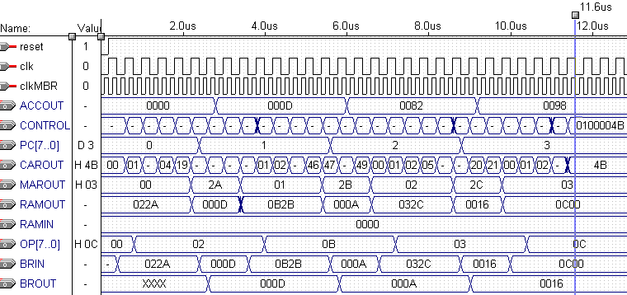
程序3波形图及逐条指令、逐个阶段、逐个操作、逐个部件逐个数据变化的对应关系分析，数据运算过程分析。（可选做）

4, Sum from 1 to 100
The contents in RAM are shown in table2.
The content in RAM addressed of A4 is 13BA(H).
The waveform of the operate:
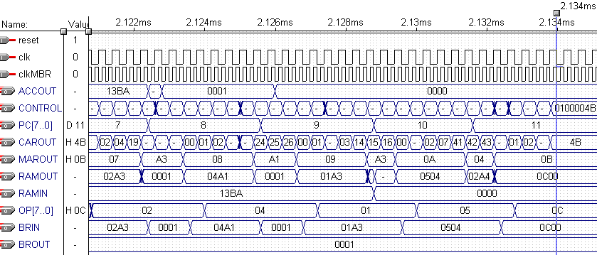
The clock cycle of CAR is 400 ns.
From the waveform, it takes 2.314ms to execute the operate. So the number of the executing cycles is 2.134/0.0004=5335.

程序4波形图及逐条指令、逐个阶段、逐个操作、逐个部件逐个数据变化的对应关系分析，数据运算过程分析。（必做）
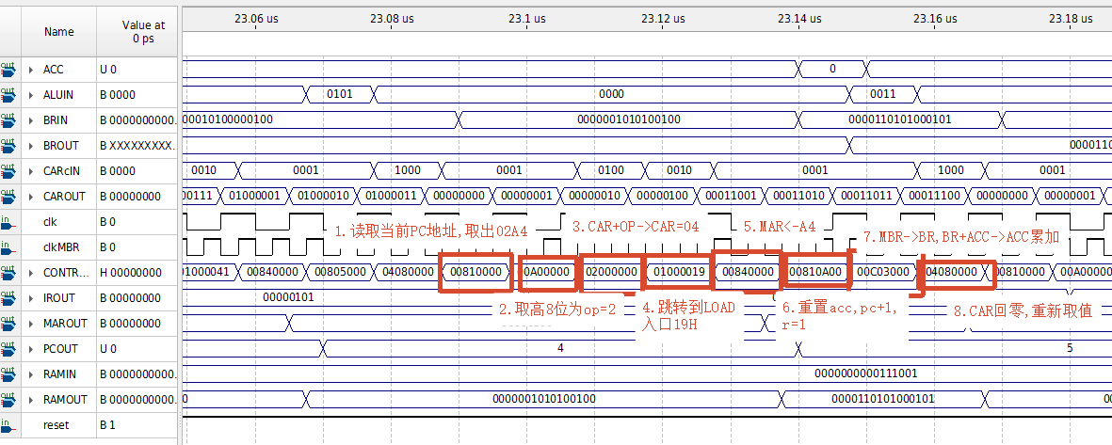
一、机器指令
PC=04时，从RAM[04]取出的机器指令为02A4。
02：LOAD操作码。
A4：操作数地址，也是累加和sum的存储地址。
因此，02A4表示：LOAD A4，即把RAM[A4]中保存的当前累加和装入ACC，为下一条ADD A3做准备。
图示时刻RAM[A4]中的值为0000H，因此执行结束后ACC=0000H。在后续循环中，RAM[A4]会保存不断更新的累加和。

二、微指令及控制信号

1. CONTROLIN=00810000，CAR=00
控制操作：R=1，CAR<-CAR+1。
PC状态：PCOUT=04。
地址总线：MAROUT=04，指向机器指令地址RAM[04]。
数据总线：RAMOUT输出02A4。
微地址变化：CAR由00变为01。

2. CONTROLIN=00A00000，CAR=01
控制操作：MBR_OPc=1，OP<-MBR[15..8]，CAR<-CAR+1。
寄存器变化：从02A4的高8位取出操作码02，送入OP/IROUT。
微地址变化：CAR由01变为02。

3. CONTROLIN=02000000，CAR=02
控制操作：CAR<-CAR+OP。
微地址计算：02H+02H=04H。
微地址变化：CAR由02跳到04，进入LOAD指令分派入口。

4. CONTROLIN=01000019，CAR=04
控制操作：CAR<-19H。
微地址变化：CAR由04跳到19H，进入LOAD执行微程序。

5. CONTROLIN=00840000，CAR=19
控制操作：MBR_MARc=1，MAR<-MBR[7..0]，CAR<-CAR+1。
地址变化：从02A4的低8位取出A4，送入MAR。
地址总线：MAROUT由04变为A4，准备访问RAM[A4]中的当前累加和。
微地址变化：CAR由19H变为1AH。

6. CONTROLIN=00810A00，CAR=1A
控制操作：PCinc=1，R=1，ACCclear=1，CAR<-CAR+1。
PC变化：PC由04变为05，指向下一条机器指令03A3，即ADD A3。
存储器操作：读取RAM[A4]，RAMOUT输出当前累加和。
寄存器变化：ACC先清零，为通过加法实现LOAD操作做准备。
微地址变化：CAR由1AH变为1BH。

7. CONTROLIN=00C03000，CAR=1B
控制操作：MBR_BRc=1，ALU控制码为0011，CAR<-CAR+1。
数据流动：RAM[A4]中的当前累加和经MBR送入BR。
ALU操作：ACC<-ACC+BR。
由于前一条微指令已经把ACC清零，因此该操作等价于ACC<-RAM[A4]。
图示时刻RAM[A4]=0000H，所以ACC=0000H。
微地址变化：CAR由1BH变为1CH。

8. CONTROLIN=04080000，CAR=1C
控制操作：PC_MARc=1，CARc=1000。
微地址变化：CAR<-00，返回公共取指微程序。
地址变化：MAR<-PC=05，地址总线指向下一条机器指令RAM[05]。

三、完整变化过程
CAR微地址：00->01->02->04->19->1A->1B->1C->00。
PC程序地址：04->05。
地址总线MAROUT：04->A4->05。
读数据总线RAMOUT：02A4->RAM[A4]中的当前累加和->03A3。
BR：接收RAM[A4]中的当前累加和。
ACC：先清零，再装入RAM[A4]中的当前累加和。

四、执行结果及作用
PC=4时执行LOAD A4，将RAM[A4]中保存的当前累加和装入ACC。
执行结束后，PC=05，MAR=05，CAR返回00。
下一条机器指令为RAM[05]=03A3，即ADD A3，把当前计数值加入ACC。
因此，PC=4和PC=5共同完成循环中的核心累加过程：
PC=4：ACC<-RAM[A4]，取出当前sum。
PC=5：ACC<-ACC+RAM[A3]，执行sum+counter。

加减交替法实现DIV:1000/500
波形图:
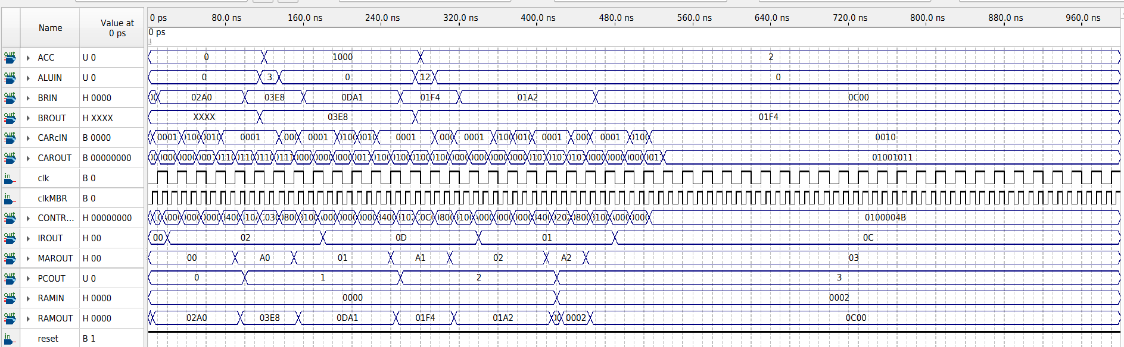
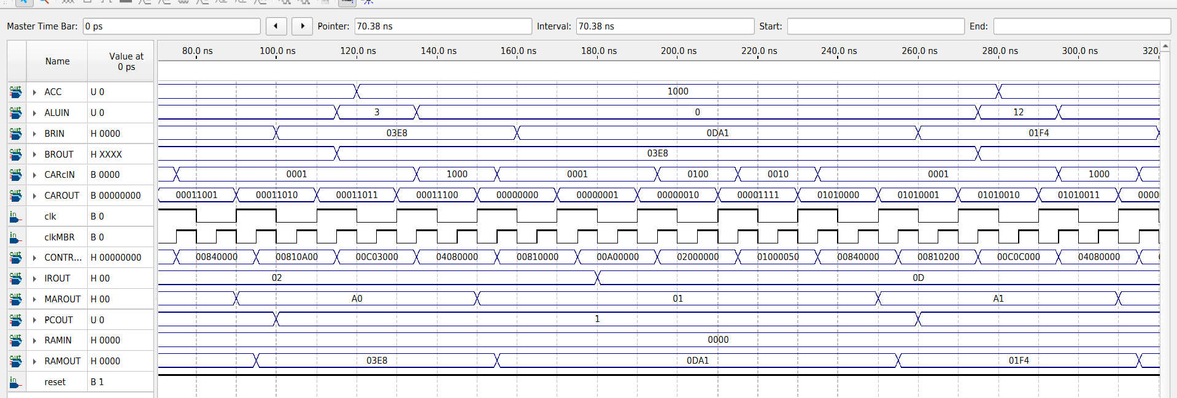
分析:以pc=1时为例
一、指令及初始状态
程序存储器01H单元内容为0DA1H：
操作码：0DH，表示DIV指令；
地址码：A1H，表示除数存放在RAM的A1H单元。
执行本指令前：
PC=01H；
ACC=03E8H=1000；
RAM[A1H]=01F4H=500。
因此本条指令完成的操作为：
ACC <- ACC / RAM[A1H] = 1000 / 500 = 2，
最终ACC应变为0002H。

二、微程序执行路径
本指令对应的微地址变化为：
00H -> 01H -> 02H -> 0FH -> 50H -> 51H -> 52H -> 53H -> 00H
波形中的CAROUT与CONTROLIN正好按上述顺序变化。

三、各微指令的数据流和控制信号
1. 微地址00H，微指令00810000H：取指地址送存储器
有效控制信号：R=1，CARc=0001。
微操作：R=1，CAR <- CAR+1。
此时上一条指令结束时已执行MAR <- PC，因此：
PCOUT=01H，MAROUT=01H。
RAM以MAROUT=01H作为地址，输出RAMOUT=0DA1H。
CAR由00H变为01H。
数据流：
PC(01H) -> MAR(01H) -> RAM地址端；
RAM[01H](0DA1H) -> RAMOUT/MBR输入端。

2. 微地址01H，微指令00A00000H：装入操作码
有效控制信号：MBR_OPc=1，CARc=0001。
微操作：OP <- MBR[15..8]，CAR <- CAR+1。
MBR从RAM输出0DA1H中取高8位0DH送入操作码通路，
因而IROUT=0DH；低8位A1H作为指令地址码保留在MBR地址通路中。
CAR由01H变为02H。
数据流：
RAMOUT(0DA1H) -> MBR；
MBR[15..8](0DH) -> OP/IROUT；
MBR[7..0](A1H) -> MBR_MAR地址通路。

3. 微地址02H，微指令02000000H：操作码译码
有效控制信号：CARc=0100。
微操作：CAR <- CAR+OP。
当前CAR=02H，OP=0DH，所以：
CAR=02H+0DH=0FH。
数据流：
OP(0DH)和CAR(02H)进入微地址形成逻辑，产生微地址0FH。

4. 微地址0FH，微指令01000050H：转入DIV微程序
有效控制信号：CARc=0010，直接地址字段CAR=50H。
微操作：CAR <- 50H。
操作码0DH经译码入口0FH跳到DIV微程序首地址50H。

5. 微地址50H，微指令00840000H：形成除数地址
有效控制信号：MBR_MARc=1，CARc=0001。
微操作：MAR <- MBR[7..0]，CAR <- CAR+1。
MBR低8位为A1H，因此MAROUT由01H变为A1H。
RAM地址随之变为A1H，RAMOUT由指令0DA1H变为01F4H。
CAR由50H变为51H。
数据流：
MBR[7..0](A1H) -> MAR(A1H) -> RAM地址端；
RAM[A1H](01F4H) -> RAMOUT。

6. 微地址51H，微指令00810200H：读取除数并修改PC
有效控制信号：R=1，PCinc=1，CARc=0001。
微操作：MBR <- RAM[A1H]，PC <- PC+1，CAR <- CAR+1。
RAM输出01F4H被送入MBR的BR数据通路，波形中BRIN变为01F4H；
PCOUT由01H增加为02H，提前指向下一条机器指令；
CAR由51H变为52H。
数据流：
RAM[A1H](01F4H) -> RAMOUT -> MBR_BR/BRIN；
PC(01H) -> PC(02H)。

7. 微地址52H，微指令00C0C000H：执行加减交替除法
有效控制信号：MBR_BRc=1，aluCONTR=1100，CARc=0001。
波形显示：ALUIN=CH，BRIN=01F4H，BROUT随后变为01F4H。
微操作：
BR <- MBR；
ACC <- div_add_sub(ACC,BR)；
CAR <- CAR+1。
BR装入除数01F4H。ALU检测到控制码1100后调用div_add_sub函数，
以ACC=03E8H为被除数、BR=01F4H为除数，执行16轮非恢复余数除法：
部分余数非负时减除数，部分余数为负时加除数；
每轮左移并根据新余数符号形成一位商。
计算结果：03E8H / 01F4H = 0002H，余数为0000H。
在clk下降沿，ALU将商0002H写回ACC；CAR由52H变为53H。
数据流：
MBR_BR(01F4H) -> BR(01F4H) -> ALU除数输入；
ACC(03E8H) -> ALU被除数输入；
ALU加减交替除法结果(0002H) -> ACC。
注意：源码中的16轮循环在组合逻辑中展开，外部微程序只需一个DIV执行微周期，
并不是CAR在52H停留16个时钟周期。

8. 微地址53H，微指令04080000H：结束本指令并返回取指周期
有效控制信号：PC_MARc=1，CARc=1000。
微操作：MAR <- PC，CAR <- 00H。
此时PC已经为02H，所以MAROUT由A1H变为02H，准备读取下一条指令；
CAR回到00H，重新进入公共取指微程序。
数据流：
PC(02H) -> MAR(02H) -> RAM地址端；
CAR(53H) -> CAR(00H)。

四、波形结论
当PC=01H时，CPU从RAM[01H]取出0DA1H，并译码为DIV A1H。
地址码A1H经MBR送入MAR，RAM[A1H]输出除数01F4H；
除数经MBR和BR送入ALU，被除数为原ACC中的03E8H。
ALUIN=CH时执行加减交替法除法，最终将商0002H写回ACC。
与此同时PC由01H增加到02H，最后MAR<-PC、CAR<-00H，开始下一条指令。
时序上，CAR和MAR主要在clk上升沿更新，PC和ACC在clk下降沿更新，
MBR的数据锁存由更快的clkMBR配合完成，从而保证地址、存储器数据和运算数据依次稳定传递。
VI. Appendix:
(I)The GDF of CPU:
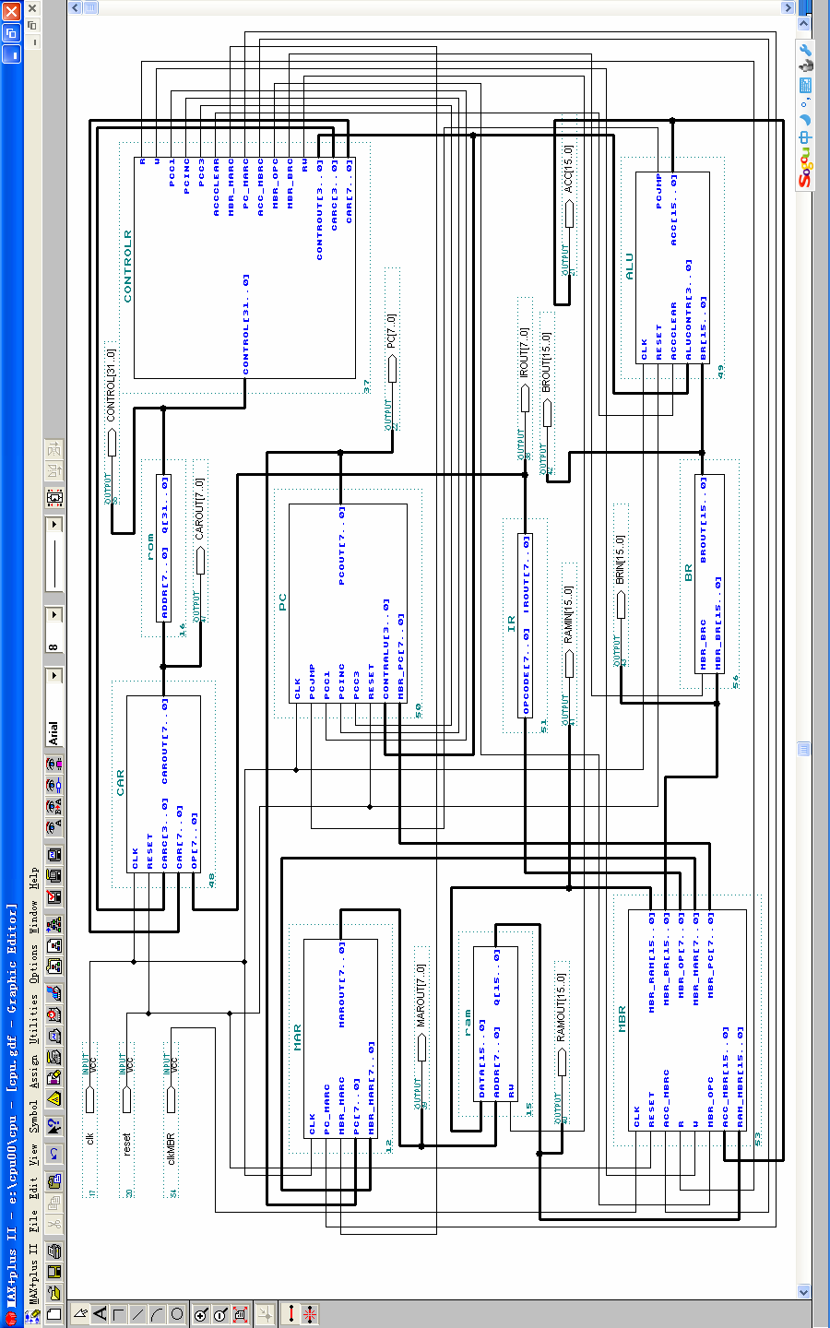
(II) The code of the CPU program:
1, MBR (Memory Buffer Register)
library ieee;
use ieee.std_logic_1164.all;
use ieee.std_logic_unsigned.all;
entity MBR is
port( clk, reset, MBR_OPc, ACC_MBRc,R,W:in std_logic;
ACC_MBR :in std_logic_vector(15 downto 0);
RAM_MBR :in std_logic_vector(15 downto 0);
MBR_RAM :out std_logic_vector(15 downto 0);
MBR_BR :out std_logic_vector(15 downto 0);
MBR_OP :out std_logic_vector(7 downto 0);
MBR_MAR :out std_logic_vector(7 downto 0);
MBR_PC :out std_logic_vector(7 downto 0));
end MBR;
architecture behave of MBR is
begin
process(clk)
variable temp:std_logic_vector(15 downto 0);
begin
if(clk'event and clk='0')then
if reset='1' then
if ACC_MBRc='1' then temp:=ACC_MBR; end if;
if R='1' then MBR_BR<=RAM_MBR; end if;
if W='1' then MBR_RAM<=temp; end if;
MBR_MAR<=RAM_MBR(7 downto 0);
MBR_PC<=RAM_MBR(7 downto 0);
if MBR_OPc='1' then MBR_OP<=RAM_MBR(15 downto 8); end if;
else MBR_BR<=x"0000";
MBR_MAR<="00000000";
MBR_OP<="00000000";
MBR_PC<="00000000";
end if;
end if;
end process;
end behave;

2, BR (Buffer Register)
library ieee;
use ieee.std_logic_1164.all;

entity BR is
port( MBR_BRc:in std_logic;
MBR_BR:in std_logic_vector(15 downto 0);
BRout:out std_logic_vector(15 downto 0));
end BR;
architecture behave of BR is
begin
process
begin
if MBR_BRc='1' then BRout<=MBR_BR; end if;
end process;
end behave;

3, MAR (Memory Address Register)
library ieee;
use ieee.std_logic_1164.all;
use ieee.std_logic_unsigned.all;
entity MAR is
port( clk,PC_MARc,MBR_MARc:in std_logic;
PC,MBR_MAR:in std_logic_vector(7 downto 0);
MARout:out std_logic_vector(7 downto 0));
end MAR;
architecture behave of MAR is
begin
process(clk)
begin
if(clk'event and clk='1')then
if PC_MARc='1' then MARout<=PC; end if;
if MBR_MARc='1' then MARout<=MBR_MAR; end if;
end if;
end process;
end behave;

4, PC (Program Counter)
library ieee;
use ieee.std_logic_1164.all;
use ieee.std_logic_unsigned.all;
entity PC is
port( clk,PCjmp,PCc1,PCinc,PCc3,reset:in std_logic;
CONTRalu :in std_logic_vector(3 downto 0);
MBR_PC :in std_logic_vector(7 downto 0);
PCout :buffer std_logic_vector(7 downto 0));
end PC;
architecture behave of PC is
begin
process(clk)
begin
if(clk'event and clk='0')then
if reset='1' then
if CONTRalu="0101" then
if PCjmp='1' then PCout<=MBR_PC;
elsif PCjmp='0' then PCout<=PCout+1;
end if;
end if;
if PCc1='1' then PCout<="00000000"; end if;
if PCinc='1' then PCout<=PCout+1; end if;
if PCc3='1' then PCout<=MBR_PC; end if;
else PCout<="00000000";
end if;
end if;
end process;
end behave;

5, IR (Instruction Register)
library ieee;
use ieee.std_logic_1164.all;
use ieee.std_logic_unsigned.all;
entity IR is
port( opcode :in std_logic_vector(7 downto 0);
IRout :out std_logic_vector(7 downto 0));
end IR;
architecture behave of IR is
begin
IRout<=opcode;
end behave;

6, CAR (Control Address Register)
library ieee;
use ieee.std_logic_1164.all;
use ieee.std_logic_unsigned.all;
entity CAR is
port( clk,reset :in std_logic;
CARc :in std_logic_vector(3 downto 0);
CAR,OP :in std_logic_vector(7 downto 0);
CARout:buffer std_logic_vector(7 downto 0));
end CAR;
architecture behave of CAR is
begin
process(clk)
begin
if(clk'event and clk='1')then
if reset='1' then
if CARc="1000" then CARout<="00000000"; end if;
if CARc="0100" then CARout<=OP+CARout; end if;
if CARc="0010" then CARout<=CAR; end if;
if CARc="0001" then CARout<=CARout+1; end if;
else CARout<="00000000";
end if;
end if;
end process;
end behave;

7, CONTRALR (Control Buffer Register)
library ieee;
use ieee.std_logic_1164.all;
use ieee.std_logic_unsigned.all;
entity CONTROLR is
port(
control :in std_logic_vector(31 downto 0);
R,W, RW, PCc1,PCinc,PCc3:out std_logic;
ACCclear,MBR_MARc,PC_MARc:out std_logic;
ACC_MBRc,MBR_OPc,MBR_BRc:out std_logic;
CONTRout:out std_logic_vector(3 downto 0);
CARc :out std_logic_vector(3 downto 0);
CAR :out std_logic_vector(7 downto 0));
end CONTROLR;
architecture behave of CONTROLR is
begin
process
begin
CAR<=control(7 downto 0);
PCc1<=control(8);
PCinc<=control(9);
PCc3<=control(10);
ACCclear<=control(11);
CONTRout<=control(15 downto 12);
R<=control(16);
W<=control(17);
MBR_MARc<=control(18);
PC_MARc<=control(19);
ACC_MBRc<=control(20);
MBR_OPc<=control(21);
MBR_BRc<=control(22);
CARc<=control(26 downto 23);
RW<=control(17);
end process;
end behave;

8, ALU (Arithmetic Logic Unit)
library ieee;
use ieee.std_logic_1164.all;
use ieee.std_logic_unsigned.all;
entity ALU is
port( clk,reset,ACCclear:in std_logic;
aluCONTR :in std_logic_vector(3 downto 0);
BR :in std_logic_vector(15 downto 0);
PCjmp :out std_logic;
ACC :buffer std_logic_vector(15 downto 0));
end ALU;
architecture behave of ALU is
begin
process(clk)
begin
if(clk'event and clk='0')then
if reset='0' then ACC<=x"0000";
else
if ACCclear='1' then ACC<=x"0000"; end if;
if aluCONTR="0011" then ACC<=BR+ACC; end if; --ADD
if aluCONTR="0100" then ACC<=ACC-BR; end if; --SUB
if aluCONTR="0110" then ACC<=ACC and BR; end if; --AND
if aluCONTR="0111" then ACC<=ACC or BR; end if; --OR
if aluCONTR="1000" then ACC<=not ACC; end if; --NOT
if aluCONTR="1001" then --SRR
ACC(14 downto 0)<=ACC(15 downto 1); ACC(15)<='0';
end if;
if aluCONTR="1010" then --SRL
ACC(15 downto 1)<=ACC(14 downto 0); ACC(0)<='0';
end if;
if aluCONTR="1011" then ACC<=ACC*BR; end if; --MPY
end if;
end if;
if ACC>0 then PCjmp<='1';
else PCjmp<='0';
end if;
end process;
end behave;

