CVFIT PROGRAM

GENERAL PURPOSE CURVE-FITTING

The CVFIT program is designed for weighted least-squares fitting of various equations (22 options at present, many with several sub-options) to relatively small amounts of data that can be typed in, and to calculate errors and plot the results. It is possible to fit several data sets simultaneously with the same equation, or to fit potency ratios (or dose ratios constrained by the Schild equation) to sets of dose-response curves.

Plotting
All graphs are drawn by the VPLOT5 subroutine, so see separate VPLOT notes for details of how to modify, plot and queue the graphs that appear on the screen.

Data storage
Data, once typed in, can be stored on disk (in a file called CVDAT.DAT by default, but any name can be used). Each CVDAT.DAT can contain several files, and each file can contain any number of data sets. The reason for this arrangement is so that several data sets (from the same file) can be plotted on the same graph, and can be fitted, either separately or simultaneously, together. Therefore the different sets in one file will generally contain related sorts of data (e.g. I/V curves on different cell types or with different ion concentrations, or dose-response curves with different antagonist concentrations). Each data set in a given file can have its own set variable specified (e.g. the ion concentration, or antagonist concentration, for each set). On the other hand, different files in the same CVDAT.DAT are quite independent; data in different files cannot be superimposed or fitted simultaneously, and different files may contain entirely different sorts of data.

Fitting method
All fitting is done by weighted least squares, i.e. we minimise
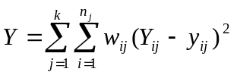 (1)
where the Y_{ij} are the calculated Y values (e.g. response), and y_{ij} are the observed values. at x_{ij}, the ith x value (e.g. concentration) in the jth data set (see below). The number of data sets is k and the number of observations in the jth set is n_{j}. The weights, w_{ij}, are defined as discussed next.

Weighting options
The fit is done by weighted least squares, and there are five different ways that the weights of each data point can be specified. For an optimum fit the weight should be 1/s², where s is the standard deviation of the data point.
The weighting options are as follows.

(1) Weights equal for all points. In this case the weights are set to 1.0, and give no information about the precision of the measurements. For the calculation of errors in the parameter estimates, the scatter is estimated from the extent to which the data points fail to lie exactly on the fitted curve, i.e. from the 'residuals' (so this method assumes that an equation has been chosen that really describes the data).

(2) Standard deviation to be typed in. This is the best method when you have a legitimate estimate of the precision of each point. Usually the estimates will come from replicate observations at each X value, which are averaged, and the standard deviation of that mean (often, undesirably, called the ‘standard error’) used to calculate the weights (but see notes below concerning excessive fluctuation of the weights).

(3) Calculate SD from x. It is common for the scatter of the points (as measured by s) to vary with x (and hence with y). Suppose that a straight line is a reasonable fit to a plot of s against x, and a fit of this line with : s = a + bx gives a and b as the intercept and slope. This option allows a and b to be specified, so the program can calculate s for each data point (from its x value). Relative values of weights can be specified this way too (see next paragraph).

(4) Calculate SD from y. Suppose that a straight line, s = a + by, is a reasonable fit to a plot of s against y. This option allows a and b to be specified, so the program can calculate s for each data point (from its y value). The values for the fitted parameters depend only on the relative weights (only the error calculations need absolute values). Thus weighting with a constant coefficient of variation can be achieved e.g. by using a = 0 and b = 0.1 (for 10% coefficient of variation). This is similar to fitting log(y) values since the latter will be equally-weighted if the original y values have a constant coefficient of variation.

(5) Specify arbitrary relative weights for each data point. Only relative values are given so they need contain no information about the size of the experimental error (errors are calculated from residuals as for method 1). One case in which this may be useful is when the data points are means, with different numbers of observations averaged for each. If you want to assume that all individual observations have equal precision then use method (5) and specify n, the number of values in the average, as the relative weight.

The ideal method (option 2) is to type in the standard deviation for each data point (i.e. if the point is a mean of several replicate values, give the standard deviation of the mean –the so-called ‘standard error’). If, for example, the data point is a single observation, not a mean, then this may not be possible, and options (1) or (5) must be used. When it is possible, make sure that the standard deviations are not wildly scattered (as may happen when small numbers of points are averaged, for example). A very small standard deviation for one point may force the fitted line to go through that point, despite the fact that in reality it is not likely to be very much more precise than other points. If the standard deviations are very scattered then try plotting the standard deviation against the Y value (or against the X value), and draw a smooth curve through the plot by eye from which 'smoothed SDs can be read off, and these smoothed values typed in for option 2. If the line is more-or-less straight then measure (approximately) its slope and intercept and use option (3) or (4).
Note that the values for the parameter estimates are dependent only on the relative values of the weights for each point, but calculation of the errors in these estimates needs the absolute values (or a separate estimate of experimental error from residuals, as in options 1 and 5).

Running the program

Starting
First the usual blue window appears, asking whether you wish the print out (cvfit.prt) to be written to disk (in the directory you specified during set up), and if so whether it should be appended to the previous print file, or should overwrite it. You are asked for the array sizes. The latest version can take (subject to having enough RAM) any number of sets and any number of observations per set; you are asked for values for these so that array sizes can be defined (it does not matter if values given are too big).
Data input. You can read back data that have already been stored on disc, read data from an ASCII file, read data from a plot queue, or type in new data. There is also an option to read in no data, which allows CVFIT to be used to plot a calculated curve only. If you ask to 'read data from disc' then you are asked where the data file (e.g. CVDAT.DAT) is. The number of files (see above) on the disc is stated, and you are asked if you want to list all the files on the disc. If you say yes, the title of every data set in the file, is given, and you get the chance to try a different disc if you want.

Adding data
Note that if you want to start a new file then choose the 'type in data' option (not 'read from disc'); type in the data and then specify the file number in which you want it kept. If, on the other hand, you want to add a data set to an existing file, then (a) read the file in question from disc (b) choose the option to view/modify the data (c) go through the window displays of the existing sets (hit ESC to go to the next as described below), and then (d) when presented with the list of options for altering the data choose '(2) add a new set'.

Typing in new data
You are first asked how many data sets you want to type in. For each set you then give the number of observations in the set (or just type <enter> and specify when data ends later by typing # in the data window -see below). You are asked whether you want to specify a set variable (see above), and if you say Yes, give its value.
Next choose how you want to specify the weights (see above). A window then appears into which the data is typed. The number of columns depends on what weighting system is used. For methods (1), (3) and (4) (see above) there are only two columns, for X and Y values (in methods 3 and 4, you are asked for the values of a and b first). For methods (2) and (5) you specify a weight, or relative weight, for each observation: you are asked whether you want to specify the value as a standard deviation (s), or as a (relative) weight, and a third column, with appropriate heading, appears for these values.
When the data window appears you can get help on how to enter the data by hitting F1 (this is stated at the bottom of the screen). The help window gives the following information.
ENTER or TAB: Move to next number
INS or SHFT-TAB: Back to previous number
ARROWS: move round in current window
PAGE-DOWN: moves down one screenful (if window is too long for it all to fit
on the screen at once).
PAGE-UP: moves up one screenful
HOME: moves up to start
END: moves down to end
Type # on line after last number to end: if the number of observations in the
set was not specified above (or even if it was), then moving to the line
following the last observation and typing '#' signifies that all data have
been entered.
ESC: finished: the window is left (and also use ESC to leave the HELP
window)
F2: X multiplier. F3: Y multiplier. If these are hit then a window appears
that asks for a multiplier for the X or Y column. After it is specified
all values in the appropriate column are multiplied by it. This is
useful, for example, to convert all X values from nM to μM.
F4: add a new observation. A new row is added at the bottom of the window for
a new data point (most useful when altering data read from disc).
F5: when several sets of data are being displayed, ESC moves on the next set, but F5
jumps out of the display altogether,
CTRL-ARROW: moves the whole window to the left or right on the screen.

This is a convenient method for entering data because you can correct a value simply by moving back to it in the window, and typing over it the corrected value.
When all data are entered, leave the window with ESC (or #). You are then asked if you want to enter labels for the graph axes (if you do they are kept on the disc with the other data). In the F90/Gino version it is not, at present, feasible to enter Greek or mathematical symbols at this stage, but this can easily be done on the graph itself (see VPLOT notes).
Lastly choose whether to keep the data that you have just entered as a file on the disc, for use again later. If so give a file number (if this file already contains data, the existing data will be overwritten).

Data read from disc
After the specified file has been read, you are asked if you want to VIEW/ALTER the data. If you say no, the data is used as it is read from the disc, except that you have an option to change the weighting method. If you say yes, a window appears that contains the data of the first set. This time the window has four columns, for X and Y values, and for both standard deviation and the corresponding weight. If the data are O.K. as they stand then just hit ESC and the next set appears. If you want to change any values, then move to the value in the window (see above) and overtype it with the new value. Note that columns 3 and 4 are linked: if you change a standard deviation then, as soon as you move out of its field, the weight changes automatically to the corresponding value. And, vice versa, altering a weight causes the SD to change automatically.
The easiest way to omit an observation is to simply set its weight to zero (or, equivalently, set its SD>10²⁰); this prevents it from affecting the fit and also prevents the point from being plotted on the graph.
After each set is seen to be satisfactory, press ESC for the next set, until all have been shown (the final values will appear on the print-out). You are then presented with a list of options for further alterations.
If you want to make no more changes, hit <enter> to carry on. If you want to change entirely the weighting system, in particular if you want to change to equal weights, it is easiest to use option (1) here, rather than to alter the weight for every observation in the window display; all the weights are converted and the data shown again for approval. An important option here is (2) ADD A SET which allows you to add another data set to the same file. You can either type the new set in (as described above), or you can duplicate an existing set (and then change its title with option (4)). It saves work to duplicate an existing set if a substantial part of the new data is the same (e.g. the X values); save the data to disc, then read it back, edit the new set and re-save the corrected new set to disc.
Option (3) is to remove the last set; option (4) is to change the title of a set; options (5) and (6) are to add or remove an observation (usually easier to do in the data window).
Option (7) allows you to change the set variables, or specify them if none were specified originally.
Once the data are approved, you are then asked if you want to enter labels for the graph axes (see above); if you do they are kept on the disc with the other data.
Then choose whether to write the data back to the same (or a different) disc file. There is obviously no point in re-storing it if no changes have been made. Even if changes have been made you may want them to be temporary. For example if the data from disc have proper standard deviations, and you want to see what an unweighted fit is like, then use the option above to change to equally-weighted points, but do not store these data on disc so that it overwrites the original data file because this will replace all the standard deviations that you typed in with 1.0

Different fitting modes
Once the data has been read in then, if the file contains more than one set of data, you are asked to select from the following options.
Fitting modes:
(1) Fit one data set only
(2) Fit selected data sets separately
(3) Fit selected data sets simultaneously with one equation
(4) Fit selected data sets to estimate relative potencies
(5) Fit selected data sets to estimate antagonist K_{B}

Fit modes 1 and 2 –separate fits
You next select which of the data set(s) are to be used. With option (2) the program is repeated once for each data set, doing a fit to one set on each repeat (the equation fitted may be different for each set (-you are asked for each set if the same equation is to be used as for the previous set). This mode should work with any of the equations that are provided.

Fit mode 3 –simultaneous fit of several sets
Option (3) (in most cases) fits all the data with one equation as though all the data were from a single set. Whereas fit mode 2 does a separate fit for each data set, fit mode 3 does only one fit for all sets. This can be used as a way to pool data from several sets, and when used in this way, any equation can be specified; and the parameters are all common to all data sets.
If you want some parameters to be shared between (common to) all sets, but others to be fitted separately to each set, it is essential to use this option. For example, in the case of set of concentration-response curves fitted with a Hill or Langmuir equation, you might want all curves to have a common maximum, or a common EC50, or you might want the log-concentration response curves to be parallel so the Hill coefficient, n_{H} is shared between all sets (i.e. a single value of n_{H} is estimated form all the data, as the best compromise between the values that would be found if the sets were fitted separately). You cannot use any of the equations for doing simultaneous fits with some parameters shared; only certain options have been programmed in, others are added as they are needed. The options are as follows (Feb. 1998).
(1) Straight line (eq.1, polynomial of degree 1) –a set of lines can be constrained such that they all have the same intercept on the X axis (this was designed to fit a set of current-voltage curves with a common reversal potential)
(2) Langmuir or Hill equations (eq.2 or 3). If each curve has one component, a set of curves can be fitted with a common maximum (Ymax) for all curves, or a common EC50 for all curves. If there are two components in each curve then there is a third option, to fit separate maximum and EC50 for each curve, but to have a common value for the relative amplitudes of the two components.
(3) Receptor mechanisms (eq. 24, n sequential bindings + opening at equilibrium). The mechanism can be fitted separately to each curve, with one Ymax value for each (fit mode 1 or 2). But if fit mode 3 is chosen, only one Ymax value is fitted for all sets and in this case it is not the observed maximum for either curve, but the common Ymax that would be found when 100% of channels are open. This option assumes that the number of channels present is the same for both curves, and that their conductance is the same for both). This was originally added for comparison of equilibrium concentration-response curves for wild type and mutant glycine receptors (Lewis et al., J. Physiol., 507, 25-40, 1998).
(4) Receptor mechanisms (eq. 25, Monod-Wyman-Changeux with n subunits at equilibrium). Options to have various parameters in common between the different sets (see list of equations at the end).

Fit modes 4 and 5: Potency ratios and dose ratios.
Options (4) and (5) are specialist options for the case where the data sets consist of a set of putatively-parallel (on log scale) concentration-response curves, each set being done, for example, with a different agonist (option 4), or with the same agonist but with a different antagonist concentration for each. In the latter case the antagonist concentration must be specified for each set as the set variable when the data are entered. The fitting can be done, in principal, with any equation that describes the curves: usually it will be a Hill equation, Langmuir equation or power function. The fitting is done with the parameters exactly the same for each set apart from a horizontal shift (on the log concentration scale: i.e. the concentration is altered by a fixed factor for each data set). This ensures that the fitted curves are parallel, so a unique potency ratio or dose ratio can be estimated.
In the case of option (4) potency ratios/dose ratios are estimated: in addition to the parameters for the fitted equation the list of fitted parameters (for which initial guesses must be specified) includes also the potency ratios, r_{i}. For example if there are four sets we estimate r2, r3, r4 which are the potency ratios for sets 2, 3, 4 relative to set one (if we fitted only sets 1, 2 and 4 the parameters would be called r2 and r4). These ratios are defined like dose ratios -a rightward shift corresponds with r > 1. If the data consist of concentration-response curves at different antagonist concentrations, the r1, r2, . . . values are dose ratios, and can be used to construct a Schild plot; in this case the values could be typed into another CVFIT file and fitted with a straight line (the slope of which could be fixed at 1, if appropriate).
In the case of option (5) the ratios are not free to vary independently, but are constrained to obey the Schild equation (by means of the antagonist concentrations that are supplied as set variables). In this case there is only one extra parameter, K_{B} , the equilibrium constant for antagonist binding. The result is the best-fitting set of curves that are not only constrained to be parallel but are also constrained to be spaced such that they obey the Schild equation (the Schild plot need not be shown because it is inevitably exactly straight with a slope of one). The adequacy of the Schild equation is judged directly by seeing how the lines fit the original data.
Do the constrained curves fit well enough? In the case of both options (4) and (5), after the fit is done you may fit the individual sets separately. By seeing how much better the separate fits are, compared with the constrained fit, a significance test can be done for the adequacy of the constrained fit. Again various options are given. The separate fits can be completely separate (the ideal). However this may not always be possible (e.g. some individual sets may not have enough points for the number of parameters to be estimated, or some may be incapable of estimating, for example, the maximum response). In such cases you can choose, in the case of Hill or Langmuir fits, to (2) fix all the maxima for the separate fits at the value just obtained for the parallel fit, or (3) to constrain the maximum to be the same for all the separate fits. After the separate fits are completed the results of the significance tests are printed.

Choose the sets to be fitted
Except in fit mode 1, you must next choose how many sets are to be fitted. Any number of sets from the current file can be chosen.

Normalising with respect to a common x value
If you fit several sets of data the program will detect if the same x value occurs in each set, if you use fit mode 2. At present, this option is resrticted to fits of Langmuir/Hill functions and power functions. If it does, then you are asked whether you wish to normalise the observations relative to the y value (‘response’) to the common x value (e.g. if x = 30 nM occurs in each set then use y(x)/y(30) as the response). These normalised observations are then fitted with the appropriate equation. For example, if the equation (calculated y value) is Y = f(x) then the normalised responses, for the example above, are fitted with Y(x)/Y(30). This fitted curve obviously goes through 1 at x = 30 (but no point should appear on the graph at x = 30). Generally, this is a rather ‘last-resort’ method of normalising (because it places a lot of reliance on a single ‘response’), so the default answer is no. If you say Yes, then a list of all the concentrations that are common to all sets appears, and you choose the one to normalise with respect to. You can see the normalised data. At present the only option next is to pool all the sets into one single set after normalising. This will generally give several observations at each x value, and the mean, and standard deviation of the mean at each x value for the pooled data can be viewed in the blue data window, These standard deviations can be used to weight the fit, so if zero weight appears (e.g. because there were no replicates at this x value, then these values will be omitted form the fit unless you put in a suitable standard deviation (or weight) in the blue data window, The next question asks whether you want to use the standard deviations that appeared in the blue window for weighting the fit –if you say No, then all weights are reset to 1.0. Not that there is no Ymax parameter for these fits (it cancels out when the ratio Y(x)/Y(30) (see above) is formed. When the graph is drawn, a point (large empty circle) is drawn at the normalising point, and the fitted curve must (as explained above) go through this point.
If you say that you do not want the data to be so normalised then various other options are available (e.g. the ‘log(y) fit’ described in the equation list below, for Hill/Langmuir curves).

Initial display
After the fit mode has been chosen, and the data sets to be used have been selected, the data are plotted on the screen (without fitted curves) for inspection. You can select which sets are to be displayed on the graph (this will usually, but not necessarily, be the sets that are fitted, which is the default response). It is best to rescale the graph, so it is roughly as you want it, now, rather than after the fit (see VPLOT notes, and the fairly extensive help within VPLOT). Leave the graph with key 9. EXIT as usual. If you wish to fit it, you must next choose the equation to be fitted.

Log scales and other transformations
Within VPLOT you can show the data with various logarithmic and other scales. It is important to notice that this affects only the display –the data for fitting are not transformed. Normally the data are typed in as their raw untransformed values, and they stay like that however you display them. Thus, for example, if you plot log(y) against log(x), and the result looks like a more-or-less straight line, you do not choose a straight line (eqn. 1 in the list below) to fit to it, but a power function (eq. 23. see below), because a power function relationship between x and y is what gives rise to a linear relationship between log(y) against log(x). In most cases this is the best way to do fitting, especially if you provide appropriate weights for the points. If you do not wish to do it this way, then you must enter the transformed values as data; in the example above you would enter the numerical values of log(y) and log(x), choose the arithmetic scales (not log-log) for display in VPLOT, and choose the straight line equation to do the fit.

Choosing an equation to fit
Next choose which equation to fit; specify the equation number if you already know it, or type F1 to see a menu of the equations that are available. The equations are listed at the end of this document.

Initial guesses for the parameters
All iterative methods require that initial guesses should be provided for each parameter. If the guesses are very bad the minimisation may not converge, and may well crash as a result, for example, of some parameter shooting off to infinity. But if the guesses are reasonable, the results should, of course, be independent of what guesses you use. But this is not always true. If parameter(s) are badly determined (i.e. changing their values hardly affects the quality of the fit), then their values will often depend on what starting guess you use and such values are, of course, useless. If error analysis shows standard deviations above roughly 50% of the estimate, or correlation coefficients above 0.9 (see error section below) it is essential to try more than one initial guess to check that the convergence is genuine.
In some cases the program will make initial guesses for you –they will appear as yellow lines superimposed on the graph. If this has not yet been programmed in, or you are not happy that the automatic guesses are reasonable ones, then you are asked to provide a guess for each parameter in turn. Each parameter has a name that is intended to suggest what the parameter means. The names of the parameters are given below, in the list of equations. At present automatic initial guesses are provided only for (a) straight lines, (b) Hill/Langmuir curves with one component, and (c) power functions.
Notice that an initial guess should never be zero, unless you intend to fix that parameter at zero. If you give a zero guess you will be warned about this; the program takes the initial step size for Simplex as a fixed fraction of the initial guess, and a zero step size will prevent fitting.

Fixing parameters.
The guess values you type in can be used to plot a curve on the graph without any fitting at all (all parameters fixed). Usually you will want to fit, but you are asked if you want to fix any parameters (and if so, which), i.e. hold them constant (at the value you supplied for the guess), rather than letting the fitting process change the value. For example the Hill equation (equation 3) has not only K value(s), the high-concentration asymptote(s) Y_{max}, and the Hill coefficient(s) as parameters, but also Y(0), the asymptote at low concentrations. In most cases it is better to fix Y(0)=0 rather than try to estimate it.
After entering the guesses a menu appears that show the names of the parameters and the initial guesses. Choose a parameter that you want to be fixed (with arrows or mouse –see the help on the menu) and confirm the value that you want it to be fixed at. When everything has been fixed as you wish, choose the bottom line of the menu (“OK now”). The menu can show up to 20 parameters at a time –if you have more than this a 2nd menu appears with the rest of them on it.

Constraining parameters.

You can also constrain the parameter estimates to be positive (this can make fitting more robust in some cases, but be sure to ask for it only if you know that negative values are not allowed for any parameters).
Lastly you get the option to constrain the ratio of two parameters to a fixed value. For example,. if fitting a straight line to an I/V curve this allows the reversal potential to be fixed, even though the reversal potential is not one of the parameters of the fit; the x intercept (value of x at y = 0) is (intercept)/slope. If this value is specified, the number of parameters to be estimated is reduced by one. Another example might be in a receptor mechanism in which two rate constants were k₂ and 2k₂. Obviously in this case there is really only one parameter to be estimated (k₂), so the second rate is constrained to be twice the first.

The fitting process
The fitting now starts. In the present version the default is to show none of the iterations, but you get the choice to show them if you wish to follow the progress of the minimisation (the iteration number, and the weighted sum of squares that is being minimised, are shown)
The fitting is usually very quick, but if convergence fails for some reason; the fitting can be aborted by hitting the F1 key. Failure to converge may occur when the initial guesses are bad enough, or when the data are not sufficiently precise to define all the parameters that you had hoped would be possible. For example, it is quite common to attempt to fit a Hill/Langmuir equation to points that do not saturate enough to define the maximum, Y_{max}. In such cases only the initial slope (Y_{max} /K) is well-defined so Y_{max} and K usual keep on getting bigger and bigger, their ratio staying constant. This will be shown as a very strong positive correlation between the two parameters (see section on errors below), and by large, or indeterminable, standard deviations for them. If this occurs you should always try alternative initial guesses, to test whether the convergence is genuine.
After convergence (or abort of fit with F1) a window appears which shows the estimates of the parameters and, if you asked for them, the approximate standard deviation for each estimate (a zero or negative value means that the SD cannot be calculated, probably because the parameter is essentially indeterminate). If errors were requested, the next window displays the correlation matrix for the estimates -any correlation bigger than 0.9 or so is a warning of problems (see section on errors, below). The observed, calculated and residual values are printed to cvfit.prt, but do not appear on the screen.
The display of the fit appears next, and at this stage you may want to label it, rescale it, output it as a graphic file, plot it or queue it (see VPLOT notes).
After the graph is left you may calculate likelihood intervals (next para), before going on to the next fit, or finishing.

Error estimates: approximate SD and Likelihood intervals.
Two methods are provided for expressing the precision of the parameter estimates, viz 'approximate standard deviations' (mentioned above), and likelihood intervals. These methods are discussed by Colquhoun & Sigworth (1995), in the slightly different context of fitting single-channel distributions (in that context the likelihood arises naturally from the problem, whereas for general purpose curve fitting, as done in CVFIT, the likelihood has to be calculated by assuming that experimental errors in the original observations are Gaussian).
The approximate standard deviations are found from the inverse of the Hessian matrix ('observed information matrix'). This is defined as

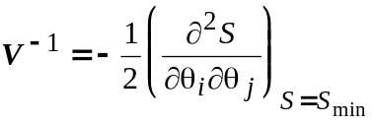
where S is the weighted sum of squares defined in equation 1, and the θ_{I} are the parameter values If the observations have a Gaussian distribution then the log-likelihood of the parameter values would be L = S/2, and the maximum likelihood estimates are the same as the least squares estimates because L_{max} = S_{min}/2. Most commercial programs use a slightly different definition of the information matrix (the ‘expected information matrix’), but the definition above is preferable in theory, though the two definitions differ little in practice.
The partial second derivatives needed for the Hessian are calculated numerically, using a default step size for each parameter (unless you opt to specify the step size as a check). If the weights used to calculate S were not based on real standard, but were set to 1 for an equally-weighted fit, then the covariance matrix must be multiplied by an error variance. In this case the error variance is calculated from the residuals (deviations of observed from fitted points) as S_{min}/(n – p), where n is the number of points fitted and p is the number of free parameters.
The covariance matrix measures the curvature of the likelihood surface at the maximum. The greater the curvature, i.e. the steeper the sides of the hill are, the more sensitive is the fit to the parameter values, and so the better the precision of the parameter estimates. Therefore it makes sense that a measure of their imprecision can be obtained by inverting the information matrix to get the covariance matrix, V. The diagonal elements of the covariance matrix give approximate variances of the parameter estimates, and the off-diagonal elements can be used to calculate the correlations between one parameter estimate and another. The correlation coefficient between the estimates of the ith and jth parameters is calculated from the elements, v_{ij} of the covariance matrix as

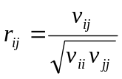.
The meaning of these quantities can be illustrated by simulation. Suppose we have an experiment like that illustrated in Fig 1A. The true curve is a Langmuir hyperbola with Y_{max} = 1 and K = 1, and five concentrations are used, from 0.1K to 10K. The errors on the points are constant, s(y) = 0.1. We now simulate 10000 experiments, with random errors added to each of the points shown in Fig 1A, the errors having a Gaussian distribution, with a standard deviation of 0.1. Each of the 10000 ‘experiments’ is then fitted with a Hill equation (e.g. using eq. 3 in CVFIT –see list of equations). The fits produce 10000 estimates of K, 10000 estimates of Y_{max}, and 10000 estimates of the Hill coefficient, n_{H}, which should, of course, be 1 in this case. The distributions of the 10000 estimates found in this way are shown in Figs 1B, 1C and 1D respectively. It can be seen that the estimates of Y_{max} are not too bad in most experiments, despite the fact that the points do not get as near to a plateau as would be desirable, but there is a long tail of Y_{max} estimates that are much too high. The values for K and n_{H} show a considerable scatter, some values being far too large. None of the distributions is symmetrical, and that is why the (symmetrical) error limits give by citing a standard deviation are rather crude. Likelihood intervals (see below) cater for this asymmetry.

Figure 2
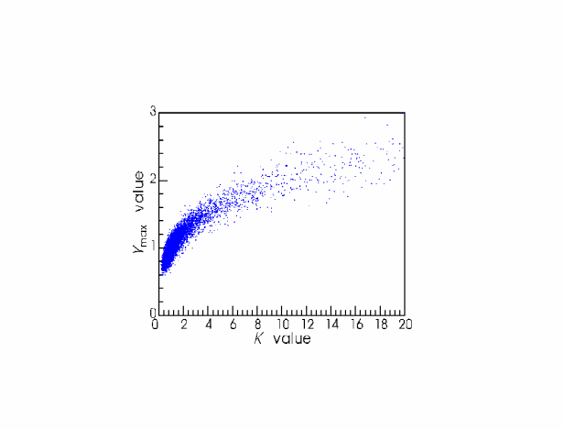
Figure 1
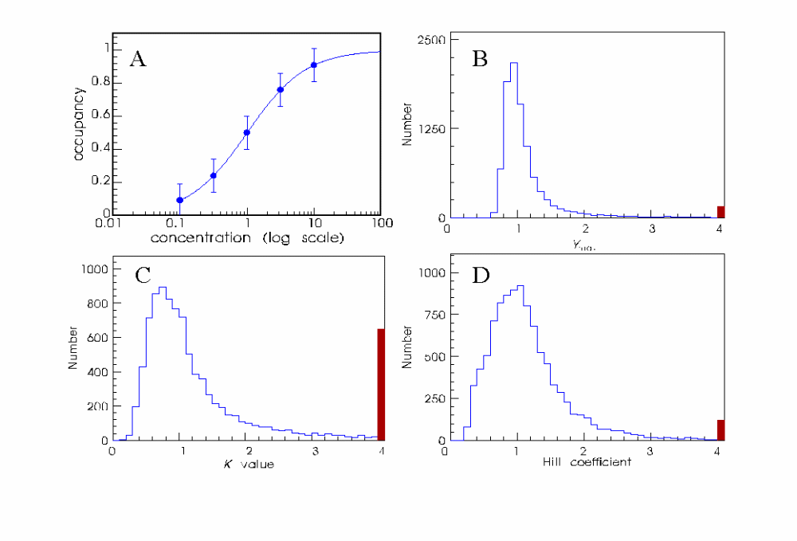
Figure 1 shows the distributions of the parameters separately, but it is found that, for example, the experiments in which Y_{max} was too high, also gave estimates of K that were too high, so there is a positive correlation between the estimates of these two parameters This correlation is very obvious when values from each experiment are plotted against each other in Fig 2. The correlation coefficients obtained (see above) from the covariance matrix measure this tendency; the correlation coefficient between Y_{max} and K is positive. Any value of a correlation coefficient greater than 0.9 or so is a danger warning. For example, if an attempt is made to fit a Langmuir equation to points that lie almost on a straight line (and this is not uncommon!), then it is impossible to estimate the maximum properly, and at low concentrations the Langmuir equation approaches Y = x(Y_{max}/K), so it is clear that only the ratio (Y_{max}/K), which is the slope of the initial linear part of the curve, can be determined. The separate values of Y_{max} and K cannot. In this case the correlation between Y_{max} and K approaches +1.

The use of a standard deviation implies that the error limits are symmetrical (i.e. can be expressed as the best estimate plus or minus some fixed value). These standard deviations are helpful only insofar as the likelihood surface has a quadratic (and therefore symmetrical) shape near its maximum. This is frequently not the case for non-linear problems. For example if you are trying to estimate a maximum P_{open} value which is close to 1.0, the upper error limit can obviously not exceed one, though the lower limit may be quite low. For example, if the best estimate of the parameter was 0.95, the approximate standard method might produce a standard deviation of 0.15 giving limits (± 1 SD) as 0.8 to 1.1, which is meaningless! For the same data the corresponding Likelihood interval might be 0.7 to 0.98, which makes more sense. In other cases, where a parameter is not well-defined, the 'standard deviations' may be highly unreliable, but calculation of likelihood intervals may reveal that a sensible lower limit can be found even though the upper limit is undefined (essentially infinite). Practical examples of such calculations are given by Colquhoun & Ogden (1988, Journal of Physiology, 395, 131-159).

Calculation of Likelihood intervals.
If you ask for this calculation, then first specify the value of m for m-unit likelihood intervals. A value of m = 0.5 corresponds roughly to (± 1 SD limits, and m = 2.0 corresponds roughly to ± 2 SD limits (see Colquhoun & Sigworth, 1995). Next specify which parameters to calculate them for (it is simpler to ask for one parameter at a time). Then you are asked if you want to calculate a lower limit, an upper limit or both. The calculation is done by a bisection method, using a minimisation at each iteration with the parameter in question fixed, until the parameter value that makes the maximum log-likelihood m units below the value for the best estimate is found. This may be slow with complicated functions or large amounts of data, but for the typical CVFIT problem it does not take long. At the end of each calculation the calculated limits is printed. As a check the maximum log-likelihood for the original fit (L_{max}) is printed, together with the value m units lower (L_{crit} = L_{max} - m); if the calculation has been successful the log-likelihood corresponding to the calculated limit, L_{limit} , should be very close to its target value, L_{crit}.
Calculation of each limit needs a pair of initial guesses that bracket the value for the lower limit. For example if the best estimate of a parameter was 5.2 with approximate SD of 0.5, then to calculate the lower m=0.5 unit limit the upper guess must be safe if you give 5.2, and the lower guess will be safe if you make it substantially lower than 5.2 - 0.5 = 4.7; say 4.0 or even 2.0. The present version supplies these initial guesses for you, and in ‘clean’ cases the values for the limits will simply be printed out. Given that one tends to want likelihood intervals in ‘difficult’ cases, in which parameters are not well determined, you may not be so lucky. If the automatic guesses do not appear to contain the result you will get asked to supply different guesses, and if no guesses seem to contain the result then that limit may be infinite. It is also possible that some of the minimisations may not converge, in which case L_{limit} may appear to change erratically with the value used for the limit.
It is worth noting that a strong argument can be made for the view that the best method of assessing the certainty of a parameter value is neither to use SDs nor likelihood intervals, but is to do as many separate experiments as possible. If each experiment can provide a value of the parameter, then it is simple to see how consistent the values are.
List of equations that are available in CVFIT (Feb 1998)

(Warning –some of these options have not been used for a long time –they stem from the original PDP 11-40 version. Let me know if they don’t work any longer!)

Equation (1) Polynomial equation
In general the polynomial of degree n is
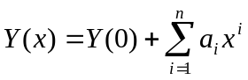
In the program, the parameters appear as Y(0), a1, a2 etc
Special cases include
(a) straight line (degree 1), with intercept Y(0) and slope a₁,
Y = Y(0) + a₁x
(b) quadratic
Y = Y(0) + a₁x + a₂x² ,
and so on.

Sub-options
You can fit a disjoint polynomial, i.e. on that has degree n₁, say, below a specified x value, but a different degree above that x value. For example the empirical description of a current-voltage relationship can sometimes require a straight line below a certain voltage but a quadratic or cubic above that voltage.

The Schild plot option
If you specify a straight line, then you are offered the option to fit the Schild equation
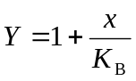
where Y the dose ratio, x is the antagonist concentration, and K_{B} is the equilibrium constant for antagonist binding (it is the only free parameter in this case, because the slope is unity in the Schild equation). (There is also an option that allows you to do this if you entered dose ratio − 1, rather than dose ratio). The advantage of this option is that the error calculations give errors for K_{B} itself, rather than its reciprocal which is what a regular straight line fit would give.
N.B. you enter as data the concentrations and dose-ratios not their logarithms (see notes above on Log scales and other transformations).

Common X intercept for a set of lines.
When fit mode 3 is used (see above), a set of lines can be constrained such that they all have the same intercept on the X axis (this was designed to fit a set of current-voltage curves with a common reversal potential). In this case the free parameters are a separate slope for each line, plus the common intercept.

Equations (2) Langmuir equation, and (3) Hill equation

These will be discussed together, since the former is a special case of the latter in which the Hill slope, n_{H}, is fixed to 1.
The Langmuir and Hill plot fits now have many options, as follows. Any number (m say, see below) of Langmuir/Hill components can be fitted to each set (curve) now. The equation fitted is as follows. Define Y(x) as the sum of m Hill-equation components
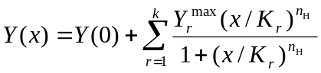
where x is usually the concentration of some ligand. The K values are not in general real equilibrium constants, and should usually be denoted EC50, rather than K. This increases with x from the baseline value Y(0) at zero concentration, to a total amplitude of Y(0) + ΣY^{max} (usually Y(0) will be fixed to 0, but it can be estimated if necessary). There is also an option to fit a decreasing Hill/Langmuir curve which falls from Y(∞) + ΣY^{max} at zero concentration to a baseline value of Y(∞) at high concentration. Commonly Y(∞) will be fixed at 0, but in some cases it should be estimated as a free parameter.

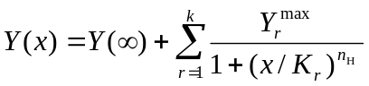

In the program the parameters appear as Y(0) or Y(inf), and Ymax1, Ymax2, K1, K2, nH1, nH2 etc (for the first and 2nd components in each curve).
If several sets are being fitted simultaneously (fit mode = 3) you are asked whether you want to estimate all the parameters, or to have some in common for all sets.
(a) a common Y_{max} value for all sets, but separate K values for each set
(b) a common K value for all sets, but separate Y_{max} values for each set
(c) as (b) but fitting to the log(y) values, as described next. This is available only if there is one component (m = 1) only is fitted and the baseline value is zero.
(d) When two components are fitted to each curve (m = 2), another option appears, to fit the EC50s (K values) and maxima separately to each curve, but to have the fraction of the total amplitude that is accounted for by the first component as a common parameter between all curves, i.e. p = Ymax1/(Ymax1 + Ymax2)is treated as a parameter that is common to all curves.

The log(y) fit for Hill equations.
It is often the case that smaller values of y have smaller standard deviations. If there are not good estimates of the standard deviations then this sort of weighting may be achieved by using weighting option 4 (see above) to give a constant coefficient of variation to each y value. This may, for example be done with option (b) above (common K value for all sets, but separate Y_{max} values). However, a similar effect can be obtained by doing the fit with log(Y_{ij}) values (equally weighted, implying constant coefficient of variation in Y_{ij} themselves). If each curve has only one component then, although the response is non-linearly related to K and n_{H} (requiring an iterative procedure), log(Y_{ij}) is linearly related to log(Y_{j}^{max}). This means that only K and n_{H} need to be estimated iteratively (by Simplex), and, at each stage the k values of Y_{j}^{max} (one for each set) can be calculated explicitly from the current values of K and n_{H}. Writing down the least squares equations shows that they can be found from

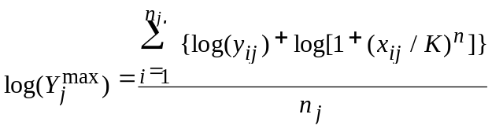

where y_{ij} is the observed response for ith concentration in the jth set. This is a rather nice mixed linear/non linear procedure. It is very fast, but for any normal number of data points this does not matter any more, now that computers are so fast.

Equation (4): Langmuir hyperbola(s)+ straight line
This is a sum of Langmuir components + a linear component, slope*x. This is actually a sub-option of eq.2, with the addition of one value of the parameter slope for each set fitted. It was designed for fitting results of binding experiments in which ‘non-specific’ binding is fitted as a linear component (as In Paton & Rang, 1966).

Equation (5): Hill equation(s) + straight line
Same as (4), but Hill rather than Langmuir equations.

Equation (6): Power function

It is not uncommon to determine only the lower end of the dose-response curves, when doing a Schild analysis. Without maxima, it is not possible to fit Hill equations etc to the curves, but we often find that the low-concentration limit of the Hill equation is quite adequate. This is a power function (y = ax^{n}), which corresponds to a straight line in log-log coordinates.
There are all sorts of ways in which this could be parametrised, but the one used in CVFIT is
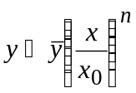.
The two free parameters are n and x₀, the latter being the value of x when y = , and is the mean of all your y values, which is a constant determined by your data. It is not essential to include the scaling constant ; the reason for formulating it in this way is to make it easier to provide initial guesses for the value of x₀, which is needed for fitting (though the current version of CVFIT does the guesses for you so you will only have to provide them manually if the automatically generated guess is bad). Since is roughly at the midpoint of your data, it is easy to eyeball the corresponding value of x. The value used for appears along with the fitted parameters, and, on the print out, the result is also expressed in its logarithmic form
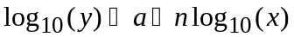,
where
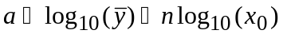 ,
and n is the slope of the log-log plot.

Equation (7): Equilibrium binding inhibition curves (Langmuir)
This is designed for experiments in which equilibrium binding of a labelled ligand (y) is plotted against inhibitor concentration (x). A single decreasing Langmuir curve is fitted, but instead of fitting the IC50 (as eq.2 would do) would, the fitted parameter is K_{B}, the equilibrium constant for binding of the antagonist. The equation for this sort of experiment is that for competitive inhibition, viz.
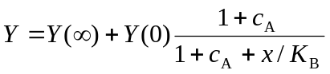,
where c_{A} is the normalised concentration of the labelled ligand (its concentration divided by its equilibrium constant). Values for c_{A} are given as the set variable when data are entered. The asymptote, at high inhibitor concentration, Y(∞), may be fixed at zero if appropriate. By fitting the correct equation we obtain errors for K_{B} directly, and we avoid the so-called Cheng-Prusoff correction (which is, of course, only a correction for having fitted the wrong equation).

Equation (8): Exponential binding onset curves
Designed to fit exponential onset of binding.
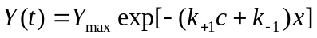,
where x is time, and the ligand concentration for each data set, c is specified as the ste variable when data are entered. The association rate constant, k₊₁, and the dissociation rate constant, k₋₁, are denoted ak1 and ak2 in the program. There are two options –the zero-time value, Y_{max}, may be common to all data sets, or estimated separately for each set.

Equation (9): General exponential and geometric curves

The exponential option fits a general sum of n exponential terms, with amplitude a_{i} and time constant τ_{i} for the ith component, thus

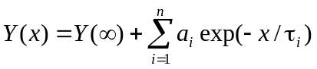,
where x is usually time, and the parameters Y(∞), a_{i} and τ_{I} are denoted in the program as Y(inf), amp1, amp2 etc, and tau1, tau2 etc.
The geometric option fits a sum of n geometrically-decaying time constants, in which the place of the time constant is taken by the ‘mean’ for each component μ_{I}’ The equation is
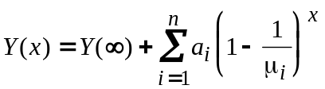,
where μ_{i} is referred to in the program as ‘tau1’, ‘tau2’ etc.

Equations for equilibrium P_{open} curves
To be completed

