Family Fortunes: A Quantitative Analysis of the Early Iron Age Cemeteries at Knossos, Crete

Dominic Pollard, Institute of Archaeology, University College London

[dominic.pollard.16@ucl.ac.uk](mailto:dominic.pollard.16@ucl.ac.uk)

14 May, 2019

Three principal interests converge in this paper: reorienting the focus of Early Iron Age Cretan archaeology; the application of computational, and quantitative methods to supplement traditional modes of inference; and open-access data and reproducible research. The Early Iron Age cemeteries of Knossos, Crete, represent the richest source of archaeological material at the site for the whole period between the end of the Bronze Age and the emergence of the Archaic *polis*. However, despite well-published excavation reports on the two largest burial grounds, the Fortetsa and Knossos North cemeteries, and a number of studies dealing with various artefact classes and individual tombs therein, no substantial comparative, quantitative analysis of these two cemeteries has yet been undertaken. This paper provides such an analysis, examining both the synchronic and diachronic variation among the tombs in these two cemeteries. Through the application of a range of quantitative techniques, this study isolates a pattern of increased rates of burial among a few select tombs, and further considers their characteristics. This paper demonstrates the potential for quantitative analyses to contribute to nuanced, context-specific theories of social practice, and advocates their wider application to the archaeological record of the Cretan Early Iron Age. It also serves as a demonstration of maximal research reproducibility, with the full datasets and code underpinning the analysis made freely available to download and use.

# Introduction

It may be felt that, of all ancient sites on Crete, Knossos is the last in need of further archaeological attention. The city and ‘palace’ of Knossos, first excavated well over a century ago (Evans 1921; 1928; 1930), retain a pre-eminent position in popular and academic accounts the island’s Bronze Age, and few, if any, other Cretan sites have been so thoroughly dug, reconstructed, and contested. However, there are reasons why the present study – a quantitative comparison of the two largest Early Iron Age cemeteries at Knossos – is not only justified, but also timely.

For one, this is not the Knossos of that illustrous, palatial period, but rather the town as it persisted and evolved during the subsequent Early Iron Age (EIA), about which much less is known. Research into this once maligned period has grown apace in the last few decades. What began as a reframing of the the twelth-seventh centuries as the gestational period of the later classical Greek world (first seen in the works of Coldstream 1977; Desborough 1972; Snodgrass 1971) has culimated in the complete rejection by many scholars of the image of a society bereft of its former palatial glory. Certainly, few would any longer defend the appelation or interpretive bagguage of the ‘Dark Ages’ (on the origins of which, see Kotsonas 2016; Morris 1997).Nonetheless, our knowledge of many EIA settlements (both new foundations, and those with BA ancestry like Knossos) remains often underdeveloped in comparison with those of the second millennium BC.

Secondly, and welcome though they are, a number of recent publications on the socio-economic (Wallace 2010) and settlement (Nowicki 2000) changes which accompanied the BA-EIA transition have directed scholarly attention toward a number of elevated, defensible settlements supposedly founded in response to the turbulent contemporary political climate. This research agenda is likewise reflected in survey work, which has focussed extensively around the Bay of Mirabello, and the Isthmus of Ierapetra. This has, unfortunately, engendered a certain disregard for continuing occupation at several lowland centres in the central region of the island, including Knossos and Phaistos. There remains, therefore, a need for studies addressing the social dynamics at these sites, with a long-term view to comparative appraisal of the divergent trajectories of communities across the island in the EIA (Whitley 2011, 667–668).

Finally, a number of authors, drawing on datasets from Crete and the wider Aegean, have in recent years demonstrated the great potential of quantitative, statistical, spatial, and network analyses to elucidate social dynamics, settlement patterning, and systems of inter-regional communication and exchange. Such work encourages the use of large (and often pre-existing) datasets, and the sharing of both data and methods to facilitate reproducible, collaborative, and innovative research. The cemeteries of Knossos offer an opportunity to introduce such approaches into EIA research, where they have yet to make much of an impact (see Kotsonas 2011). The Fortesta and North Cemetery complexes are both well-published (Brock 1957; Coldstream and Catling 1996) and have been considered variously in relation to their “oriental”" imports (Antoniadis 2012), antiques (Crowe 2016), and religious context (J. Coldstream 1984a). But a lack of quantitative analyses, or systematic comparisons between different cemeteries, has left us with many intuited trends, some clearly exceptional tombs, but a general impression of un-patterned multiplicity.

I suggest that the application of a range of quantitative and statistical methods may provide new insight into the social behaviours underlying the mortuary assemblages. With a dataset including information on every find and tomb recorded in the Fortetsa and Knossos North Cemetery publications (Brock 1957; Coldstream and Catling 1996), the following analysis examines both the synchronic and diachronic variation among the tombs of both cemeteries. In doing so, I aim to demonstrate the potential for quantitative methods, firstly, to permit more reliable identification, and more nuanced characterisation, of significant patterning in the archaeological material; secondly, to facilitate a more systematic appraisal of the cemeteries’ largest tombs, and set their development in a richer socio-economic context; and, finally, to offer not just generalities, but evidence by which to consider, in tangible and context-specific ways, the motivations and identities of the burial groups themselves.

# Early Iron Age Knossos

## Settlement Evidence: ‘A meagre filling in a very thick sandwich’

Settlement evidence at EIA Knossos is, in a word, insubstantial. Speaking of the town’s stratigraphic sequence, Coldstream lamented that “the remains of [this] period are like a meagre filling in a very thick sandwich” between Bronze Age and later Greek and Roman levels (Coldstream 1991, 287). Most individual finds of Protogeometric or Geometric date take the form of flimsy foundations, patches of earth floor, wells or simple scatters of pottery, and for a long time it was believed the town contracted, moved, or even dissolved following the collapse of the palace. Indeed, Alexiou (Αίο 1950) thought it likely that the area comprised several dispersed villages, which later coalesced into a single city, as per Aristotle’s model of synoecism.

However, by the time of Hood and Smyth’s (1981) survey-cum-synthesis of prior excavations, a concentration of activity slightly to the west of the old palace presented a good case for continuing, nucleated settlement, something strongly advocated by Coldstream (1984b; 2000). More recently, the findings of the Knossos Urban Landscape Project suggest a PG settlement of up to 40ha, extending from the Kairatos River to the western slope of the Acropolis, and from the northern slope of Gypsades to between the Minoan palace and the Kephala hill (Kotsonas et al. 2011, 5–8). This estimate remains our best guess in the absence of substantial excavatied deposits but, if it is accurate, then EIA Knossos was one of the largest sites of the contemporary Aegean, and we should expect the existence of relatively complex forms of social interaction and organisation within this exceptional community.

## The Early Iron Age Cemeteries

Survey aside, our most abundant evidence for EIA Knossos comes from the mortuary record. The transitional period between the LBA and EIA, admittedly, yields few if any securely datable burials. In the EIA proper, however, the evidence becomes more plentiful, with multiple burials known from the Kephala ridge (Coldstream 1963, 38; Hogarth 1899, 82–85), the modern suburbs of Ayios Ioannis and Atsalenio (Boardman 1960; Davaras 1968, 133–146), the cave of Mavro Spelio (Antoniadis 2012, 58–59), and the Khaniale Teke site with its well-known tholos, mooted as evidence for the presence immigrant craftsmen from the Near East (Boardman 1967; Hutchinson and Boardman 1954; cf. Hoffman 1997 Kotsonas (2006)). Taken together, these scattered tombs point to a variegated set of funerary practices, all within about 30 minutes’ walk of each other, each serving some sub-section of the Knossian population. But despite their reasonable number when considered collectively, these tombs, so dispersed and often solitary, provide little scope for systematic quantitative analysis.

Fortunately, far larger burial accumulations are to be found in the Fortetsa and the Knossos North cemeteries, which together comprise some 134 tombs, ranging in date from the Subminoan to Late Orienatalising periods – a span of around 400 years. Though many were robbed in antiquity, and others destroyed by the digging of later burials, building work, or just the ravages of time, they still represent the most comprehensive and abundant source of evidence for not just mortuary practices, but for social life of any kind at EIA Knossos. They are thus the ideal candidates for a quantitative analysis of the kind advanced here.

## The Fortetsa and the Knossos North Cemeteries

The cemetery on the slope facing the eponymous village of Fortetsa is composed of twelve tombs excavated in 1933, and another eight uncovered in 1935 (Brock 1957, xi). These tombs cluster in three main groups. The largest of these, including tombs IX, VIII, VII, V, II, III, IV, V and P, is arranged on a north-south axis, with the *dromos* of each tomb extending downslope to the west (Tomb P is set on a slightly different orientation, though, as we shall see, this tomb is particularly exceptional). Further north lies the cluster of tombs OD, X, XI, LST and BLT. The third group lies south of the first, and comprises tombs Θ, Ϙ and F. Finally, three tombs excavated in 1933 – L, TFT and Π – which lie close to the main road north of the Acropolis hill (Brock 1957, 1–2) are now considered to belong the Knossos North Cemetery.

To the northeast of the Fortetsa cemetery, a collection of ten badly damaged tombs known, after the year of their excavation, as the Fortetsa 1967 tombs, were probably the southernmost burials of the North Cemetery. Unfortunately, all had been looted at the time of excavation, and no in situ deposit was found in any tomb. For this reason, unfortunately, they feature little in the present analysis. Northwest of these tombs, and just south of the Teke Tholos, the Teke tombs represent the northern reaches of the KNC. The Teke tholos itself, and the tombs around it, were almost certainly part of the same complex, with six unpublished tombs excavated by the Archaeological Service during the construction of intervening buildings in the 1980s. The central section of the KNC comprises the ‘Medical Faculty’ site, so named because it was the construction of an extension for the university of Crete that prompted major rescue excavations here in 1978. Some 89 tombs of Subminoan to Late Orientalising date were found, by far the largest single concentration of EIA tombs in the whole Knossos area (Coldstream and Catling 1996, 53–55).

The 134 tombs that make up these two cemeteries, some of which were in use for several centuries, suggest an established, relatively stable community for whom tradition formed an important foundation in mortuary beliefs and behaviours (Coldstream 1994, 106–108). The tombs fall into three main types, the chamber tomb, shaft grave, and pit cave or tomb; the latter two are largely Subminoam phenomena, with the former by far the most abundant. The chamber tomb comprises a descending ramp or passage, the *dromos*, leading to the chamber itself, cut into the bedrock. The *dromos* and chamber are separated by the *stomion*, an opening often set a step or two lower than the *dromos*, which is covered by a large stone slab, smaller stacked stones, or a combination of both (Antoniadis 2012, 47–48). It is not uncommon for dromoi to have niches cut into them, to house later burials that could not fit in the chamber (e.g. T. II), or even, in some cases, cinerary urns removed from the chamber so that new interments could be fitted in (e.g. T. TFT; Brock (1957), 3-4).

The majority of burials in these two cemeteries are cremations, a rite that appears at Knossos in the Subminoan period, in the Tomb 200+ complex (Ts. 200, 201 and 202 are three chambers of a single pit tomb) in the KNC (Coldstream 1994, 109). Inhumation does not completely disappear in the EIA, but by the Orientalising period it appears restricted to child burials, and in those instances where it is attested (Ts. L, 45, 98, 112 and F67:5), these burials appear to be among the very earliest in each tomb (Antoniadis 2012, 69). This degree of coexistence suggests that the shift between the two rites need not have marked a major ideological break; the preference for communal chamber tombs, for instance, something practiced since the Middle Minoan period at Knossos, remained constant. Whether this is linked to a strong sense of historical continuity or tradition, close kinship ties, or simply the need to bury large numbers of people in a small geographical area, we cannot be sure.

## Chronological developments in the cemeteries

The chronological sequence of the cemeteries has received much attention. It has been claimed that no tomb crosses the LM IIIC-SM divide [Coldstream (1998), 58; Coldstream (2006), 582), but there is a strong possibility that this is a classificatory artefact (Hallager 2010). The earliest tomb appears to be the T. 200+ complex, with its precocious cremations and imported artefacts. There remain ongoing debates about whether the KNC represents a foundation on virgin soil, as instances of BA tombs reused the EIA are known (e.g. the Khaniale Teke tholos). Cavanagh (1996), for one, could not rule out the possibility of some KNC tombs being of BA date based on his cluster analysis, but other evidence would suggest this is unlikely.

During the use of the cemeteries, correspondences have been highlighted between changing pottery styles, and patterns of tomb construction and abandonment. In the Protogeometric period, some 22 tombs then in use in the KNC, and nine at Fortetsa, ceased to receive interments, followed in the succeeding Protogeometric B period by the founding of 22 new tombs (16 and six respectively). The PGB was defined by Brock (1957), 143], who hailed it as “the most remarkable phase in Cretan vase-painting”. Apparently a Cretan anomaly, this phase sees Attic geometric motifs mixed with experimental patterns possibly deriving from Near Eastern metalwork, as well as iconography drawn seemingly from the Minoan repertoire (Coldstream 1984, 93–4). Coldstream has argued that the concurrence of this style and a rash of newly founded tombs points to a reformulation of elite mortuary display, noting how, in this period also, redeposited Minoan larnakes began appearing in and around some tombs, in one case even inspiring the decoration of a PGB vessel (in T. 107; see J. Coldstream (1984a); Coldstream (1994), 112–3). Whether simply nostalgia (Coldstream 1998, 60), or a more tactical strategy by newly emerging elite groups (Coldstream 1994, 114–115), it seems that the Bronze Age past possessed a significant cultural cachet mobilised by various actors over the lives of these cemeteries.

The final mystery of the chronological sequence at the KNC and Fortetsa is the quite abrupt cessation of new burials around 630 BCE. There had been changes in tomb use in both cemeteries in the preceding century, with no new tombs built in Fortetsa, and few in the KNC, though interments in old tombs continued [Brock (1957), 4; Cavanagh (1996); 651-3]. This curiosity has, along with the equally scanty evidence for the period in the wider settlement, become known as the ‘Archaic Gap’. The causes of this lacuna, which persists until the recrudescence of archaeological evidence in the Late Archaic period, remain unknown. Although various explanations have been forwarded, (Coldstream, Huxley, and Webb 1999, 301–302; Huxley 1994, 126; Kotsonas 2002, 41–44), it seems there are now strong reasons to doubt the settlement was truly abandoned (Whitelaw, pers comm.).

## Heroes and Heirlooms: Object Biographies and Exceptional Burials

A popular approach to the study of Knossos’ EIA tombs has been the investigation of ‘object biography’, a term derived from Appadurai (1986) and Kopytoff (1986). Influenced by Mauss’ (1954) formulation of ‘the gift’, these authors stressed the mutuable nature of an object’s social meanings, and its capacity for acquiring a ‘biography’, through the transformations of its social existence. In Aegean archaeology, these ideas proved attractive because of their resonance with the Homeric motif of gift-giving accompanied by accounts of an object’s illustrious heritage (Whitley 2002, 220–221). It is hardly suprising that, when direct parallels for such objects have appeared archaeologically – such as the boar’s tusk helmet from Tomb 200+ and that given to Odysseus by Meriones (*Iliad* 10.260-271) – a particular interpretive lens, melding Homeric and anthropological ideas, has been applied to certain elaborate burials.

Catling’s discussion of the T. 200+ complex is a notable example. Tomb 201 contained the remains of at least two adults, and possibly a child. The burial objects included a bronze sword, spearhead, and arrowhead, an iron dirk or knife, fragments of an antique bronze stand, probably of Cypriot origin, and pieces of the aforementioned BA-style boar’s tusk helmet (Catling 1995, 123). Catling identifies similarities between this tomb and burials at Tiryns, Kaloriziki, and the famous *hērōön* of Lefkandi. All contained imported items at an early date, were of ‘warrior grave’ type, and formed loci for later burials. Catling argues that those individuals who dared to travel abroad in this time of more limited seafaring, accruing with precious artefacts and stories of distant lands – ‘heroes returned’ in Catling’s phrase – would have been accorded exceptional treatment in death (Catling 1995), 127–8].

Complementing the theme of heroes abroad has been a similar degree of interest in foreigners at home. Two caches of gold jewellery, found in pits flanking the entrance to the Teke Tholos, were argued by Boardman (1967) to be foundation deposits – a known Near Eastern custom – for the burial place of an immigrant craftsman, probably Phoenician, practising his trade at Knossos. Kotsonas has revisited this attribution, suggesting that the tholos is more likely the resting place of an elite individual or family with a monopoly over a metal workshop’s output (2006, 155–159). While certainty in such individual cases may be moot, it seems unlikely that traders or craftsmen of non-Cretan heritage never visited or resided at Knossos during the EIA (Hoffman 1997, 176–185; Schreiber 2003, 293–306).

Finally, a recurrent interest has been in the ‘presence of the past’ in these tombs. The practice of hero or ancestor cult, much discussed on the mainland (see Antonaccio (1994); Coldstream (1976)), is not common here. Instead, we see several Late Minoan larnakes (and a few other vessels) redeposited in tombs and pits in the KNC and Fortetsa from the PGB period onward. A thorough analysis of these artefacts has been provided by Crowe (2016), who argues that the larnakes were robbed from tombs in the Knossos area, perhaps with a particular preference for painted specimens where available. A particularly evocative case comres from tomb 107, where parts of an elaborate figured LM larnax have been found along with a PGB vessel by the so-called Tree Painter. Both feature women in the company of birds and spiralling trees, and it seems certain that the former inspired the design of the latter. The PGB vessel also seems to draw on Oriental motifs, with the polos crown worn by the goddess having Near Eastern origins (J. Coldstream 1984a, 94–101). The magpie-like amalgamation of these styles and motifs seem to exemplify the particular cultural openness, fluidity and competition suggested to characterise the PGB period. Artefacts such as this hint towards an intimate discourse of (re)discovery; a painter, struck by the strangeness, or perhaps the uncanny familiarity, of centuries-old images, incorporated them into his own work.

## Number Crunching: Quantitative Analyses of the Cemeteries

Generally speaking, the above analyses have tended to rely more on particular finds, single tombs, or observable, but limited, patterns in the data to form their conclusions. A few authors have applied more quantative approaches, and these point toward their potential utility. Antoniadis (2012, 172–176), in his study of Oriental imports, divided the EIA tombs of Knossos into three groups, those with fewer than 10 pots, fewer than 50 pots, and more than 50 pots, and found that, in each successive case, the proportions of tombs containing imports and imitations increased. The implication is that a hierarchy existed, with differing degrees of control over the accumulation of prestigious goods. That said, the relationship between such items and tomb ‘wealth’ is examined critically in the present work, and may prove more complex than Antoniadis implies.

Cluster analyses have been employed by both Cavanagh (1996, 653–657) and Antoniadis (2012, 193–197), the most sophisticated statistical techniques so far applied to the present material. Cavanagh’s analysis of tomb architecture has been mentioned, while Antoniadis’ more holistic approach corroborates quantitatively some of the intuitive correspondences noted between specific tombs in previous studies. Antoniadis does not interrogate his findings as much as he might have, but his highlighting of the relationship between tomb foundation dates, associated finds, and geographical location points towards social processes of self-definition and exclusion among the burial groups that would reward further investigation, something offered by the present study.

# Methods

## Databases

The cornerstone of the present study is a database (or, rather, three linked databases) based on the excavation reports for the Fortetsa and Knossos North cemeteries (Brock 1957; Coldstream and Catling 1996). The first database includes an entry for each individual ceramic vessel, by far the largest portion of all known finds. Each entry includes: the tomb from which the vessel came; the vessel shape; whether it was an open or closed vessel; its main dimensions; its ceramic period and corresponding absolute dating measures (see below). In addition, all imports, Oriental imitations, and antique (that is, Bronze Age) artefacts were accordingly categorised, using the studies of Antoniadis (2012), Jones (2000), and Crowe (2016) to supplement omissions in the original excavation reports. In total, this database comprised just over 4540 individual artefacts.

The second database is similar, but with each entry corresponding to a find other than a ceramic vessel. The categories remained the same as in the pottery database, but with the addition of a ‘material’ variable, as of course these finds were not all made of the same substance. This database included some 1620 individual artefacts. The final database concerns the tombs themselves. Each of the 134 tombs was accorded its own entry, with variables including dating (both in relative and absolute terms), surviving dimensions, and the known and estimated number of interments. Each entry also included a tally of the objects recorded in the other two databases. These tallies were arranged by shape for the pottery, and by material and category (e.g. weapon, adornment, seal, funerary paraphernalia) for the other objects. Finally, the total number of imports, imitations and antiques in each tomb was calculated.

Taken together, these databases constitute a detailed record of all the finds from the Fortetsa and KNC excavations, and offer the opportunity for carrying out a range of robust quantitative analyses. It must be conceded that, with many of the tombs evidently looted, dug into or destroyed over the centuries, this cannot be a complete picture of the tombs’ original contents. If we assume, though, that natural or accidental destruction was relatively indiscriminate, and that, even in cases of looting, certain object classes (particularly cinerary urns) were seldom robbed, then the data are by no means rendered useless. As Snodgrass (1996) notes, the situation means we should be extremely cautious about making negative arguments – that is, conclusions drawn about the lack of features in certain tombs – but may be somewhat more hopeful in the forming of positive ones.

## Reproducibility and data-sharing

An ever-growing number of archaeologists have begun to advocate the utility, indeed the necessity, of making available not just the data underpinning their professional output, but the full methodologies by which their analyses were conducted, and in formats which facilitate reproducibilty and further investigation. It is felt that, with the opportunities afforded by current technologies (digital databases, statistical software packages, online repositories etc.), there remain ever fewer obstacles - and excuses - preventing the full and free sharing of both data and workflows. In Marwick’s words (2017, 445), “[t]he technical problems are largely solved; the challenge now is to change the norms of the discipline to make high reproducibility a canonical attribute of high-quality scholarly work”.

This is not the place for a detailed investigation into the lack of reproducible research in archaeology (for this, see …). Suffice it to say the problem exists, though, granted, gradual progress is being spearheaded by some. This article is, among other things, an attempt to bring these principles of maximal reproducibility to the archaeology of Early Iron Age Crete. Within this field, catalogues and excavation reports abound and, though many of these may be forgiven based on their dates of publication, the lack of readily utilisable digital data from a number of recent articles and monographs, indeed, the failure to even present the data such that they could be manually digitsed, is less pardonable. Preparation of databases such as those of the present study can (and did) involve prolongued trawling of printed tables (often without consistent formatting, coding or presentation which would enable easy digitisation), cross-referencing artefacts listed inconsistently in different contexts, or else grappling with catalogues which, through their unexplained lack of certain critical information (e.g. coordinates in site catalogues), offer little research potential beyond their descriptive face-value.

There are, of course, complications to the sharing of data and methods. There are real and valid reservations around issues of copyright, the protection of sites from looting, the possibility of being scooped with one’s own data, or simply the significant investment of time demanded by the preparation of open-access research. But I would argue that the potential gains outweigh these concerns, and that research on the EIA would benefit greatly from the greater accessability of datasets and workflows.

In this vein, the present article has been composed making use of Ben Marwick’s “rrtools”, an open-source package for the statistical software R Studio, which provides the author with the tools to create a self-contained “compendium”, which can be freely downloaded, and from which anyone can accurately reproduce the entire workflow of the present analysis. This analysis was conducted in R, and the full code, as well as the raw and derived datasets, complete bibliography (in BibTex format, for export to any major reference manager), figures, and article as originally submitted to this journal are included in the package. It can be downloaded as a repository from GitHub, at the following address: <https://github.com/DCPollard94/knossoscemeteries>, and the raw datasets have been stored with the online repository Figshare, here:

Though not visible in the present paper, every figure and table herein was produced directly, through written code, from the raw data using R. The full code can be viewed and followed by downloading the repository from GitHub, and all the data are made available through an MIT license, which permits unlimited use, ammendation, and dissemination thereof, yet frees the present author from any responsibilty for that use, or for any perceived errors or inaccuracies in the data. It is sincerely hoped that others may find interest in, and themselves further explore and expand upon the research presented here, by downloading this compedium.

## Estimating interments

A first important step in preparing the data for analysis was the estimation of the number of individuals buried in each tomb. The method chosen for this estimation broadly follows that of Cavanagh (1996, 659–660), who took the number of pithoi (the most common urn type) and the number of pithoi, amphorae and kraters (which were in some cases used as urns) as middle and upper estimates of the number of interments, with all securely identified interments (in the form of ashes or osteological material) being the lower limit (Figure 1). In the present study, the mean of these three estimates was taken, to provide a single aggregate measure for the purposes of analysis (where no interments were known, this variable was still assigned a value of “1”, for all tombs must have contained at least one burial).

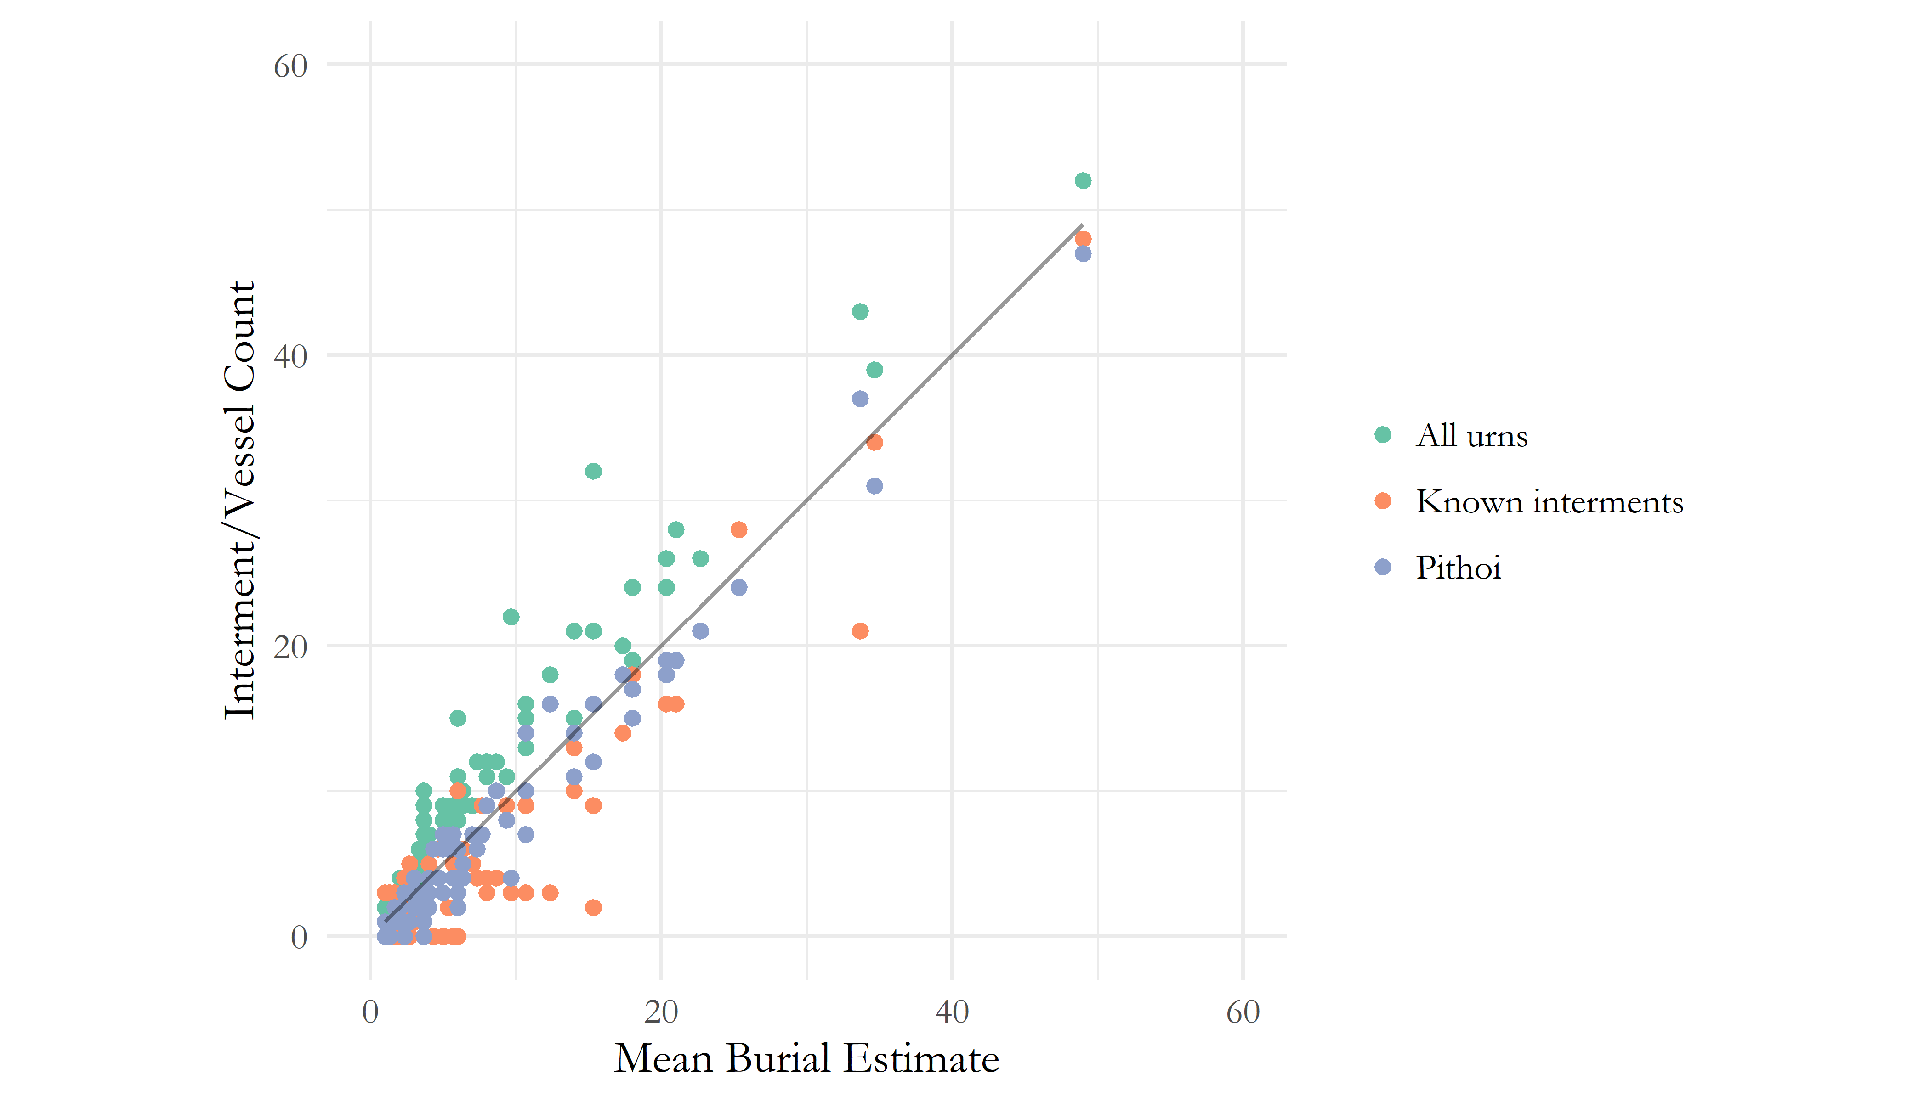

Figure 1 Relationship between known interments, counts of pithoi, and counts of pithoi, amphorae and kraters. The straight line represents the mean estimate based on these three values.

For most diachronic analyses, however, pithoi alone were taken as the best proxy for burial numbers. In most cases, and often simply by virtue of the methods employed, any tombs lacking identified remains or a single vessel suitable for use as an urn were not considered, thus excluding what are presumably among the most heavily damaged and looted tombs.

## Aoristic approaches to dating

A central concern of the present study was how to deal with the temporal uncertainty implicit within the assigning of individual vessels to stylistically-defined periods. A vessel dated to the Protogeometric B period could, on our best estimates of absolute chronology, date to any point between 840 and 810 BC. This situation results in major challenges to the visualisation and analysis of such data through mean which normally rely on event- and not range-based data inputs. A simple, if unsatisfying, solution is to use the midpoint of the range assigned to each vessel (i.e. 825 for our PGB example). This method is used in a couple of instances in the present paper when the course-grained sorting of the data (into 50 year periods) renders the inaccuracies of such a method less significant.

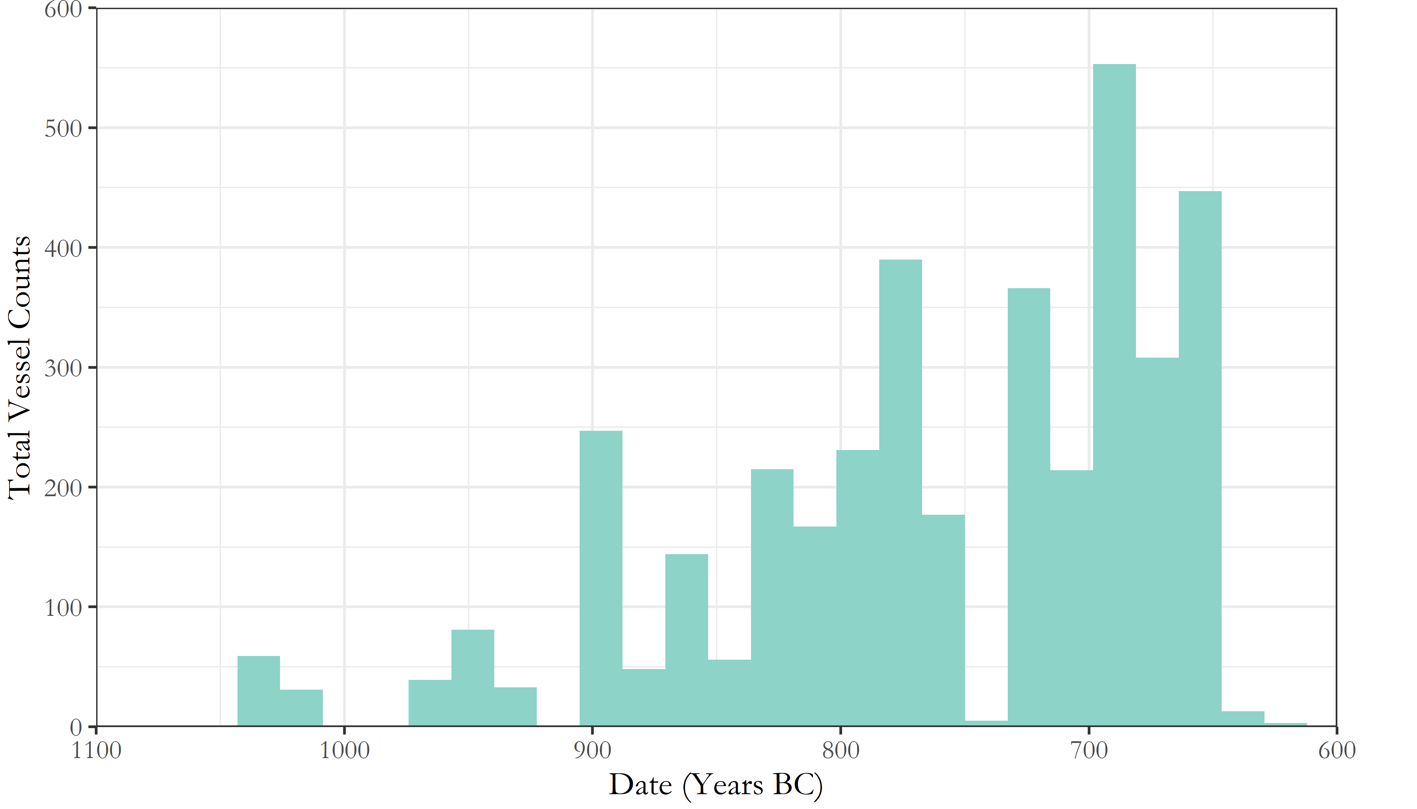

Figure 2 Counts of pithoi across both cemeteries through time. Vessel dates have here been based on the midpoint of the absolute date range accompanying their respective ceramic periods.

But the artificial clustering this technique engenders around select absolute dates proves misleading when, for instance, the total number of pithoi deposited by date are plotted via a histogram (Figure 2); the apparent cessation of burial activity for 30 years in the 8th century, followed by the most intense episode of deposition yet seen, is simply a fiction generated by the processing of the data.

A alternative way of dealing with temporal uncertainty, and the method employed extensively in this paper, is the use of so-called “aoristic analysis” (for original use in criminology, see Ratcliffe 2000; for archaeological applications, see Crema, Bevan, and Lake 2010; Crema 2012; Johnson 2004). Here, rather than assign a pot a single date, the entire time span under investigation is divided into equal chunks (in this case, decades), and probability values summing to 1 are then assigned for each vessel, per chunk of time, based on its accordant date range. So, our PGB vessel, datable between 840 and 810 BC would register a value of 0.33 for each of the three decades within which we it could theoretically have been produced. These values for individual vessels can can then simply be summed to produce tomb- or cemetery-level signatures. The major contribution of this method (though it too creates problems; see Crema, Bevan, and Lake (2010), 1123-1124) is that it incorporates temporal uncertainty into the size of the resulting values, that is, “events with tight temporal definition contribute more to the total probability over their range than do loosely defined events” (Johnson 2004, 450).

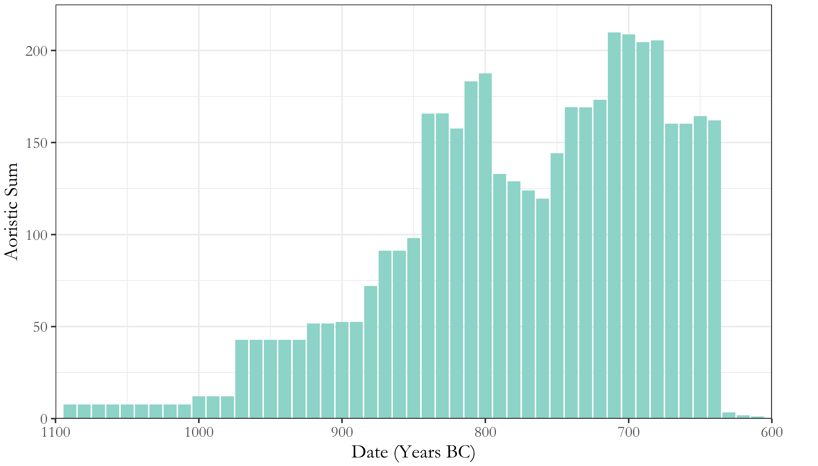

Figure 3 Aoristic sums of all vessels across both cemeteries. This represents a probabilistically weighted visualisation of depositional activity through time.

As seen in Figure 3, the artificial peaks and troughs of the simple averaging method are avoided, and different patterns become visible. Though these methods present their own limitations, which will be explored in the following sections, they are considered a more robust and productive approach to the temporal uncertainty of ceramic dating and, as such, are used for much of the present analysis.

## Theory and method

Before proceeding to the main discussion, it should be stressed that, though I hope to demonstrate the power of quantitative and statistical approaches to the mortuary record, data-points cannot replace description, and theory must not be absent in the use of such methods. Quantifications and statistical analyses should, ideally, be employed as tools for the development and exploration of theoretically-informed models of social practice. Throughout the following analysis, I aim to link the observed patterning in the material back to possible forms of human behaviour, which in turn guides the focus of subsequent analyses, and so on. It is hoped that the value of such an approach will become clear.

# Analysis

## Introduction

The great advantage of the large, quantitative data set compiled for the present analysis is that it permits investigation of several nested levels of potentially significant patterning in the material. From individual burials, to collective tombs, to the cemeteries as a whole, and between cemeteries in the landscape, we have the opportunity to study and compare both the synchronic and diachronic variation across these various levels. The following analysis is divided broadly into these two distinct, though complementary, perspectives. I consider, firstly, how temporal variations in the material may relate to broader social dynamics and, secondly, how the form and content of the tombs and their assemblages can enrich the schematic picture derived from the chronological patterns. Taken together, these two approaches enable us to develop a nuanced account of the changing social landscape of EIA Knossos, drawing together issues of group identity, external relations, and the communication of wealth and status through funerary practice.

## Temporal variation in the Knossian Cemeteries

An obvious place to begin is with the chronology of the burials themselves. The rate and number of burials being made through time provides the background against which to consider all other developments.

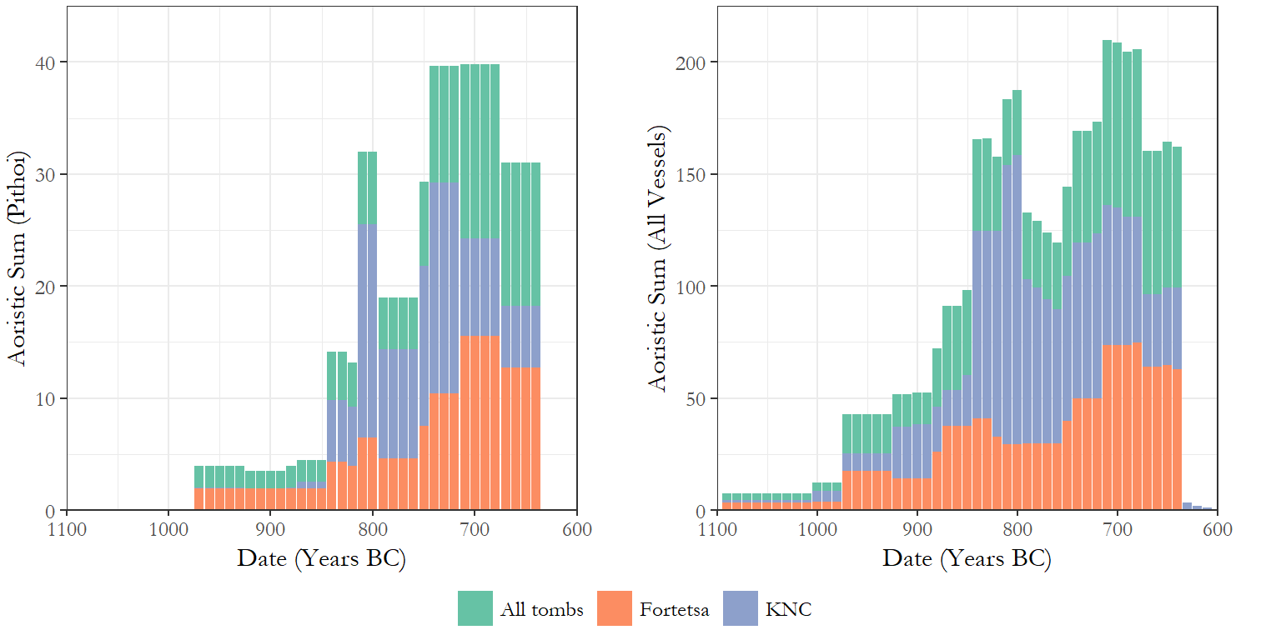

Figure 4 Aorist sums of pithoi (left) as a proxy for cremation burials, and all vessels (right). The sums are colour coded to show the values of the two cemeteries, and the total values.

Figure 4 presents the aoristic sums of pithoi (as a proxy for burials) and of all vessels, respectively. Immediately apparent are the broad correspondences between both cemeteries. Despite differences in scale and timing, we can see the Fortetsa and Knossos North Cemeteries experieced similar chronological developments in the volume of burials and, to a slightly lesser degree, grave goods. In both cemeteries, the rate of cremation burial began rising around the end of the 9th century, plateaued slightly in the early 8th, and then rose again to a peak in the late 8th and early 7th centuries. Across all vessels, the developments are more volatile, but again there was growth beginning in the later 10th century - reaching an especially marked peak in the KNC by the end of the 9th - then a slight decline and levelling into the 8th century, before a final early 7th century flourit of depositional activity.

The near total absence of pithoi from the 11th and early 10th centuries reflects the delayed onset of cremation burial, with inhumations representing a significant proportion of earlier interments. Nonetheless, the clear inference would appear to be that, at both cemeteries, the late 8th and early 7th centuries witnessed an unprecedented level of burial activity, something which makes the sudden and total decline of chamber-tomb burials around 630 BC even more notable. We might assume that these developments would be mirrored in the construction of new tombs, but this proves not to be the case.

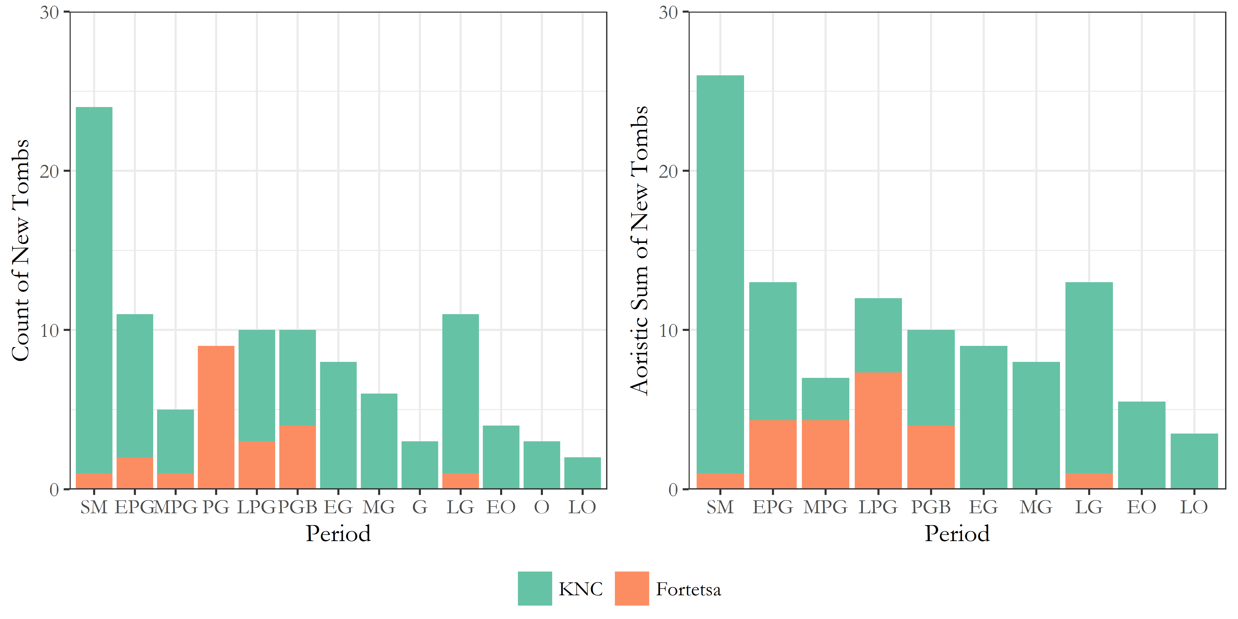

Figure 5 Visulations of tomb construction through time at both cemeteries. On the left are counts based on the earliest dated pottery in each tomb, while on the left are aoristic sums likewise based on the earliest ceramic-based assignations. In both cases, tombs lacking any securely dateable pottery (i.e. N/As) are excluded.

Figure 5 presents two ways of dating the construction of the tombs. On the left, counts are presented, based on the ceramic phase considered most likely to correspond to the tomb’s first use, including the broad labels “PG”, “G” and “O” where no greater specificity is possible. On the right, aoristic sums are presented, and essentially represent the spreading of the uncertainty associated with those general assignations across the sub-periods they encompass. In both cases, the trend appears clear. The North Cemetery began with a rash of building during the, admittedly prolongued, SM period, followed by a protracted decline in rates of consruction, offset by small resurgences in the late 9th and 8th centuries. It should be noted, too, that many of the later “tombs” are not chamber tombs, but a mix of pit, larnax, and pithos burials. The Fortetsa, meanwhile, saw next to no new chamber tomb construction from the 8th century onwards. In both cases, then, the rates of tomb building run counter the late 8th-early 7th century spate of burial activity. These countervalent trends present a number of interpretive problems. The abatement of chamber tomb construction has been noted before (Brock 1957, 4; Cavanagh 1996, 652–3) and has been somewhat implicitly read as evidence of restructuring of the funerary rite, if not a decline in the fortunes of the wider community. But this image of a waigning investment in chamber burials sits uneasily with the apparent growth in mortuary activity suggested by both counts of artefacts, and estimates of the number of tombs in use in each period.

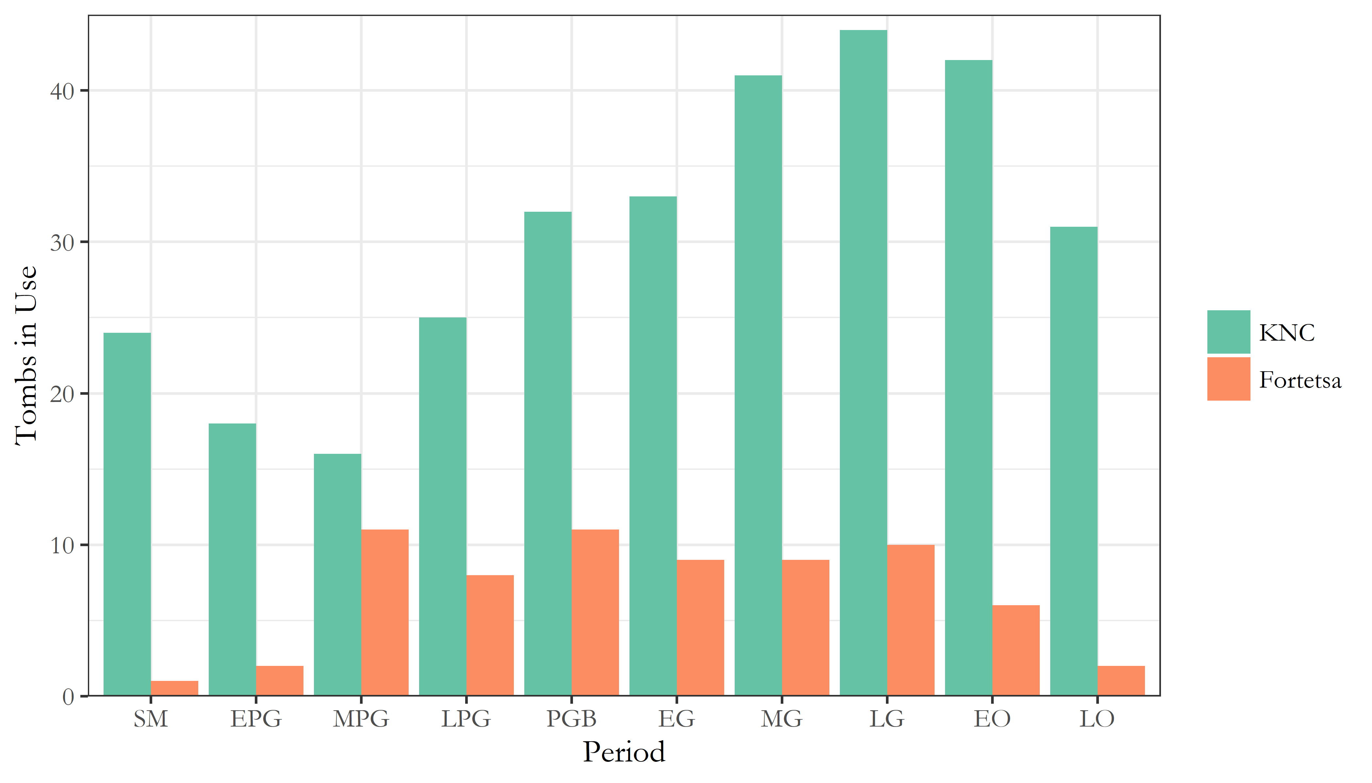

Figure 6 Estimates of the number of tombs in use during each of the ceramic phases attested in both cemetaries.

Figure 6 presents the estimated number of tombs in use throughout the EIA at both cemeteries, that is, the number of tombs which yielded pottery of each period. At the Forteta, this number remained rlatively stable from the MPG to LG periods before declining (and bear in mind, there are only around 20 tombs belonging to this cemetery throughout the period), while at the KNC, the numbers of tombs in use rose to a preak in the late 8th century before declining. The cessation of burials there certainly appears more sudden and marked than at Fortetsa, though, again, it was always a larger cemetery. But with the data available, we can interrogate these trends further.

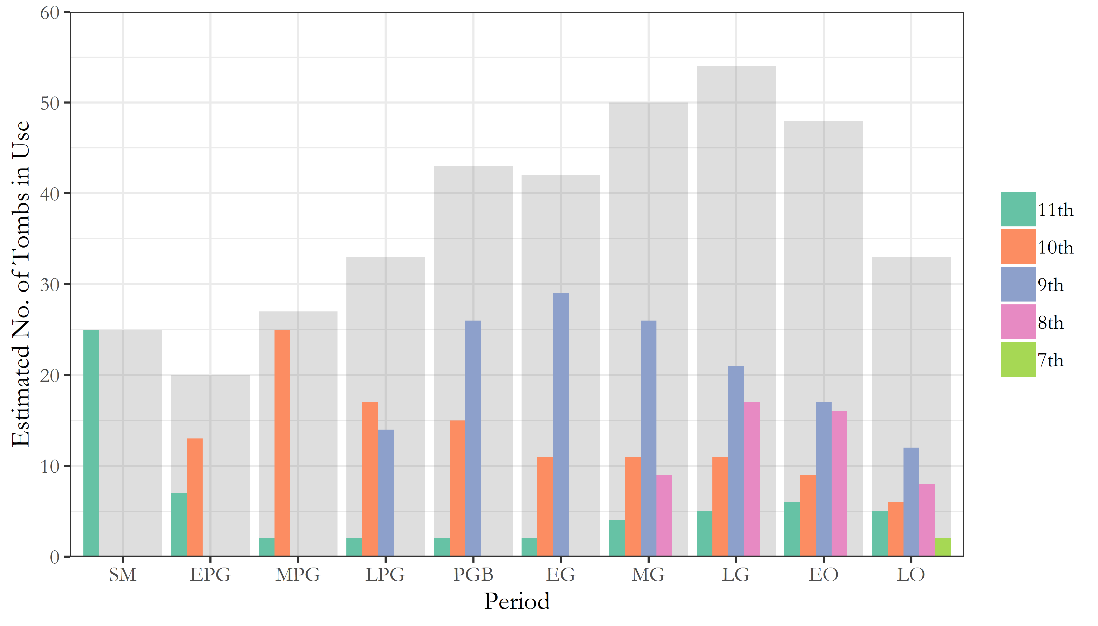

Figure 7 Estimates of the number of tombs in use through time across both cemeteries. The grey background represents the total number of tombs in use in each period, while the smaller coloured bars correspond to tombs built in each of the five centuries of EIA activity at the cemeteries.

Figure 7 presents the number of tombs in use in each period, divided by the centuries in which those tombs were constructed, all overlaid on the total number of tombs in use across both cemeteries. Perhaps unsurprisingly, a wave-like pattern can be observed with each century marked by the construction of new tombs which then steadily go out of use, as new ones are built. This would seem to accord with Cavanagh’s suggestion that “[t]he length of time the tombs last seems […] to reflect the duration of the social group which had access to the sepulchre”, and perhaps even that this access was lineally inehrited, leading to frequent fission and, thus, limited trans-generational use. However, something else is going here, which can only be appreciated by considering which tombs became the focus of the intense period of depositional activity in the late 8th and erly 7th centuries.

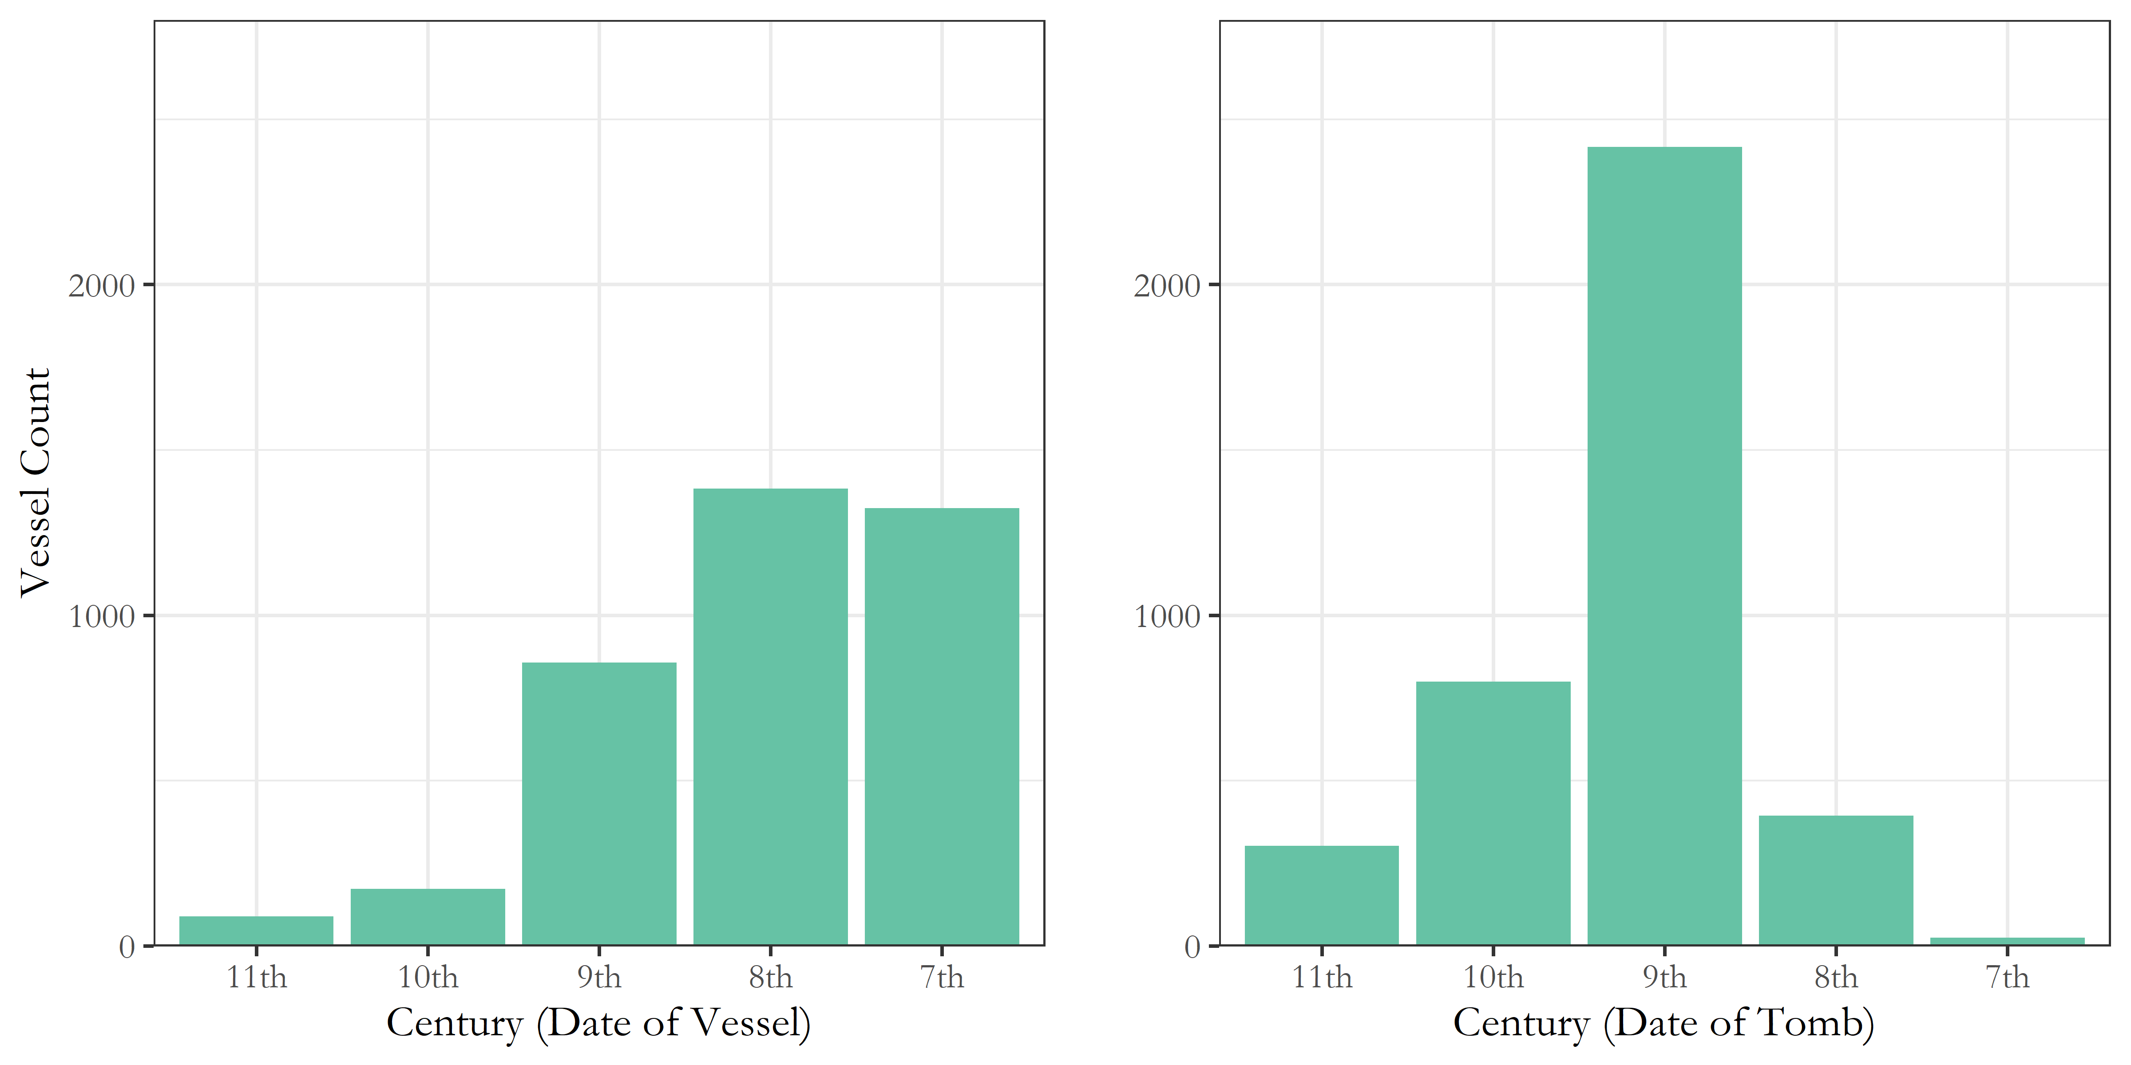

Figure 8 Counts of vessels from across all tombs in both cemeteries, arranged, on the left, by the century to which they are assigned based on their ceramic period and, on the right, by the centuries in which the tombs they come from were built.

Figure 8 shows, firstly, the number of vessels dating to each century across both cemeteries, based on their assigned ceramic period, essentially a simplified version of the trend illustrated in Figure 3. But, on the right, Figure 8 shows those pots divided into the centuries to which the tombs they were found in date. So as can be seen, though the late 8th and early 7th centuries represented the apex of burial activity in across both cemeteries, it was not the tombs built in those centuries, but rather those built in the centuries prior, which received the lion’s share of the burials and associated ceramics. This is all the more notable when, returning to Figure 7, we see that the number of 9th and 10th century tombs in use by the late 8th and early 7th centuries were declining.

|  |  |  |  |  |
| --- | --- | --- | --- | --- |
| Tombs | Date of pithoi (burials) | No. of pithoi (burials) | Number of tombs represented | Burials per tomb |
| 10th century tombs |  |  |  |  |
|  | 10th century | 5 | 2 | 2.5 |
|  | 9th century | 33 | 13 | 2.54 |
|  | 8th century | 34 | 9 | 3.78 |
|  | 7th century | 25 | 6 | 4.17 |
| 9th century tombs |  |  |  |  |
|  | 9th century | 49 | 15 | 3.27 |
|  | 8th century | 161 | 23 | 7 |
|  | 7th century | 162 | 13 | 12.46 |
| 8th century tombs |  |  |  |  |
|  | 8th century | 34 | 14 | 2.43 |
|  | 7th century | 46 | 15 | 3.07 |
| 7th century tombs |  |  |  |  |
|  | 7th century | 5 | 2 | 2.5 |

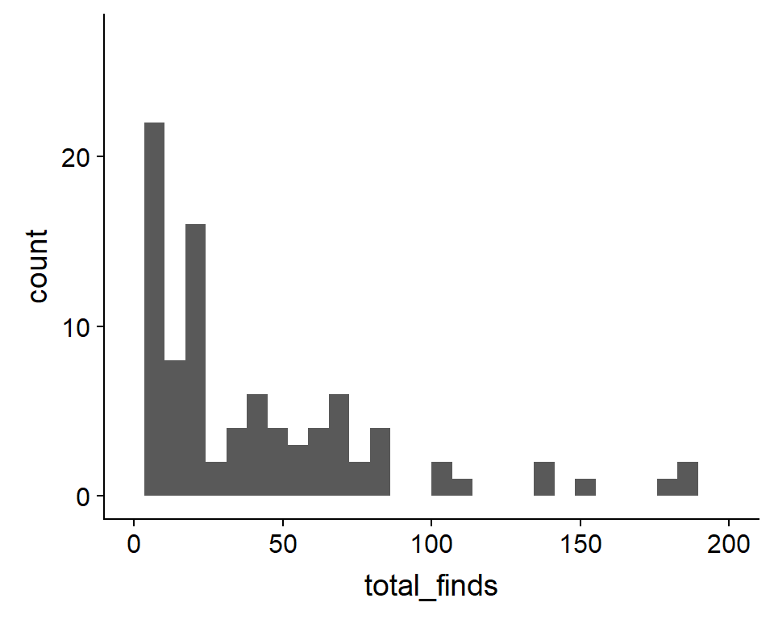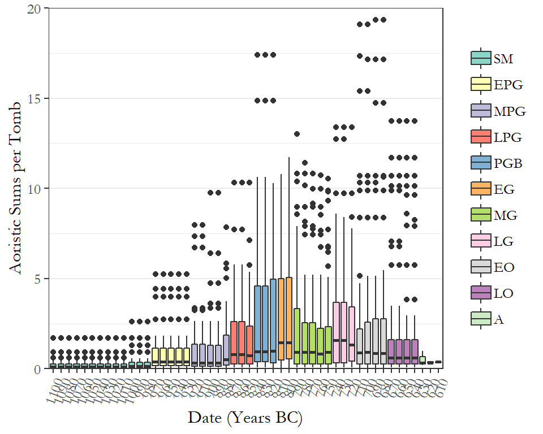

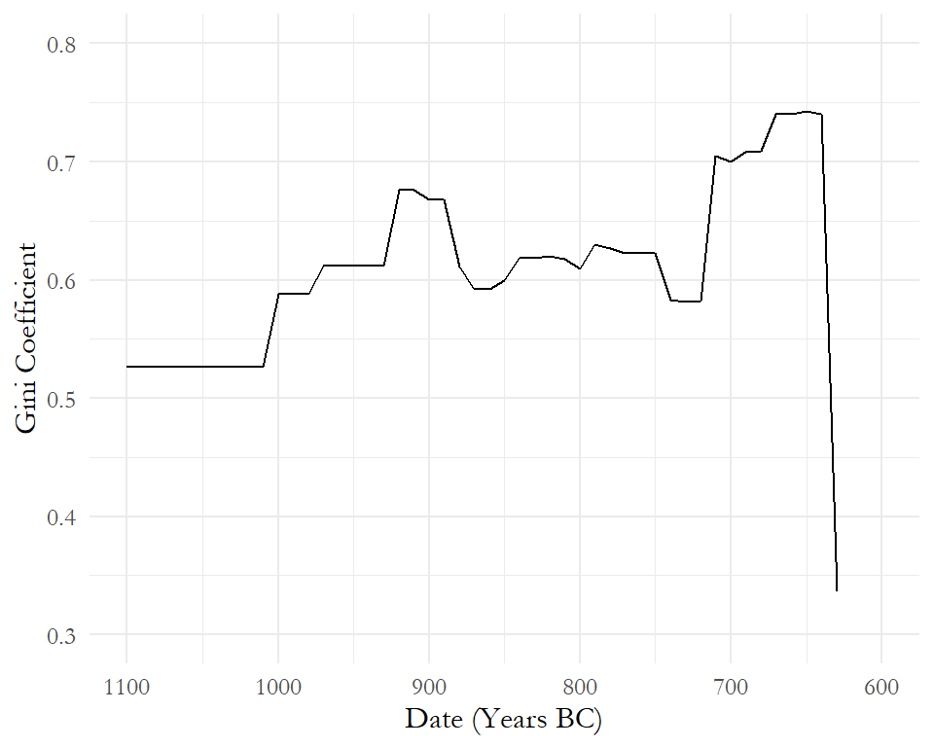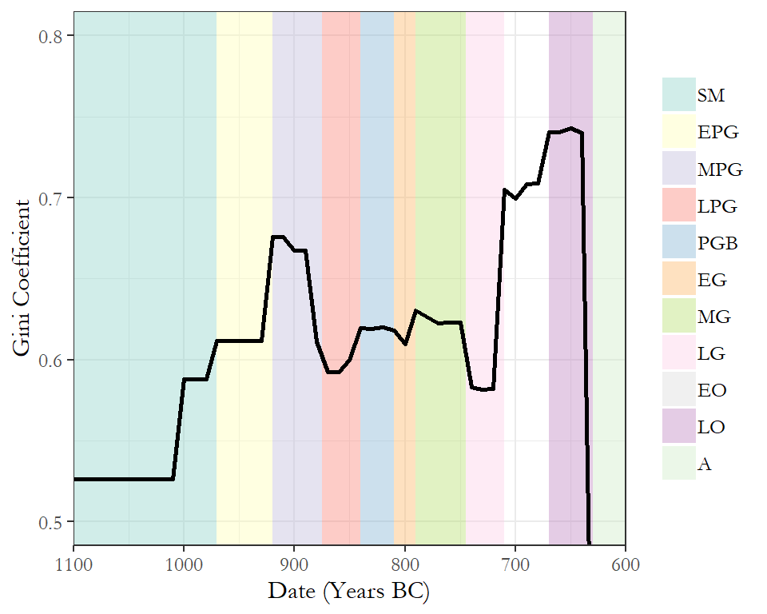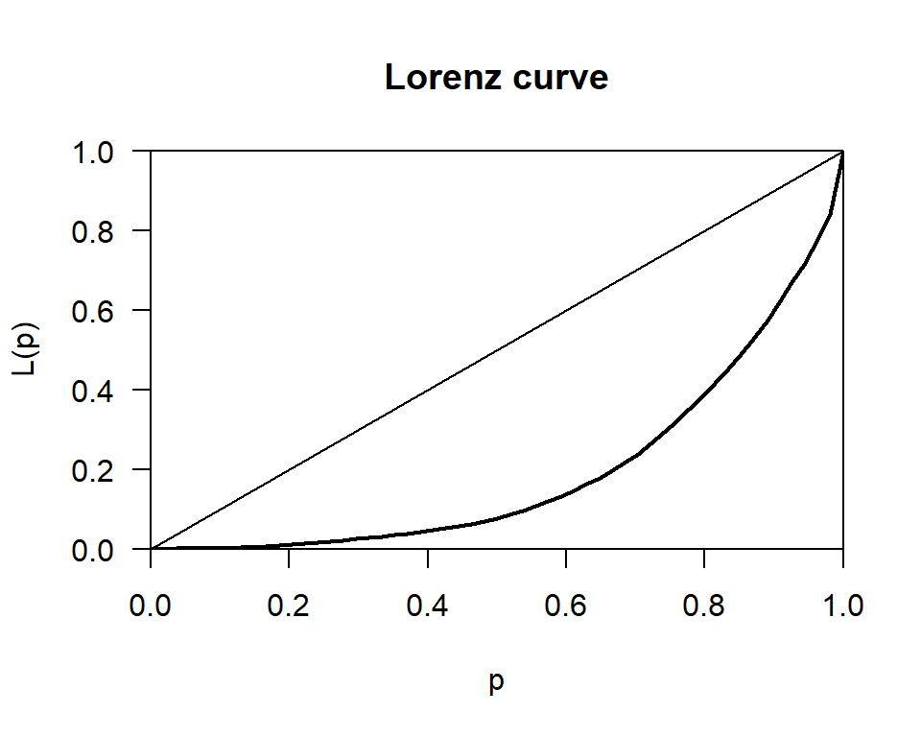

We can also make a table (Table ??)

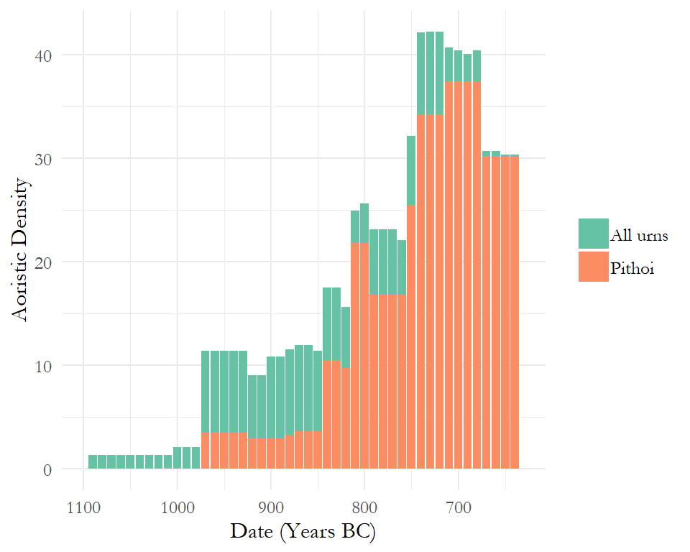

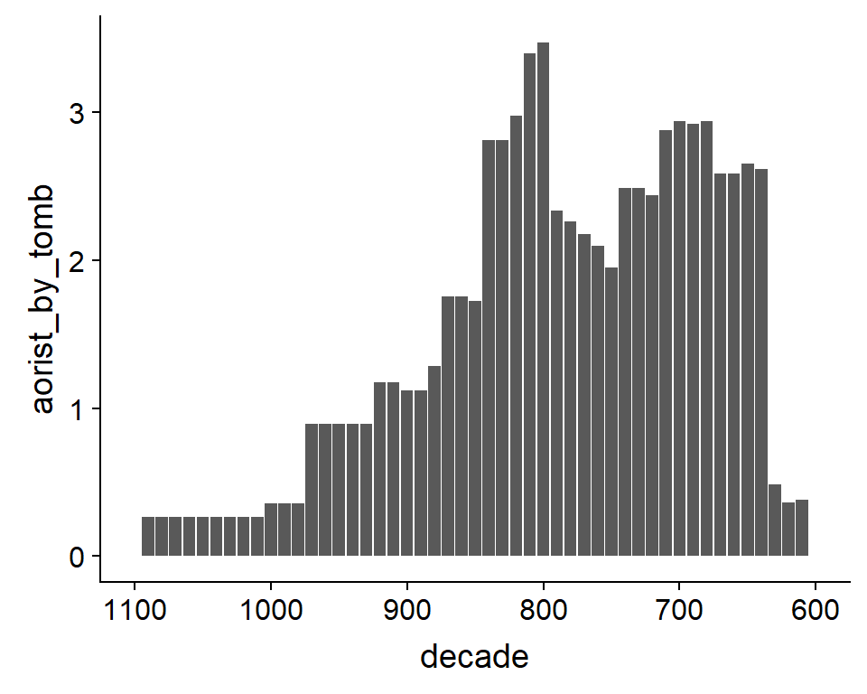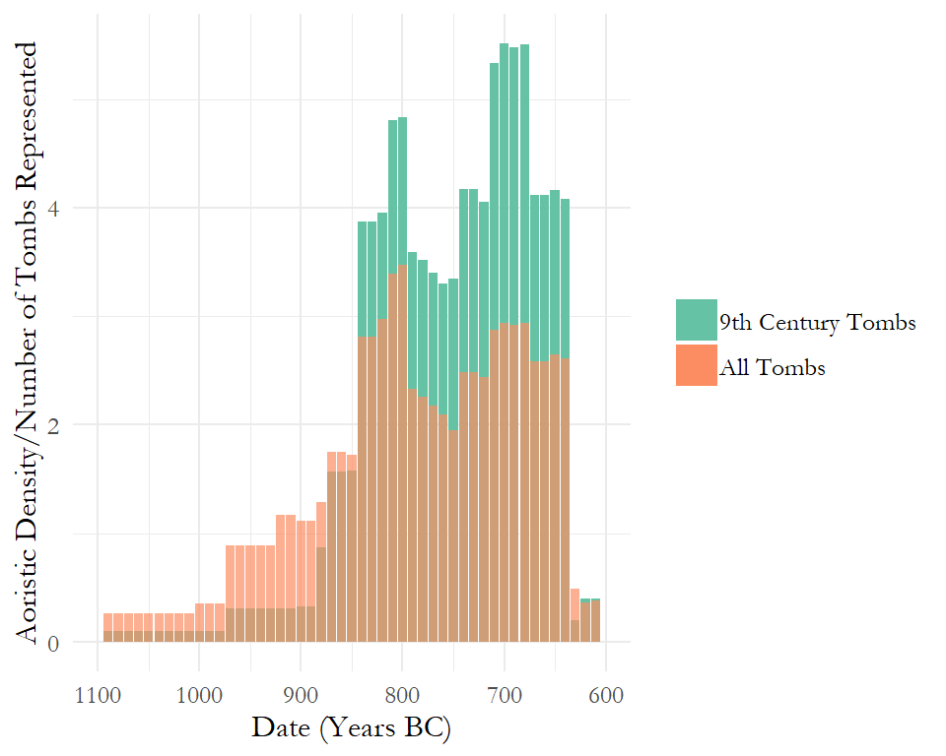

#> [1] "tomb" "cemetery"   
#> [3] "cem_condensed" "tomb_type"   
#> [5] "tomb_type_condensed" "SM"   
#> [7] "EPG" "MPG"   
#> [9] "LPG" "PGB"   
#> [11] "EG" "MG"   
#> [13] "LG" "EO"   
#> [15] "LO" "start_period"   
#> [17] "period_use" "start_date"   
#> [19] "end_date" "time_in_use"   
#> [21] "century_built" "chamber_diameter"   
#> [23] "chamber_width" "chamber_depth"   
#> [25] "chamber_area" "stomion_width"   
#> [27] "stomion_depth" "dromos_length"   
#> [29] "dromos_width" "chamber_burials"   
#> [31] "dromos_burials" "total_burials"   
#> [33] "pithoi" "all_urns"   
#> [35] "est_burials" "gold"   
#> [37] "iron" "bronze"   
#> [39] "silver" "lead"   
#> [41] "electrum" "other_metal"   
#> [43] "total_metal" "bone_ivory"   
#> [45] "faience_blue" "amber"   
#> [47] "organics" "stone"   
#> [49] "glass_paste" "clay"   
#> [51] "unknown_mat" "total_object"   
#> [53] "adornment" "tool"   
#> [55] "weapon" "model"   
#> [57] "jewellery" "strip"   
#> [59] "sheet" "cooking"   
#> [61] "loom" "clothing_armour"   
#> [63] "scarab" "coin"   
#> [65] "component" "seal"   
#> [67] "ornament" "fitting"   
#> [69] "vessel" "unidentified_use"   
#> [71] "other_use" "stirrup_jar"   
#> [73] "jar" "flask"   
#> [75] "oinochoai" "amphora"   
#> [77] "thelastron" "amphoriskos"   
#> [79] "hydria" "pithos"   
#> [81] "jug_let" "olpe"   
#> [83] "alabastron" "lentoid_flask"   
#> [85] "lekythos" "alabastron_aryballos"   
#> [87] "aryballos" "bottle"   
#> [89] "bird_askos" "pyxis"   
#> [91] "dinos" "krater"   
#> [93] "krateriskos" "lekanis"   
#> [95] "skyphos" "bowl"   
#> [97] "cup" "kantharos"   
#> [99] "plate_tray" "kotyle"   
#> [101] "kalathos" "lid"   
#> [103] "larnax" "stand"   
#> [105] "house_model" "kernos"   
#> [107] "other_vessel" "unidentified_vessel"   
#> [109] "total_open_vessel" "total_closed_vessel"   
#> [111] "total_other_vessel" "total_pottery"   
#> [113] "total_finds" "total_import"   
#> [115] "total_import_imitation" "total_imitation"   
#> [117] "antique" "pithoi1100.1050"   
#> [119] "pithoi1050.1000" "pithoi1000.950"   
#> [121] "pithoi950.900" "pithoi900.850"   
#> [123] "pithoi850.800" "pithoi800.750"   
#> [125] "pithoi750.700" "pithoi700.650"   
#> [127] "pithoi650.600" "pots1100.1050"   
#> [129] "pots1050.1000" "pots1000.950"   
#> [131] "pots950.900" "pots900.850"   
#> [133] "pots850.800" "pots800.750"   
#> [135] "pots750.700" "pots700.650"   
#> [137] "pots650.600" "SMpithoi"   
#> [139] "EPGpithoi" "MPGpithoi"   
#> [141] "LPGpithoi" "PGBpithoi"   
#> [143] "EGpithoi" "MGpithoi"   
#> [145] "LGpithoi" "EOpithoi"   
#> [147] "LOpithoi" "SMpots"   
#> [149] "EPGpots" "MPGpots"   
#> [151] "LPGpots" "PGBpots"   
#> [153] "EGpots" "MGpots"   
#> [155] "LGpots" "EOpots"   
#> [157] "LOpots" "X1100"   
#> [159] "X1090" "X1080"   
#> [161] "X1070" "X1060"   
#> [163] "X1050" "X1040"   
#> [165] "X1030" "X1020"   
#> [167] "X1010" "X1000"   
#> [169] "X990" "X980"   
#> [171] "X970" "X960"   
#> [173] "X950" "X940"   
#> [175] "X930" "X920"   
#> [177] "X910" "X900"   
#> [179] "X890" "X880"   
#> [181] "X870" "X860"   
#> [183] "X850" "X840"   
#> [185] "X830" "X820"   
#> [187] "X810" "X800"   
#> [189] "X790" "X780"   
#> [191] "X770" "X760"   
#> [193] "X750" "X740"   
#> [195] "X730" "X720"   
#> [197] "X710" "X700"   
#> [199] "X690" "X680"   
#> [201] "X670" "X660"   
#> [203] "X650" "X640"   
#> [205] "X630" "X620"   
#> [207] "X610" "pithoi1100"   
#> [209] "pithoi1090" "pithoi1080"   
#> [211] "pithoi1070" "pithoi1060"   
#> [213] "pithoi1050" "pithoi1040"   
#> [215] "pithoi1030" "pithoi1020"   
#> [217] "pithoi1010" "pithoi1000"   
#> [219] "pithoi990" "pithoi980"   
#> [221] "pithoi970" "pithoi960"   
#> [223] "pithoi950" "pithoi940"   
#> [225] "pithoi930" "pithoi920"   
#> [227] "pithoi910" "pithoi900"   
#> [229] "pithoi890" "pithoi880"   
#> [231] "pithoi870" "pithoi860"   
#> [233] "pithoi850" "pithoi840"   
#> [235] "pithoi830" "pithoi820"   
#> [237] "pithoi810" "pithoi800"   
#> [239] "pithoi790" "pithoi780"   
#> [241] "pithoi770" "pithoi760"   
#> [243] "pithoi750" "pithoi740"   
#> [245] "pithoi730" "pithoi720"   
#> [247] "pithoi710" "pithoi700"   
#> [249] "pithoi690" "pithoi680"   
#> [251] "pithoi670" "pithoi660"   
#> [253] "pithoi650" "pithoi640"   
#> [255] "pithoi630" "pithoi620"   
#> [257] "pithoi610"

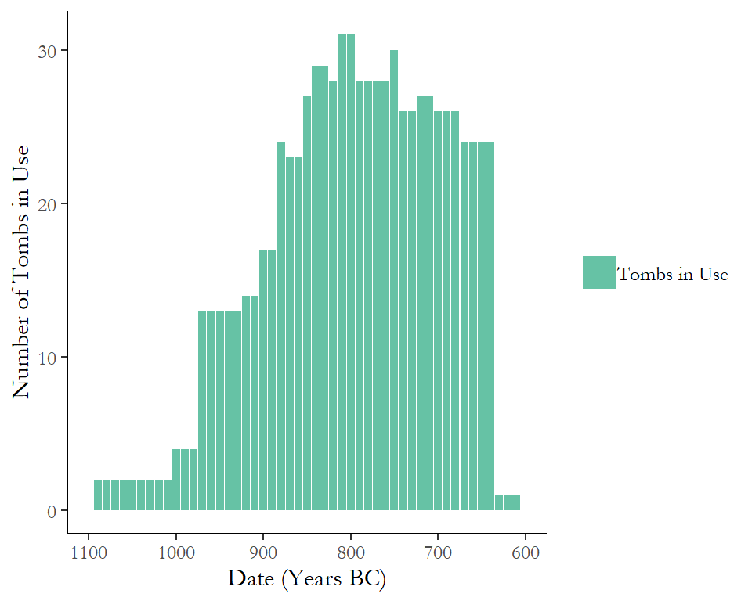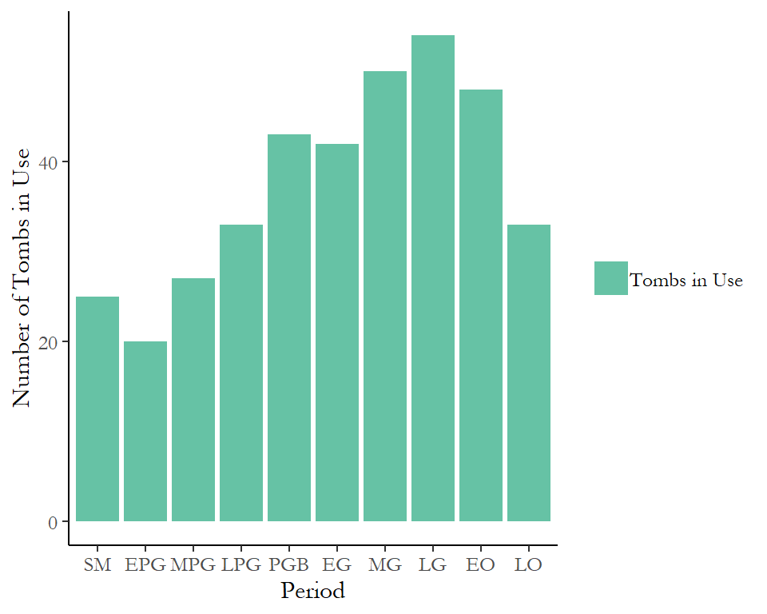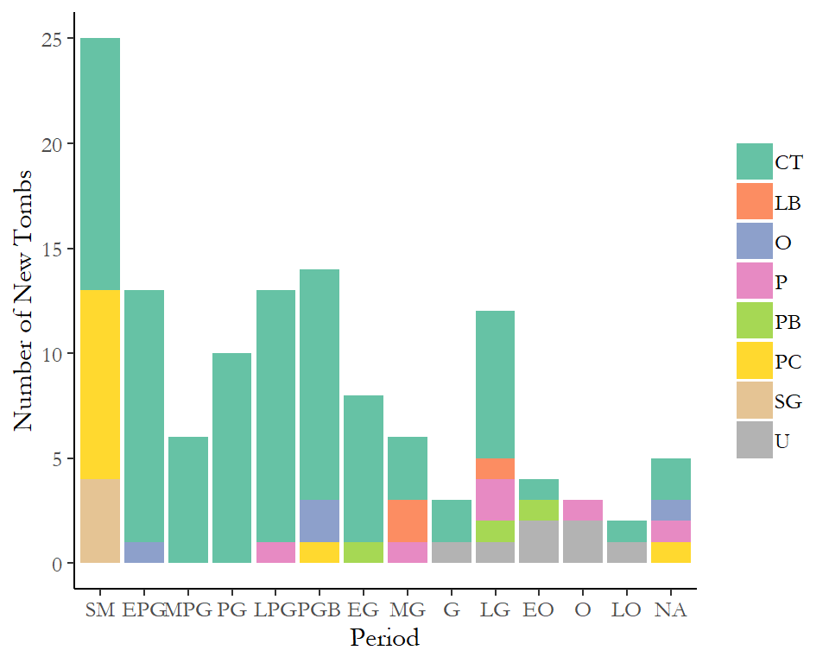

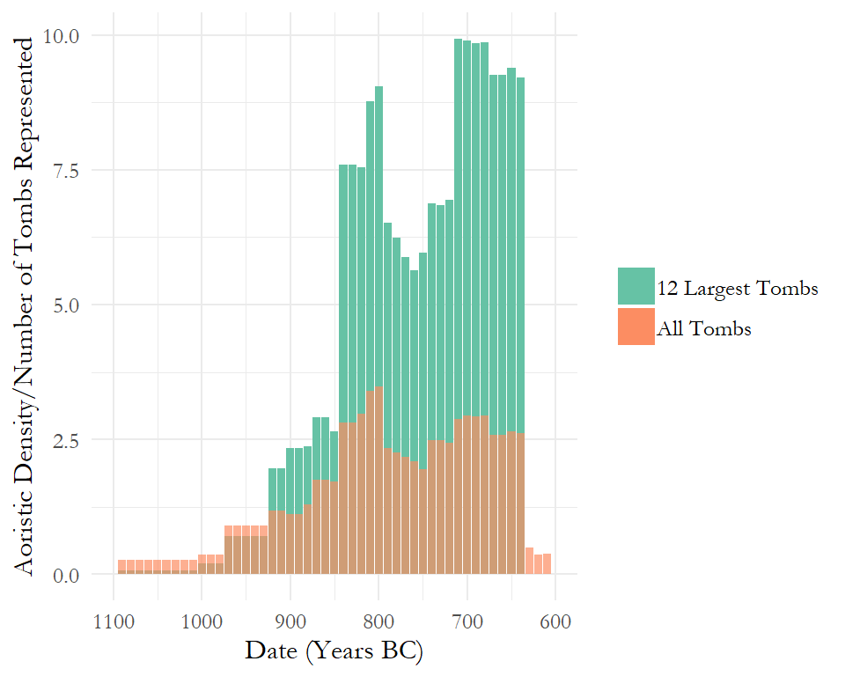

#> 'data.frame': 600 obs. of 3 variables:  
#> $ tomb : Factor w/ 154 levels "1","100","103",..: 143 61 79 7 58 127 153 122 44 4 ...  
#> $ variable: Factor w/ 50 levels "1100","1090",..: 1 1 1 1 1 1 1 1 1 1 ...  
#> $ value : num 0 0 0 0 0.0556 ...

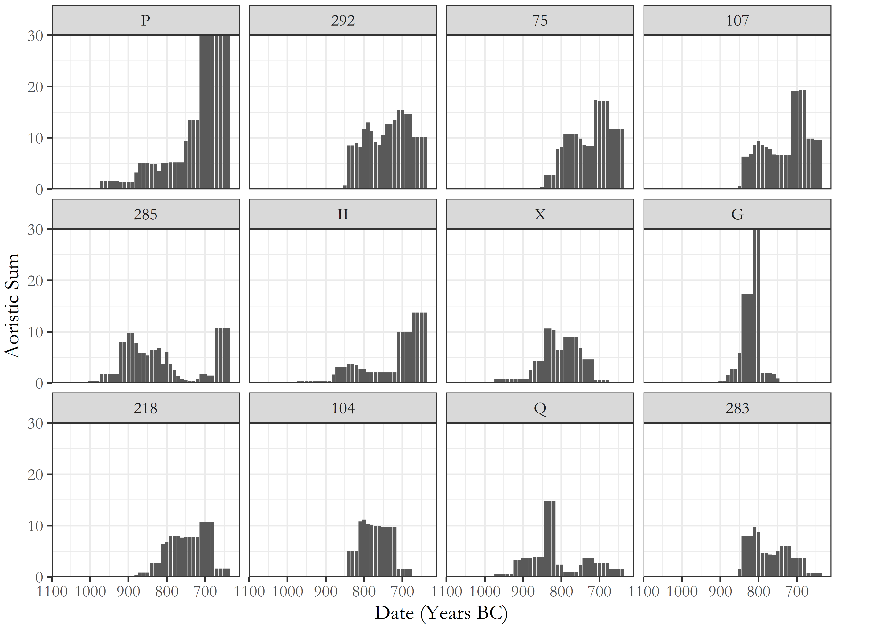

# Results

# Discussion

# Conclusion

# Acknowledgements

##### pagebreak

# References

Antonaccio, Carla M. 1994. “Contesting the Past : Hero Cult, Tomb Cult, and Epic in Early Greece.” *American Journal of Archaeology* 98 (3): 389–410. doi:[10.2307/506436](https://doi.org/10.2307/506436).

Antoniadis, Vyron. 2012. “Early Iron Age Cementeries at Knossos: The Appreciation of Oriental Imports and their Imitations by Knossian Society.” PhD thesis, Universitat Pompeu Fabra. <http://www.tdx.cat/handle/10803/85060>.

Appadurai, Arjun. 1986. *The Social Life of Things : commodities in cultural perspective*. Cambridge: Cambridge University Press.

Boardman, John. 1960. “Protogeometric Graves at Agios Ioannis near Knossos (Knossos Survey 3).” *The Annual of the British School at Athens* 55: 128–148.

Boardman, John. 1967. “The Khaniale Tekke Tombs, II.” *BSA* 62: 57–75.

Brock, J.K. 1957. *Fortetsa: Early Greek Tombs Near Knossos*. Cambridge: Cambridge University Press.

Catling, H W. 1995. “Heroes Returned? Subminoan Burials from Crete.” In *The Ages of Homer: A Tribute to Emily Townsend Vermeule*, edited by Jane B Carter and Sarah P Morris, 123–136. Austin: University of Texas Press.

Cavanagh, W.G. 1996. “The Burial Customs.” In *Knossos North Cemetery: Early Greek Tombs*, edited by J.N. Coldstream and H W Catling, 651–675. London: The British School at Athens Supplement 28. Vol.II.

Coldstream, J N. 1976. “Hero-cults in the age of Homer.” *The Journal of Hellenic Studies* 96 (1976): 8–17. doi:[10.2307/631220](https://doi.org/10.2307/631220).

Coldstream, J N. 1977. *Geometric Greece*. 1st ed. London: Ernest Benn.

Coldstream, J N. 1994. “Urns with Lids: The Visible Face of the Knossian ’Dark Age’.” In *Knossos: A Labyrinth of History. Papers Presented in Honour of Sinclair Hood*, edited by Don Evely, Helen Hughes-Brock, and Nicoletta Momigliano, 105–122. Oxford: The British School at Athens.

Coldstream, J N. 1998. “Minos Redivivus: some nostalgic Knossians of the ninth century BC (a summary).” *Brtish School at Athens Studies* 2 (POST-MINOAN CRETE: Proceedings of the First Colloquium on Post-Minoan Crete held by the British School at Athens and the Institute of Archaeology, University College London, 10-11 November 1995): 58–61.

Coldstream, J N, and H W Catling. 1996. *Knossos North Cemetery: Early Greek Tombs*. Edited by J N Coldstream and H W Catling. London: The British School at Athens Supplement 28. Vol.I-IV.

Coldstream, J. N. 1963. “Five Tombs at Knossos.” *The Annual of the British School at Athens* 58: 30–43.

Coldstream, J. N., G. L. Huxley, and V. E. S. Webb. 1999. “Knossos: The Archaic Gap.” *The Annual of the British School at Athens* 94: 289–307.

Coldstream, J.N. 1984a. “A Protogeometric Nature Goddess from Knossos.” *Bulletin of the Institute of Classical Studies* 31: 93–104.

Coldstream, J.N. 1984b. “Dorian Knossos and Aristotle’s Villages.” In *Aux Origines de L’Hellénisme: La Crète et La Grèce. Hommage à Henri van Effenterre.*, edited by Centre Gustave Glotz, 311–322. Paris: Université de Paris-I.

Coldstream, J.N. 1991. “Knossos: An Urban Nucleus in the Dark Age.” In *La Transizione Dal Miceneo All’Alto Arcaismo: Dal Palazzo Alla Città. Atti Del Convegno Internazionale, Roma, 14–19 Marzo 1988.*, edited by Domenico Musti, 287–299. Roma: Consiglio nazionale delle ricerche.

Coldstream, J.N. 2000. “Evans’ Greek Finds: The Early Greek Town of Knossos, and its Encroachment on the Borders of the Minoan Palace.” *BSA* 95: 260–299.

Coldstream, J.N. 2006. “Knossos in Early Greek Times.” In *Ancient Greece: From the Mycenaean Palaces to the Age of Homer*, edited by Sigrid Deger-Jalkotzy and Irene S Lemos, 581–596. Edinburgh: Edinburgh University Press.

Coldstream, J.N., and G Huxley. 1996. “Fortetsa 1967 Tombs.” In *Knossos North Cemetery: Early Greek Tombs*, edited by J.N. Coldstream and H W Catling, 284. London: The British School at Athens Supplement 28. Vol.I.

Crema, Enrico R. 2012. “Modelling Temporal Uncertainty in Archaeological Analysis.” *Journal of Archaeological Method Theory* 19 (3): 440–461.

Crema, Enrico R., Andrew Bevan, and Mark W. Lake. 2010. “A probabilistic framework for assessing spatio-temporal point patterns in the archaeological record.” *Journal of Archaeological Science* 37 (5): 1118–1130.

Crowe, Alice. 2016. “The Minoan Past in the Past: Bronze Age Objects in Early Iron Age Burials at Knossos, Crete.” *Unpublished Master’s Dissertation.*

Davaras, C. 1968. “Two Geometric Tombs at Atsalenio near Knossos.” *BSA* 63: 133–146.

Desborough, Vincent Robin d’Arba. 1972. *The Greek Dark Ages*. London: Benn.

Evans, Arthur. 1921. *The palace of Minos: a comparative account of the successive stages of the early Cretan civilization as illustrated by the discoveries at Knossos I*. London: Macmillan.

Evans, Arthur. 1928. *The palace of Minos: a comparative account of the successive stages of the early Cretan civilization as illustrated by the discoveries at Knossos II*. London: Macmillan.

Evans, Arthur. 1930. *The palace of Minos: a comparative account of the successive stages of the early Cretan civilization as illustrated by the discoveries at Knossos III*. London: Macmillan.

Hallager, Birgitta P. 2010. “The elusive Late IIIC and the ill-named Subminoan.” *British School at Athens Studies* 18 (CRETAN OFFERINGS: Studies in honour of Peter Warren): 141–155.

Hoffman, Gail L. 1997. *Imports and Immigrants: Near Eastern Contacts with Iron Age Crete*. Ann Arbor: University of Michigan Press.

Hogarth, D.G. 1899. “Knossos: Early Town and Cemeteries.” *BSA* 6: 70–85.

Hood, Sinclair, and David Smyth. 1981. *Archaeological Survey of the Knossos Area. The British School at Athens Supplementary Volumes, No. 14.* 2nd ed. London: Thames; Hudson.

Hutchinson, R.W., and John Boardman. 1954. “The Khaniale Tekke Tombs.” *BSA* 49: 215–230.

Huxley, G. 1994. “On Knossos and her Neighbours (7th Century to Mid-4th Century B.C.).” In *Knossos: A Labyrinth of History. Papers Presented in Honour of Sinclair Hood*, edited by Don Evely, Helen Hughes-Brock, and Nicoletta Momigliano, 123–134. Oxford: The British School at Athens.

Johnson, Ian. 2004. “Aorisitc Analysis: Seeds of a new approach to mapping archaeological distributions through time.” In *[Enter the Past]. the E-Way into the Four Dimensions of Cultural Heritage. Caa 2003. Computer Applications and Quantitative Methods in Archaeology. Proceedings of the 31st Conference, Vienna, Austria, April 2003*, edited by K Ausserer Fischer, W Börner, M Goriany, and L Karlhuber-Vöckl, 448–452. Oxford: BAR International Series 1227.

Kopytoff, I. 1986. “The cultural biography of things: commoditization as process.” In *The Social Life of Things: Commodities in Cultural …*, edited by Arjun Appadurai, 64–92. Cambridge: Cambridge University Press.

Kotsonas, Antonis. 2002. “The rise of the polis in Central Crete.” *’Eulimene*, no. 3: 37–74.

Kotsonas, Antonis. 2006. “Wealth and Status in Iron Age Knossos.” *Oxford Journal of Archaeology* 2: 149–172.

Kotsonas, Antonis. 2011. “Quantification of ceramics from Early Iron Age tombs.” In *Early Iron Age Pottery : A Quantitative Approach : Proceedings of the International Round Table Organized by the Swiss School of Archaeology in Greece (Athens, November 28-30, 2008)*, edited by Samuel Verdan, Thierry Theurillat, and Anne Pfyffer Kenzelmann, 129–138. Oxford: Archaeopress.

Kotsonas, Antonis. 2016. “Politics of Periodization and the Archaeology of Early Greece.” *American Journal of Archaeology* 120 (2): 239–270.

Kotsonas, Antonis, Todd Whitelaw, Antonis Vasilakis, and Maria Bredaki. 2011. “Early Iron Age Knossos: An overview from the Knossos Urban Landscape Project (KULP).” In *Έ ο 11ο ούς κοοού ίο, ρέο, 21-27 οίο 2011*. Ρέο.

Marwick, Ben. 2017. “Computational Reproducibility in Archaeological Research: Basic Principles and a Case Study of Their Implementation.” *Journal of Archaeological Method and Theory* 24 (2). Springer US: 424–450. doi:[10.1007/s10816-015-9272-9](https://doi.org/10.1007/s10816-015-9272-9).

Mauss, Marcel. 1954. *The gift: forms and functions of exchange in archaic societies*. Edited by Ian Cunnison. London: Cohen & West.

Morris, I. 1997. “Periodization and the Heroes: Inventing a Dark Age.” In *Inventing Ancient Culture*, edited by Mark Golden and Peter Toohey, 96–131. London: Routledge.

Nowicki, Krzysztof. 2000. *Defensible sites in Crete c.1200-800 B.C. : (LM IIIB/IIIC through early Geometric)*. Liège: Université de Liège.

Ratcliffe, Jerry H. 2000. “Aoristic analysis: the spatial interpretation of unspecific temporal events.” *International Journal of Geographical Information Science* 14 (7): 669–679.

Schreiber, N. 2003. *The Cypro-Phoenician Pottery of the Iron Age*. Leiden/Boston: Brill.

Snodgrass, Anthony McElrea. 1971. *The Dark Age of Greece*. Edinburgh: Edinburgh University Press.

Wallace, Saro. 2010. *Ancient Crete: From Successful Collapse to Democracy’s Alternatives, Twelth to Fifth Centuries BC*. Cambridge: Cambridge University Press#.

Whitley, James. 2002. “Objects with Attitude: Biographical Facts and Fallacies in the Study of Late Bronze Age and Early Iron Age Warrior Graves.” *Cambridge Archaeological Journal* 12 (2). Cambridge University Press: 217–232.

Whitley, James. 2011. “Saro Wallace. Ancient Crete: From Successful Collapse to Democracy’s Alternatives, Twelfth to Fifth Centuries BC. (review).” *American Journal of Philology* 132 (4): 667–670. doi:[10.1353/ajp.2011.0043](https://doi.org/10.1353/ajp.2011.0043).

Αίο, . 1950. “άς ούοος ί οώ ί Κής.” *Κά Χοά* 4: 294–318.

##### pagebreak

### Colophon

This report was generated on 2019-05-14 16:22:45 using the following computational environment and dependencies:

#> - Session info ----------------------------------------------------------  
#> setting value   
#> version R version 3.5.1 (2018-07-02)  
#> os Windows 10 x64   
#> system x86_64, mingw32   
#> ui RTerm   
#> language (EN)   
#> collate English_United Kingdom.1252   
#> ctype English_United Kingdom.1252   
#> tz Europe/London   
#> date 2019-05-14   
#>   
#> - Packages --------------------------------------------------------------  
#> package * version date lib source   
#> assertthat 0.2.0 2017-04-11 [1] CRAN (R 3.5.2)  
#> backports 1.1.3 2018-12-14 [1] CRAN (R 3.5.2)  
#> bookdown 0.9 2018-12-21 [1] CRAN (R 3.5.2)  
#> callr 3.1.1 2018-12-21 [1] CRAN (R 3.5.2)  
#> cli 1.0.1 2018-09-25 [1] CRAN (R 3.5.2)  
#> colorspace 1.4-0 2019-01-13 [1] CRAN (R 3.5.2)  
#> cowplot * 0.9.4 2019-01-08 [1] CRAN (R 3.5.3)  
#> crayon 1.3.4 2017-09-16 [1] CRAN (R 3.5.2)  
#> data.table * 1.12.0 2019-01-13 [1] CRAN (R 3.5.3)  
#> desc 1.2.0 2018-05-01 [1] CRAN (R 3.5.2)  
#> devtools 2.0.1 2018-10-26 [1] CRAN (R 3.5.3)  
#> digest 0.6.18 2018-10-10 [1] CRAN (R 3.5.2)  
#> dplyr * 0.8.0.1 2019-02-15 [1] CRAN (R 3.5.2)  
#> evaluate 0.13 2019-02-12 [1] CRAN (R 3.5.2)  
#> extrafont * 0.17 2014-12-08 [1] CRAN (R 3.5.2)  
#> extrafontdb 1.0 2012-06-11 [1] CRAN (R 3.5.2)  
#> fs 1.2.6 2018-08-23 [1] CRAN (R 3.5.2)  
#> ggplot2 * 3.1.0 2018-10-25 [1] CRAN (R 3.5.2)  
#> ggpubr * 0.2 2018-11-15 [1] CRAN (R 3.5.2)  
#> ggrepel * 0.8.0 2018-05-09 [1] CRAN (R 3.5.3)  
#> glue 1.3.1 2019-03-12 [1] CRAN (R 3.5.3)  
#> gridExtra * 2.3 2017-09-09 [1] CRAN (R 3.5.3)  
#> gtable 0.2.0 2016-02-26 [1] CRAN (R 3.5.2)  
#> highr 0.7 2018-06-09 [1] CRAN (R 3.5.2)  
#> htmltools 0.3.6 2017-04-28 [1] CRAN (R 3.5.2)  
#> ineq * 0.2-13 2014-07-21 [1] CRAN (R 3.5.2)  
#> knitr 1.21 2018-12-10 [1] CRAN (R 3.5.2)  
#> labeling 0.3 2014-08-23 [1] CRAN (R 3.5.2)  
#> lazyeval 0.2.1 2017-10-29 [1] CRAN (R 3.5.2)  
#> magrittr * 1.5 2014-11-22 [1] CRAN (R 3.5.2)  
#> memoise 1.1.0 2017-04-21 [1] CRAN (R 3.5.2)  
#> munsell 0.5.0 2018-06-12 [1] CRAN (R 3.5.2)  
#> pillar 1.3.1 2018-12-15 [1] CRAN (R 3.5.2)  
#> pkgbuild 1.0.2 2018-10-16 [1] CRAN (R 3.5.2)  
#> pkgconfig 2.0.2 2018-08-16 [1] CRAN (R 3.5.2)  
#> pkgload 1.0.2 2018-10-29 [1] CRAN (R 3.5.2)  
#> plyr * 1.8.4 2016-06-08 [1] CRAN (R 3.5.2)  
#> prettyunits 1.0.2 2015-07-13 [1] CRAN (R 3.5.2)  
#> processx 3.2.1 2018-12-05 [1] CRAN (R 3.5.2)  
#> ps 1.3.0 2018-12-21 [1] CRAN (R 3.5.2)  
#> purrr 0.3.0 2019-01-27 [1] CRAN (R 3.5.2)  
#> R6 2.4.0 2019-02-14 [1] CRAN (R 3.5.2)  
#> RColorBrewer * 1.1-2 2014-12-07 [1] CRAN (R 3.5.2)  
#> Rcpp 1.0.0 2018-11-07 [1] CRAN (R 3.5.2)  
#> remotes 2.0.2 2018-10-30 [1] CRAN (R 3.5.2)  
#> reshape * 0.8.8 2018-10-23 [1] CRAN (R 3.5.3)  
#> reshape2 1.4.3 2017-12-11 [1] CRAN (R 3.5.2)  
#> rlang 0.3.1 2019-01-08 [1] CRAN (R 3.5.2)  
#> rmarkdown 1.11 2018-12-08 [1] CRAN (R 3.5.2)  
#> rprojroot 1.3-2 2018-01-03 [1] CRAN (R 3.5.2)  
#> Rttf2pt1 1.3.7 2018-06-29 [1] CRAN (R 3.5.2)  
#> scales 1.0.0 2018-08-09 [1] CRAN (R 3.5.2)  
#> sessioninfo 1.1.1 2018-11-05 [1] CRAN (R 3.5.2)  
#> stringi 1.3.1 2019-02-13 [1] CRAN (R 3.5.2)  
#> stringr 1.4.0 2019-02-10 [1] CRAN (R 3.5.2)  
#> tibble 2.0.1 2019-01-12 [1] CRAN (R 3.5.2)  
#> tidyselect 0.2.5 2018-10-11 [1] CRAN (R 3.5.2)  
#> usethis 1.4.0 2018-08-14 [1] CRAN (R 3.5.2)  
#> withr 2.1.2 2018-03-15 [1] CRAN (R 3.5.2)  
#> xfun 0.5 2019-02-20 [1] CRAN (R 3.5.2)  
#> yaml 2.2.0 2018-07-25 [1] CRAN (R 3.5.2)  
#>   
#> [1] C:/Users/dcpol/R/win-library/3.5  
#> [2] C:/Program Files/R/R-3.5.1/library

The current Git commit details are:

#> Local: master C:/Users/dcpol/domproject  
#> Remote: master @ origin (https://github.com/DCPollard94/knossoscemeteries.git)  
#> Head: [39634fd] 2019-05-13: Writing analysis part 1