sudo systemctl enable Jenkins
sudo systemctl start Jenkins

http://localhost:8080

mkdir Jenkins
cd Jenkins

vim app.py
print("Hello from Jenkins CI/CD Pipeline!")

vim test.py
def test_message():
assert "Hello" in "Hello from Jenkins CI/CD Pipeline!"

vim requirements.txt
pytest

vim Jenkinsfile
pipeline {
agent any

stages {
stage('Checkout') {
steps {
git branch: 'main', url: 'https://github.com/Nikhil-0-9/jenkins.git'
}
}

stage('Build & Test') {
steps {
sh 'echo "Building project..."'
sh 'pytest > result.log || true'
sh 'cat result.log'
}
}

stage('Deploy') {
steps {
sh 'echo "Deploying application..."'
}
}
}
}

Git init
Git add .
Git commit -m “bla bla bla”
Git branch -M main
Git remote add origin <Link>
Git push -u origin main

Jenkins
New item -> name something -> pipeline -> ok
Definition with scm
Scm -> git
Repo url
Credentials add -> username and token as password save
Type main instead of master
Build now tick mark we get

Here’s a clear and concise theory explanation for both topics — written in a way that fits assignment or exam-style answers 👇

1. Using Git Commands for Local and Remote Repository Operations
Git is a distributed version control system that helps developers track changes in source code and collaborate effectively.
It allows operations both locally (on your own computer) and remotely (with repositories hosted on platforms like GitHub, GitLab, or Bitbucket).
Key Local Repository Commands
- git init
Initializes a new local Git repository in the current directory.
- git init
- git add <file>
Stages changes (files) to be committed.
- git add filename.js
- git add . # adds all files
- git commit -m "message"
Records staged changes permanently in the local repository.
- git commit -m "Initial commit"
- git status
Shows the current state of the working directory and staging area.
- git log
Displays the commit history.
- git branch / git checkout -b <branch>
Creates and switches between branches.

Remote Repository Commands
To collaborate with others or back up your code, you connect your local repo to a remote one.
- git remote add origin <URL>
Links the local repository to a remote repository (like GitHub).
- git remote add origin https://github.com/user/repo.git
- git push origin <branch>
Uploads local commits to the remote branch.
- git push origin main
- git pull origin <branch>
Fetches changes from the remote repo and merges them into the current branch.
- git clone <URL>
Creates a copy of a remote repository on your local machine.
- git clone https://github.com/user/repo.git
- git fetch
Downloads changes from the remote repo without merging them automatically.

Git Workflow Summary
- Create local repo → git init
- Make changes → git add
- Commit changes → git commit
- Link to remote → git remote add origin
- Push to remote → git push
- Pull updates when needed → git pull

git init
git add .
git commit -m "message"
git branch -M main
git remote add origin <link>
git push -u origin main

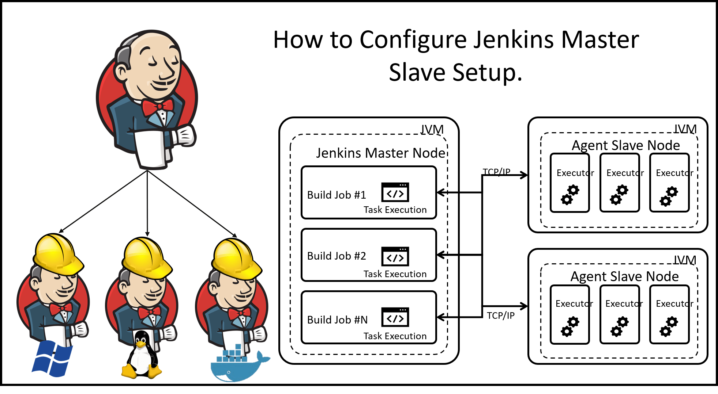
2. Jenkins Master-Slave Architecture (Within Local Machine)
Introduction
Jenkins is an open-source automation server used for Continuous Integration (CI) and Continuous Deployment (CD).
Its Master-Slave (or Controller-Agent) architecture is designed to distribute build and test workloads efficiently across multiple systems.

Architecture Overview
- Master Node (Controller):
  - Controls the overall Jenkins environment.
  - Schedules jobs, monitors agents, and records build results.
  - Provides the web interface and stores configuration details.
- Slave Node (Agent):
  - Executes the jobs assigned by the master.
  - Can be on the same machine or different systems.
  - Helps in parallel execution and load distribution.

Working Principle
- Job Scheduling:
The Jenkins Master receives build jobs (from triggers like Git commits or manual builds).
- Job Delegation:
The Master assigns jobs to available Slave nodes based on labels or workload.
- Execution:
The Slave executes the assigned job and returns results (build success/failure) to the Master.
- Reporting:
The Master updates the Jenkins dashboard with build results.

Setting Up Master-Slave on Local Machine
You can simulate Master-Slave architecture on a single system:
- Run Jenkins Master
  - Start Jenkins normally (runs on default port 8080).
- Create a Slave Node
  - In Jenkins Dashboard → Manage Jenkins → Nodes and Clouds → New Node
  - Add details like Node name, Remote root directory, and launch method.
- Launch the Slave
  - Launch agent via command line using a .jar file (agent.jar) provided by Jenkins.
  - Example:
  - java -jar agent.jar -jnlpUrl http://localhost:8080/computer/slave-node/slave-agent.jnlp -secret <secret-key>
- Assign Jobs to Slave
  - In Job Configuration → Restrict where this project can be run → select Slave label.

Advantages
- Parallel Execution: Multiple jobs can run simultaneously.
- Load Balancing: Reduces load on the master.
- Platform Independence: Agents can run on different OSs.
- Scalability: Easy to add new nodes for growing workloads.

Example (Local Setup)
- Master: Runs Jenkins web interface (port 8080).
- Slave: Runs as an agent process on the same machine (different workspace).
- Jobs can be assigned specifically to the slave using labels.

Conclusion
The Git system ensures version control and collaboration, while Jenkins Master-Slave architecture ensures efficient, distributed, and automated build execution — together forming the backbone of a modern DevOps workflow.

