**R & QGIS: Integrating Statistical and Spatial Data Analysis**

We have seen how different spatial data can be imported, manipulated and visualised in R.

In this practical, you can try to put this into practice by trying to certain replicate images. If you get stuck, message on the Teams channel, or look through the PowerPoint, you should be able to find most of the methods you’ll need to use from the presentation.

At the beginning of next class, we will briefly go over this practical together, following example code, but please do get in touch before hand if there are any questions/issues!

**Importing and Plotting**

You should have downloaded the data for practical 1. Make sure you can navigate to the directory where you downloaded the data from your working directory in R. **(getwd() shows the working directory and setwd() changes it).**

Import the ‘Constituencies’ spatialpolygon into your R environment, and plot it as shown below using plot().

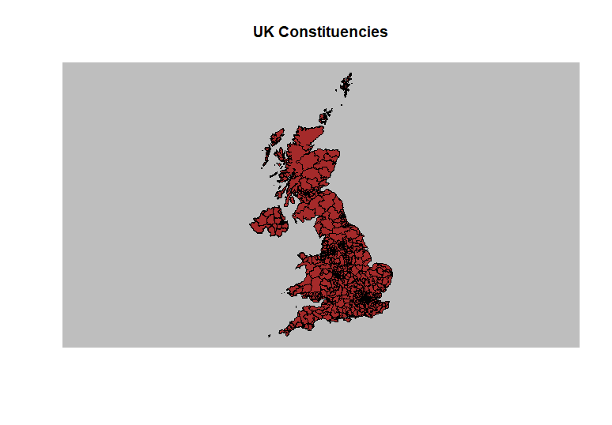

Check what the coordinate reference system is, and change it to EPSG: 4326 if it is not already **(use "+proj=longlat +datum=WGS84" to create a CRS object for EPSG: 4326. The codes for other CRS can be found using CRS("+init=epsg:xxxx"))**

Then check the attributes in the data for the spatialpolygon and plot the constituencies coloured by the first party in each one, as below. **(some relevant colour codes ('#013056', '#304e52', '#00cd00', '#808080', '#cd1500', '#ec9e0a', '#299220', '#002600', '#7fff7f', '#eaec08', '#ec08b4', '#63145f', '#00e5e5')**

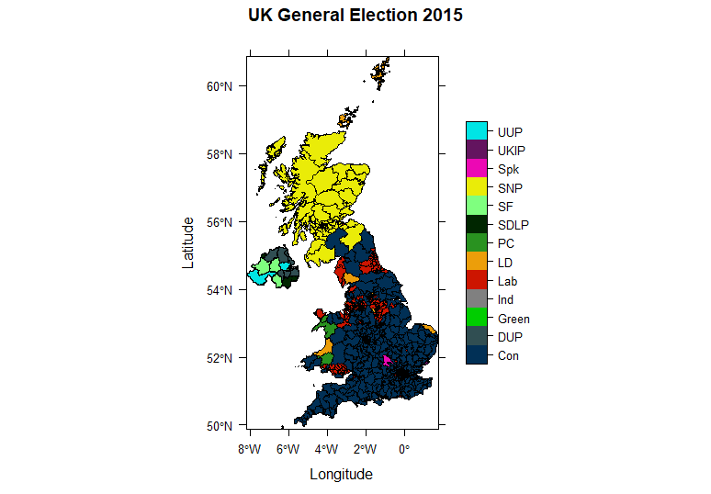

Look at the rest of the attributes in ‘Constits’. See if you can create a map showing the turnout of the electorate in each constituency, and then compare it to the winning party. **(remember the ‘ncol’ argument in grid.arrange())**

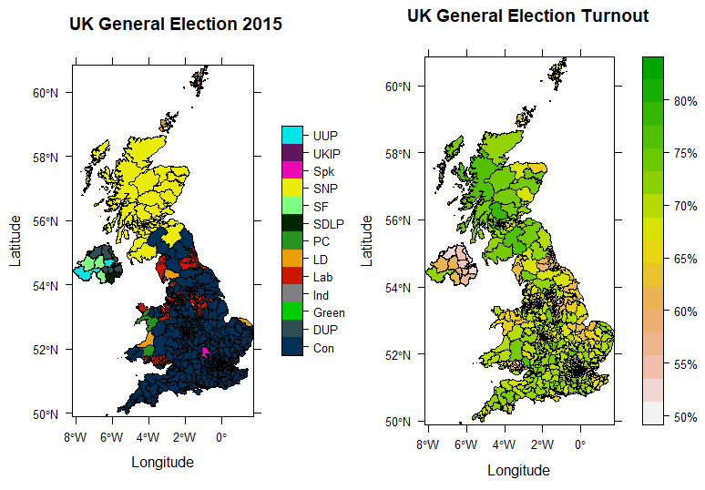

Try to plot the percentage of the population in each constituency that lives in an urban setting, and compare this to the first party in each constituency **(urban population was not available for Northern Ireland, so you’ll need to import the GB dataset. Some relevant colour codes '#013056', '#00cd00', '#cd1500', '#ec9e0a', '#299220', '#eaec08', '#ec08b4', '#63145f')**

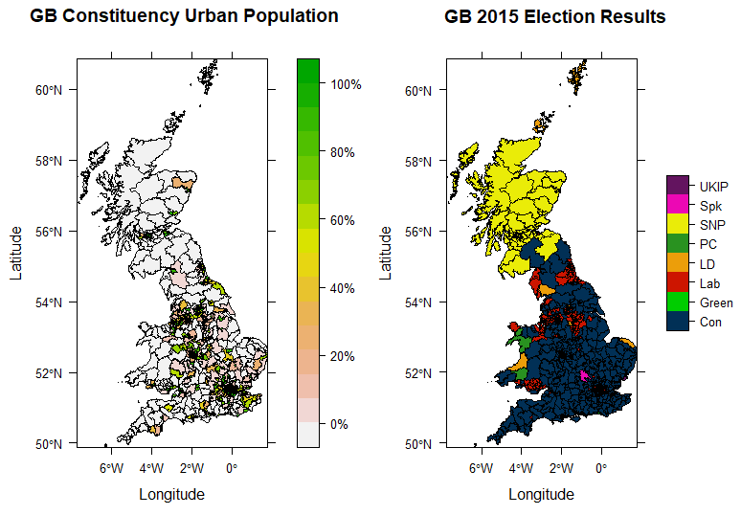

Use the Scottish Index of Multiple Deprivation data to plot the SIMD2020 against the election results of 2015. **(use different colour ramps/labels for the SIMD map if you prefer)**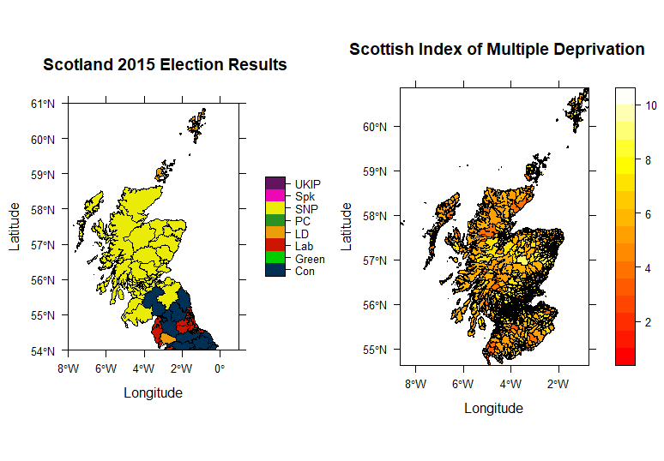

Finally, try to add some points to the plots. Use the ‘Cities’ data in the practical folder.

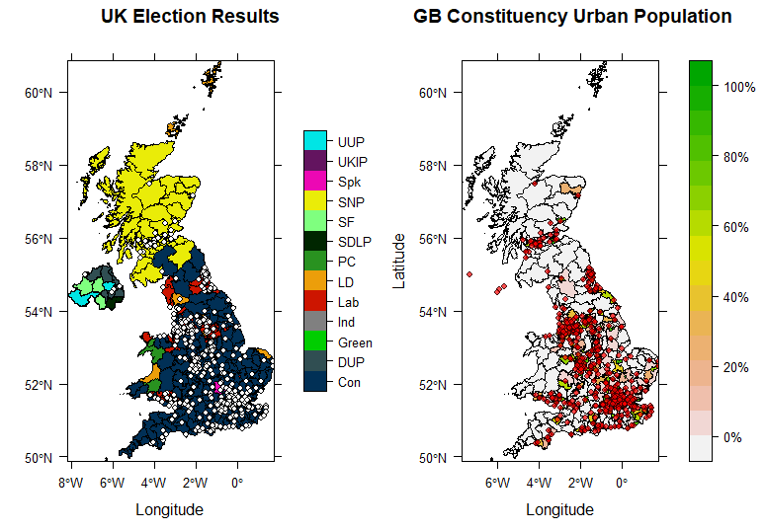

Feel free to play around with the various datasets (or especially your own!) using some of these methods/techniques. As is always the case, if there is something extra you would like to try and do with this, I am always happy to answer any questions. Other than that, Googling a query is almost always helpful.