**R & QGIS: Integrating Statistical and Spatial Data Analysis**

We now know how to visualise, manipulate and even generate new statistical data from shapefile in QGIS.

In this practical, we will use the same data from last week, but in QGIS, to see how we can understand the visualisation and analytical capacities of each of the two software. As with last week, if there are any issue or questions, message on the Teams channel. The Powerpoint should also help, but of course there isn’t code to copy and paste this time!

**Visualisation, manipulation and generation of data in QGIS**

Import the constituencies shapefile into QGIS and join it with the Election_Results.csv. Try to label the Constituencies with their names, as below.

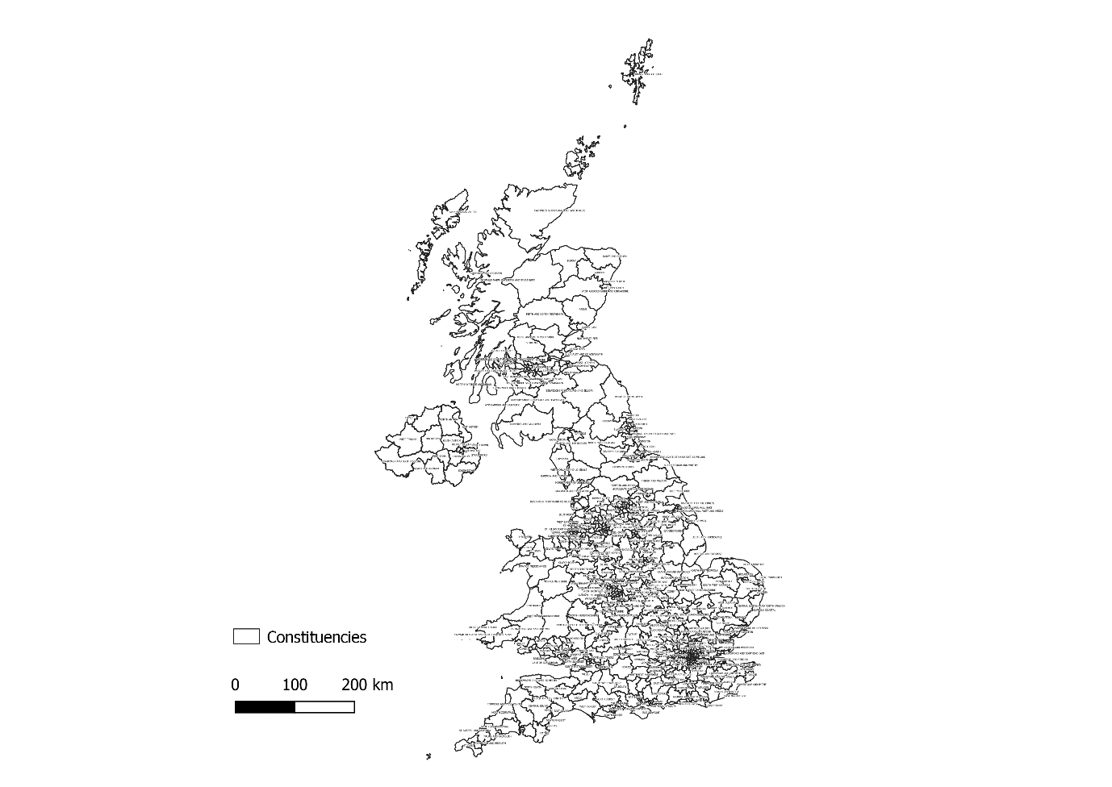

Obviously the labelling here doesn’t tell us very much. Try importing ‘Election_Results.csv’ and joining it with the Constituencies shapefile. Now see if you can replicate the map below, showing the winning parties in each constituency. **(Some *familiar* colours: Con-'#013056', DUP- '#304e52', Green-'#00cd00', Ind-'#808080', Lab-'#cd1500', LD-'#ec9e0a', PC-'#299220', SDLP-'#002600', SF-'#7fff7f', SNP-'#eaec08', Spk-'#ec08b4', UKIP-'#63145f', UUP-'#00e5e5')**

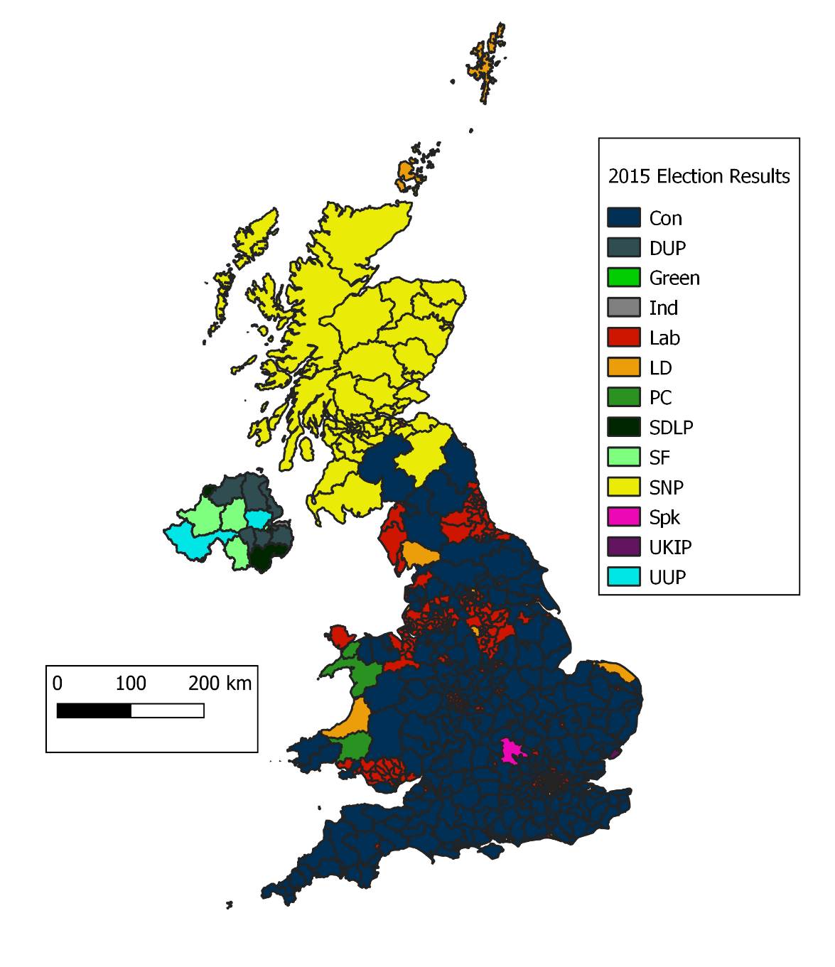

Ok, now we already have a map that looks of similar quality to those we made last week. But what else can we do in QGIS?

Using the extra data you have joined from ‘Election_Results.csv’, see if you can replicate the map below, showing the size of the margin each constituency was won by, through the size of the features label. **(remember to join the correct data and create some rules. Adjust the fill line width as needed)**

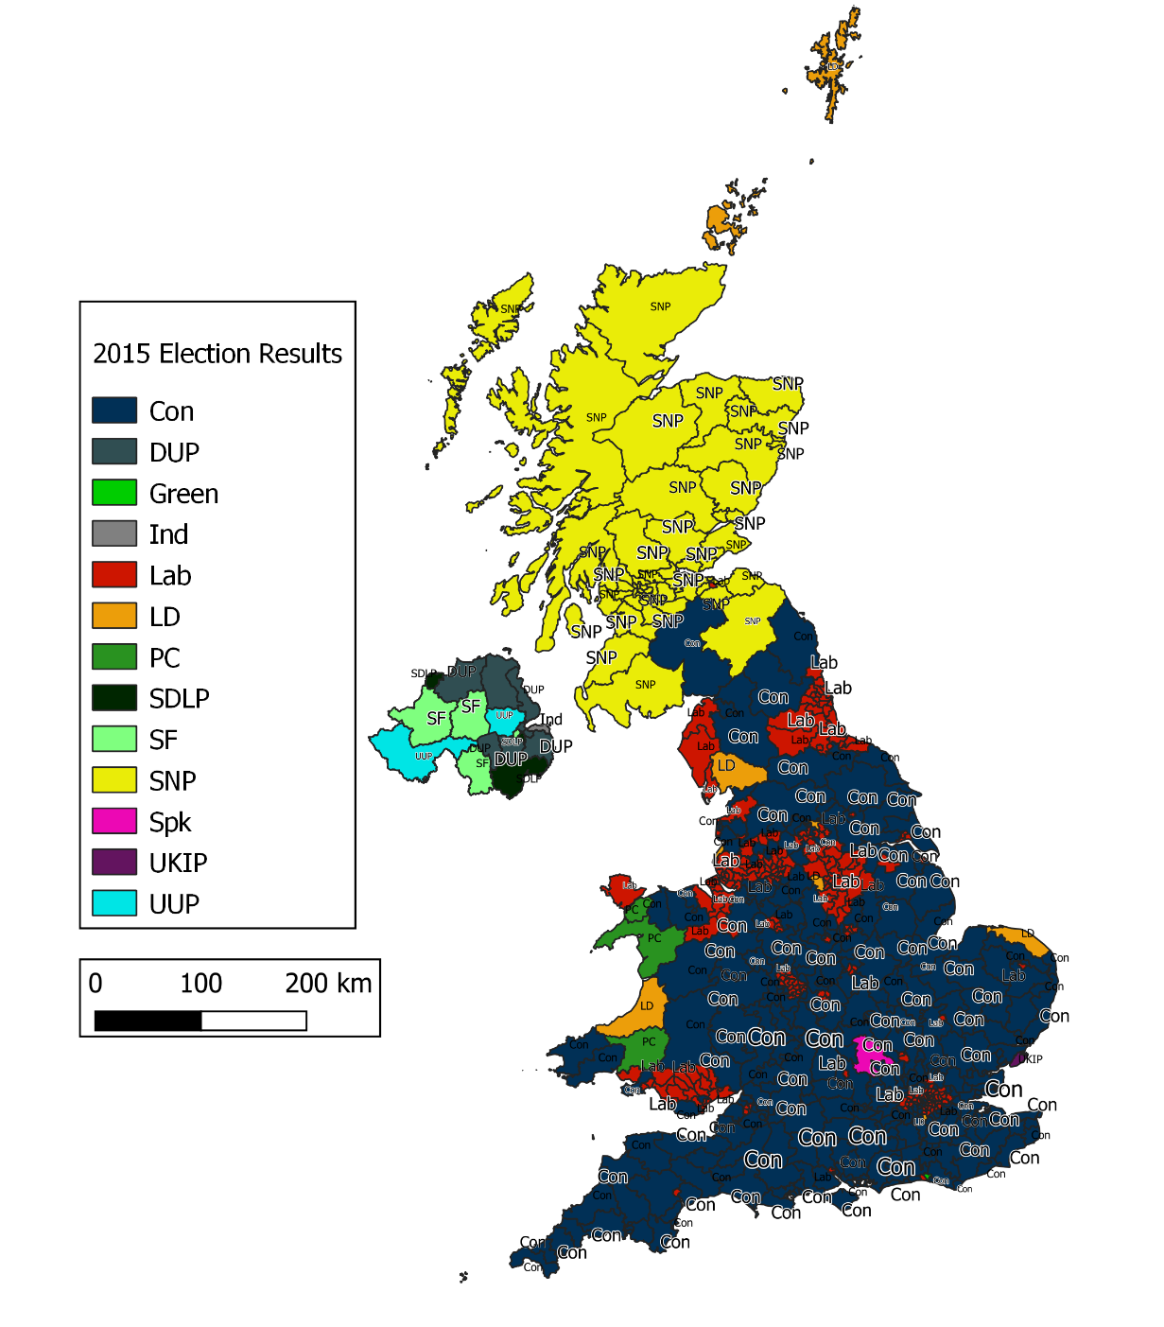

Now lets have a look at turnout and creating a gradient colour ramp based on this. **(I’ve removed the turnout attribute, so you’ll have to use the field calculator to create a new field! You may need to export a new shapefile with the join data rather than altering the .csv)**

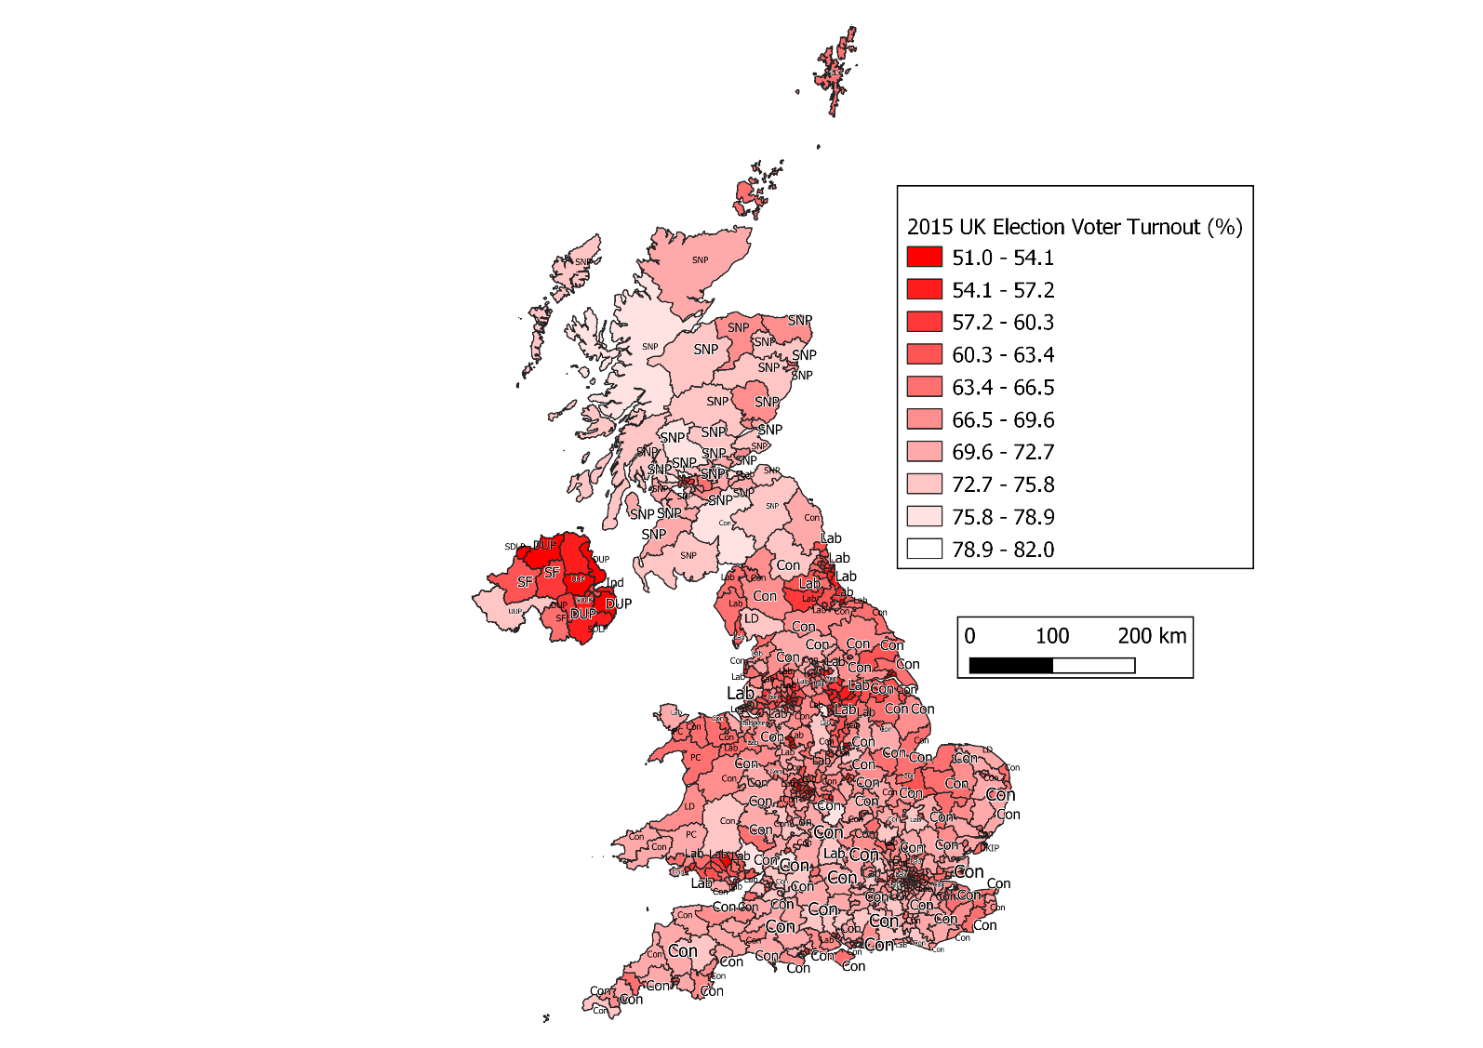

What if we want to know where each party has its biggest win? Try using the field calculator and maximum() to show each parties largest majority.

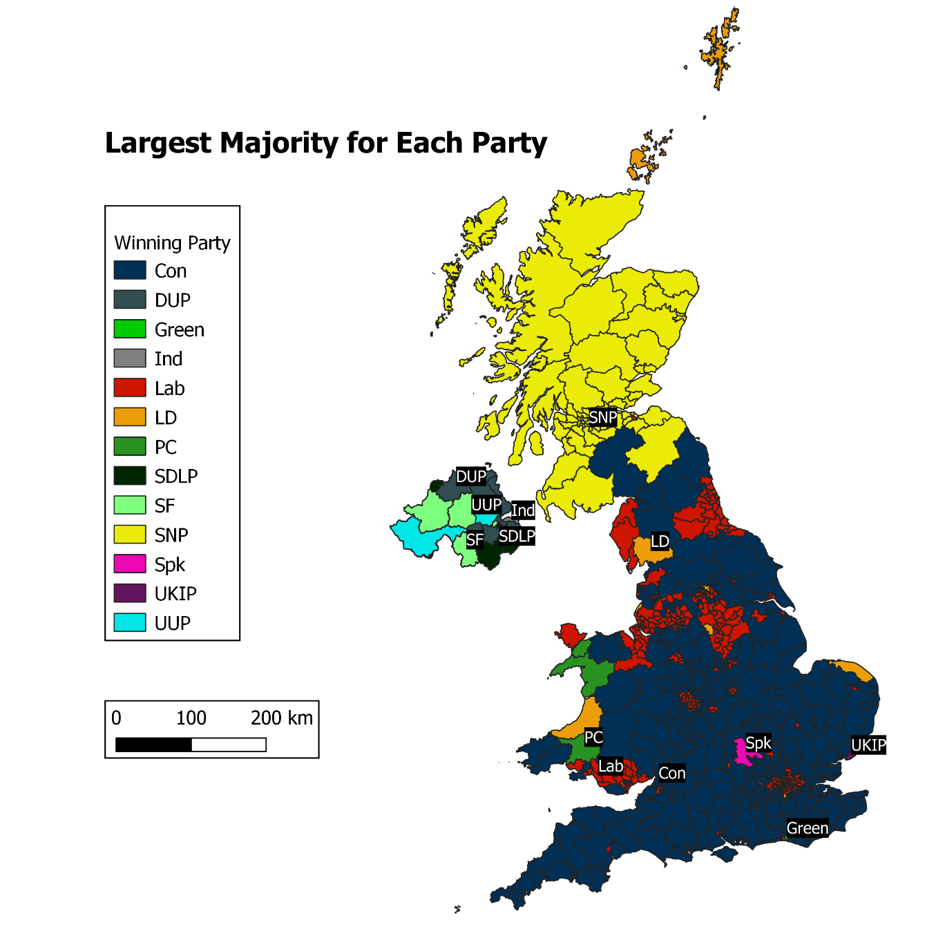

Finally, can you use QGIS to workout which party has the most cities within their overall winning constituencies and compare them all in R? Try to replicate some of the plots below (but with labels!). This will be good preparation for the final week where we will be working between R and QGIS much more. **(You’ll have to import the cities data and clip the points with the constituency polygons by first party, and then use basic ggplot (or plot) in R)**



