Document Version:

1.0

Author Information:

Karun Thankachan (thankachankarun639@gmail.com)

Kruthika Suresh Ved

(kruthika.ved@gmail.com)

July 24th, 2014

­Sentiment Analyzer

Breaking down live twitter feed into simple representations.

SECURITY WARNING

The information contained herein is proprietary to Dell Inc. and must not be disclosed to non-Dell personnel. The recipient of this document, by its retention and use, agrees to protect the information contained herein.

Readers are advised that this project may be subject to the terms of a non-disclosure agreement.

DO NOT DISCLOSE ANY OF THIS INFORMATION WITHOUT OBTAINING PERMISSION FROM THE MANAGEMENT RESPONSIBLE FOR THIS DOCUMENT.

Contents

1 Document Revision History 2

2 Document Approval History 2

3 Scope of the Design 3

4 Application Architecture 3

5 Technologies 4

6 Design 5

7 Business value 8

# Document Revision History

The revision history shows the history for this Business Requirements Document and provides descriptions of particular changes made.

|  |  |  |  |  |
| --- | --- | --- | --- | --- |
| Date | Version | Section/Page | Update Description | Contact Name |
| 24th July, 2014 | 0.1 | All |  | Karun Thankachan  Kruthika Ved |
|  |  |  |  |  |
|  |  |  |  |  |

# Document Approval History

The section tracks the review and approval of this Technical Design Document. This is also the list of who has authority to approve changes in the document.

| Name | Role | Date | Responsibility |
| --- | --- | --- | --- |
|  |  |  |  |
|  |  |  |  |
|  |  |  |  |
|  |  |  |  |

# Scope of the Design

An NLP based analysis of social networks, customer survey and feedback to get the sentiment towards various Dell products / services.

The end result is that huge amount of data is broken into easily interpretable representations like graphs and heat maps, helping to better respond to customer reviews.

# Application Architecture

The following diagram depicts the architecture of this initiative. The tweets gathered via Twitter API are passed to the database after some initial filtering (via python). This data is accessed by PHP on AJAX request triggered by the User. The data is filtered by Google APIs or custom APIs to obtain necessary JSON sent to the client side.

The sentiment analyzer, the core of the project is run as a sub-process by PHP on certain request to generate necessary data. The architecture framework utilized is client-server architecture to reduce load on the server and divide part of the work onto the client side.

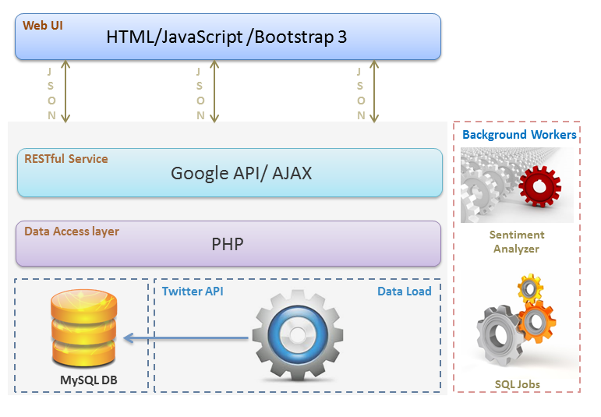

# Technologies

* NLTK -- Text Processing
* SentiWordNet -- Word sentiment
* Google Maps JavaScript API v3 Geocoding Service -- Resolving location of tweet
* Twitter API -- Collecting data
* Google Chart API – for making Graphs
* HTML5
* CSS (Bootstrap)
* Python

# Design

## Sentiment Analyzer Design

## 

## Web UI design

## 

## Index Page Sequence Diagram

## 

## Tweets/Search Page Sequence Diagram

## 

## 

## Sequence Diagram for Plots and HeatMap pages

# Business value

## Huge amount of data broken into easily interpretable representations, helping to better respond to customer reviews.

## Improve customer relationship, thereby bettering NPS and brand value

## Real-time control-center representation of data, to monitor during major announcements.

The One-Shot Views are depicted as follows

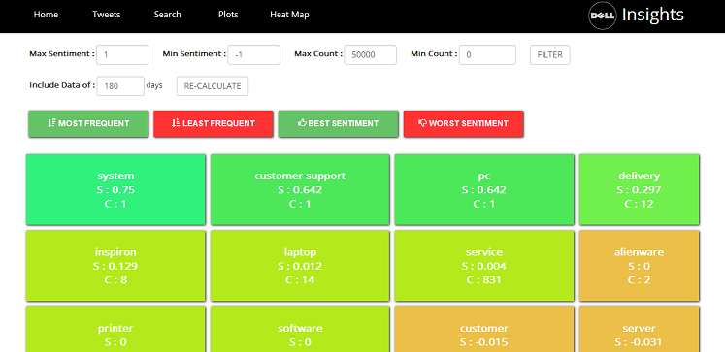

Keyword-specific sentiment

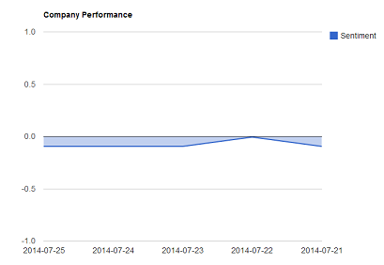

The company performance

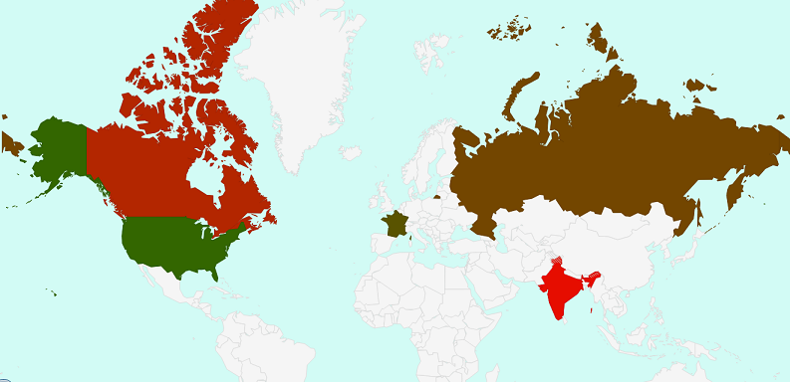

The sentiment on the company on a global scale heat mapped from red to green

The entire project code is available on Github

<https://github.com/DCSGInterns/NLP>