

Assignment 2

DARREN CHIA XIN YANG (U2323231A)
CHEN SHELLEY LI QI (N2500373B)
MAI TAM THANH (N2500378J)
QIAO SARAH YIXIN (N2500377A)
HANG BILLIE BINRU (N2500362G)

Contents
INTRODUCTION 4
SYSTEM ARCHITECTURE 4
DATA FLOW 5
KEY ALGORITHMS 5
QEP AND AQP RETRIEVAL (preprocessing.py) 5
get_qep (Retrieval of Query Execution Plan) 5
get_aqps (Generating Alternative Query Plans) 6
get_plan_nodes (DFS Traversal of Plan Tree) 7
SQL FRAGMENT EXTRACTION (annotation.py) 7
ANNOTATION ENGINE (annotation.py) 8
SCAN NODE ANNOTATION 9
JOIN NODE ANNOTATION WITH COST COMPARISON 9
AGGREGATE AND SORT ANNOTATION 10
GRAPHICAL USER INTERFACE 11
Architecture 11
PANELS AND FUNCTIONALITY 11
ANNOTATED SQL VIEW GENERATION 12
LIMITATIONS 13
AQP Generation Granularity 13
AQP infeasibility 13
SQL Fragment Matching 13
Join Annotation Deduplication 14
Cost Model Dependency 14
INSTRUCTIONS TO RUN SOFTWARE 14
Prerequisites 14
Installation 14
Execution 14
USE OF AI TOOLS 14
Project Repository 15

INTRODUCTION
This report describes the design and implementation of a Query Plan-Based SQL Annotation Tool developed for SC3020 Database Systems Principles (Project 2). The tool assists users, including those relying on AI-generated SQL in understanding how the PostgreSQL query optimizer executes their queries and why specific operators are selected over alternatives.
The system automatically annotates an input SQL query by:
- Retrieving the Query Execution Plan (QEP) from PostgreSQL using EXPLAIN.
- Generating representative Alternative Query Plans (AQPs) by selectively disabling planner operators (e.g., hash join, sequential scan).
- Analyzing and comparing cost estimates across the QEP and AQPs.
- Producing natural-language annotations attached to specific SQL fragments, explaining what operator is used and why
- Presenting results through an interactive PyQt5 GUI

SYSTEM ARCHITECTURE
The application follows a modular three-component architecture
Module | File | Responsibility
Frontend / GUI | interface.py | PyQt5 desktop interface; query input, QEP tree, annotated view, AQP cost table
Annotation Engine | annotation.py | Parses SQL and QEP nodes; generates natural-language annotations with cost comparisons
Preprocessing | preprocessing.py | Database connectivity; EXPLAIN calls; AQP generation; table statistics retrieval
Entry Point | project.py | Launches the GUI via open_gui()

DATA FLOW
The end-to-data flow is as follows:
- User enters connection credentials in the DB settings dialog and clicks Connect. The system calls test_connection() in preprocessing.py to verify the connection.
- User pastes or types an SQL query into the editor panel and clicks Annotate Query.
- The GUI spawns an AnnotationWorker (AW) on a background QThread to avoid blocking the UI
- Preprocessing: get_qep() issues EXPLAIN (FORMAT JSON) to retrieve the QEP. get_aqps() generates six AQPs by disabling pairs of join and scan operators. get_all_table_stats() queries pg_class and pg_indexes for row estimates and index metadata.
- Annotation: AnnotationEngine traverses all QEP nodes, matches each node type to an annotation handler, and assembles a deduplicated list of Annotation objects.
- The finished signal returns annotations, the QEP dict, and an AQP cost summary to the GUI, which renders the QEP tree, annotated SQL view, annotation detail list, and AQP comparison table.

KEY ALGORITHMS

QEP AND AQP RETRIEVAL (preprocessing.py)

get_qep (Retrieval of Query Execution Plan)

PostgreSQL’s EXPLAIN statement is invoked with FORMAT JSON to return a machine-readable plan:

EXPLAIN (FORMAT JSON, ANALYSE FALSE, VERBOSE FALSE)<query>;

The function returns result which is the whole tuple and result[0][0] unwraps the list to get the actual plan dictionary, which is the top-level plan dictionary. ANALYSE FALSE is used so that the query is not actually executed; only cost estimates are retrieved. This keeps annotation fast even for expensive queries.

get_aqps (Generating Alternative Query Plans)
AQPs are generated by exploiting PostgreSQL’s planner method configuration flags (enable_hashjoin, enable_mergejoin, enable_nestloop, enable_seqscan, enable_indexscan, enable_bitmapscan). By disabling operators’ pair, the planner is forced to choose a specific alternative.
Six ACP configurations are generated, three for join types and three for scan types
Configuration | Operators Disabled | Forced Operator
Forced Nested Loop | enable_hashjoin=off, enable_mergejoin=off | Nested Loop Join
Force Merge Join | enable_hashjoin=off, enable_nestloop=off | Merge Join
Force Hash Join | enable_mergejoin=off, enable_nestloop=off | Hash Join
Force Index Scan | enable_seqscan=off, enable_bitmapscan=off | Index Scan
Force Seq Scan | enable_indexscan=off, enable_bitmapscan=off | Sequential Scan
Force Bitmap Scan | enable_seqscan=off, enable_indexscan=off | Bitmap Heap Scan

set_planner_options() with SET <settings> = <value>; and are reset after each AQP is retrieved with reset_planner_options(). This plan cost of each AQP is extracted from the root node’s Total Cost Field. If a plan is not possible under a given configuration, the error is recorded as “None”.

get_plan_nodes (DFS Traversal of Plan Tree)
QEP nodes are extracted by a depth=first traversal of the nested plan dictionary:
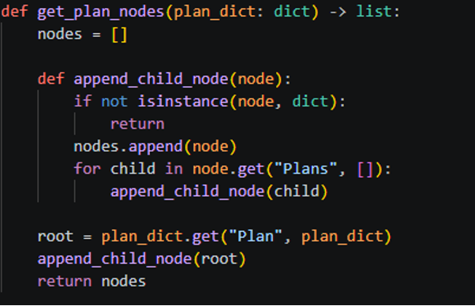
The resulting list contains every operator node in pre-order (parent before children). This is used both for annotation and for computing the minimum AQP join cost across all nodes.

SQL FRAGMENT EXTRACTION (annotation.py)
For each annotated operator, the engine must link the annotation back to a fragment of the original SQL query so the GUI can highlight the relevant cause
Annotation Category | Fragment Extraction Strategy
SCAN | Regrex search for the relation’s name in the SQL string. A 5-character prefix and 10-character suffix are included for context.
JOIN | Regrex search for a JOIN … ON clause; falls back to the WHERE clause if no explicit JOIN syntax is found.
SORT | Regex search for the ORDER BY keyword and up to 80 trailing characters.
AGGREGATE | Regex search for aggregate function calls (COUNT, SUM, AVG, MIN, MAX); falls back to GROUP BY clause.
LIMIT | Regex search for the LIMIT keyword.
SUBQUERY | Fixed fragment: (SELECT …).
MATERIALISE | Empty fragment (internal planner node with no direct SQL counterpart)

Example:
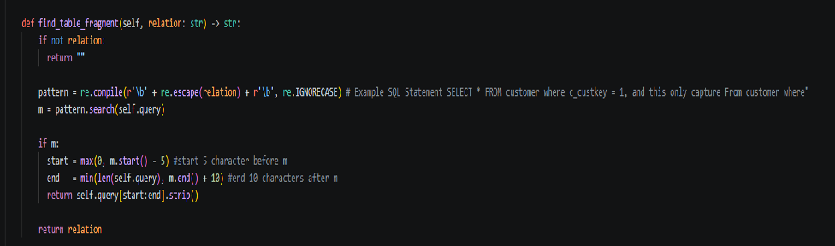

ANNOTATION ENGINE (annotation.py)
The AnnotationEngine.annotate() method is the core algorithm. It processes every node returned by get_plan_nodes() and deduplicates annotations by (category, operator) key, keeping the most expensive occurrence:

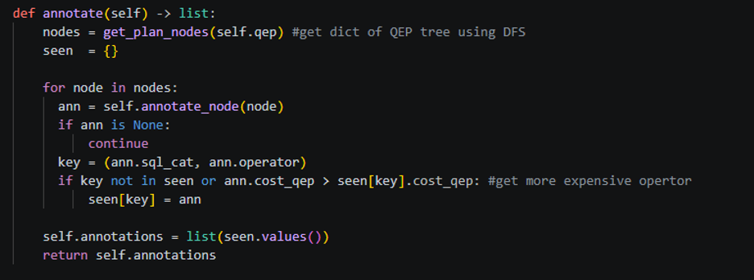
Deduplication is important because a QEP may contain multiple sequential scans or hash joins the annotation surfaces are the most significant one. annotate_node() dispatches to one of seven specialist handlers based on Node Type.

SCAN NODE ANNOTATION
explain_scan_node() produces scan explanations that are aware of table index metadata retrieved from pg_indexes:
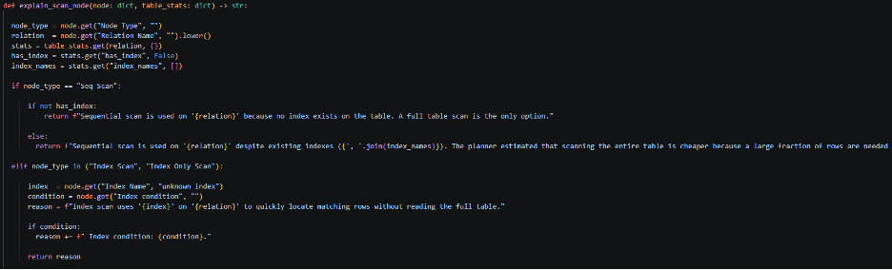
This produces explanations that not only name the operator but also explain the optimizer’s reasoning in terms of index availability and selectivity.

JOIN NODE ANNOTATION WITH COST COMPARISON
explain_join_node() compares the QEP join cost against the costs of alternative join operators computed from the AQPs:
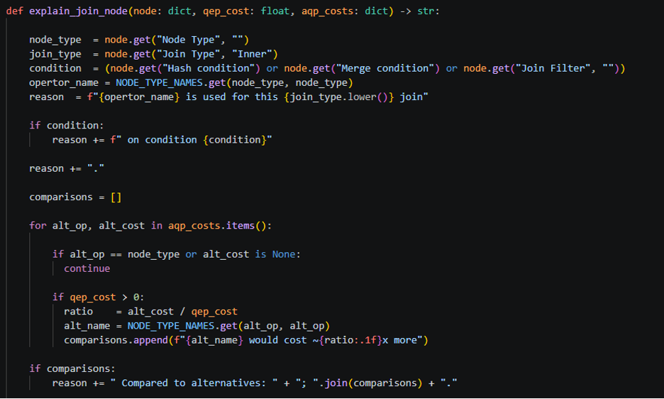

In compute_aqp_join_costs(), the AQP join costs are computed by scanning all AQP plans and saving the minimum costs observed for each join type. For instance, the ratio explains to the user why Hash Join was selected instead of Merge Join.

AGGREGATE AND SORT ANNOTATION
Aggregate nodes are annotated based on their Strategy field (Hashed vs. Sorted) and cross-referenced with the presence of GROUP BY and aggregate functions in the SQL string, detected by regex:
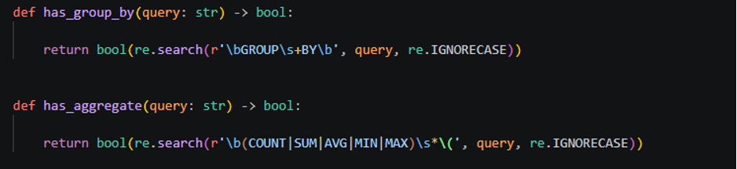
Sort nodes are similarly cross-referenced with ORDER BY detection, distinguishing between user-requested sorts and internal sorts introduced by the planner to satisfy downstream operators (e.g., Merge Join input requirements).

GRAPHICAL USER INTERFACE

Architecture
The GUI is built with PyQt5. Annotation retrieval is offloaded to a background QThread via the AnnotationWorker class to prevent UI freezing during potentially slow database operations. Worker, GUI communication uses Qt signals:
- finished – emits (annotations, qep, aqps_summary) on success
- error – emits an error message string on failure

PANELS AND FUNCTIONALITY
Panel | Description
Toolbar | DB Settings button (opens ConnectionDialog), Connect button with status indicator, Annotate Query button, Clear button
SQL Editor | QPlainTextEdit for entering SQL queries; monospaced font for readability
QEP Tree | QTreeWidget displaying the operator tree; nodes colour-coded by type (blue=join, green=scan, brown=sort, purple=aggregate); click for detailed metadata
Annotated View | HTML-rendered view showing the SQL with highlighted fragments and colour-coded annotation cards below
Annotated Details | Detailed breakdown of each annotation: operator, SQL fragment, reason, QEP cost, alternative costs
AQP Comparison | HTML table listing all six AQP configurations with their estimated total costs, highlighting the QEP row in green
Raw QEP JSON | Pretty-printed raw JSON output of the EXPLAIN result for advanced inspection

ANNOTATED SQL VIEW GENERATION
The annotated view is produced by generated_annotated_view(). Each annotations SQL fragment is HTML-escaped and wrapped in a coloured span with a bottom border. JOIN annotations are excluded from fragment highlighting (as join conditions often span multiple lines.) below the SQL, a colour-coded card table lists each annotation’s category, operator, fragment and reason.

WALKTHROUGH
Consider the following SQL query
SELECT n_name, SUM(l_extendedprice*(1-l_discount)) AS revenue
FROM customer, orders, lineitem, supplier, nation, region
WHERE c_custkey = o_custkey
AND l_orderkey = o_orderkey
AND l_suppkey = s_suppkey
AND c_nationkey = s_nationkey
AND s_nationkey = n_nationkey
AND n_regionkey = r_regionkey
AND r_name = ‘ASIA’
AND o_orderdate >= ‘1994-01-01’
AND o_orderdate < ‘1995-01-01’
GROUP BY n_name
ORDER BY revenue DESC;

The system would produce annotations such as:
Category | Operator | SQL Fragment | Explanation (Summary)
SCAN | Sequential Scan | region | No index on region; full scan is the only option.
SCAN | Index Scan | lineitem | Index on l_orderkey used to avoid full table scan.
JOIN | Hash Join | WHERE c_custkey = o_custkey | Hash Join chosen; Merge Join estimated ~12.3x more expensive.
AGGREGATE | Hash Aggregate | SUM | In-memory hash table on group keys; satisfies GROUP BY.
SORT | Sort | ORDER BY | Sort on revenue DESC corresponds to ORDER BY clause

LIMITATIONS

AQP Generation Granularity
The current approach to generating AQPs disables operator types globally for the entire query using SET enable_* commands. This means it is not possible to force a specific join type on one join while using a different type on another. With the current approach you cannot generate that specific mixed plan. You can only generate either all hash join, merge join, or nested loop.

AQP infeasibility
Some AQP configurations may be rejected by PostgreSQL as infeasible (e.g., forcing an Index Scan on a table with no index). In these cases, the plan is recorded as “None” and the AQP table displays “N/A”. The annotation engine handles “None” costs gracefully by omitting them from cost ratios.

SQL Fragment Matching
SQL fragment extraction relies on regular expressions applied to the raw SQL string. This approach may produce suboptimal fragments for complex or deeply nested queries. In particular:
- Aliased tables are resolved via a simple alias-to-table dictionary; aliases within subqueries may not be correctly identified.
- Correlated subqueries and CTEs (WITH clauses) are not explicitly handled
- Queries containing string literals that resemble keywords (e.g., a table named ORDER) may confuse the regex patterns.

Join Annotation Deduplication
Because the deduplication key is (sql_cat,operator), only one Hash Join annotation is surfaced even if the query contains multiple hash joins on different tables. The kept annotation is the most expensive one, which is generally the most informative, but information about cheaper joins is discarded.

Cost Model Dependency
Every cost comparison is made against PostgreSQL’s internal cost model which considers sequential/random page costs, CPU tuple costs, etc. the model is an approximation and has the potential to miss estimating actual execution times, particularly on systems with customised storage features, uncached data, or other non-default characteristics.

INSTRUCTIONS TO RUN SOFTWARE

Prerequisites
- Python 3.8 or above
- PostgreSQL server running locally or remotely
- Python packages: psycopg2, PyQt5
- TPC-H database loaded into PostgreSQL (see Appendix of project specification)

Installation
pip install psycopg2-binary PyQt5

Execution
python project.py

USE OF AI TOOLS
Large Language Model tools (ChatGPT) were used in the following limited capacities:
- Grammar and phrasing review of report text.
- Generating repetitive boilerplate code such as the node symbol mapping table (NODE_TYPE_NAMES dictionary) and routine if-else dispatch branches
All core algorithmic components including the annotation engine, AQP generation logic, SQL fragment extraction, QEP tree traversal, and GUI design were designed and implemented by the team.

Project Repository
Project file can be found on https://github.com/DCXY1997/SC3020

