1. According to the World Health Organization (WHO), CVDs are responsible for an estimated 17.9 million deaths annually, representing approximately 32% of all global mortality (World Health Organization, 2021) 是否真实，32%是WHO写出来的，还是怎么计算的
2. Analyzing a standard CMR cine sequence generates hundreds of 2D slices, rendering manual annotation a highly labor-intensive process that can consume up to 30 minutes per patient (Bernard et al., 2018). 是否真实，30min是文章中写出来的，还是怎么计算的
3. The U-Net architecture (?),这里的ref没有引用上
4. While deep stacking of convolutional layers theoretically expands the receptive field, empirical evidence demonstrates that CNNs struggle to intrinsically model continuous, longrange spatio-temporal dependencies这里太苍白了，什么实证，怎么证明的，要写清楚，要有对应的真实的ref，人家做了的工作我们要引用，我们自己论证一定要清晰。
5. e.g., SOTA SegResNet at 18.80M parameters是真实的吗，不加ref吗？
6. Current State-of-the-Art (SOTA) models, such as SegResNet and Swin-UNETR, demand massive parameter counts (often exceeding 18 million) and extremely high Video RAM (VRAM) to process a single patient’s scan. 每次提到都需要引用哦，不要把别人的工作当成自己的
7. Deploying a 18-million-parameter Transformer model in such environments is physically and economically unfeasible.我们前面的论证并没有提到经济上的不可行，要补上吧。
8. 2.3小节的论述太少太苍白了
9. To systematically address the critical spatio-temporal and computational limitations articulated in Chapter 2, the primary goal of this research这里的叙述有点奇怪，感觉不像围绕着我的实验，是围绕着章节和模板，我觉得这样是不对的。
10. To operationalize the primary goal, the specific engineering and analytical objectives are defined as follows:这里也是，太公式化太模板化了，太生硬，不像毕业论文诶
11. In direct alignment with the empirical objectives, this thesis seeks to answer the following core research questions through programmatic experimentation:跟第九点一样，也是一样的问题，太公式化太模板化了，太生硬。
12. 1. RQ1:这里这些标号很奇怪，都有123了，还rq123吗，我觉得保留一个即可。
提出的这三个问题在后面都解决了吗，具体体现在了实验的哪个部分？我咋没印象嘞姐姐
14. This chapter provides an exhaustive, multidisciplinary critical examination of the evolutionary trajectory of medical image segmentation.这个也是和第九点一样的问题，感觉文章中这种句子很多啊
15. For dynamic cardiac function assessment, Steady-State Free Precession (SSFP) cine-MRI is the clinical gold standard (?)
The ACDC dataset encompasses five specific pathophysiological states, each presenting unique morphological challenges for convolutional filters (?):
The subsequent introduction of the U-Net architecture (?) became the de facto standard.
A genetic disorder characterized by severe, asymmetric thickening of the myocardial wall (hypertrophy) (?).
Oktay et al. (?) proposed the Attention U-Net.
这些ref怎么都是？呢，出什么问题了
16. However, this led to the notorious degradation problem: as networks grew deeper, AI味儿太重了
17. 4.3.4、4.3.5一直到文章末尾，好像没有文献支撑
18. 4.3.4指 He et al. 残差学习，但He, K., …(2015). Delving deep into rectifiers…，没有2016 ResNet.
19.Beyond the architectural paradigm shifts from CNNs to State Space Models, the mathematical formulation of the optimization objective—the loss function—has undergone a profound evolutionary trajectory AI味有些重了
20. 图4.2的图注解释有些过于潦草了，泛泛而谈，不够详细
21. 4.5.2中A∈RN×N is the state transition matrix that dictates the memory…B∈RN×1\mathbf{B}\in\mathbb{R}^{N\times1}B∈RN×1 and C∈R1×N\mathbf{C}\in\mathbb{R}^{1\times N}C∈R1×N project the input and output和5.4.2中A∈RN×N is the critically important state transition matrix that dictates the memory decay…B∈RN×1\mathbf{B}\in\mathbb{R}^{N\times1}B∈RN×1 and C∈R1×N\mathbf{C}\in\mathbb{R}^{1\times N}C∈R1×N are learnable projection matrices 居然一毛一样
22. 式(4.11)(4.12)和式(5.9)(5.10) 两处也是一样，不知道是不是故意的写一样的
23. 5.9.2 Table1和6.4中Table 6.2感觉逻辑性不够强
24. 7.5-7.5.1这里，topological hallucinations, predicting disconnected fragments好像没有放失败的图
25. Table 6.1的Ablation (No Mamba)93.73 与Ablation (Half Mamba)80.40 这两行感觉有些逻辑矛盾
26. 7.4This proves that relying strictly on 3×3×33\times3\times33×3×3 localized……the 128-channel Mamba configuration is the absolute optimal bound 这个地方的跟27一样，也感觉逻辑怪怪的（该死的感觉哈哈哈哈）
27. 8.1结论中1、2、3、4有点儿像人机了

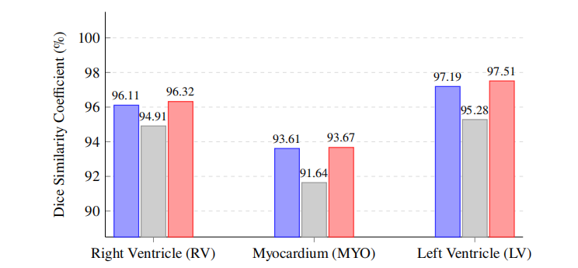
28. 这个图可以考虑改成堆叠的柱状图，我们教育学上有的，班门弄斧了
29. Milletari, F., …(2016a). V-net…565–571与Milletari, F., …(2016b). V-net…565–571 两处也是一样，不知道是不是故意的写一样的
30.参考文献较少，引用的文献年份有点老
31.unequivocally / definitively proven / absolute optimal bound / catastrophic / profound / transformative / disaster 表达好像有点儿夸张

