Service 6: Basic Understanding of Org and Space.

Intro: On SAP Cloud Platform - Cloud Foundry you will hear terms like Global account, Organization, Spaces, api endpoint. In this document we will explain those terms:

1. When you login to SAP Cloud Platform cockpit, you will see the home page which has Global Accounts. 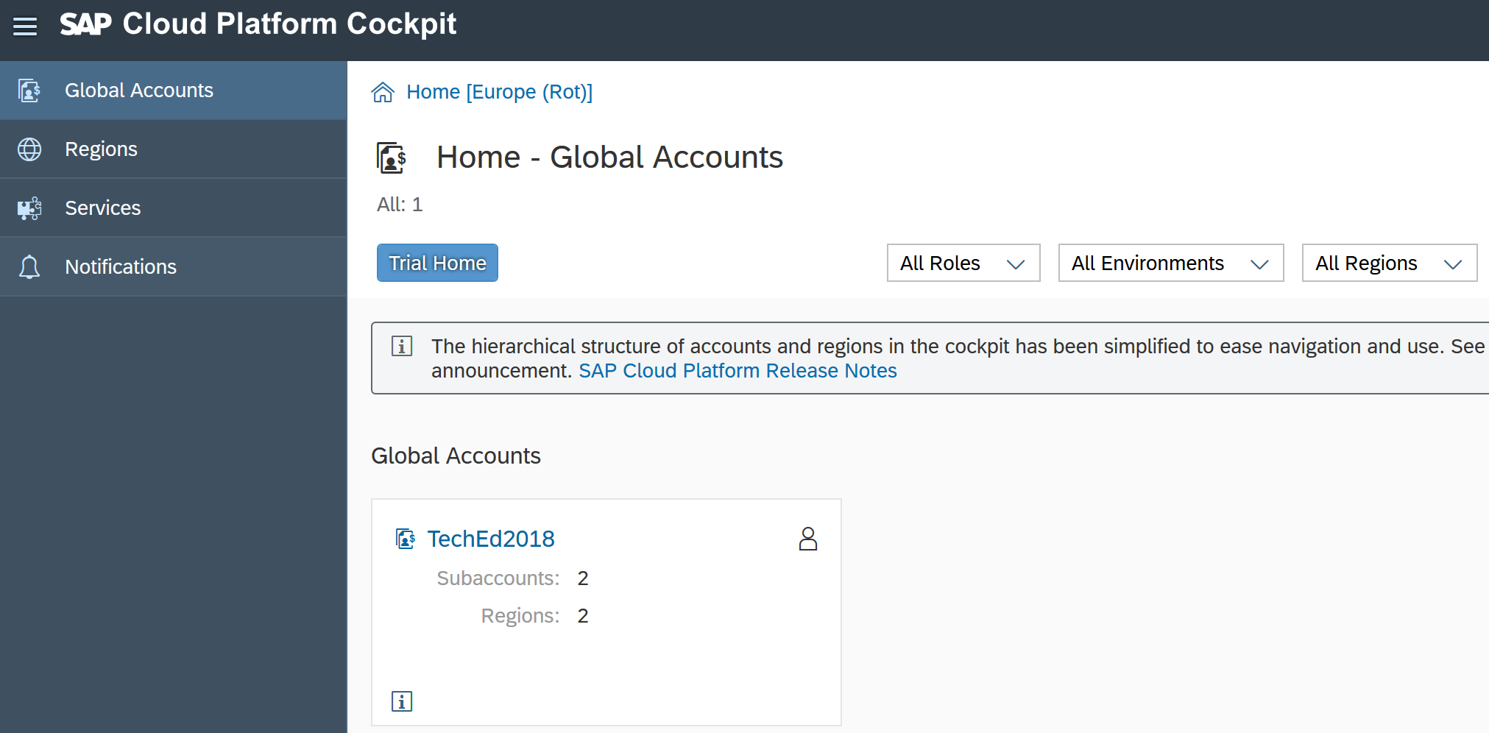

Global Accounts: Global accounts are hosted environments that represent the scope of the functionality and the level of support based on a customer or partner’s entitlement to platform resources and services.

A global account can contain one or more subaccounts in which you deploy applications, use services, and manage your subscriptions. More on [help guide](https://help.sap.com/viewer/e275296cbb1e4d5886fa38a2a2c78c06/Cloud/en-US/c165d95ee700407eb181770901caec94.html?q=global%20accounts)

1. On the left side you will see the regions on which SAP Cloud Platform is available, Services that can be used and different notifications. 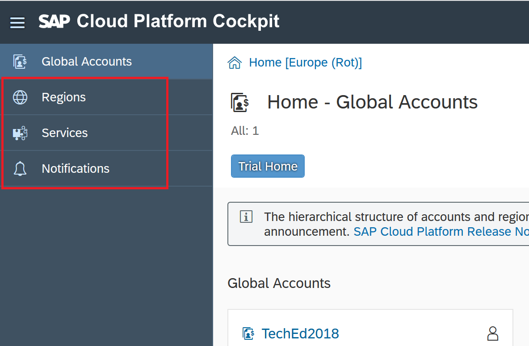
2. Click on the tile with TechEd2018. 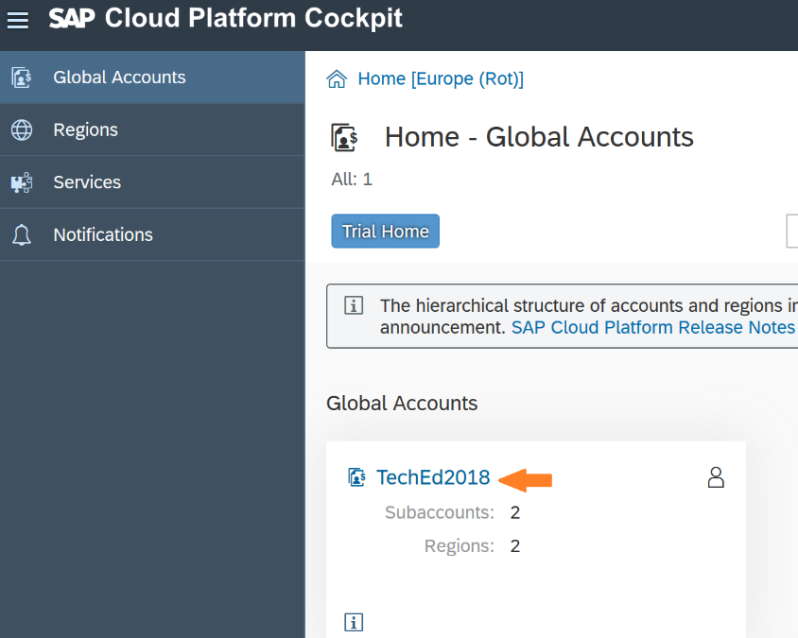
3. Here you will see the two subaccounts. OPP363 and OPP363CF. 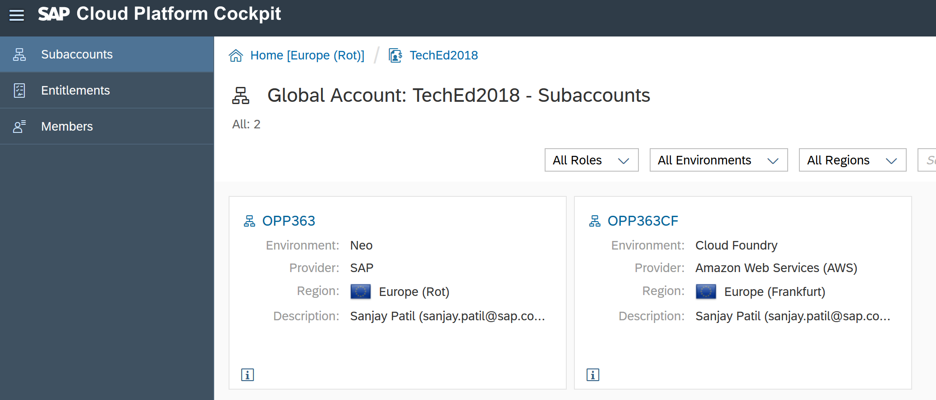

Subaccounts: Is the place where you can deploy applications, use services, and manage subscriptions on SAP Cloud Platform.

1. On left you can see the Entitlements and Members to your Global account. 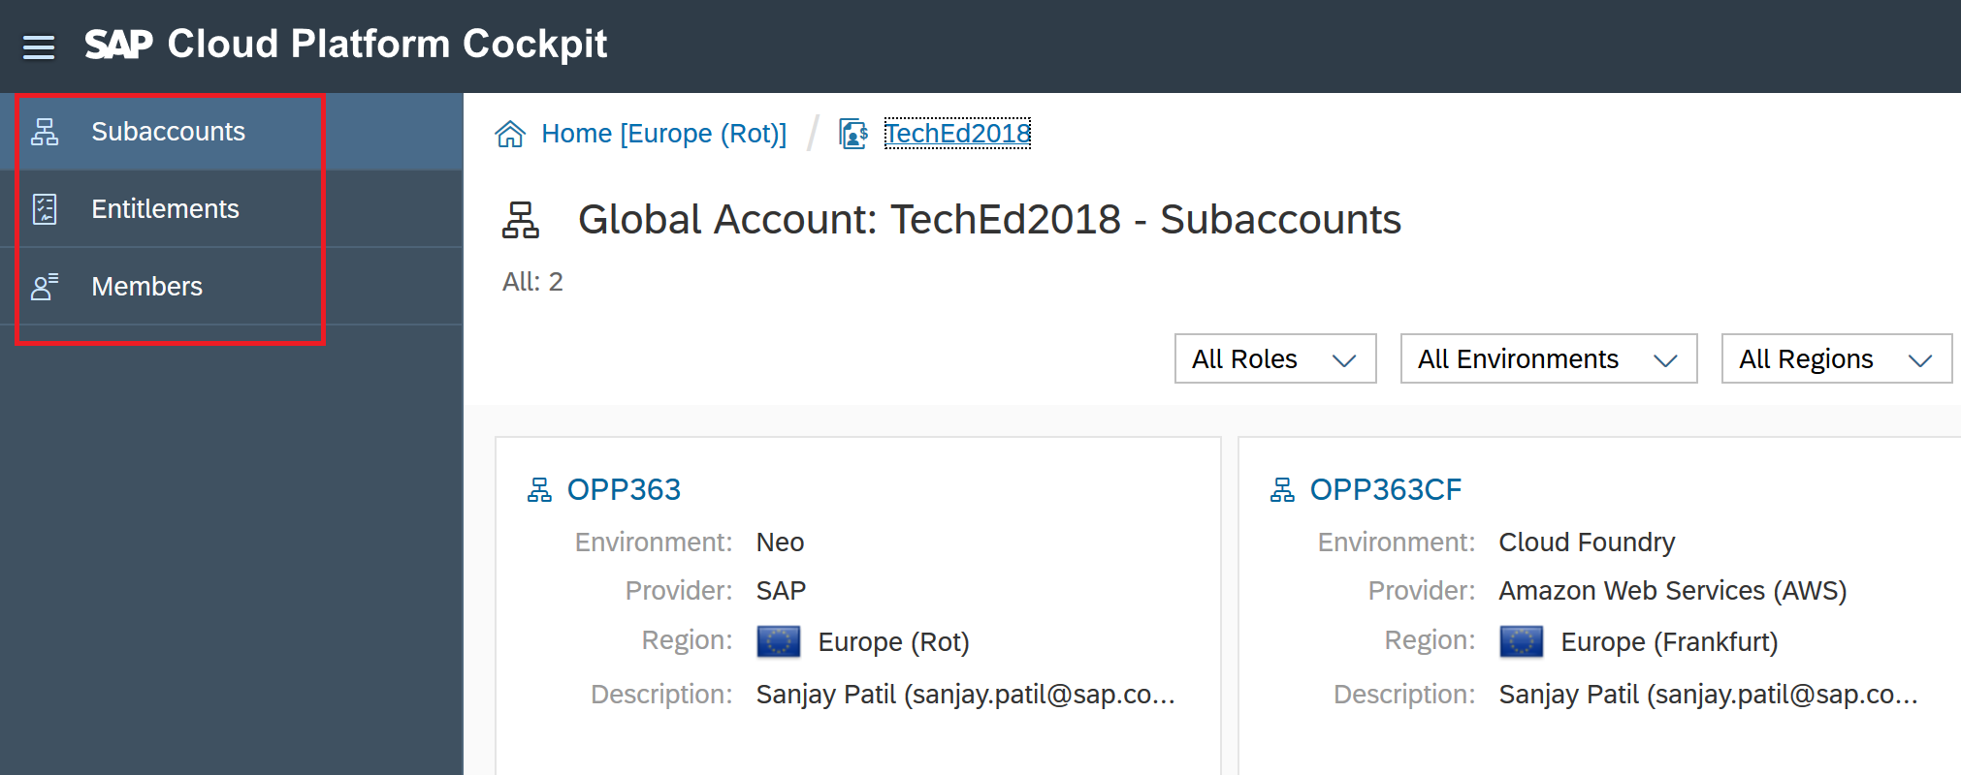
2. Click on Entitlements to see the quota available to the Global account and to which subaccount it is assigned.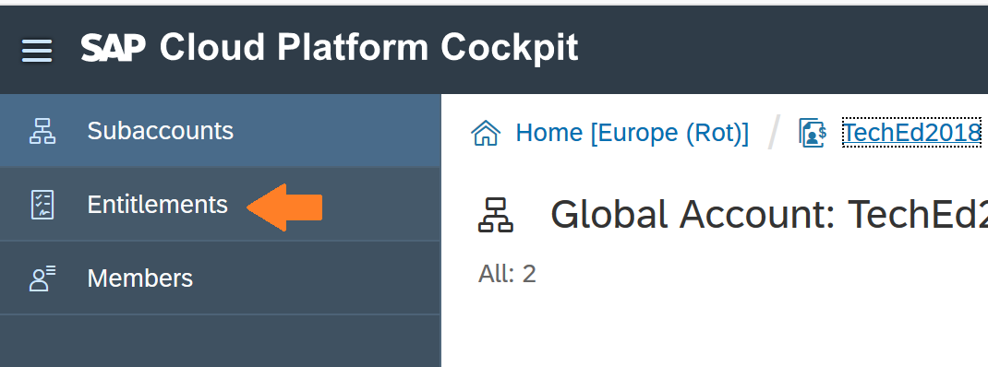

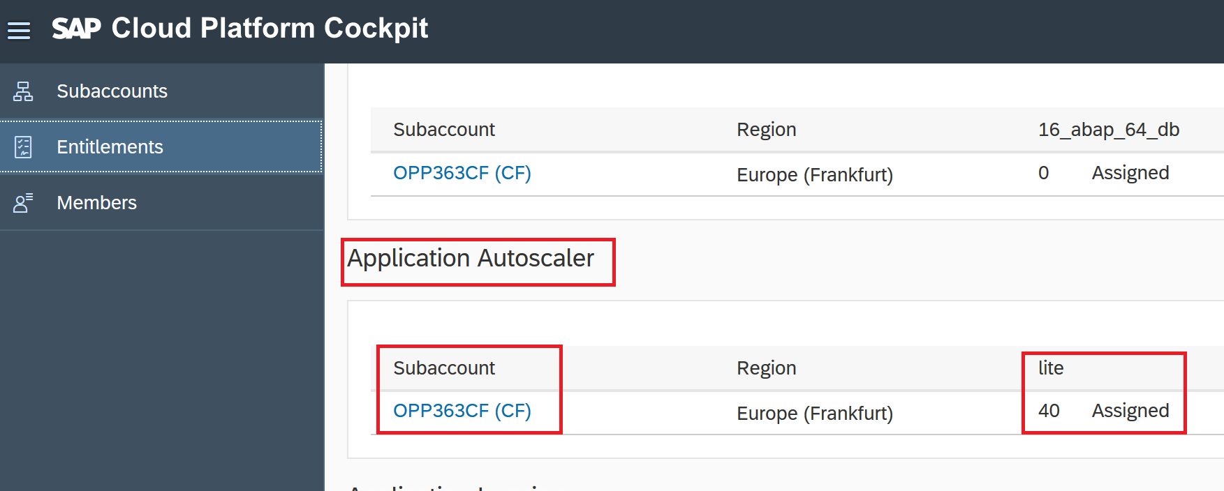

1. Click on Subaccounts to go back.
2. Click on OPP363CF to go the Organization overview page aka subaccount overview page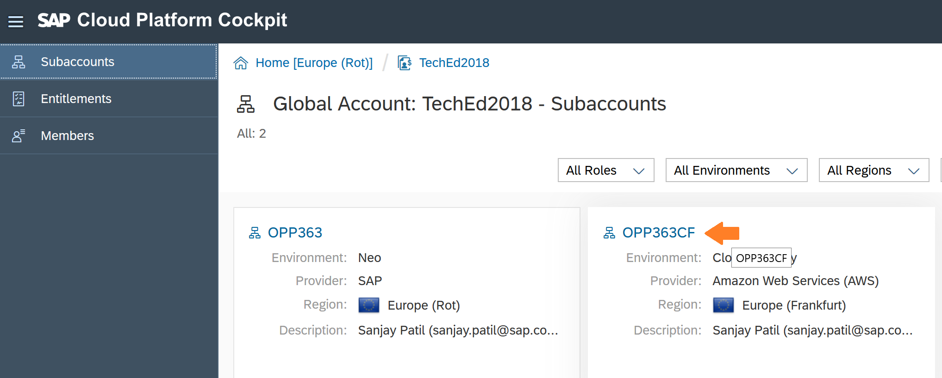

Organization: An org is a development account that an individual or multiple collaborator can own and use. It has a resource quota plan, applications, services availability, and custom domains. 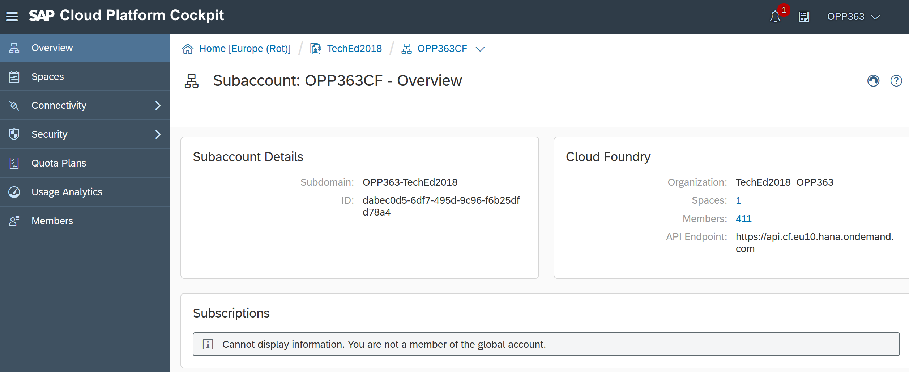

1. On left you can see the Spaces, create Destinations under Connectivity, create Roles and Trust configuration s under Security, view quota assigned to your space, and the Members. 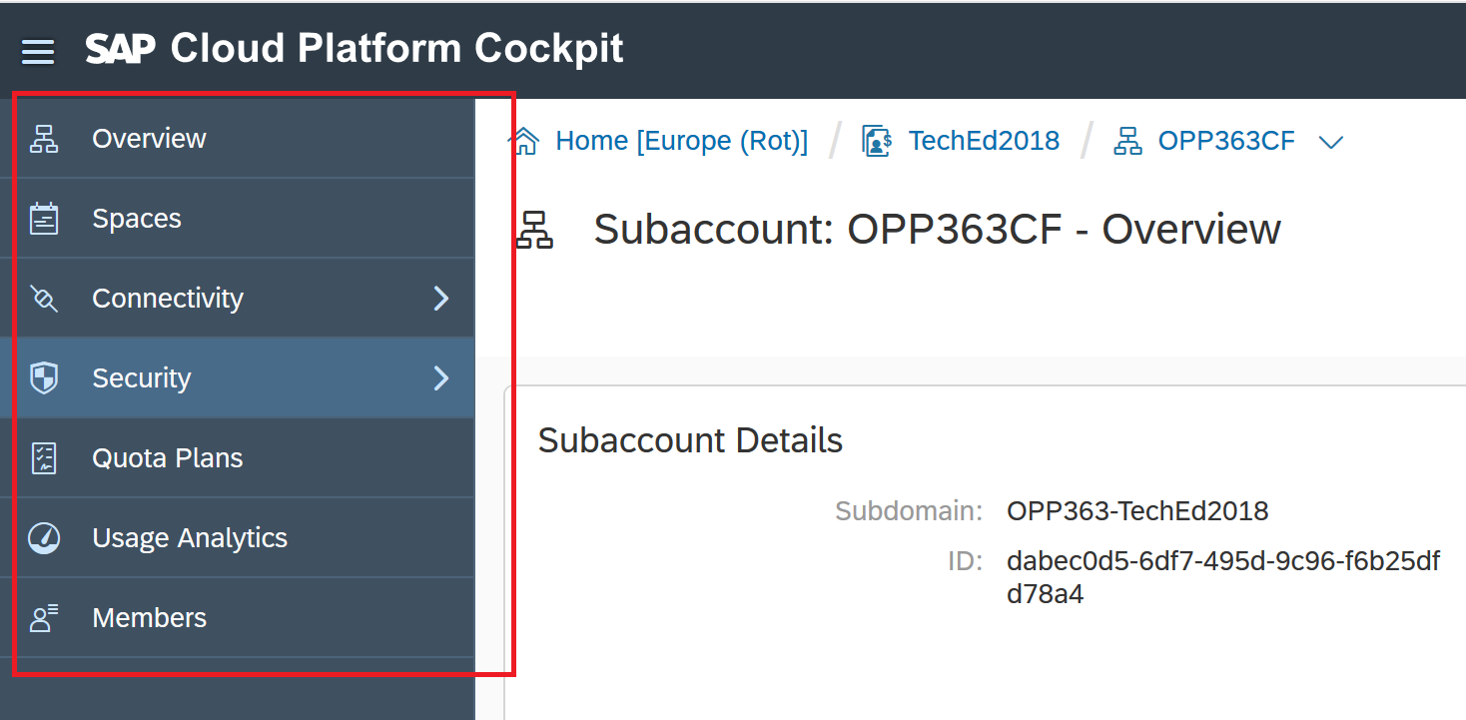

Spaces: A space provides users with access to a shared location for application development, deployment, and maintenance. More information on our [help guide](https://help.sap.com/viewer/e275296cbb1e4d5886fa38a2a2c78c06/Cloud/en-US/8426b2c65ebe4b1fa3ad9e1e571a2f28.html)

1. On right you can see the API endpoint and subaccount details. 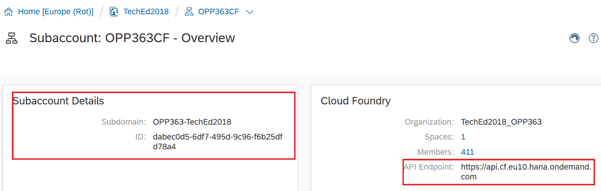

API Endpoint: The API endpoint, or target URL, for your Cloud Foundry instance is the URL of the Cloud Controller. More information on our [help guide](https://help.sap.com/viewer/65de2977205c403bbc107264b8eccf4b/Cloud/en-US/350356d1dc314d3199dca15bd2ab9b0e.html)

1. Click on Spaces.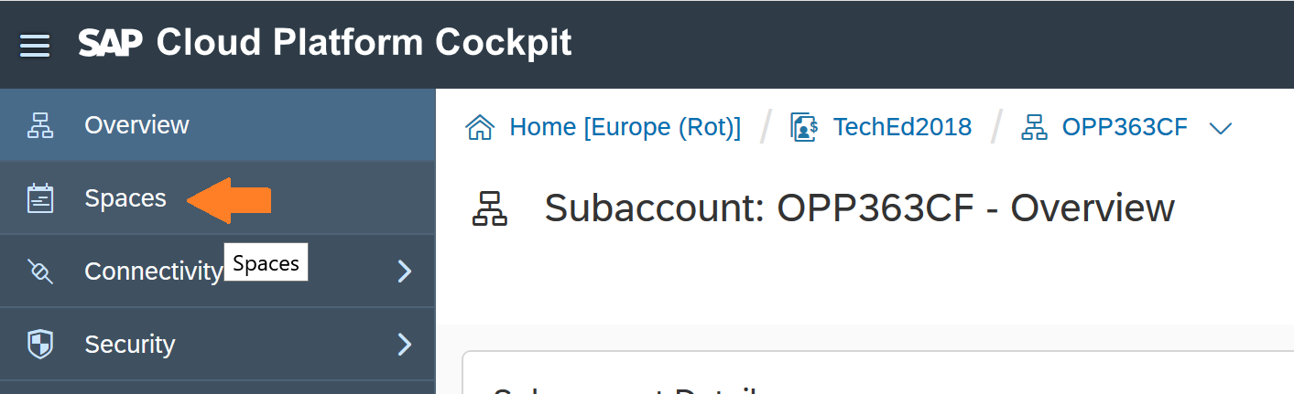
2. Here you can see the space and the related information like started and stopped applications quota assigned. 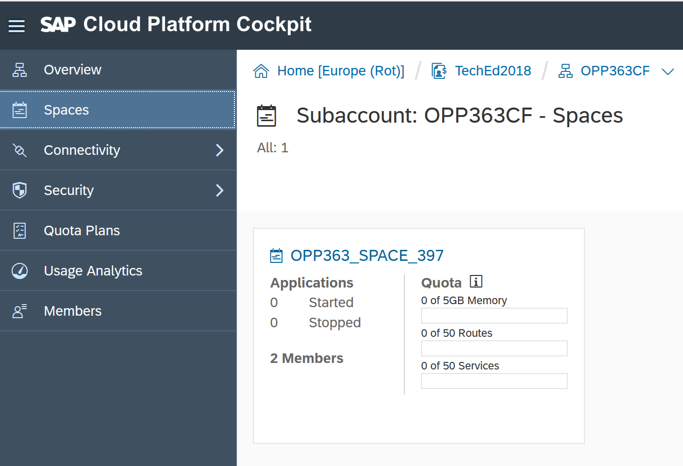

Make sure you have the available resources as highlighted below.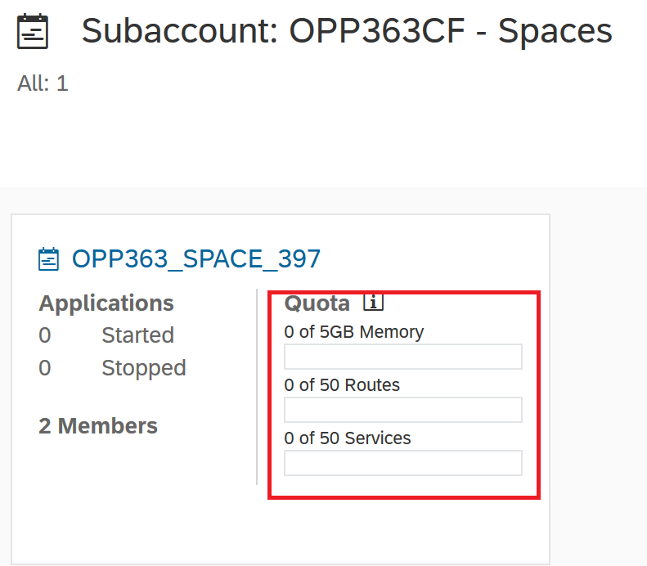

1. Click on the space. 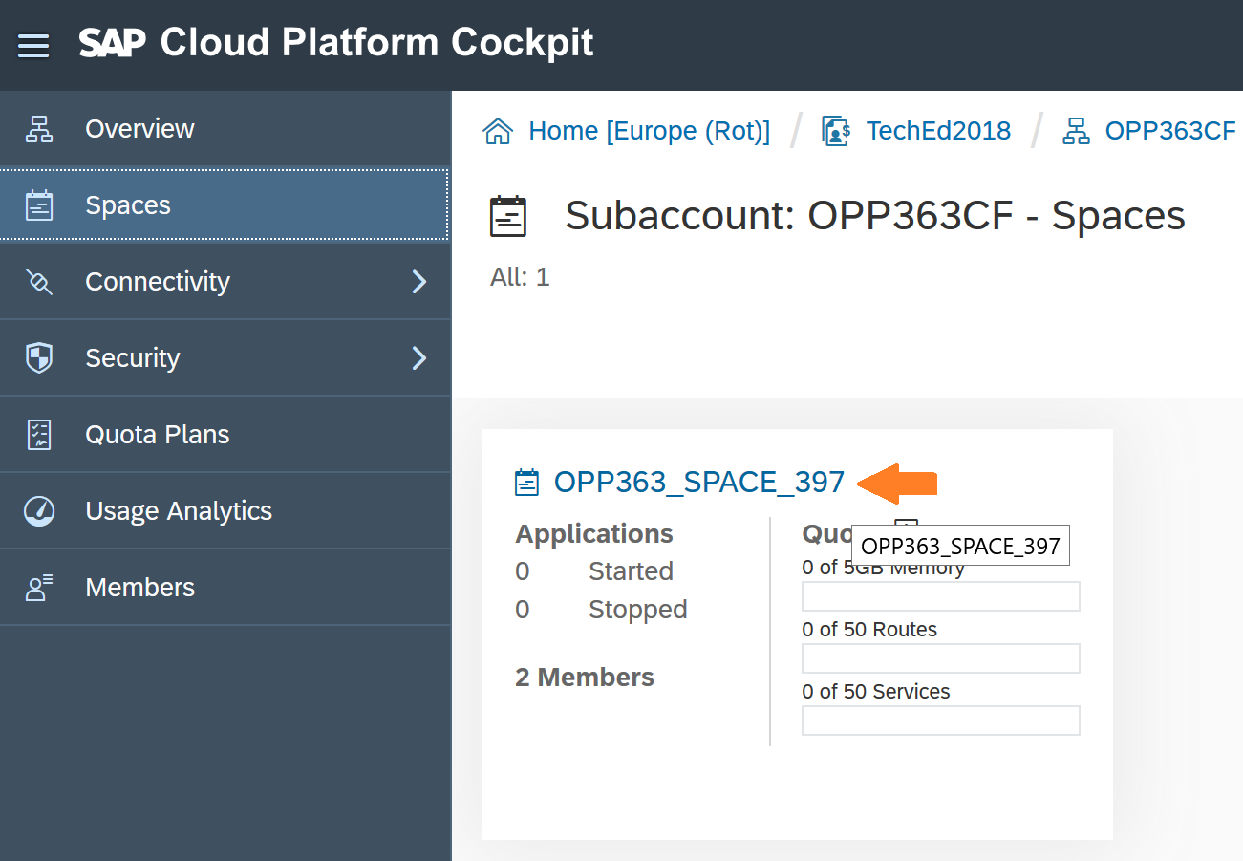
2. This is the overview page of the space, and the operations that you can perform with the resources available to your space.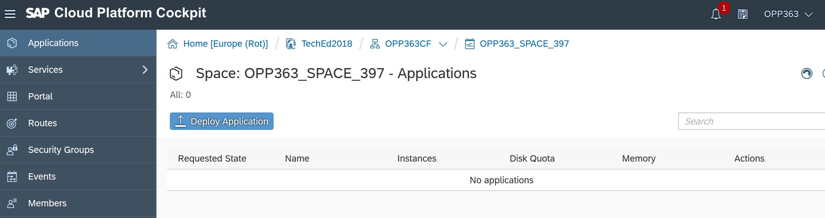
3. On left you can see Services where you can create service instance for your application to use, Routes where you can see the host names, Events and the Member List, Security Groups.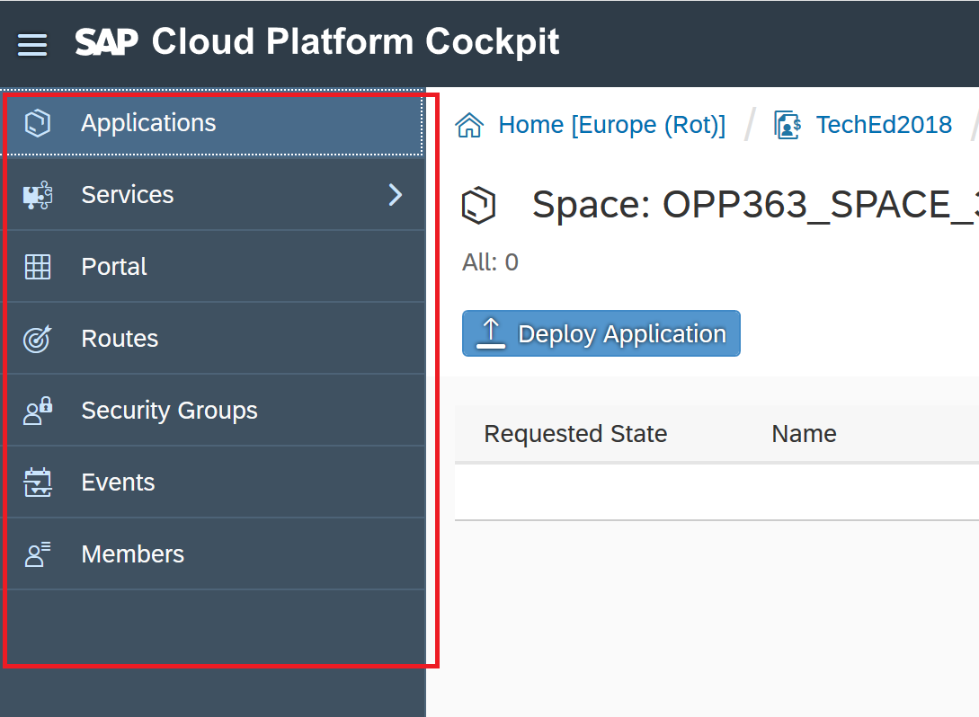
4. Click on Service, to expand it.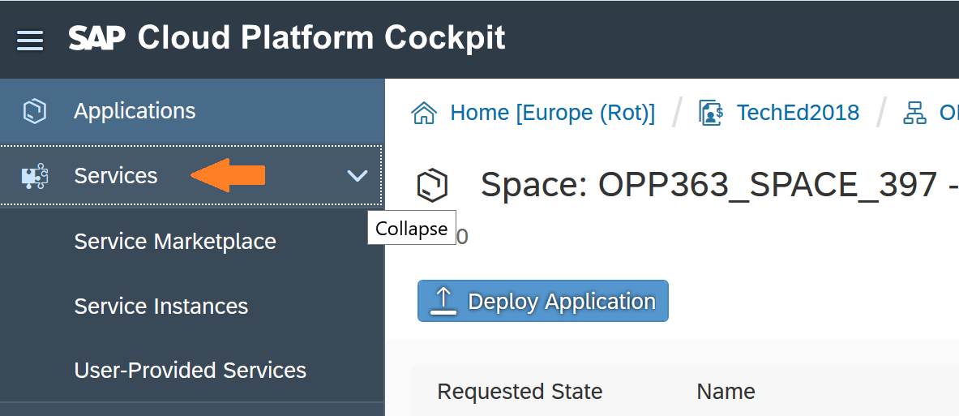
5. Click on Service Marketplace. This shows you all the services available to your space which your applications can use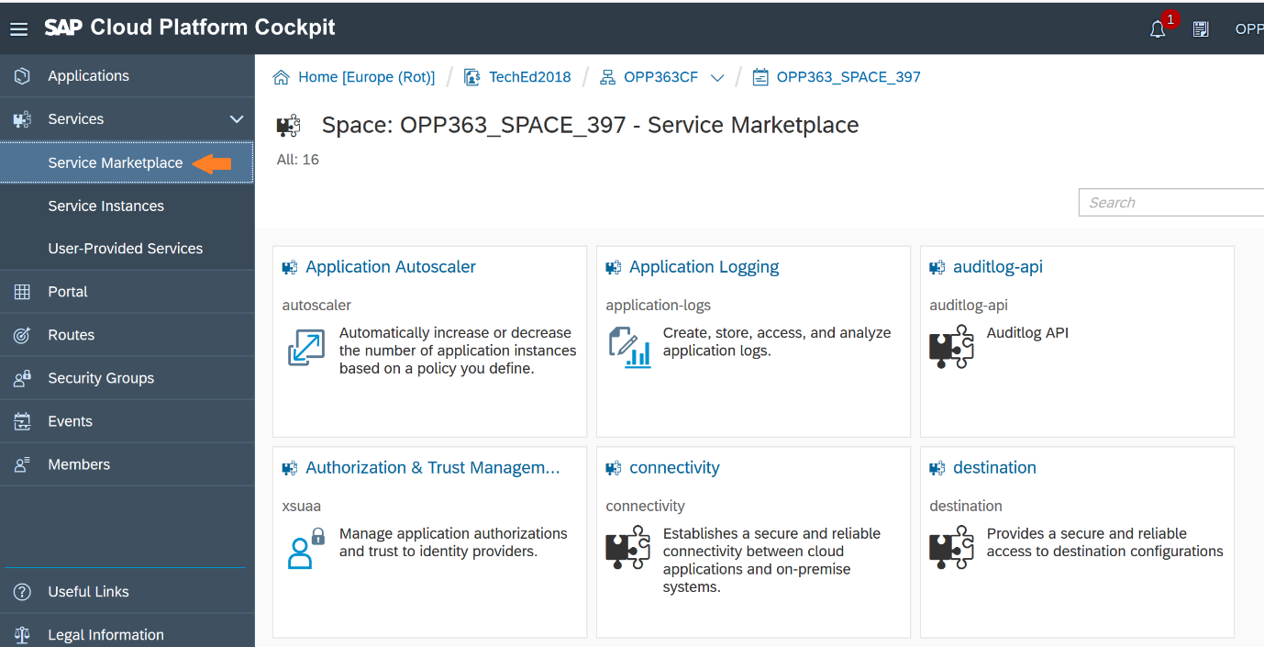
6. Click on Service Instances. This is the place where you will be able to see the instances of the services that you have created, and the applications are using it.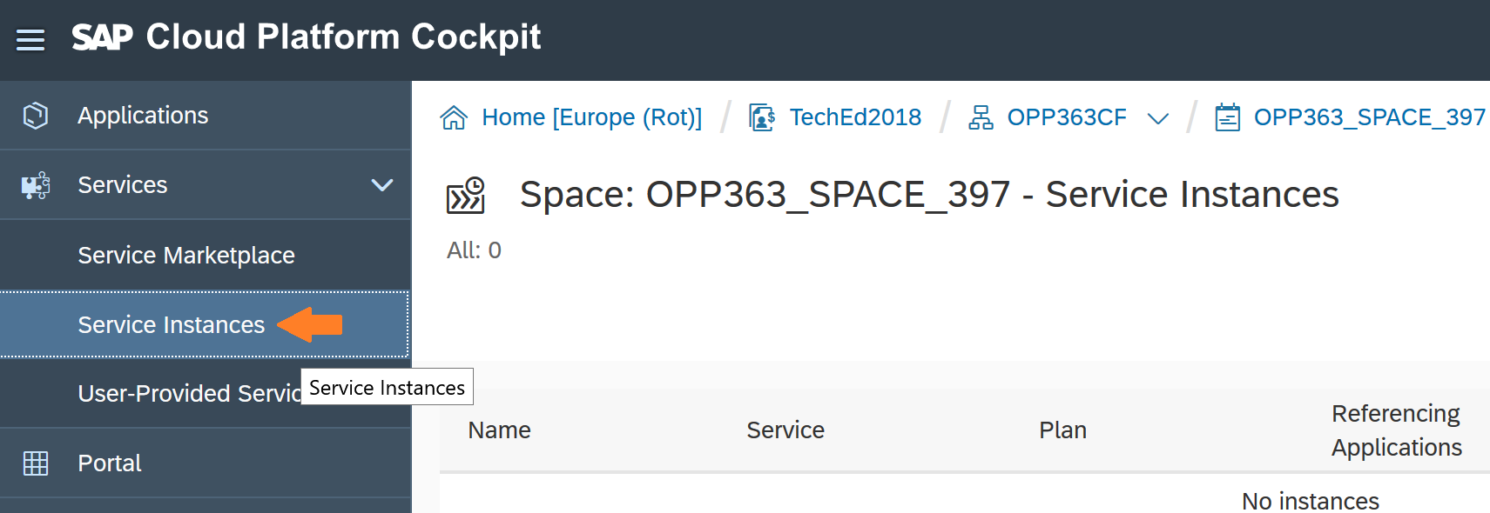

User provided Service: User-provided service instances enable you to use services that are not available in the marketplace with your applications running in the Cloud Foundry environment. More information on our [help guide](https://help.sap.com/viewer/65de2977205c403bbc107264b8eccf4b/Cloud/en-US/a44355e200b44b968d98ddaa42f07c3a.html?q=User-Provided%20Services)

1. This is your Home page. 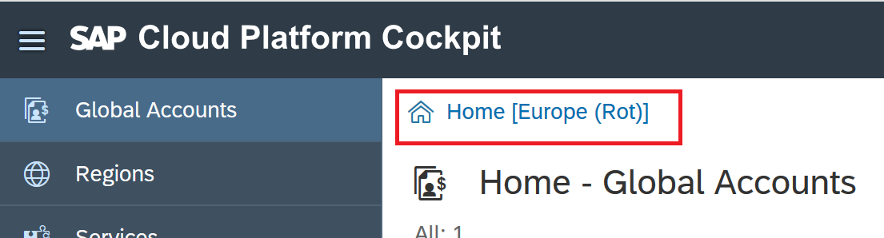
2. These are the regions where you are allocated resources. 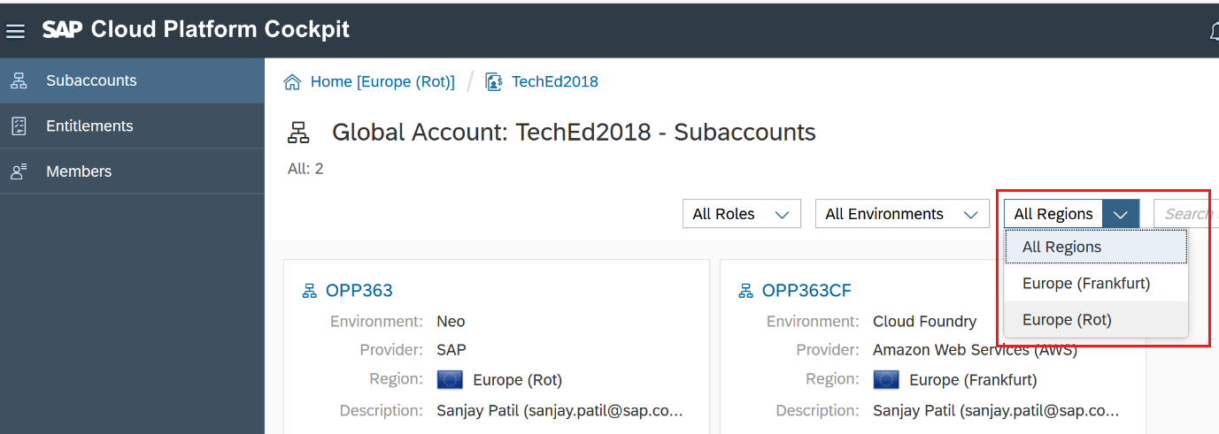
3. This is your Global account. 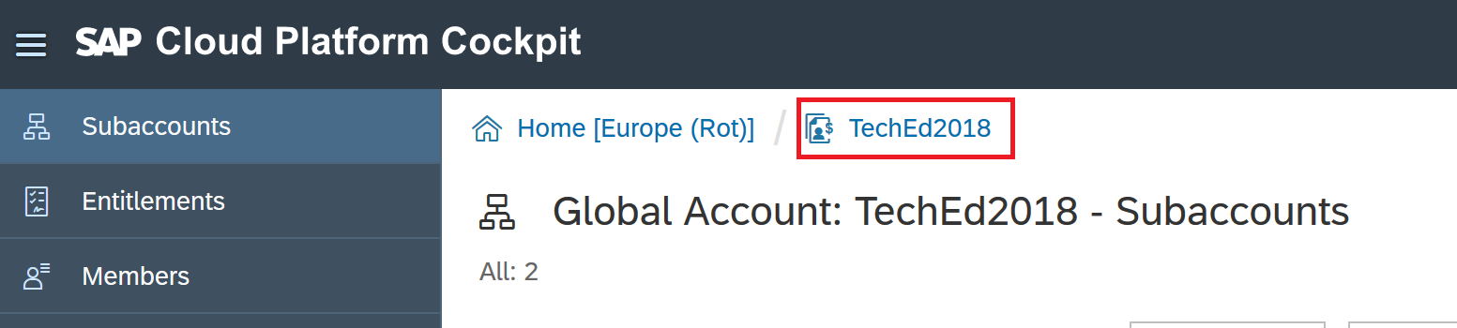
4. These are your subaccounts. 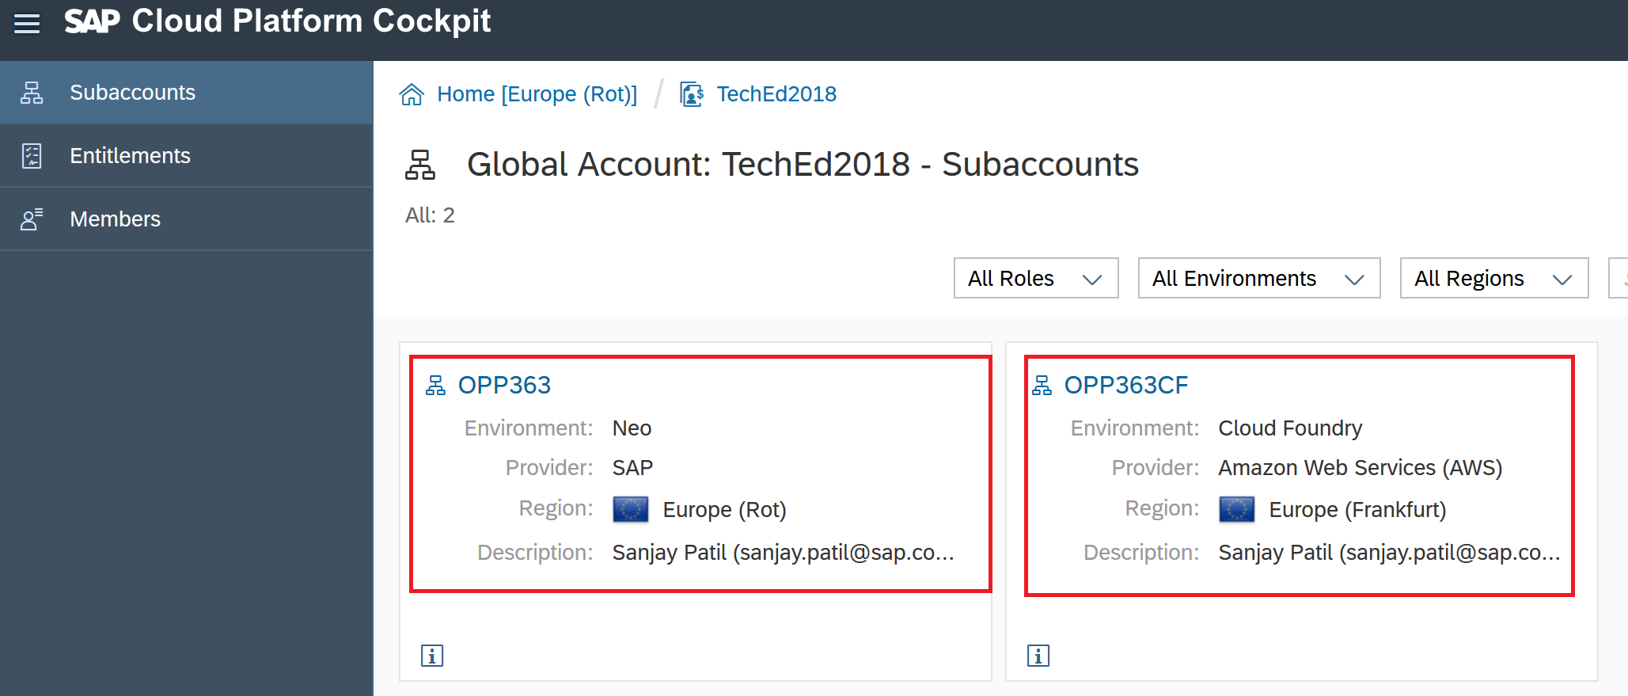
5. This is your Org. 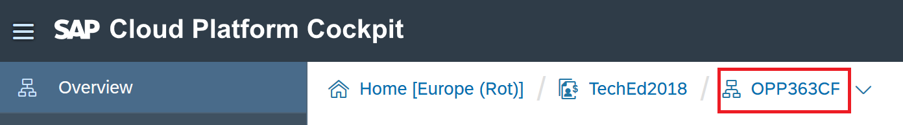
6. This is your space. 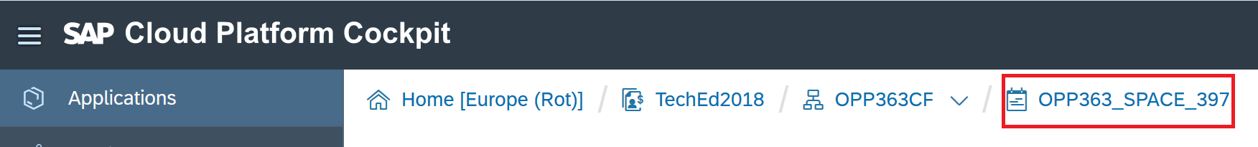

The number 397 will be different for you, it will be your student number.