Over the past week, I've been looking to shore up my experience and knowledge in an IT Support or helpdesk context in order to get a better grasp on how I may actually operate in the position. There is only so much reading and "book-smarts" that one can build before the need for hands-on application and experience becomes crucial. I've seen this in my time spent studying with UMBC. In my opinion, this not only applies to mainly technical fields, but even the more intangible ones such as sociology or psychology. The practical application of learned knowledge enhances our fundamental understanding on the subject, but often provides even more valuable growth opportunities. For example, I know about Active Directory and the various Windows Administrative tools, but never really had a reason to delve deeper. Now ask me how to do specific tasks according to specific problems, there may be a bit of an issue there. That is why I found the virtual/simulated lab portions of my studies to be extremely rewarding.

Previously I've used a professional license of Vmware provided by various courses. However, have moved to VirtualBox due to it being free, but still extremely capable. I already had a Windows 2022 Server and Windows 10 Pro VM created and ready to go. However, there were a few things I did to tune it for the purposes of learning more about a helpdesk role.

* Using the Server Manager, we need to install Active Directory Domain Services.
* Navigate to Manage->Add roles/features->Role-based or feature-based features->Active Directory Domain Services. There are a number of services available here, but I only wanted to focus on the aforementioned.
* Configured a new forest named {Balamb_Garden.com}.
* There were no forests initially present, and we needed one to interact with many of the features available to us.

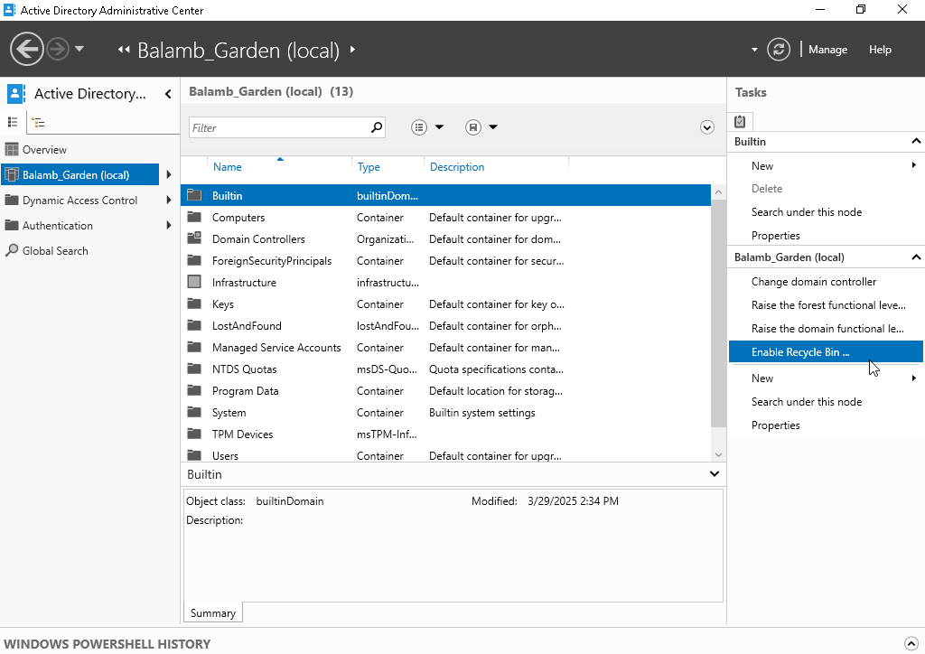

* For convenience-sake, I created a pin to the Active Directory Users and Computers window for easy access.
* This window allows us to peer into some of the many things that I may interact with on a daily basis. By going to View->Advanced Features, we can see even more information about our domain.

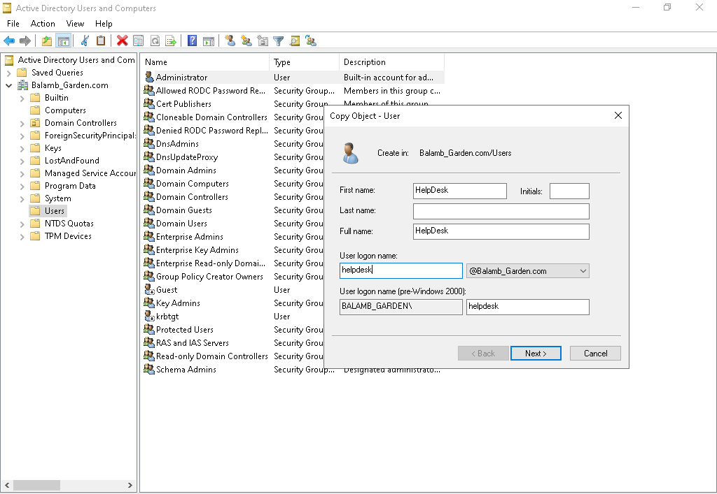

* For an IT Support role, we should be expected to have some type of elevated privileges. They may not be exactly Administrator-level, but for the purposes of my lab, I gave them to a designated helpdesk account.
* Copy the Administrator account and name the new account, HelpDesk.
* This gives us our HelpDesk account with the necessary privileges to do a number of important tasks.

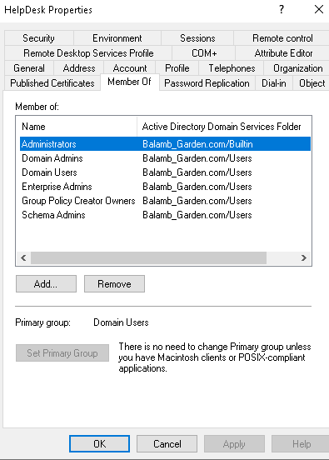

* It is much more efficient to copy a previous user's settings (that you want to replicate) to a new account than to create a fresh account and manually apply these same settings.
* So now we have our Windows 2022 Server & {Balamb_Garden.com} domain set-up, an admin-level HelpDesk account to work with, along with a look at the administrative tools we may be using.

So, clearly, we won't be able to learn much about the actual duties of support personnel by using only a Windows Server. We need actual devices within that domain and network to interact with. My next task was setting up a Windows 10 Pro account (which fortunately I had already done the brunt of the work for).

I had named this machine [Desktop1] for simplicity's sake . It will act as the main machine that I'd be accessing my HelpDesk account from. For that purpose, it will need all the necessary tools to be able to provide support that a normal account wouldn't normally have.

* Enable the Administrator account
* Navigate to My Computer->Right-Click->Manage->Local Users and Groups
* We might see that the Administrator account is initially disabled. All we need to do is Enable it through it's Properties window to have access upon Sign-In. You may need to set-up a password if it wasn't set already.
* Log-in to Administrator to install RSAT tools/services. These enable us to use AD tools on a typical Windows 10 machine.
* These are many of the tools and services that we already have access to on the Windows Server. But we likely won't be working from it directly.
* Navigate to [Optional Features] to find the various resources.
* I installed [Server Manager] [Remote Desktop Services Tools] [DNS Server Tools] [Group Policy Management Tools] [DHCP Server Tools] [Active Directory Domain Services & Lightweight Directory Services Tools] [Active Directory Certificate Services Tools]
* Note: To even see/install these, you will need the appropriate privileges on the account.

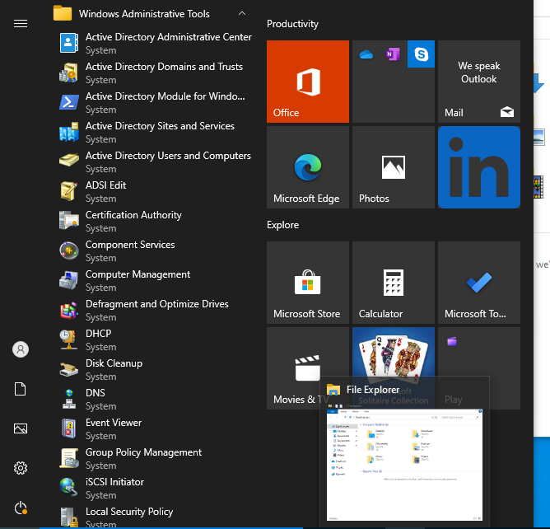

Once that is settled, we need to now connect Desktop1 to our domain. This means making sure that the devices are in the appropriate network, so that they may communicate with each other. A screenshot of a computer

[Note: This isn’t the final IP configuration for the network]

Admittedly, this took some trial & error for me due to how VirtualBox interacts with networks and the like. However, it was good practice and probably similar to something that I'd encounter out in the field. My key takeaway was to ensure that our Domain Server and associated machines have their Ips correctly configured. You might also need to add a new rule to allow ICMP (ping) requests. I used a static IP to make sure that things were working as intended. The "**ping**" and "**ipconfig**" commands were essential in troubleshooting. If the server and machine couldn't communicate both ways or only one-way, that meant I needed to fix something. The Windows Firewall often came up as a pain-point, but I decided against simply disabling it altogether to get past these errors. I would rather not sacrifice security in favor of simplicity. With enough time and effort, I got it working correctly.

**Server: 192.168.56.10**

**Desktop1: 192.168.56.11**

We can see here that the machine has been added to our domain.

Desktop1 can also be seen under Computers in the AD Users and Computers window.

  It additionally appears on the Sign-In screen.

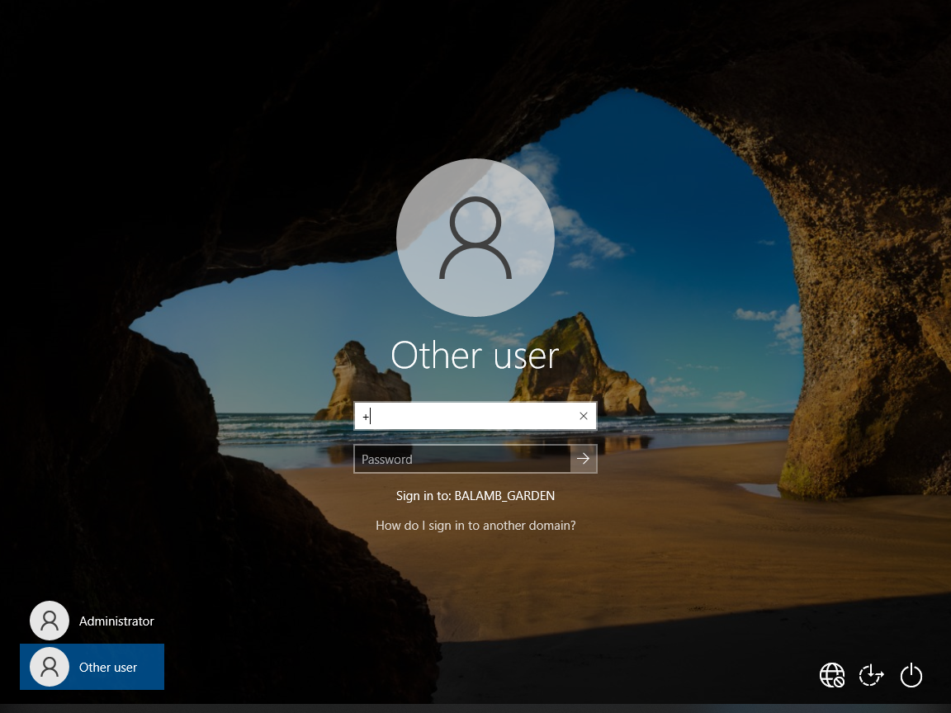

This allowed me to add Desktop1 to the {Balamb_Garden.com} domain and have them both able to communicate. I also installed items such as Teamviewer and Chrome for future experience.