**Setting Up a Second VM as a User Workstation**

**Creating a Second Virtual Machine**

* Created a new virtual machine (VM2) named **Desktop2.**
* Configured **Desktop2** to function as a standard employee or general user workstation.

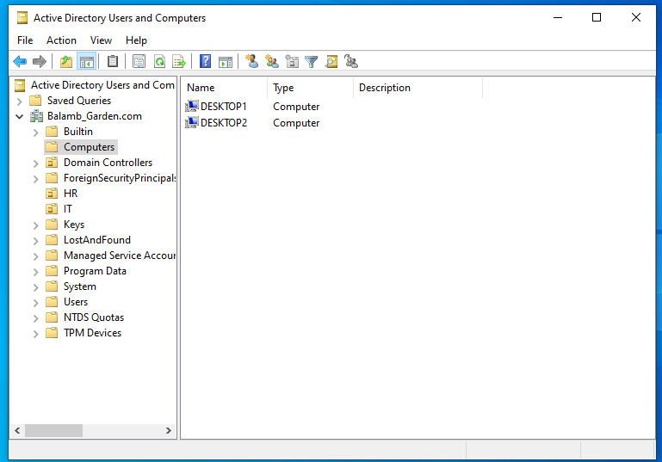

**Configuring Active Directory Organizational Units (OUs)**

1. **Creating and Organizing OUs:**
   * Created a new **HR Organizational Unit (OU)**.
   * Created a new user, **Xu**, and moved it to the **HR OU**.

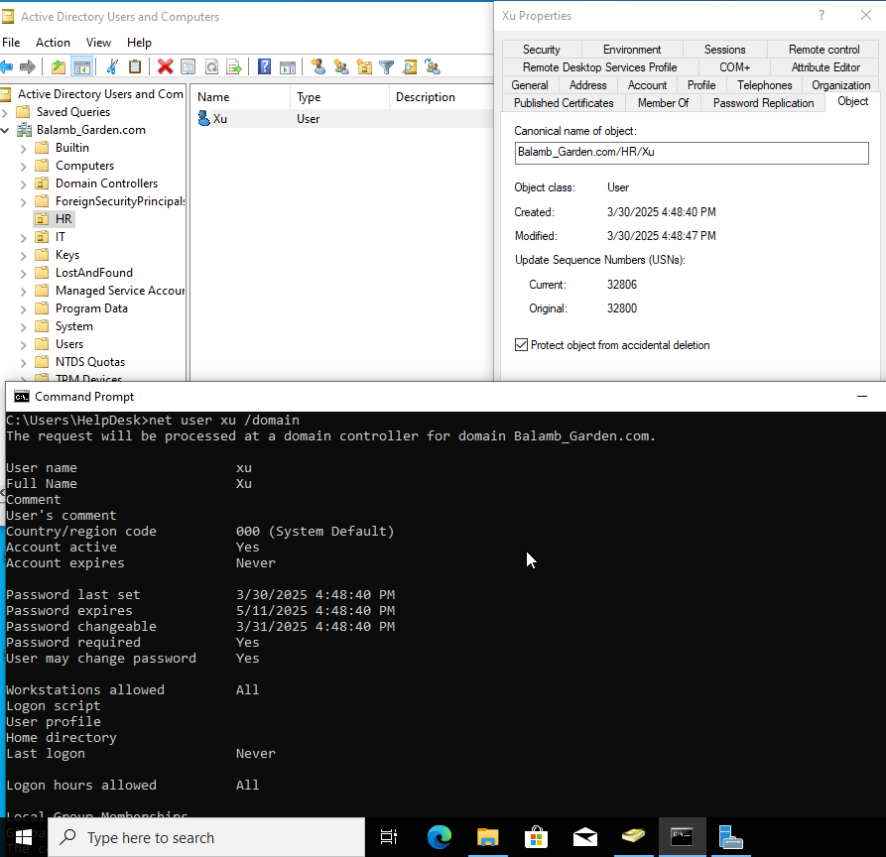

* + Created an **IT OU** and moved the **Helpdesk user** into the IT OU.

1. **Using the Attribute Editor:**
   * **Properties → Attribute Editor** provides detailed information about any selected object within Active Directory (e.g., users, computers, and OUs).

**Managing Group Policies**

1. **Accessing Group Policy Management:**
   * Navigate to **Group Policy Management**.
   * Go to **Domains → [Your Domain] → Default Domain Policy**.

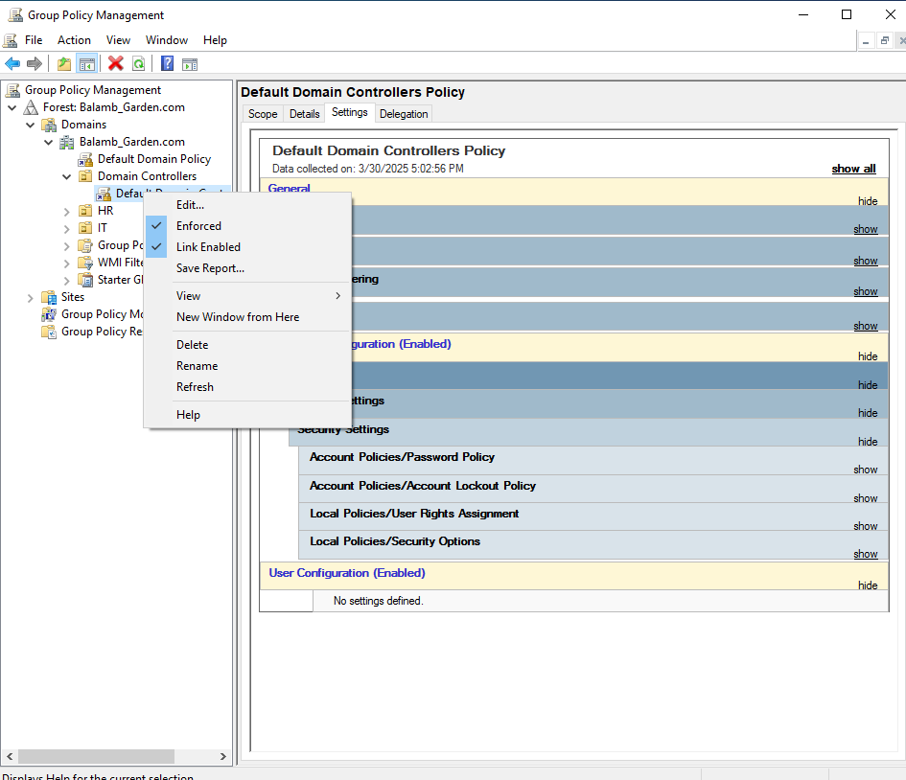

1. **Editing Domain Policies:**
   * Contains policies related to **password settings, user restrictions, and expiration policies**.
   * To modify domain-wide settings, edit **Domain Controllers → Default Domain Controllers Policy**.
   * Ensure that changes are properly enforced by selecting **Enforced** after applying edits.

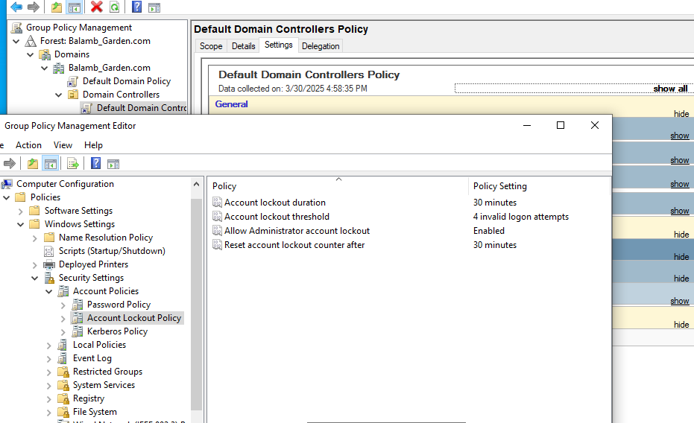

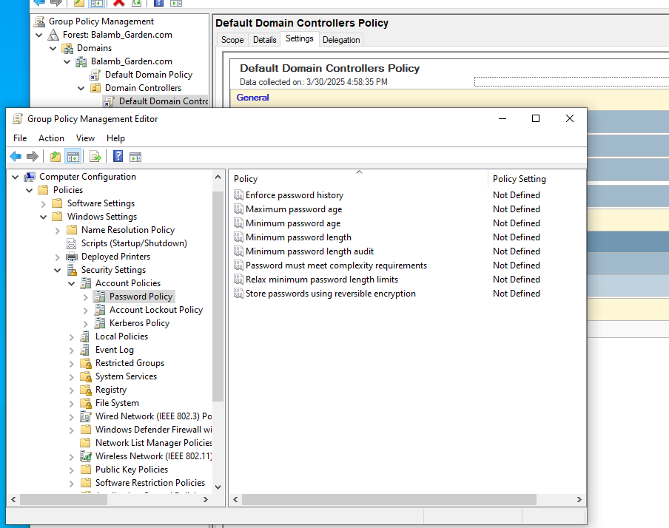

**Adding Desktop2 to the Network and Domain**

1. **Assigning a Static IP to Desktop2:**
   * Configured **static IP settings** for **Desktop2** to ensure reliable network connectivity.
   * Verified network communication by **pinging the domain** (e.g., balamb_garden.com) or directly testing with the **server IP address**.
2. **Joining Desktop2 to the Domain:**
   * Added **Desktop2 to the domain** to integrate it into the network environment.