Experiment: 4
Student Name: Sahil Goyal
UID: 24BDA70148
Branch: CSE
Section/Group: AIT-KRG-GP2
Semester: 4th
Date of Performance: 27/02/26
Subject Name: DBMS

Aim of the Practical:
To understand and apply conditional logic in SQL by using the modulus operator (MOD / %) to analyze numerical data and classify employee salaries as odd or even, thereby improving data analysis and decision-making skills in SQL.
Tool Used:
Database Management System:
PostgreSQL
Database Administration Tool:
psql (iTerm2 Terminal)

Objective:
To write and execute SQL queries that use the MOD() function to check employee salaries and classify them as odd or even values from an employee table.

Practical / Experimental Steps
Step 1: Open pgAdmin and connect to the PostgreSQL server.
Step 2: Create the Employee table with required attributes.
Step 3: Insert multiple records into the Employee table.
Step 4: Write a SELECT query using CASE statement and MOD() function to classify salaries as odd or even.
Step 5: Execute the query and observe the output.
Step 6: Verify the correctness of the results.

• I / O Analysis
1️⃣ Table Creation

Program:
CREATE TABLE Employee(
emp_id INT PRIMARY KEY,
name VARCHAR(50) NOT NULL,
salary INT NOT NULL
);

Output:
Table "Employee" created successfully.

2️⃣ INSERT TABLE

Program:

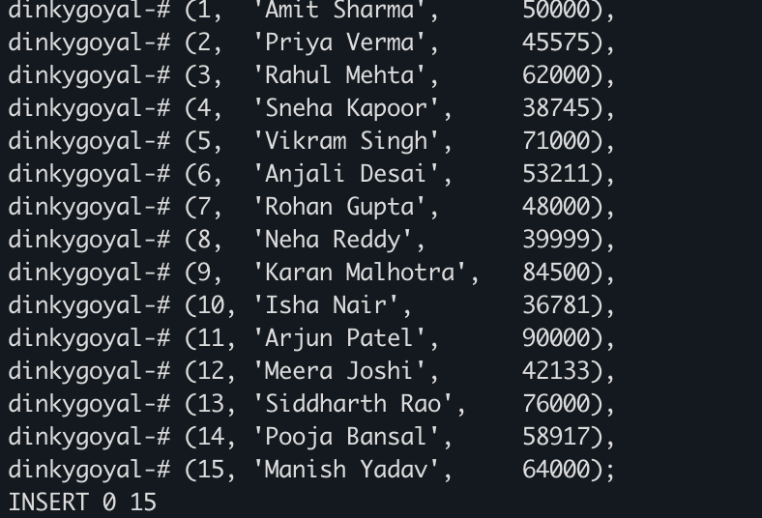

Output:
15 rows inserted successfully into the Employee table.

3️⃣ Display Odd and Even Salaries

Program:
SELECT
emp_id AS "Employee ID",
name AS "Employee Name",
salary AS "Salary",
CASE
WHEN MOD(salary,2) = 0 THEN 'Even'
ELSE 'Odd'
END AS "Salary Category"
FROM Employee
ORDER BY salary;

Output:
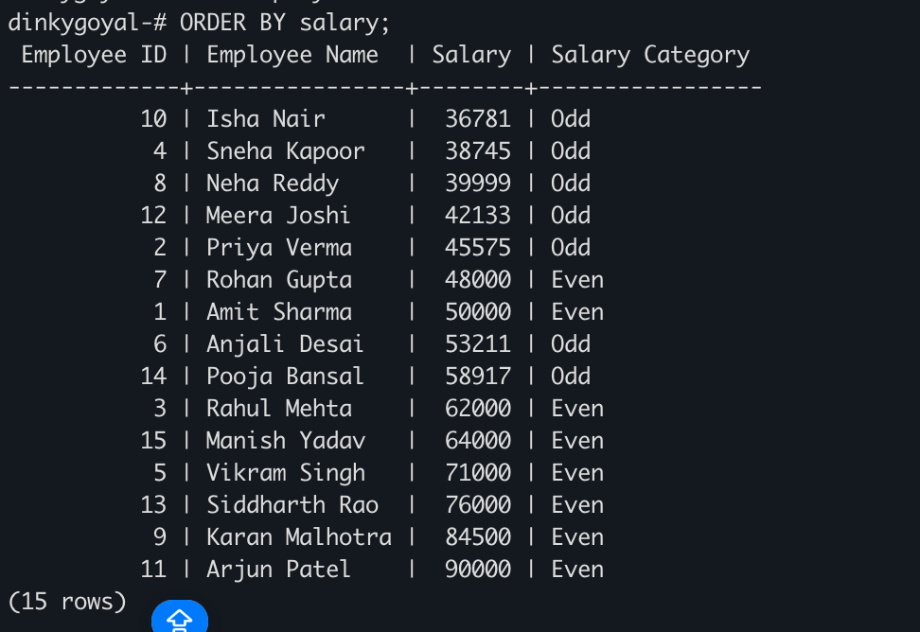

• Learning Outcomes (What I Have Learnt):
• Understood how to create tables in PostgreSQL.
• Learned how to insert multiple records into a database table.
• Gained knowledge of using the MOD() function to determine odd and even values.
• Learned to apply conditional logic using CASE statements in SQL queries.
• Developed the ability to classify and analyze salary data directly in SQL.
• Improved understanding of SQL-based data analysis and decision-making.

