Experiment 3 – Cursor Based Row Processing in PL/pgSQL

Student Name: Sahil Goyal
UID: 24BDA70148
Branch: CSE
Section/Group: AIT-KRG-GP2
Semester: 4th
Subject Name: DBMS

Experiment
Experiment 7: Design and implementation of simple views, complex views, and materialized views in PostgreSQL and comparison of their query execution performance.

Aim
To design and implement a materialized view and analyze the performance difference between simple views, complex views, and materialized views.

Objective
- To understand the concept of database views
- To create simple views and complex views
- To implement materialized views in PostgreSQL
- To compare query execution performance
- To understand the benefits of materialized views in enterprise systems

Software Requirements
- Database: PostgreSQL
- Tool: iterm2

Practical / Experiment Steps
- reate tables for Employee, Department, and Payroll.
- Insert sample records into the tables.
- Create a Simple View based on the Employee table.
- Create a Complex View using JOIN operations.
- Create a Materialized View for storing precomputed results.
- Execute queries on each view.
- Analyze execution performance using EXPLAIN ANALYZE.

Input / Output Details

Input

Tables used:
- Employee
- Department
- Payroll
Operations performed:
- Creation of views
- Execution of queries
- Performance comparison

Output
- Display records from Simple View
- Display records from Complex View
- Display records from Materialized View
- Show execution time comparison using EXPLAIN ANALYZE

SQL / PL/pgSQL Code
1.TABLE CREATION
CREATE TABLE Employee (
EmpID INT PRIMARY KEY,
EmpName VARCHAR(50),
DeptID INT,
Salary NUMERIC(10,2)
);

CREATE TABLE Department (
DeptID INT PRIMARY KEY,
DeptName VARCHAR(50)
);

CREATE TABLE Payroll (
EmpID INT,
PayDate DATE,
PayAmount NUMERIC(10,2),
PRIMARY KEY (EmpID, PayDate)
);

2.INSERT DATA

INSERT INTO Department VALUES (1,'IT');
INSERT INTO Department VALUES (2,'Finance');
INSERT INTO Department VALUES (3,'HR');

INSERT INTO Employee VALUES (101,'Alice',1,70000);
INSERT INTO Employee VALUES (102,'Bob',2,80000);
INSERT INTO Employee VALUES (103,'Charlie',1,65000);
INSERT INTO Employee VALUES (104,'David',3,60000);

INSERT INTO Payroll VALUES (101,'2026-02-01',7000);
INSERT INTO Payroll VALUES (102,'2026-02-01',8000);
INSERT INTO Payroll VALUES (103,'2026-02-01',6500);
INSERT INTO Payroll VALUES (104,'2026-02-01',6000);

3.SIMPLE VIEW

CREATE VIEW SimpleEmployeeView AS
SELECT EmpID, EmpName, Salary
FROM Employee;

SELECT * FROM SimpleEmployeeView;

4.COMPLEX VIEW

CREATE VIEW ComplexEmployeePayroll AS
SELECT e.EmpID, e.EmpName, d.DeptName,
SUM(p.PayAmount) AS TotalPaid
FROM Employee e
JOIN Department d ON e.DeptID = d.DeptID
JOIN Payroll p ON e.EmpID = p.EmpID
GROUP BY e.EmpID, e.EmpName, d.DeptName;

SELECT * FROM ComplexEmployeePayroll;

5.MATERALIZED VIEW

CREATE MATERIALIZED VIEW MaterializedEmployeePayroll AS
SELECT e.EmpID, e.EmpName, d.DeptName,
SUM(p.PayAmount) AS TotalPaid
FROM Employee e
JOIN Department d ON e.DeptID = d.DeptID
JOIN Payroll p ON e.EmpID = p.EmpID
GROUP BY e.EmpID, e.EmpName, d.DeptName;

SELECT * FROM MaterializedEmployeePayroll;

6.PERFORMANCE ANALYSIS

EXPLAIN ANALYZE SELECT * FROM SimpleEmployeeView;
EXPLAIN ANALYZE SELECT * FROM ComplexEmployeePayroll;
EXPLAIN ANALYZE SELECT * FROM MaterializedEmployeePayroll;

Screenshots
- Screenshot 1: Table creation and data insertion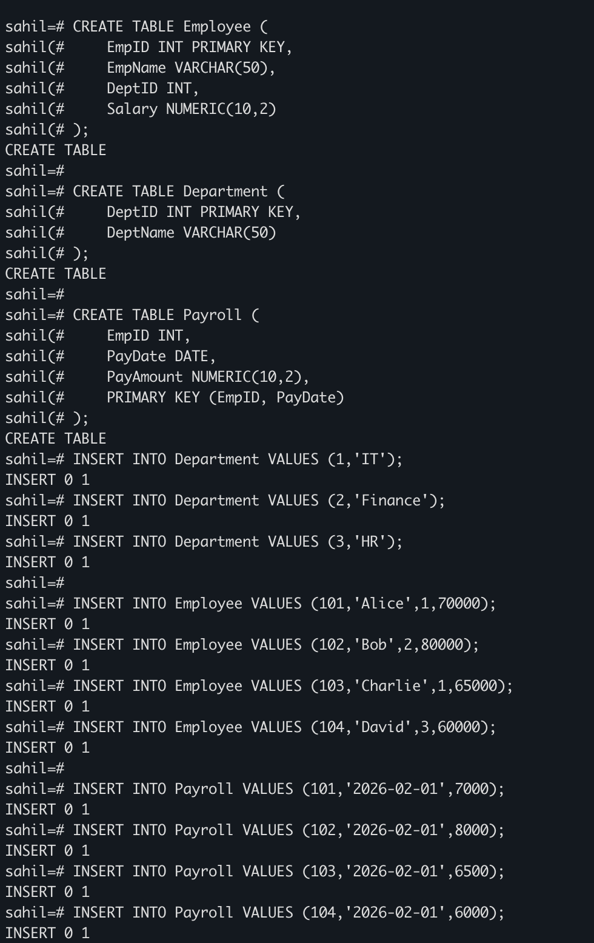

- Screenshot 2: Output of Simple View
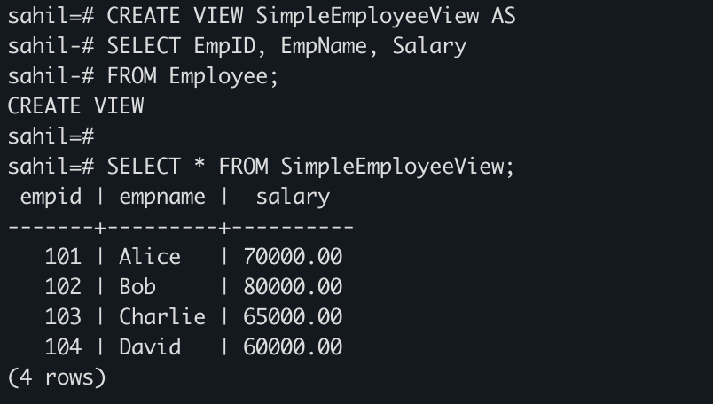
- Screenshot 3: Output of Complex View
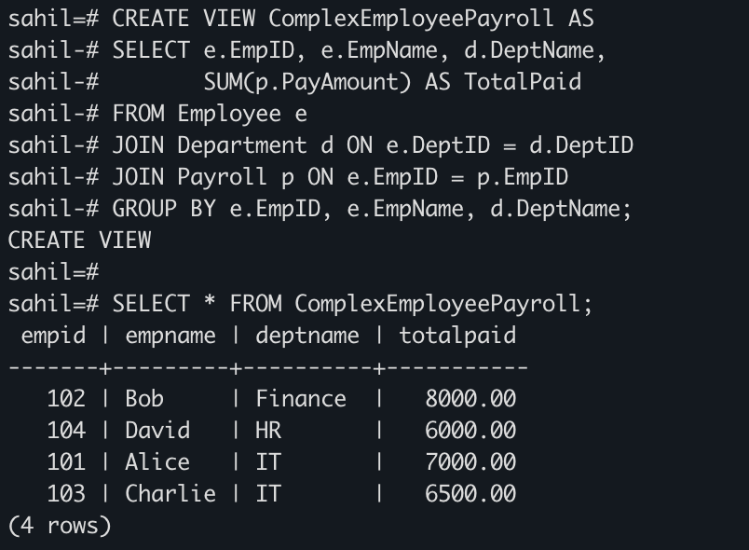

- Screenshot 4: Output of Materialized View
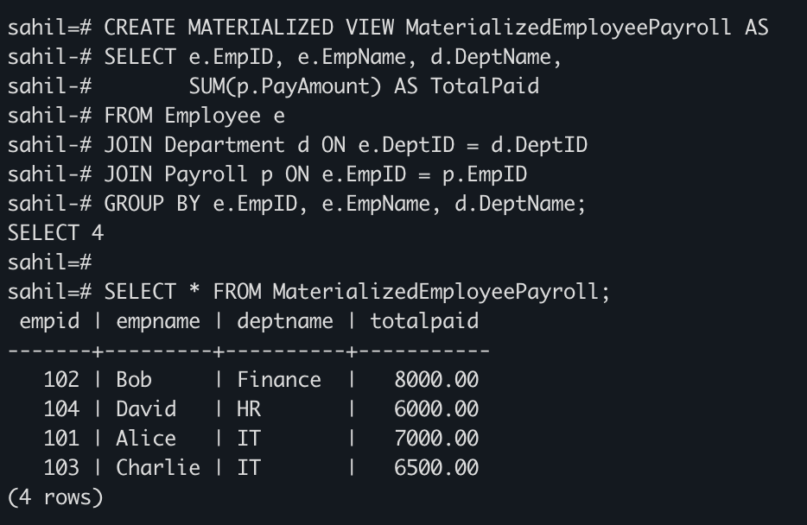
- Screenshot 5: Performance comparison using EXPLAIN ANALYZE
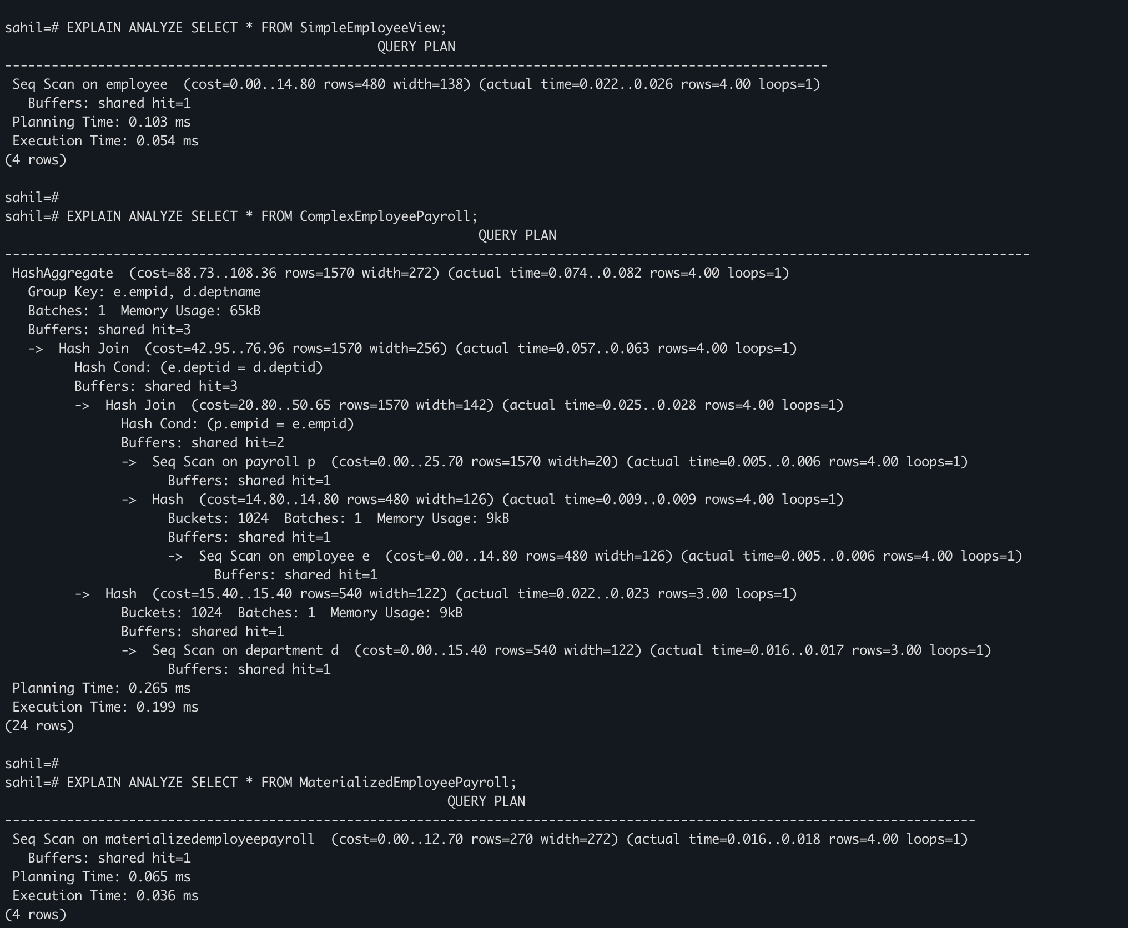

Learning Outcome
- Learned the concept and purpose of database views in PostgreSQL.
- Understood the difference between simple views, complex views, and materialized views.
- Learned how to create and query simple views based on a single table.
- Learned how to create complex views using joins and aggregation functions.
- Understood how materialized views store precomputed results to improve query performance.
- Gained knowledge of using EXPLAIN ANALYZE to measure and compare query execution time.
- Developed an understanding of how materialized views improve performance in data-intensive enterprise applications.

