Experiment: 10

Student Name: Sahil Goyal UID:24BDA70148
Branch: CSE Section/Group: AIT-KRG-GP2
Semester: 4th Date of Performance:24/04/2026
Subject Name: DBMS

- Aim of the practical: To design a trigger that automatically implements the functionality of a primary key, ensuring unique identification of records without manual intervention.

2. Tool Used:
● Database Management System:

○ PostgreSQL

● Database Administration Tool:

○ pgAdmin

- Objective:
To create a database trigger that automatically enforces primary key constraints or generates unique key values, replicating the functionality of a stored procedure.

- Practical / Experimental Steps

Step 1: Create the required table with a primary key column.
Step 2: Create a sequence to generate unique key values.
Step 3: Write a trigger function to assign the sequence value before insertion.
Step 4: Define a BEFORE INSERT trigger on the table.
Step 5: Link the trigger to the trigger function.
Step 6: Insert multiple records without specifying the primary key.
Step 7: Verify that unique primary keys are generated automatically.

- I / O Analysis

CREATE TABLE employees (
id INT PRIMARY KEY,
name VARCHAR(100),
salary INT
);

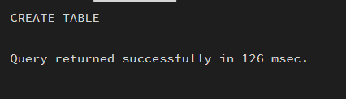

CREATE SEQUENCE emp_seq
START 1;
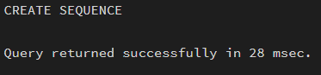

CREATE OR REPLACE FUNCTION assign_emp_id()
RETURNS TRIGGER AS $$
BEGIN
-- If ID is not provided, generate it automatically
IF NEW.id IS NULL THEN
NEW.id := nextval('emp_seq');
END IF;

RETURN NEW;
END;
$$ LANGUAGE plpgsql;
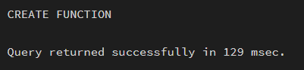

CREATE TRIGGER before_insert_emp
BEFORE INSERT ON employees
FOR EACH ROW
EXECUTE FUNCTION assign_emp_id();
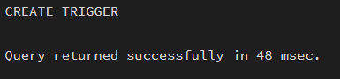

INSERT INTO employees (name, salary) VALUES ('Rahul', 50000);
INSERT INTO employees (name, salary) VALUES ('Anita', 60000);
INSERT INTO employees (name, salary) VALUES ('Vikas', 55000);
SELECT * FROM employees;
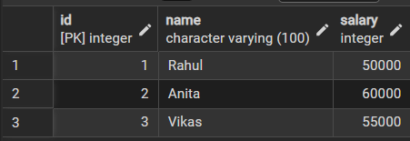

- Learning outcomes (What I have learnt):
- Understand the purpose and working of database triggers.
- Implement automated primary key functionality using triggers
- Ensure data integrity without manual key assignment.
- Apply trigger-based automation in real-world enterprise applications such as Amazon, Flipkart, and Oracle.

