Experiment 3 – PL/pgSQL Salary and Bonus Calculation

Experiment
Experiment 3: Calculating employee salary and applying a bonus using PL/pgSQL. This experiment demonstrates variable declaration, arithmetic operations, and displaying output using RAISE NOTICE.

Aim
To practice writing PL/pgSQL blocks that perform calculations on employee data, calculate bonuses, and display results.

Objective
- To declare variables in PL/pgSQL.
- To perform arithmetic calculations on employee salary.
- To calculate a bonus amount based on a percentage of salary.
- To display employee details and salary information before and after applying the bonus.

Software Requirements
- Database: PostgreSQL
- Tool: pgAdmin or psql

Practical / Experiment Steps
- Declare variables for employee ID, name, and salary.
- Calculate a 10% bonus on the employee salary.
- Calculate the total salary after adding the bonus.
- Display employee details and salary information before and after bonus using RAISE NOTICE.
- Take screenshots of outputs for documentation.

Input / Output Details

Input
- Employee details:
  - emp_id INT
  - emp_name VARCHAR(50)
  - emp_salary INT
- Bonus calculation: 10% of employee salary

Output
- Step 1: Display employee details and original salary.
- Step 2: Display bonus amount and total salary after applying 10% bonus.
- Screenshots of outputs (s1 and s2) are attached.

SQL / PL/pgSQL Code
DO
$$
DECLARE
emp_id INT := 101;
emp_name VARCHAR(50) := 'Jay';
emp_salary INT := 222222;
bonus_amount NUMERIC;
new_salary NUMERIC;
BEGIN
-- Calculate 10% bonus
bonus_amount := emp_salary * 0.10;
new_salary := emp_salary + bonus_amount;

-- Display Employee Details
RAISE NOTICE 'Employee Details';
RAISE NOTICE '----------------';
RAISE NOTICE 'Employee ID : %', emp_id;
RAISE NOTICE 'Employee Name : %', emp_name;

-- Display Salary Details
RAISE NOTICE '';
RAISE NOTICE 'Salary Details';
RAISE NOTICE '----------------';
RAISE NOTICE 'Salary Before Bonus : %', emp_salary;
RAISE NOTICE '10%% Bonus Amount : %', bonus_amount;
RAISE NOTICE 'Salary After Bonus : %', new_salary;
END
$$;

Screenshots
- Screenshot 1: DO block execution
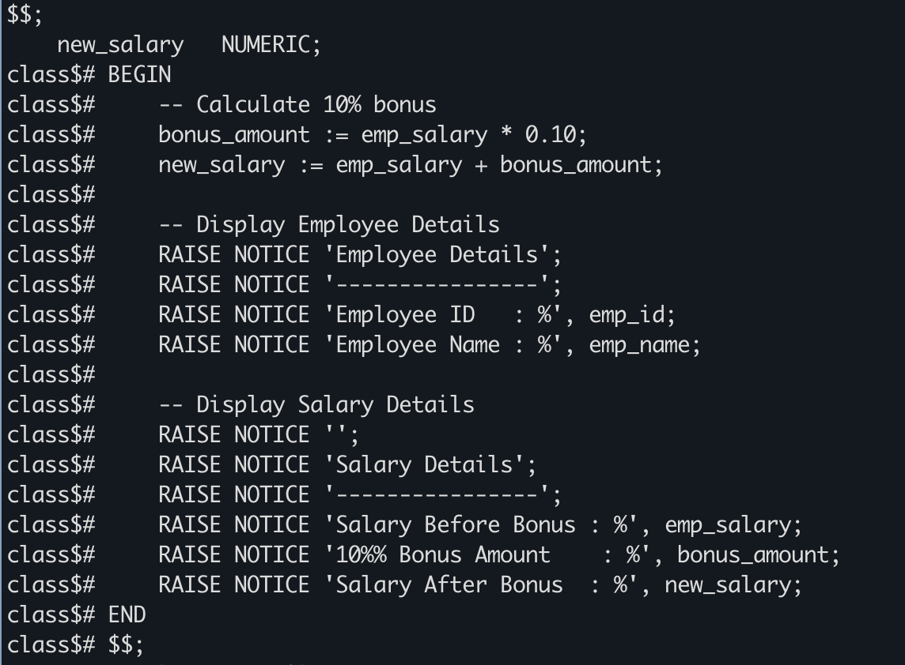
- Screenshot 2: Output showing Employee ID, Name, Salary, Bonus, and Total Salary
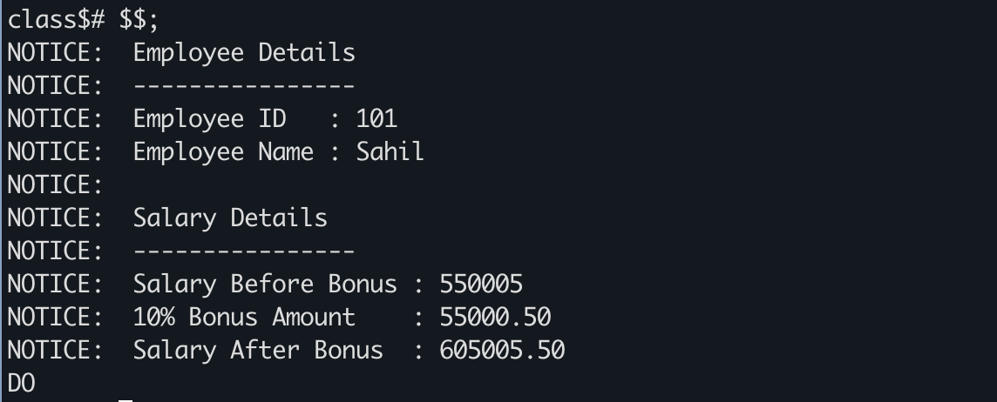

Learning Outcome
- Learned to declare variables in PL/pgSQL.
- Learned to perform arithmetic calculations in PostgreSQL.
- Learned to display output using RAISE NOTICE.
- Learned to calculate a bonus and total salary dynamically.

