Experiment: 8

Student Name: Sahil UID:24BDA70148
Branch: CSE Section/Group:AIT-KRG-GP2
Semester: 4th DATE: 31/03/2026
Subject Name: DBMS

1. Aim of the Practical
To create and execute a stored procedure that retrieves employee data based on gender using input parameters, demonstrating the use of procedures, functions, IN/OUT parameters, and procedural logic in PostgreSQL.

2. Tool Used
Database Management System: PostgreSQL
Database Administration Tool: pgAdmin

3. Objective
To write and execute a PL/SQL stored procedure that dynamically accepts gender as an argument and computes the employee count corresponding to the given gender. Also to create a function that returns a table of employee data.

4. Practical / Experimental Steps
- Step 1: Create the base table employees with attributes emp_id, emp_name, gender, and salary.
- Step 2: Insert sample records into the employees table to simulate real-world employee data.
- Step 3: Define and create a stored procedure get_Employee_Count_BY_Gender that accepts gender as an IN parameter, returns count as an OUT parameter, and uses an INOUT status parameter.
- Step 4: Implement logic inside the procedure to count employees matching the given gender using a SELECT COUNT(*) query.
- Step 5: Execute the stored procedure using a DO block with dynamically declared variables.
- Step 6: Display the output using RAISE NOTICE to show gender, employee count, and status.
- Step 7: Create a function Get_Data() that returns a table of employee names and salaries using RETURN QUERY.
- Step 8: Execute the function using SELECT * FROM Get_Data() and verify the output.

5. I/O Analysis

5.1 Create Table
CREATE TABLE employees (
emp_id SERIAL PRIMARY KEY,
emp_name VARCHAR(50),
gender VARCHAR(10),
salary NUMERIC(10,2)
);
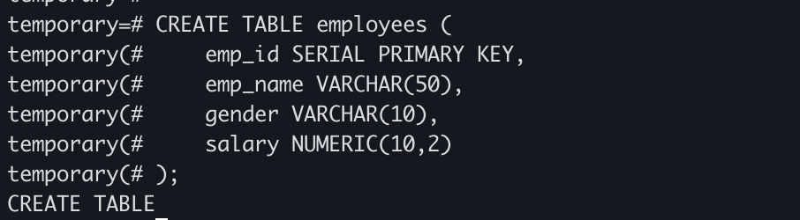

5.2 Insert Sample Data
INSERT INTO employees (emp_name, gender, salary) VALUES
('Amit', 'Male', 30000),
('Riya', 'Female', 35000),
('John', 'Male', 28000),
('Sneha', 'Female', 40000);
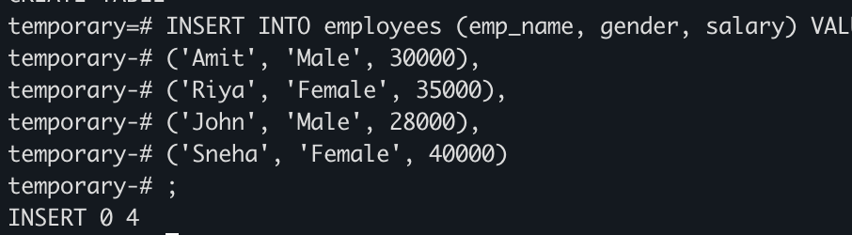

5.3 Stored Procedure - get_Employee_Count_BY_Gender
CREATE OR REPLACE PROCEDURE get_Employee_Count_BY_Gender(
IN P_GEN VARCHAR(20),
OUT COUNT_EMP INT,
INOUT STATUS VARCHAR
)
AS
$$
BEGIN
SELECT COUNT(*) INTO COUNT_EMP
FROM EMPLOYEES
WHERE GENDER = P_GEN;
STATUS := 'SUCCESS';
END;
$$ LANGUAGE PLPGSQL;
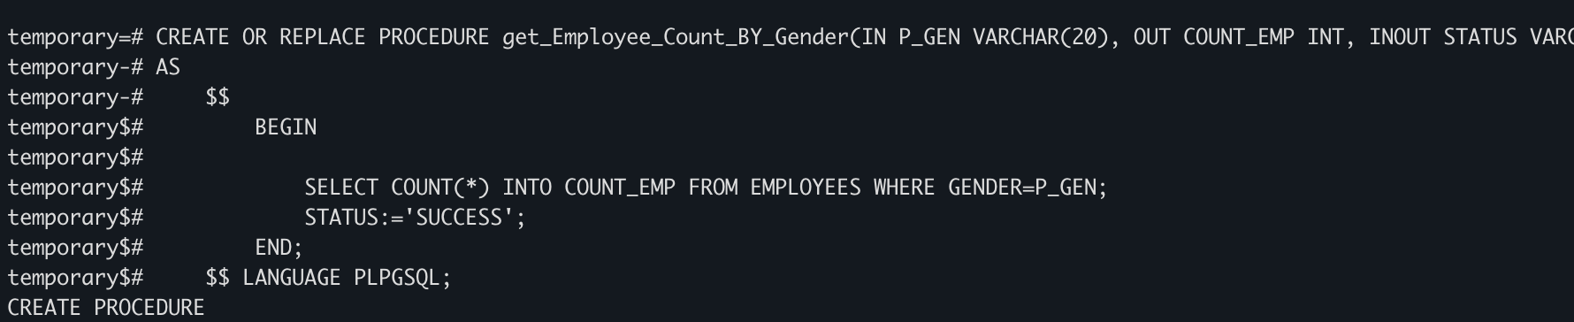

5.4 Execute Procedure using DO Block
DO
$$
DECLARE
GEN VARCHAR(20) := 'Male';
COUNT_BY_GEN INT;
STATUS VARCHAR(20) := 'Fail';
BEGIN
CALL get_Employee_Count_BY_Gender(GEN, COUNT_BY_GEN, STATUS);
RAISE NOTICE 'GENDER IS % YOUR COUNT IS % AND STATUS IS %',
GEN, COUNT_BY_GEN, STATUS;
END;
$$;

Expected Output: NOTICE: GENDER IS Male YOUR COUNT IS 2 AND STATUS IS SUCCESS
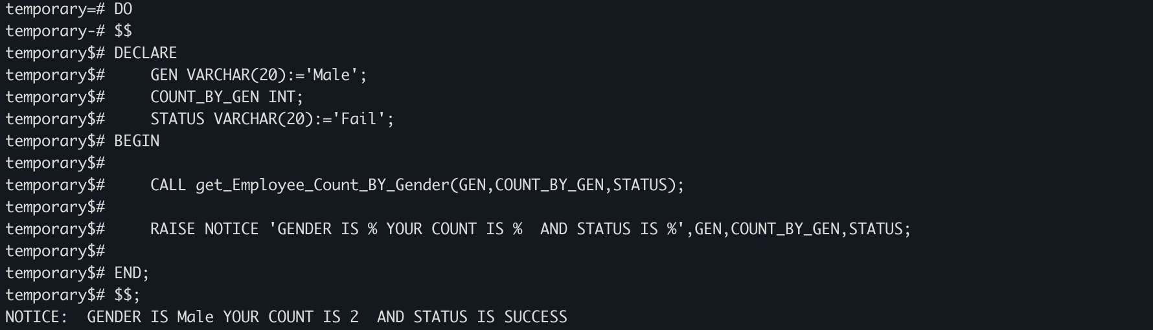

5.5 Function - Get_Data()
CREATE OR REPLACE FUNCTION Get_Data()
RETURNS TABLE(name_emp VARCHAR(10), emp_salary NUMERIC(10,2))
AS
$$
BEGIN
RETURN QUERY SELECT emp_name, salary FROM employees;
END;
$$ LANGUAGE PLPGSQL;

SELECT * FROM Get_Data();
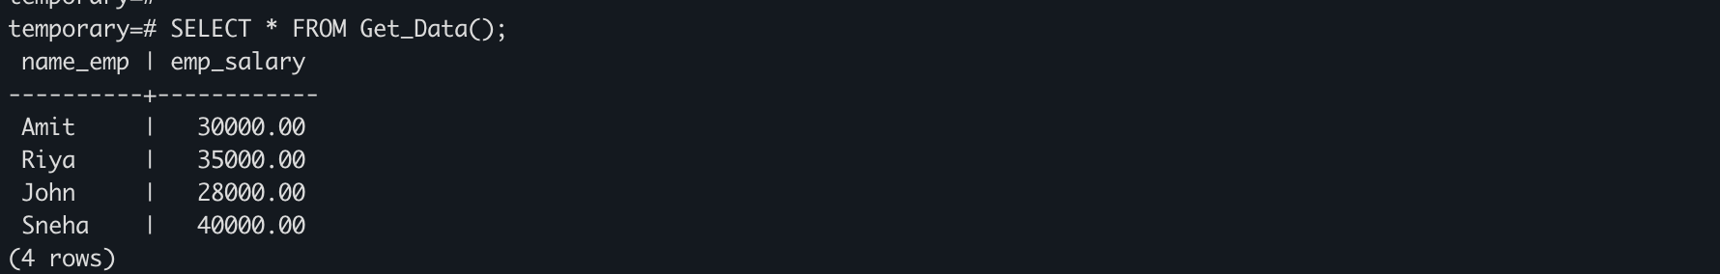
Expected Output:
Returns a table with columns name_emp and emp_salary listing all employee records.

6. Learning Outcomes
- Understood the structure and syntax of stored procedures in PostgreSQL using PL/pgSQL.
- Learned how to use IN, OUT, and INOUT parameters in procedures.
- Practiced passing dynamic input values to procedures using a DO block and CALL statement.
- Applied aggregate functions like COUNT(*) inside procedural logic for data analysis.
- Learned how to create functions that return tables using RETURNS TABLE and RETURN QUERY.
- Developed reusable database logic that can be applied in real-world business scenarios.

