Graphics Documentation

Team Members:

Mat Siwoski, Damien Sathanielle, Konstantin Boyarinov, Sam Youssef, Robin Hsieh, Tim Kim

# Milestones

## Milestone 1 – February 21, 2014

This milestone will include the basic startup of the game. This game will follow a very simplistic implementation of Cops vs. Robbers. Being able to display the map on screen, render up to two players, and allow for user input to maneuver a player around the map. Each user will connect to this server, and when both users have connected, the game will commence. When the game opens, there will be a map that will be displayed with an external wall that will prevent users from going off-screen, and there will be some internal walls to impede players. Throughout the map, there will be 4 placed “systems” that the Robber must compromise.  To win, the Robber must compromise three of the four systems and the Cop must arrest the robber. To compromise a system, a Robber must simply go over the compromised system. To arrest a robber, the Cop must collide with a Robber. The game will be round based and be a best of 7 where a point is given to either an arrest or 3 compromised systems. On each round, the roles will be changed between users.

The following image is how our game design will look during milestone 1:

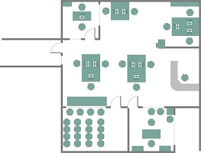

The following image will be used as a reference and style for our game design:

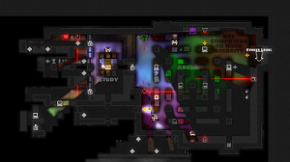

## Milestone 2 – March 6, 2014

Robustness of the gameplay is a focus in milestone 2. Multiple players will be a focus, allowing for teams to a maximum of 16 players per side (32 in total). Multiple floors will be introduced, which will be accessed through stairs. When a player enters the stairs going up or down, they will be moved up or down a floor, to the maximum of 8 floors. Randomized “objectives” will be placed across the multiple floors. The total floors available will be determined by the number of players connected, with every 4 players generating a new floor. After pressing Start on the menu screen, users will be taken to a lobby, where they will see the other users connected within the game. The users will be able to select which team they would like to play for; however, the game will rectify any balancing issues. Overall goal will be to improve graphics from previous milestone.

## Milestone 3 – March 20, 2014

Our final milestone, which many of the features deemed necessary have been implemented. The lobby will now be a “playable” map (being able to move around the map), where users will be able to decide by their location on the map to which team they would like to play for. This lobby will be much like a floor in the game and will be interactive. More variety in the maps will be introduced with different passages such as “vents.” User interaction with the objectives will now be possible. User interaction would include such actions such that a certain action will affect the system/map in a different way. Fog of war will also be added as a feature in this milestone. Both sides of the players will have a circle of vision, and this vision will give live view of the players in the map. Also, included with the sight of all players to respective teams.

The robbers will start the game with no vision, except for your own, and teammates circle of vision. As they explore, they will reveal the map, example follows:

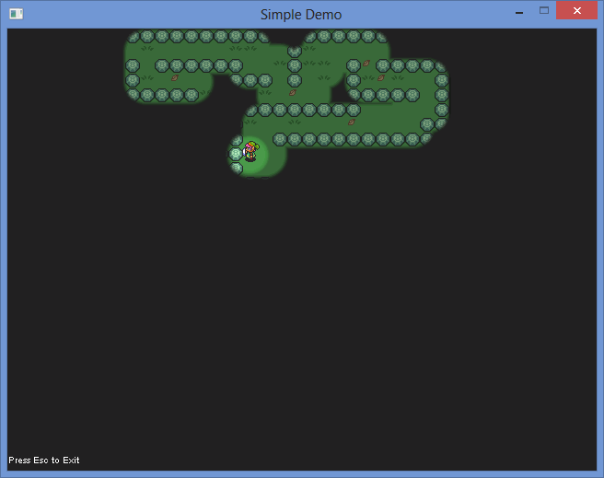

The cops will start the game with the overview of the map where they will be able to see the layout, but not robbers’ location. As example above, the cops has the same fog of war effect, but just with no black.

# State Transition Diagram



# Pseudo-Code

int main(){

initialize(){}

create thread for loading images()

bool quit = false;

SDL_Event e;//Event handler

while( !quit ) //While application is running

{

while( SDL_PollEvent( &e ) != 0 )//Handle events on queue

{

if( e.type == SDL_QUIT ) //User requests quit

{

quit = true;

}

}

render_system(&world, surface);

/*SDL_RenderClear( gRenderer ); //Clear screen

SDL_RenderCopy( gRenderer, gTexture, NULL, NULL ); //Render texture to screen

SDL_RenderPresent( gRenderer );//Update screen*/

SDL_UpdateWindowSurface(window);

}

close();

}

bool initialize(){

initialize SDL{

}

create window(){

}

create renderer(){

}

initialize img_loading{

}

return true;

}

bool load_media(){

}

void close(){

SDL_DestoryTexture();

SDL_DestroyRenderer();

SDL_DestroyWindow();

//free memory

free();

IMG_QUIT();

SDL_QUIT();

}

# Testing

|  |  |  |  |  |
| --- | --- | --- | --- | --- |
| Test # | Test Description | Tools | Expected result | Pass/Fail |
| 1 |  |  |  |  |
| 2 |  |  |  |  |
| 3 |  |  |  |  |
| 4 |  |  |  |  |
| 5 |  |  |  |  |
| 6 |  |  |  |  |
| 7 |  |  |  |  |