Before starting, please ensure the numpy package is loaded. I used the Conda environment but I am new to the packaging techniques in Python so I’m not sure that it worked correctly.

>>> nohup python ./Ising.py > Ising.out &

>>> gnuplot

>>> plot ‘Ising.out’ using 1:2 w p

>>> plot ‘Ising.out’ using 1:3 w p

>>> plot ‘Ising.out’ using 1:4 w p

>>> plot ‘Ising.out’ using 1:5 w p

These will plot the average energies, magnetization, specific heat, and susceptibility with respect to temperature.

To successfully create the Ising model numerically, the Hastings-Metropolis algorithm was used. At its core, the energy cost of a randomly flipped state from +1 to -1 is calculated based on the temperature and a uniformly random distribution. If the cost is favorable, i.e. less than the previous state, the spin state is accepted. Otherwise, the random distribution decides whether or not a state change is accepted. This is iterated until all the spins in the system are tested, known as one unit of Monte Carlo time. From here on, the average magnetization and energies are calculated periodically until the system has met its equilibrium state.

For a zero magnetic field and unity exchange interaction, we have the following results:

Average Energy:

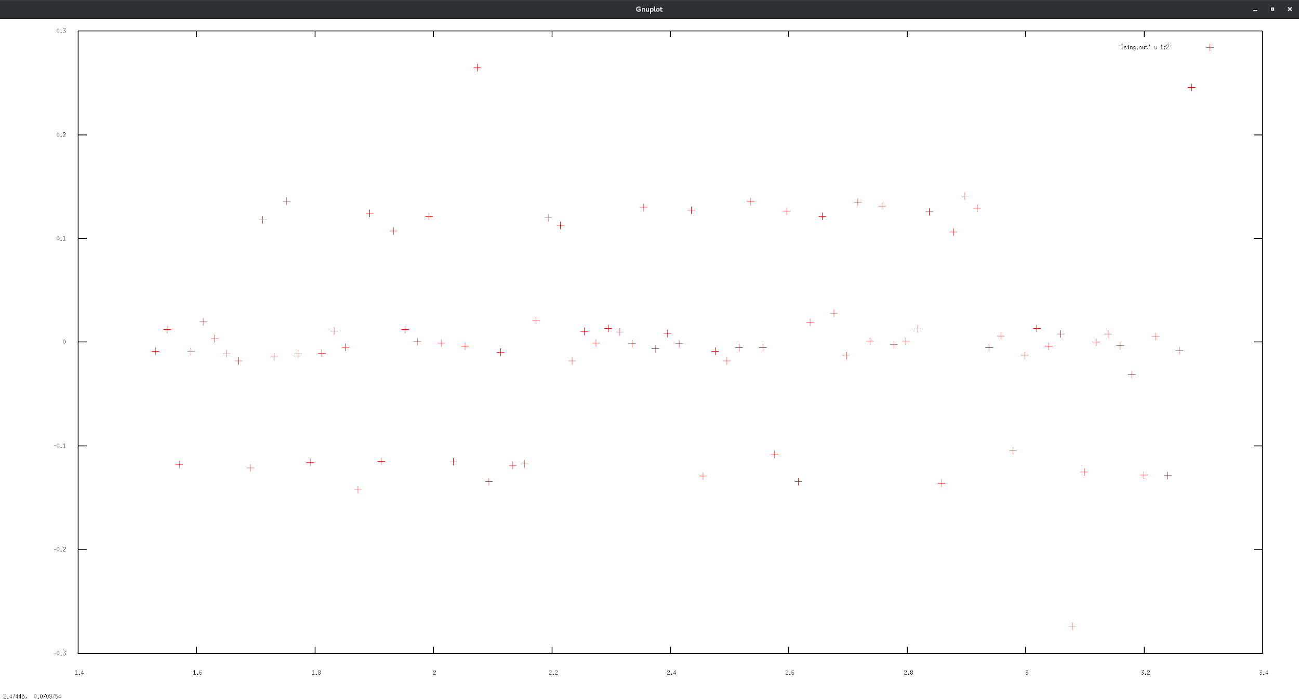

The energy levels are quantized and evenly spaced.

Average magnetization:

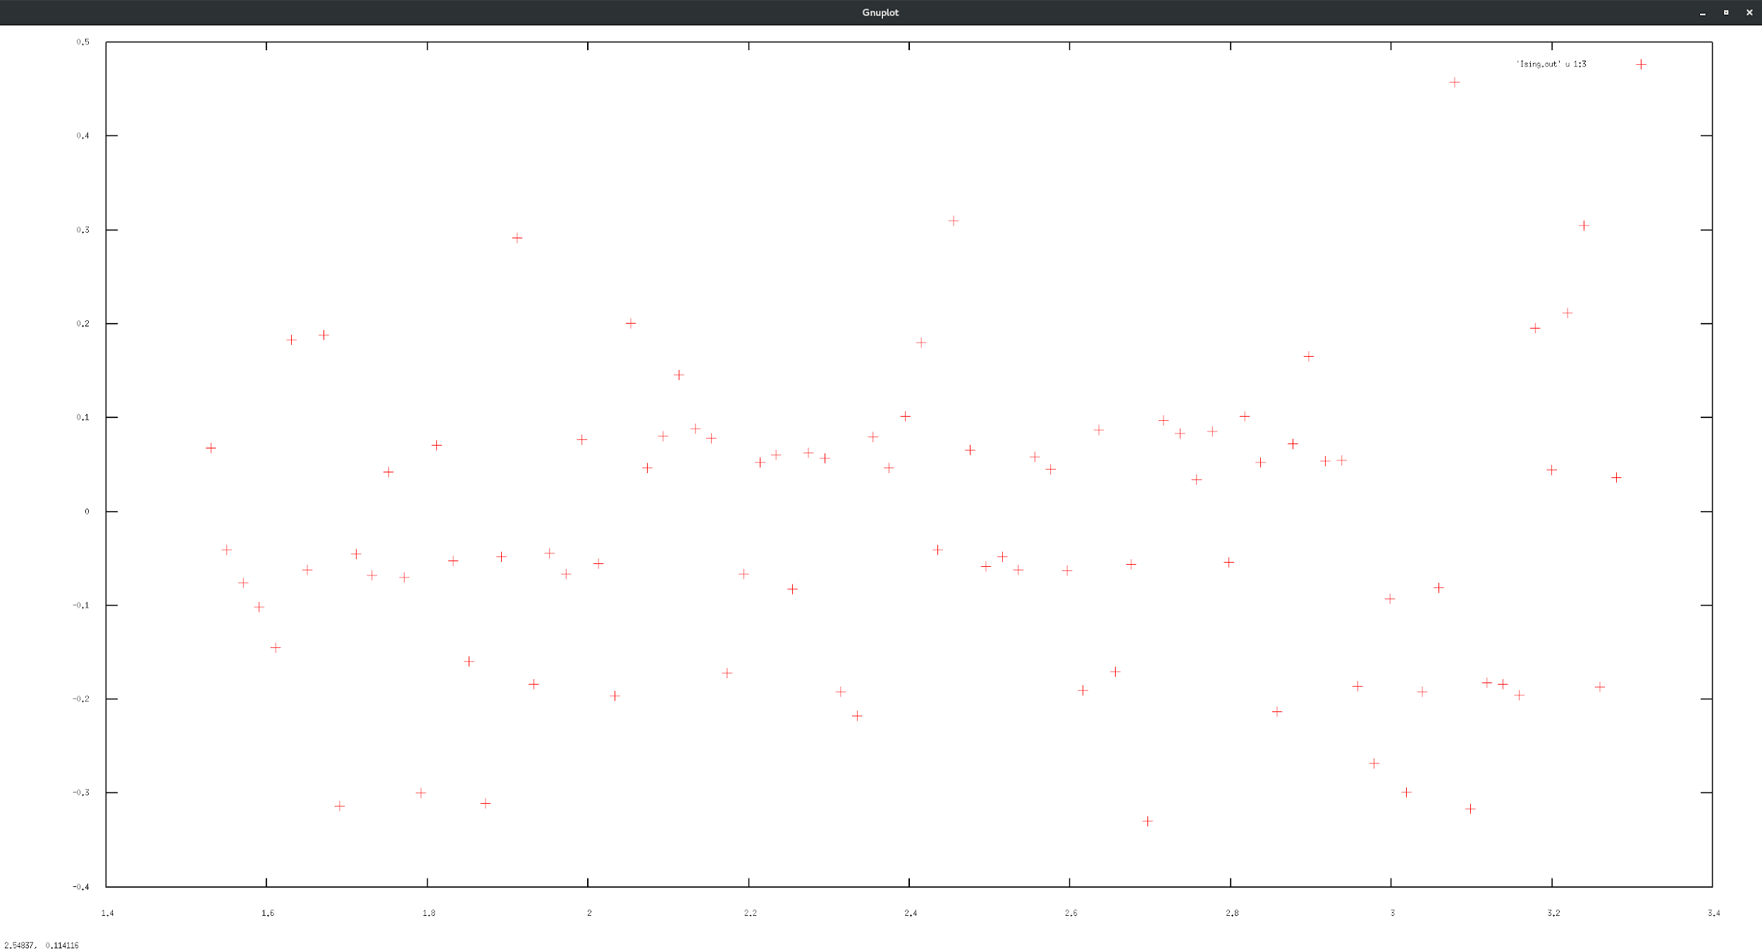

The average magnetization appears to have no correlation with temperature.

Specific heat: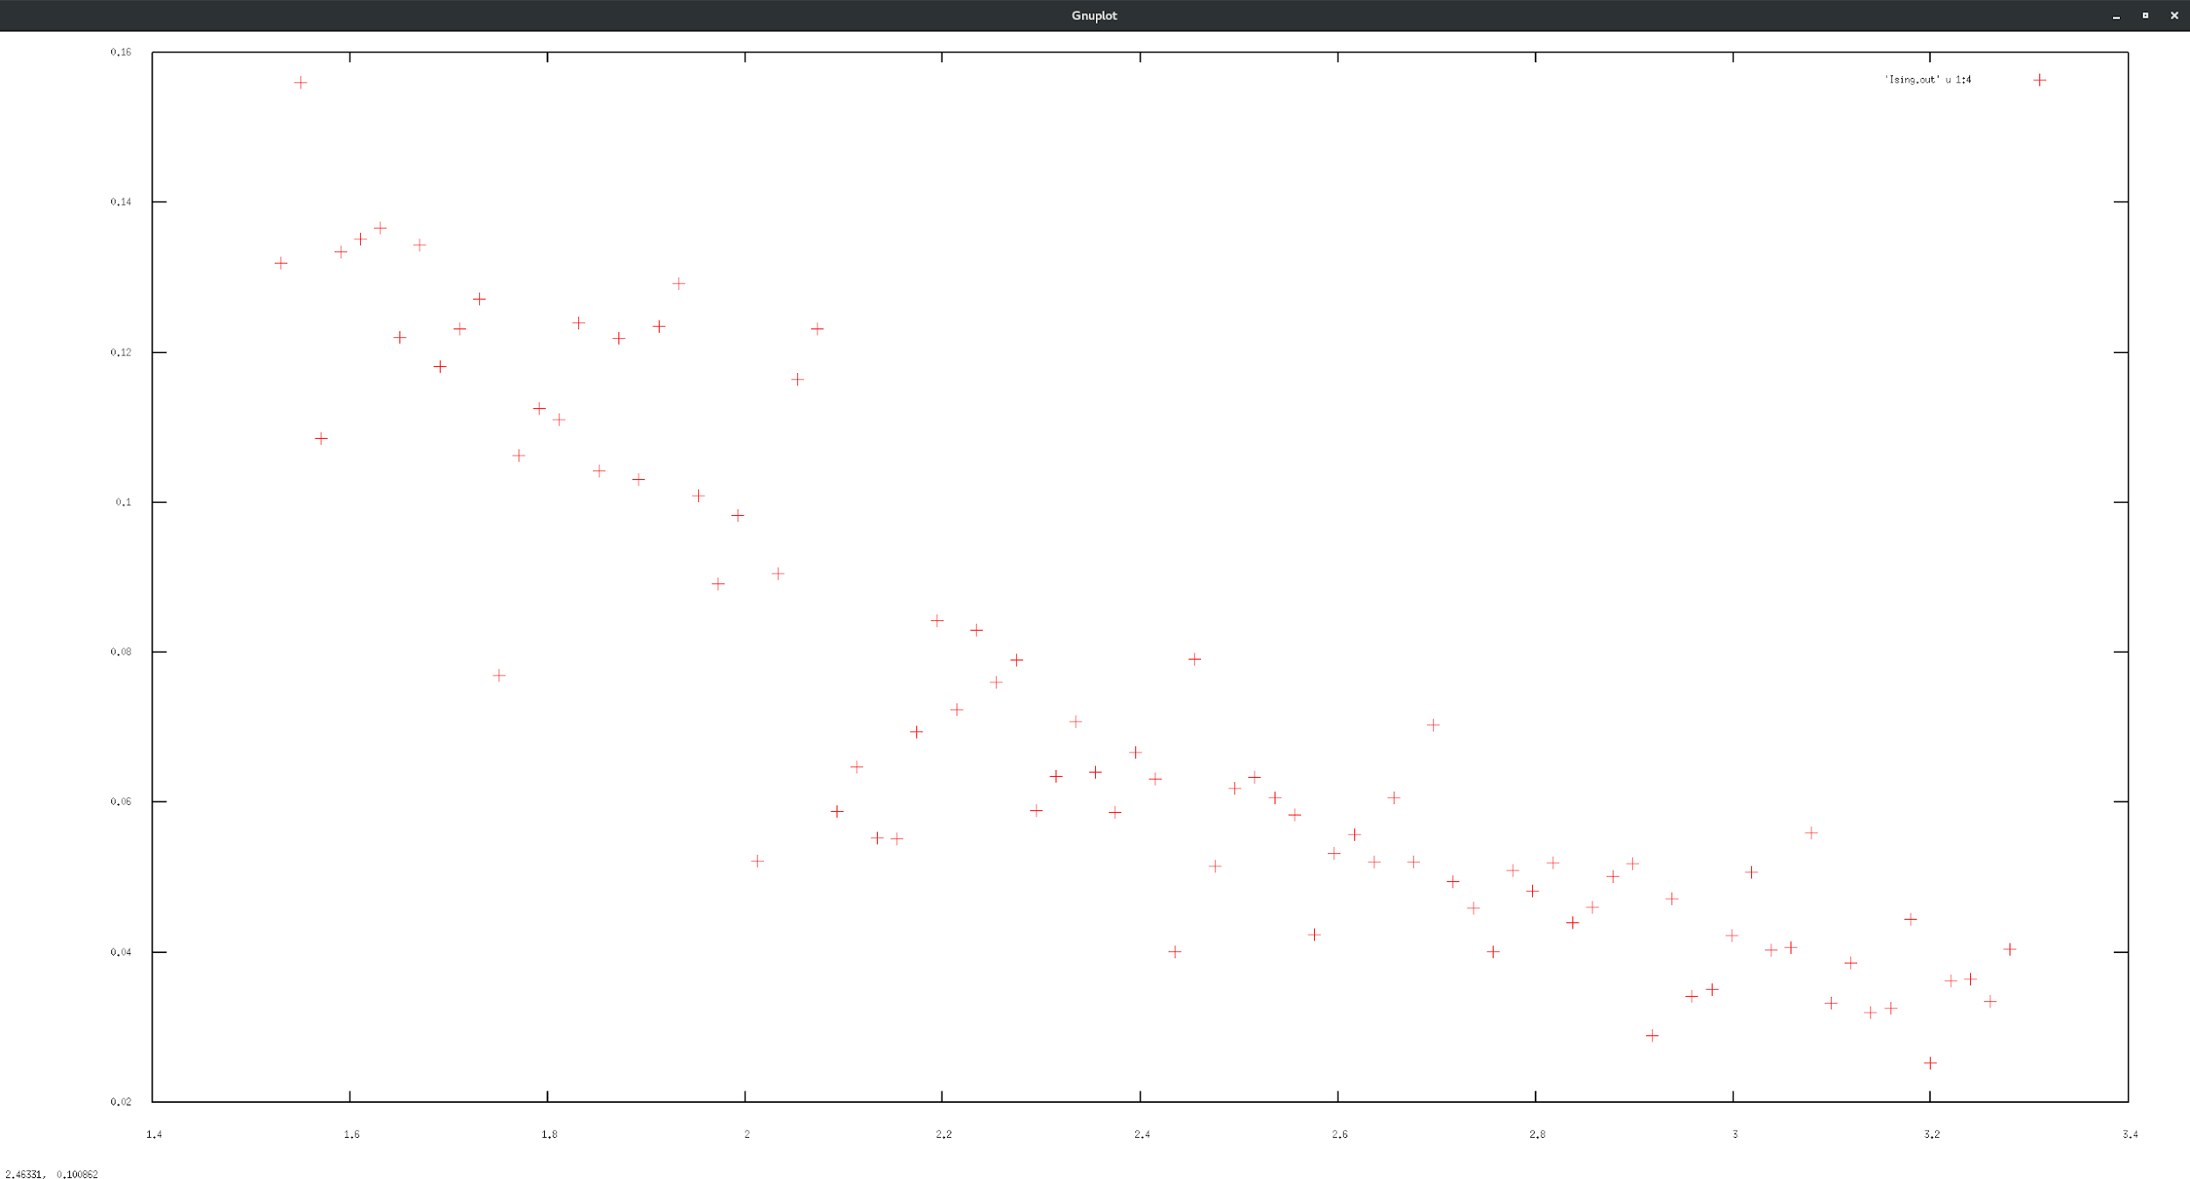

The specific heat of the system, however, has a negative regression as T increases. Similarly, for the susceptibility, we have a negative trend.

Susceptibility: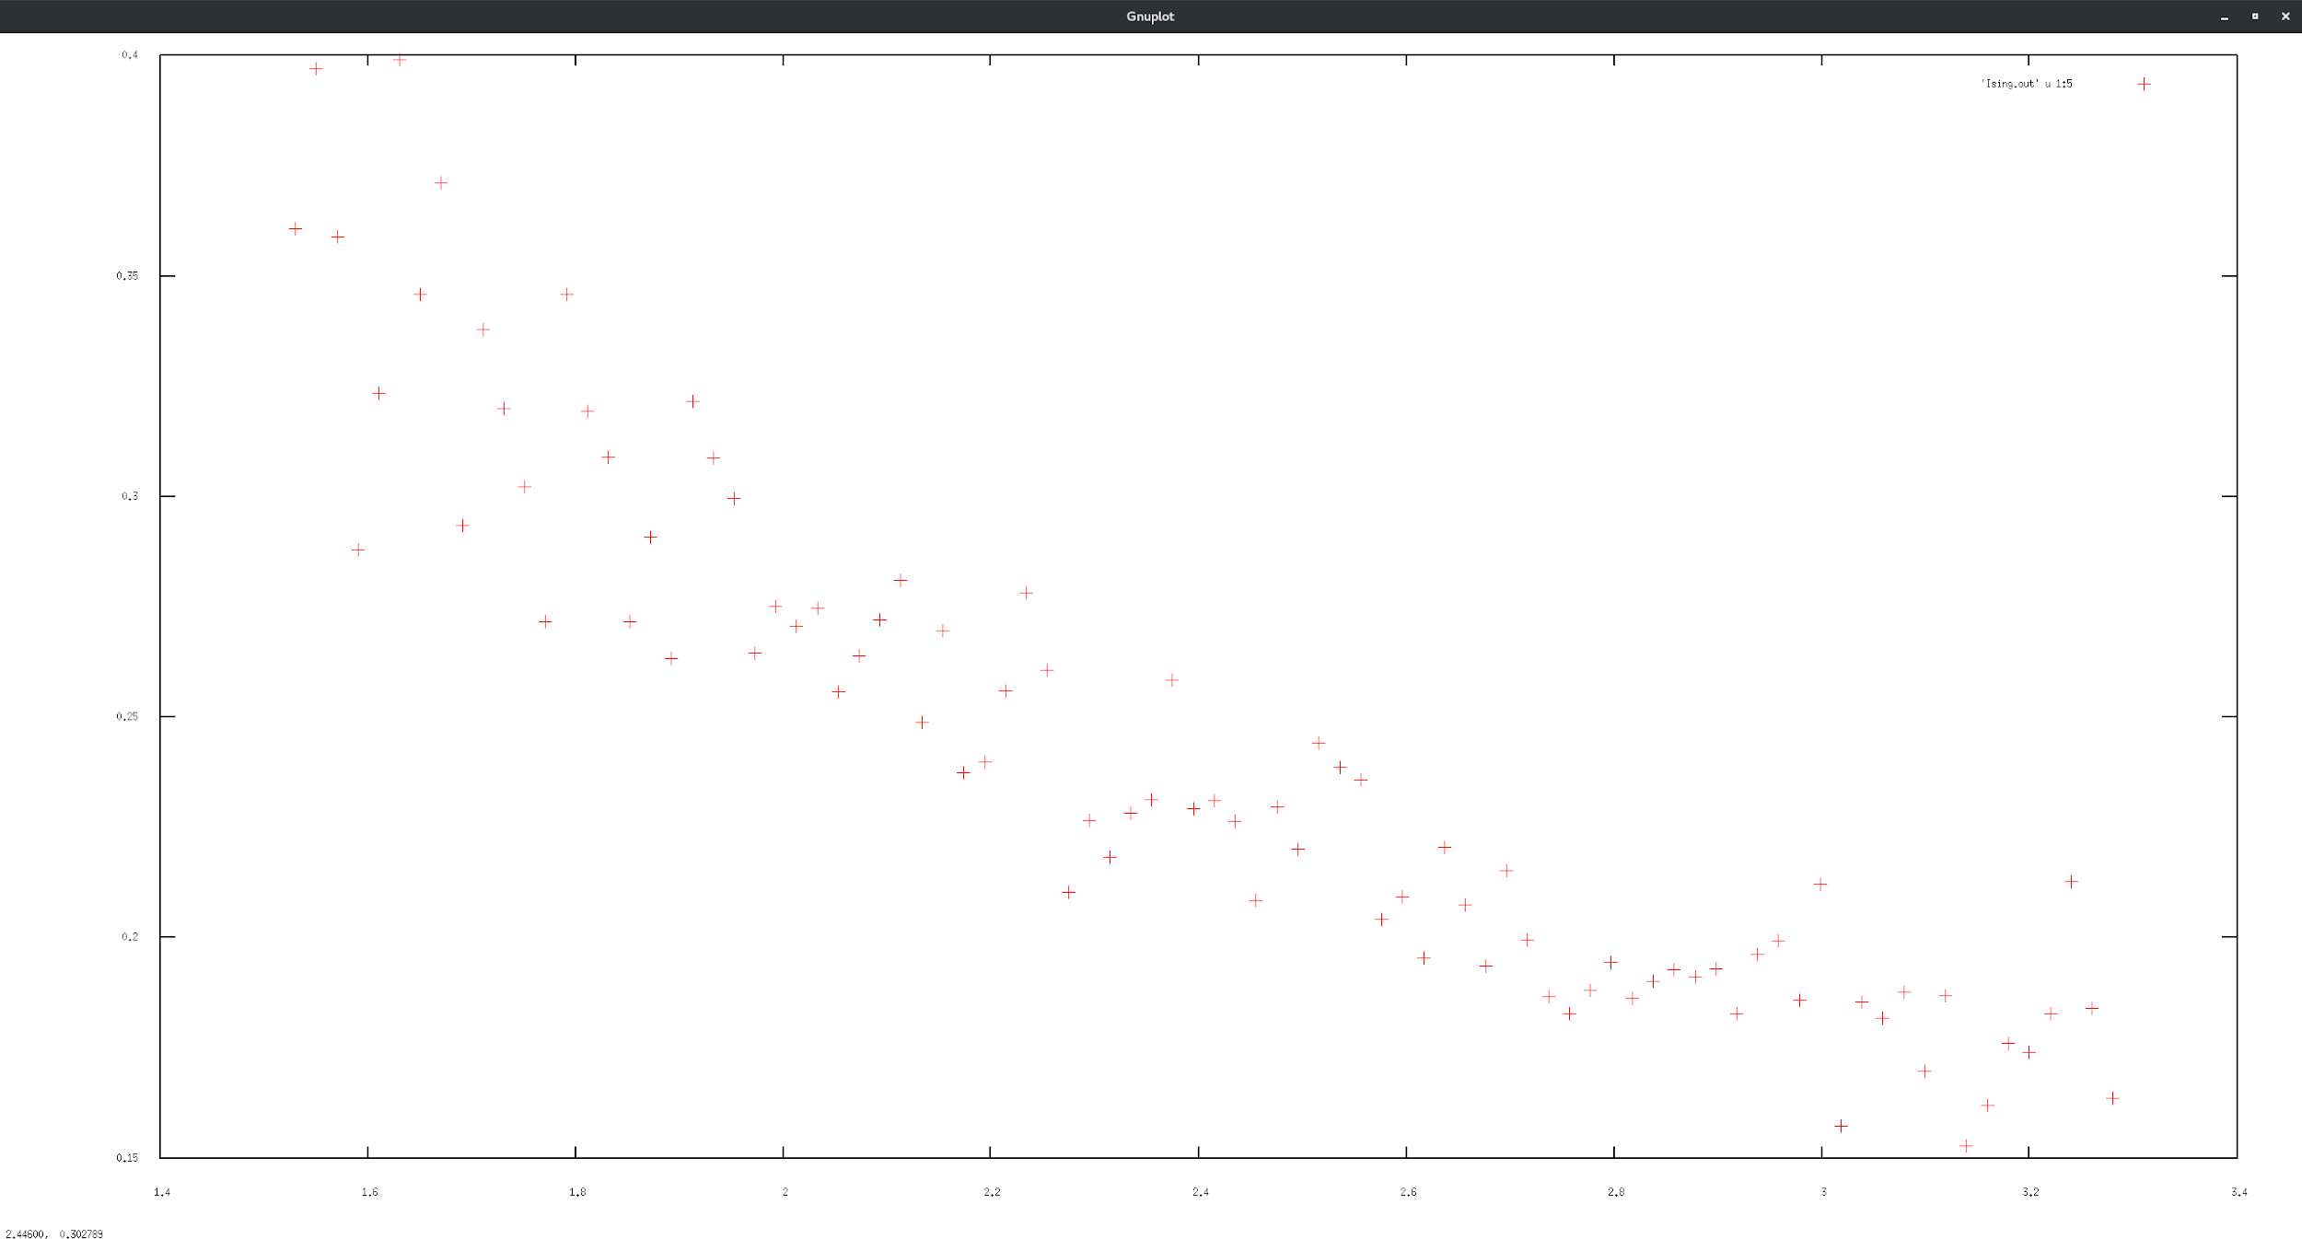

At the critical temperature, Tc = 2.269 K, there should be a sharper slope for the specific heat phase transition. This is not seen in the graphs. More data points and a longer thermalization time would allow for more accuracy to show this transition.

As the magnetic field increases, the magnetization becomes biased towards the polarity of the magnetic field. The stronger the field, the more difficult it is for phase changes to occur.

If the exchange interaction is positive, the material is ferromagnetic. In the case of negative values, the material is antiferromagnetic. Only positive interactions were considered in this model.