UHS AMS Candidate Focused UAT Retest
Focused verification after remediation for selected defects and security findings

Field | Value
Application | UHS AMS Candidate System
Application URL | http://127.0.0.1:8002/login
Repository state | Local repo main at 7bd9f94, Merge pull request #295 from DCxProduct/devdevdev; public GitHub repository page inspected.
Retest date | 27 September 2026
Scope | Focused retest only; not a full 72-test UAT suite.
Production decision | RETEST REQUIRED

Authorized Admin, Registrar, and Cashier accounts were used. The shared password is intentionally omitted from this report.

Retest Scope
This retest covered BUG-001 through BUG-006, SEC-001 through SEC-008, and a small regression check for login, logout-by-role-switching, dashboards, and direct access controls. Destructive actions, payment creation, Clear Data, deletes, external sync, password reset email delivery, and broad regression coverage were not executed.

Retest Summary
Status | Count
PASS | 3
FAIL | 9
PARTIAL | 1
BLOCKED | 1
NOT TESTED | 0
REQUIRES BUSINESS CONFIRMATION | 0

Focused result: RETEST REQUIRED. Candidate exact and no-result search and Registrar direct-access restrictions improved in this rerun, but high-severity issues remain in search clear-state, payment validation, receipt uniqueness, upload/storage controls, audit coverage, and seeded credentials.
Severity | Count | Items
High | 8 | BUG-002, BUG-003, BUG-004, SEC-001, SEC-002, SEC-003, SEC-006, SEC-007
Medium | 3 | BUG-006, SEC-005, SEC-008
Business confirmation | 0 | None in this focused rerun
Closed / verified | 3 | BUG-001, BUG-005, SEC-004

Top Pre-Production Fixes
- Repair Candidate Requested search clear-state behavior so clearing the search removes the URL/query state and restores default records.
- Enforce positive payment amounts in browser, server validation, and persistence rules; reject zero, negative, and blank values.
- Add receipt-number uniqueness at application and database level, with a safe migration for existing data.
- Harden uploads and storage, expand audit logging beyond admin-only actors where required, and make production seeding/configuration safe.
Not tested or blocked: the prior full 72-test UAT suite, destructive Clear Data/delete flows, real payment submission, external sync, email delivery, and broad cross-browser/responsive coverage were intentionally out of scope. Automated PHP tests were blocked because project dependencies were not installed in repo/vendor.

Fixed Issue Retest Table
ID | Issue | Previous Status | New Status | Evidence | Notes
BUG-001 | Candidate search exact/no-result | Open/Fail | PASS | Figures 1-2 | Exact DEMO-087 returned 1 matching row; NO_SUCH_QA_927 returned no records.
BUG-002 | Search state clear | Open/Fail | FAIL | Figure 3 | Clearing search did not clear the query or restore default rows; URL/state retained search=NO_SUCH_QA_927.
BUG-003 | Payment amount validation | Open/Fail | FAIL | Figure 4; source | 0 remained accepted in the modal; -1 normalized to 1 instead of a validation rejection; source still has no gt:0/min rule.
BUG-004 | Receipt uniqueness | Open/Fail | FAIL | Source/database | payments.receipt_number remains nullable without a unique index in the reviewed migration.
BUG-005 | Audit Logs 500 | Open/High | PASS | Figure 5 | Admin /audit-logs loaded as Audit Logs - UHS-AMS with no observed 500, SQL exception, or stack trace.
BUG-006 | Debug exposure | Open | PARTIAL | Figure 6 | 404 and observed 403 pages showed simple error pages without stack trace; no safe 500 was intentionally generated.
SEC-001 | Dynamic upload validation | Open | FAIL | Source/config | Dynamic student form FileUpload still uses public disk without explicit accepted file types or max size.
SEC-002 | Audit coverage | Open | FAIL | Source | AuditLogger still returns early unless the actor is admin; non-destructive registrar/cashier action logging was not proven.
SEC-003 | Payment constraints | Open | FAIL | Browser/source | Same evidence as BUG-003 and BUG-004.
SEC-004 | Registrar permissions | Business review | PASS | Browser | Registrar received 403 for /system-users, /shield/roles, and /audit-logs, and could access Candidate Requested.
SEC-005 | Configuration | Open | FAIL | Source | .env.example still contains APP_DEBUG=true, a concrete sample APP_KEY, and DB_PASSWORD placeholder value.
SEC-006 | Storage exposure | Open | FAIL | Source/config | Custom form uploads and payment slips still use public storage configuration in reviewed source.
SEC-007 | Seeded credentials | Open | FAIL | Source/workflow | Local test accounts may remain, but production workflow runs db:seed --force and reviewed seeders include predictable seeded credentials.
SEC-008 | Automated tests | Open | BLOCKED | CLI | php artisan test failed because repo/vendor/autoload.php is missing.

Security Retest
Source review found no evidence that dynamic upload security, public storage exposure, positive payment constraints, or seeded production-safety controls are fully remediated in the checked-out repository. The Audit Logs page availability improved, but audit coverage remains admin-scoped in source.
Finding | Focused Result | Basis
Upload validation/storage | FAIL | Student dynamic uploads still public and unconstrained by explicit MIME/max size in source.
Audit coverage | FAIL | AuditLogger shouldLogForActor remains admin-only.
Configuration | FAIL | Sample config still includes local/debug values and placeholder DB password.
Seeded credentials | FAIL | Production deployment workflow runs db:seed --force; reviewed seeder includes predictable credentials.

Regression Check
Check | Status | Evidence
Admin login/dashboard | PASS | Dashboard - UHS-AMS
Registrar login/dashboard | PASS | Dashboard - UHS-AMS
Cashier login/dashboard | PASS | Dashboard - UHS-AMS
Logout / role switching | PASS | Role switching required sign-out and resulted in each target role dashboard.
Registrar cannot access Admin-only pages | PASS | Registrar received 403 for /system-users, /shield/roles, and /audit-logs.
Cashier cannot access Admin/Registrar-only pages | PASS | Cashier received 403 for /candidate-requested and /custom-forms; could access cashier pages.

Remaining Issues
- Candidate Requested search clear-state is not reliable enough for production workflows.
- Payment amount validation does not reject zero and negative input as required.
- Receipt uniqueness is not enforced at the database level.
- Upload/storage and audit coverage findings remain open in source.
- Automated tests could not run from this checkout because PHP dependencies are missing.

Screenshot Evidence
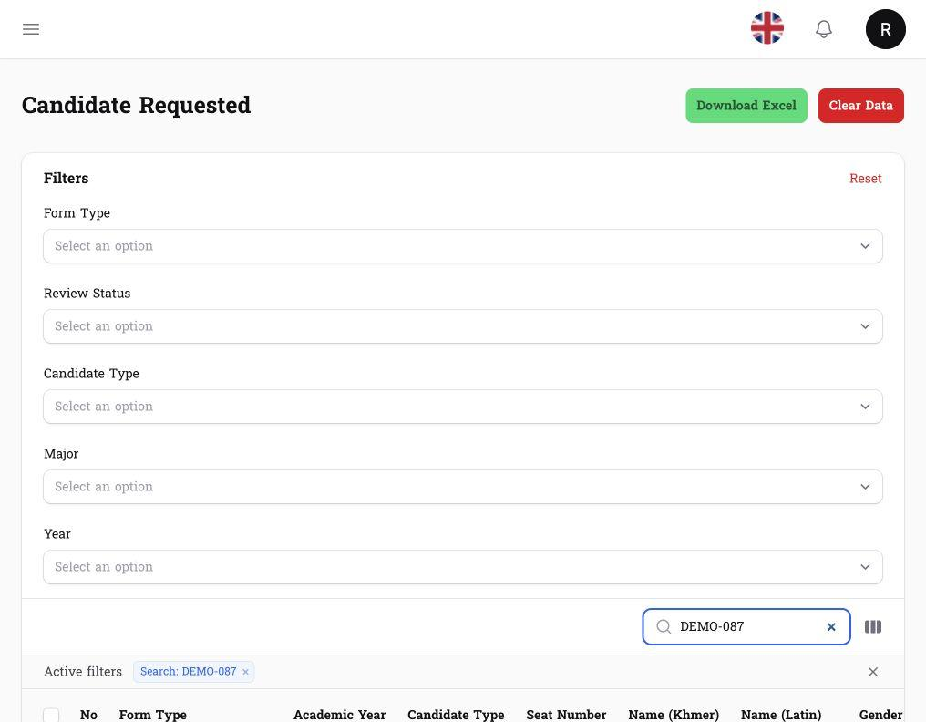
Figure 1 - Exact DEMO-087 search returned one matching record.
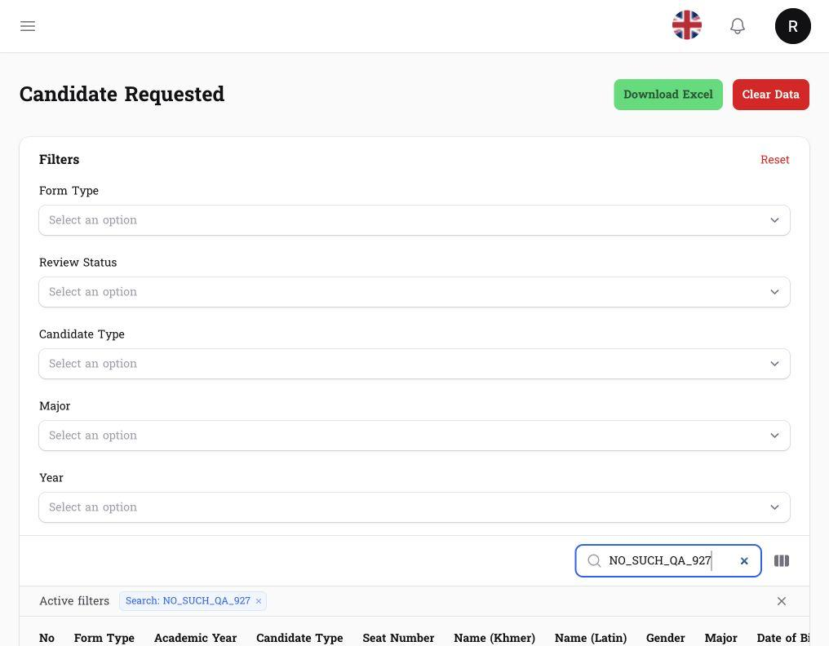
Figure 2 - No-result search returned no records.
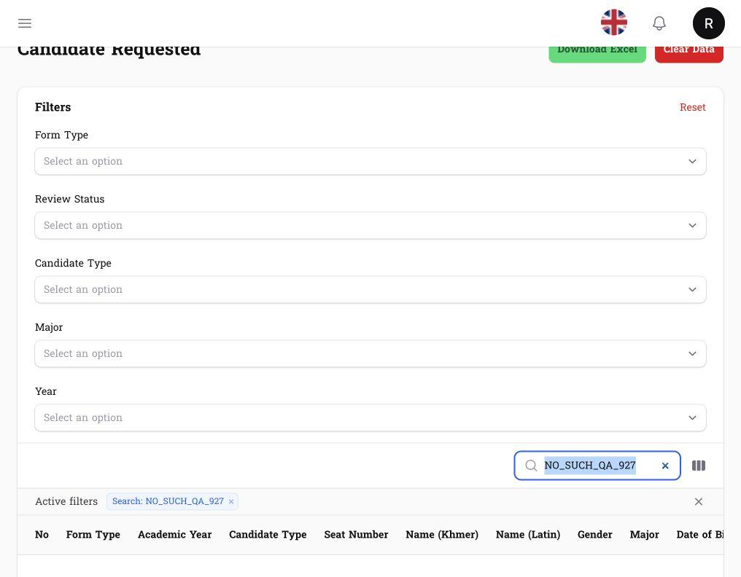
Figure 3 - Search clear retained stale no-result query in URL/state.
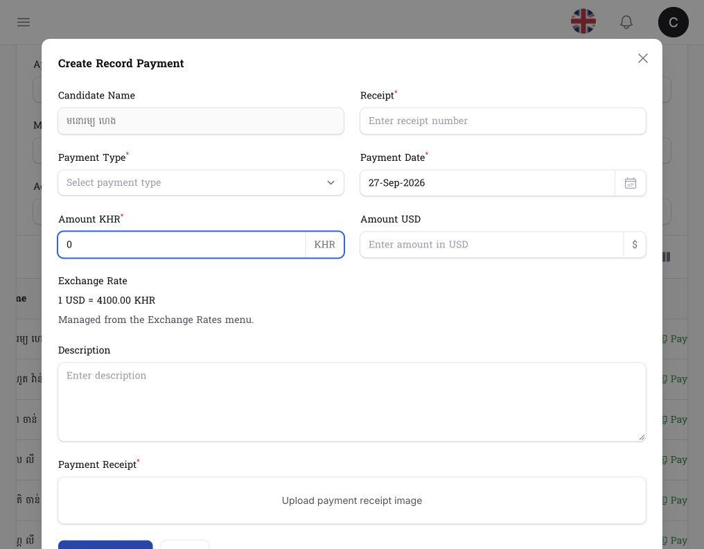
Figure 4 - Payment modal accepted zero amount in field.
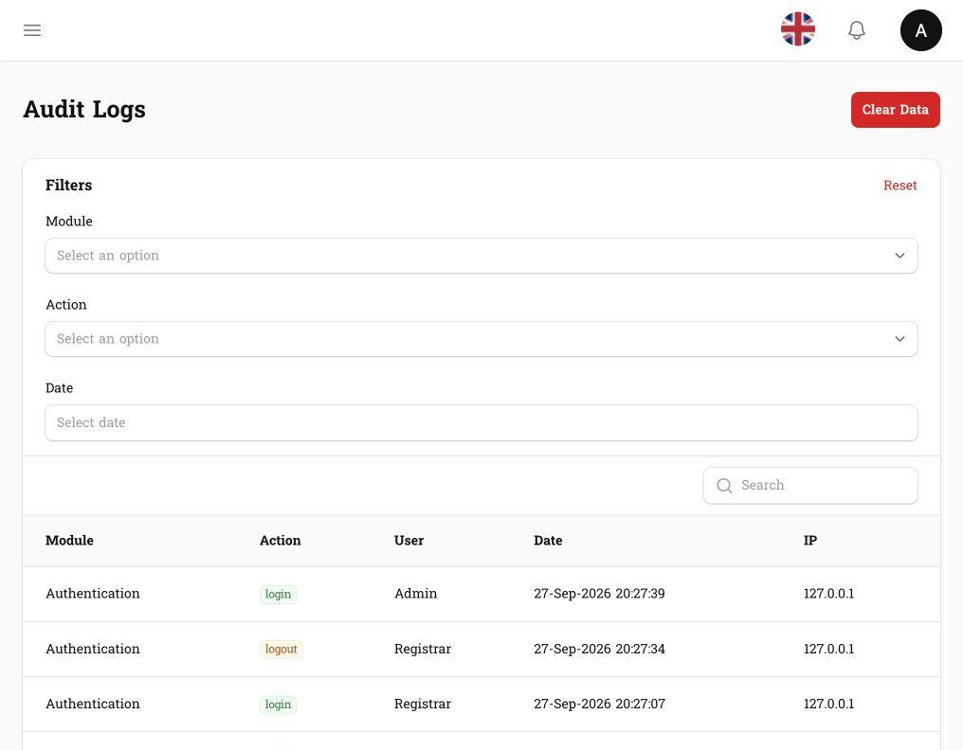
Figure 5 - Audit Logs page loaded without observed 500.
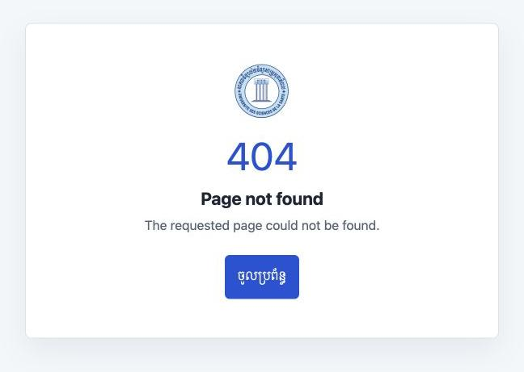
Figure 6 - 404 page showed a non-debug error message.

Production Readiness
Production decision: RETEST REQUIRED. The focused remediation retest did not pass because multiple high-severity technical findings remain unresolved or only partially verified.
Required before production: fix Candidate Requested search-clear state; enforce positive payment amount validation and receipt uniqueness; harden upload storage and validation; expand audit logging beyond admin-only actors or document an accepted control; make production seeding/configuration safe; install dependencies and run targeted tests.

Sign Off
Role | Name | Signature | Date
Prepared By
Reviewed By
Client Representative

Final UAT Status: ☐ Accepted ☐ Accepted with Conditions ☑ Retest Required

