**Spring Core and Maven**

**1) Configuring a Basic Spring Application**

**pom.xml :**

<!-- Spring Core Dependency -->

<dependency>

<groupId>org.springframework</groupId>

<artifactId>spring-context</artifactId>

<version>5.3.34</version>

</dependency>

**applicationContext.xml :**

<?xml version="1.0" encoding="UTF-8"?>

<beans xmlns="http://www.springframework.org/schema/beans"

       xmlns:xsi="http://www.w3.org/2001/XMLSchema-instance"

       xsi:schemaLocation="

           http://www.springframework.org/schema/beans

           http://www.springframework.org/schema/beans/spring-beans.xsd">

    <!-- BookRepository Bean -->

    <bean id="bookRepository" class="com.library.repository.BookRepository"/>

    <!-- BookService Bean -->

    <bean id="bookService" class="com.library.service.BookService">

        <property name="bookRepository" ref="bookRepository"/>

    </bean>

</beans>

**BookRepository.java :**

package com.library.repository;

public class BookRepository {

    public void displayBooks() {

        System.out.println("BookRepository: Displaying book list...");

    }

}

**BookService.java :**

package com.library.service;

import com.library.repository.BookRepository;

public class BookService {

    private BookRepository bookRepository;

    // Setter for dependency injection

    public void setBookRepository(BookRepository bookRepository) {

        this.bookRepository = bookRepository;

    }

    public void showBooks() {

        System.out.println("BookService: Calling repository...");

        bookRepository.displayBooks();

    }

}

**MainApp.java :**

package com.library;

import org.springframework.context.ApplicationContext;

import org.springframework.context.support.ClassPathXmlApplicationContext;

import com.library.service.BookService;

public class MainApp {

    public static void main(String[] args) {

        ApplicationContext context = new ClassPathXmlApplicationContext("applicationContext.xml");

        BookService bookService = context.getBean("bookService", BookService.class);

        bookService.showBooks();

    }

}

**Output :**

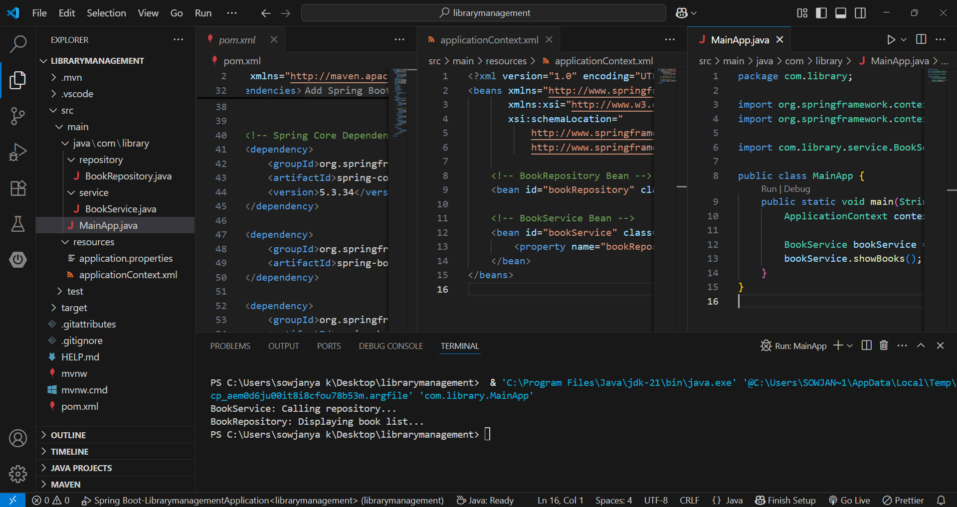

**2) Implementing Dependency Injection**

**\*applicationContext.xml :**

<?xml version="1.0" encoding="UTF-8"?>

<beans xmlns="http://www.springframework.org/schema/beans"

       xmlns:xsi="http://www.w3.org/2001/XMLSchema-instance"

       xsi:schemaLocation="

           http://www.springframework.org/schema/beans

           http://www.springframework.org/schema/beans/spring-beans.xsd">

    <!-- BookRepository Bean -->

    <bean id="bookRepository" class="com.library.repository.BookRepository"/>

    <!-- BookService Bean -->

    <bean id="bookService" class="com.library.service.BookService">

        <property name="bookRepository" ref="bookRepository"/>

    </bean>

</beans>

**BookRepository.java :**

package com.library.repository;

public class BookRepository {

    public void displayBooks() {

        System.out.println("BookRepository: Displaying book list...");

    }

}

**BookService.java :**

package com.library.service;

import com.library.repository.BookRepository;

public class BookService {

    private BookRepository bookRepository;

    // Setter for dependency injection

    public void setBookRepository(BookRepository bookRepository) {

        this.bookRepository = bookRepository;

    }

    public void showBooks() {

        System.out.println("BookService: Calling repository...");

        bookRepository.displayBooks();

    }

}

**MainApp.java :**

package com.library;

import org.springframework.context.ApplicationContext;

import org.springframework.context.support.ClassPathXmlApplicationContext;

import com.library.service.BookService;

public class MainApp {

    public static void main(String[] args) {

        ApplicationContext context = new ClassPathXmlApplicationContext("applicationContext.xml");

        BookService bookService = context.getBean("bookService", BookService.class);

        bookService.showBooks();

    }

}

**Output :**

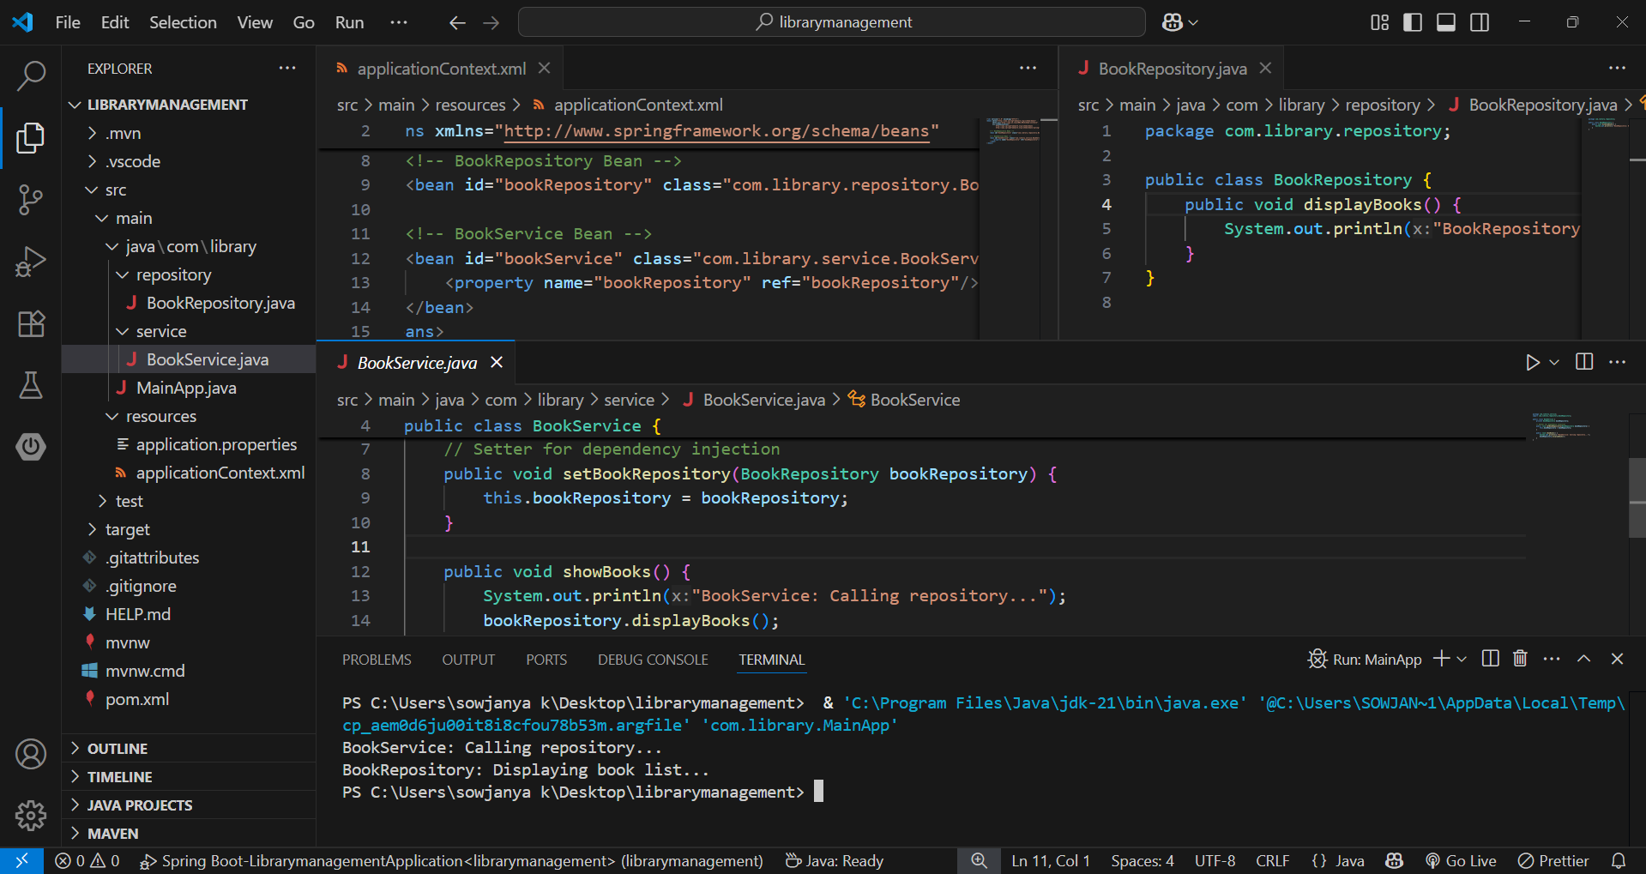

* The output shows that Spring’s IoC container successfully manages the dependency between BookService and BookRepository using setter-based Dependency Injection.
* The <property> element in applicationContext.xml wires BookRepository into BookService, and the setter method setBookRepository() ensures the injection works correctly when running the MainApp class.

**3) Creating and Configuring a Maven Project**

**pom.xml :**

<project xmlns="http://maven.apache.org/POM/4.0.0"

xmlns:xsi="http://www.w3.org/2001/XMLSchema-instance"

xsi:schemaLocation="

http://maven.apache.org/POM/4.0.0

http://maven.apache.org/xsd/maven-4.0.0.xsd">

<modelVersion>4.0.0</modelVersion>

<groupId>com.library</groupId>

<artifactId>LibraryManagement</artifactId>

<version>1.0-SNAPSHOT</version>

<dependencies>

<!-- Spring Context -->

<dependency>

<groupId>org.springframework</groupId>

<artifactId>spring-context</artifactId>

<version>5.3.34</version>

</dependency>

<!-- Spring AOP -->

<dependency>

<groupId>org.springframework</groupId>

<artifactId>spring-aop</artifactId>

<version>5.3.34</version>

</dependency>

<!-- Spring WebMVC -->

<dependency>

<groupId>org.springframework</groupId>

<artifactId>spring-webmvc</artifactId>

<version>5.3.34</version>

</dependency>

</dependencies>

<build>

<plugins>

<!-- Maven Compiler Plugin for Java 1.8 -->

<plugin>

<groupId>org.apache.maven.plugins</groupId>

<artifactId>maven-compiler-plugin</artifactId>

<version>3.8.1</version>

<configuration>

<source>1.8</source>

<target>1.8</target>

</configuration>

</plugin>

</plugins>

</build>

</project>

**Output :**

* The pom.xml is configured for the LibraryManagement project with Spring Context, Spring AOP, and Spring WebMVC dependencies.
* The Maven Compiler Plugin is set for Java version 1.8.