A data-driven decision-support framework for office chair adjustment and design: from global risk control to local comfort optimization

Min Qu, Chaoran Deng, Ruiwen Qi*

Contact information: School of Architecture and Design, Nanchang University, Nanchang, Jiangxi, China.
*Corresponding author: qiruiwen@ncu.edu.cn

Abstract: Designing office chairs that balance both high perceived comfort and low postural risk remain a complex challenge due to the potential conflicts between subjective user preferences and objective biomechanical safety criteria. This study introduces a data-driven decision-support framework for chair adjustment and design, leveraging human-computer interaction principles and machine learning techniques to provide personalized parameter recommendations. In a controlled laboratory study, 100 participants completed chair-adjustment trials, yielding 190 valid samples after quality control. A semi-automated workflow extracted joint angles from lateral images and computed RULA-based risk indices, along with anthropometric data, adjustable chair parameters, and 9-point comfort ratings. The results revealed a significant comfort-risk discrepancy. To resolve this conflict, a surrogate-model-based optimization framework was developed using multi-objective optimization algorithms to generate chair parameter configurations that meet predefined comfort requirements while minimizing postural risk. Chair adjustment was framed as a constrained decision problem, where comfort was treated as a satisficing criterion under a health-first strategy. The optimized configurations reduced L4/L5 compression (6.6%), shear force (39.6%), and trunk moment (13.1%) in biomechanical simulations. Further analysis revealed systematic relationships between design parameters, supporting a strategy that prioritizes global structural adjustments for risk reduction, followed by local refinements for comfort. Overall, the proposed framework offers an interpretable, user-centered decision-support approach for ergonomic chair design, advancing human-computer interaction by integrating user preferences with health-driven optimization.
Keywords：Ergonomic office chair; RULA; Random Forest; Multi-objective optimization; JACK; User experience;

- Introduction
The global economy is shifting from manufacturing-led growth toward knowledge- and digital-based production, expanding the population of sedentary office workers. Office employees reportedly spend approximately 80% of working hours seated (Clemes, O'Connell, & Edwardson, 2014). Sedentary behavior has therefore become a population-level exposure with substantial health implications, particularly for musculoskeletal disorders (MSDs). Beyond musculoskeletal outcomes, prolonged sitting has also been associated with chronic conditions such as cardiovascular disease and diabetes (Triglav et al., 2019). Accordingly, interventions that target office seating and posture have become crucial for mitigating occupational health risks, and the optimization of office chairs has gained attention as a key factor in promoting both comfort and health.
Previous research has largely focused on the biomechanical effects of chair design. (De Carvalho & Callaghan, 2022) reported that lumbar support and forward-tilt configurations can improve objective spinal posture. However, their “pain developers” phenomenon suggests that improved posture does not necessarily translate into reduced perceived pain, highlighting a key challenge: objective biomechanical improvements achieved through design may not align with users’ subjective comfort and symptom reports. (Helander, 2010) further noted that users have limited sensitivity to subtle seat adjustments, whereas comfort judgments can occur rapidly, implying that chair design should consider affective factors while maintaining ergonomic safeguards. (Frey, Barrett, & De Carvalho, 2021) similarly found that dynamic seating can reduce pain scores and seat pressure, yet produces limited changes in spinal angles and muscle activity. This highlights a persistent gap in the literature: subjective comfort and objective risk are often treated as separate endpoints, and there remains a need for a unified approach that can quantify and optimize both simultaneously.
When objectives conflict, multi-objective evolutionary algorithms are widely used to identify Pareto-optimal solutions and provide design trade-offs. (Nourmohammadi, Ng, Fathi, Vollebregt, & Hanson, 2023) combined digital human modeling with REBA-based risk assessment to develop E-NSGA-II for balancing productivity and worker health, demonstrating the potential of multi-objective optimization in ergonomics. However, traditional posture assessment methods (e.g., manual RULA scoring) are time-consuming and susceptible to inter-rater variability, limiting their utility for large-sample or individualized parameter optimization. To improve efficiency and consistency, recent studies have incorporated computer vision and machine learning into ergonomic assessment pipelines for automated posture identification and risk scoring. For example, (Hu, Yan, Wan, Peng, & Qi, 2024) proposed a computer-vision-based method with PSO-RF and reported an accuracy of 89%. However, much of this research focuses on posture classification or risk scoring, rather than optimizing seat parameters to simultaneously model subjective comfort and objective risk through multi-objective optimization, followed by biomechanical validation.
To address these gaps, we propose a data-driven seat-parameter design framework that integrates posture assessment, machine-learning surrogate modeling, and multi-objective optimization, followed by biomechanical simulation for verification. The framework formulates chair adjustment as a constrained decision problem that prioritizes reducing posture-related health risk while satisfying comfort requirements, thereby enabling a principled trade-off between subjective comfort and objective ergonomic risk. In addition, it provides design-relevant insights into parameter roles and adjustment strategies, supporting design-oriented decision-making and personalized configuration. The main contributions are as follows. (1) Constrained decision formulation for ergonomic adjustment: We reformulate personalized chair-parameter adjustment as a constrained decision problem, in which subjective comfort is treated as a satisficing criterion and objective ergonomic risk is explicitly minimized. This formulation integrates comfort constraints with risk-driven optimization, providing a structured and interpretable decision framework. (2) Data-driven parameter recommendation for ergonomic adjustment: A surrogate-model-based optimization framework is developed to generate personalized chair-parameter configurations within a bounded design space. By coupling Random Forest prediction with multi-objective optimization, the framework enables efficient exploration and ranking of candidate configurations, supporting actionable parameter recommendations under competing comfort and risk objectives. (3) Design-oriented insight into parameter roles: The results reveal distinct functional roles of design variables, where local support parameters are primarily associated with perceived comfort, while global structural parameters are more strongly related to objective risk. This leads to a design strategy that prioritizes global structural adjustments for risk reduction, followed by local refinements for comfort improvement, which provides actionable guidance for both product design and user adjustment. (4) Simulation-based biomechanical validation: The optimized chair configurations are evaluated using JACK digital human simulation, where biomechanical indicators such as L4/L5 compression, shear loads, and trunk moments are compared with baseline conditions. This provides independent verification of the proposed recommendations and strengthens the reliability of the framework. The overall workflow is illustrated in Fig. 1.
The remainder of this paper is organized as follows. Section 2 reviews related work on office chair design, posture assessment, and intelligent optimization and summarizes key research gaps. Section 3 presents the proposed framework and methodological details. Section 4 describes the experimental design, dataset construction, surrogate modeling results, optimization outcomes, and JACK-based biomechanical validation. Section 5 discusses implications and limitations. Section 6 concludes the paper and outlines directions for future work.

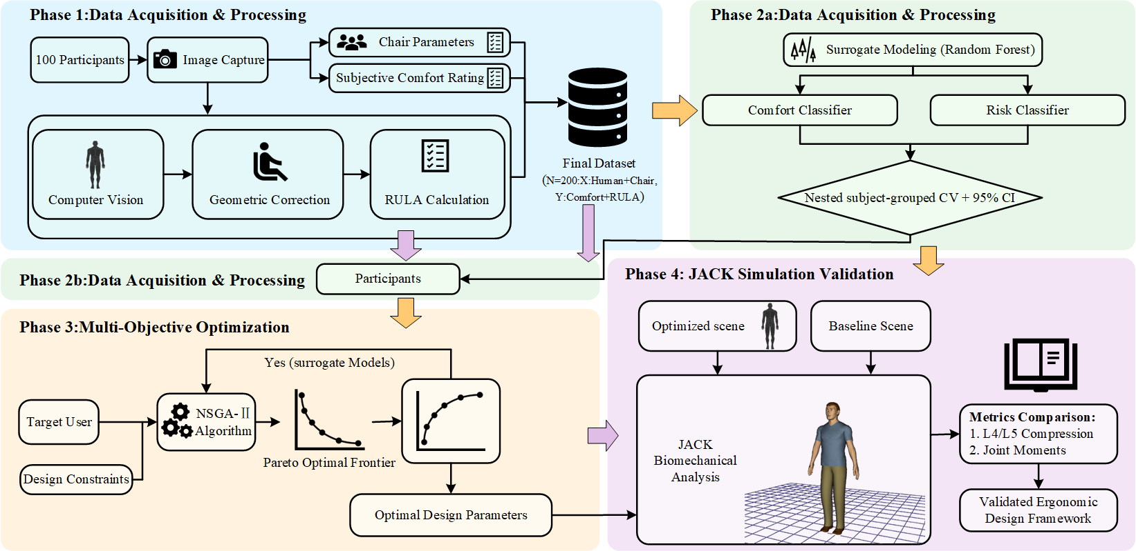
Fig. 1 The overall framework of the proposed method

- Literature Review

  - Chair Design and Comfort Risk Gap
Regarding health risks associated with prolonged sitting, prior work has examined how key office-chair parameters influence spinal loading and posture from a biomechanical perspective. (Huang, Hajizadeh, Gibson, & Lee, 2016) used biomechanical modeling to show that the effect of backrest angle on lumbar compressive forces depends on multiple interacting factors; specifically, moderate seat depth combined with an appropriate backrest height can help reduce lumbar loading. Using in vivo implant measurements, (Rohlmann, Zander, Graichen, Dreischarf, & Bergmann, 2011) reported that trunk flexion substantially increases spinal load, whereas moderate trunk extension and larger backrest angles reduce loading. Relative to standard stools, office chairs markedly decrease spinal load, and providing upper-limb support can further reduce it.
In contrast, comfortable sitting is not characterized by a single “optimal” posture and shows substantial inter-individual variability. (Chen, Chan, & Zhang, 2021) observed considerable postural variability as individuals searched for their most comfortable sitting positions. Related evidence also suggests that the relationship between perceived comfort and postural activity is non-linear and task-dependent (Chen et al., 2021; Vergara & Page, 2002). Taken together, chair configurations that appear biomechanically favorable may not be perceived as more comfortable, underscoring a persistent comfort–risk mismatch. Motivated by this gap, the present study integrates subjective comfort and objective ergonomic risk into a unified decision-making and optimization framework. For practical recommendations, we adopt a comfort-satisficing, health-first strategy: posture-related risk is minimized while predefined comfort requirements are satisfied, enabling actionable parameter recommendations and design optimization that balance subjective and objective outcomes.

  - Posture Risk Assessment
Incorporating health risk into decision-making frameworks requires reliable and task-appropriate posture risk metrics. (Varghese, V, & George, 2025) compared four observational assessment tools—Ovako Working Posture Analysis System (OWAS), Rapid Upper Limb Assessment (RULA), Rapid Entire Body Assessment (REBA), and Postural Ergonomic Risk Assessment (PERA)—and reported that RULA was the most suitable for evaluating postural load in rubber tapping. This comparison also highlights that the suitability of ergonomic assessment tools is task dependent and may require tool selection and, where appropriate, adaptation to the target activity. RULA has been widely applied for rapid screening in diverse contexts, including sewing-machine operators (Öztürk & Esin, 2011), smartphone-use postures where higher RULA scores were associated with neck and back symptoms (Namwongsa, Puntumetakul, Neubert, Chaiklieng, & Boucaut, 2018), and dental workstations assessed using high-precision inertial motion capture combined with RULA-based evaluation (Holzgreve et al., 2025). (Tahernejad et al., 2022) further combined a posture recording/classification approach with RULA to address the limitations of conventional office ergonomics in preventing prolonged poor and static sitting postures.
Collectively, these studies support the practical utility of RULA across multiple application scenarios. However, for large-sample studies of everyday office sitting, RULA scoring often relies either on manual observation or on specialized measurement systems. Manual scoring is time-consuming and susceptible to inter-rater variability, whereas instrumented approaches can be costly and operationally burdensome, limiting scalability and personalization. To address these constraints, the present study leverages computer vision to extract sagittal-plane joint angles from lateral images and to compute RULA scores in a semi-automated pipeline. This approach improves efficiency and consistency and provides objective labels for subsequent data-driven modeling and optimization.

  - Data-driven Ergonomic Modeling and Multi-objective Design Optimization
In recent years, machine learning (ML) has been increasingly adopted in ergonomics, particularly for posture recognition, risk assessment, and the prediction of related biomechanical or physiological metrics. (Çakit & Karwowski, 2025) reviewed 130 publications (2015–2024) on ML in human factors and ergonomics and reported a marked growth in ML adoption after 2019, with posture-recognition tasks often achieving high accuracy. ML-based approaches have also been integrated with physiological sensing to support ergonomic evaluation; for example, (Mudiyanselage, Nguyen, Rajabi, & Akhavian, 2021) combined surface electromyography (sEMG) with multiple models to automate risk assessment for manual material-handling tasks, and (Baklouti et al., 2024) integrated force myography (FMG) with support vector machines (SVM) for muscle-effort recognition. These studies indicate that ML is well suited to capturing high-dimensional features and non-linear relationships, providing a methodological basis for data-driven decision-making in human factors. Beyond risk scoring, (Xu & Chen, 2025) combined the PLEASURC multidimensional evaluation framework with explainable-ML techniques (e.g., SHAP) to address discrepancies between expert and student evaluations in classroom nap-chair design while meeting dual requirements for learning and rest. (Farhani, Zhou, Danielson, & Trejos, 2022) further demonstrated that combining multiple ML models (e.g., Random Forests, SVM, and LSTM–CNN) can accurately classify postures during dynamic seating and predict subsequent movements.
For engineering design problems with conflicting objectives, multi-objective optimization is commonly used to generate Pareto-optimal solution sets to support design selection. (Nourmohammadi et al., 2023) combined digital human modeling with REBA to develop E-NSGA-II for jointly optimizing cycle time and ergonomic risk. (Giridhar & Panicker, 2024) similarly applied NSGA-II and related approaches to assembly-line balancing with ergonomics considerations, supporting the feasibility of multi-objective evolutionary algorithms for human factors problems.
Despite these advances, two limitations remain. First, many ML applications emphasize risk identification, posture classification, or single-metric prediction, but do not explicitly map model outputs to adjustable design variables in a way that yields actionable parameter recommendations. Second, multi-objective optimization studies in ergonomics often focus on system-level trade-offs (e.g., productivity vs. risk) rather than establishing a closed-loop pipeline—from data-driven modeling to parameter optimization to independent validation—tailored to office chair settings. In particular, there is limited work that uses ML models as surrogate objectives/constraints for efficient design-space exploration (e.g., via NSGA-II) and then integrates digital human simulation to verify biomechanical outcomes.
To address these gaps, we propose an RF–NSGA-II framework for office-chair parameter recommendation. A Random Forest surrogate model is trained to predict posture angles as interpretable intermediate variables and to support downstream estimation of ergonomic risk. During optimization, NSGA-II searches the feasible adjustment range to generate candidate trade-off solutions. A comfort-satisficing, health-first decision strategy is then used to select recommended settings by minimizing estimated risk subject to comfort requirements. Finally, digital human simulation is employed to verify the biomechanical plausibility of the optimized solutions, yielding a reusable closed-loop system for chair-parameter optimization.

- Methods

  - RULA
RULA enables rapid screening of postural risk by evaluating neck, trunk, and upper-limb posture, as well as muscle use and external load factors (McAtamney & Nigel Corlett, 1993). It has been widely used to support workstation evaluation and ergonomic intervention aimed at reducing fatigue and mitigating musculoskeletal disorder (MSD) risk (Zhang, Li, Xu, Zhao, & Gao, 2024). In the RULA procedure, posture is scored in two sections: Group A (upper arm, lower arm, and wrist) and Group B (neck, trunk, and legs). Sub-scores are first computed for each section and then combined into an overall RULA score using standardized lookup tables. The key advantages of RULA include standardized scoring and high practical feasibility, which make it suitable for rapid screening and comparative assessments.
Because the present study focuses on static seated office postures and uses lateral images, RULA scoring primarily depends on sagittal-plane angles of the neck, trunk, and upper limbs. To ensure consistency with this study’s measurement conventions and data-collection constraints, we adopted the following operational assumptions. (1) Sign conventions: neck flexion ≥ 0 indicates flexion and neck flexion < 0 indicates extension; trunk flexion ≥ 0 indicates recline (extension) and trunk flexion < 0 indicates forward trunk flexion. (2) Upper-arm angle correction: the raw image-based upper-arm angle is converted to an elevation magnitude relative to the vertical reference. (3) Score aggregation: component scores are combined using the official RULA lookup tables to obtain the total score. (4) Controlled items: wrist-related items, muscle use, and external load are treated as controlled (constant) conditions for the seated office task in this study. (5) Leg support: foot/leg support is assumed to be present; therefore, the leg score is treated as constant. Detailed scoring rules are provided in Table 1.
This operationalization should be interpreted as a sagittal-plane, task-controlled implementation of RULA for standardized comparisons within the present seated-office context. Specifically, because a single lateral view cannot reliably resolve out-of-plane components (e.g., axial rotation, abduction/adduction) and fine wrist deviations, the resulting scores are intended for relative risk ranking and optimization within the sampled design space rather than as a full multi-planar clinical-grade RULA assessment.

Table 1 Angle-to-component scoring rules adapted from RULA
RULA score item | Formula | Score (thresholds)
Upper arm position | UA = 180°-  |Upper Arm Flexion| | +1 (0, 20°]  +2 (20°, 45°]  +3 (45°, 90°]  +4 (90°, ∞)
Lower arm position | LA = Elbow Angle | +1 [60°, 100°]  +2 (-∞, 60°) ∪ (100°, ∞)
Neck angle | N = Neck Flexion | +1 [0°, 10°]  +2 (10°, 20°]  +3 (20°, ∞)  +4 (-∞, 0°)
Trunk angle (recline case) | T = Trunk Flexion, if T≥0 | +1 [0°, 60°]  +4 (60°, ∞)
Trunk angle (flexion case) | Tf = |Trunk Flexion|, if Trunk Flexion<0 | +2 [0°, 20°]  +3 (20°, 60°]  +4 (60°, ∞)
Wrist posture | constant | +1 (assumed neutral)
Muscle use / external load | constant | +0 (assumed negligible load)
Legs (controlled) | constant | +1 (assumed supported sitting)

  - Computer Vision-enabled Automated RULA Scoring
RULA scores are commonly obtained through direct observation or by analyzing still images or video recordings (MassirisFernández, Fernández, Bajo, & Delrieux, 2020). However, manual scoring is labor intensive and susceptible to observer-related variability, which limits reproducibility and makes large-sample analyses impractical. To address these limitations, a semi-automated posture assessment workflow was implemented. Specifically, stable and visually identifiable anatomical landmarks are manually annotated on lateral seated images; the resulting 2D coordinates are then used to compute joint angles under a sagittal-plane approximation, and these angles are mapped to RULA scores using standardized decision rules. The workflow is summarized in Fig. 2.
It should be noted that, due to the use of lateral-view images, the present implementation represents a sagittal-plane, task-controlled approximation of the RULA method. Certain components of the original RULA assessment (e.g., wrist twist, muscle use, and external load) were treated as controlled or constant across trials, given the standardized seated task conditions. Therefore, the computed RULA scores should be interpreted as relative indicators for posture-related risk ranking and comparison across configurations, rather than as full multi-planar clinical assessments. This formulation ensures consistency across samples under controlled task conditions and supports its use in comparative analysis and optimization.

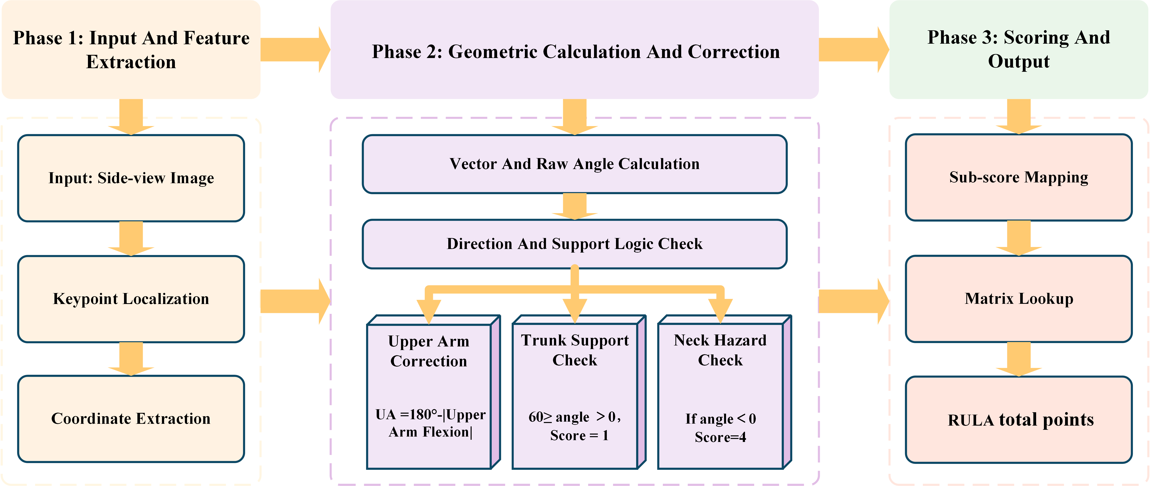
Fig. 2 Flowchart of Automated RULA Assessment

Image-based posture analysis is sensitive to recording conditions. (Plantard, Shum, Le Pierres, & Multon, 2017) noted that common imaging challenges—such as non-uniform illumination, viewpoint changes, crowding, and occlusion—can degrade measurement quality and lead to missing or unreliable information. To reduce such information loss, we selected a set of anatomical landmarks that are typically stable and visually identifiable in lateral views: the outer canthus, tragus, acromion, elbow, wrist, palm, greater trochanter, knee, and ankle. These landmarks were used to construct segment vectors and compute sagittal-plane posture angles, as illustrated in Fig. 3.
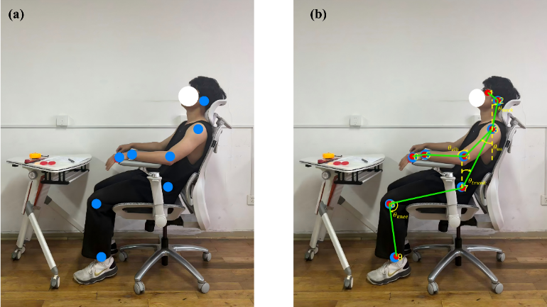
Fig. 3 The computer vision-based posture quantification framework. (a) Original side-profile image; (b) Biomechanical skeletonization and geometric definition of postural angles. The dashed yellow lines represent
Based on the key node coordinates $p_{i}=\left(u_{i},v_{i}\right)$，derived from side-view image annotations, this paper employs vector geometry methods to compute the key joint angles required for RULA pose estimation. Angle polarity is defined relative to a unified reference direction oriented vertically upward. To ensure stable and consistent quadrant determination, all attitude angles are calculated using the inverse tangent function $atan2$. The following outlines the angle computations and sign definitions for each key node.
- Vector Definition and Reference Angle Calculation
Given any two key nodes $p_{a}=\left(u_{a},v_{a}\right), p_{b}=\left(u_{b},v_{b}\right)$，the two-dimensional vector from point $p_{a}$ to $p_{b}$ is defined as:
$$\begin{aligned}d_{a→b}=\left[\begin{matrix}Δu \\ Δv\end{matrix}\right]=\left[\begin{matrix}u_{b}-u_{a} \\ v_{b}-v_{a}\end{matrix}\right]\#\left(1\right)\end{aligned}$$
To define the vertical upward direction as the reference orientation, $atan2\left(y,x\right)$ returns the signed angle between the vector $\left(x,y\right)$ and the horizontal axis. The angle calculation formula in this document is as follows:
$$\begin{aligned}θ\left(d_{a→b}\right)=atan2\left(Δu,-Δv\right)⋅\frac{180}{π}\#\left(2\right)\end{aligned}$$
In the formula, $θ$ is measured in degrees; the first parameter $Δu$ corresponds to $y$ in $atan2\left(y,x\right)$，while $-Δv$ corresponds to $x$, thereby achieving stable quadrant determination.
(2) Neck Angle
Take the tragus point $p_{ear}$ ​and the acromion point $p_{sho}$. Define the neck bone segment vector as the vector directed from the acromion to the tragus:
$$\begin{aligned}d_{neck}=d_{sho→ear}=\left[\begin{matrix}u_{ear}-u_{sho} \\ v_{ear}-v_{sho}\end{matrix}\right]\#\left(3\right)\end{aligned}$$
The neck angle is calculated directly using the reference angle formula:
$$\begin{aligned}θ_{neck}=θ\left(d_{neck}\right)\#\left(4\right)\end{aligned}$$
When $θ_{neck}>0$, it indicates neck flexion; when $θ_{neck}<0$, it indicates neck extension.
(3) Trunk angle
Take the greater trochanter point $p_{hip}$​ and the acromion point $p_{sho}$​，Define the trunk bone segment vector as the vector pointing from the hip point to the shoulder point:
$$\begin{aligned}d_{trunk}=d_{hip→sho}=\left[\begin{matrix}u_{sho}-u_{hip} \\ v_{sho}-v_{hip}\end{matrix}\right]\#\left(5\right)\end{aligned}$$
The trunk angle is calculated directly using the reference angle formula:
$$\begin{aligned}θ_{trunk}=θ\left(d_{trunk}\right)\#(6)\end{aligned}$$
When $θ_{trunk}>0$, it indicates trunk extension; when $θ_{trunk}<0$, it indicates trunk flexion.
(4) Upper Arm Angle
Take the acromion point $p_{sho}$​ and the elbow joint point $p_{elb}$ ​. Define the upper arm bone segment vector as the vector pointing from the shoulder point to the elbow joint point:
$$\begin{aligned}d_{ua}=d_{sho→elb}=\left[\begin{matrix}u_{elb}-u_{sho} \\ v_{elb}-v_{sho}\end{matrix}\right]\#\left(7\right)\end{aligned}$$
First, obtain the original angle of the upper arm using the reference angle formula:
$$\begin{aligned}θ_{ua,raw}=θ\left(d_{ua}\right)\#\left(8\right)\end{aligned}$$
To ensure consistency between the angular values and the relative vertical elevation of the RULA scoring criteria, the original angles undergo normalization correction using the following formula:
$$\begin{aligned}θ_{ua}={180}^{∘}-\left|θ_{ua,raw}\right|\#\left(9\right)\end{aligned}$$
Taking the absolute value eliminates the quadrant sign difference in the angle, allowing $θ_{ua}$​ to represent only the elevation angle of the upper arm relative to the vertical direction. The corrected angle $θ_{ua}$​ is used for subsequent RULA upper arm posture score mapping.
(5) Elbow Joint Angle
Taking the acromion point $p_{sho}$, elbow joint point $p_{elb}$​, and wrist joint point $p_{wri}$​, define the upper arm vector and forearm vector at the elbow joint respectively:
$$\begin{aligned}d_{up}=d_{elb→sho}=\left[\begin{matrix}u_{sho}-u_{elb} \\ v_{sho}-v_{elb}\end{matrix}\right],d_{low}=d_{elb→wri}=\left[\begin{matrix}u_{wri}-u_{elb} \\ v_{wri}-v_{elb}\end{matrix}\right]\#\left(10\right)\end{aligned}$$
Both vectors originate from the elbow point, ensuring the calculated angle represents the internal angle of the elbow joint to avoid directional ambiguity. The formula for the internal angle of the elbow joint is:
$$\begin{aligned}θ_{elb}=arccos\left(\frac{d_{up}⋅d_{low}}{∥d_{up}∥∥d_{low}∥}\right)⋅\frac{180}{π}\#\left(11\right)\end{aligned}$$
The defined angles, vector construction rules, and unified notation conventions possess clear geometric meanings and reproducible computational processes. This provides a stable geometric foundation for subsequent RULA sub-score mapping and overall score calculation.

  - Random Forest
Random Forests (RF) are ensemble models that aggregate multiple decision trees and are widely used due to strong predictive performance, robustness to noise/outliers, and effective handling of high-dimensional features (Breiman, 2001). Accordingly, we use RF to construct surrogate models for chair-parameter optimization, enabling rapid estimation of ergonomic outcomes given individual anthropometrics and adjustable chair settings, and providing efficient fitness evaluations for NSGA-II.
Because both posture-related risk and perceived comfort are strongly mediated by sitting posture, a direct mapping from anthropometrics and chair parameters to risk/comfort can be sensitive to inter-individual variability and measurement noise. We therefore adopt a two-stage surrogate modeling strategy:
- Postural-angle prediction. Anthropometric variables and chair parameters are used as inputs, and the joint angles computed from the image-annotation workflow serve as supervised labels. An RF regressor predicts key sagittal-plane angles (neck, trunk, upper arm, elbow, and knee), yielding a predicted posture vector $\left(\hat{p}\right)$. Prediction error is evaluated on cross-validated test folds. During optimization, $\left(\hat{p}\right)$ replaces image-derived posture inputs that are unavailable at inference time and is used as an intermediate representation for the second stage.
- Risk and comfort surrogates. The predicted posture vector $\left(\hat{p}\right)$ is concatenated with standardized input features to form an augmented feature set. An RF classifier is trained to output two probabilistic scores: $\left(P\left(\text{RULA}≤3\right)\right)$ (low-risk probability) and $\left(P\left(\text{Comfort}≥7\right)\right)$ (comfort-satisfied probability), where $Comfort ≥ 7$ defines the comfort-acceptable range and $RULA ≤ 3$ defines the low-risk range.
The overall feature set includes anthropometric characteristics and chair characteristics, and the targets include the comfort rating and the final RULA score (Table 2).

Table 2 Input features and prediction targets
Item | Definition (units)
Human features | Gender (1=Male, 2=Female), Stature (cm), Weight (kg), Sitting Height (cm), Popliteal Height (cm), Buttock Pop Length (cm)
Chair parameters | Chair Seat Height (cm), Chair Seat Depth (cm), Chair Backrest Angle (°), Chair Armrest Height (cm), Chair Lumbar Height (cm), Chair Headrest Height (cm)
Pose targets (stage 1) | Neck Flexion (°), Trunk Flexion (°), Upper Arm Flexion (°), Elbow Angle (°), Knee Angle (°)
Classification targets (stage 2) | High comfort:$\left(P\left(\text{Comfort}≥7\right)\right)$; Low risk: $\left(P\left(\text{RULA}≤3\right)\right)$

To ensure consistent feature scaling between model training and the subsequent optimization stage, we apply Z-score normalization:
$$\begin{aligned}x^{*}=\frac{x-μ}{σ}\#\left(12\right)\end{aligned}$$
where$\left(μ\right)$and$\left(σ\right)$ are estimated from the training data and reused during optimization.
Generalization is assessed using nested, subject-grouped cross-validation to avoid information leakage from having the same participant appear in both training and test sets. For the risk and comfort binary classification task, ROC–AUC is used as the primary metric, summarized as the mean with the 95% confidence interval across outer folds. For the postural-angle regression task, mean absolute error (MAE, degrees) is reported.
To prevent leakage in the two-stage pipeline, the stage-1 posture predictors are always trained using only the training subjects of a given split, and posture features for the corresponding test subjects are generated strictly as out-of-fold predictions. The stage-2 classifiers are then trained and evaluated using these split-consistent (OOF) posture predictions, with hyperparameter tuning performed only within the inner loop of the nested, subject-grouped cross-validation.
During optimization, the two-stage surrogate is wrapped as the fitness function for NSGA-II. Under a comfort-satisficing, health-first decision strategy, candidate solutions are first required to satisfy $\left(P\left(\text{Comfort}≥7\right)≥α\right)$, where $\left(α=0.80\right)$ in this study. Among solutions meeting the comfort constraint, we prioritize configurations that maximize$\left(P\left(\text{RULA}≤3\right)\right)$. The resulting recommended parameters are then imported into JACK digital human simulation for biomechanical validation.

  - Multi-objective Optimization with NSGA-II
To balance maximizing subjective comfort and minimizing objective postural risk, we employ the trained Random Forest surrogate as the evaluation core and use NSGA-II (Deb, Pratap, Agarwal, & Meyarivan, 2002), t to search for Pareto-optimal solutions in a continuous decision space. NSGA-II preserves population diversity via fast non-dominated sorting, elitism, and crowding-distance mechanisms and has been widely used in engineering design trade-off problems.
Let the six adjustable chair parameters in Table 2 define the decision vector $\left(s∈\left[smin,smax\right]\right)$. Given a target user with anthropometric features $\left(h\right)$, the surrogate model outputs two probability scores for each candidate $\left(s\right)$: the low-risk probability $p_{R}\left(h,s\right)=P\left(RULA≤3\right)$and the comfort-satisfied probability $p_{C}\left(h,s\right)=P\left(Comfort≥7\right)$. To ensure consistency between model training and optimization, each candidate feature vector $\left(\left[h,s\right]\right)$ is Z-score normalized using the mean $\left(μ\right)$ and standard deviation $\left(σ\right)$ estimated from the training set, and the surrogate is then queried to obtain $\left(p_{R}\right)$ and $\left(p_{C}\right)$.
Considering the inherent variability and subjectivity in comfort ratings, and the relatively lower predictive stability observed for comfort compared with risk, comfort was not treated as a maximization objective. Instead, a comfort-satisficing, health-first strategy was adopted, in which comfort is enforced as a constraint while optimization prioritizes minimizing postural risk. Specifically, a comfort threshold $\left(α\right)$ $(( α= 0.80 )$ in this study) was defined, and only solutions satisfying $\left(p_{C}\left(h,s\right)≥α\right)$ were considered acceptable. Within this feasible region, the objective is to maximize $\left(p_{R}\left(h,s\right)\right)$. For computational implementation, this formulation can be expressed as a constrained optimization problem, where violations of the comfort constraint are penalized:
$$\begin{aligned}min\left[-p_{R}\left(h,s\right), λmax{\left(0,α-p_{C}\left(h,s\right)\right)}^{2}\right]\#\left(13\right)\end{aligned}$$
where $\left(λ\right)$ is a penalty weight that discourages solutions that do not meet the comfort requirement.
The optimization was conducted using a population size of 150 and a maximum of 80 generations to balance solution quality and computational cost. From the resulting candidate set, the final recommendation $\left(s^{*}\right)$ is selected as follows: (i) if any solutions satisfy $\left(p_{C}≥α\right)$, choose the solution with the largest $\left(p_{R}\right)$; (ii) otherwise, select the solution with the smallest penalty term and, among ties, the largest $\left(p_{R}\right)$. The recommended parameters are subsequently evaluated using JACK digital human simulation.

- Experiment and Results

  - Experiment Setup and Data
To ensure data integrity and model validity, standardized data collection was conducted in a controlled laboratory environment. The experiments collected subjective comfort ratings and objective lateral posture images under multiple seat configurations to construct a dataset for subsequent machine-learning modeling. A high-end ergonomic office chair with multi-parameter adjustability was used. The chair allows independent adjustment in six dimensions: seat height, seat depth, backrest angle, armrest height, lumbar support height, and headrest height. The adjustable ranges of these parameters—used to define the search-space bounds for subsequent optimization—are provided in Table 3. To acquire lateral posture images for RULA assessment, a high-definition camera was mounted on a tripod 3.0 m to the right of the chair. The camera height was adjusted so that the optical axis aligned with the approximate horizontal midline of the participant’s seated trunk, and the optical axis was kept perpendicular to the participant’s sagittal plane. This setup reduced perspective-related errors in two-dimensional angle estimation.

Table 3 Specification of adjustable parameters for the ergonomic chair
Design Parameter | Range / Value |  | Adjustment Capability | Unit
Seat Height | 42.0 – 50.0 |  | 8.0 cm (Gas lift) | cm
Seat Depth | 47.5 – 53.5 |  | 6.0 cm (Sliding) | cm
Backrest Angle | 95.0 – 140.0 | 45.0° (Recline mechanism) |  | degree (°)
Armrest Height | 17.0 – 23.0 |  | 6.0 cm (Vertical lift) | cm
Lumbar Height | 13.0 – 18.0 |  | 3.0 cm (Vertical lift) | cm
Headrest Height | 55.0 – 69.0 |  | 14.0 cm (Vertical lift) | cm

A total of 100 healthy adults were recruited (41 males and 59 females). Participants were office workers or university students aged 20–50 years with long-term experience in desk-based work. The study was approved by the Research Ethics Committee of Nanchang University and conducted in accordance with the Declaration of Helsinki and its subsequent amendments. Prior to participation, the study aims and procedures were explained, and written informed consent was obtained from all participants. All participants received a cash compensation of RMB 20 upon completion of the entire experimental procedure.
The experiment followed a within-subject design with two phases:
Phase 1: Self-adjustment. Participants were instructed to adjust the chair to their most comfortable configuration based on personal preference, reflecting natural and unguided usage. After reaching a stable posture, participants maintained the selected configuration for 10 min. Subsequently, seat parameters were recorded, lateral-view images were captured, and subjective comfort was assessed. Comfort was evaluated using a 9-point rating scale, where 1 indicated “extremely uncomfortable” and 9 indicated “very comfortable.” Participants were asked to rate their overall seated comfort under the current configuration immediately after the 10-min sitting period. This single-item global rating was adopted to capture overall perceived comfort in a direct and low-burden manner under controlled short-term sitting conditions.
Phase 2: Controlled perturbation for design space coverage. To improve coverage of the adjustable parameter space and enhance the discriminability of the subsequent surrogate model, the initial configurations were systematically perturbed within the allowable adjustment ranges. Chair parameters were modified using random combinations with randomly selected magnitudes, generating a broader range of feasible configurations, including both well-adjusted and suboptimal settings. All adjustments remained within the manufacturer-defined allowable ranges to ensure ecological validity. Participants passively accepted the perturbed configurations and maintained the posture for 10 min under the same controlled conditions as in Phase 1. The same recording procedure (parameter logging, image capture, and comfort rating) was then performed.
This two-phase design enabled the dataset to capture both preferred (high-comfort) and non-preferred (lower-comfort or higher-risk) configurations within realistic adjustment limits, thereby supporting robust model training and reliable exploration of the comfort–risk trade-off space.
Overall, 200 samples were collected. After data cleaning and quality control, 190 valid samples were retained for model development and validation. For each sample, computer-vision methods were applied to the lateral images to estimate joint angles and compute the final RULA score according to the standard scoring rules. Automated quality checks were used to identify and remove abnormal samples.
The final dataset consists of three components: (1) Input features: six anthropometric variables and six chair-setting variables, yielding a 12-dimensional feature vector; (2) Output labels: subjective comfort ratings and objective posture-risk scores (RULA); and (3) Preprocessing: the raw data were cleaned to remove obvious entry errors. During model training and cross-validation, normalization parameters were estimated using only the training folds and then applied to the corresponding test folds to prevent information leakage. All input features were standardized using z-scores to mitigate scale effects during model fitting.
Overall, the dataset covers a broad range of seated postures, from non-neutral to neutral, thereby improving sample diversity and strengthening the evaluation of model generalizability.

  - Experiment Description and Data Analysis
To improve the generalizability of the findings across individuals with diverse body dimensions, participant recruitment targeted a broad distribution of anthropometric characteristics. Descriptive statistics are reported in Table 4. The relatively large standard deviations across several measures indicate substantial anthropometric variability in the sample.

Table 4 Anthropometric characteristics of the participants (N=100)
Variable | Male (n=41) | Female (n=59) | Total (N=100)
Stature (cm) | 176.4±7.4 | 162.4±5.7 | 168.1±9.4
Weight (kg) | 71.2±14.6 | 54.5±6.6 | 61.4±13.4
BMI (kg/m²) | 22.7±3.5 | 20.7±2.3 | 21.5±3.0
Sitting Height (cm) | 94.2±3.6 | 87.4±4.4 | 90.2±5.3
Popliteal Height (cm) | 44.0±2.0 | 42.3±4.0 | 43.0±3.4

Using the 200 collected trials, we analyzed the distributions of objective postural risk and subjective comfort (Fig. 4). As shown in Figure 4(a), most RULA scores clustered around 4, suggesting that typical office sitting postures often fall within a range where ergonomic intervention may be warranted; only a small proportion of trials achieved low-risk scores of 1–2. This pattern implies that intuitive, unguided chair adjustments alone may be insufficient to achieve biomechanically favorable postures. In contrast, Figure 4(b) shows that comfort ratings were frequently high, with many trials concentrated in the 7–9 range. Together, these distributions highlight a persistent comfort–risk mismatch: participants often reported high comfort while adopting postures associated with elevated RULA-based risk. This evidence reinforces the study motivation that subjective comfort alone is an incomplete design criterion and supports the need for a multi-objective optimization framework that explicitly incorporates health-related risk.

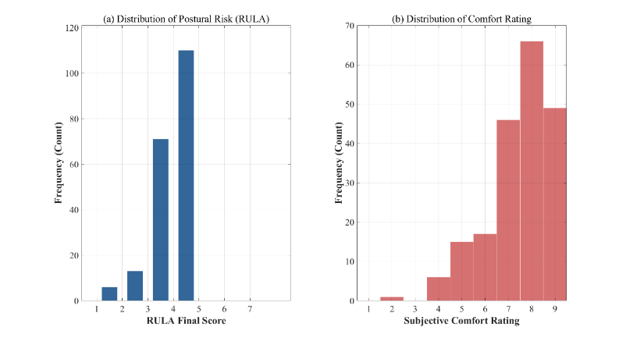
Fig. 4 The distribution of posture risk and subjective comfort level

  - Performance of Surrogate Models
To enable efficient exploration of the seat-parameter space with NSGA-II, we developed surrogate models for personalized chair adjustment. Given the non-linear relationships among ergonomic variables and the cross-subject heterogeneity in anthropometrics and comfort ratings, we adopted a two-stage modeling strategy. Stage 1 predicts key seated posture angles from anthropometric measurements and chair parameters. Stage 2 integrates the predicted posture features to estimate the probability of a low-risk state ($\left(≤3\right)$) and a comfort-satisfied state ($\left(≥7\right)$), which are subsequently used to construct objective functions and perform optimization screening.
To ensure that performance reflects generalization to unseen individuals, we used subject-grouped cross-validation, such that samples from the same participant never appeared in both the training and test sets. During model selection, we compared Random Forest (RF) with Support Vector Machines (SVM) and a baseline Logistic Regression model using subject-grouped out-of-fold (OOF) predictions after hyperparameter tuning. As shown in Fig. 5, RF achieved the best performance for both tasks (Risk AUC = 0.714; Comfort AUC = 0.610), outperforming Logistic Regression (Risk AUC = 0.612; Comfort AUC = 0.581) and SVM (Risk AUC = 0.467; Comfort AUC = 0.384). We therefore selected RF as the surrogate model for subsequent NSGA-II optimization.

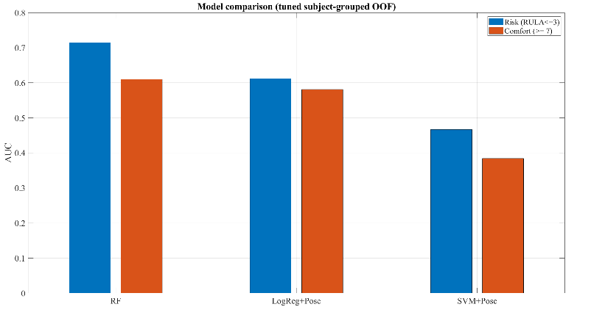
Fig. 5 Model performance comparison

To reduce optimism bias from hyperparameter tuning and obtain more reliable estimates, we further employed nested, subject-grouped cross-validation: outer folds evaluated generalization on unseen participants, and inner folds were used exclusively for hyperparameter selection. The mean, standard deviation, and 95% confidence intervals were computed from the outer-fold results (Table 5). Risk prediction showed stable cross-subject discriminative performance, supporting its use as a primary objective in health-oriented optimization. Comfort prediction showed moderate discrimination on average but with wide confidence intervals, indicating greater uncertainty in cross-subject generalization for a subjective outcome. This uncertainty may reflect individual differences in rating behavior and the available sample size. Because the engineering goal is not to precisely regress each individual’s comfort score but to determine whether a configuration satisfies an acceptable comfort range, we treat comfort as a satisficing constraint in subsequent optimization: solutions must satisfy $\left(≥7\right)$, and postural-risk indicators are optimized within this feasible set.

Table 5 Generalization performance of the selected surrogate models under nested subject-grouped cross-validation (outer K=5)
Task | Definition | Metric | Mean | SD | 95% CI
Risk classification | Low risk if  RULA ≤ 3 | AUC | 0.696 | 0.059 | $$\left[0.622, 0.769\right]$$
Comfort classification | High comfort if  Comfort ≥ 7 | AUC | 0.668 | 0.143 | [0.491, 0.845]

After establishing the RF surrogate, we examined the relative importance of the six adjustable chair parameters for predicting risk and comfort after controlling for individual-specific characteristics (Fig. 6). The results indicate distinct drivers for subjective comfort and objective risk. In the comfort model, headrest height and armrest height showed higher relative importance, suggesting that perceived comfort is more strongly influenced by localized support. In contrast, in the risk model, seat height and backrest angle were more influential, indicating that global seating geometry plays a more critical role in postural risk. Notably, backrest angle exhibited relatively low importance for comfort but high importance for risk, implying that users may not readily perceive the biomechanical consequences of backrest configuration, which can lead to a latent risk where high comfort co-occurs with elevated risk. This pattern provides a mechanistic explanation for the observed comfort–risk discrepancy and indicates that reliance on subjective feedback alone may overemphasize local support at the expense of overall biomechanical alignment. From a design perspective, these findings imply that global structural parameters (e.g., seat height and backrest angle) play a primary role in controlling postural risk, whereas local support parameters (e.g., headrest and armrest) mainly contribute to perceived comfort. This distinction suggests that ergonomic design should prioritize the configuration of global structural parameters to ensure biomechanical safety, while using local support features to refine comfort perception. Such differentiation provides a clearer design rationale by linking parameter categories to distinct functional roles in health protection and comfort enhancement.

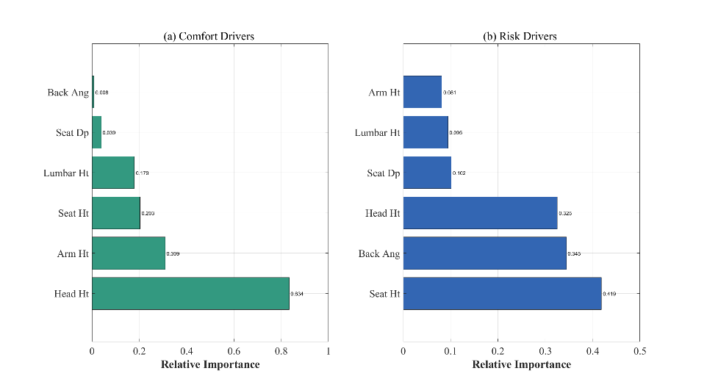
Fig. 6 Comparison of feature importance for design parameters between subjective comfort (a) and objective risk (b)

  - Multi-objective Optimization Results and Analysis
To evaluate the effectiveness of the proposed RF–NSGA-II optimization framework, we conducted a case study using a representative male participant. The target user’s anthropometric characteristics (sex, stature, body mass, and key seated dimensions) are summarized in Table 6. These inputs were provided to the trained two-stage Random Forest surrogate model, and NSGA-II was used to search the chair-parameter space defined in Table 3.

Table 6 Anthropometric specifications of the target user
Anthropometric Feature | Value | Unit
Gender | Male | -
Stature | 175.0 | cm
Weight | 70.0 | kg
Sitting Height | 92.0 | cm
Popliteal Height | 42.0 | cm
Buttock-Popliteal Length | 46.0 | cm

Because comfort ratings are subjective and can be noisy, and the engineering goal is to ensure an acceptable comfort level rather than maximize the rating, we adopt a comfort-satisficing, health-first decision strategy. Comfort is treated as a feasibility constraint, $\left(P\left(≥7\right)≥0.80\right)$. Among candidate solutions satisfying this constraint, the health objective $\left(P\left(≤3\right)\right)$ is maximized. The distribution of NSGA-II candidate solutions and the selected recommendation are shown in Fig. 7. The horizontal dashed line denotes the comfort-feasibility threshold (0.80), and the red asterisk indicates the final recommended solution—the configuration with the highest predicted low-risk probability within the comfort-feasible region. For this configuration, the surrogate predicts $\left(P\left(≤3\right)=0.943\right)$ and $\left(P\left(≥7\right)=0.801\right)$, indicating that it satisfies the comfort constraint while achieving a high predicted probability of low risk. These probabilities are surrogate-model outputs used for design-space search and ranking; biomechanical effects are subsequently examined using digital human simulation and load/moment analyses.
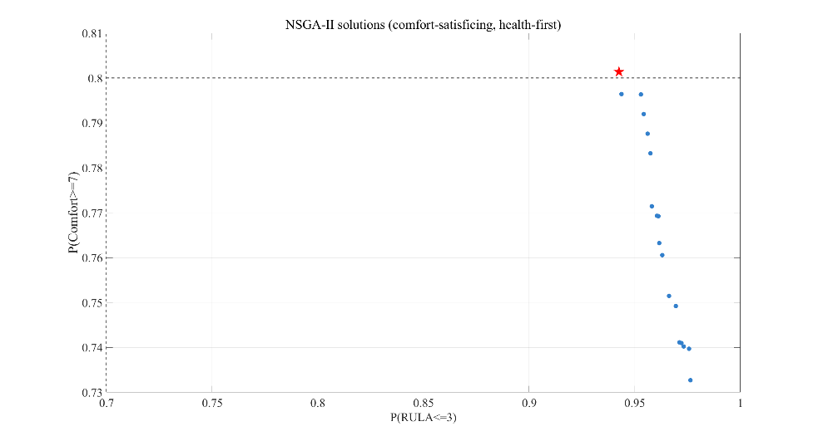
Fig. 7 NSGA-II solutions in surrogate probability space

To contextualize the recommendation relative to observed behavior in the dataset, we compared the optimized parameters with the mean chair settings across all trials (Table 7). The optimized configuration suggests consistent adjustment directions for key parameters (e.g., seat height, backrest angle, and headrest height), increasing the predicted probability of low-risk posture while satisfying the comfort constraint. This comparison also suggests that unguided, preference-based adjustments may not reliably produce low-risk sitting postures, whereas incorporating RULA-based health constraints can provide corrective guidance for structurally important parameters.

Table 7 Comparison of chair design parameters
Design Parameter | Dataset mean | Optimized Value | Unit
Seat Height | 49.8 | 43.6 | cm
Seat Depth | 49.3 | 47.7 | cm
Backrest Angle | 113 | 114.1 | degree (°)
Armrest Height | 21.5 | 19.7 | cm
Lumbar Height | 15.1 | 13.2 | cm
Headrest Height | 61.7 | 55.2 | cm

  - Validation with JACK Simulation
To evaluate the biomechanical plausibility of the seat-parameter combinations recommended by RF–NSGA-II, we performed comparative simulations in Siemens JACK ForceSolver for baseline (pre-optimization) and optimized designs. Verification focused on lower-lumbar loading at L4/L5, including compression and anteroposterior (AP) shear, with trunk flexion moment reported as an indirect indicator of the muscular demand required to maintain the seated posture.
A target-user digital human model was created in JACK with anthropometric settings fixed at male, 175 cm, and 70 kg. To ensure a fair comparison between the baseline (white) and optimized (purple) configurations, the following conditions were held constant: (1) external loads were set to 0 N; (2) the same ForceSolver sitting-support strategy was applied; (3) workday settings were identical, with frequency/duration compensation enabled and the workday duration set to 9 h to approximate quasi-static loading under a 9-h seated-work assumption; and (4) both conditions used JACK’s standard sitting template, with only minimal posture adjustments to maintain stable seat/backrest contact. Under these controls, differences in outcomes primarily reflect mechanical changes attributable to chair-parameter variations. The specific results are shown in Fig. 8.

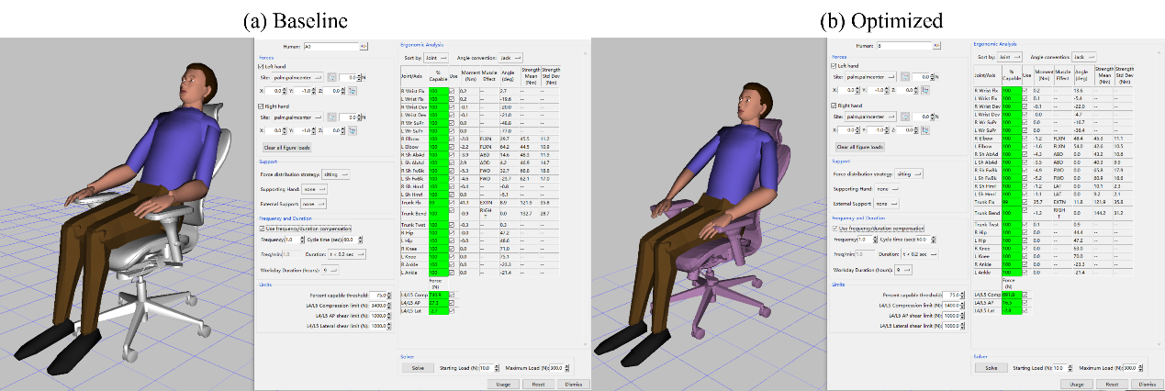
Fig. 8 JACK ForceSolver validation comparing (a) baseline and (b) optimized

Table 8 summarizes the biomechanical indicators. Because lateral shear at L4/L5 was approximately zero in both conditions (|shear| < 3 N) with negligible differences, we focus on compression and AP shear.

Table 8 Biomechanical comparison at L4/L5 derived from JACK simulations
Metric | Baseline | Optimized | Improvement
L4/L5 Compression (N) | 740.9 | 691.8 | 6.6%
L4/L5 AP Shear (N) | 27.3 | 16.5 | 39.6%
Trunk Flexion moment (Nm) | 41.1 | 35.7 | 13.1%

Relative to baseline, the optimized configuration showed consistent reductions in lumbar loading: L4/L5 compression decreased from 740.9 N to 691.8 N (6.6%); L4/L5 AP shear decreased from 27.3 N to 16.5 N (39.6%); and trunk flexion moment decreased from 41.1 Nm to 35.7 Nm (13.1%). These results are interpreted as reduced vertical disc loading, reduced anterior–posterior shear tendency, and reduced static trunk-muscle demand, respectively. Notably, the simulations were conducted under controlled and consistent assumptions; thus, the comparison emphasizes relative differences between configurations rather than absolute load magnitudes.
Overall, the JACK simulations provide independent biomechanical support that the RF–NSGA-II recommendations can reduce L4/L5 compression and AP shear and lower trunk flexion moment under the seated-workday assumption, thereby strengthening the evidence chain from data-driven optimization to biomechanical verification.

- Discussion

The results of this study underscore the complexity of balancing subjective comfort and objective health risk in ergonomic design. Parameter settings that maximize perceived comfort do not necessarily coincide with biomechanically optimal conditions (Carcone & Keir, 2007). Our study reaffirms this challenge, demonstrating that in our personalized office-chair experiment, configurations rated as highly comfortable were frequently associated with elevated postural risk, a common issue in office seating design. This highlights the critical need for a more integrated approach to ergonomic design that considers both user experience and health outcomes.
Building on this observation, we formulate chair-parameter adjustment as a constrained decision problem, instead of a simple single-objective optimization task. By treating comfort as a satisficing criterion and prioritizing risk reduction, the proposed framework provides a structured approach to balancing subjective and objective considerations in personalized chair adjustment. This formulation leverages multi-objective optimization techniques and data-driven exploration, enabling a more consistent and interpretable ergonomic recommendation process, which aligns well with principles of human-computer interaction (HCI) by considering both the user's comfort and health in the design.
The results further suggest that subjective comfort primarily reflects an integrated perception of local pressure distribution, perceived support adequacy, and immediate relaxation, whereas objective metrics (e.g., RULA scores) mainly capture how postural structure shapes joint loading and exposure to non-neutral postures. These two types of measures therefore differ in both evaluation targets and time scales: comfort emphasizes short-term, localized, and consciously perceived sensations, whereas risk measures reflect overall postural structure and cumulative exposure. Consequently, parameter adjustments guided primarily by subjective feedback may prioritize immediately noticeable, local changes while overlooking structural determinants that are more strongly linked to long-term risk.
Feature-importance analysis provides further evidence of this distinction at the variable level. Local support features, such as headrests and armrests, exert stronger influence on comfort ratings, whereas global structural variables, such as seat height and backrest angle, are more strongly associated with objective health risk. Notably, backrest angle exhibited relatively low importance in the subjective model but higher importance in the objective model, suggesting that users have limited sensitivity to changes in postural structure. This mismatch emphasizes that comfort and risk are governed by different subsets of design variables and may not be strongly correlated. As a result, optimization strategies that focus on a single objective (either comfort or risk) may fail to capture critical aspects of ergonomic performance. By combining comfort-based feasibility screening with risk-oriented optimization, our framework provides a systematic approach to evaluate design variables, ensuring a more health-oriented rationality in parameter recommendations.
Compared with conventional approaches that rely solely on subjective feedback or objective risk assessment, the proposed framework explicitly integrates both dimensions within a unified decision structure. This multi-dimensional integration enables the model to generate chair-parameter configurations that simultaneously satisfy predefined comfort requirements while minimizing postural risk, providing actionable parameter recommendations under competing objectives. By embedding comfort as a satisficing constraint within a risk-driven optimization process, the framework moves beyond descriptive evaluation and supports explicit decision-making in ergonomic adjustment. This capability provides a practical mechanism for translating ergonomic principles into implementable solutions, bridging the gap between theoretical optimality and real-world usability. In practical ergonomic settings, such as office environments, this is particularly important, as purely optimal solutions may be rejected by users if their perceived comfort is not adequately considered.
To examine the biomechanical implications of the optimized configurations, simulation-based analysis was conducted using JACK. The optimized settings consistently reduced lumbar loading and trunk moment. Mechanistically, the combined adjustments of seat height and backrest angle likely altered trunk posture and support conditions, shifting the trunk center of mass and the line of action of external reactions, thereby influencing lumbar load transfer and stabilization demands. Importantly, the contribution of these findings lies not in the absolute magnitude of individual indicators, but in the consistent improvement observed across multiple biomechanical metrics. This pattern suggests coherent benefits in terms of postural stability, required muscle moments, and spinal loading. From a practical perspective, such consistency is particularly relevant for ergonomic decision-making, where robustness across multiple indicators is often more important than optimizing a single metric.
Overall, these results demonstrate that the proposed framework provides an effective and interpretable decision-support approach for chair-parameter recommendation under competing comfort and risk objectives, while also supporting the formulation of design strategies by linking parameter categories to distinct ergonomic functions.

- Conclusions

This study proposes and validates a data-driven parameter-recommendation framework that integrates machine learning and multi-objective optimization for office-chair adjustment and design, together with ergonomic evaluation. The results demonstrate a systematic mismatch between subjective comfort and objective postural risk in office sitting, highlighting the need to jointly consider these two dimensions. Within this context, the proposed RF–NSGA-II workflow enables the generation of chair-parameter configurations that simultaneously satisfy predefined comfort requirements while reducing postural risk, thereby providing actionable and implementable parameter recommendations.
Analysis of the design variables further reveals distinct functional roles across the two metric types. Local support parameters (e.g., headrest and armrest height) are more strongly associated with perceived comfort, whereas global structural parameters (e.g., seat height and backrest angle) are more closely related to objective risk. These findings provide a clearer rationale for ergonomic adjustment, suggesting that comfort and risk should be addressed through different but coordinated design strategies, thereby establishing a practically applicable framework that links parameter categories to distinct ergonomic objectives. In addition, simulation-based verification using JACK shows consistent reductions in lumbar loading and trunk moment across multiple biomechanical indicators, providing convergent evidence for the effectiveness of the proposed framework.
Overall, this study contributes a closed-loop pipeline—from surrogate modeling (RF), to multi-objective optimization (NSGA-II), to simulation-based verification (JACK)—for ergonomic parameter recommendation. Beyond the specific application to office-chair adjustment, the proposed approach offers a generalizable decision-support framework for balancing competing ergonomic objectives within a bounded design space.
Several limitations should be noted. First, the study focuses on short-term seated postures and does not account for fatigue accumulation or posture variation over prolonged exposure. Second, the JACK-based verification is quasi-static and cannot fully capture dynamic behaviors or inter-individual differences in muscle activation. Third, the surrogate model is inherently constrained by the sampled design space and is primarily intended for optimization and relative ranking within that space; its generalizability across populations and task contexts requires further validation.
Future work will extend the present framework in three directions. First, broader and more diverse populations will be included to assess robustness across sex, body types, and anthropometric percentiles. Second, dynamic tasks and longer-duration exposure will be incorporated, together with additional physiological measures (e.g., fatigue-related indicators or electromyography), to improve risk characterization. Third, the framework will be translated into practical recommendation tools, such as rule-based adjustment guidelines or interactive systems, and validated through user studies in real or simulated office environments.

ACKNOWLEDGEMENTS
This research is supported by Jiangxi Provincial Housing and Urban-Rural Construction Science and Technology Project Plan: Research on the Design of Modular Age-Friendly Outdoor Furniture Systems for Old Communities in Nanchang Aimed at “Four Good” Construction (Grant No. 20251KYSH719).

Use of Generative AI
To ensure transparency, the authors state that ChatGPT (OpenAI) was used only for English translation and language polishing, while all research design, data analysis, and conclusions are the independent work of the authors.

Author Contributions
Min Qu conceived and designed the study, and revised the manuscript.
Chaoran Deng developed the methodology, conducted the experiments, analyzed the data, and drafted the manuscript.
Ruiwen Qi supervised the project, provided resources and funding, and managed the project administration.
All authors have read and approved the final manuscript.

References

Baklouti, S., Rezgui, T., Chaker, A., Mefteh, S., Ben Mansour, K., Sahbani, A., & Bennour, S. (2024). An Integrated Force Myography and SVM-Based Machine Learning System for Enhanced Muscle Exertion Assessment in Industrial Settings. Arabian Journal for Science and Engineering, 50(14), 11019-11032. https://doi.org/10.1007/s13369-024-09138-8
Breiman, L. (2001). Random Forests. Machine Learning, 45(1), 5-32. https://doi.org/10.1023/A:1010933404324
Çakit, E., & Karwowski, W. (2025). Applications of Machine Learning in Human Factors and Ergonomics: A Comprehensive Review of Research From the Past Decade. IEEE Access, 13, 115263-115288. https://doi.org/10.1109/access.2025.3585773
Carcone, S. M., & Keir, P. J. (2007). Effects of backrest design on biomechanics and comfort during seated work. Appl Ergon, 38(6), 755-764. https://doi.org/10.1016/j.apergo.2006.11.001
Chen, Y. L., Chan, Y. C., & Zhang, L. P. (2021). Postural Variabilities Associated with the Most Comfortable Sitting Postures: A Preliminary Study. Healthcare (Basel), 9(12). https://doi.org/10.3390/healthcare9121685
Clemes, S. A., O'Connell, S. E., & Edwardson, C. L. (2014). Office Workers' Objectively Measured Sedentary Behavior and Physical Activity During and Outside Working Hours. Journal of Occupational & Environmental Medicine, 56(3), 298-303. https://doi.org/10.1097/jom.0000000000000101
De Carvalho, D. E., & Callaghan, J. P. (2022). Effect of office chair design features on lumbar spine posture, muscle activity and perceived pain during prolonged sitting. Ergonomics, 66(10), 1465-1476. https://doi.org/10.1080/00140139.2022.2152113
Deb, K., Pratap, A., Agarwal, S., & Meyarivan, T. (2002). A fast and elitist multiobjective genetic algorithm: NSGA-II. IEEE Transactions on Evolutionary Computation, 6(2), 182-197. https://doi.org/10.1109/4235.996017
Farhani, G., Zhou, Y., Danielson, P., & Trejos, A. L. (2022). Implementing Machine Learning Algorithms to Classify Postures and Forecast Motions When Using a Dynamic Chair. Sensors (Basel), 22(1). https://doi.org/10.3390/s22010400
Frey, M., Barrett, M., & De Carvalho, D. (2021). Effect of a dynamic seat pan design on spine biomechanics, calf circumference and perceived pain during prolonged sitting. Applied Ergonomics, 97. https://doi.org/10.1016/j.apergo.2021.103546
Giridhar, M. P., & Panicker, V. V. (2024). Effect of ergonomic aspects on single‐ and multiproduct assembly‐line balancing problems. Human Factors and Ergonomics in Manufacturing & Service Industries, 34(6), 491-515. https://doi.org/10.1002/hfm.21046
Helander, M. G. (2010). Forget about ergonomics in chair design? Focus on aesthetics and comfort! Ergonomics, 46(13-14), 1306-1319. https://doi.org/10.1080/00140130310001610847
Holzgreve, F., Preuss, J., Erbe, C., Betz, W., Wanke, E. M., Oremek, G., . . . Ohlendorf, D. (2025). The Role of Chair Design in Dental Ergonomics: A Kinematic Assessment of Movement and Ergonomic Risk. Bioengineering (Basel), 12(4). https://doi.org/10.3390/bioengineering12040353
Hu, X., Yan, H., Wan, C., Peng, L., & Qi, Y. (2024). Online Rapid Job Analysis and Evaluation Using Particle Swarm Optimized Random Forest. IEEE Access, 12, 156420-156432. https://doi.org/10.1109/access.2024.3484671
Huang, M., Hajizadeh, K., Gibson, I., & Lee, T. (2016). The Influence of Various Seat Design Parameters: A Computational Analysis. Human Factors and Ergonomics in Manufacturing & Service Industries, 26(3), 356-366. https://doi.org/10.1002/hfm.20649
MassirisFernández, M., Fernández, J. Á., Bajo, J. M., & Delrieux, C. A. (2020). Ergonomic risk assessment based on computer vision and machine learning. Computers & Industrial Engineering, 149. https://doi.org/10.1016/j.cie.2020.106816
McAtamney, L., & Nigel Corlett, E. (1993). RULA: a survey method for the investigation of work-related upper limb disorders. Applied Ergonomics, 24(2), 91-99. https://doi.org/https://doi.org/10.1016/0003-6870(93)90080-S
Mudiyanselage, S. E., Nguyen, P. H. D., Rajabi, M. S., & Akhavian, R. (2021). Automated Workers’ Ergonomic Risk Assessment in Manual Material Handling Using sEMG Wearable Sensors and Machine Learning. Electronics, 10(20). https://doi.org/10.3390/electronics10202558
Namwongsa, S., Puntumetakul, R., Neubert, M. S., Chaiklieng, S., & Boucaut, R. (2018). Ergonomic risk assessment of smartphone users using the Rapid Upper Limb Assessment (RULA) tool. PLoS One, 13(8), e0203394. https://doi.org/10.1371/journal.pone.0203394
Nourmohammadi, A., Ng, A. H. C., Fathi, M., Vollebregt, J., & Hanson, L. (2023). Multi-objective optimization of mixed-model assembly lines incorporating musculoskeletal risks assessment using digital human modeling. CIRP Journal of Manufacturing Science and Technology, 47, 71-85. https://doi.org/10.1016/j.cirpj.2023.09.002
Öztürk, N., & Esin, M. N. (2011). Investigation of musculoskeletal symptoms and ergonomic risk factors among female sewing machine operators in Turkey. International Journal of Industrial Ergonomics, 41(6), 585-591. https://doi.org/10.1016/j.ergon.2011.07.001
Plantard, P., Shum, H. P. H., Le Pierres, A. S., & Multon, F. (2017). Validation of an ergonomic assessment method using Kinect data in real workplace conditions. Appl Ergon, 65, 562-569. https://doi.org/10.1016/j.apergo.2016.10.015
Rohlmann, A., Zander, T., Graichen, F., Dreischarf, M., & Bergmann, G. (2011). Measured loads on a vertebral body replacement during sitting. Spine J, 11(9), 870-875. https://doi.org/10.1016/j.spinee.2011.06.017
Tahernejad, S., Choobineh, A., Razeghi, M., Abdoli-Eramaki, M., Parsaei, H., Daneshmandi, H., & Seif, M. (2022). Investigation of office workers' sitting behaviors in an ergonomically adjusted workstation. Int J Occup Saf Ergon, 28(4), 2346-2354. https://doi.org/10.1080/10803548.2021.1990581
Triglav, J., Howe, E., Cheema, J., Dube, B., Fenske, M. J., Strzalkowski, N., & Bent, L. (2019). Physiological and cognitive measures during prolonged sitting: Comparisons between a standard and multi-axial office chair. Applied Ergonomics, 78, 176-183. https://doi.org/10.1016/j.apergo.2019.03.002
Varghese, A., V, V. P., & George, J. (2025). Posture Assessment of Rubber Tappers: A Comparative Analysis of OWAS, REBA, RULA, and PERA Methods. Med Lav, 116(3), 15875. https://doi.org/10.23749/mdl.v116i3.15875
Vergara, M., & Page, A. (2002). Relationship between comfort and back posture and mobility in sitting-posture. Applied Ergonomics, 33(1), 1-8. https://doi.org/10.1016/S0003-6870(01)00056-4
Xu, W., & Chen, Y. (2025). Framework for the Evaluation of Nap-Compatible Classroom Chairs. Buildings, 15(18). https://doi.org/10.3390/buildings15183321
Zhang, F., Li, X., Xu, S., Zhao, X., & Gao, Y. (2024). Ergonomic design of safety protective wearables in confined space operations. Advanced Design Research, 2(2), 137-150. https://doi.org/10.1016/j.ijadr.2025.01.001

