Design and Evaluation of Wooden Furniture for Student Dormitories Based on User Needs

Chaoran Deng,ª Hongzhao Yu,^{b} Ruiwen Qi,ª and Min Qu ^{a,}*

* Corresponding author: qumin@ncu.edu.cn

DOI: 10.15376/biores.21.2.

GRAPHICAL ABSTRACT

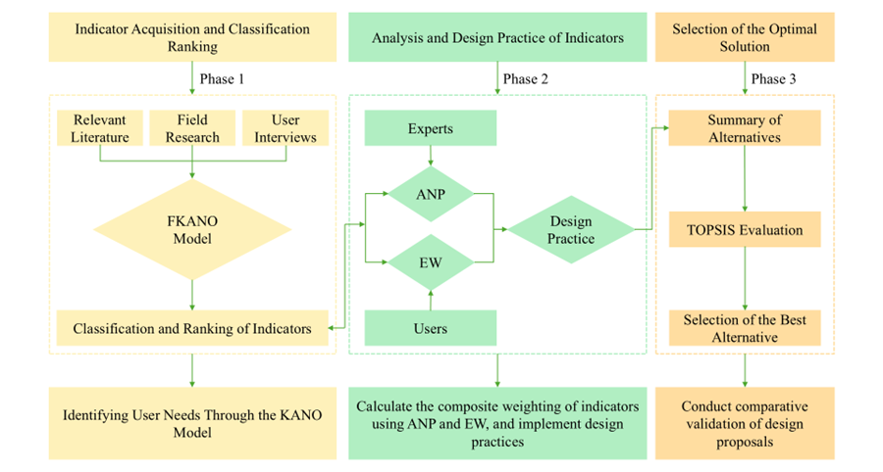

Design and Evaluation of Wooden Furniture for Student Dormitories Based on User Needs

Chaoran Deng,ª Hongzhao Yu,^{b} Ruiwen Qi,ª and Min Qu ^{a,}*

In recent years, the number of university students in China has increased, while dormitory furniture often fails to meet students’ diverse needs. This study developed a hybrid FKANO-ANP-EW-TOPSIS model to design and evaluate dormitory beds, aiming to meet students’ diverse needs while promoting the sustainable development of dormitory furniture. First, demand indicators were identified through interviews and a literature review. The Fuzzy KANO (FKANO) model was used to screen these indicators. Key indicators were then integrated into a network model based on the Analytic Network Process (ANP) to analyze their weights and interdependencies. The Entropy Weight (EW) method was combined to determine the final weights for each indicator. The results showed that structural stability, storage capacity, and modular design had the highest weights. Modular design emerged as the core element, with sustainability as the foundational element in the core relationship chain. Based on this, three sustainable, multifunctional wooden dormitory bed designs were proposed. The Technique for Order Preference by Similarity to an Ideal Solution (TOPSIS) was used to compare these designs with two popular products, identifying the optimal solution. This model offers a more comprehensive perspective for designing dormitory furniture, providing valuable insights for furniture manufacturers and designers.

DOI: 10.15376/biores.21.2.

Keywords: Student dormitory furniture; Sustainability; Modularity

Contact information: a: School of Architecture and Design, Nanchang University, Nanchang, Jiangxi, China; b: School of Mechanical and Vehicle Engineering, Nanchang Institute of Science and Technology, Nanchang, Jiangxi, China; *Corresponding author: qumin@ncu.edu.cn

INTRODUCTION

With the rapid expansion of higher education in China, the number of college students has continued to increase. According to the latest statistics from the Ministry of Education, as to December 15, 2024, student enrollment in Chinese universities exceeded 59 million, and this figure is expected to keep growing. In universities, dormitory environments play a crucial role in shaping students’ overall experience. A well-designed dormitory environment can foster students’ social adaptation skills and emotional resilience, while enhancing social competencies through interactive and collaborative experiences (He and Zeng 2025). In Chinese universities, dorm rooms typically house 2 to 6 occupants. Given the fixed size and layout constraints of these shared spaces, enhancing student experiences within limited areas largely depends on the design and functionality of dorm furniture. As the economy continues to develop, the quality of university housing is steadily improving. In the future, double rooms are likely to become the predominant dormitory format. Therefore, this study focuses on an in-depth examination and discussion of furniture specifically designed for double-occupancy dorm rooms.
In recent years, increasing scholarly attention has been devoted to the design of university furniture. Taifa and Desai (2017) examined the body dimensions of Indian students. They proposed detailed dimensional recommendations for adjustable desks and chairs to enhance comfort, safety, and academic performance. Wei and Chen (2025) applied digital human modeling techniques with Jack software to ergonomically optimize dormitory furniture. Through posture-based comfort simulations, they suggested design improvements to accommodate diverse body types. Saha et al. (2024) collected 11 anthropometric measurements from 380 students and compared them with 11 dimensions of existing computer lab furniture. Their findings informed new dimension designs to improve comfort during computer use and reduce the risk of musculoskeletal disorders. While these studies have focused on specific functional, morphological, and dimensional aspects of student furniture, they largely have neglected how different furniture types can be combined into more effective and sustainable configurations. Unlike conventional home furniture, dormitory furniture is arranged within relatively small spaces and usually comprises only a few types of items—primarily desks, chairs, beds, and cabinets. Thus, research on dormitory furniture design should not be restricted to the performance or dimensions of individual pieces. Instead, greater emphasis must be placed on the multifaceted, symbiotic relationships among these elements (Yu et al. 2019).
This study focused on the dormitory bed as the central subject, highlighting its interconnections with other dormitory furniture and exploring pathways for sustainable development. The specific objectives were: (1) To conduct an in-depth analysis of user needs using the Fuzzy Kano (FKANO) model, apply the Analytic Network Process (ANP) to construct a demand network and examine interdependent chain relationships, and integrate ANP with the Entropy Weight (EW) method to obtain comprehensive indicator weights. (2) To integrate these chain relationships with both subjective and objective weights of various indicators in the design of dormitory beds, applying modular design principles to foster symbiotic interactions between beds and other furniture, and to establish a cradle-to-cradle sustainability pathway. (3) To develop a comprehensive evaluation framework for dormitory beds by combining subjective/ objective weighting with the Technique for Order Preference by Similarity to an Ideal Solution (TOPSIS), thereby assessing multiple design proposals and selecting the optimal solution. Overall, this research introduced a methodological approach to university dormitory furniture design that is grounded in holistic demand network structures and emphasizes sustainable symbiosis among key furniture components.
This study integrated the FKANO, ANP, EW, and TOPSIS methodologies to support research on dormitory bed design. First, the FKANO model was applied to classify and filter the needs of 146 users, thereby identifying core requirements. A panel of nine domain experts from diverse backgrounds was then convened as the decision-making group. These core needs were subsequently introduced into the ANP framework, where the expert panel identified interdependent chain relationships among demand indicators and assigned corresponding ANP weights. To reduce subjectivity in the weighting process, the EW method was applied to generate objective weights. The subjective and objective weights were then combined to obtain comprehensive weightings. Based on the analysis of core requirements and their interdependencies, three sustainable and multifunctional dormitory bed designs were developed using the constructed network structure model and the comprehensive weights of each indicator. These designs were then compared with two widely used commercial models through TOPSIS analysis, enabling the selection of the optimal design solution with sustainability as a primary criterion. This integrated approach strengthens the scientific rigor of the design process. Moreover, the integrated model effectively captures the complex chain relationships underlying various factors. Such analysis provides a systematic and comprehensive perspective for the design of sustainable dormitory furniture.

Current State of Research on Sustainable Furniture Design
With the continuous deterioration of the global environment, awareness of sustainable development has gradually increased, and sustainable furniture design has attracted widespread scholarly attention. Numerous researchers have conducted studies in this field. Zhang and Sun (2024) adopted an integrated AHP-QFD-FBS design method to quantify user demand indicators and proposed an ecologically sustainable scheme for urban public seating. Wang and Xiao (2022), drawing on product life-cycle theory, proposed a sustainable multifunctional furniture design method based on modularity.(Bianco et al. 2021) developed a life cycle assessment (LCA)-based tool to support the eco-design of wooden furniture. Yang and Vezzoli (2024) proposed a comprehensive life cycle design (LCD) framework comprising 21 sub-strategies and 154 guidelines, and developed a furniture toolkit aimed at improving the environmental efficiency of furniture design. Li et al. (2023), based on sustainable design theory, examined the entire life cycle of furniture design and development and proposed environmentally friendly design strategies. Kuys et al. (2021), through university–industry collaboration, conducted case studies on sustainable furniture design and found that user-participatory modular furniture more effectively met user needs. Xie et al. (2024) employed a combined AHP-GCA method to evaluate green design in kindergarten furniture, proposed optimization strategies, and provided theoretical as well as practical references for advancing green furniture design and promoting industry-wide sustainability.
Existing research on sustainable furniture design has advanced considerably, yet certain limitations remain. First, most current studies focus on individual furniture pieces, the overall production process, or the use of eco-friendly materials, while generally neglecting how multiple items can achieve sustainable coexistence within limited living spaces—a critical issue for student dormitories. Second, the majority of studies emphasize sustainability in isolation, without adopting a more holistic perspective on the sustainable development of furniture design. Broadening the scope beyond sustainability alone reveals that the factors influencing sustainable development are multifaceted. Dimensions such as functionality, safety, and aesthetics can exert significant influence on sustainable development. This broader perspective is of paramount importance for advancing research on the sustainable development of furniture.
Therefore, the innovation of this study lies in its focus on exploring the functional attributes of dormitory beds. Under the premise that the bed serves as the primary carrier, dormitory furniture achieves sustainable coexistence within limited spaces. Furthermore, this study proposes a multi-criteria decision-making model that integrates FKANO, ANP, EW, and TOPSIS. This model effectively identifies user needs and establishes dimensions and indicators to guide subsequent design and evaluation processes. It constructs a network structure model from a holistic perspective, offering a novel approach to investigating the sustainable development of student dormitory furniture.

Application of Multi-Criteria Decision-Making Methods in Furniture Design
Multi-criteria decision-making methods play a critical role in furniture design. As a multi-stage and interconnected process, furniture design involves diverse evaluation criteria. Accordingly, multi-criteria decision-making not only ensures that designs better align with user needs but also significantly advances the sustainable development of products. Chen et al. (2024) addressed design challenges in willow furniture by integrating the Kano model, Analytic Hierarchy Process (AHP), and TRIZ theory. Wang and Chen (2024) applied the Kano–FAST integrated approach to analyze auditorium chair design based on user needs, establishing safety and stability as fundamental requirements, identifying comfort as the most critical factor, and emphasizing the necessity of incorporating intelligent functionality. Liu et al. (2024) combined the Kano model and AHP to investigate user needs for outdoor leisure chairs, established design priorities, and developed a design solution that enhanced user experience and satisfaction. Wang et al. (2024) employed the KANO–AHP–AD model to design an adaptable solid wood children’s bed. Yu et al. (2024) evaluated emotional design in children’s furniture using AHP and TOPSIS.
Multi-criteria decision-making methods have been widely applied in furniture design, ranging from the identification of initial user requirements to the evaluation of final design schemes. Throughout this process, scholars have experimented with various methodological combinations; however, certain shortcomings remain. First, the metrics used to guide and evaluate furniture design are not independent. Complex interdependencies exist among these metrics, yet prior studies often overlook them, treating metrics in isolation and failing to explore their underlying relationships in depth. Second, existing research frequently suffers from excessive subjectivity. Thus, a persistent challenge in furniture design research is how to enhance the objectivity of decision-making methods while ensuring that the resulting designs better align with users’ personalized needs.
The multi-criteria decision-making model proposed in this study, which integrates FKANO, ANP, EW, and TOPSIS, partially addresses the shortcomings of existing research. First, this model not only captures users’ genuine needs with greater precision, but it also effectively identifies the complex interdependencies underlying these needs through network structure modeling. By pinpointing pivotal indicators and using them as benchmarks to map core chain relationships, it enables more holistic and systematic design approaches that promote sustainable furniture design. Second, to improve objectivity in design decisions, the FKANO model combined with fuzzy logic was applied during user requirement screening, thereby reducing excessive subjectivity in initial requirement collection. In addition, since ANP weighting judgments can be prone to bias, this study employs an ANP–EW composite weighting method. By integrating subjective and objective weighting approaches, the method significantly enhances the credibility of indicator weights while mitigating subjectivity. Finally, the TOPSIS method is applied to compare the design outcomes of this study with popular commercial products, thereby identifying the optimal solution. This integrated approach strengthens the systematic and scientific basis of furniture design and further advances its sustainable development.

EXPERIMENTAL

Proposed Framework
This study primarily focused on the design and evaluation of student dormitory beds. In student dormitories, where space is limited, beds often serve multiple purposes beyond sleeping; they are typically integrated with other furniture, such as storage cabinets and desks, leading to the widely adopted loft-style bed–desk combinations in Chinese universities. The complex integration of multifunctional features in dormitory furniture generates diverse and intricate user needs. Consequently, substantial research potential remains in the design and evaluation of student dormitory furniture. To address this, the present study integrates the FKANO model, ANP, EW, and TOPSIS into a multi-criteria decision-making framework. Applying this multi-criteria decision-making framework provides a novel perspective for the design and evaluation of student dormitory beds. Figure 1 illustrates the proposed framework for this study.
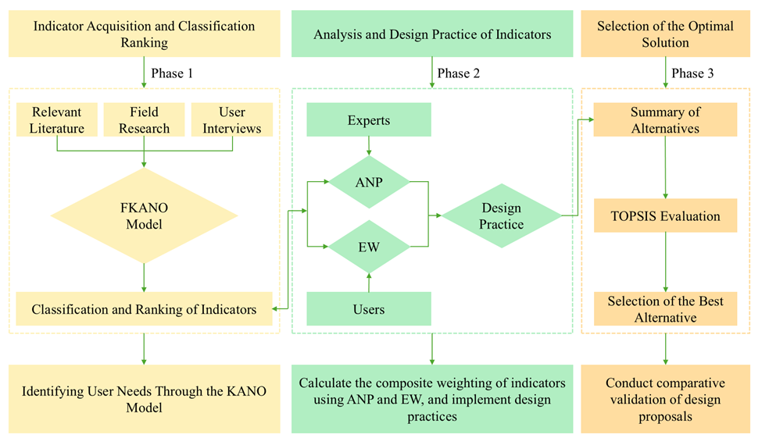
Fig. 1. Proposed framework

The specific steps are summarized as follows:
- Demand Collection. This phase focuses on gathering user requirements through interviews, and literature review to gain in-depth insights into students’ needs for dormitory furniture. Particular attention is given to four dimensions of demand: safety, functionality, aesthetics, and sustainability. The requirements within each dimension are then categorized and synthesized to construct a comprehensive structural model of user needs.
- Demand Screening. Based on the user-demand data collected, an FKANO questionnaire was constructed, and the FKANO model was used to screen and classify each indicator.
- Index Weight Determination and Impact Relationship Identification. An expert group identifies the interrelationships among indicators and constructs pairwise comparison matrices for scoring. The analytic network process (ANP) method is used to derive indicator weights and capture the impact relationships. To minimize subjective bias, the expected weighting (EW) method is combined to derive a comprehensive weight, ensuring the scientific rigor of the weighting process.
- Student Dormitory Beds Design. Drawing on the screened demands, analyzed interrelationships, and derived weights, design solutions for dormitory beds are developed to meet students’ practical needs.
- Design Decision-Making. Three self-designed dormitory bed prototypes are compared with two best-selling commercial products. The TOPSIS method is applied to calculate the distances of each alternative from the positive-ideal and negative-ideal solutions, thereby identifying the optimal scheme. This process ensures the rationality and practical usability of the proposed designs.

FKANO Model
Noriaki Kano proposed the Kano model, which has been widely applied in user-demand analysis and effectively captures the relationship between product performance and user satisfaction (Zhang et al. 2024). However, researchers applying the Kano model often fail to account for the ambiguity and uncertainty of psychological and emotional factors when designing questionnaires. The FKANO model extends the Kano model by incorporating fuzzy logic. In the FKANO questionnaire, respondents assign fuzzy values to each option (i.e., values between 0 and 1), ensuring that the total sum of assignments equals 1. This model categorizes user needs into six classes (Karakurt and Cebi 2025): Must-be (M), Attractive (A), One-dimensional (O), Indifferent (I), Reverse (R), and Questionable (Q). Compared to the traditional KANO model, the FKANO model enables a deeper analysis of the ambiguity and uncertainty inherent in users' subjective emotions. This approach mitigates the issue of excessive subjectivity and yields more precise final results. The specific application steps are as follows:
Step 1: Data are collected through a fuzzy Kano questionnaire, in which respondents assign membership degrees to different satisfaction levels (e.g., very satisfied, satisfied, neutral, dissatisfied, very dissatisfied) for both the presence and absence of each attribute.
Step 2: Construction of a $5×5$ Fuzzy Relation Matrix $S$.
$S_{ij}={\sum{ }}_{k=1}^{r}m{\left(P\right)}_{ki}⋅m{\left(N\right)}_{kj}$ (1)
where $m(P)_{ki}$ denotes the membership degree of option $i$ in the positive question for respondent $k$, and $m(N)_{kj}$ denotes the membership degree of option $j$ in the reverse question for respondent $k$.
Step 3: Calculation of the Total Membership Degree $T_{h}$ for Categories
$T_{h}=\underset{\left(i,j\right)∈C_{h}}{\sum{ }}S_{ij}$ (2)
where C_{h} represents the set of all cells (i,j) that belong to category h.
Step 4: Fuzzy Pattern Determination
$FKM=arg{\max_{h}\left\{T_{h}\right\}}\left(h∈\left\{Q,R,I,A,O,M\right\}\right)$ (3)
where multiple category $T_{h}$ entries are identical, selection is made according to the subsequent sorting order. $M>O>A>I>R>Q$.

Analysis Network Process
In real-world scenarios, user needs are not isolated; different dimensions and their respective indicators are often interdependent, forming a networked structure rather than a strictly top-down linear hierarchy. The Analytic Network Process (ANP), proposed by Professor Saaty at the University of Pittsburgh in 1996, is a decision-making method designed for such non-independent hierarchical structures. Essentially, ANP extends the Analytic Hierarchy Process (AHP) by incorporating a feedback mechanism (Saaty 2004). The key distinction between ANP and AHP lies in their applicability: ANP is suited to problems involving interdependent criteria or alternatives, whereas AHP is limited to cases where criteria or alternatives are independent (Chen 2021).
The specific application steps of ANP are as follows:
Step 1: Construction of the ANP Network Structure. This step involves identifying the criteria, elements, and clusters of elements, as well as determining the influence relationships among them. Establishing inter-element influence relationships generally requires experts to define an influence relationship matrix. The influence relationship matrix specifies the dependencies among elements and thereby identifies influence relationships between clusters. Specifically, if any element within a cluster influences an element within the same cluster or another cluster, the entire cluster is considered to exert influence on the corresponding cluster(s).
Step 2: Construction of the Judgment Matrix, formulated based on the principle of indirect dominance. Elements or element groups determined to have no relationships in Step 1 are excluded from the matrix construction. Assume that the control layer of the ANP network structure contains $m$ criteria $a_{1},a_{2},…,a_{m}$, and the network layer includes $n$element groups $c_{1},c_{2},…,c_{n}$. Elements within element group $c_{i}$ are denoted as $e_{i1},e_{i2},…,e_{ik}$. Using an element $e_{jl}$ in element group $c_{j}$ as a criterion, pairwise comparisons are conducted for all elements affecting $e_{jl}$ under element group $c_{i}$, employing the 1-9 scaling method to construct the judgment matrix. The normalized eigenvector is then calculated using the eigenroot method. And require all judgment matrices to pass the consistency test.
The normalized eigenvectors, obtained from constructing judgment matrices for all elements in cluster $c_{j}$ with respect to elements in cluster $c_{i}$ are then combined to form the weight vector matrix $w_{ij}$.
$W_{ij}=\left[\begin{matrix}w_{i1}^{j1} & w_{i1}^{j2} & ⋯ & w_{i1}^{jl} \\ w_{i2}^{j1} & w_{i2}^{j2} & ⋯ & w_{i2}^{jl} \\ ⋮ & ⋮ & ⋱ & ⋮ \\ w_{ik}^{j1} & w_{ik}^{j2} & ⋯ & w_{ik}^{jl}\end{matrix}\right]$ (4)
In this matrix, the column vectors represent the normalized eigenvectors derived from constructing judgment matrices using elements in cluster $c_{i}$ that influence specific elements in cluster $c_{j}$ (as a sub-criterion). If elements in $c_{j}$ are not influenced by those in $c_{i}$, $W_{ij}$=0. The row number $k$ corresponds to the number of elements in cluster $c_{i}$, while the column number $l$ corresponds to the number of elements in cluster $c_{j}$.
Step 3: Construction of the supermatrix. Let $W_{ij}$ represent the influence matrix of cluster $c_{i}$ on cluster $c_{j}$. This process is repeated for all $n$ clusters (with $i$ = 1, 2, …, n;$j$ = 1, 2, …, n), yielding the supermatrix $W$. Each column of the supermatrix consists of a set of weight vectors derived from all clusters that influence a specific element $e$. For clusters that influence element $e$, the sum of the weight vectors equals 1; for elements with no influencing clusters, all corresponding weight vectors are set to 0.
$W=\left[\begin{matrix}W_{11} & W_{12} & ⋯ & W_{1n} \\ W_{21} & W_{22} & ⋯ & W_{2n} \\ ⋮ & ⋮ & ⋱ & ⋮ \\ W_{n1} & W_{n1} & ⋯ & W_{nn}\end{matrix}\right]$ (5)
Step 4: Calculation of the weighted supermatrix. For each cluster $c_{i}(i=1,2,⋯,n)$, pairwise comparisons of the importance of the clusters are conducted, yielding a judgment matrix. If a cluster is unrelated to $c_{i}$, the corresponding component of its ranking vector is set to 0, producing the weighted matrix $A$:
$A=\left[\begin{matrix}a_{11} & a_{12} & ⋯ & a_{1n} \\ a_{21} & a_{22} & ⋯ & a_{2n} \\ ⋮ & ⋮ & ⋱ & ⋮ \\ a_{n1} & a_{n2} & ⋯ & a_{nn}\end{matrix}\right]$ (6)
Weighting the supermatrix $W$ with matrix $A$ yields the weighted supermatrix $\overline{W}$.
$\overline{W}=\left[\begin{matrix}a_{11}W_{11} & a_{12}W_{12} & ⋯ & a_{1n}W_{1n} \\ a_{21}W_{21} & a_{22}W_{22} & ⋯ & a_{2n}W_{2n} \\ ⋮ & ⋮ & ⋱ & ⋮ \\ a_{n1}W_{n1} & a_{n2}W_{n2} & ⋯ & a_{nn}W_{nn}\end{matrix}\right]$ (7)
Column-wise normalization of $\overline{W}$ is then performed to ensure that the sum of each column equals 1.
Step 5: Calculation of the limit supermatrix. Let the elements of the weighted supermatrix $\overline{W}$ be denoted as $w_{ij}$. The magnitude of $w_{ij}$ reflects the relative dominance of element $i$ over element $j$, The limit supermatrix is obtained as: ${\overline{W}}^{∞}=\lim_{t→∞}{\overline{W}}^{t}$.

Entropy Weight
The EW method is an important information-weighting model that has been extensively studied and applied (Zhu et al. 2020). In this method, entropy values from information theory are used to quantify the uncertainty of information, evaluate the capacity of attributes to convey decision-making information, and derive the relative weights of attributes (Chen 2020). As an objective weighting approach, the EW method enables decision-makers to obtain more precise and rational results. The specific implementation steps of the EW method are as follows:
Step 1: Data Normalization. Assume there are $m$ samples and $n$ evaluation indicators, forming the original data matrix $X=(x_{ij})_{m×n}$, where $x_{ij}$ denotes the value of the $j$-th indicator for the $i$-th sample $(i=1,2,…,m;j=1,2,…,n)$. Since the indicators may include both positive and negative types, data normalization is performed to eliminate dimensional effects. This step leverages entropy values from information theory to quantify uncertainty.
$y_{ij}=\frac{x_{ij}-\min_{j}x_{ij}}{\max_{j}x_{ij}-\min_{j}x_{ij}}$ (8)
$y_{ij}=\frac{\max_{i}x_{ij}-x_{ij}}{\max_{j}x_{ij}-\min_{j}x_{ij}}$ (9)
Step 2: Proportion Calculation. The proportion $p_{ij}$ of the $i$-th sample under the $j$-th indicator is computed to transform the normalized data into a probability distribution, ensuring that the sum of proportions for each indicator equals 1.
$p_{ij}=\frac{y_{ij}}{{\sum{ }}_{i=1}^{m}y_{ij}}$ (10)
Step 3: Information Entropy Calculation. The information entropy $e_{j}$ of the $j$-th indicator.
$e_{j}=-k\sum_{i=1}^{m}{p_{ij}\ln{p_{ij}}}\text{，}k=\frac{1}{\ln{m}}$ (11)
$k$ serves as the normalization constant to ensure $0≤e_{j}≤1$.
Step 4: Difference Coefficient Calculation. The difference coefficient $g_{j}$ of the index, which represents the effective information content of the indicator and is negatively correlated with entropy values.
$g_{j}=1-e_{j}$ (12)
Step 5: Weight Calculation. The indicator weight $w_{j}$ is computed as
$w_{j}=\frac{g_{j}}{{\sum{ }}_{j=1}^{n}g_{j}}$ (13)
where the weight is the normalized result of the difference coefficient, with the total sum equal to 1.

TOPSIS
The TOPSIS method is based on the principle of minimizing the distance to the positive ideal solution while maximizing the distance from the negative ideal solution (Solangi et al. 2019). Owing to this principle, TOPSIS has been widely applied to multi-criteria decision-making (MCDM) problems (Li et al. 2012). The TOPSIS procedure generally consists of the following seven steps:
Step 1: Decision Matrix Construction. Construct the original decision matrix. Assume there are $n$ alternatives $\left(A_{1},A_{2},…,A_{n}\right)$, each evaluated by $m$ criteria $\left(C_{1},C_{2},…,C_{m}\right)$. The original data matrix is expressed as $X={\left[\begin{matrix}x_{ij}\end{matrix}\right]}_{n×m}$, where $x_{ij}$ denotes the value of the $j$-th criterion for the $i$-th alternative. ($i=1,2,…,n;j=1,2,…,m$)
Step 2: Standardize the data by classifying positive and negative indicators to eliminate dimensional effects:
$r_{ij}=\frac{x_{ij}}{\sqrt{{\sum{ }}_{i=1}^{n}x_{ij}^{2}}},i=1,2,…,n;j=1,2,…,m$ (14)
The standardized matrix $R={[\begin{matrix}r_{ij}\end{matrix}]}_{n×m}$ satisfies $\sum_{i=1}^{n}{r_{ij}^{2}}=1$.
Step 3: Weight Determination. Determine the indicator weights $w_{j}$. In this study, the weights are comprehensive weights obtained by integrating ANP and EW.
Step 4: Weighted Matrix Construction. Construct the weighted standardized matrix by combining the standardized data with the corresponding weights.
$v_{ij}=r_{ij}⋅w_{j},i=1,2,…,n;j=1,2,…,m$ (15)
The weighted matrix $V={\left[\begin{matrix}v_{ij}\end{matrix}\right]}_{n×m}$.
Step 5: The positive ideal solution $V^{+}$ and the negative ideal solution $V^{-}$ are defined as:
$V^{+}=\left(v_{1}^{+},v_{2}^{+},…,v_{m}^{+}\right),v_{j}^{+}=\max_{i}\left(v_{ij}\right)$ (16)

$V^{-}=\left(v_{1}^{-},v_{2}^{-},…,v_{m}^{-}\right),v_{j}^{-}=\min_{i}\left(v_{ij}\right)$ (17)
Step 6: The Euclidean distances of each alternative to the positive and negative ideal solutions are calculated as:
$d_{i}^{+}=\sqrt{{\sum{ }}_{j=1}^{m}{\left(v_{ij}-v_{j}^{+}\right)}^{2}},i=1,2,…,n$ (18)
$d_{i}^{-}=\sqrt{{\sum{ }}_{j=1}^{m}{\left(v_{ij}-v_{j}^{-}\right)}^{2}},i=1,2,…,n$ (19)
Step 7: Closeness Calculation. The closeness coefficient $C_{i}$, serving as a comprehensive evaluation index for each alternative, is calculated as:
$C_{i}=\frac{d_{i}^{-}}{d_{i}^{+}+d_{i}^{-}},i=1,2,…,n$ (20)
The alternatives are sorted based on $C_{i}$ in descending order to determine the optimal solution, where the alternative with the highest $C_{i}$ value is the optimal one.

CASE VERIFICATION

Establishment of Evaluation Indicators
Designing furniture for student dormitories is a comprehensive process that requires consideration of multiple factors. In this study, evaluation indicators for sustainable dormitory beds were identified through extensive literature reviews and in-depth user interviews (Table 1). These indicators are classified into four dimensions: safety, functionality, aesthetics, and sustainability.

Table 1. Evaluation Metrics for Dormitory Beds
Dimension | Indicator | Description | Reference
Safety | Stability | Is the overall structure properly designed | Liu et al. (2023)
 | No Sharp Edges | Edge detail treatment adequacy | Ilhan and Togay (2024)
 | Privacy | Users’ personal space | User Interview
Function | Storage Space | Adequacy of capacity | User Interview
 | Modularity | Modularity design | Zhao and Xu (2023)
 | Ease of Use | Easy to understand how to use | Li and Han (2022)
Aesthetic | Appearance | Adequacy of aesthetics design | Xu et al. (2024)
 | Personalization | The personalization option | User Interview
 | Harmony | The adequacy of a dormitory’s unified styling | Liu et al. (2025)
Sustainability | Eco-friendly | Environmental impact reduction | Bumgardner and Nicholls (2020)
 | Durability | Product lifespan adequacy | Phuah et al. (2022)
 | Maintainability | Maintenance and repair facilitation adequacy | Frahm et al. (2022)

User Demand Analysis
Users’ opinions and experiences are critical in the design of student dormitory bedding. To accurately capture user needs, an FKANO questionnaire was developed based on the 12 evaluation indicators identified earlier and distributed to university student groups. In total, 200 questionnaires were distributed through both online and offline channels. After excluding invalid responses, 182 valid questionnaires remained. These 182 valid datasets were subsequently organized and analyzed using the FKANO model.
Table 2 presents the category judgment matrix of the FKANO model. Next, the total category membership degree $T_{h}$ was calculated and substituted into the category judgment matrix to determine the classification of the indicator. Table 3 provides partial content of the FKANO questionnaire, illustrating the classification procedure.

Table 2. FKANO Model Judgment Matrix
Dissatisfied  Satisfied | Like | Must-be | Indifferent | Tolerable | Dislike
Like | Q | A | A | A | O
Must-be | R | I | I | I | M
Indifferent | R | I | I | I | M
Tolerable | R | I | I | I | M
Dislike | R | R | R | R | Q

Taking the ‘stability’ in Table 5 as an example, the calculation method of the FKANO model can derive matrix $P=\left[0.7 0.2 0.1 0 0\right]$ and matrix $N=\left[0 0 0 0.2 0.8\right]$. The interaction matrix is then established based on matrices $P$ and $N$:

$$S=\left[\begin{matrix}0.00 & 0.00 & 0.00 & 0.14 & 0.56 \\ 0.00 & 0.00 & 0.00 & 0.04 & 0.16 \\ 0.00 & 0.00 & 0.00 & 0.02 & 0.08 \\ 0.00 & 0.00 & 0.00 & 0.00 & 0.00 \\ 0.00 & 0.00 & 0.00 & 0.00 & 0.00\end{matrix}\right]$$

By corresponding the values in Table 3 with those in matrix $S$, the corresponding T value (i.e., membership degree vector) can be obtained.
$$T_{M}=0.24 T_{O}=0.56 { T}_{A}=0.14 T_{I}=0.06{ T}_{R}=0{ T}_{Q}=0$$
The value of $T_{O}$ can be identified as the highest, with no duplicated $T$ values observed. Accordingly, based on this dataset, the attribute of this indicator in the FKANO questionnaire is classified as O.

Table 3. Section of FKANO Questionnaire
Indicator |  | Very Satisfied | Satisfied | Neutral | Dissatisfied | Very Dissatisfied
Stability | With | 0.7 | 0.2 | 0.1
 | Without |  |  |  | 0.2 | 0.8
... | ... | ... | ... | ... | ... | ...
Storage Space | With | 0.7 | 0.3
 | Without |  |  | 0.2 | 0.7 | 0.1
... | ... | ... | ... | ... | ... | ...
Appearance | With | 0.6 | 0.4
 | Without |  |  |  | 0.2 | 0.8
... | ... | ... | ... | ... | ... | ...
Durability | With | 0.8 | 0.2
 | Without |  |  |  | 0.5 | 0.5
... | ... | ... | ... | ... | ... | ...

Twelve indicator categories were identified by repeating the above steps, as shown in Table 4. The evaluation framework retains the three attributes: Mandatory (M), Attractiveness (A), and One-dimensional (O), while excluding the Indifferent (I) attribute. The final evaluation system consisted of 10 indicators, as shown in Fig. 2.

Table 4. Categorized Statistical Results of Design Evaluation Indicators
Indicator | Type | $$T_{M}$$ | $${ T}_{A}$$ | $$T_{I}$$ | $$T_{O}$$ | $${ T}_{R}$$ | $${ T}_{Q}$$
Ease of Use | A | 16.79 | 59.19 | 54.21 | 51.81 | 0 | 0
Personalization | A | 7.82 | 78.62 | 65.48 | 28.08 | 1 | 1
Eco-friendly | A | 12.21 | 72.01 | 54.99 | 42.79 | 0 | 0
Stability | O | 28.75 | 51.54 | 32.15 | 69.65 | 0 | 0
Storage Space | O | 14.31 | 66.81 | 19.99 | 80.89 | 0 | 0
Modularity | O | 45.14 | 40.74 | 35.66 | 60.46 | 0 | 0
Durability | O | 27.39 | 46.49 | 36.51 | 69.61 | 0 | 2
Privacy | O | 11.52 | 58.42 | 19.58 | 92.48 | 0 | 0
Appearance | A | 10.72 | 77.02 | 67.48 | 26.78 | 0 | 0
Maintainability | O | 40.98 | 38.68 | 32.52 | 69.82 | 0 | 0
Harmony | I | 12.21 | 27.79 | 118.81 | 42.79 | 0 | 0
No Sharp Edges | I | 11.81 | 37.61 | 120.59 | 10.99 | 1 | 0

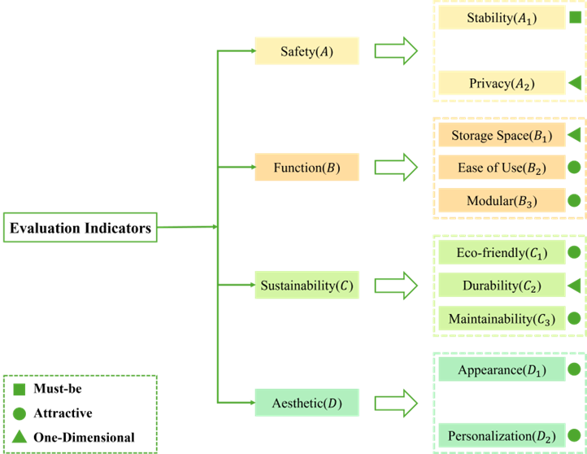

Fig. 2. Dormitory bed design evaluation criteria

Obtaining ANP Weights
A nine-member expert decision-making panel was established, consisting of two professors specializing in industrial design, one professional furniture designer, one furniture factory owner with over 20 years of manufacturing experience, one PhD candidate in industrial design, and four master’s students engaged in furniture design research. The ANP method was then applied to assess the influence relationships among the ten demand indicators filtered by the FKANO model. If more than half of the experts agreed that two indicators were interrelated, the relationship was assigned a value of “1”; otherwise, it was assigned a value of “0” to indicate no influence. The results are summarized in Table 5.

Table 5. Influence Relationship Matrix
 | A₁ | A₂ | B₁ | B₂ | B₃ | C₁ | C₂ | C₃ | D₁ | D₂
A₁ | 0 | 0 | 1 | 0 | 1 | 1 | 1 | 1 | 1 | 0
A₂ | 0 | 0 | 1 | 0 | 0 | 0 | 0 | 0 | 1 | 1
B₁ | 1 | 0 | 0 | 1 | 1 | 0 | 1 | 0 | 1 | 1
B₂ | 0 | 0 | 1 | 0 | 1 | 0 | 1 | 1 | 1 | 1
B₃ | 1 | 0 | 1 | 1 | 0 | 1 | 1 | 1 | 1 | 1
C₁ | 0 | 0 | 0 | 0 | 1 | 0 | 1 | 0 | 1 | 0
C₂ | 1 | 0 | 0 | 0 | 1 | 1 | 0 | 1 | 0 | 0
C₃ | 1 | 0 | 0 | 1 | 1 | 1 | 1 | 0 | 0 | 0
D₁ | 1 | 1 | 1 | 0 | 0 | 1 | 0 | 0 | 0 | 1
D₂ | 0 | 0 | 1 | 0 | 0 | 1 | 0 | 0 | 1 | 0

The influence relationships determined by experts were input into the YAANP software to construct an ANP network structure model, as shown in Fig. 3.

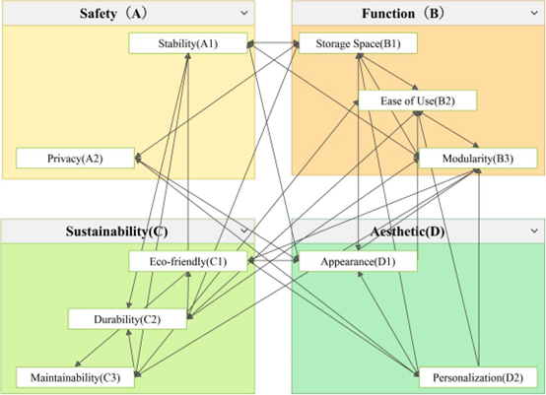

Fig. 3. Network structure model

Based on the constructed network structure model, the expert decision-making panel was reconvened to establish judgment matrices for the importance of indicators using the 1 to 9 scaling method. The weights of each matrix were then calculated. Subsequently, an unweighted supermatrix was constructed (Table 6), illustrating the interdependencies among the indicators.
Table 6. Unweighted Hyper-matrix
 |  | Safety (A) |  | Function (B) |  |  | Sustainability (C) |  |  | Aesthetic (D)
 |  | A₁ | A₂ | B₁ | B₂ | B₃ | C₁ | C₂ | C₃ | D₁ | D₂
A | A₁ | 0 | 0 | 0.233 | 0 | 1 | 1 | 1 | 1 | 0.641 | 0
 | A₂ | 0 | 0 | 0.767 | 0 | 0 | 0 | 0 | 0 | 0.359 | 1
B | B₁ | 0.556 | 0 | 0 | 0.407 | 0.574 | 0 | 0.414 | 0 | 0.360 | 0.307
 | B₂ | 0 | 0 | 0.393 | 0 | 0.426 | 0 | 0.210 | 0.319 | 0.193 | 0.169
 | B₃ | 0.444 | 0 | 0.607 | 0.593 | 0 | 1 | 0.376 | 0.681 | 0.447 | 0.524
C | C₁ | 0 | 0 | 0 | 0 | 0.255 | 0 | 0.630 | 0 | 1 | 0
 | C₂ | 0.667 | 0 | 0 | 0 | 0.458 | 0.678 | 0 | 1 | 0 | 0
 | C₃ | 0.333 | 0 | 0 | 1 | 0.286 | 0.322 | 0.370 | 0 | 0 | 0
D | D₁ | 1 | 1 | 0.426 | 0 | 0 | 0.5 | 0 | 0 | 0 | 1
 | D₂ | 0 | 0 | 0.574 | 0 | 0 | 0.5 | 0 | 0 | 1 | 0

As shown in the matrix, a value of 1 represents a strong influence between two indicators, whereas a value of 0.5 or higher represents a relatively strong influence. Based on these results, three chain relationships among the indicators can be summarized.
The first chain relationship follows the sequence from appearance to safety, functionality, and ultimately sustainability: beginning with appearance (D1), progressing to structural stability (A1), then to modular design (B3), and finally to the use of eco-friendly materials (C1). This indicates that design aesthetics must be achieved while ensuring structural stability. Structural stability, in turn, provides the foundation for modular design, and the integration of modular design with eco-friendly materials further promotes sustainable development.
The second chain relationship progresses from functionality to safety, then returns to functionality, and ultimately leads to sustainability. The specific path is from storage space (B1) to structural stability (A1), then to modular design (B3), and finally to eco-friendly materials (C1). Specifically, the layout of storage space influences structural stability. A more robust structure can better support modular expansion, while the integration of eco-friendly materials with modular design further strengthens sustainable development.
The third chain relationship extends from sustainability to functionality, then returns to functionality, and ultimately circles back to sustainability. Specifically, the path proceeds from maintainability (C3) to ease of use (B2), then to modular design (B3), and finally to eco-friendly materials (C1). This can be further explained as follows: maintainability has a significant impact on usability, while a user-friendly modular design is inherently more rational. Furthermore, modular components should ideally incorporate eco-friendly materials to foster the sustainable development of student dormitory furniture.
From the analysis of the chain relationships described above, the following conclusions can be drawn. First, the sustainability dimension serves as the origin point among the four dimensions, with all core chain relationships ultimately converging on sustainable development. Second, modular design (B3) serves as a pivotal hub within network models. These findings underscore the critical importance of both the sustainability dimension and modular design. Therefore, subsequent design efforts should prioritize optimizing their integration with other criteria.
Finally, the limit supermatrix is calculated to obtain the final ANP weights, as shown in Table 7. This matrix presents the final ANP weights for each indicator.

Table 7. Limit Hyper-Matrix
 | Safety(A) |  | Function(B) |  |  | Sustainability(C) |  |  | Aesthetic(D)
 | A₁ | A₂ | B₁ | B₂ | B₃ | C₁ | C₂ | C₃ | D₁ | D₂
A₁ | 0.188 | 0.188 | 0.188 | 0.188 | 0.188 | 0.188 | 0.188 | 0.188 | 0.188 | 0.188
A₂ | 0.052 | 0.052 | 0.052 | 0.052 | 0.052 | 0.052 | 0.052 | 0.052 | 0.052 | 0.052
B₁ | 0.099 | 0.099 | 0.099 | 0.099 | 0.099 | 0.099 | 0.099 | 0.099 | 0.099 | 0.099
B₂ | 0.061 | 0.061 | 0.061 | 0.061 | 0.061 | 0.061 | 0.061 | 0.061 | 0.061 | 0.061
B₃ | 0.129 | 0.129 | 0.129 | 0.129 | 0.129 | 0.129 | 0.129 | 0.129 | 0.129 | 0.129
C₁ | 0.077 | 0.077 | 0.077 | 0.077 | 0.077 | 0.077 | 0.077 | 0.077 | 0.077 | 0.077
C₂ | 0.155 | 0.155 | 0.155 | 0.155 | 0.155 | 0.155 | 0.155 | 0.155 | 0.155 | 0.155
C₃ | 0.105 | 0.105 | 0.105 | 0.105 | 0.105 | 0.105 | 0.105 | 0.105 | 0.105 | 0.105
D₁ | 0.098 | 0.098 | 0.098 | 0.098 | 0.098 | 0.098 | 0.098 | 0.098 | 0.098 | 0.098
D₂ | 0.037 | 0.037 | 0.037 | 0.037 | 0.037 | 0.037 | 0.037 | 0.037 | 0.037 | 0.037

Acquisition of Comprehensive Weights
To minimize subjective bias in deriving ANP weights, the EW method was applied to obtain objective weights for the indicators, resulting in a comprehensive weighting scheme that integrates both subjective and objective perspectives. Thirty on-campus graduate students were invited to form a decision-making group, which employed a 9-point scale (1–9) to assign values to the ten benefit-oriented indicators. The scores for each indicator were subsequently entered into SPSS software for reliability and validity testing. The results show that $Cronbach^{'}sα$ coefficients exceeded 0.8, while $KMO$ coefficients ranged between 0.7 and 0.8, confirming the evaluation framework’s high reliability and scientific validity. According to Eq. 8, the final calculation results are shown in Table 8.

Table 8. Partially Standardized Matrix
Member  Indicator | A₁ | A₂ | B₁ | B₂ | B₃ | C₁ | C₂ | C₃ | D₁ | D₂
1 | 0.75 | 0.80 | 1 | 0.50 | 0.50 | 0.71 | 0.17 | 0.33 | 0 | 0.33
2 | 0.75 | 0.40 | 1 | 1 | 0.50 | 0.71 | 0.83 | 1 | 0.67 | 0.67
3 | 1 | 1 | 1 | 1 | 0.83 | 0.86 | 1 | 0.83 | 0.67 | 0.5
... | ... | ... | ... | ... | ... | ... | ... | ... | ... | ...

Based on the EW method and Eqs. 10 to 13, the information entropy values (e), variation coefficients (g), and indicator weights (w) were calculated, as presented in Table 9.

Table 9. Objective Weight Values of Indicator
Indicator | entropy value | Variation coefficient | Weight
A₁ | 0.9495 | 0.0505 | 14.6465%
A₂ | 0.9748 | 0.0252 | 7.3086%
B₁ | 0.9288 | 0.0712 | 20.6301%
B₂ | 0.9802 | 0.0198 | 5.7301%
B₃ | 0.9596 | 0.0404 | 11.6984%
C₁ | 0.9739 | 0.0261 | 7.5513%
C₂ | 0.9806 | 0.0194 | 5.6355%
C₃ | 0.9711 | 0.0289 | 8.3767%
D₁ | 0.9635 | 0.0365 | 10.5895%
D₂ | 0.973 | 0.027 | 7.8334%
After obtaining the objective weights, they were combined with the ANP weights using an equal-weight averaging method to calculate the comprehensive weights, as presented in Table 10. Based on the results of the comprehensive weight calculation, the final ranking of indicators was as follows: A1 > B1 > B3 > C2 > D1 > C3 > C1 > A2 > B2 > D2.

Table 10. Comprehensive Weights
Indicator  Weight | ANP weight | Entropy weigh | Comprehensive weight
A₁ | 0.188 | 14.6465% | 16.7283%
A₂ | 0.052 | 7.3086% | 6.2393%
B₁ | 0.099 | 20.6301% | 15.2751%
B₂ | 0.061 | 5.7301% | 5.9051%
B₃ | 0.129 | 11.6984% | 12.3042%
C₁ | 0.077 | 7.5513% | 7.6157%
C₂ | 0.155 | 5.6355% | 10.5478%
C₃ | 0.105 | 8.3767% | 9.4234%
D₁ | 0.098 | 10.5895% | 10.1948%
D₂ | 0.037 | 7.8334% | 5.7667%

Case Design
Based on the three highest-ranked criteria—structural stability (A1), storage capacity (B1), and modular design (B3)—three design solutions were developed with sustainability as the starting point and modular design as the central hub, as shown in Fig. 4.

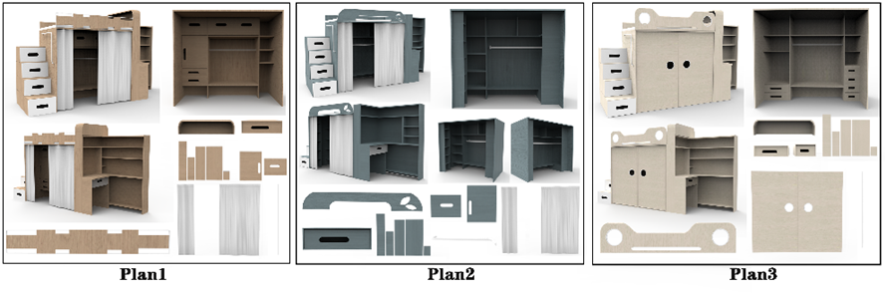
Fig. 4. Design plans

Sustainable Materials: Wood is the primary material in this design. Considering both cost and durability, composite wood that meets E0-grade environmental standards (formaldehyde emission ≤ 0.050 mg/m³) was selected.
Modular Design: All standard components in the three designs adopt a modular approach, allowing students to freely combine and replace parts through the university’s logistics platform. Within the modular design framework, worn standard components can be replaced through the university’s logistics platform. The logistics management office is responsible for repairing components according to the degree of wear, or cutting and reassembling them when necessary. In cases of severe wear, eco-friendly wood can be recycled by crushing and screening to produce remanufactured particleboard or medium-density fiberboard (MDF) for reuse.
Structural Stability: All three bed frame designs employ aluminum alloy to ensure structural integrity. Traditional screw connections are replaced with snap-fit metal slots, thereby eliminating the risk of instability caused by screw loosening over time.
Storage Space: All three design proposals integrate the bed with a compact walk-in closet to maximize storage capacity, but they differ in specific details. Proposal 1 prioritizes meticulous compartmentalization of storage spaces. Proposal 2 emphasizes flexibility, featuring an expanded hanging area inside the closet without detailed subdivisions, while also eliminating the bedside table to allow greater freedom for personal customization. Proposal 3 highlights privacy, incorporating sliding doors and increased internal drawer capacity to enhance personal seclusion.
This study centers on modular construction supplemented by eco-friendly materials, pursuing a full-lifecycle approach to student dormitory furnishings while ensuring structural stability. By integrating modular design with eco-friendly materials, the components achieve disassemblability, recyclability, and enhanced durability. Grounded in a co-creation philosophy between the school and students, this approach establishes a closed-loop cycle—progressing from sustainability to functionality, safety, and aesthetics, and ultimately returning to sustainability. In this way, the lifecycle transcends the traditional “cradle-to-grave” model and evolves into a “cradle-to-cradle” paradigm.

Evaluation of Design Proposals
To validate the rationality of these proposals, two widely sold commercial dormitory beds Plan 4 and Plan 5 are selected for comparative evaluation with the design plans developed in this study, as shown in Fig. 5.

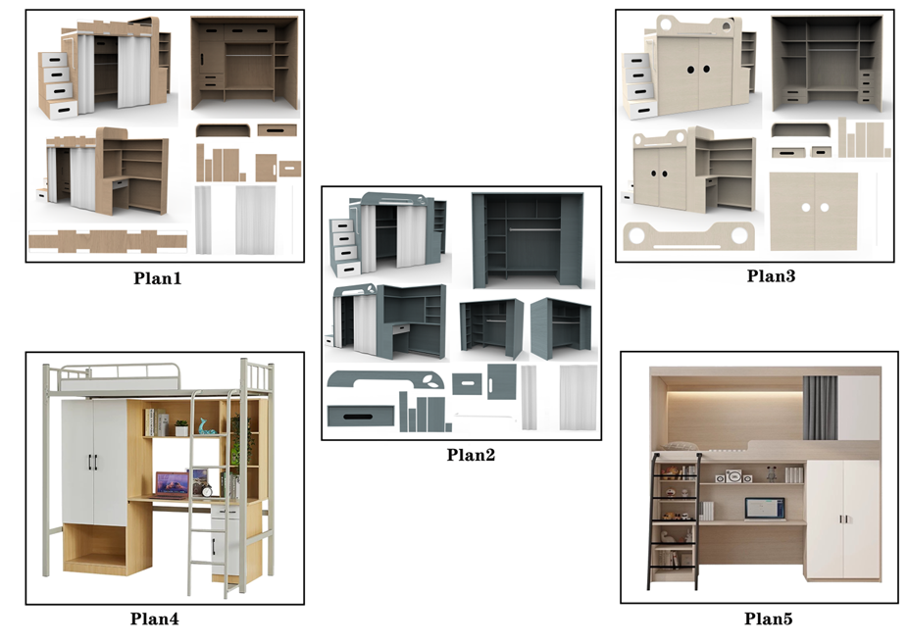
Fig. 5. Five plans in the decision-making process
Based on the five schemes and the ten evaluation criteria described above, a questionnaire employing a 9-point scale was developed and distributed to the expert decision-making panel for scoring. The average scores were then used to construct a decision matrix. To verify the reliability of the scoring process, a reliability test was conducted, yielding a $Cronbach^{'}sα$ coefficient of 0.790. According to formula (14), the final calculation results are shown in Table 11.

Table 11. Squared Sum Normalized Matrix
Plan | A₁ | A₂ | B₁ | B₂ | B₃ | C₁ | C₂ | C₃ | D₁ | D₂
1 | 0.458 | 0.451 | 0.464 | 0.456 | 0.450 | 0.452 | 0.439 | 0.438 | 0.443 | 0.455
2 | 0.442 | 0.445 | 0.453 | 0.445 | 0.443 | 0.440 | 0.445 | 0.450 | 0.448 | 0.455
3 | 0.442 | 0.451 | 0.458 | 0.451 | 0.462 | 0.464 | 0.451 | 0.455 | 0.454 | 0.461
4 | 0.447 | 0.439 | 0.441 | 0.456 | 0.443 | 0.440 | 0.451 | 0.444 | 0.443 | 0.450
5 | 0.447 | 0.451 | 0.418 | 0.427 | 0.437 | 0.440 | 0.451 | 0.450 | 0.448 | 0.415

The comprehensive weights are substituted into the normalized matrix, and the final evaluation results are derived based on Eqs. 15 to 20, as shown in Table 12.

Table 12. Comprehensive Evaluation Results
Plan | D | D- | C | Ranking Results
1 | 0.009 | 0.025 | 0.727 | 2
2 | 0.013 | 0.018 | 0.580 | 3
3 | 0.007 | 0.025 | 0.770 | 1
4 | 0.015 | 0.016 | 0.518 | 4
5 | 0.027 | 0.006 | 0.186 | 5

According to the final comprehensive evaluation results, Plan 3 achieved the highest relative closeness value (C), making it the optimal solution. Moreover, the evaluation process indicates that the three design proposals developed in this study outperformed the best-selling products currently available on the market in terms of overall performance.
Through comparative analysis, the scientific validity and effectiveness of the hybrid model proposed in this study were further validated. However, this research has certain limitations. First, the survey sample size was insufficient, and it was primarily based on universities in China. Second, the proposed hybrid model is relatively complex and lacks simplicity.
Future research will focus on the following directions: First, the authors will expand data sources by incorporating additional comment collection and utilizing text analysis. Second, the team will explore more concise and practical evaluation methods to accommodate diverse decision-makers. Third, while this study focused solely on the bed itself, the overall layout of the dormitory environment also influences product design. Therefore, subsequent research will incorporate the entire dormitory layout into design considerations.

CONCLUSIONS

- This study focused on dormitory beds as the research target. The FKANO model was used to select ten core evaluation indicators, including stability, storage capacity, and modular design. The analytic network process (ANP) method was applied to determine the weights of these indicators. A network model was established to explore and clarify the complex interrelationships between the indicators, providing a more comprehensive approach to sustainable dormitory furniture design.
- To reduce potential subjectivity in the ANP weighting, the expected weighting (EW) method was integrated to derive composite weights. Analysis of these weights and relationships reveals sustainability as the central element that all chain interactions ultimately relate back to, with modular design acting as the central hub within the network model.
- FKANO was found to be able to deeply analyze the ambiguity and uncertainty inherent in users’ subjective emotions, while ANP method clarified the interdependencies among various indicators by constructing a network model. EW effectively prevented excessive subjectivity in indicator weighting. The model’s validity was further validated by comparing it with popular market products using TOPSIS. Results showed that Proposal 3 achieved the highest overall score, outperforming all other proposals. The three proposals developed in this study collectively outperformed market designs, further validating the effectiveness of this integrated approach. This methodology overcomes the limitations of isolated indicators in traditional multi-criteria decision-making, providing a more comprehensive and rigorous framework for dormitory furniture design and evaluation.

ACKNOWLEDGEMENTS

This research was funded by Provincial Innovation Funds for Postgraduates in Jiangxi Province (YC2025-S296) and Jiangxi Provincial Planning Special Project of Education Science (Grant No. 2025ZX187). The authors would like to thank Dr. Ren Zhaoxian from Northwestern Polytechnical University for all the kind help he offered.

Use of Generative AI
To ensure transparency, the authors state that ChatGPT (OpenAI) was used only for English translation and language polishing, while all research design, data analysis, and conclusions are the independent work of the authors.

REFERENCES CITED

Bianco, I., Thiébat, F., Carbonaro, C., Pagliolico, S., Blengini, G. A., and Comino, E. (2021). “Life cycle assessment (LCA)-based tools for the eco-design of wooden furniture,” Journal of Cleaner Production 324, article 129249. https://doi.org/10.1016/j.jclepro.2021.129249
Bumgardner, M. S., and Nicholls, D. L. (2020). “Sustainable practices in furniture design: A literature study on customization, biomimicry, competitiveness, and product communication,” Forests 11(12), article 1277. DOI: 10.3390/f11121277
Chen, C. H. (2020). “A novel multi-criteria decision-making model for building material supplier selection based on entropy-AHP weighted TOPSIS,” Entropy 22(2), article 259. https://doi.org/10.3390/e22020259
Chen, C. H. (2021). “A hybrid multi-criteria decision-making approach based on ANP-entropy TOPSIS for building materials supplier selection,” Entropy 23(12), article 1597. https://doi.org/10.3390/e23121597
Chen, Y. M., Liu, M. B., Xu, J. Y., Yu, S., and Chen, L. P. (2024). “Research on willow furniture design based on Kano-AHP and TRIZ,” BioResources 19(4), 7723-7736. https://doi.org/10.15376/biores.19.4.7723-7736
Frahm, L. B., Laursen, L. N., and Tollestrup, C. (2022). “Categories and design properties of inherited long-lasting products,” Sustainability 14(7), article 3835. https://doi.org/10.3390/su14073835
Ilhan, A. E., and Togay, A. (2024). “Use of eye-tracking technology for appreciation-based information in design decisions related to product details: Furniture example,” Multimedia Tools and Applications 83(3), 8013-8042. https://doi.org/10.1007/s11042-023-15947-0
He, W., and Zeng, N. (2025). “The relationship between university dormitory environmental factors and students’ informal learning experiences: A case study of three universities in Guangdong Province,” Buildings 15(14). https://doi.org/10.3390/buildings15142518
Karakurt, N. F., and Cebi, S. (2025). “A fuzzy Kano model proposal for sustainable product design: Mobile application feature analysis,” Applied Soft Computing 172, article 112824. https://doi.org/10.1016/j.asoc.2025.112824
Kuys, J., Al Mahmud, A., and Kuys, B. (2021). “A case study of university–industry collaboration for sustainable furniture design,” Sustainability 13(19), article 10915. https://doi.org/10.3390/su131910915
Li, J. L., and Han, H. (2022). “Emotional design strategy of smart furniture for small households based on user experience,” in: Distributed, Ambient and Pervasive Interactions, Smart Environments, Ecosystems, and Cities, Part I, Springer, Cham, 13325, 311-320. https://doi.org/10.1007/978-3-031-05463-1_22
Li, P., Wu, J., and Qian, H. (2012). “Groundwater quality assessment based on rough sets attribute reduction and TOPSIS method in a semi-arid area, China,” Environmental Monitoring and Assessment 184(8), 4841-4854. https://doi.org/10.1007/s10661-011-2306-1
Li, Y., Xiong, X., and Qu, M. (2023). “Research on the whole life cycle of a furniture design and development system based on sustainable design theory,” Sustainability 15(18), article 13928. https://doi.org/10.3390/su151813928
Liu, M. B., Cheng, H. B., Chen, L. P., Liao, A. H., and Kong, Q. (2024). “Research on harmonious design of chairs based on the Kano model and analytic hierarchy process,” BioResources 19(3), 5535-5548. https://doi.org/10.15376/biores.19.3.5535-5548
Liu, M. B., Zhu, X. R., Chen, Y. M., and Kong, Q. (2023). “Evaluation and design of dining room chair based on analytic hierarchy process (AHP) and fuzzy AHP,” BioResources 18(2), 2574-2588. https://doi.org/10.15376/biores.18.2.2574-2588
Liu, W., Fei, Y. N., Yu, C. L., Hu, Z. Y., and Chen, J. Q. (2025). “Unveiling the core design elements of bamboo furniture,” IEEE Access 13, 13341-13355. https://doi.org/10.1109/ACCESS.2025.3529779
Phuah, Z. Y., Ng, P. K., Lim, B. K., Nathan, R. J., Ng, Y. J., and Yeow, J. A. (2022). “The conceptualisation of inventive and repurposable children's furniture,” Forests 13(12), article 2053. https://doi.org/10.3390/f13122053
Saaty, T. L. (2004). “Fundamentals of the analytic network process—Dependence and feedback in decision-making with a single network,” Journal of Systems Science and Systems Engineering 13(2), 129-157. https://doi.org/10.1007/s11518-006-0158-y
Saha, A. K., Jahin, M. A., Rafiquzzaman, M., and Mridha, M. F. (2024). “Ergonomic design of computer laboratory furniture: Mismatch analysis utilizing anthropometric data of university students,” Heliyon 10(14), article e34063. https://doi.org/10.1016/j.heliyon.2024.e34063
Solangi, Y. A., Tan, Q., Mirjat, N. H., and Ali, S. (2019). “Evaluating the strategies for sustainable energy planning in Pakistan: An integrated SWOT-AHP and fuzzy-TOPSIS approach,” Journal of Cleaner Production 236, article 117655. https://doi.org/10.1016/j.jclepro.2019.117655
Taifa, I. W., and Desai, D. A. (2017). “Anthropometric measurements for ergonomic design of students’ furniture in India,” Engineering Science and Technology, an International Journal 20(1), 232-239. https://doi.org/10.1016/j.jestch.2016.08.004
Wang, J. J., Liang, Q. W., Ma, X. Y., Wei, Y. H., and Chen, Y. S. (2024). “Research on the design of growable solid wood children's beds,” BioResources 19(4), 8257-8272. https://doi.org/10.15376/biores.19.4.8257-8272
Wang, Q., and Chen, Y. S. (2024). “Applying a Kano-FAST integration approach to design requirements for auditorium chairs,” BioResources 19(3), 5825-5838. https://doi.org/10.15376/biores.19.3.5825-5838
Wang, S., and Xiao, W. (2022). “Application of product life cycle management method in furniture modular design,” Mathematical Problems in Engineering 2022, article 7192152. https://doi.org/10.1155/2022/7192152
Wei, Y., and Chen, Y. (2025). “Ergonomic optimization of university dormitory furniture: A digital human modeling approach using Jack software,” Sustainability 17(1), article 299. https://doi.org/10.3390/su17010299
Xie, X. J., Zhu, J. G., Ding, S., and Chen, J. J. (2024). “AHP and GCA combined approach to green design evaluation of kindergarten furniture,” Sustainability 16(1), article 1. https://doi.org/10.3390/su16010001
Xu, J. Y., Wei, D. P., Zhang, X. D., Li, X. L., and Chen, Y. M. (2024). “Dining table design research based on user needs hierarchy and DEMATEL-ISM,” BioResources 19(4), 8959-8975. https://doi.org/10.15376/biores.19.4.8959-8975
Yang, D., and Vezzoli, C. (2024). “Designing environmentally sustainable furniture products: Furniture-specific life cycle design guidelines and a toolkit to promote environmental performance,” Sustainability 16(7), article 2628. DOI: 10.3390/su16072628
Yu, G., Dai, C., Huang, S., Gan, L., and Gao, W. (2019). “Research on innovative application of modular design in university student apartment furniture,” IOP Conference Series: Materials Science and Engineering 573(1), article 012016. https://doi.org/10.1088/1757-899X/573/1/012016
Yu, S., Liu, M. B., Chen, L. P., Chen, Y. M., and Yao, L. (2024). “Emotional design and evaluation of children's furniture based on AHP-TOPSIS,” BioResources 19(4), 7418-7433. https://doi.org/10.15376/biores.19.4.7418-7433
Zhang, F., Li, X., Xu, S., Zhao, X., and Gao, Y. (2024). “Ergonomic design of safety protective wearables in confined space operations,” Advanced Design Research 2(2), 137-150. https://doi.org/10.1016/j.ijadr.2025.01.001
Zhang, Z., and Sun, Q. (2024). “Integrated design methods for sustainable public seating in urban communities—A Shanghai case study,” Sustainability 16(20), article 9096. https://doi.org/10.3390/su16209096
Zhao, Y., and Xu, Y. J. (2023). “Evaluation model for modular children's wooden storage cabinet design,” BioResources 18(4), 7818-7838. https://doi.org/10.15376/biores.18.4.7818-7838
Zhu, Y., Tian, D., and Yan, F. (2020). “Effectiveness of entropy weight method in decision-making,” Mathematical Problems in Engineering 2020, 3564835. https://doi.org/10.1155/2020/3564835

Article submitted: September 19, 2025; Peer review completed: January 23, 2026; Revised version received and accepted: February 3, 2026; Published:

