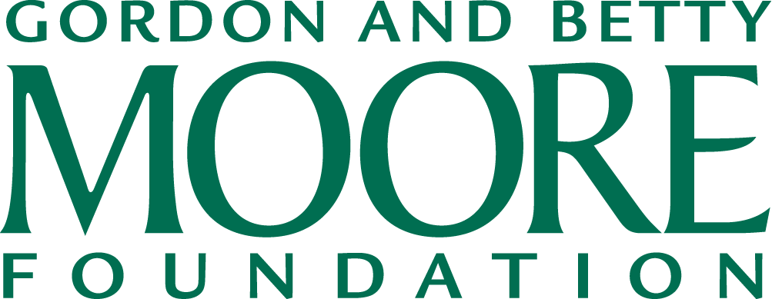

May 10, 2016

In an effort to increase the efficiency of our accounts payable process, the Gordon and Betty Moore Foundation encourages remitting payments to our vendors via ACH (Automatic Clearing House). This overnight electronic funds transfer enables direct deposit of your payments that is faster and safer than the traditional check payments. If you are interested to participate in this program, please provide us with the following information. We will maintain strict confidentiality of your bank information.

|  |  |
| --- | --- |
| **Name** |  |
| **Bank name** |  |
| **Account name & type**  **(Checking v. Savings)** |  |
| **Account number** |  |
| **ACH routing number** |  |
| **Contact phone number** |  |
| **Email address to which we can send our remittance information** |  |

Please forward this information to Natalie Caulk (natalie.caulk@moore.org). If you prefer to send this information via mail, please return this form to the following address:

ATTN: Natalie Caulk

Gordon & Betty Moore Foundation

1661 Page Mill Road

Palo Alto, CA 94304