Side note: The user needs to be authenticated for them to even open the dashboard and continue with their processes and actions

- Retail Customer
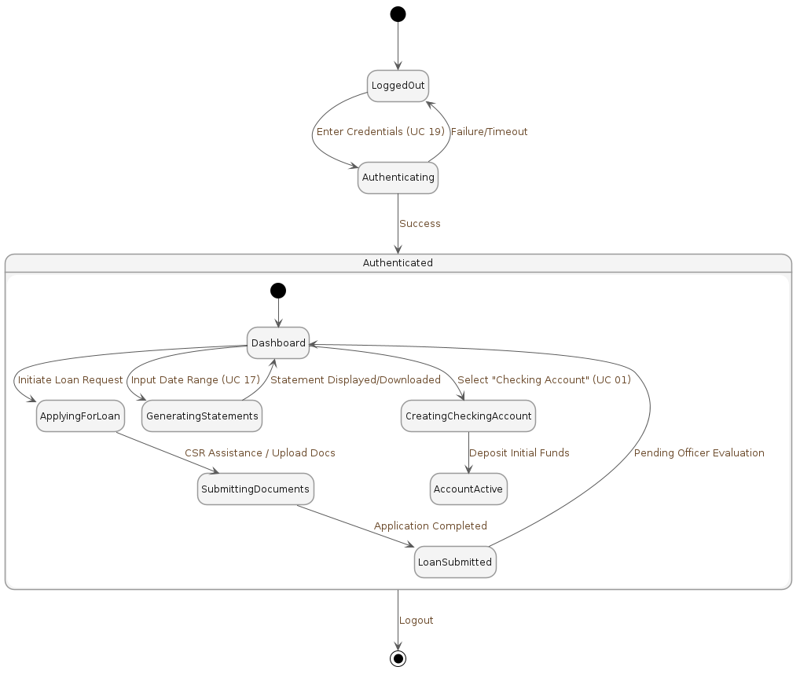
Made by: Orest Zeqollari

- Corporate Customer
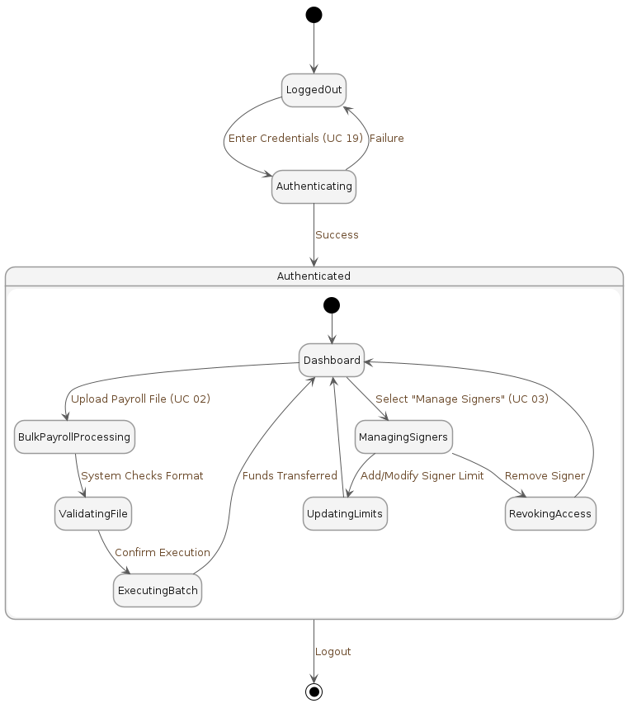
Made by: Orest Zeqollari

- HR Manager
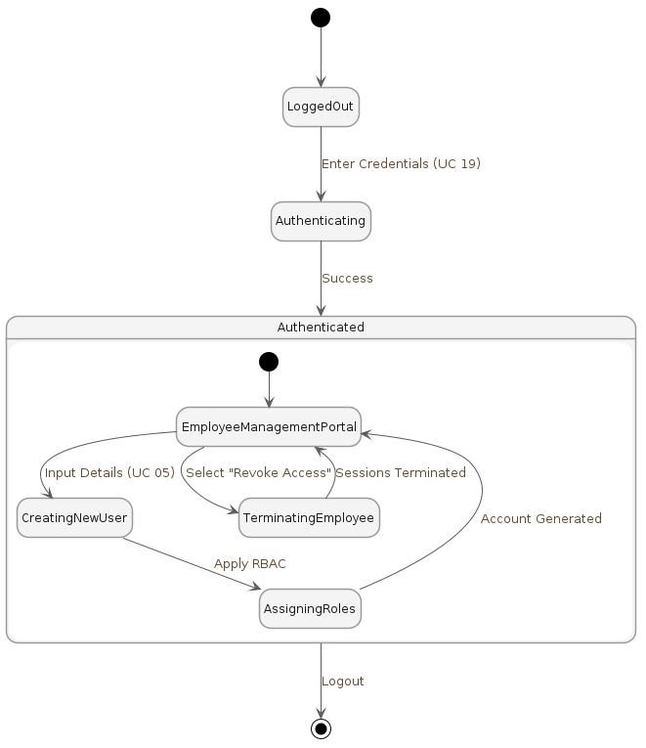
Made by: Orest Zeqollari

- Bank Teller
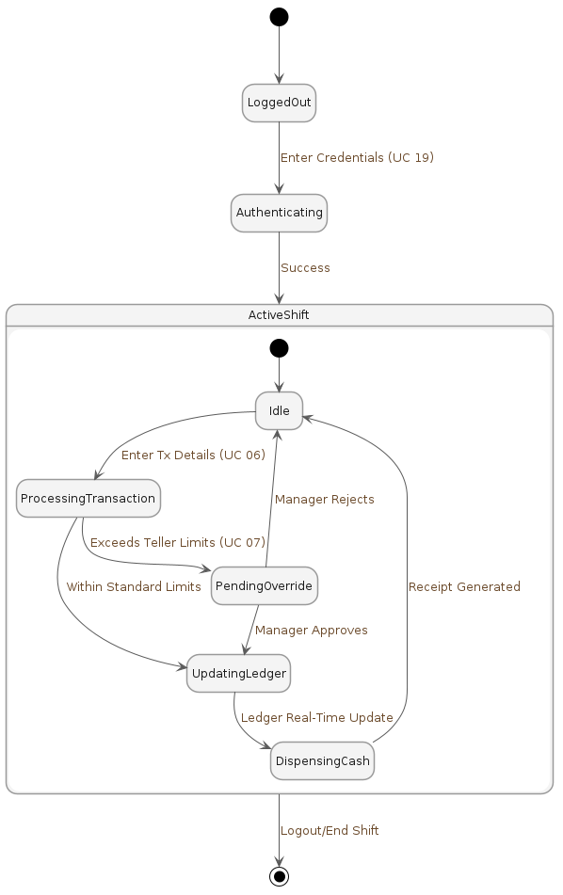
Made by: Kristian Avrami

- Assistant Branch Manager
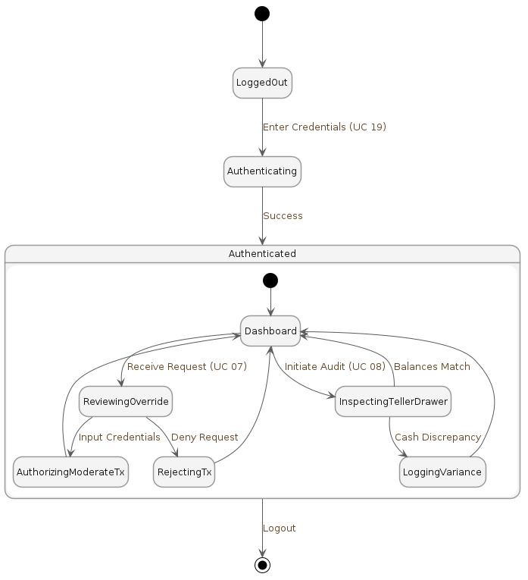
Made by: Kristian Avrami

- Branch Manager
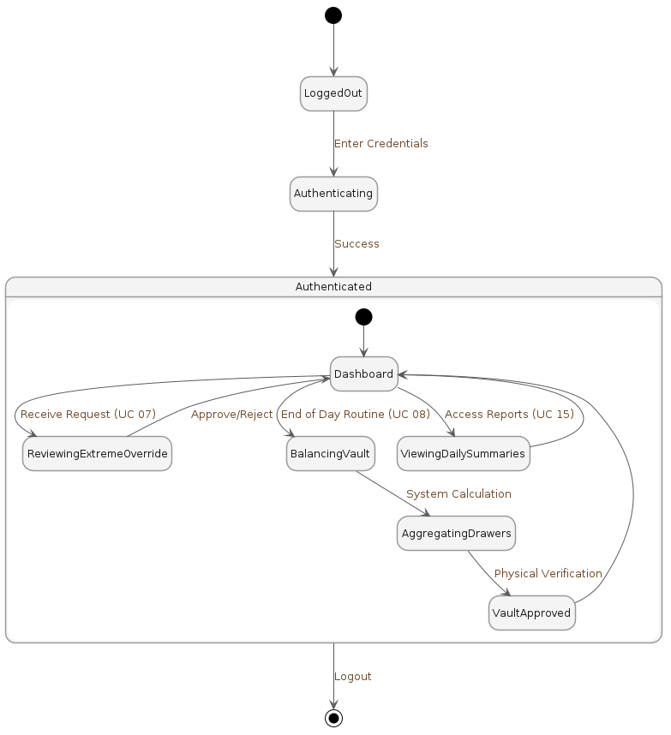
Made by: Kristian Avrami

- Personal Banker
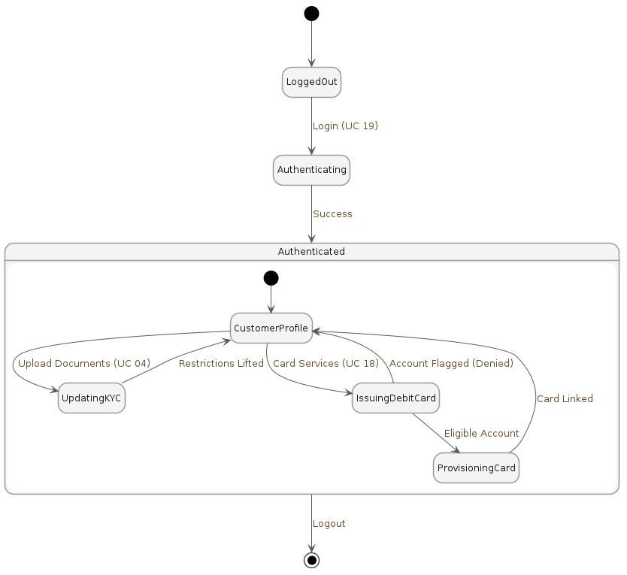
Made by: Kristian Avrami

- Loan Evaluator (Retail Loan Officer and Corporate Credit Analyst)
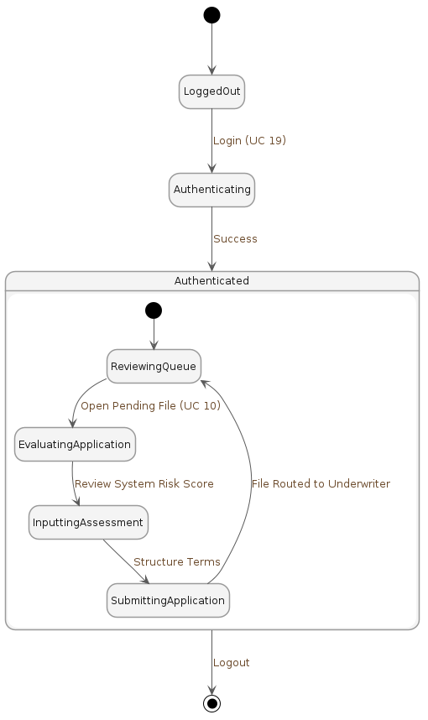
Made by: Denis Robi

- Underwriter
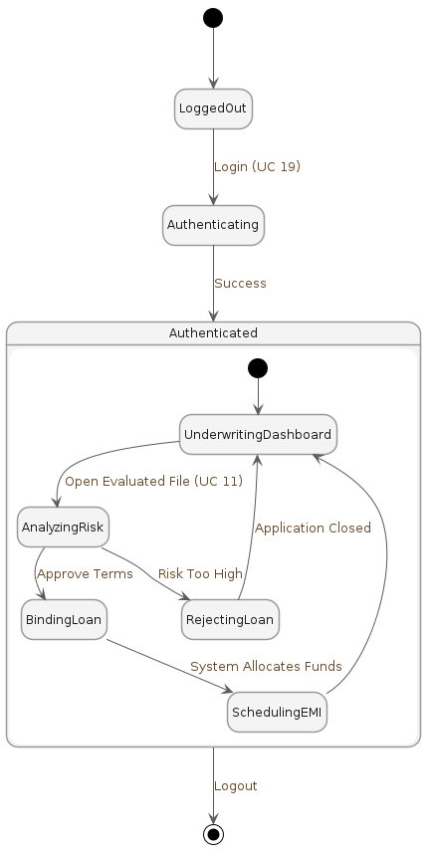
Made by: Denis Robi

- Collections Officer
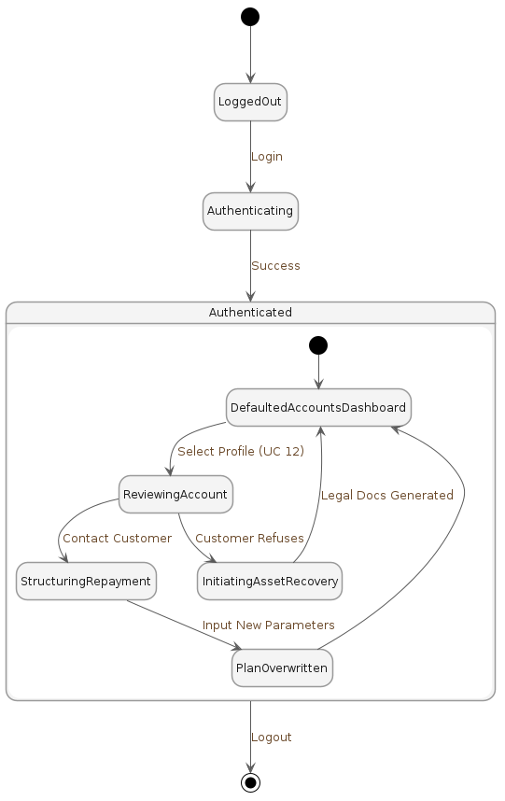
Made by: Denis Robi

- AML/KYC Compliance Officer
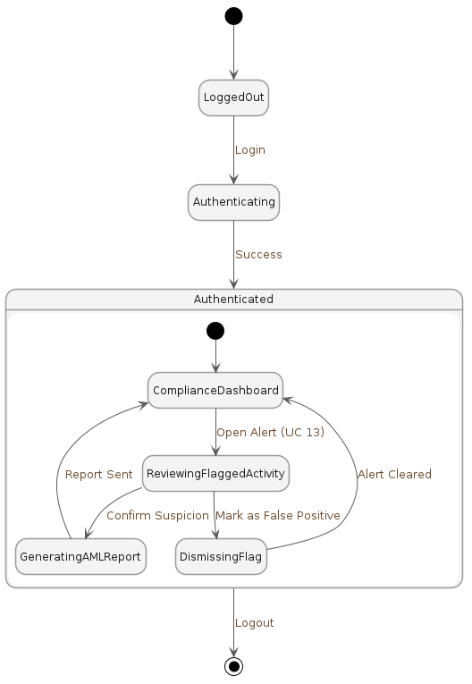
Made by: Denis Robi

- Internal Auditor
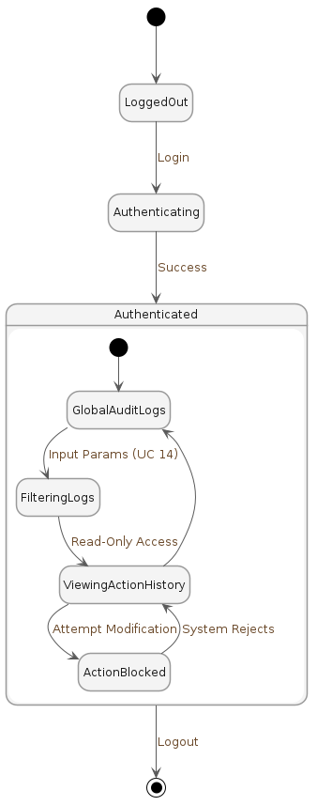
Made by: Daniel Salianji

- Regional Director of Operations
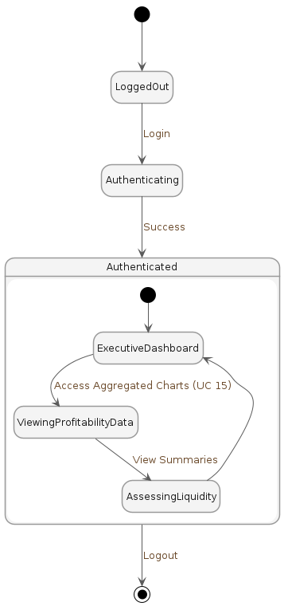
Made by: Daniel Salianji

- IT Administrators (System Admin, Security Admin, DBA)
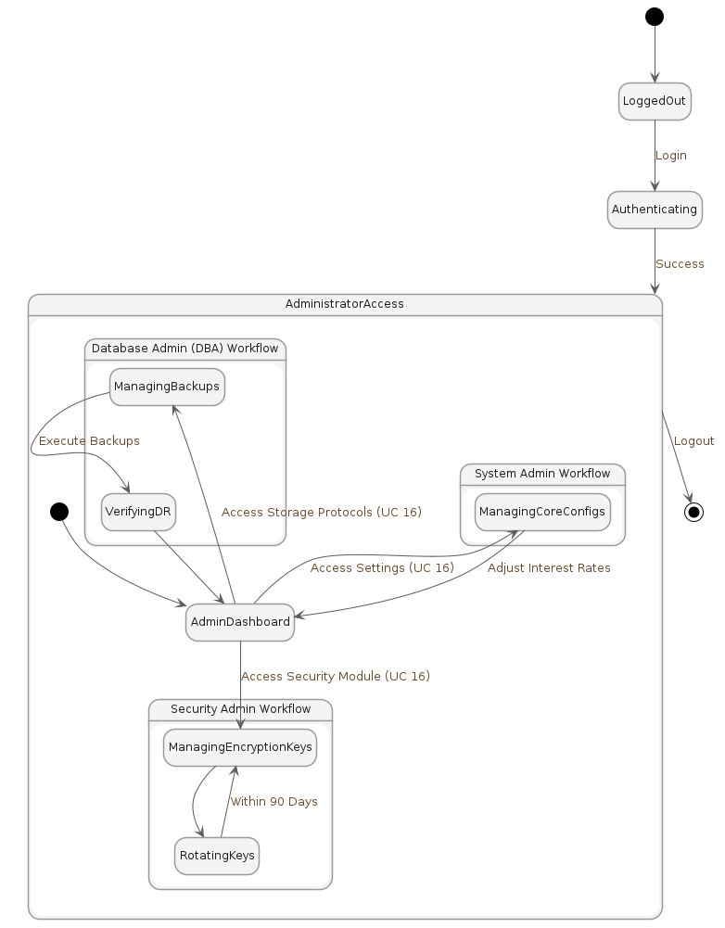
Made by: Daniel Salianji

- Chief Risk Officer (CRO)
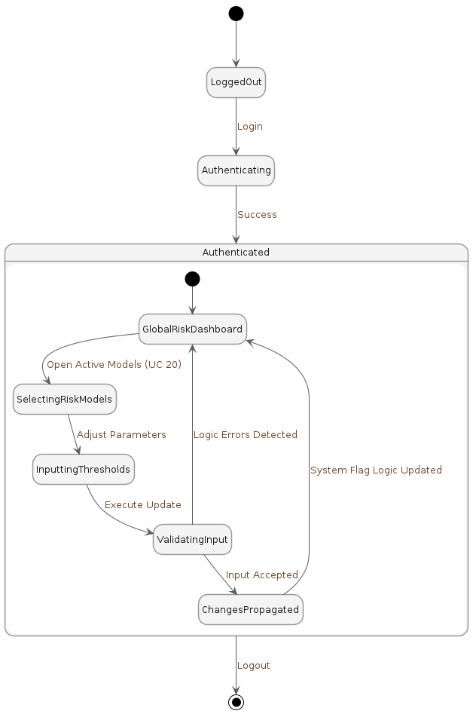
Made by: Denis Musaraj

- Automated System
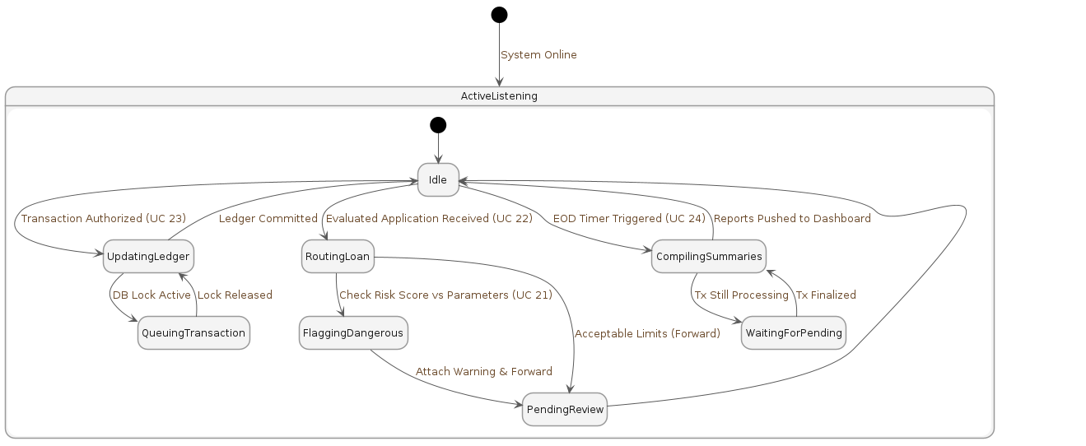
Made by: Denis Musaraj

- External Payment Gateway
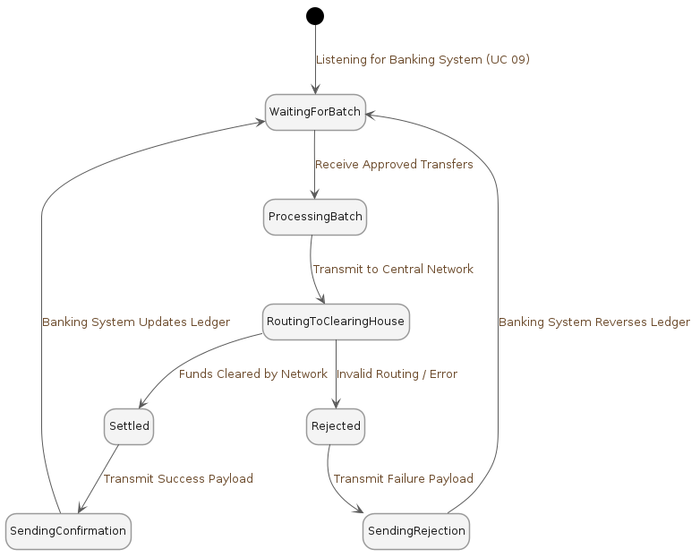
Made by: Denis Musaraj

- Account Lifecycle
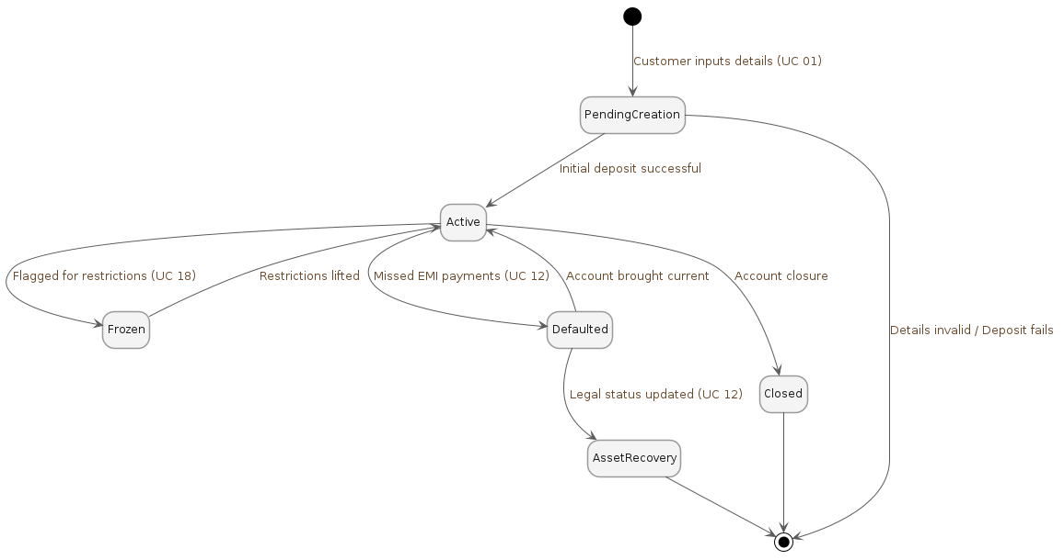
Made by: Dariel Hamzallari
19. Transaction Lifecycle
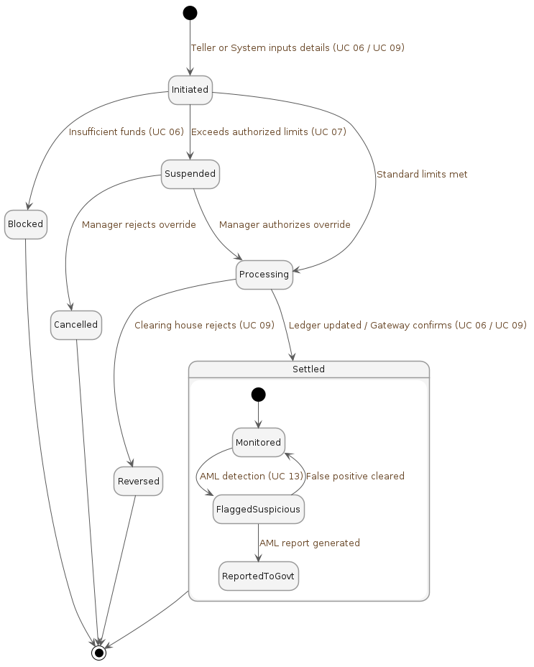
Made by: Dariel Hamzallari

20. Loan Application and Agreement Lifecycle
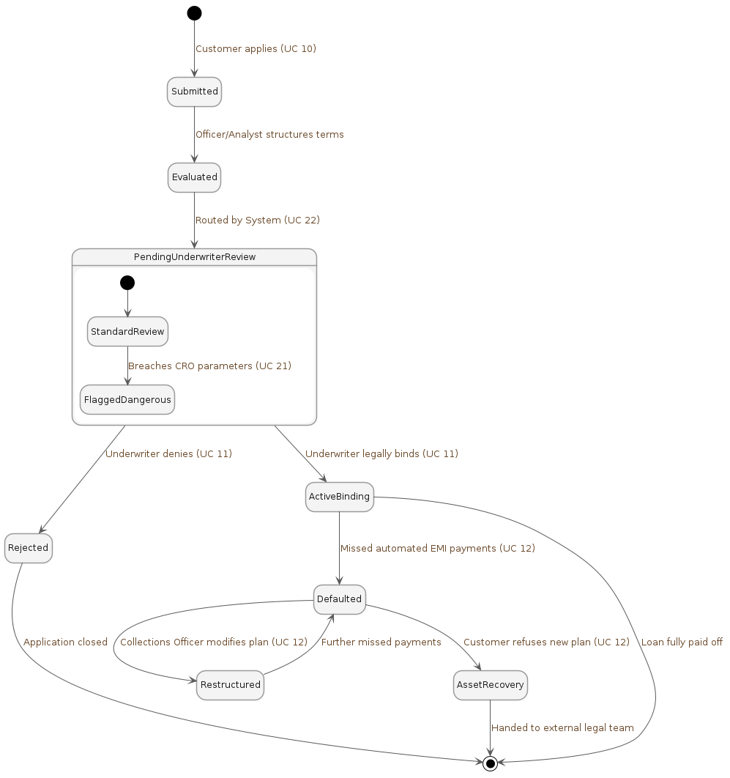
Made by: Dariel Hamzallari

