Design Patterns Applied in the Banking Management System
The Banking Management System applies three design patterns to keep its architecture flexible and maintainable as features are added. The used patterns are one Creational pattern visible in the Class Diagram, and two Behavioral patterns visible in the State Diagram and the Sequence / Collaboration Diagrams. Each pattern is presented with the problem it solves, how it works in general, how it maps to our specific classes, and its trade-offs.

1. Singleton — Global Risk Model
Category: Creational

Problem
The Chief Risk Officer (CRO) sets a single set of global parameters (minimum credit score, maximum debt-to-income ratio, dangerous-loan thresholds) that every loan evaluation across every branch must reference (referring to UC 20: Set Global Risk Parameters). If each branch or each loan officer instantiated its own risk model, evaluations would drift apart and the bank would lose a consistent risk policy. We need exactly one shared risk model that is globally accessible.

How It Works
The Singleton pattern restricts a class to a single instance and provides a global access point to it. The class enforces this internally by hiding its constructor and exposing a static accessor that creates the one and only instance, then returns the same reference on every subsequent call.

Structure in the Project
The GlobalRiskModel class in the system class diagram is marked with the «Singleton» stereotype. Its attributes (maxDebtToIncomeRatio, minCreditScore) and its operation validateLoanParameters(loan) are shared globally. Loan objects call validateLoanParameters() against the single instance during evaluation, and the ChiefRiskOfficer actor mutates that same instance via setGlobalRiskParameters() (UC 20). UC 21 (Flag Dangerous Loans) then reads from the same instance to decide whether a loan breaches the threshold.

Pros
- Guarantees a consistent risk policy across every loan evaluation, branch, and underwriter.
- Parameter updates by the CRO propagate instantly system-wide, satisfying UC 20's zero-downtime requirement.
- A single controlled access point makes audit logging of risk-policy changes straightforward.

Cons
- Singletons behave as global state, which can complicate isolated unit testing of loan logic.
- If the bank later requires region-specific risk parameters, the Singleton must be refactored into a registry of instances keyed by region.
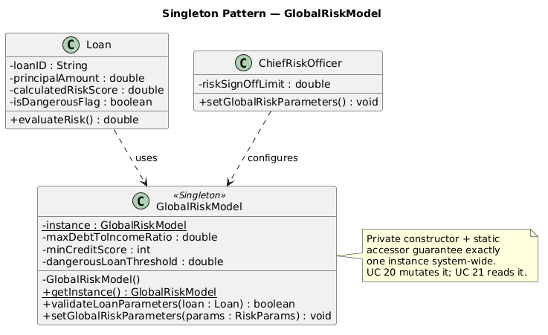

2. State — Account Lifecycle
Category: Behavioral

Problem
An Account behaves differently depending on its current status. A frozen account must reject withdrawals but may still accept deposits; a closed account must reject everything; an account under asset recovery has its own restricted set of allowed operations. Without the State pattern, the Account class accumulates a long chain of if (status == "Frozen") ... else if (status == "Closed") ... checks inside every method, which becomes unreadable and forces an edit to every method each time a new state is added. A direct violation of the Open/Closed Principle.

How It Works
The State pattern extracts each state into its own class that implements a common state interface. The original object holds a reference to one of these state objects and delegates state-dependent behavior to it. When the state changes, the context simply swaps the reference, and from then on all calls automatically route to the new state's implementation.

Structure in the Project
Our State Diagram for Account defines six states: PendingCreation, Active, Frozen, Defaulted, Closed, and AssetRecovery. Each of these becomes a concrete class implementing an AccountState interface that declares operations such as deposit(amount), withdraw(amount), and applyFee(). Account (original object) holds an AccountState currentState reference; a call to account.withdraw(amount) delegates to currentState.withdraw(account, amount).

Example
FrozenState.withdraw() throws a RestrictedOperationException, while FrozenState.deposit() is permitted. AssetRecoveryState blocks both deposit and withdraw. ActiveState performs the normal ledger update flow. Transitions between states (e.g., Active → Defaulted when an EMI is missed in UC 12) are triggered by domain events and result in account.setState(new DefaultedState()).

Pros
- Open/Closed Principle: a new state (e.g., UnderInvestigation) means adding one class, not editing every method on Account.
- Single Responsibility Principle: each state class owns only the rules that apply to that state.
- Eliminates the large nested-conditional chain inside Account, making the code drastically more readable.

Cons
- Can be a bit over the top if a state machine has only two or three states with trivial rules but with the six states in our diagram, the trade-off clearly favors the pattern.
- Introduces more classes, which slightly increases the size of the class diagram and the project footprint.
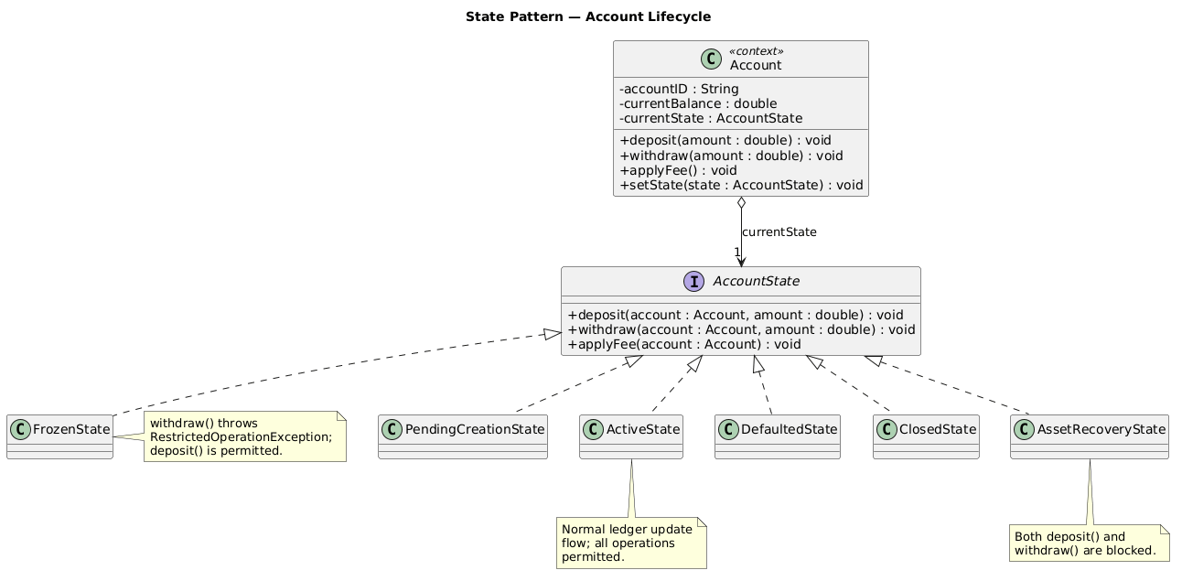

3. Observer — Real-Time Transaction Monitoring
Category: Behavioral

Problem
Every time the SystemLedger commits a transaction, multiple parts of the system need to react: the AML/KYC Officer must screen for suspicious activity (UC 13), the Internal Auditor needs an immutable record written to the audit log (UC 14), and the customer may need a transaction receipt or notification (UC 06, UC 17). Hard-coding these downstream calls directly inside SystemLedger would tightly couple it to every consumer and force a code change every time a new consumer is added.

How It Works
The Observer pattern defines a one-to-many dependency between objects: when one object (the subject also called the publisher) changes state, all of its dependents the observers (subscribers) are notified automatically. The subject maintains a list of observers and exposes attach(), detach(), and notify() methods. Observers implement a common interface so the subject can call them uniformly without knowing their concrete types.

Structure in the Project
The subject is SystemLedger already shown in the Class Diagram as a «System Actor» with commitTransaction(tx). It maintains an internal list of TransactionObserver references. The interface declares a single method, onTransactionCommitted(transaction). Concrete observers include AMLOfficer (already in our Class Diagram, with monitorTransactions() and generateAMLReport()), an AuditLogger that writes the immutable trail required by UC 14 (View Action History and Audit Logs), and a CustomerNotifier for customer-facing alerts. On every successful commitTransaction(), the ledger iterates its observer list and invokes each observer's onTransactionCommitted() method.

Trace Through Our Diagrams
The Sequence Diagrams show the flow Teller → Account → SystemLedger → commit. The Observer pattern fits between the commit step and the downstream flagSuspicious() and audit-logging steps that the Collaboration Diagrams already depict. The pattern formalizes those downstream notifications as a subscription mechanism rather than direct method calls baked into the ledger.

Pros
- Open/Closed Principle: a new observer (e.g., a fraud-scoring ML engine) can be added without modifying SystemLedger or any existing observer.
- Loose coupling between the ledger and its consumers; either side can evolve independently.
- Subscriptions can be created and torn down at runtime, which supports admin features like enabling or disabling notification streams.

Cons
- Notification order is not guaranteed, which matters if one observer's correctness depends on another having already run.
- Observers that throw exceptions or block can stall the notification chain unless the ledger uses asynchronous dispatch.
