Swimlane Diagrams

Use Case 1: Create a personal checking account
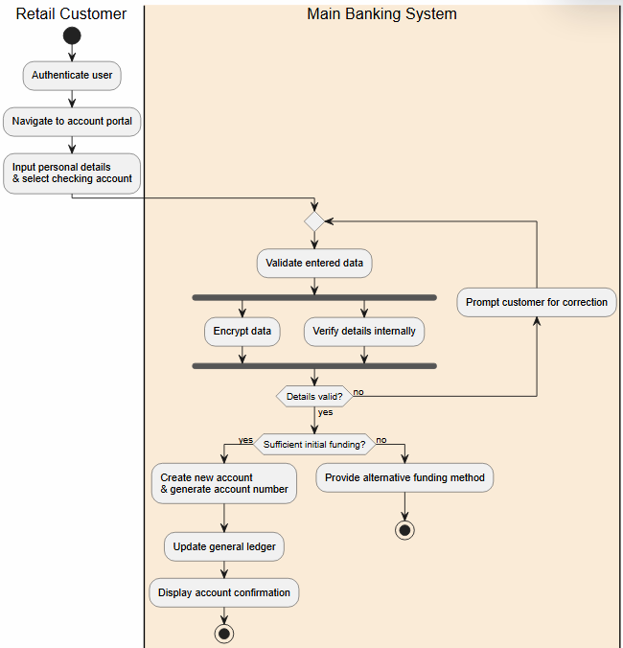
Made by: Orest Zeqollari

Use Case 2: Initiate Bulk Payroll processing

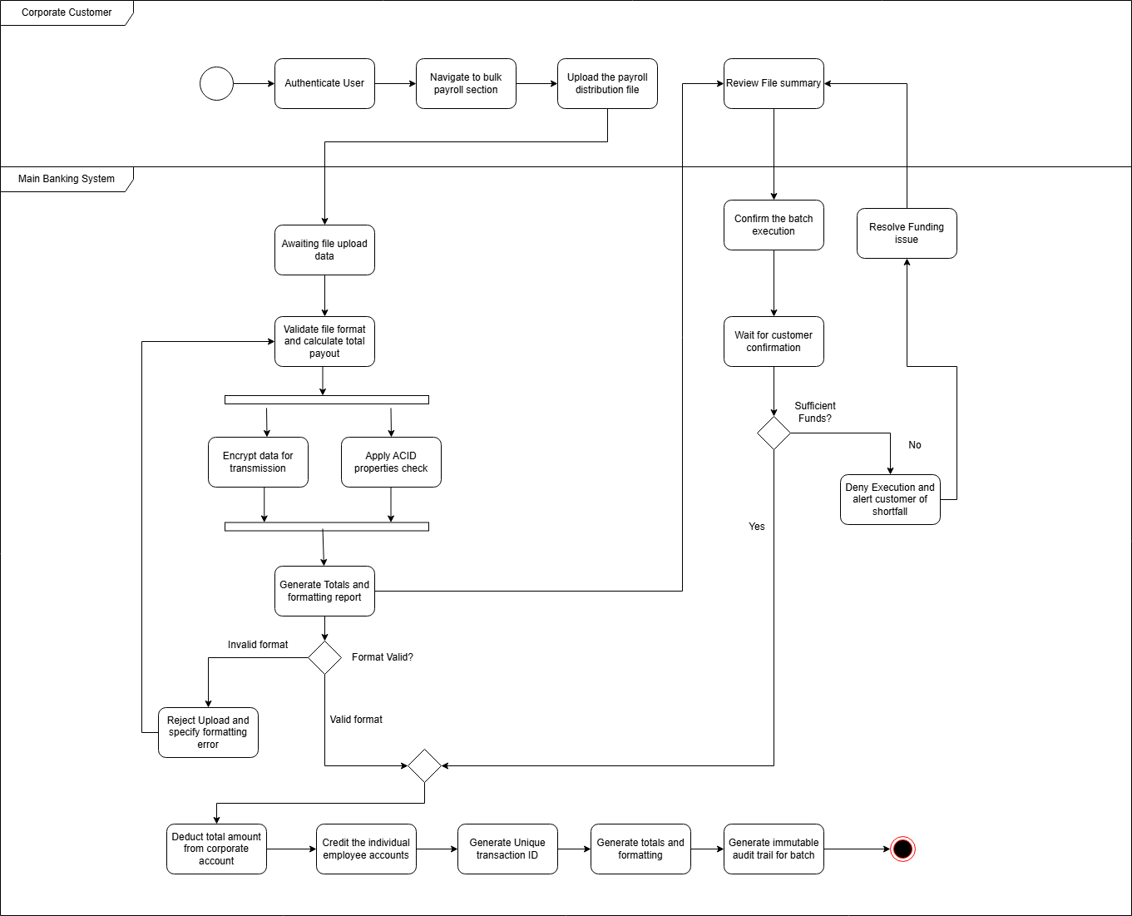
Made by: Orest Zeqollari

Use Case 3: Manage Multiple Authorized Signers
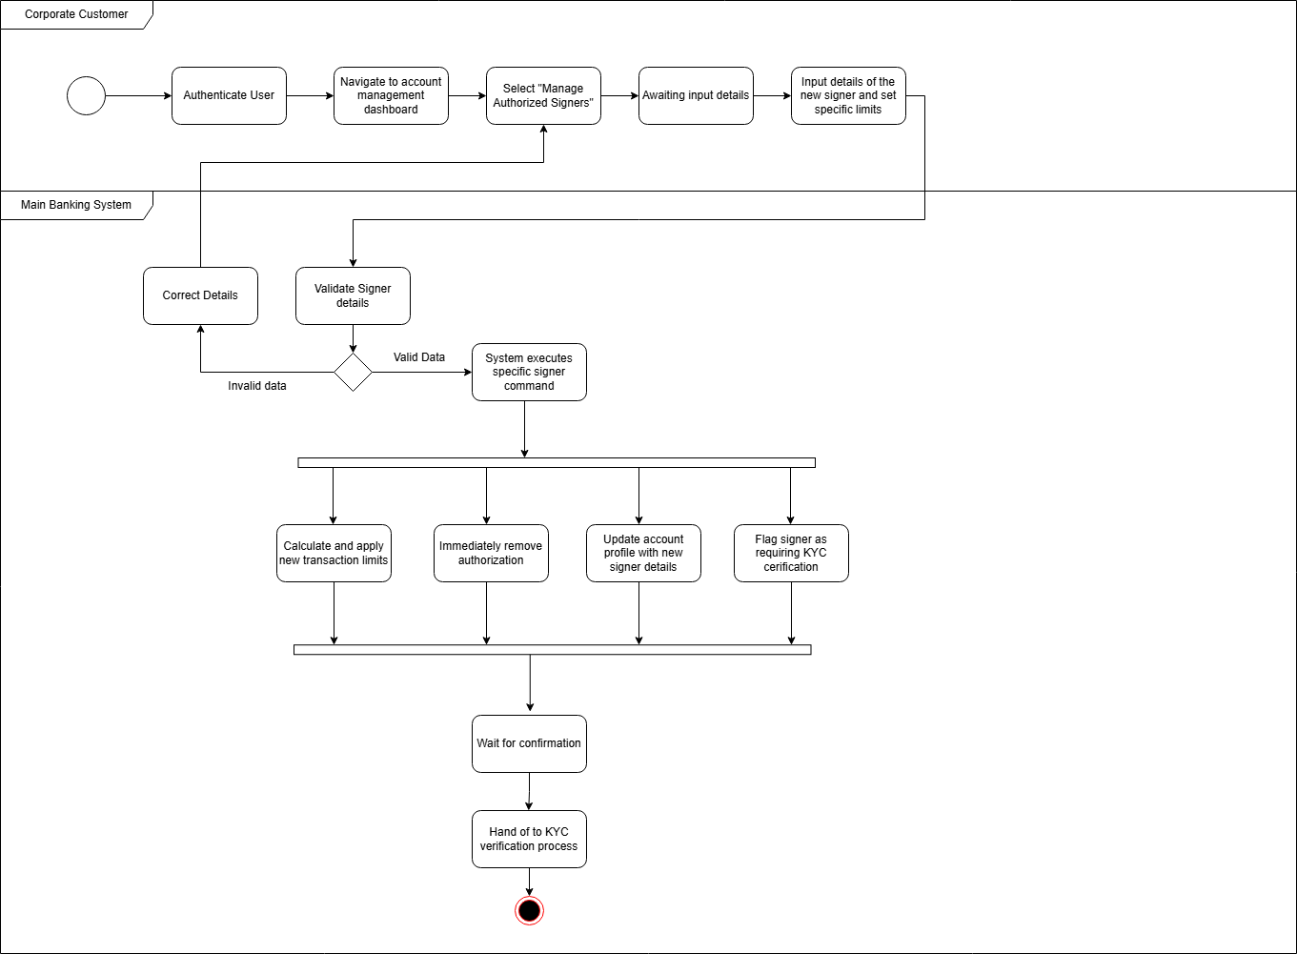
Made by: Orest Zeqollari

Use Case 4: Update KYC Documents
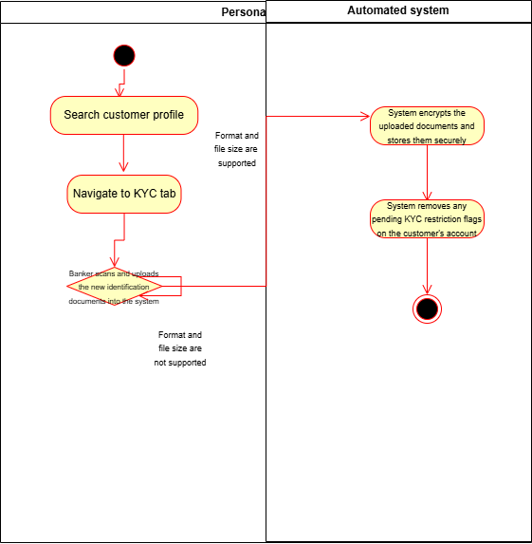
Made by: Aksel Luarasi

Use Case 5: Manage User Accounts (HR)
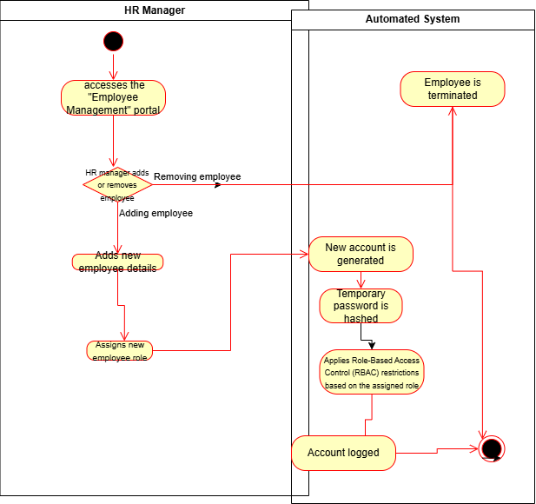
Made by: Aksel Luarasi

Use Case 6: Process Cash transactions (Deposit and Withdraw)
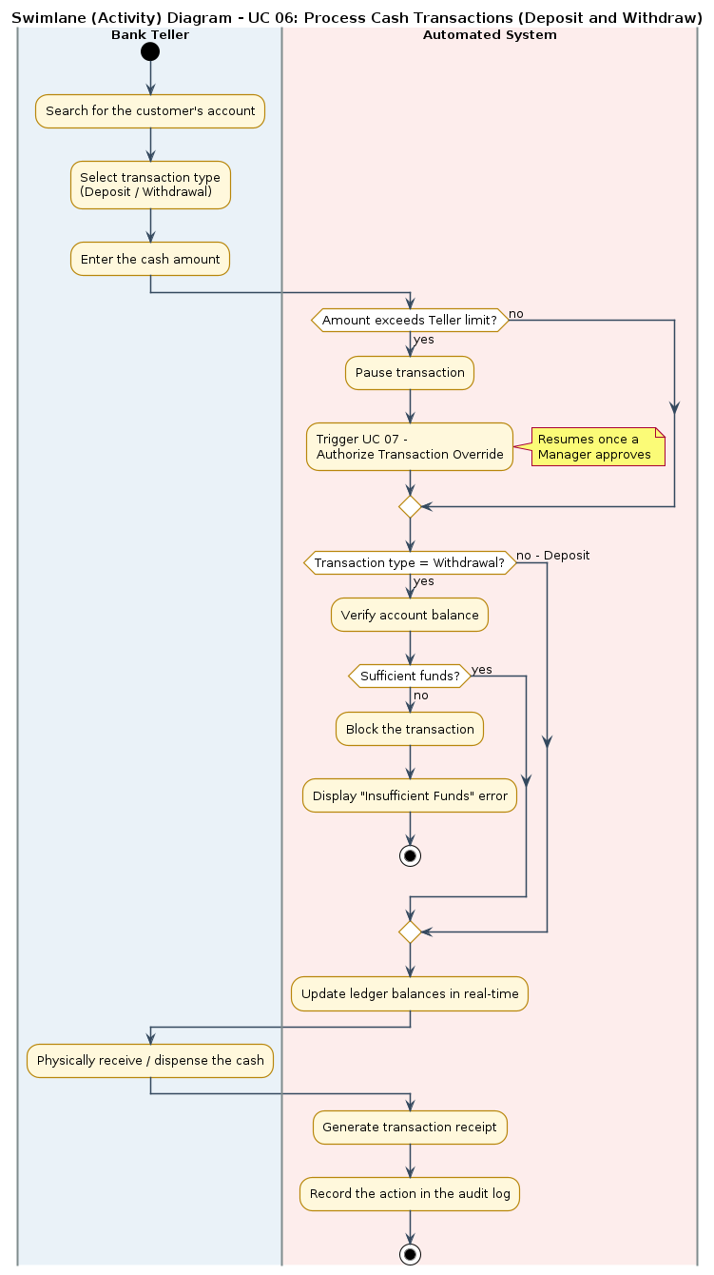
Made by: Aksel Luarasi

Use Case 7: Authorize Transaction Overrides
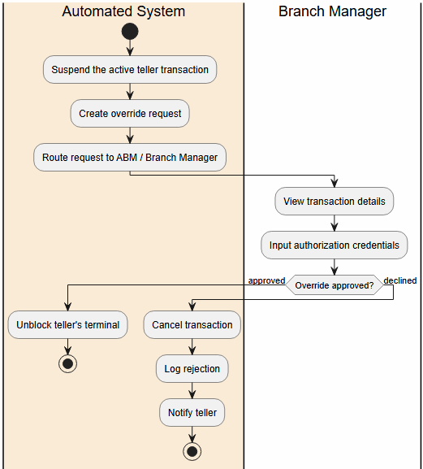
Made by: Kristian Avrami

Use Case 8: Manage Branch Cash and Vault Operations
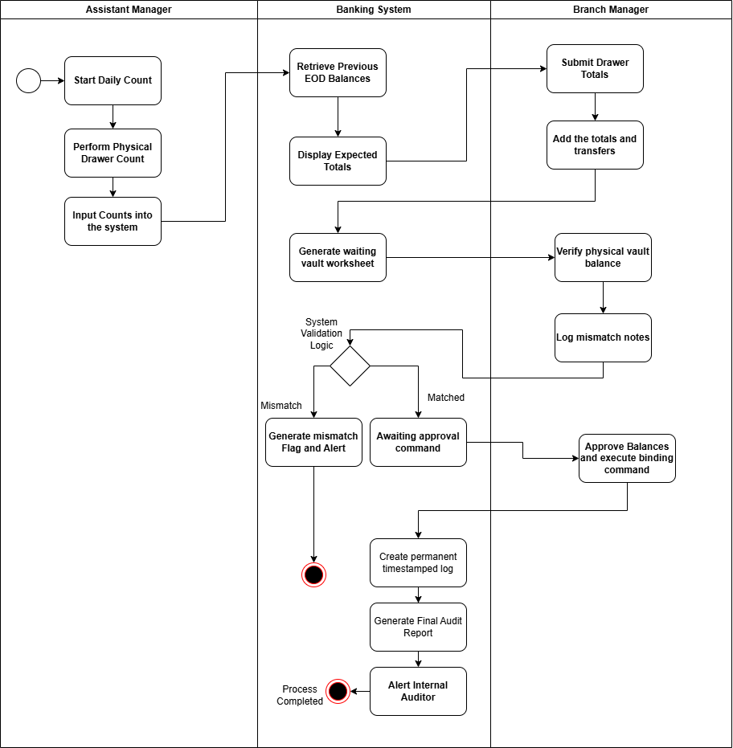
Made by: Kristian Avrami

Use Case 9: Settle External Transfers
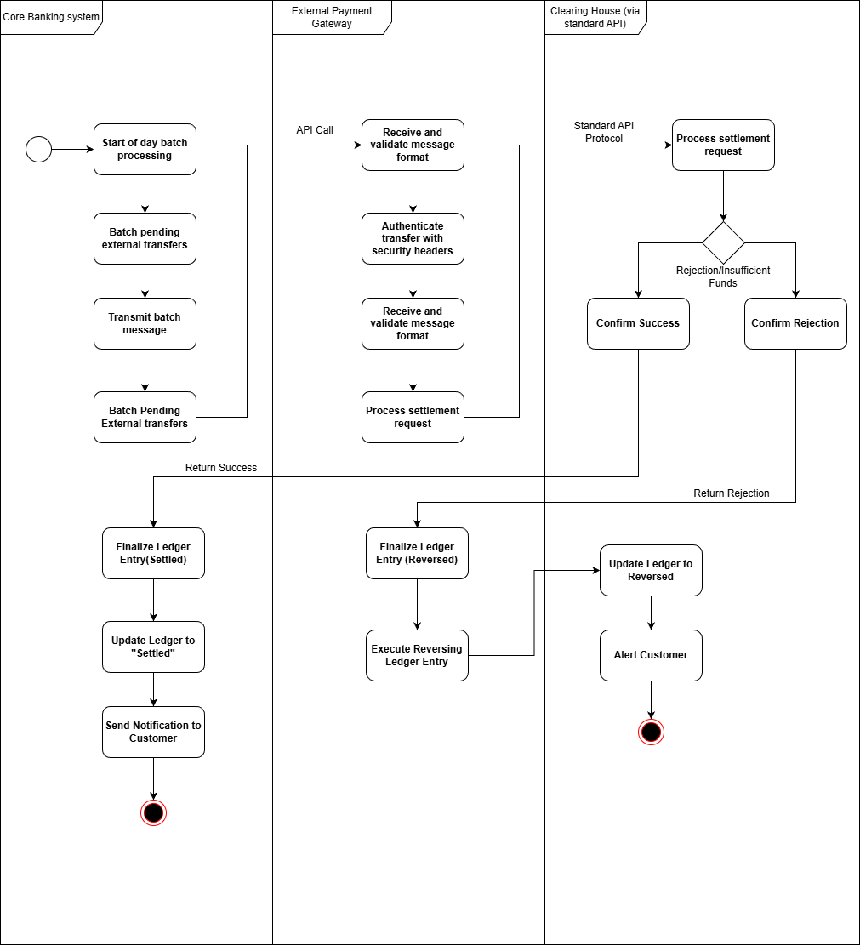
Made by: Kristian Avrami

Use Case 10: Evaluate Loan Applications
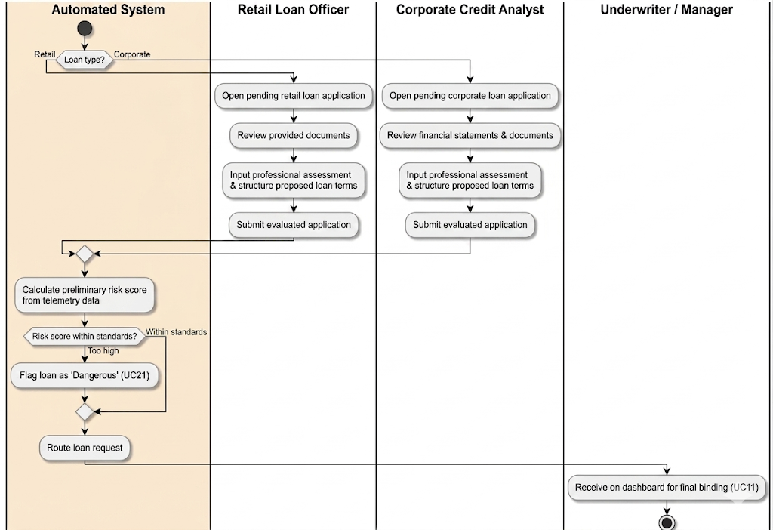
Made by: Erald Saraci

Use Case 11: Underwrite and Bind Loan Agreement

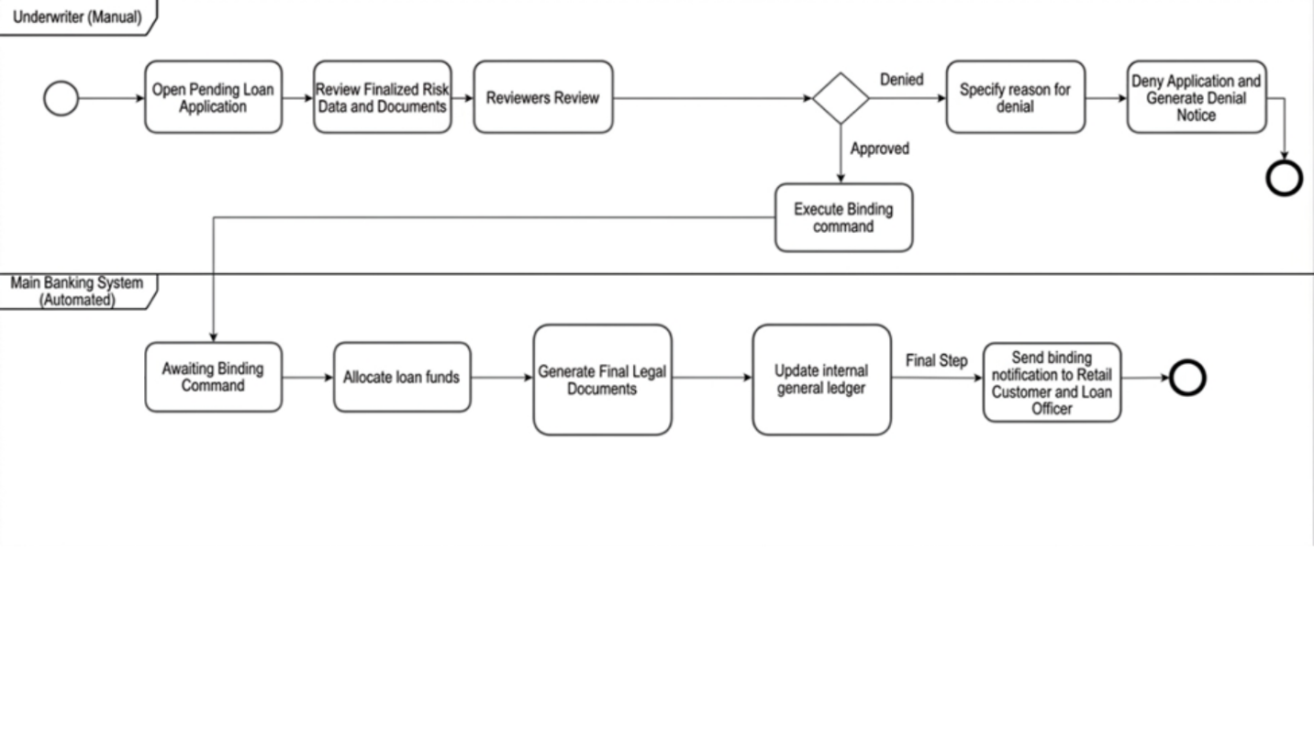
Made by: Erald Saraci

Use Case 12: Manage Defaulted Accounts and Asset Recovery
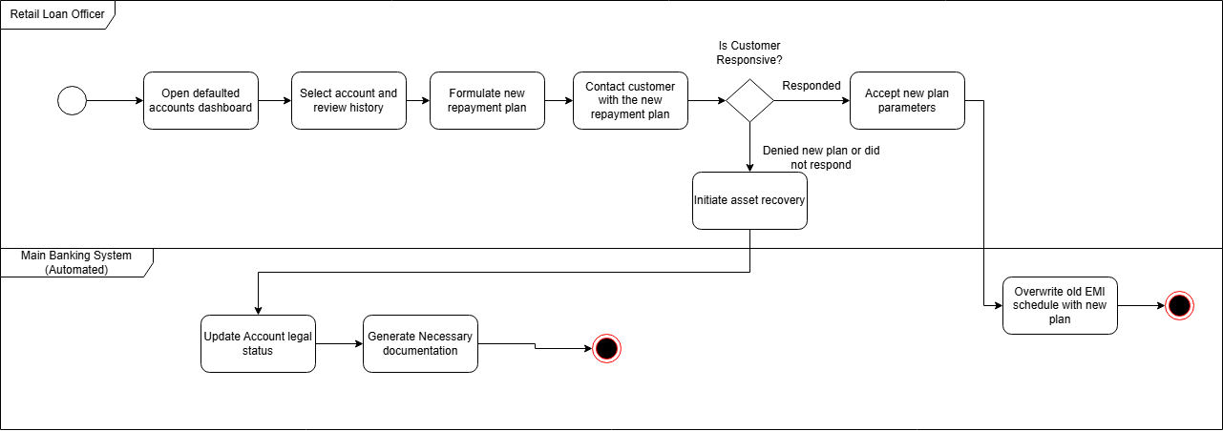
Made by: Denis Robi

Use Case 13: UC 13 Monitor Transactions and Generate AML Reports
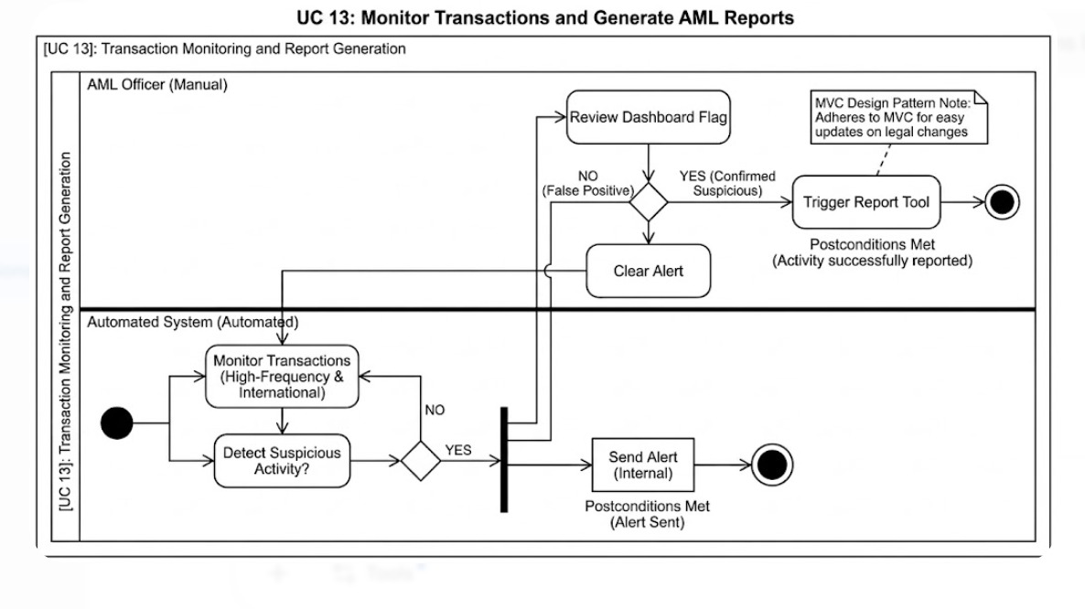
Made by: Denis Robi
Use Case 14: View Action History and Audit Logs
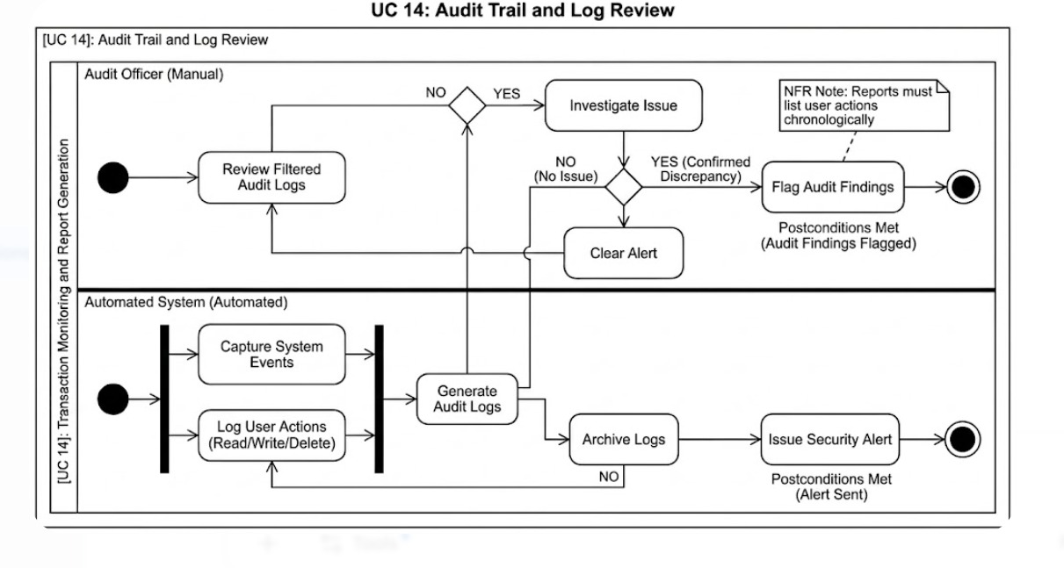
Made by: Denis Robi
Use Case 15: View Profitability and Transaction Summaries
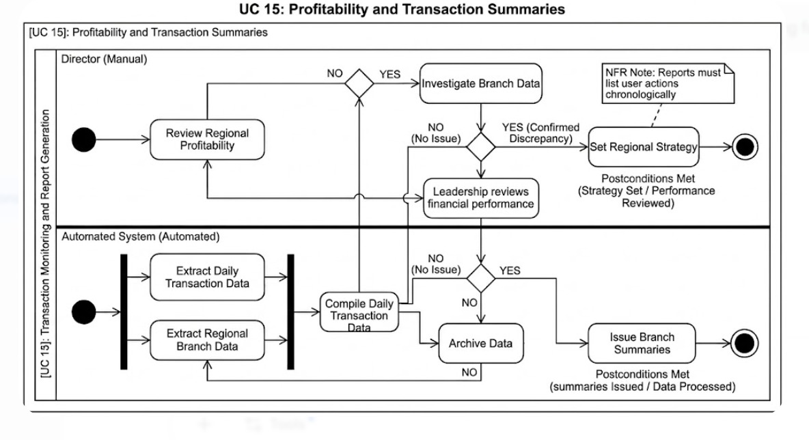
Made by: Denis Robi

Use Case 16: Manage Core System Configurations and Backups
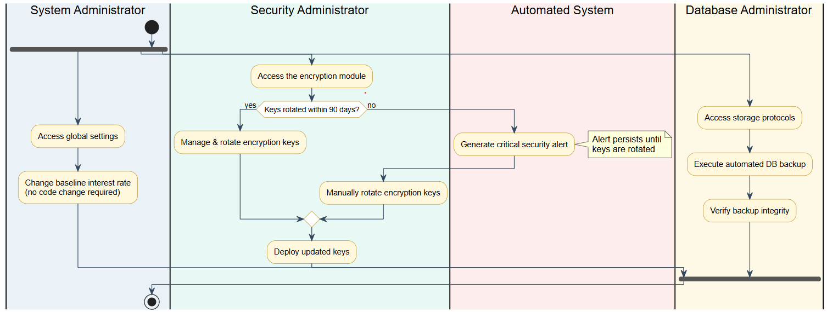
Made by: Daniel Salianji
Use Case 17: Generate Account Statements
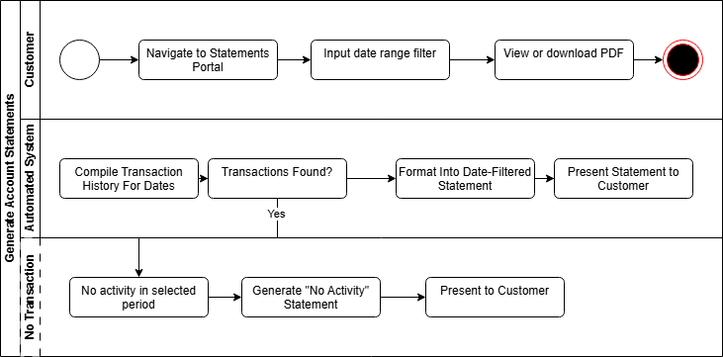
Made by: Daniel Salianji
Use Case 18: Issue New Debit Card
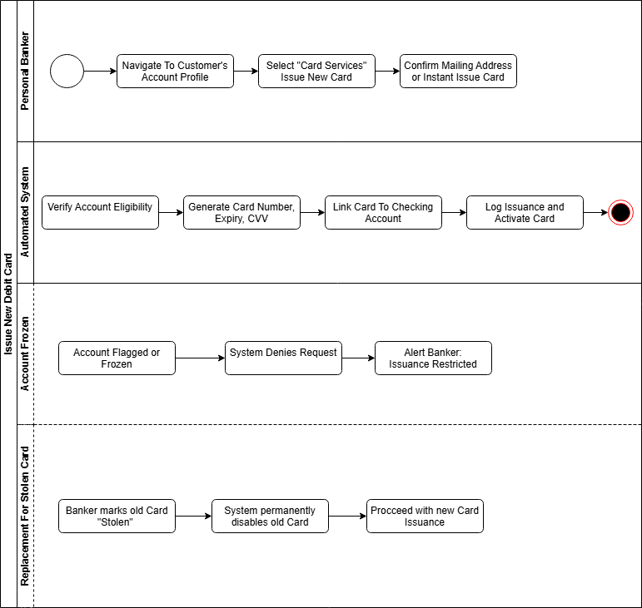
Made by: Daniel Salianji
Use Case 19: Authenticate User
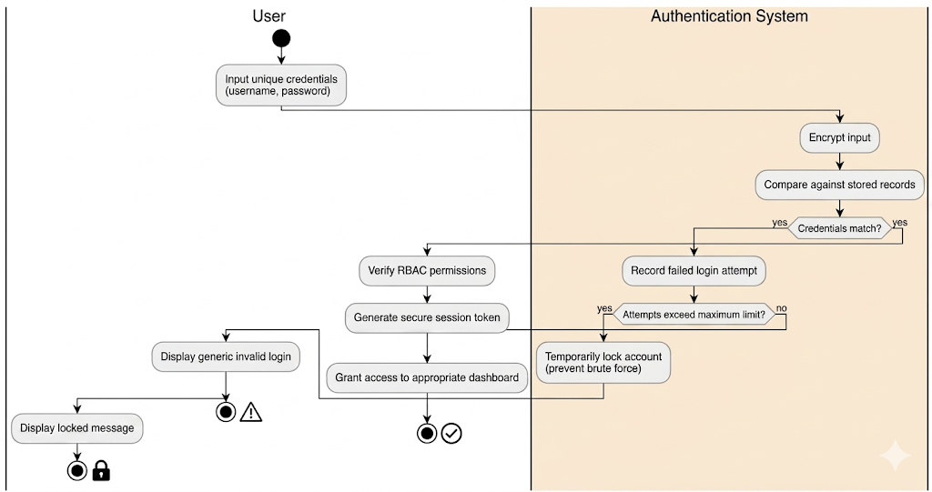
Made by: Denis Musaraj
Use Case 20: Set Global Risk Parameters
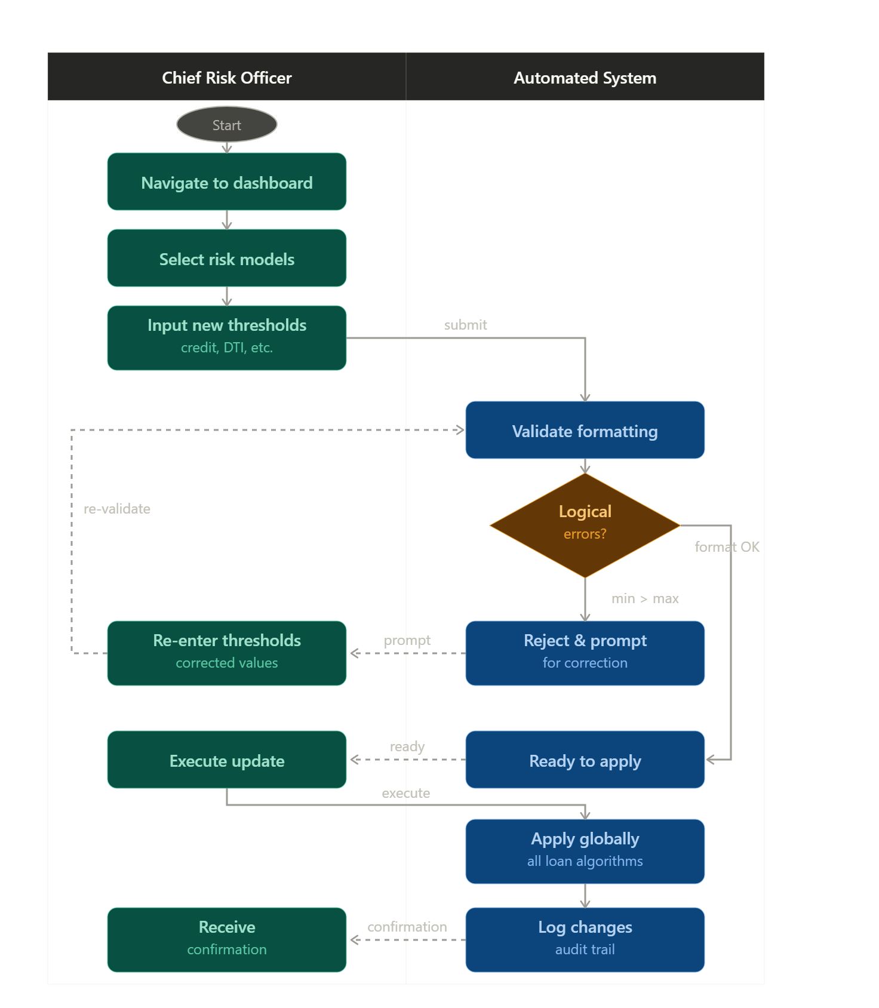
Made by: Denis Musaraj
Use Case 21: Flag Dangerous Loans
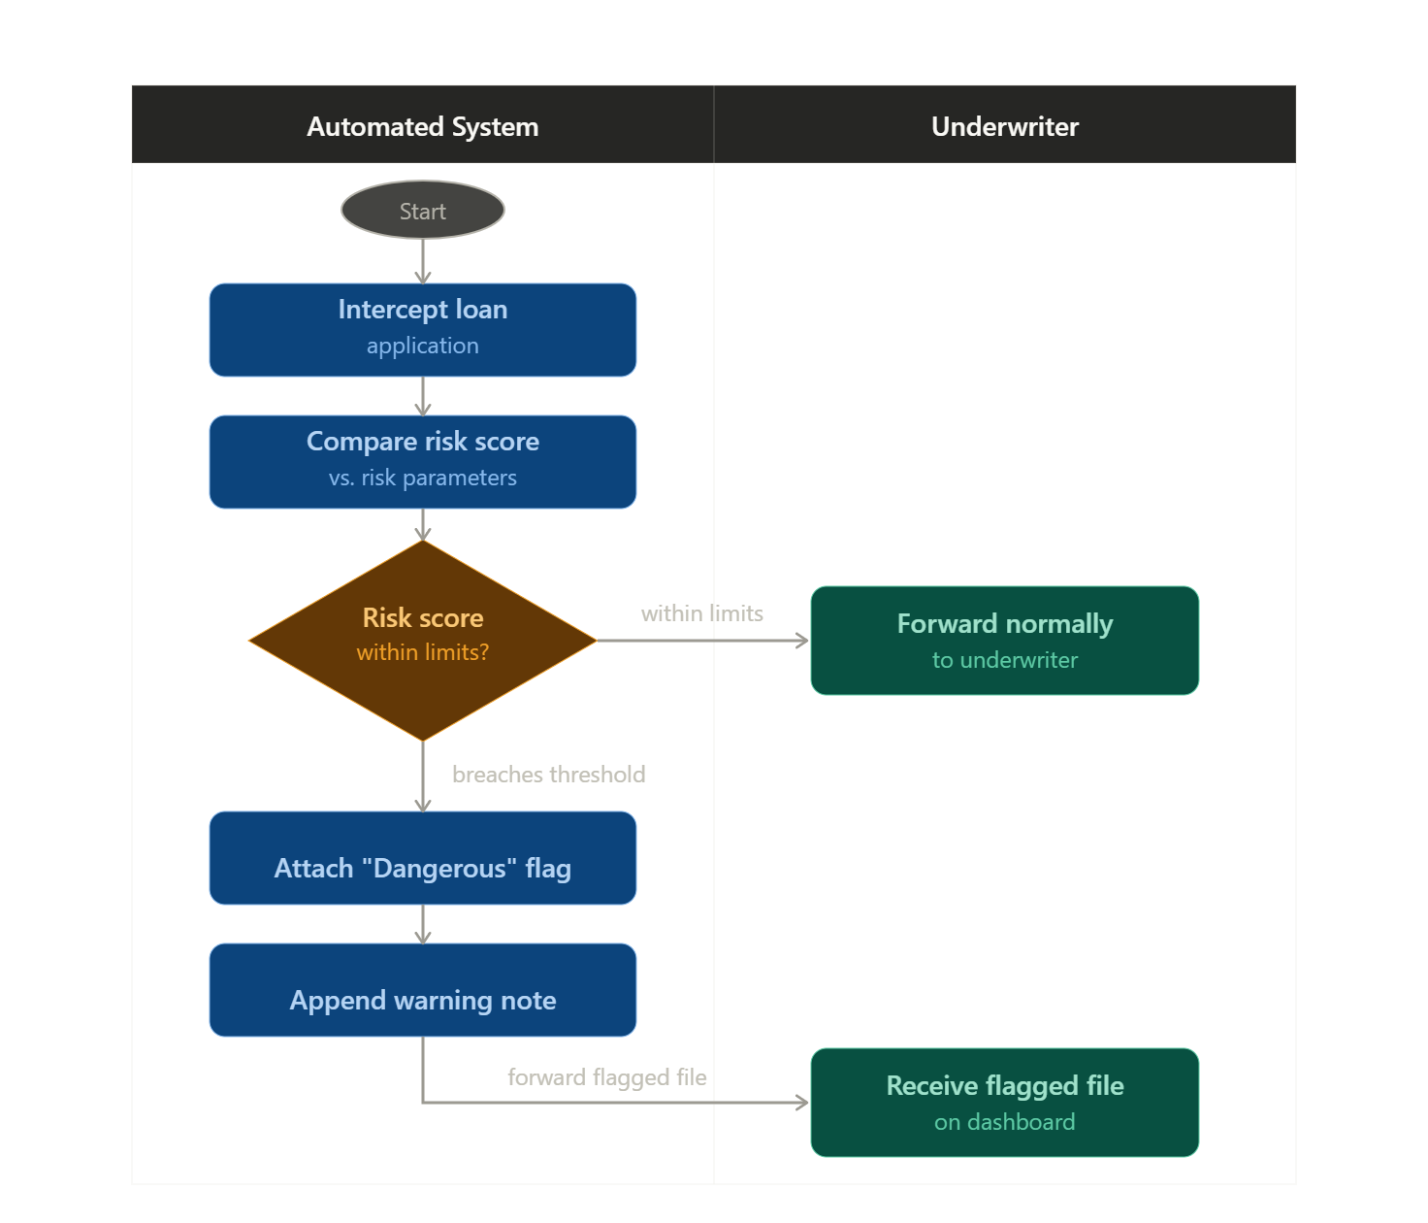
Made by: Denis Musaraj
Use Case 22: Route Loan Requests
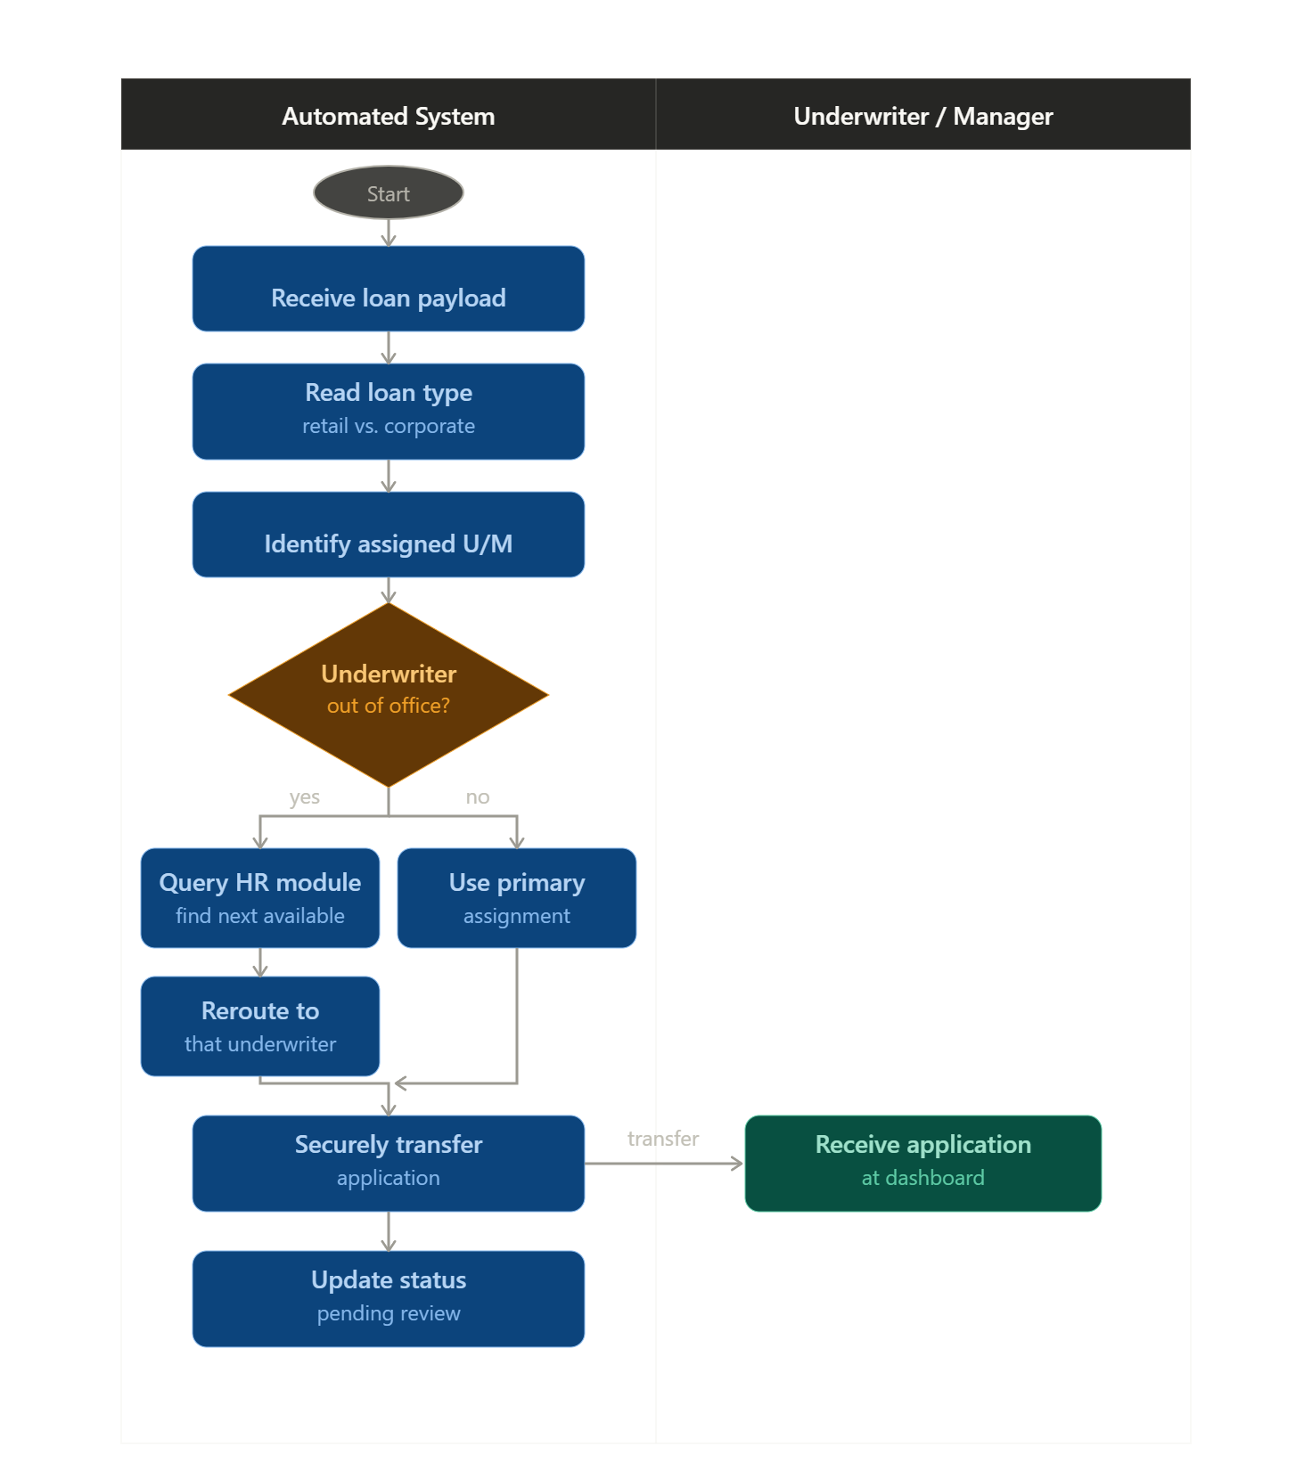
Made by: Dariel Hamzallari
Use Case 23: Update Ledger Balances in Real-Time
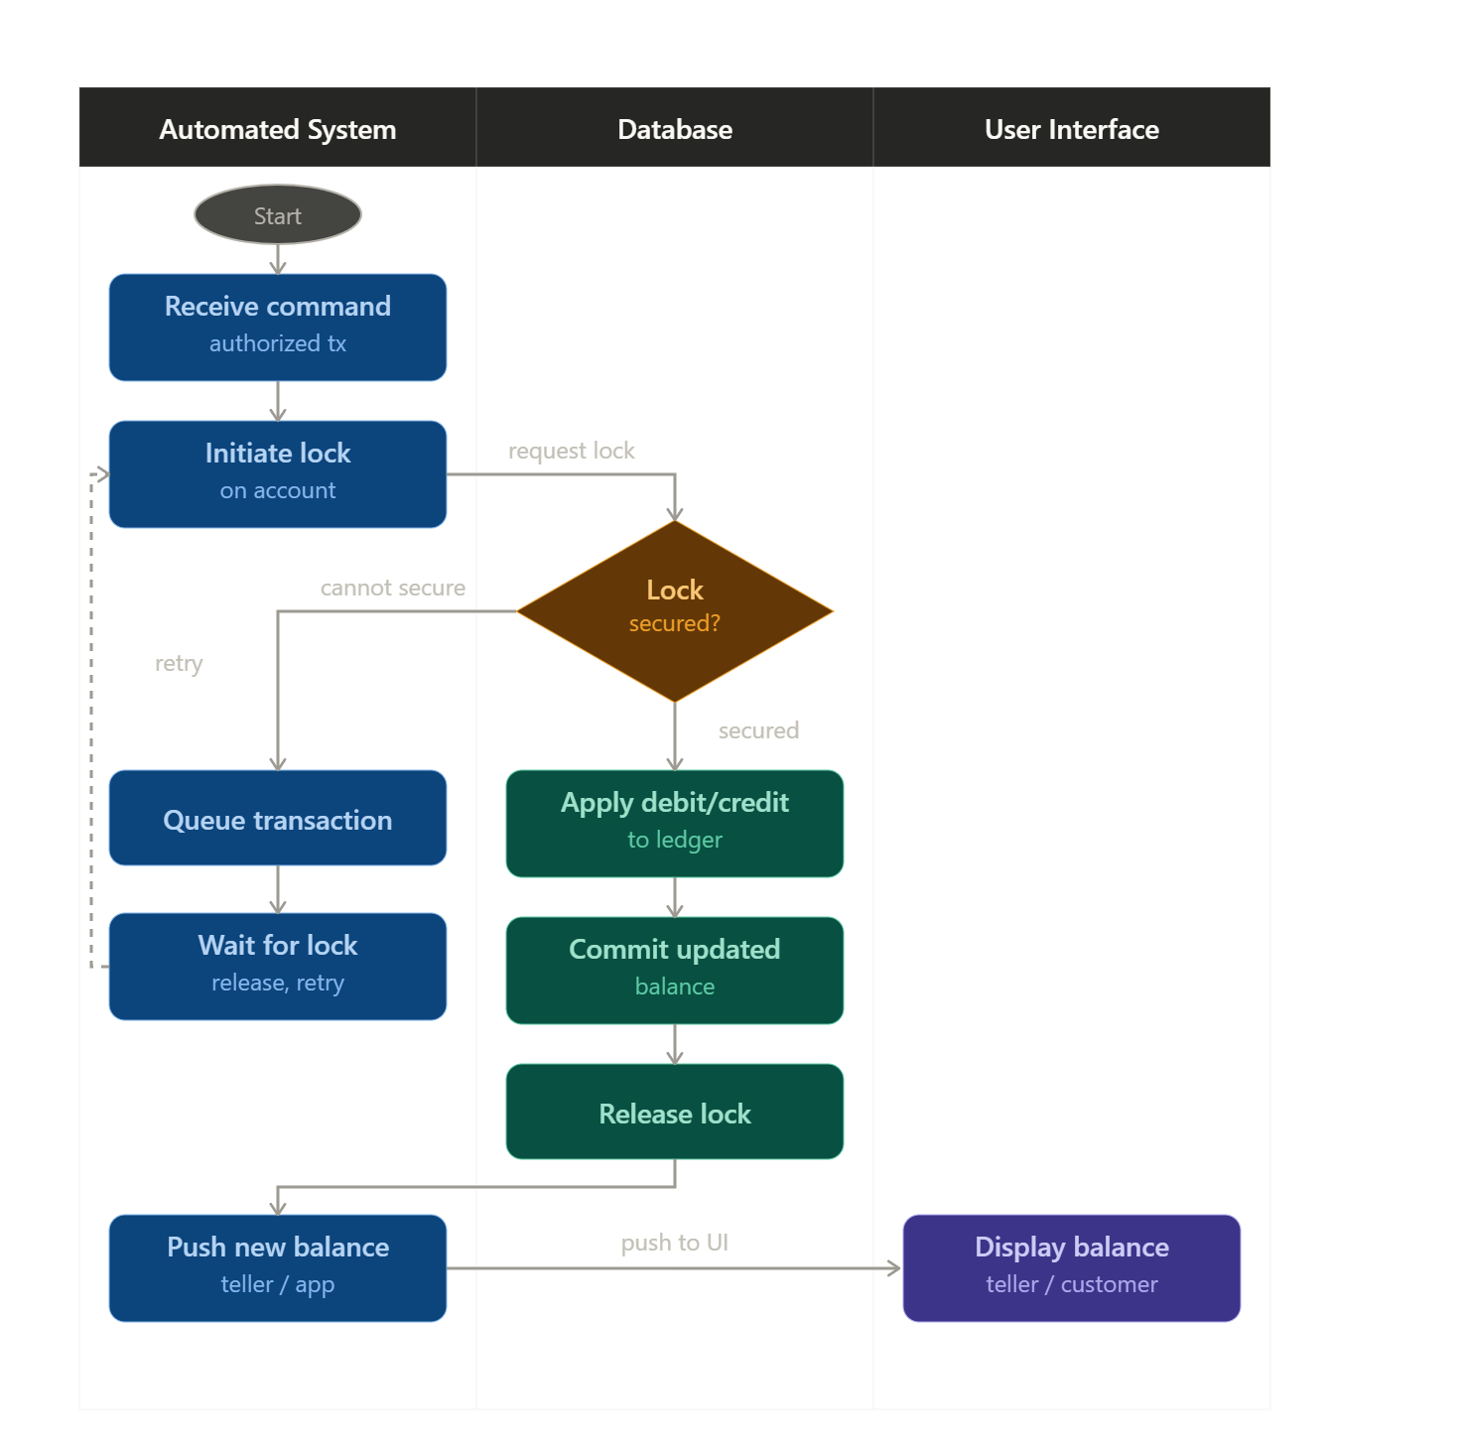
Made by: Dariel Hamzallari

Use Case 24: Generate Daily Transaction Summaries

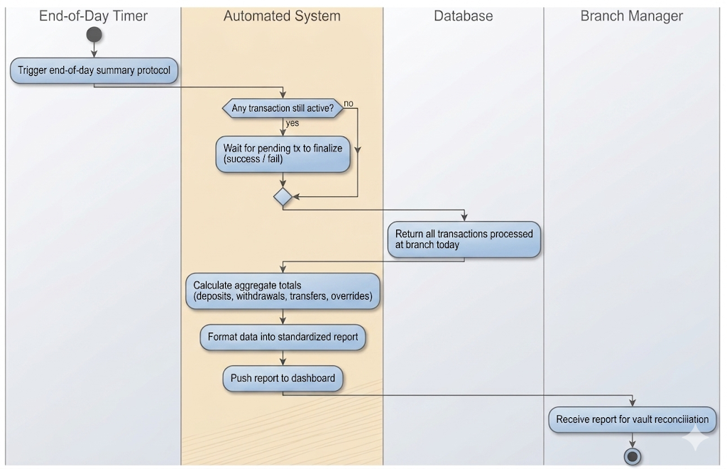

Made by: Dariel Hamzallari

