$$∏_{ID,names}((takse ÷{∏_{course_id}(σ}_{year<2009 or (year=2009 and semester=’spring’)}(course⋈section)) ) ⋈students)$$

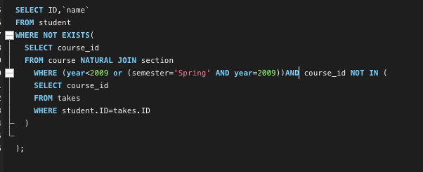

SELECT ID,`name`

FROM student

WHERE NOT EXISTS(

SELECT course_id

FROM course NATURAL JOIN section

WHERE (year<2009 or (semester='Spring' AND year=2009))AND course_id NOT IN (

SELECT course_id

FROM takes

WHERE student.ID=takes.ID

)

);

1)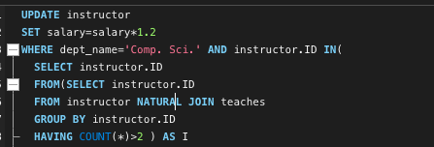

UPDATE instructor

SET salary=salary*1.2

WHERE dept_name='Comp. Sci.' AND instructor.ID IN(

SELECT instructor.ID

FROM(SELECT instructor.ID

FROM instructor NATURAL JOIN teaches

GROUP BY instructor.ID

HAVING COUNT(*)>2 ) AS I );

1. 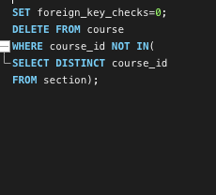

SET foreign_key_checks=0;

DELETE FROM course

WHERE course_id NOT IN(

SELECT DISTINCT course_id

FROM section);

3)

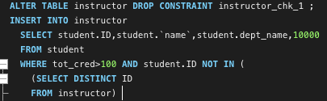

ALTER TABLE instructor DROP CONSTRAINT instructor_chk_1 ;

INSERT INTO instructor

SELECT student.ID,student.`name`,student.dept_name,10000

FROM student

WHERE tot_cred>100 AND student.ID NOT IN (

(SELECT DISTINCT ID

FROM instructor)

) ;