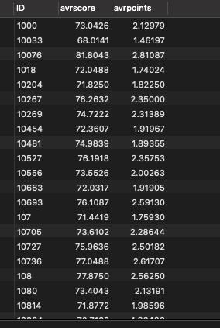

CREATE FUNCTION toscore(grade varchar(2)) RETURNS INTEGER DETERMINISTIC

BEGIN

DECLARE score integer;

SELECT (CASE

when grade = 'A+' then 100

when grade = 'A' then 94

when grade = 'A-' then 89

when grade = 'B+' then 84

when grade = 'B' then 79

when grade = 'B-' then 74

when grade = 'C+' then 70

when grade = 'C' then 67

when grade = 'C-' then 64

when grade = 'D' then 61

else 59

end)    INTO score;

RETURN score;

END;

CREATE FUNCTION topoint(grade varchar(2)) RETURNS numeric(2,1) DETERMINISTIC

BEGIN

DECLARE point numeric(2,1);

SELECT (CASE

when grade = 'A+' then 4.3

 when grade = 'A' then 4.0

when grade = 'A-' then 3.7

when grade = 'B+' then 3.3

when grade = 'B' then 3.0

when grade = 'B-' then 2.7

when grade = 'C+' then 2.3

when grade = 'C' then 2.0

when grade = 'C-' then 1.7

when grade = 'D' then 1.0

else 0.0

end)    INTO point;

RETURN point;

END;

CREATE PROCEDURE handle() DETERMINISTIC

BEGIN

SELECT ID , sum(s)/sum(credits) AS avrscore,

                  sum(p)/sum(credits)AS avrpoints

FROM ( SELECT ID, credits,

                        toscore(grade)\*credits AS s ,

                        topoint(grade)\*credits AS p

            FROM takes NATURAL JOIN course ) AS t

 GROUP BY ID;

END;