Problem 2:

At time N\*(L/R) the first packet has reached the destination, the second packet is stored

in the last router, the third packet is stored in the next-to-last router, etc.

At time N\*(L/R) + L/R, the second packet has reached the destination, the third packet is stored in the last router, etc.

So at time N\*(L/R) + (P-1)\*(L/R) = (N+P-1)\*(L/R) all packets have reached the destination.

Problem 7:

Generating time: 56.8/64x10^3 = 7msec;

Transmitting time: 56.8/2x10^6 = 224μsec;

Propagation delaying time = 10msec;

Result: 7msec + 224μsec + 10msec = 17.224msec.

Problem 8:

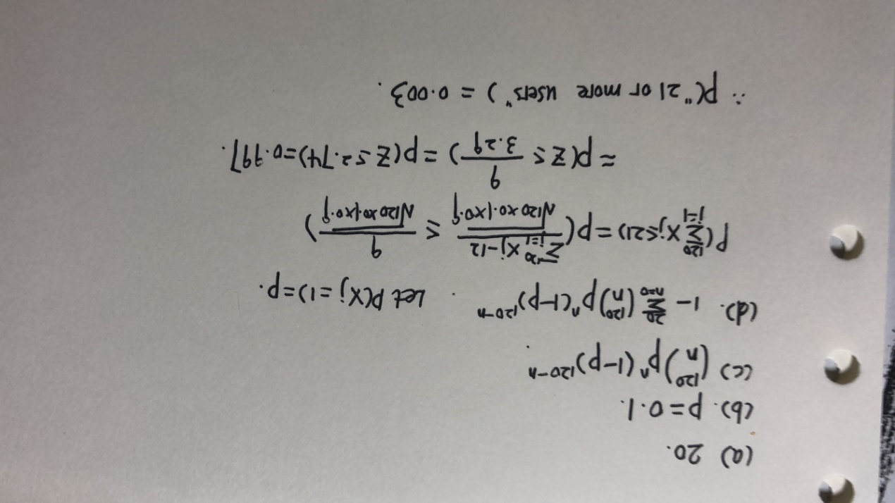

Ping另外一台计算机：

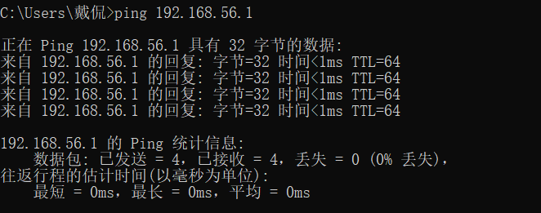

Tracert服务器：

