1. telnet whu.edu.cn 25

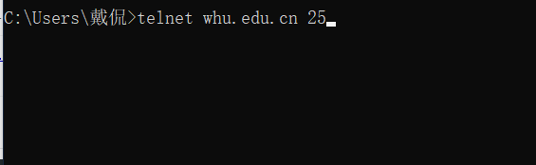

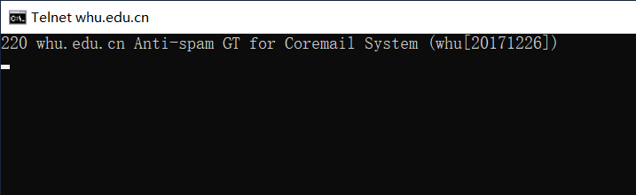

1. 课本第二章习题任选五道

Problem 1: F; T; F; F; F

Problem 4:

1. URL: <http://gaia.cs.umass.edu/cs453/index.html>
2. Version 1.1;
3. “Keep-alive” means this browser requests a persistent connection;
4. This message doesn’t contain such information.
5. Mozilla/5.0. this one can send different versions of the same object to different browsers.

Problem 5:

1. Successfully. The document replay was provided on Tuesday, 07 Mar 2008 12:39:45 GMT.
2. On Saturday, 10 Dec 2005 18:27:46 GMT.
3. 3874.
4. <!doc.

“keep-alive” means the server agreed to a persistent connection.

Problem 7:

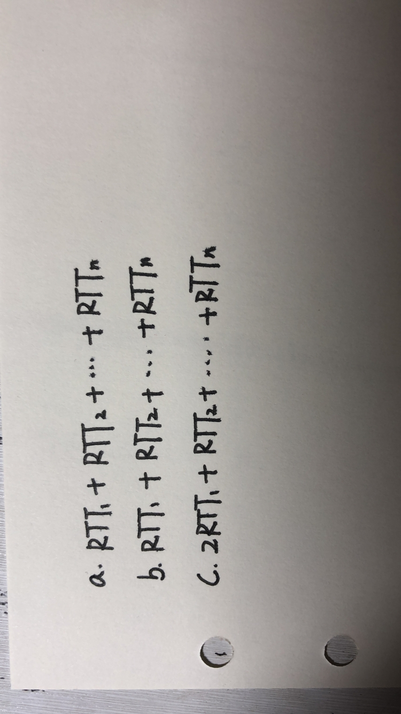

Problem 8:

