Image1
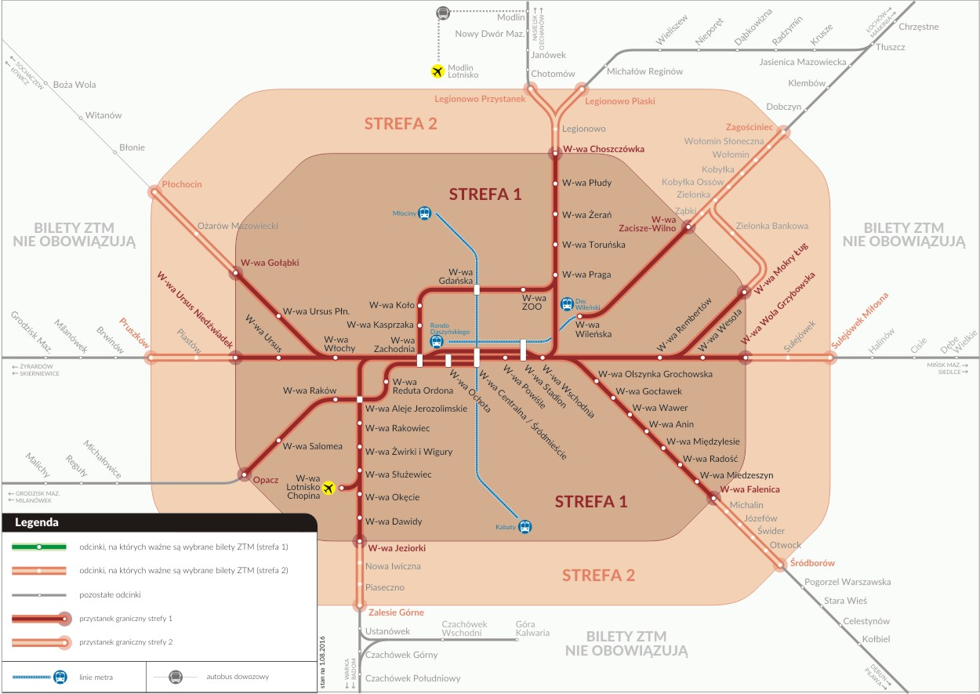

https://www.w3schools.com/tags/tag_img.asp

