Installing Ubuntu 12.04.1 LTS with full disk encryption

Intro:

This is a simple step by step tutorial showing you how to install Ubuntu 12.04.1 LTS with enabled full disk encryption. If you don't know what this means, or have no experience with advanced partitioning layouts, please consider at least reading further information on “full disk encryption” and the Linux “logical volume manager”.

With this setup, except of the /boot partition, all your data - including the / folder and even your swap area - will reside inside of a 256bit AES encrypted container. This means a large security plus for you and should at least be the standard for laptops or computers with sensitive data on it. Keep in mind that if you forget your passphrase, you won't have access to your files anymore and that there are still ways to get access to encrypted files if you loose physical control of the system!

This tutorial will use the GUI installer. It won't use the “Guided - use entire disk and set up encrypted LVM" option, just to be flexible enough to get a custom partitioning schema.

Feel free to share this tutorial as you wish. It comes with no warranties ;)

Let's start:

1. Download the “Alternate install cd” via http://releases.ubuntu.com/12.04/

2. Use this iso/medium to install the system

3. Select “Install Ubuntu”

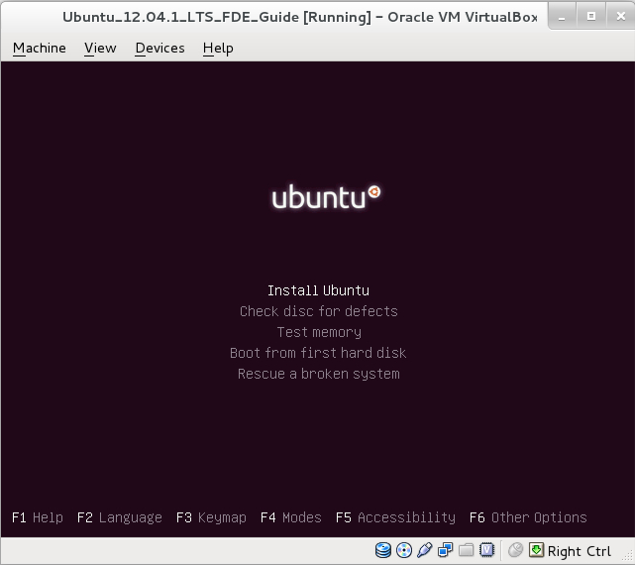

4. Choose your language, keyboard layout, time zone settings and set up your basic user account with password.
5. Since the whole drive will be encrypted, it makes no sense to further encrypt a single /home directory. Select “No”.

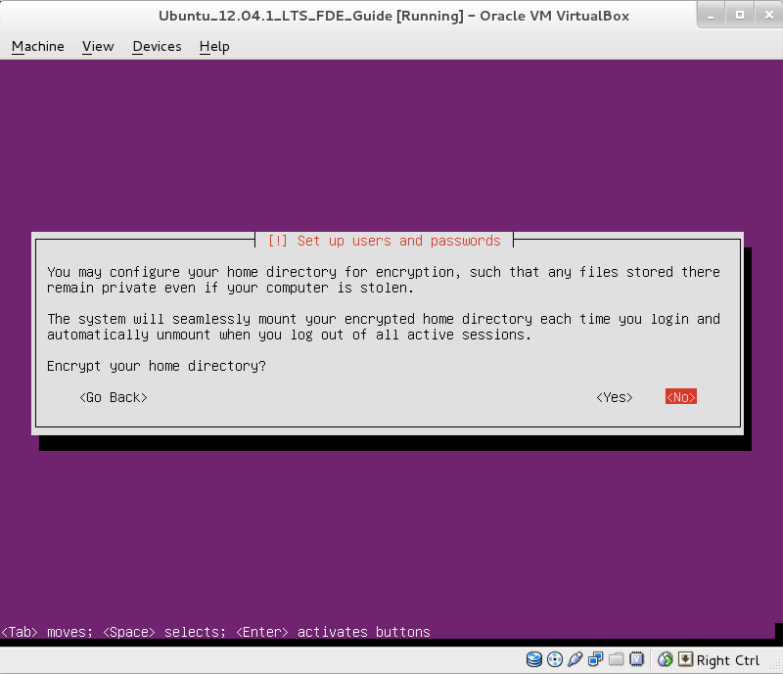

6. Select “Manual”.

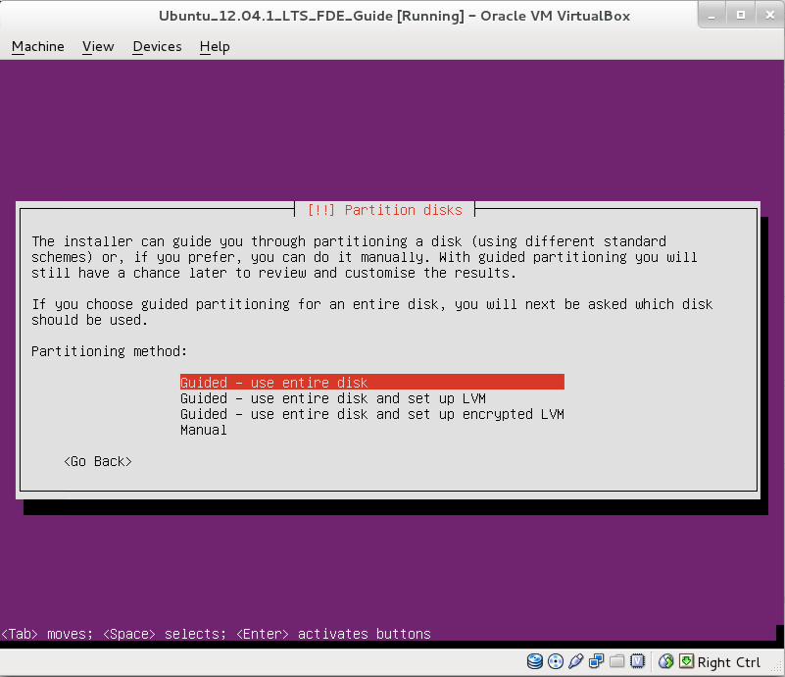

7. Choose the hard drive on which you want to install the system.

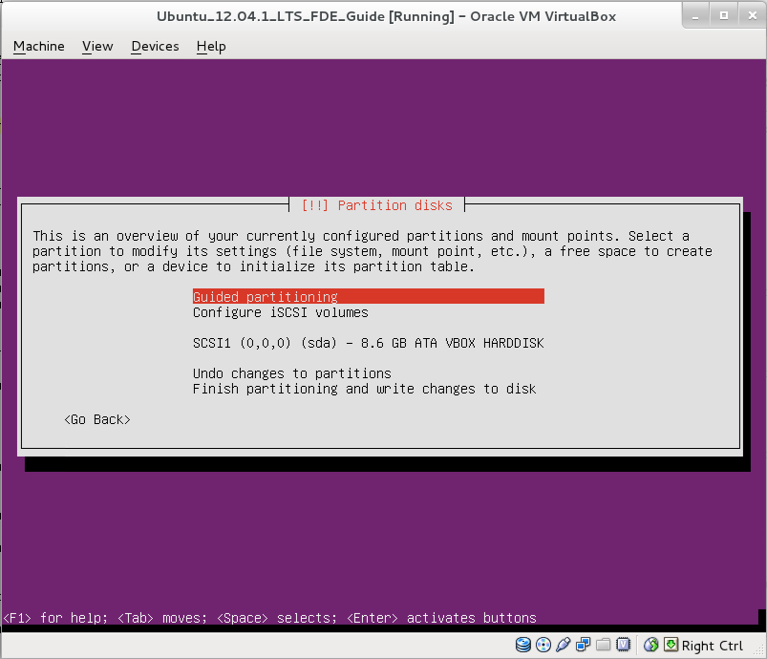

8. Select “Yes”. The hard drive needs a boot block in the first sector to be able to create a partitioning schema.

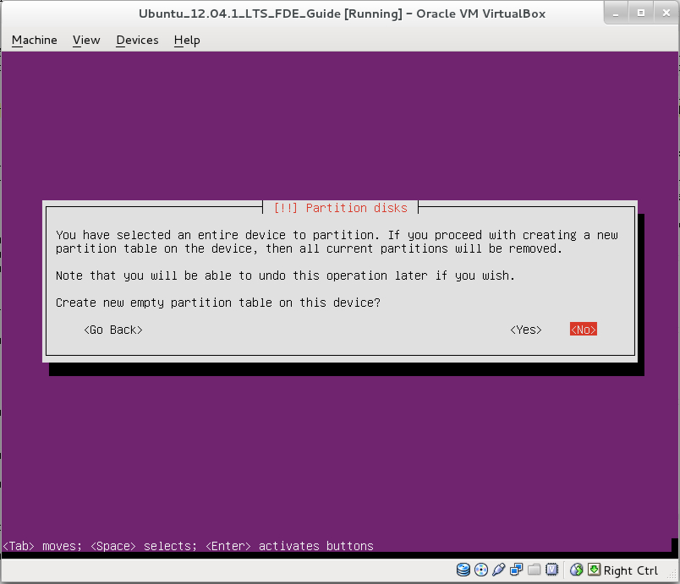

9. That's the basic partitioning dialog. First step is to create a partition that holds the /boot directory of the system which has to be a basic partition that is not encrypted. Select the drive.

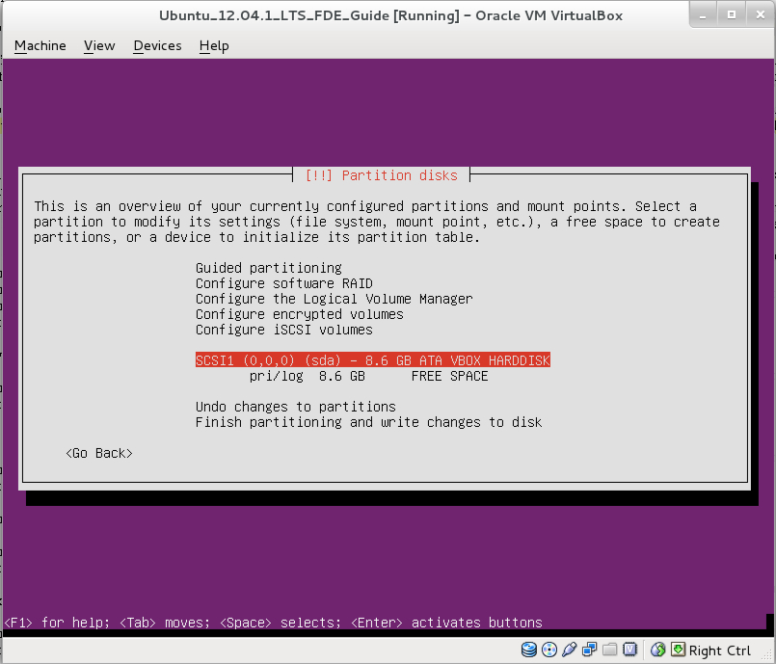

10. Select “Create a new partition”.

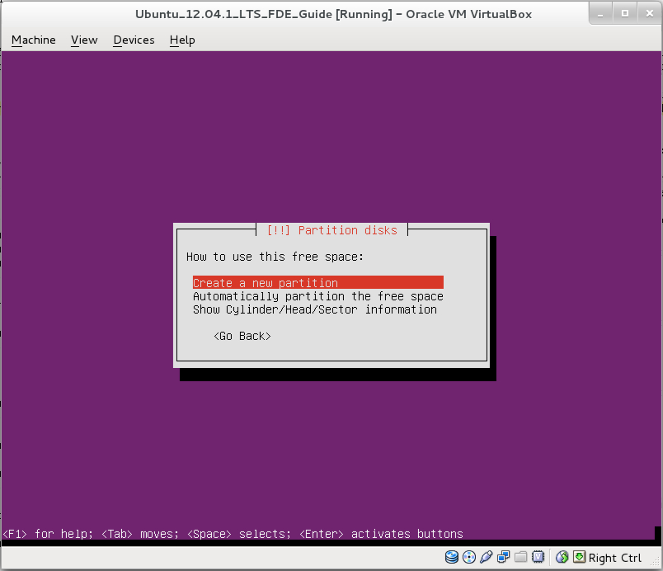

11. Select a size for the /boot partition. 200 MB should be more than enough. Select “Continue”.

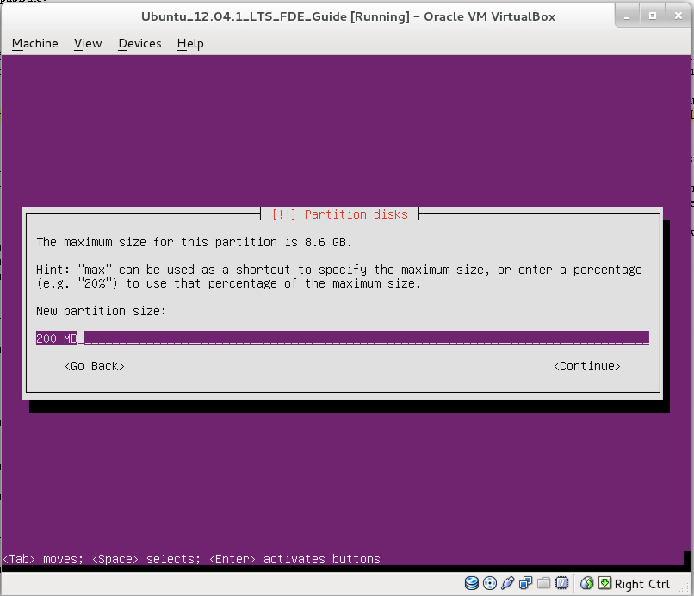

12. Select “Primary”.

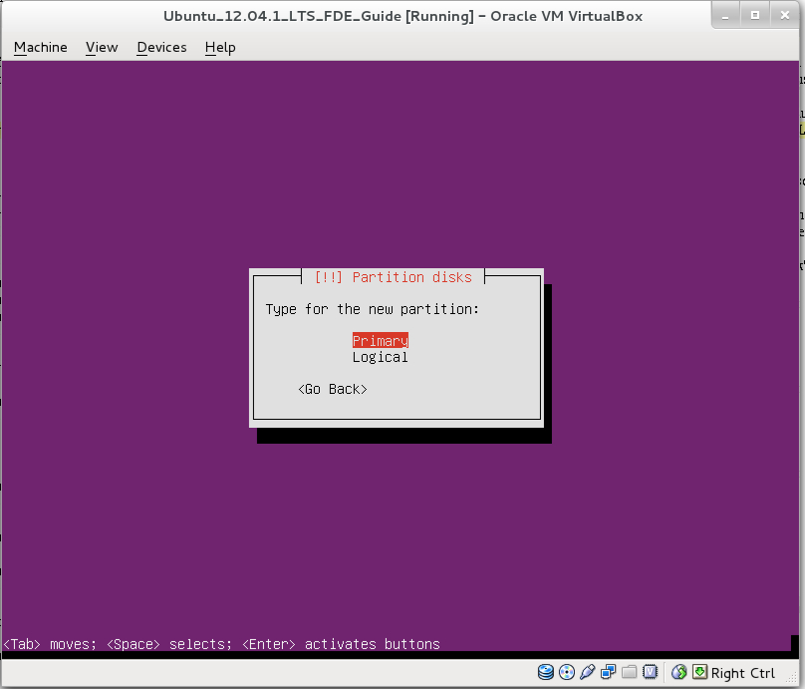

13. Select “Beginning”.

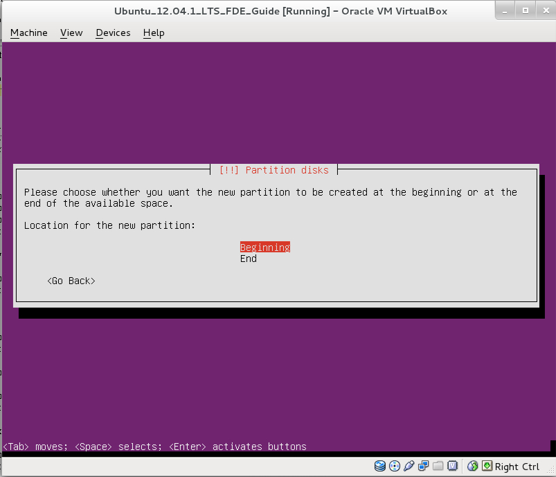

14. “Ext4” as the file system seems to be a good choice if you don't have special requirements. Set “Mount point:” to “/boot” and Select “Done setting up the partition”.

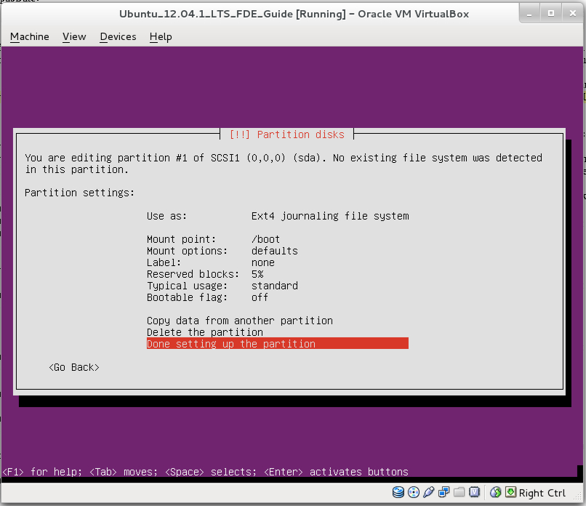

15. As you can see, the /boot partition was successfully created. Now select “Configure encrypted volumes”.

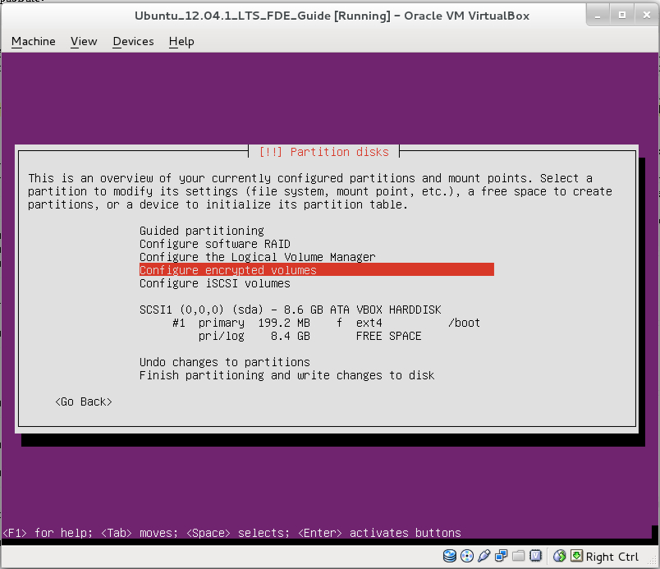

16. Select “Yes”.

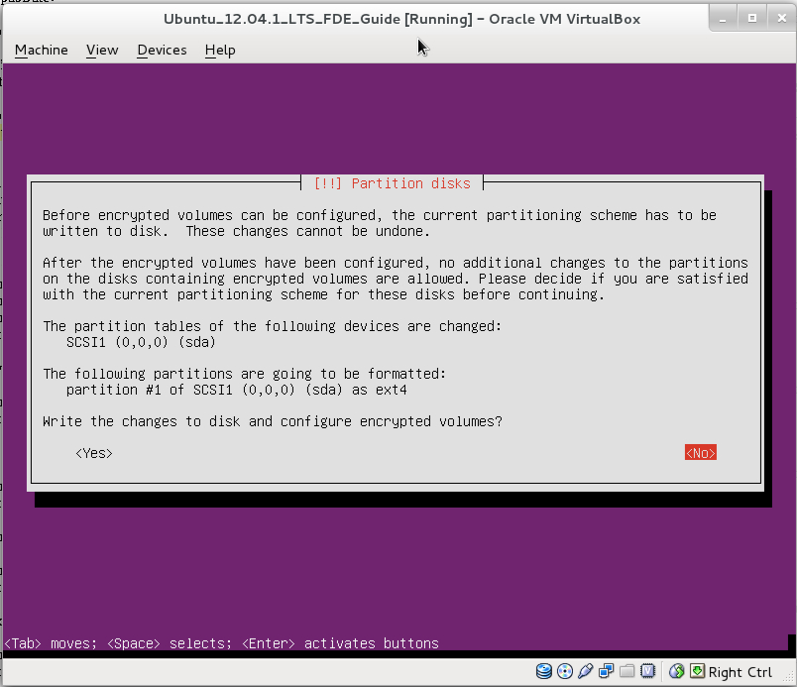

17. Select “Create encrypted volumes”.

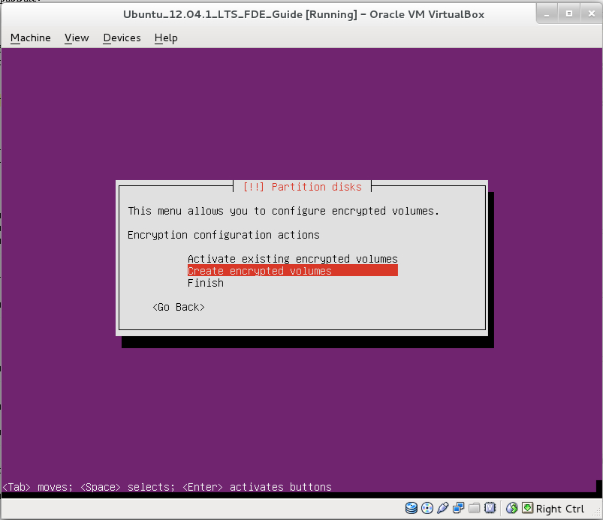

18. Select the “free space”.

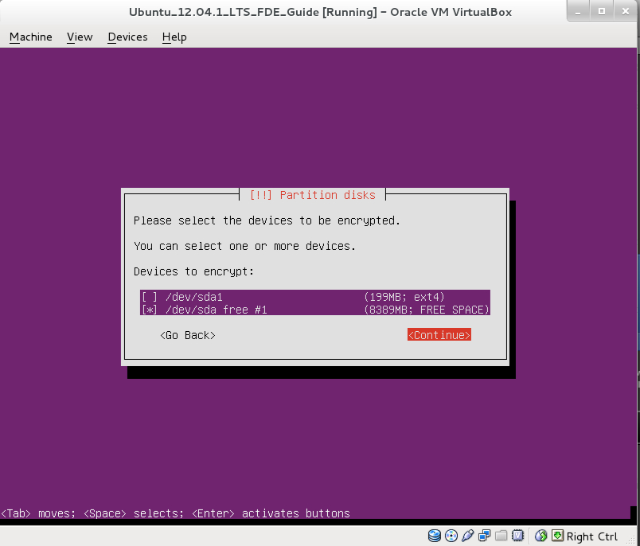

19. It you have already used the hard drive, set “Erase data:” to “yes”, which will wipe all the old data (...and grab a coffee. This will take a lot of time!). Select “Done setting up the partition”.

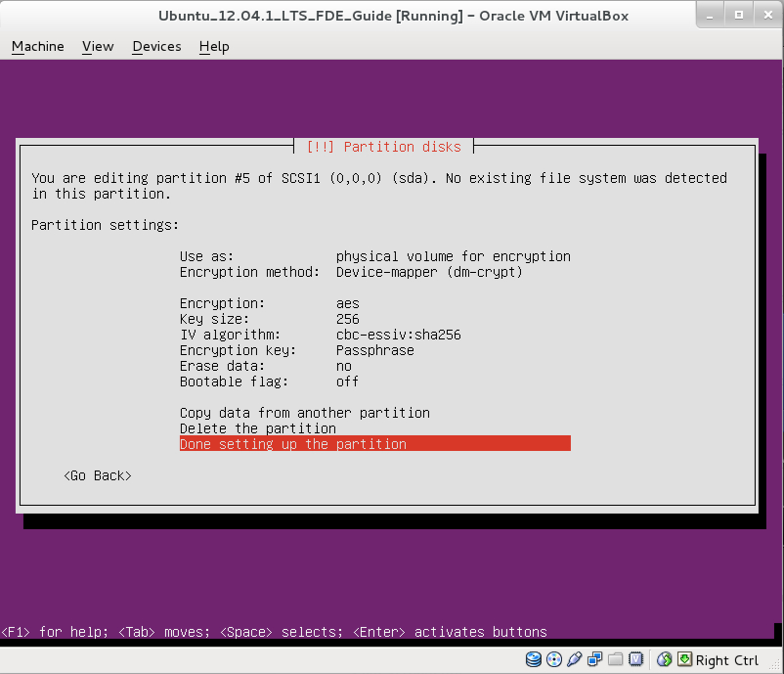

20. Select “Yes”.

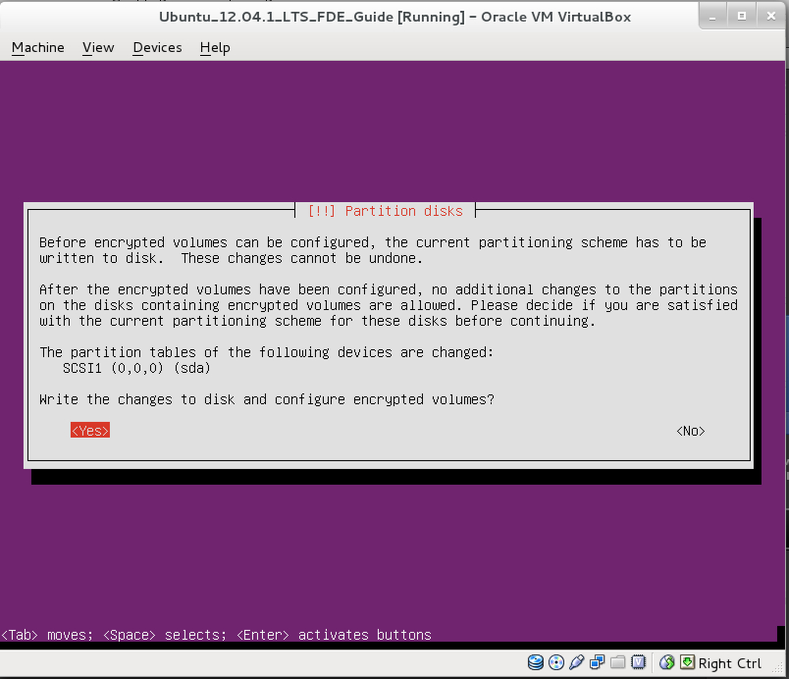

21. Select “Finish”.

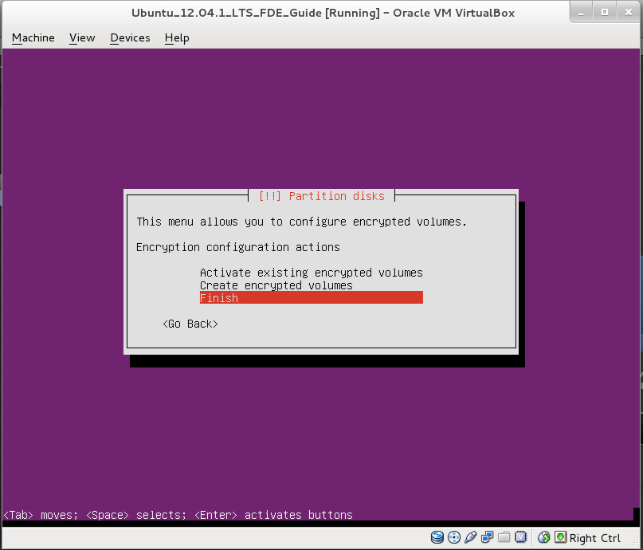

22. Please use a really strong password, otherwise you will screw all the afford! This password protects all your data.

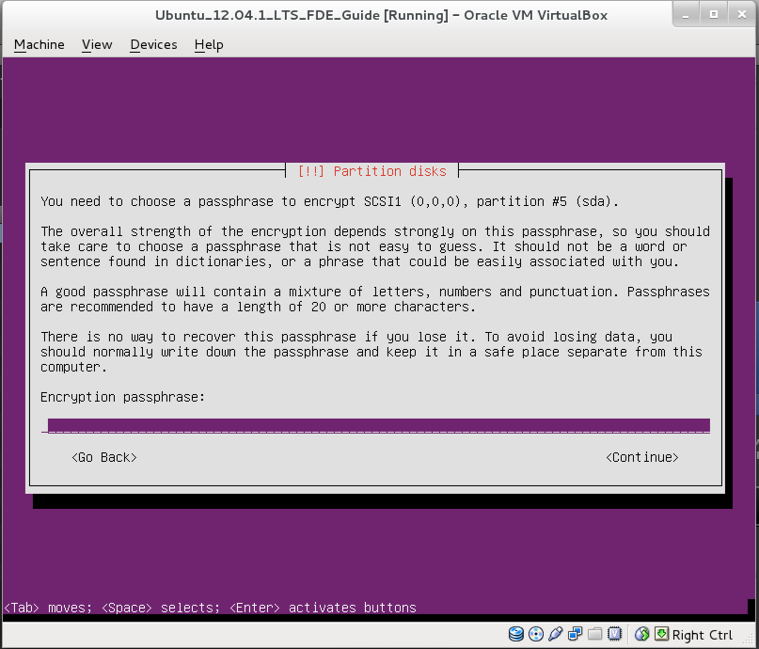

23. That's how it should look right now. You can see the “normal” /boot partition and the crypto container. Select “Configure the Logical Volume Manager” to create logical volumes inside of the crypto container.

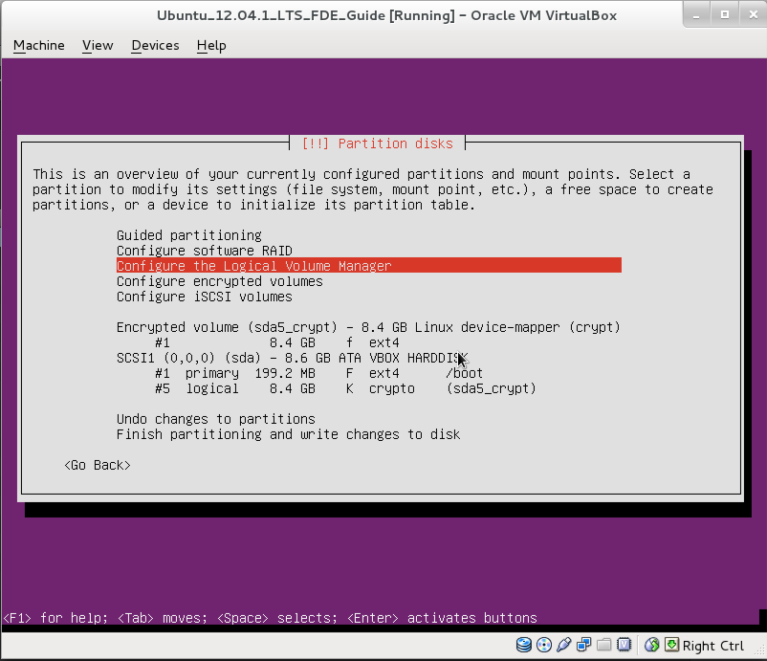

24. Select “Yes”.

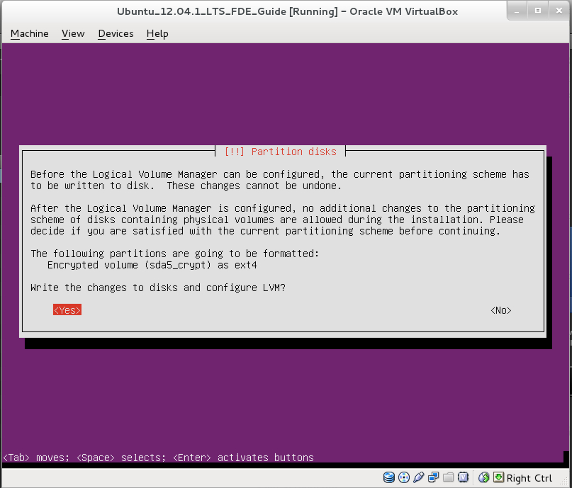

25. That's the LVM configuration dialogue. Select “Create volume group”.

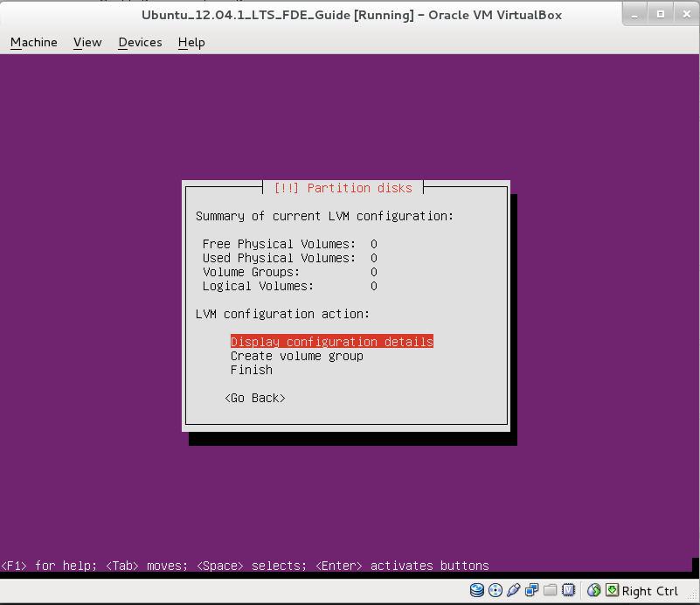

26. Select a name for the volume group. I'll name it “system-group”.

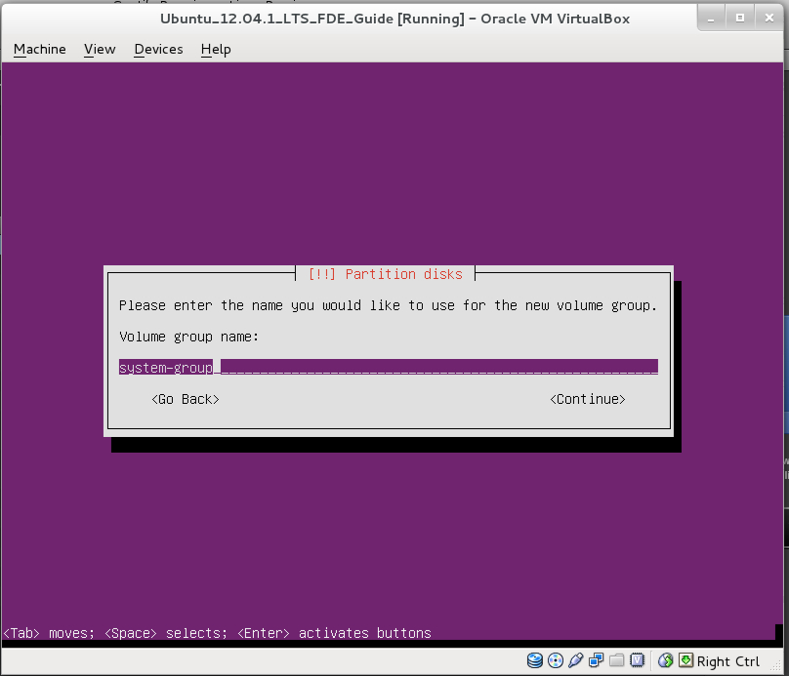

27. Mark the crypt device and select “Continue”.

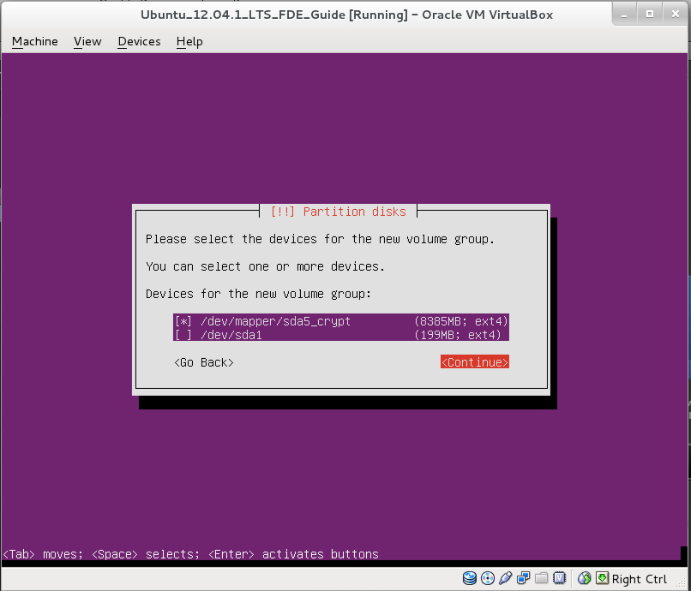

28. As you can see, there's one volume group. Now, select “Create logical volume”.

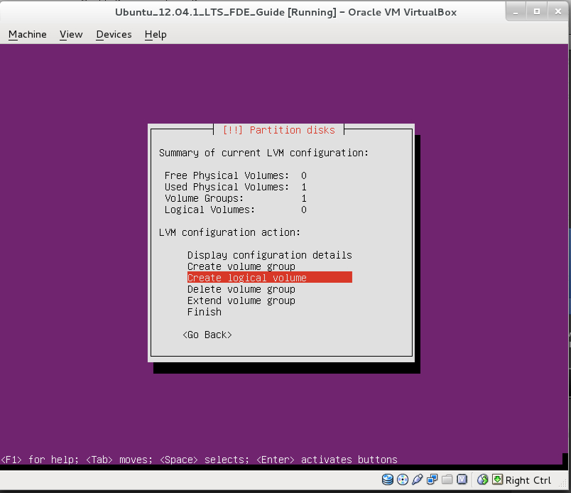

29. Select the volume group.

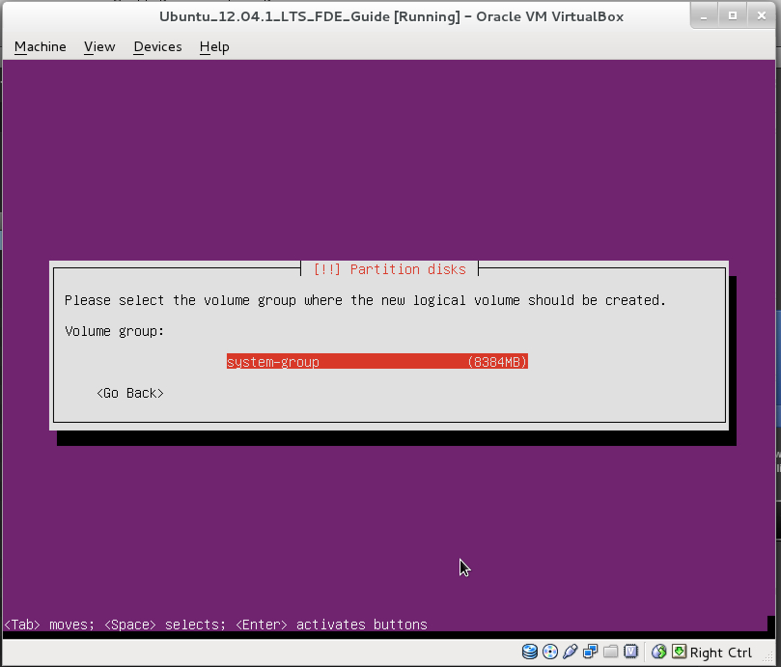

30. Select a name for the first logical volume. We'll use this for the / directory, so the name “root” seems to make sense. Select “Continue”.

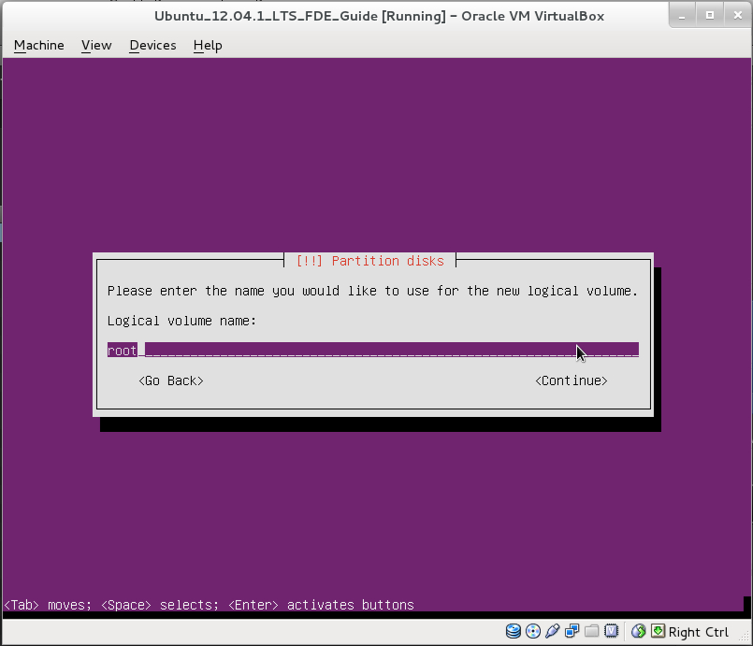

31. Choose the size of the volume. Make sure to give the / volume enough amount of space. Select “Continue”.

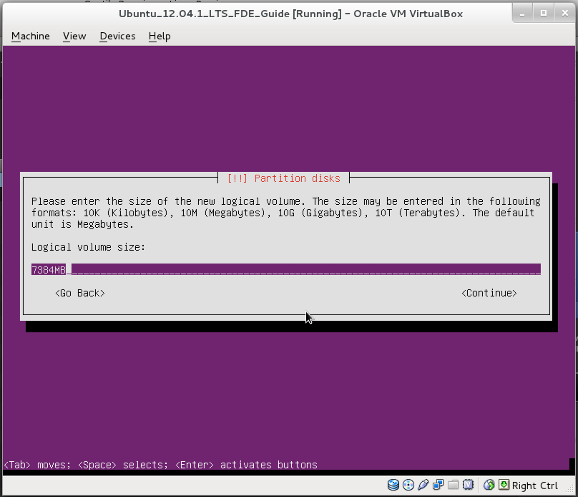

32. That's it. Repeat this step to at least create another logical volume group called “swap” that will be used for the swap area later on.

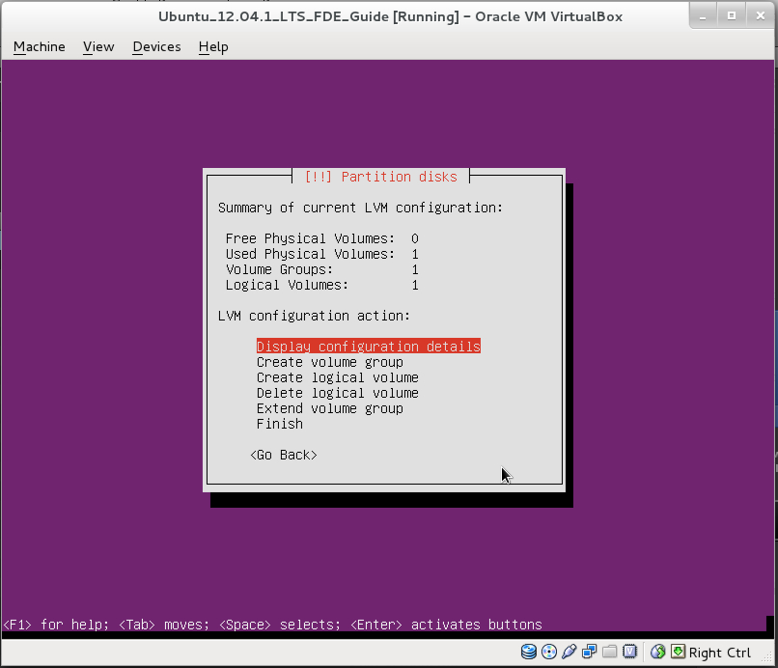

33. That's how it should look like: One volume group with two logical volumes in it (root and swap). Select “Finish”.

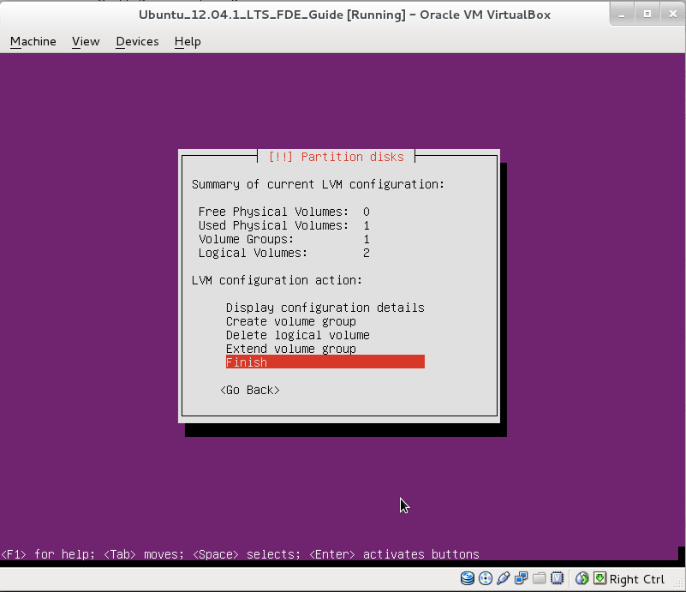

34. The LVM part is now finished. The volume group exists and both volumes are ready to store the file systems we need. Select the volume called “root” to create a file system for it.

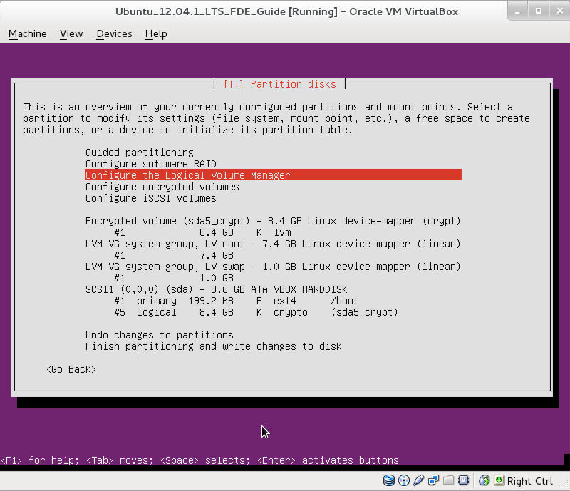

35. Set “Use as:” to “Ext4 journaling file system” and “Mount point:” to “/”.

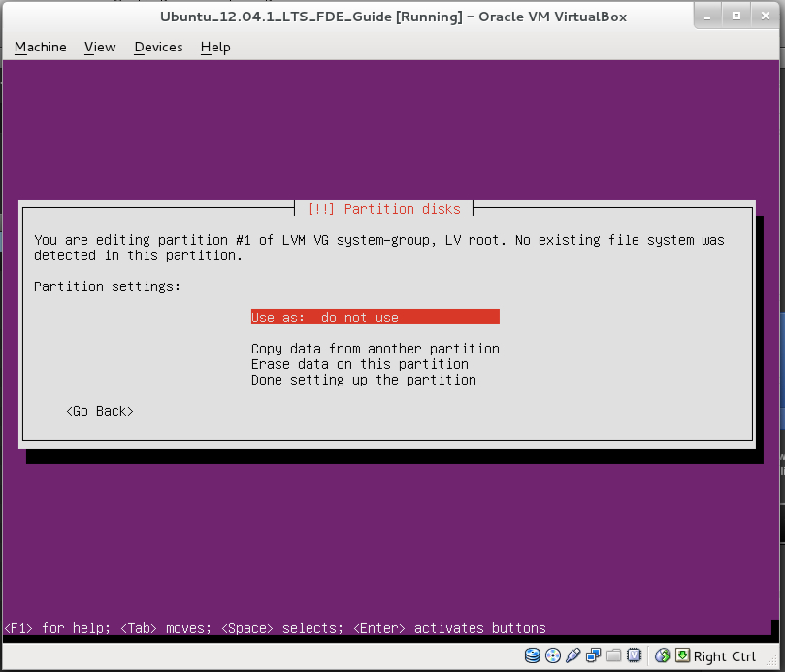

36. Should look like this now. Select “Done setting up the partition.”

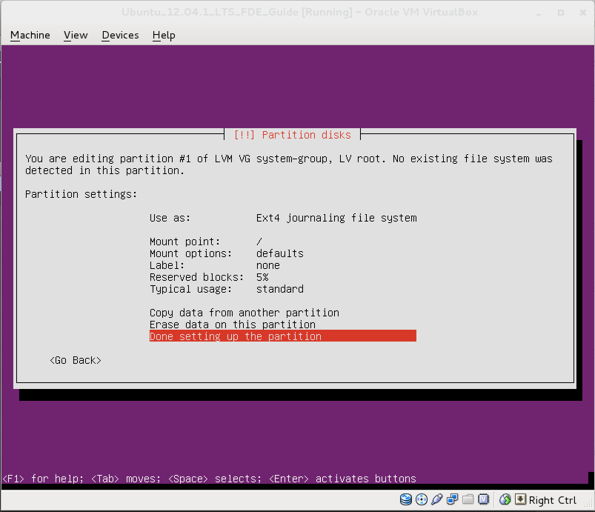

37. Now it's time to format the swap area. Select the logical volume “swap”.

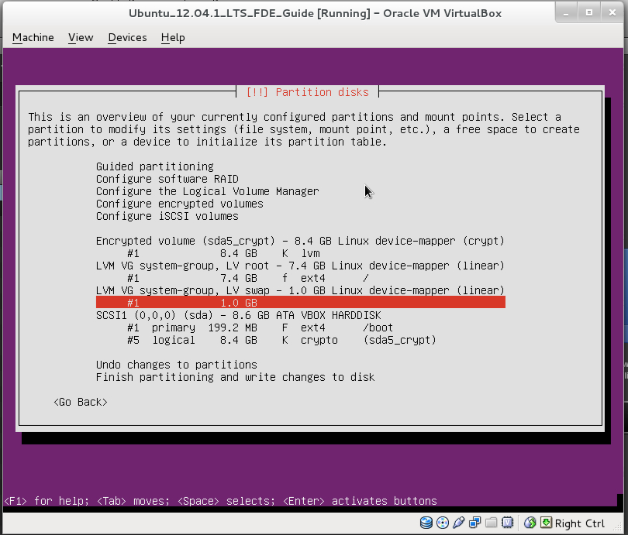

38. You only have to set “Use as:” to “swap area”, because the swap area uses no “classic” file system. Select “Done setting up the partition”.

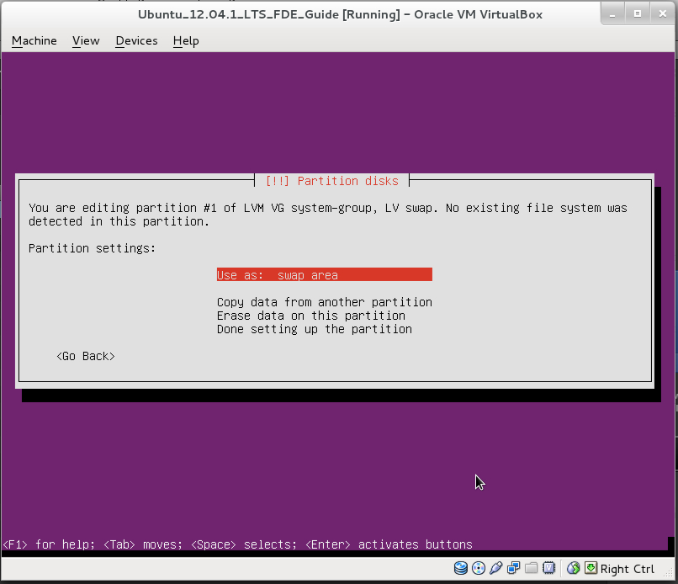

39. This is the final layout!

We have a primary partition that we use for the /boot partition. This one is 200 MB in size and not encrypted. After that, we created a 8.4 GB crypto container. Inside of this crypto container, we created the volume group “system-group” that uses the whole space. Inside of this volume group, we created the logical volumes “root” (7.4 GB) and “swap” (1 GB). The root volume was formatted with an Ext4 file system. The swap volume has it's own layout. That's how your setup should look like.

[ ! ] Keep in mind that this was just one way to do it. Feel free to create separate logical volumes for your /home or /opt partition and use other file systems. The steps are all the same!

Select “Finish partitioning and write changes to disk”.

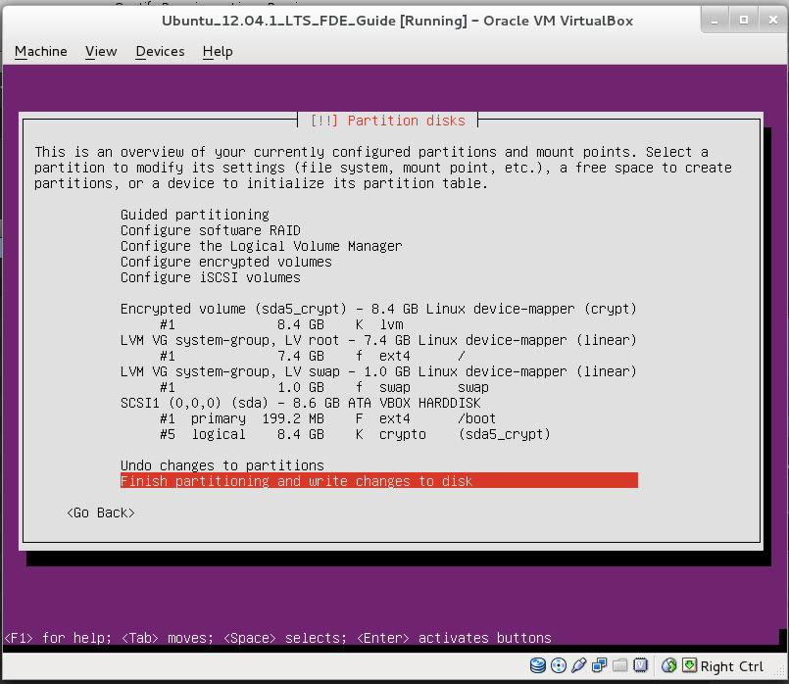

40. Select “Yes”.

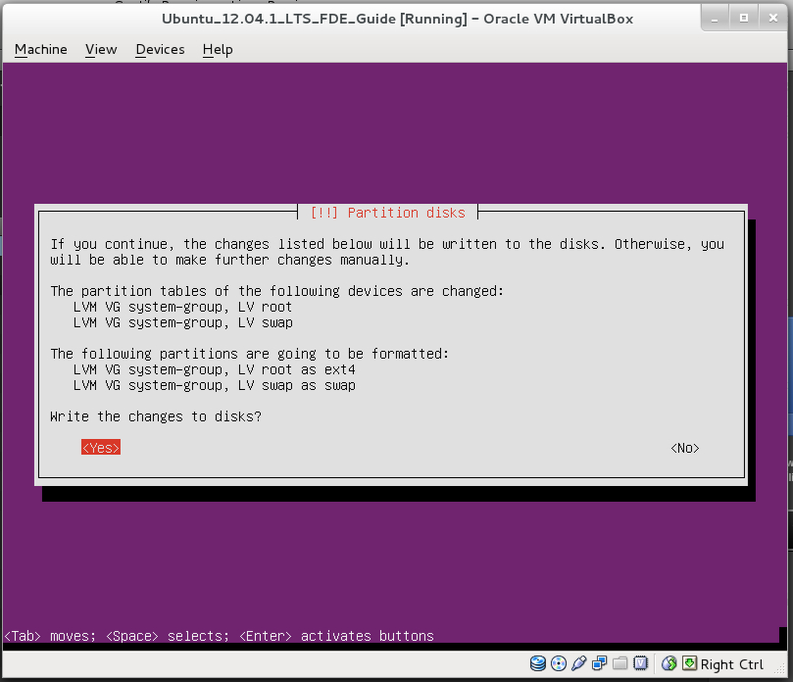

41. Next steps are self explaining. Just wait until the basic installation finishes.

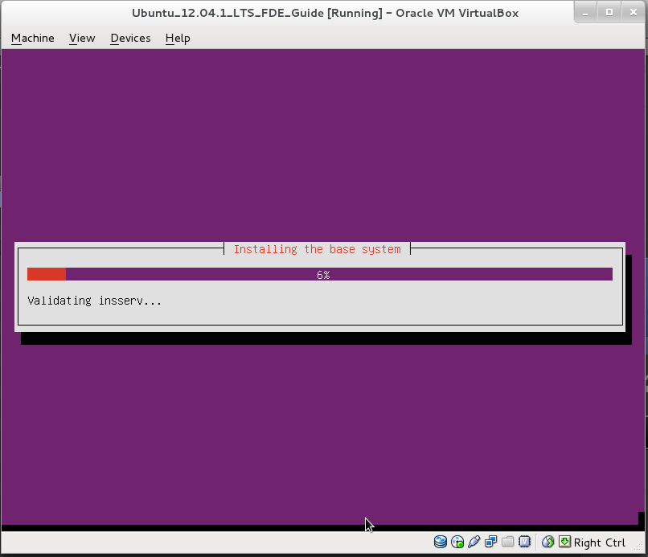

42. Select “Yes” to install the boot loader.

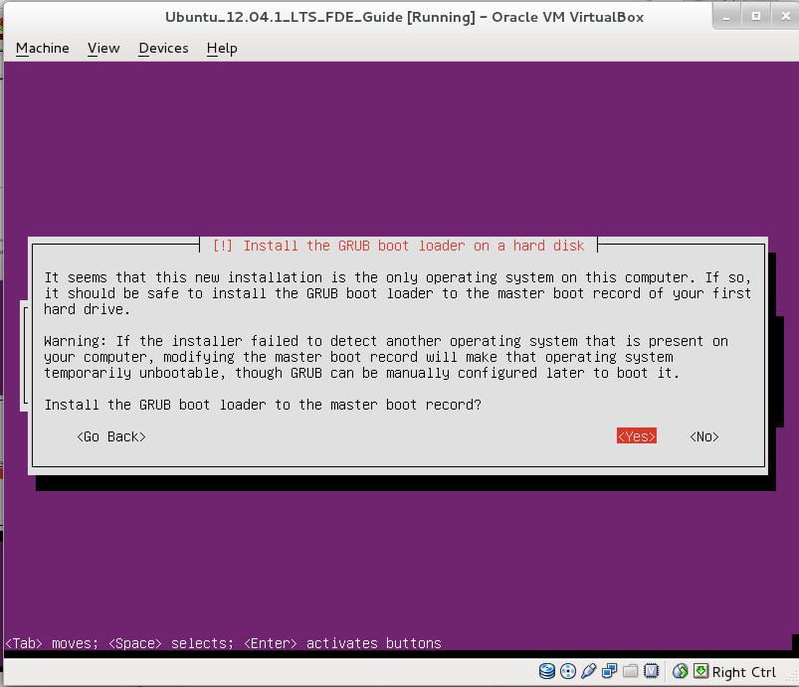

43. That's it. Installation finished. Time to reboot. Select “Continue”.

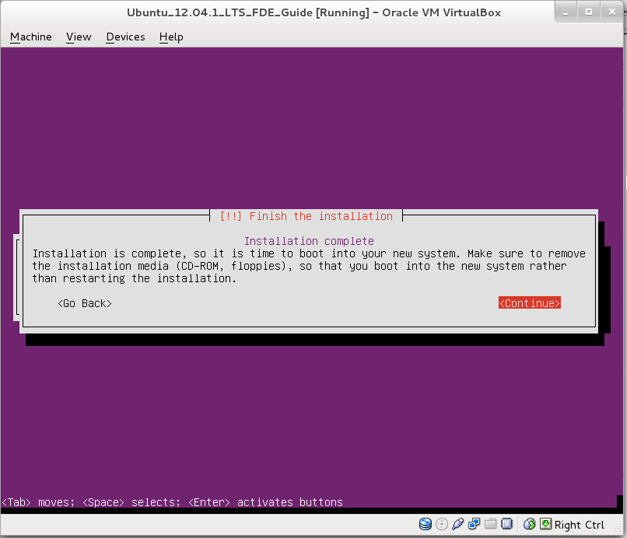

44. That's what should happen after you successfully installed the system. Just type in the encryption password.

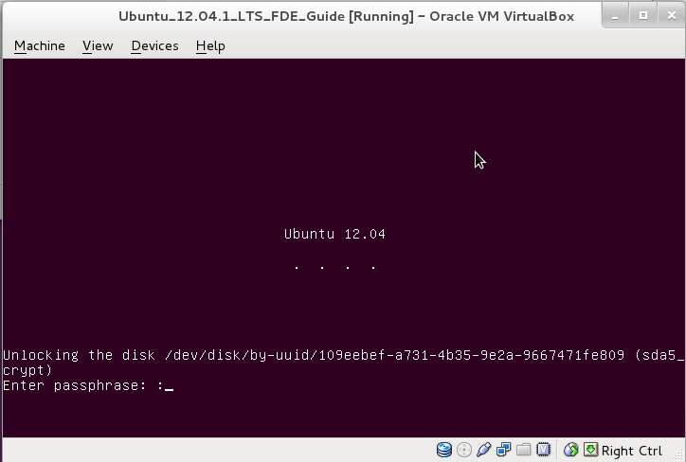

45. If the password is right, the system will boot.

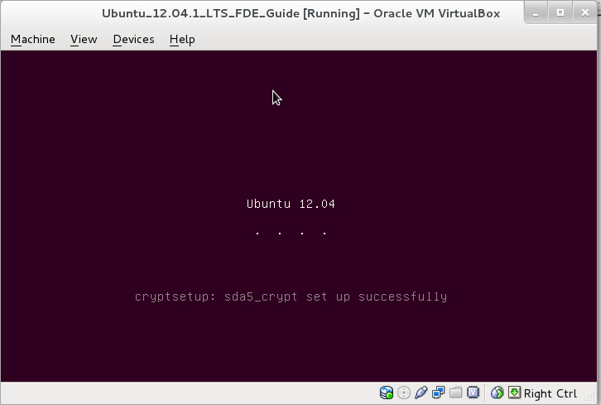

46. Have fun with your full disk encrypted Ubuntu 12.04.1 LTS installation!



