IBM Message Broker
default MQ Listener port number is 1414

Quemanager
A node responcible for accepting and delivering of messages.
Several queuemanagers can run on the same server.
Channel
Queue managers, within the infrastructure, are connected by logical channels over a communications network.

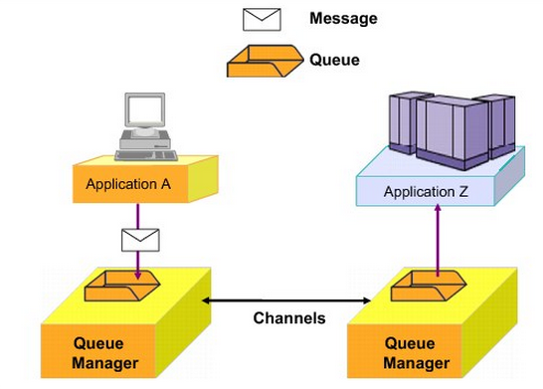

Websphere MQ client
A WebSphere MQ client is a lightweight component of WebSphere MQ that does not require the queue manager runtime code to reside on the client system. It enables an application, running on a machine where only the client runtime code is installed, to connect to a queue manager that is running on another machine and perform messaging operations with that queue manager. Such an application is called a client and the queue manager is referred to as a server.
Application programming interfaces (APIs)
Applications can use WebSphere MQ with several programming interfaces.
Standardized APIs
Using a standardized API can add additional flexibility when accessing services through a message queuing infrastructure. This book uses the term standardized API to represent APIs that are not proprietary to an individual product, such as WebSphere MQ.
The following list notes examples of standardized APIs that can be used to access services that are provided through a WebSphere MQ infrastructure:

- Java Message Service (JMS)
- IBM Message Service Client (XMS)

Wide adoption of these APIs can occur across multiple products. For example, the JMS API is an industry standardized API for messaging within the Java Enterprise Edition (Java EE) specification.

Active MQ

JNDI
jndi.properties file should be in the <bin> map in your Eclipse workspace.

Linux
No route to host may NOT be what it says
Example
$telnet 192.168.2.242 61616

If the destination IP and port is not reaceable the telnet reports No Rooute To Host

Install activeMQ
unzip/tar extract to install dir.
Setup JAVA_HOME if missing
start activemq with <install dir>/bin/activemq start
verify that activemq is started by verifying the TCP port
netstat -an|grep 61616
verify by opening the console
http://192.168.2.242:8161/

Getting statred Java examples from the book Java Message Service
2nd Edition from O'Reilly Media Inc

Download non sping examples from the book
http://examples.oreilly.com/9780596522056/JMS_2ed_non_spring.zip

MetaData.java Exemple Java app that connects and shows JMS version etc.
Qlender.java Exemple bank loan server
Qborrower.java Exemple bank borrow client

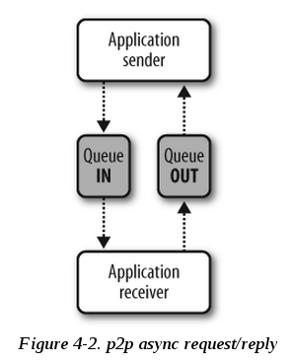
The example appication is a typical point to point application with an asyncronius message handling.

The borrower sends a loan request and blocks on wait for a response.

The lender reads the message, runs the business logic and sends a response banck to the borrower.

Configure activeMQ for the loan/lender test application

Goto the activeMQ conf directory <install dir>/conf
Make a copy of the origianal config file $cp ./activemq.xml ./activemq.xml_ORG

Add the following configuration entry to the activemq.xml file within the <broker> tag.

<destinations>
<queue name="LoanRequestQ" physicalName="jms.LoanRequestQ" />
<queue name="LoanResponseQ" physicalName="jms.LoanResponseQ" />
</destinations>

restart activemq <install dir>/bin/activemq restart

Verify that the two new queues are create by opeing the activemq admin console
http://192.168.2.242:8161/
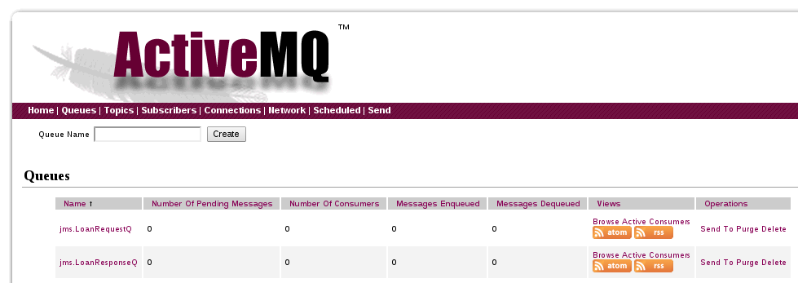

Next import or copy the example code into a new Eclipse project
Copy the activemq-all5.9.1.jar to your project and add the jar file to the build path.

