Final Comment
To keep a hawk safe for many years, think every action through, and don't take unnecessary risks. There are enough deadly risks in the field, so make your handling 100% safe. Any routine that is good, practice it even when you don't have to. An example of this is the clipping of the hawk to your glove when you take him up. Is it necessary in the mew? Of course not, but if you do it, it gets ingrained in your behavior. Five years from now that habit might save your hawk's life.

Table of Contents (Second Edition)

i) Introduction
ii) Kit Contents
- Harris' Hawks in Falconry
- Natural History
- Training
- Diet, Feeding Weight Control
- Housing, Water, and Screaming
- Equipment and Hawk Furniture
- Hooding
- Hunting Techniques
- The Molt
- Quarry
- Hazards, Precautions
- Best Practices
- Telemetry
- Suggested Reading
Suggested Reading

Desert Hawking, Harry McElroy and others
And One Makes Three, Bill Boni
In Season, Matthew Mullenix
Hunting with Harris' Hawks, Bob Dalton
A Passion For Harris' Hawks, Martin Hollinshead
The Harris Hawk, Lee William Harris
The Modern Falconer, Diana Durman-Walters
Telemetry

Dart is one of the most dependable hawks you will fly. Nevertheless, flying with telemetry is always recommended. In order of preference, probably the best attachment methods are the Marshall Track Pack®, tail mount, and leg mount. Although the best compromise, the tail mount has the disadvantage that this hawk likes to get into the weeds; grass sometimes will wrap around the transmitter. The plectrum is a good tail mount method because it distributes the weight between the two deck feathers, and the bell may be conveniently carried as well.

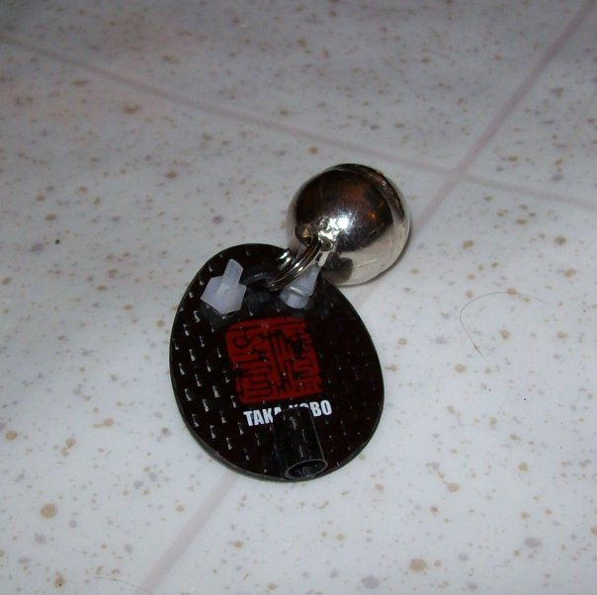

Plectrum Mount with Pakistani Bell Attached

Introduction

I flew my first Harris' hawk in the fall of 2008, a captive bred Coulson tiercel, in his second season. He was a hand-me-down bird that I ended up with as a result of Hurricane Ike's destruction of Chris Comeaux's house on Bolivar Peninsula. Chris was already flying two gyr-peregrine tiercels, and had many storm related issues to deal with, including the rebuilding of his house, so the hawk had to go. Chris got him from Bryan Chenault, who had to give the bird away because of Bryan's health issues. At the time I was flying a successful red-tail and didn't need another hawk, but was glad to get this one.

Early on, while still at molting weight, “Dart” was a bit of trouble, but once he lost 100 grams, he became a fine hunting hawk. One afternoon he turned it around and it became obvious to me why Harris' hawks are the most popular falconry bird in the world. Harris' hawks have charm, brains, guts, personality, and are extremely versatile.

I decided to give the hawk to Lynne Holder, my friend and apprentice, because I didn't really have the time to fly two hawks. I was committed to keeping the red-tail, a fine bird in his own right.

I wrote this primer for Lynne, both for fun, and because I thought it might be useful. A lot of the material is just reinforcement of basic concepts, but I hope that there is a useful tip or two included. The reader will notice that there is scant reference to training a Harris' hawk. The hawk was fully trained when I got him. I have never trained a Harris' hawk, but was the first of the three falconers who flew this one to have much success with him. That may or may not qualify me to write this primer. I wish Lynne further success with this great hawk.

Chuck Redding, April, 2009

Dart Kit Contents:

- One tiercel Harris' hawk, called Dart;
- One pair of Alymeri anklets with jesses;
- One leash extender setup containing a leather strip, two small Sampo swivels, and one large Sampo swivel;
- One green, custom made Coroplast hawk box;
- Two week's supply of food

Best Practices
- Always keep control of your bird. When picking up from a perch, grab jesses directly with the open hand. Jesses should always go from legs to your closed fist. Don't allow the jesses and leash to roll around the back of hand;

- Clip a safety snap from glove to a jess or swivel ring every time that you pick up the bird.

- Check equipment regularly for wear and cracks; replace anything that looks remotely suspect. Keep leather well greased and pliable to prevent cracking;

- Keep an eye on the bird's feet, inside his mouth, and around his cere for signs of disease; get in the habit of checking bottom of feet;

- Always get to the bird quickly when he has taken quarry in the field, as ambush by a red-tail, dog or coyote can happen quickly. If your hawk is pursuing on a long flight you should always be running after him. When your Harris' hawk is down on quarry, get to him fast.

- Don't allow your hawk to bate on abrasive or hard surfaces, or to walk around on a mute contaminated surface. Clean surface or move hawk if it gets contaminated.

- Be aware of the air that he breathes, keeping it fresh. Harris' are acutely sensitive to carbon monoxide, so getting stuck in traffic can be an issue.

- Never let the hawk weather out unattended. If not in an enclosure, you should stay with him. A large dog can cripple or kill a hawk in seconds.

- When you approach a plate glass door, always keep the bird away from the glass so that he does bate into the window.

- Keep your mew screened for mosquitoes.
Hazards and Precautions

- Window strikes can be very dangerous for a Harris' hawk, more likely to be killed than a red-tail, because of his faster acceleration. There is no excuse for this happening. Always have bird clipped to glove, especially in house. Never place the bird on a scale or perch, untethered in the house. Tragedy can happen in an instant.

- Cyclone and barbed wire fences should be avoided whenever possible.

- In the field if he has a long flight away from you, attack by a red-tail is a real concern. Get to him ASAP. If he hunts with a dog this will alleviate the issue as the dog will stay near him on the kill.

- Avoid nasty looking power poles and transformers.

- Avoid red-tail hawks and horned owls. He is not afraid of either, and they are dangerous.
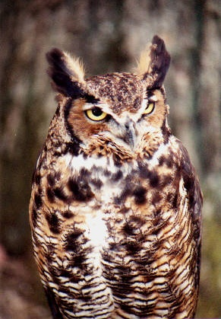

Bubo virginianus

Harris' Hawks in Falconry

In the last forty years, since about the mid-sixties, the Harris' hawk has made its mark on falconry. Almost unheard of previously, now they are the most popular bird worldwide. In the United States they are the second most widely flown falconry bird, with the red-tail's being the the first. The first Harris' hawk that I ever saw was a haggard tiercel trapped by a prep-school friend in early 1967. My friend, Paul Glasser, flew this bird for about two years, being among the first falconers in the world to fly one. Paul trapped this bird for no other reason than Harris' hawks happened to live near his house in Pleasanton, TX. He caught a number of wood rats with the bird, but it never would take a rabbit. Paul released the Harris' in order to fly an eyas red-tail.

Falconers today hunt an enormous range of game with Harris' hawks. Harris's will catch any quarry caught by any other falconry bird. A partial list includes: rabbits and hares, ducks, geese, squirrels, quail, pheasant, snipe and grouse. In addition, they are excellent sparrow hawks, and will take starlings and grackles. Their social nature enables the falconer to fly his or her hawk with other trained Harris' hawks, though my particular bird was never flown by me in a cast. The one attempt I made resulted in serious crabbing with Paul Moore's passage tiercel.

Their intelligence and curiosity make them fun to be around and interesting to watch.

Harris' hawks may be hunted at night with a spotlight, and will ride the mirror of a car taking game as it flushes (this activity is only legal under certain conditions).

If Harris' hawks have any limitation it is related to the cold. They are susceptible to frostbite, and in cold climates can lose toes. It is best to fly a red-tail or goshawk in regions where the temperature regularly gets down into the twenties. However, in all other conditions Harris' hawks excel.
Natural History
Harris' hawks (Parabuteo unicintus) include three subspecies. In the wild, the females weigh roughly 1000 grams, while the males average around 700. They range from the southwest United States, including the southern parts of Texas, Arizona, New Mexico, and California to Chile and Argentina. One of the few hawks that hunt and live communally, Harris' hawks hunt small birds, lizards, snakes, and mammals up to the size of rabbits and hares. They thrive in the desert.

From Peregrine Fund Web Site:
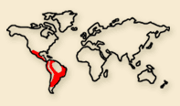
MEASUREMENTS: The Harris’ Hawk has a body length of 18 - 24 inches, a wingspan of 3 1/2 - 4 feet, and weighs 1 1/2 - 2 1/2 pounds.

HABITAT: These hawks are found in semiarid habitats like savannas, chaparrals, scrub prairies, and mesquite and saguaro deserts. They range from the southwestern United States through Central America and into much of the drier habitats in South America.

DIET AND HUNTING: Harris’ Hawks eat mammals, birds, and reptilian prey. They hunt from a perch or as they are flying. In some areas, family groups will hunt cooperatively. When hunting larger prey, like jackrabbits, hunting in a group will increase their chance of success.

REPRODUCTION: Harris’ Hawks build stick nests in trees, bushes, cacti, and on man-made structures. The female lays 2 - 4 eggs that are incubated for 33 - 36 days. The young hawks fledge at nearly 6 weeks, but stay close to the nest for an additional 3 - 4 months.

NAME DERIVATION: The scientific name comes from the Greek word para, meaning beside or near, and the Latin words buteo, referring to a kind of hawk; uni meaning once; and cinctus meaning girdled, and refers to the white band at the base of the tail. The bird was named by John James Audubon after his friend Edward Harris. This hawk has also been called a Bay-winged Hawk and Dusky Hawk.

Quarry

Harris' hawks can catch an enormous range of quarry. In the areas surrounding Houston, the most commonly hunted game will be rabbits, sparrows, starlings, grackles, and cotton rats. Hunt squirrels with caution, and avoid fox squirrels. All avian quarry must be taken on a short slip, or he will not pursue. He once chased a jack rabbit, but did not close on it.

To enter on ducks or any other new quarry will probably require some weight reduction. Do this very gradually, perhaps five grams at a time to see if he will respond. Remember that he hunts well at 620, and his reduced flying weight should not be much below that. After he begins to take the new quarry, raise his weight again.

Passer domesticus

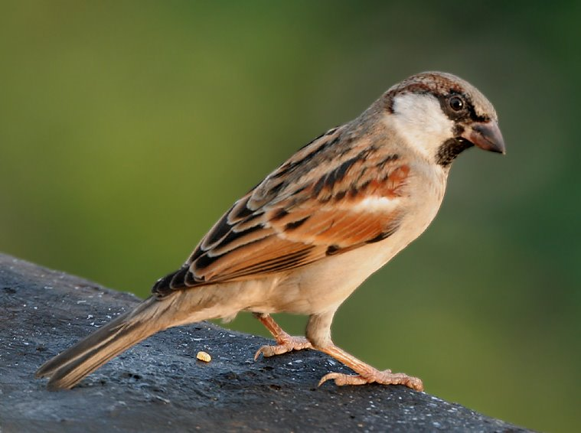
The Molt

Dart should molt with 700 to 710 grams being his 48 hours (not 24) weight. Feed about 130 grams of rabbit every other day, but add as much variety to his diet as possible. Bring his weight up as close to 1% per day as possible, and do not let his weight get too high. 710 is plenty fat. Vita Hawk supplement is good during the molt, especially if feeding non-game food like turkey necks. Keep a sparrow trap and feed some house sparrows.

He will hunt during the molt, responds well and will chase small game. Exercise during the molt is good. Install his telemetry and take him out, letting him fly around. Or fly to the fist for tidbits in the yard.

Avoid stress during the molt as stress can cause shock marks, weakening the feathers.

At the end of the molt drop his weight approximately 1% per day. DOCs are good food for controlling weight reduction. Try 1 chick, ½ chick, etc., as you bring the weight down. The more gradual the weight reduction, the less likely he is to scream, or so I've heard.

Training
I have never trained a Harris' hawk, so I picked up these bullets from Matthew Mullenix's web site:

- Perch inside for the first couple days
- Handle liberally and early
- Walk the hawk around the block every night
- Avoid extended feeding on the glove (ie., few or no tirings)
- Try to get him hopping indoors soon as possible
- Go to the creance and to free flight soon as possible
- Spend a day training to follow and/or coming to the carry pole
- HUNT, HUNT, HUNT. NEVER STOP HUNTING.
- Read: T&J Coulson, Toby Bradshaw, Harry McElroy

Diet, Feeding, and Weight Control

The first and one of the most important points related to feeding is this: do not feed the Harris' hawk on the glove, and offer very small tidbits when he flies to fist. For the main course, drop food on the ground as inconspicuously as possible, and leave the area immediately. Feeding on the fist, and sitting with him as he feeds encourages mantling and possessiveness.

Harris' hawks eat a wide variety of game in the wild, and should have similar variety as a falconry bird. The following are acceptable food items for the hawk: rabbit, squirrel, quail, smashed chicken and turkey necks, day-old-chicks, sparrows, grackles, starlings, cotton rats, and of course anything he catches while hunting. Be cautious about dove and pigeon because of frounce. Freeze first, and remove feet and gizzard. In emergency, you may feed very lean beef. An occasional dose of Vita hawk, ¼ teaspoon per dose, is good.

Always smash bones that appear too large. Do not allow him to swallow a rabbit femur under any condition. Avoid sharp bones. He is a smaller bird than a red-tail, and the tidbits fed should be correspondingly smaller.

Food that is thawed quickly is preferable to slow thawed food because of the growth of microbes.

Especially in cold weather avoid feeding frozen or very cold food.

Never gorge your hawk, as Harris's are not immune to crop stasis or sour crop. 150 grams is 25% of his weight, so get in the habit of thinking smaller, compared to a red-tail.

The hawk's best flying weight is 615 to 620 grams. If not hunting daily, you should feed every other day, and have him come into weight at your scheduled flying time. This will enable you to fly him heavier, but still have excellent response. Because he will catch and eat many small birds and animals, it will be difficult to keep him at a keen flying weight, especially when giving him lots of field time. Alas, you will have to deal with this. If his field response shows a serious decline, you may have to put him up for a few days. When he is heavy, you will observe a decreased efficiency in his catching prey, although he will continue to pursue.

Hunting Techniques

The Harris' may be flown from the fist, from trees, or from a T-pole. The T-pole is usually recommended, and works in a variety of conditions. He loves the T-pole, and you may have trouble getting him to do much else. In most conditions, this is fine, though there may be times when you want him following along a tree line, and instead he will want to ride the pole. We lost a rabbit once because the hawk wouldn't stay in the trees and landed on the ground while a rabbit scurried off. I didn't offer the pole, and he would not stay in the tree line to keep an eye on the rabbit.

As mentioned previously, all avian prey must be taken on a short slip. If not, he will ignore most birds in the field.

In wind it is useful to carry the T-pole with the perch pointing upwind. This will allow the hawk to turn either way, and is a good compromise.

In areas where it is legal, this hawk should be good at car hawking, though he needs more training. He already will return to the fist, just by your putting the gloved and garnished fist out the window. Refrain from getting out of car if you don't have to.

Roost hawking. Go to a parking lot where grackles, starlings, and sparrows congregate and throw him at the tress.

Once on a kill Dart mantles vigorously, and will drag the kill away from the falconer. Matt Mullenix told me that all captive bred Harris' hawks are like this, but not feeding on the fist helps to some degree.

To transfer him off a kill, put your hand on the prey, and toss a tidbit just ahead of him. He will usually chase the tidbit, leaving you with the kill. Of course, you must dispatch the prey first.

Hooding

This hawk is difficult to hood, but you will need to persist, and hood him regularly. He gets very active while riding in the hawk box, and damages feathers. It is recommended that he is hooded before each hunting trip. He is much more difficult to hood than your red-tail was, and considerably worse than Cisco. Just keep after it.

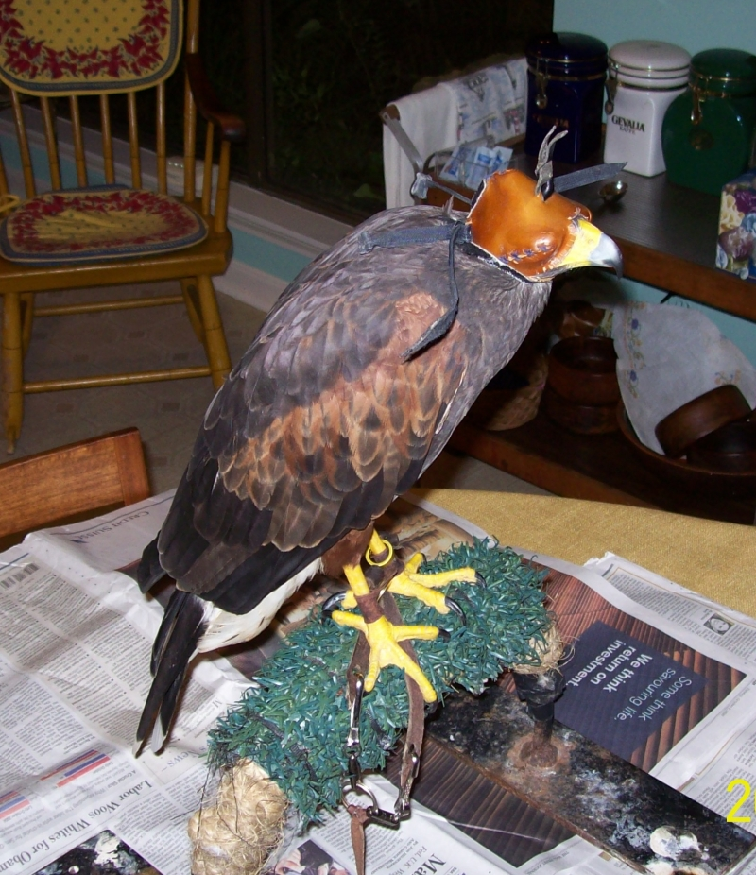

Housing

Not much to say here as your mew is excellent. He free lofts just fine and you can experiment to see whether he is better off tethered or free-lofted. As a rule, tethering provides better plumage, sharper talons and a tame hawk. On the rare occasions where the temperature gets down into the twenties, it is important to bring him indoors. These temperatures are fine for a red-tail or goshawk, but Harris's are desert birds.

Water

- Always have a bath pan with fresh water available, winter and summer. Replace water daily, as microbes will grow in the tepid water. If the hawk mutes in the water, clean pan, and quickly replace with fresh water. Don't allow the pan to get “scummy.”

- Regularly offer him a drink of fresh water from a spray bottle.

- Spray his feet after a bloody kill, for both aesthetics and hygienic reasons.

Screaming

This is the worst screaming bird I have ever encountered. End of story. He screams while bathing and you may see him scream with head under wing. Except when there is a red-tail perched nearby, he is quiet during the molt, when carrying that extra weight. His screaming may abate as he gets older.

Equipment and Hawk Furniture

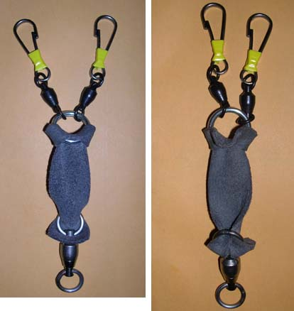

- Shown above is the recommended “setup”, which came from Matthew Mullenix's web site. The 316 stainless steel split ring should be about 7/8” diameter and have a .10” minimum wire cross section. The large swivel is 500 pound test Sampo, the small ones should be 200 pound test. Replace the split ring each season and keep the leather well oiled. The length between rings is 2” to 3”. I use a variation of this without a split ring.

- A coroplast hawk box roughly 10 3/4” wide by 20” deep by 22” high is recommended. Perch should be 6” from front, and 6” off floor.

- The best leashes I have seen are made by Laura Kirby and are available for $10. Website: http://www.yarak-ce.com Email is hawkart@yarak-ce.com

- Cut a 15” length of parachute cord and keep a snap clip and a French clip tied with a bowline to the end. Tie the cord with a bowline to a grommeted hole in the glove sleeve. The bowline is important, as it won't slip. Google “bowline” to see how it is tied. The French clip works well with metal rings, but will slip off leather. Always have your hawk clipped to the swivel or jess while sitting on glove.
Equipment and Hawk Furniture continued

- Perch: One suitable perch design is my U-perch. Tie bird to one side without sliding ring, and place bath pan on same side as leash is tied. Go to www.chucksfalconry.com and look for $50 perch link.

- Hoods. Excellent hoods are available from Hawkhill Hoods (Bryant Tarr) and Big Jer's Hoods (Jeremy Bradshaw). Mike Wiegel makes good hoods also. Google to find these.

- Telemetry - Both Marshall and L.L. make good transmitters. I recommend a L.L. LF-3 for economy, and their LF-4 for more money. Go for shorter antennae. The Marshall RT+ is good also, but is more pricey.

- Bath pan - A large oval shaped kitty litter pan is fine for a bath pan.

- Jesses. Medium or heavy weight kangaroo hide is recommended. Kangaroo is very strong and lasts for years, but you should check occasionally for rot. The jesses should be short, about, 5” to 6”, with a very small hole punched in the end. This hole should be maintained. If it enlarges, trim the end of jess, and punch a new hole.

- Kangaroo hide anklets should be Alymeri, or a pattern shown in Matthew Mullenix's kestrel book, only larger. 7/8” to 1” wide is sufficient. With kangaroo, the new anklet should be quite snug. It will stretch out quickly.

- Lure: A moccasin works well and the hawk is used to it. Rather than one big chunk of meat, use multiple tidbits each tied securely, or clipped on with a half dozen alligator clips. That way the hawk will not strip the lure and fly off.

- Bells: Larry Counce, Dave Noble are good bell makers, but I recommend the bells from Jim Ince.

